**Restaurant SIMULATION PROJECT**

* This is a simple simulation project of a restaurant
* aims to know the profit to gain the business cost
* Customers is two types of priority (low and High)
* High priority customer serves first
* The restaurant has 5 types of food types (items)each type has price and time to finish
* Each customer can order many numbers of food types
* It shows whether the presence of the restaurant is a specific environment, the business will succeed or not

**Our simulation output**

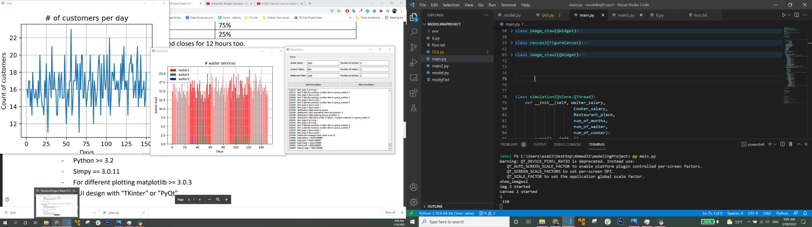

**Files**

The project includes one file "main.py"

This file consists of two parts, GUI part using python and (PyQt5, matplotlib) and the simulation code part using simply

**main.py** **(the simulation code part)**

* This file includes some libraries that we use in simulation such as "simpy" library and "randint" to generate random numbers and some variables to make the simulation model.
* Our simulation of restaurant code consists of 3 functions

1. Customer_generator
2. cook_gen
3. waiter_gen

**main.py (GUI part)**

* This file includes some libraries to make GUI, drawing charts such as "matplotlib",” numpy”and “Tkinter”.
* In GUI part there is 6 inputs Waiter Salary, Cooker Salary, Restaurant Place, Number of months, Number of waiters, Number of cooks that user can change the salary or number of months to detect the profit

Each input has initial value

* Two bottoms -Start Simuliation that call start_simulation function that call simulation restaurant code (model)
* Stop Simuliation Simuliation that call stop_simulation_func() function that close all simulations windows

**Hints**

The GUI update the charts manually So to enter new values .. press Start Simuliation and build the project again

Frist chart define customer numbers each day

Second chart define the load on each waiter