OOP(assignment 3 )

**DBMS report**

horizontal line

# 

# 1)Ahmed Mohammed Abdelhameed (06)

# 2)Ahmad Abdallah (04)

# 3)Abdelfattah Mohamed (24)

# 4)Abdelrahman Kamal Attia (23)

### Description

A Computer Database is a structured collection of records or data that is stored in a computer system. On the other hand, a Database Management System (DBMS) is a complex set of software programs that controls the organization, storage, management, and retrieval of data in a database. DBMS are categorized according to their data structures or types. The DBMS accepts requests for data from the application program and instructs the operating system to transfer the appropriate data. Extensible Markup Language (XML) (encoding: ISO-8859-1) is a set of rules for encoding documents in machine readable form. It is defined in the XML 1.0 Specification produced by the W3C, and several other related specifications, all gratis open standards.

horizontal line

### User Manual

### 1)create DB

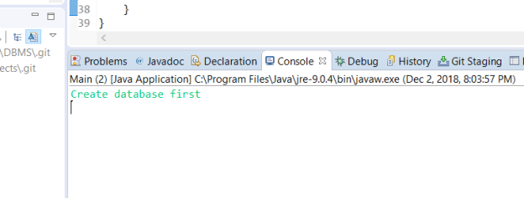

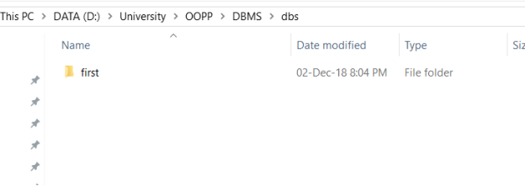

### 

### 2)Create table

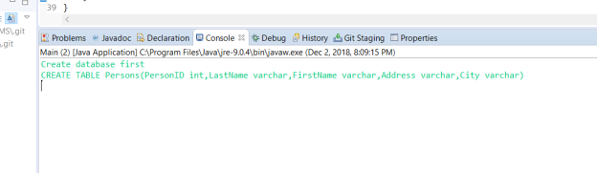

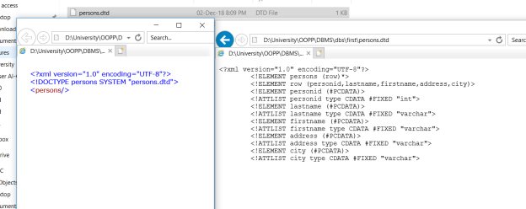

### Insert into table

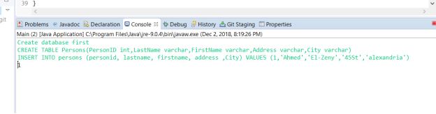

### 

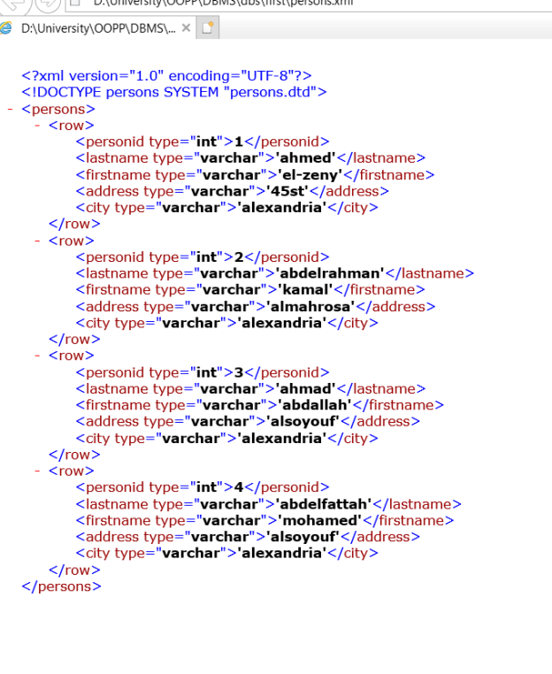

### Update

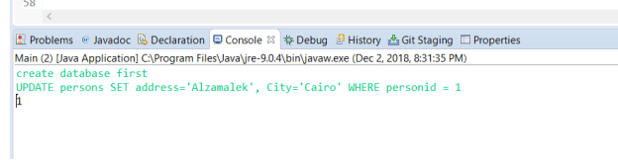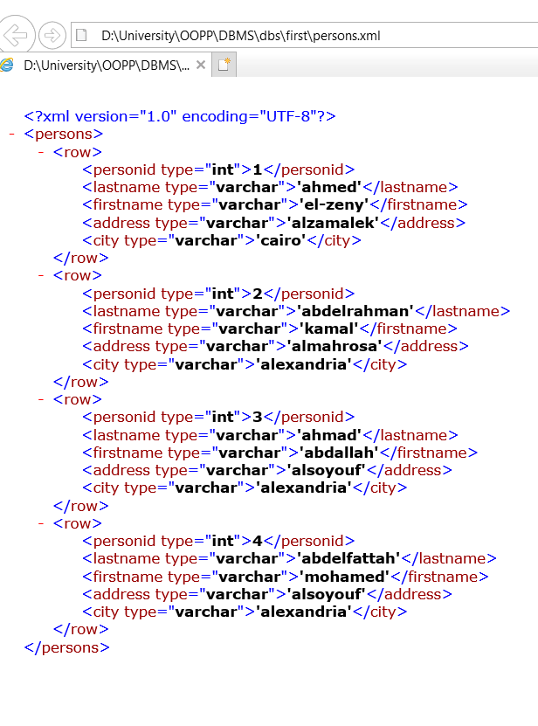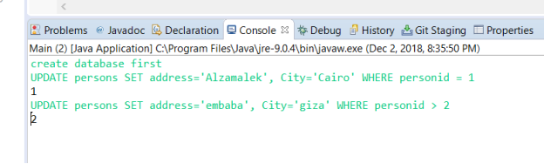

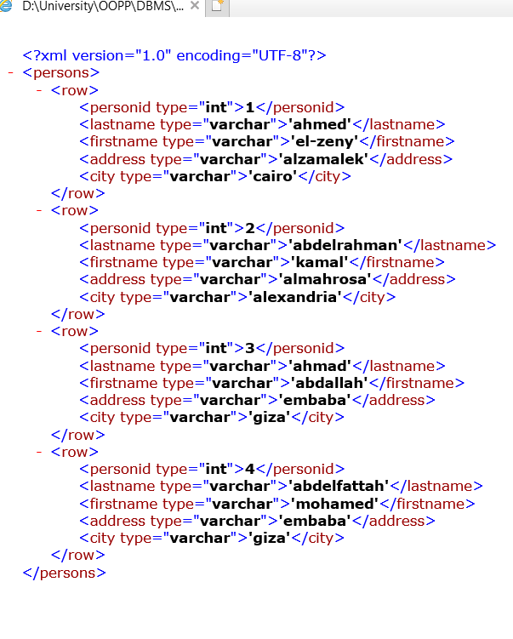

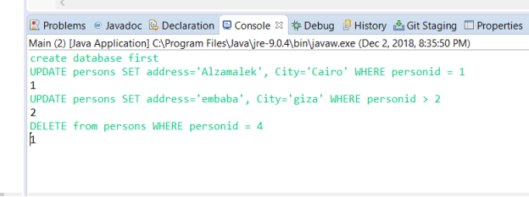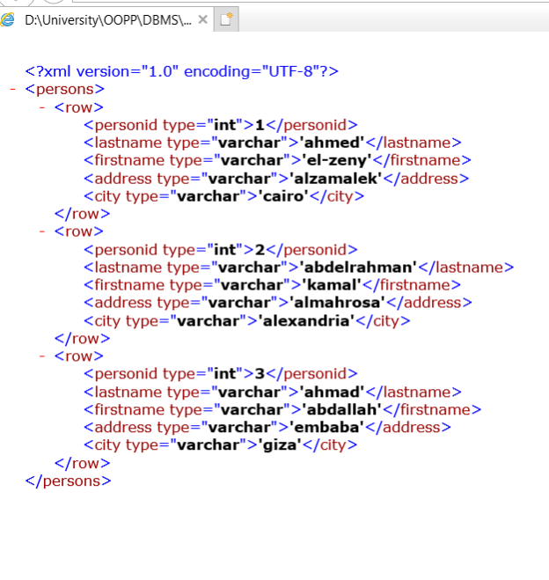

### Select (ps. We changed it so it doesn’t show the \\’ char)

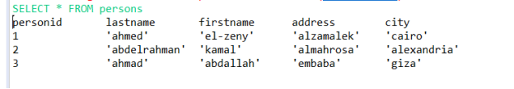

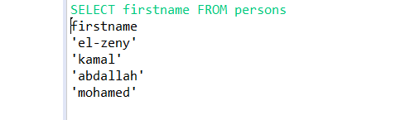

### Delete

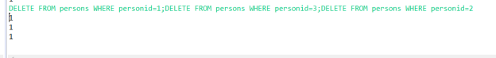

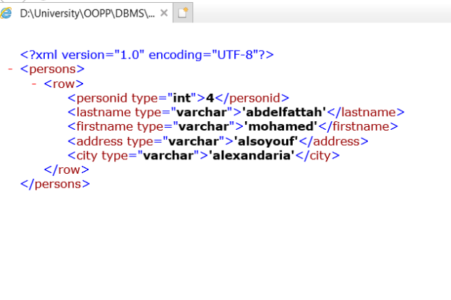

### Drop

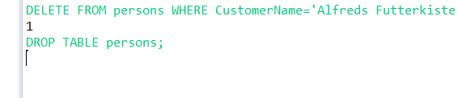

TADAAAA!! :’’D

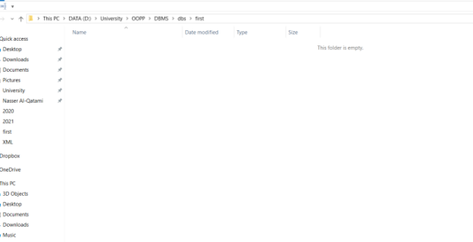

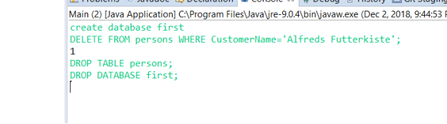

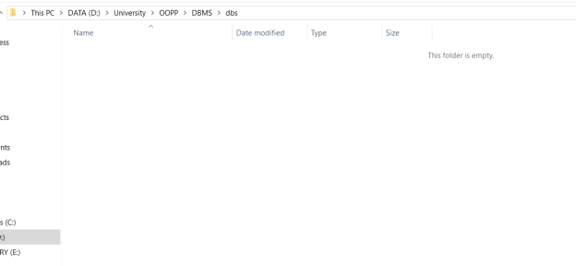

### Design description

First of all the user inter the query he want to execute , this is scanned in the main class ,, the main class then sends this query to the splitter which decide which method of the concrete class methods will be called depending on the query itself .

The method is called then the query is tested to be valid for each operation from the operations in this method through the validation class of his method using a method in this validation class for each operation in this method ,,and if it’s confirmed to be valid it’s now delivered to the parser class that parses the query into certain groups and now call the xml files classes and execute the right operation with the correct parameters .

### Wrong queries

If the user entered a wrong query (wrong syntax , bad parameters , not existing table or DB , type mismatch ….)

The program won’t execute the query and will inform the user of the error he has done.

### Design decisions

The user should press enter after each statement in the query ,, if the user was to insert more than 1 statement together without pressing enter he must separate them with semicolon (;) otherwise we will execute only the first query and the other queries are syntax error

### Design process

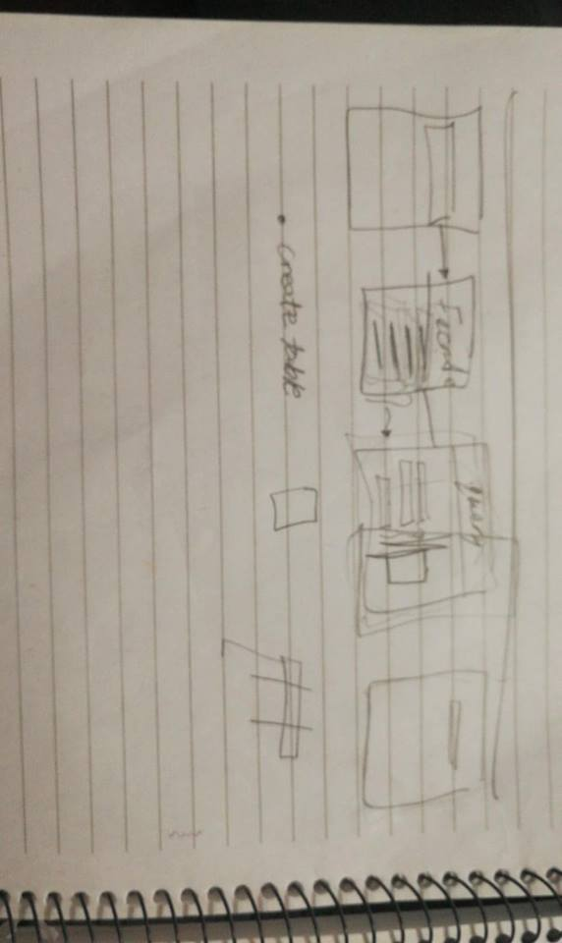

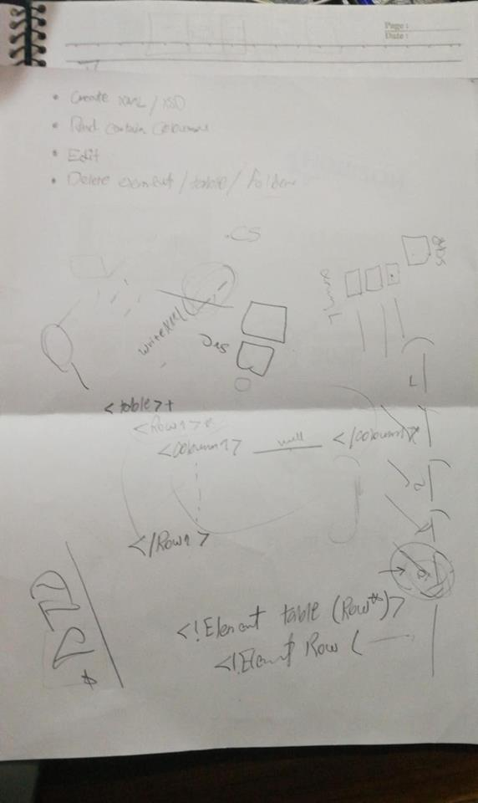

### UML Diagram

### 

### 

### 

### 

### horizontal line