DEFECT-001: Transfer Funds Allows Transaction Exceeding Available Account Balance
Module: Transfer Funds
Severity: Critical
Priority: High
Preconditions
- User is logged into ParaBank.
- Source account has insufficient balance compared to the transfer amount.
Steps to Reproduce
- Login to ParaBank.
- Navigate to Transfer Funds.
- Select a source account.
- Enter a transfer amount greater than the available balance.
- Submit the transfer request.
Expected Result
The system should validate the available account balance and prevent the transaction from being processed. An appropriate error message should be displayed, such as:
"Insufficient balance. Transfer cannot be completed."
Actual Result
The transfer is processed successfully even though the transfer amount exceeds the available balance.
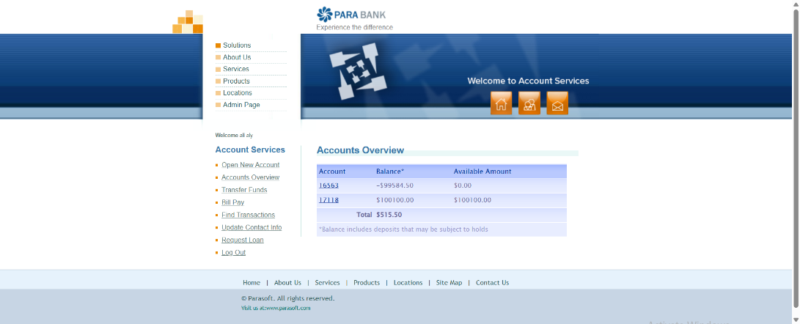

DEFECT-002: Account Balance Not Updated After Bill Payment
Module: Bill Payment
Severity: High
Priority: High
Preconditions
- User is logged in.
- Account has sufficient balance.
- A bill payment is available.
Steps to Reproduce
- Login to ParaBank.
- Navigate to Bill Pay.
- Perform a successful bill payment transaction.
- Return to Accounts Overview.
- Verify account balance.
Expected Result
The account balance should be reduced by the paid amount immediately after successful bill payment.
Actual Result
The bill payment is successful; however, the deducted amount is not reflected in the account balance.
Before paybill screenshot:
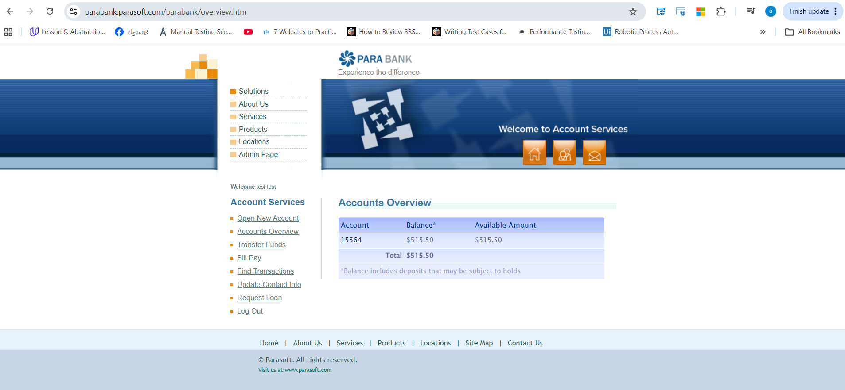

After paybill:

DEFECT-003: Loan Request Creates New Account Automatically
Module: Loan Management
Severity: High
Priority: High
Description
A new account is automatically created immediately after submitting a loan request.
Preconditions
- User is logged into ParaBank.
Steps to Reproduce
- Login to ParaBank.
- Navigate to Request Loan.
- Enter valid loan details.
- Submit the loan request.
- Review loan processing result.
Expected Result
After loan approval, funds should be associated with the existing designated account or handled according to business requirements. The system should not automatically create a new account unless explicitly required by the business process and communicated to the user.
Actual Result
A new account is automatically generated after loan processing.
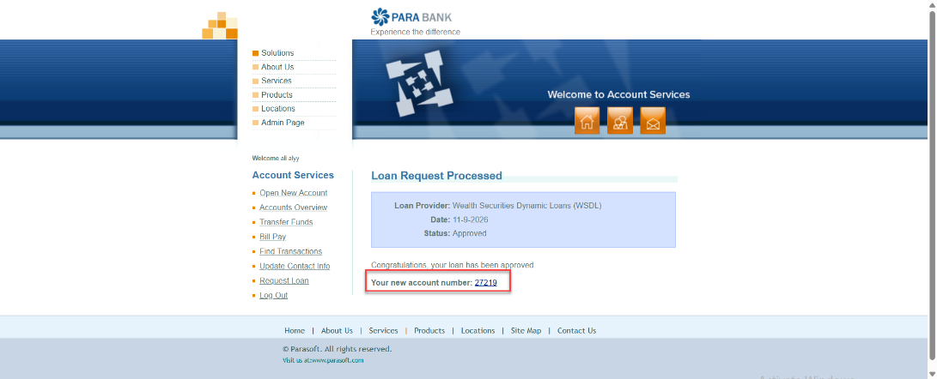
DEFECT-004: System Allows Funds Transfer to the Same Source Account
Module: Transfer Funds
Severity: Medium
Priority: Medium
Preconditions
- User is logged into ParaBank.
- User has at least one active account.
Steps to Reproduce
- Login to ParaBank.
- Navigate to Transfer Funds.
- Select an account in the From Account dropdown.
- Select the same account in the To Account dropdown.
- Enter any valid transfer amount.
- Click Transfer.
Expected Result
The system should prevent the transaction and display a validation message such as:
"Source account and destination account cannot be the same."
Actual Result
The system allows the transfer request to be submitted and processed when the source and destination accounts are the same.
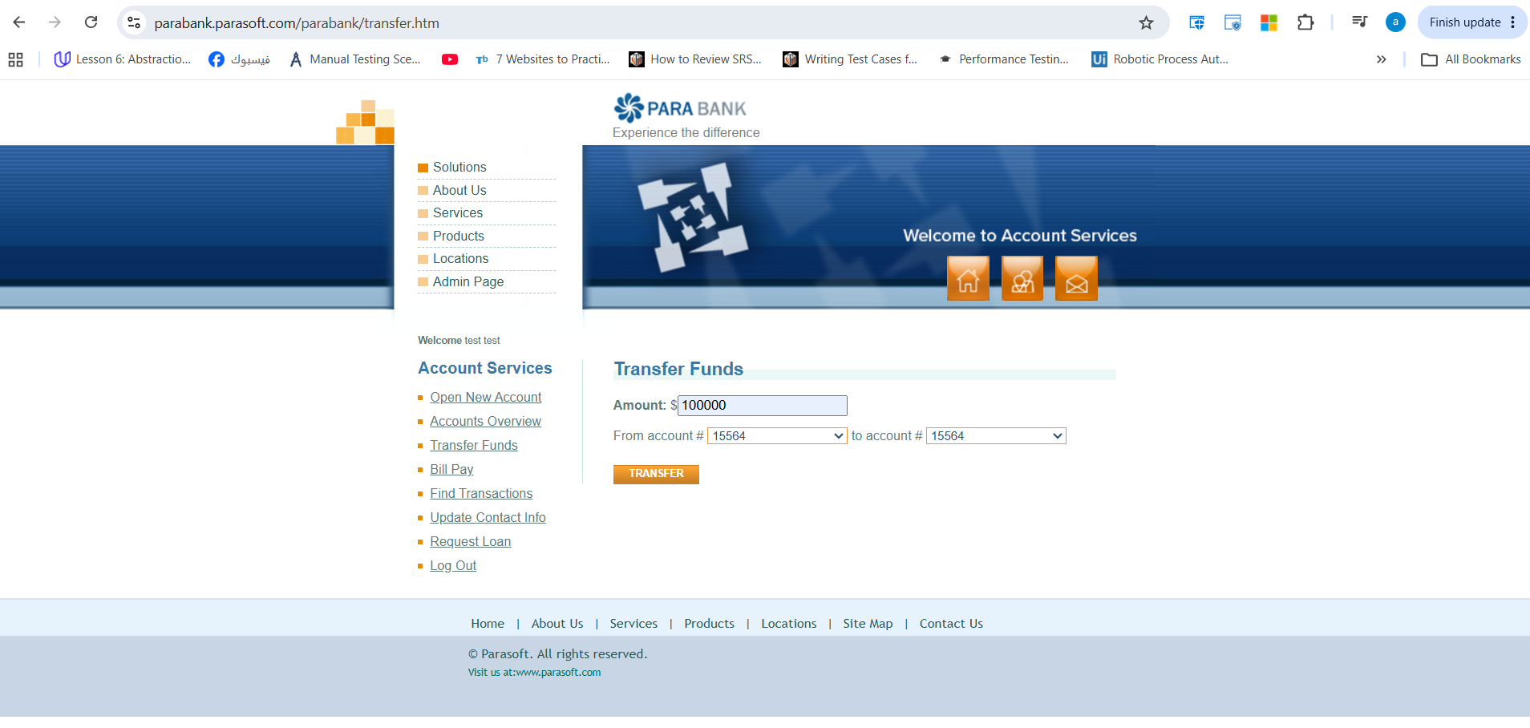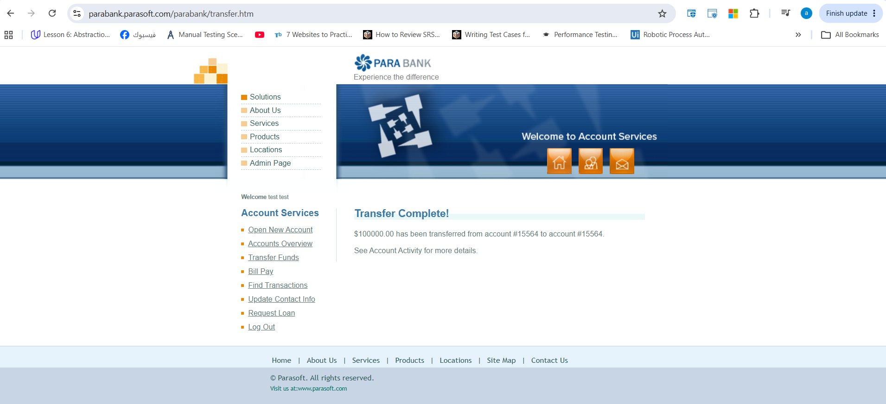

DEFECT-005: Transfer Funds Accepts Negative Amount Values
Module: Transfer Funds
Severity: High
Priority: High
Preconditions
- User is logged into ParaBank.
- User has at least one active account.
Steps to Reproduce
- Login to ParaBank.
- Navigate to Transfer Funds.
- Select valid source and destination accounts.
- Enter a negative value in the Amount field (e.g., -100).
- Click Transfer.
Expected Result
The system should validate the amount field and reject negative values. An appropriate validation message should be displayed, such as:
"Transfer amount must be greater than zero."
Actual Result
The system accepts the negative amount and processes the transfer transaction.
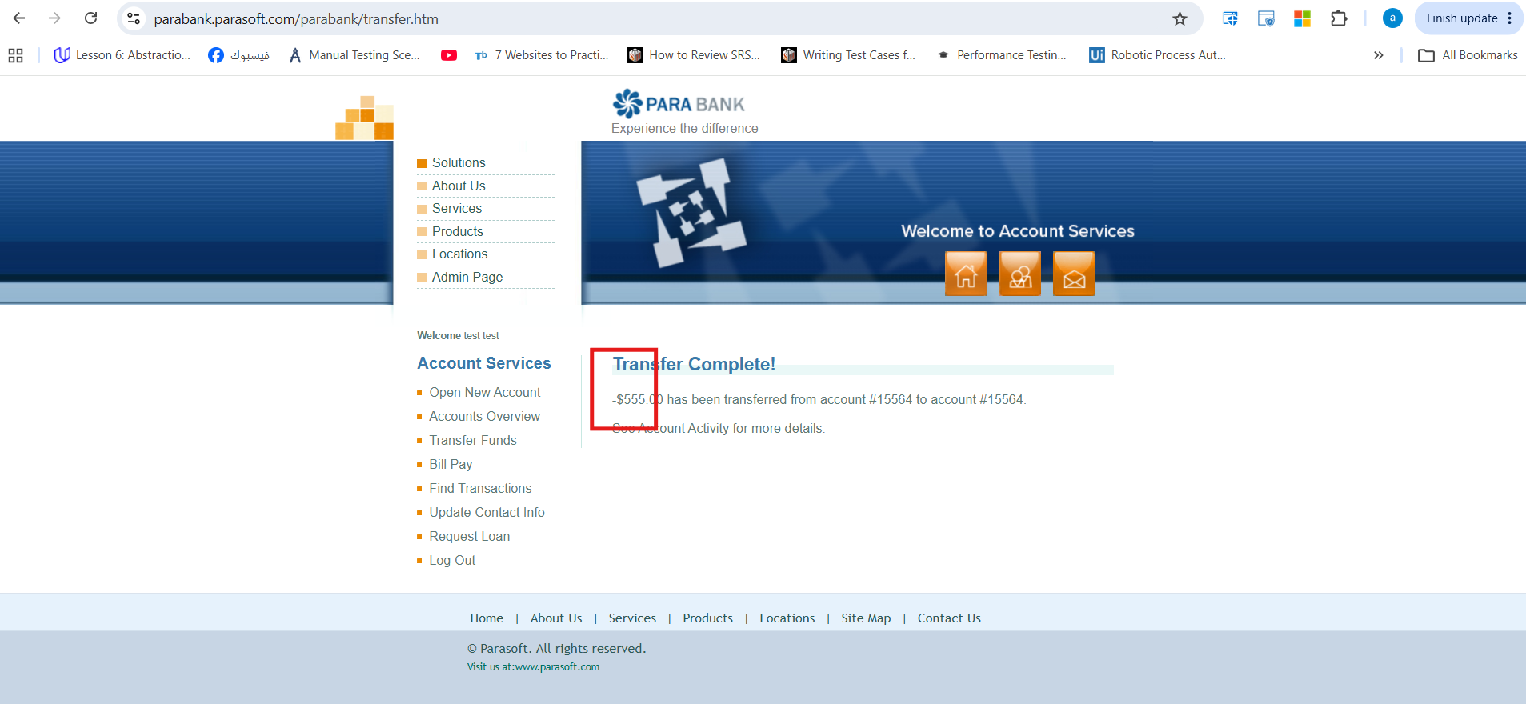

DEFECT-006: Phone Number Field Accepts Alphabetic Characters
Module: Customer Registration / Profile Management
Severity: Medium
Priority: Medium
Preconditions
- User is on Registration or Profile Update page.
Steps to Reproduce
- Navigate to Registration/Profile page.
- Enter alphabetic characters (e.g., "ABCDEF") in the Phone Number field.
- Submit the form.
Expected Result
The Phone Number field should only accept numeric values and valid phone number formats.
Actual Result
The system accepts alphabetic characters in the Phone Number field.

