# sub1 sub 2

Trending

Recommendations

Name

# sub 3

# sub 4

sign up login



slogan

About us

sign up login

sub1

sub2

Name

sub3

sub4

paragraph

footer

Sub 1 Sub 2

Name

Q&A

Sub3 Sub 4

sign up login

footer

Your paragraph text

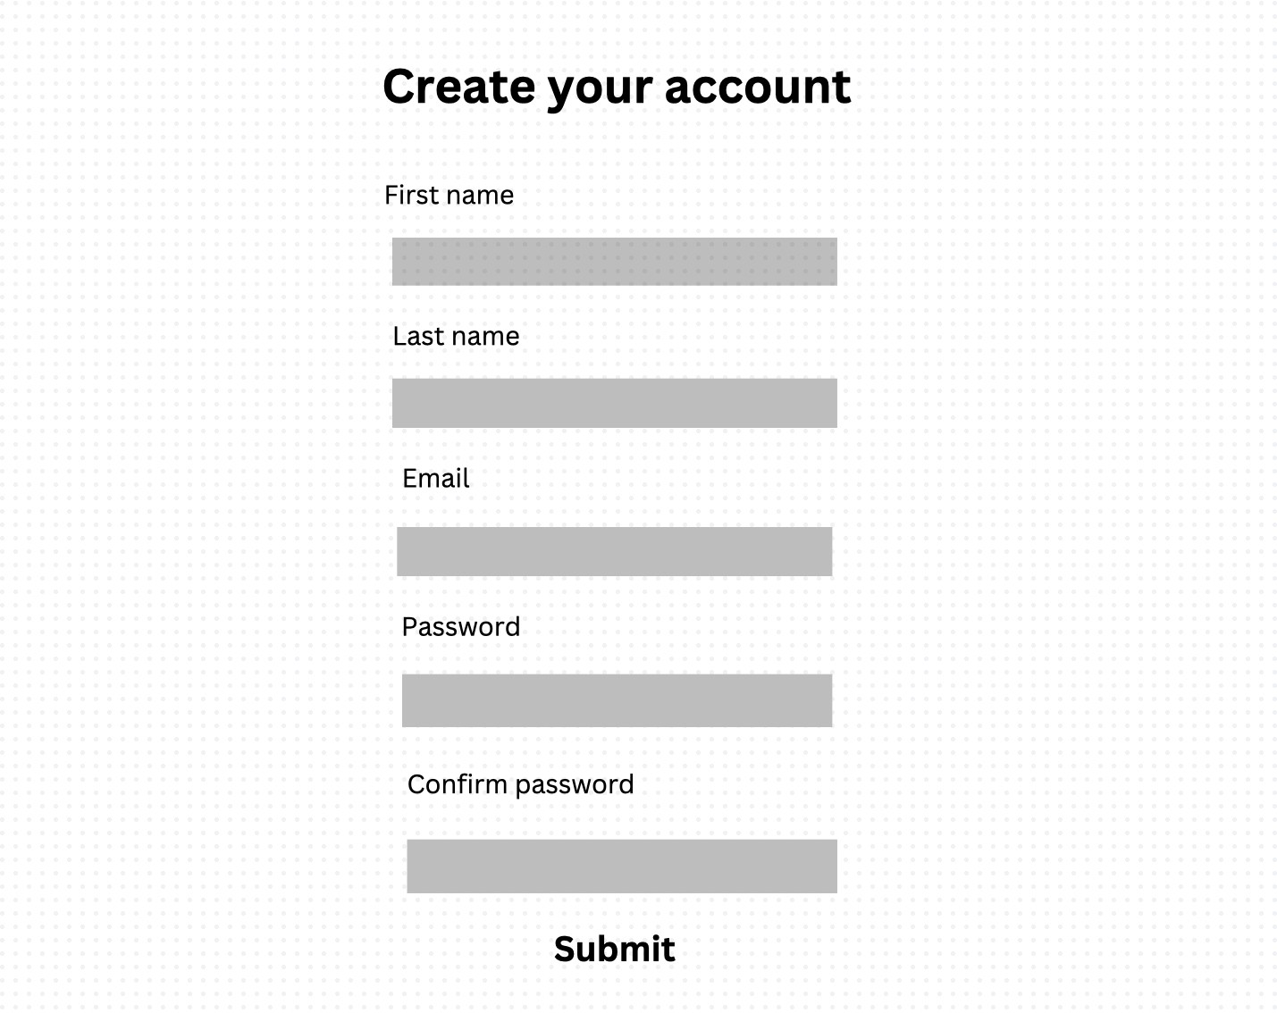

footer

this page do use a table to structure the content

Categories

|  |  |  |  |  |  |  |  |
| --- | --- | --- | --- | --- | --- | --- | --- |
| Sub 1 Sub 2 Name Sub 3 Sub 4 | | | | | | | |
| Category1 | |  | Category2 |  | Category3 |  | Category4 |
|  | text |  | text |  | text |  | text |
|  | | | | | | | |
| Footer | | | | | | | |

SiteMap

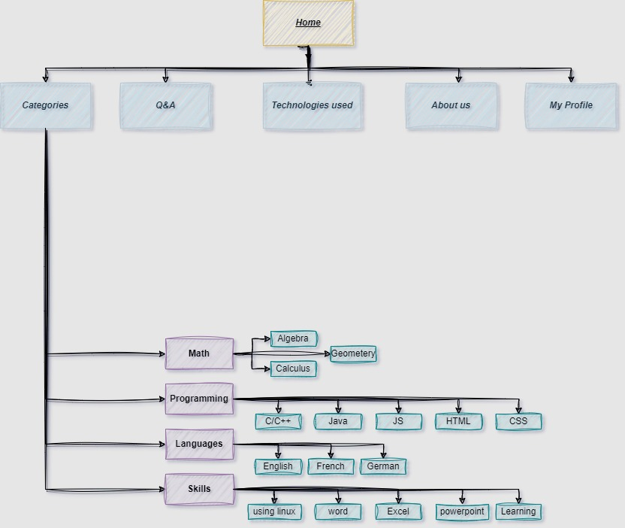

mainstyle.css

techUsedStyle.css

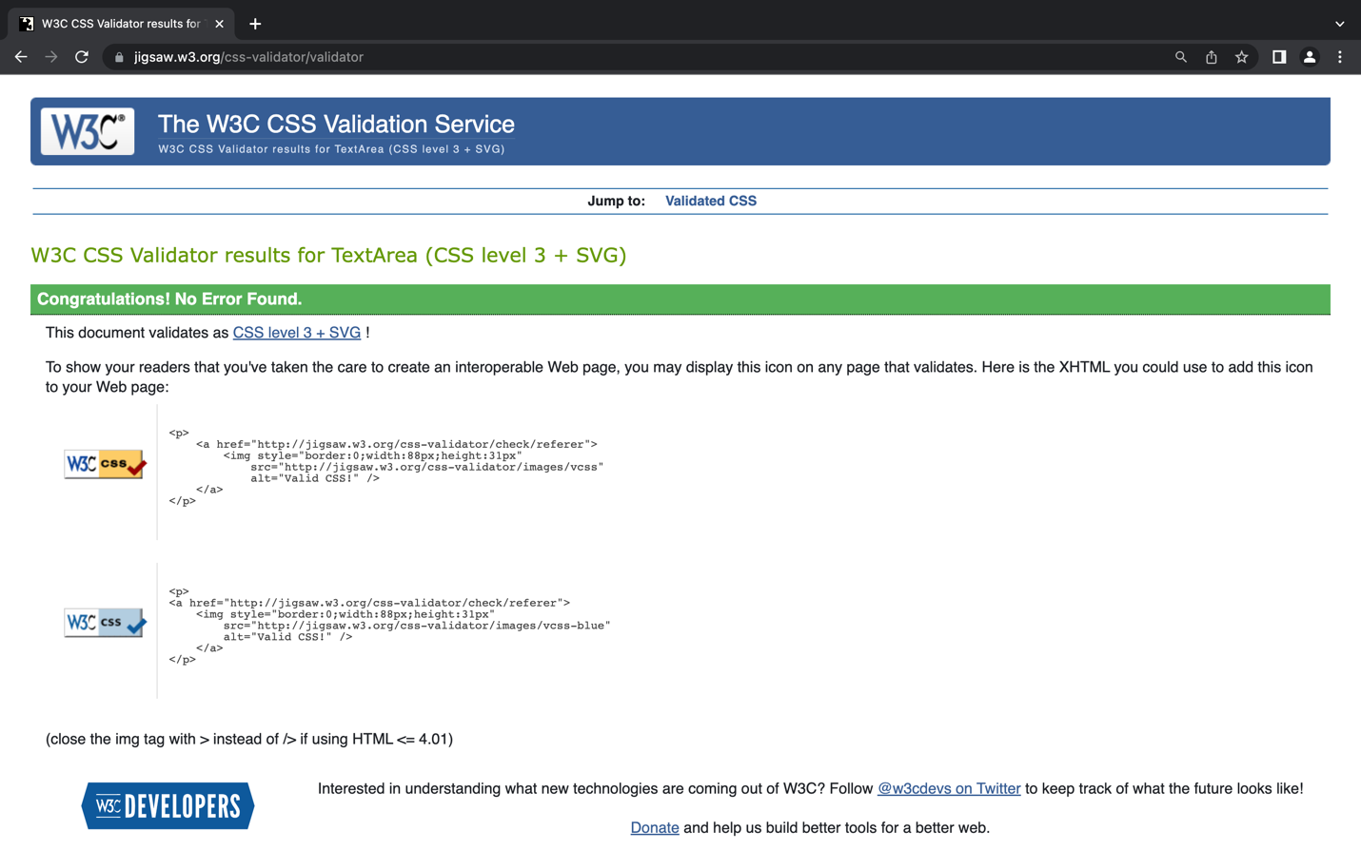

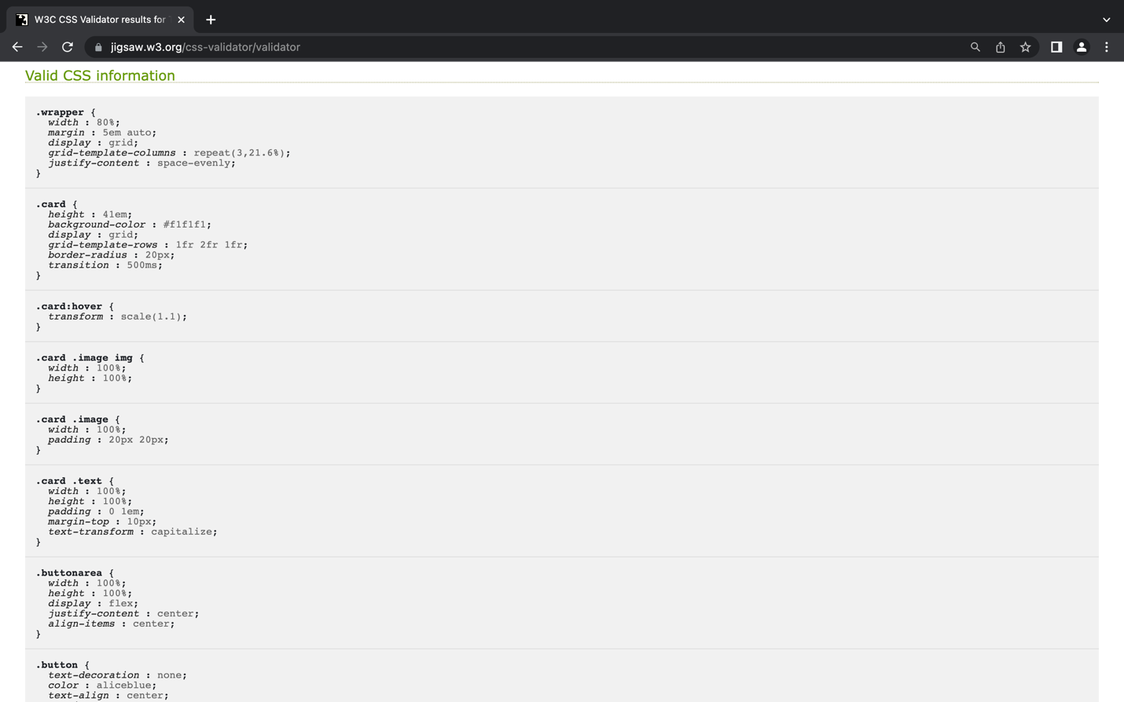

styleindex.css

categories.css

aboutUsStyle.css

Index.html

techUsed.html

categories.html

aboutUs.html

