**SV Randomization & Functional Coverage Assignment**

**Abdelrahman Mohamed Ali**

|  |  |
| --- | --- |
| **Gmail** | [abdelrahmansalby23@gmail.com](mailto:abdelrahmansalby23@gmail.com) |
| **LinkedIn** | [Abdelrahman Mohamed](https://www.linkedin.com/in/abdelrahman-mohamed-814a9022a/) |
| **GitHub** | [Abdelrahman1810](https://github.com/Abdelrahman1810?tab=repositories) |

**verification Plane flow**

|  |  |  |  |  |
| --- | --- | --- | --- | --- |
| Label | Description | Stimulus Generation | Functional Coverage | Functionality Check |
| ALSU_1 | Incase of invalid cases do not occur, when opcode is add, then out should perform the addition on ports A and B taking cin if parameter FULL_ADDER is high | Randomization under constraints on the A and B to have the maximum, minimum and zero values most of the time | Included as coverpoint for A and B. Included with cross coverage when ALU opcode is addition or multiplication | Output Checked against golden model |
| ALSU_2 | Incase of invalid cases do not occur, when opcode is mult, then out should perform the multiplication on ports A and B | Randomization under constraints on the A and B to have the maximum, minimum and zero values most of the time | Included in coverpoint2 for A and B. Included with cross coverage when ALU opcode is addition or multiplication | Output Checked against golden model |
| ALSU_3 | When invalid cases exist, out output should be low and leds should blink | Randomization under constraints where invalid cases do not occur as frequent as valid cases | Included in a coverpoint for opcode. Included with cross coverage to make sure invalid cases occur | Output Checked against golden model |
| ALSU_4 | If invalid cases do not occur and the bypass inputs are high, then the output out should by bypass port A or B based on the prioirty if the both bypass ports are high | Randomization for bypass | Included in a coverpoint for bypass | Output Checked against golden model |
| ALSU_5 | If invalid cases do not occur and the reduction operation are high and opcode nither OR nor XOR, then the output out should by zero and leds should blink as an INVALED case | Randomization for reduction operation | Included in cover group a cross covarage for reduction Invalid (reduction_invalid) Included with cross coverage when ALU opcode is addition or multiplication | Output Checked against golden model and from invvalid signal |
| ALSU_6 | Incase of invalid cases do not occur, when opcode is OR and reduction operation is low, then out should perform make A OR B | Randomization under constraints on the A to be invert B (A=~B) | Included in coverpoint for A and B. Included with cross coverage when ALU opcode is arithmatic | Output Checked against golden model |
| ALSU_7 | Incase of invalid cases do not occur, when opcode is XOR and reduction operation is low, then out should perform A XOR B | Randomization under constraints on the A to be invert B (A=~B) | Included in coverpoint for A and B. Included with cross coverage when ALU opcode is arithmatic | Output Checked against golden model |
| ALSU_8 | Incase of invalid cases do not occur, when opcode either OR or XOR and reduction operation is high for port A, then out should perform reduction OR or XOR on ports A onley | Randomization under constraint the input B most of the time to have one bit high in its 3 bits while constraining the A to be low | Included in coverpoint for A. when A is {001, 010, 100} and only the red_op_A is high | Output Checked against golden model |
| ALSU_9 | Incase of invalid cases do not occur, when opcode either OR or XOR and reduction operation is high for port B, then out should perform reduction OR or XOR on ports B onley | Randomization under constraint the input A most of the time to have one bit high in its 3 bits while constraining the B to be low | Included in coverpoint for A. when B is {001, 010, 100} and onley red_op_A is low and red_op_B is high | Output Checked against golden model |
| ALSU_10 | Incase of invalid cases do not occur, when opcode is SHIFT and direction is low, then out should perform shift left logical for last out with serial in | Randomization for A and B with no constraint | Included in coverpoint2 for A and B. Included with cross coverage when ALU opcode is SHIFT or ROTATE | Output Checked against golden model |
| ALSU_11 | Incase of invalid cases do not occur, when opcode is SHIFT and direction is high, then out should perform shift right logical for last out with serial in | Randomization for A and B with no constraint | Included in coverpoint2 for A and B. Included with cross coverage when ALU opcode is SHIFT or ROTATE | Output Checked against golden model |
| ALSU_12 | Incase of invalid cases do not occur, when opcode is ROTATE and direction is high, then out should perform the MSB to be LSB | Randomization for A and B with no constraint | Included in coverpoint2 for A and B. Included with cross coverage when ALU opcode is SHIFT or ROTATE | Output Checked against golden model |
| ALSU_13 | Incase of invalid cases do not occur, when opcode is ROTATE and direction is low, then out should perform the LSB to be MSB | Randomization for A and B with no constraint | Included in coverpoint2 for A and B. Included with cross coverage when ALU opcode is SHIFT or ROTATE | Output Checked against golden model |
| ALSU_14 | rst is high | Randomization under constraints on rst to be low most of time and make the first randomized value is high in post_randomize | include in coverpoint with weight zero | Output Checked from wave |
| ALSU_15 | making opcode always valid | randomize an array and make it unique with no INVALID value | included in coverpoint ALU_cp | Output Checked against golden model |

**Do file**

vlib work

vlog -coveropt 3 +cover +acc {Codes/pkgs/shared_pkg.sv}

vlog -coveropt 3 +cover +acc {Codes/pkgs/transaction_pkg.sv}

vlog -coveropt 3 +cover +acc {Codes/pkgs/coverage_pkg.sv}

##

vlog -coveropt 3 +cover +acc {Codes/Design/ALSU.v}

vlog -coveropt 3 +cover +acc {Codes/Design/ALSU_sva.sv}

##

vlog -coveropt 3 +cover +acc {Codes/golden_model/ALUS_ref.sv}

##

vlog -coveropt 3 +cover +acc {Codes/testbench/testbench.sv}

vsim -voptargs=+acc work.testbench

add wave *

add wave /testbench/assert_invaled

add wave /testbench/assert_invaled_opcode

add wave /testbench/assert_invaled_ref_op

add wave /testbench/assert_out

add wave /testbench/sva/redA_OR_assert

add wave /testbench/sva/redB_OR_assert

add wave /testbench/sva/redA_XR_assert

add wave /testbench/sva/redB_XR_assert

add wave /testbench/sva/Invalid_assert

add wave /testbench/sva/OR_assert

add wave /testbench/sva/XOR_assert

add wave /testbench/sva/add_assert

add wave /testbench/sva/mult_assert

add wave /testbench/sva/shiftL_assert

add wave /testbench/sva/shiftR_assert

add wave /testbench/sva/rotateL_assert

add wave /testbench/sva/rotateR_assert

add wave /testbench/sva/reset_assertion/rst_out_assert

add wave /testbench/sva/reset_assertion/rst_leds_assert

# free thw next command and comment the quit -sim to see the wave form

#run -all

vsim -coverage -vopt work.testbench -c -do "coverage save -onexit -du ALSU -directive -codeAll cover.ucdb; run -all"

#

coverage report -detail -cvg -directive -comments -output {Reports\FUNCTION_COVER_ALSU.txt} {}

#

quit -sim

#

vcover report cover.ucdb -details -all -annotate -output  {Reports\cover_alsu.txt}

#

vcover report -html cover.ucdb -output  {Reports\html_report\.}

**Shared_pkg:**

package shared_pkg;

    parameter INPUT_PRIORITY = "A";

    parameter FULL_ADDER = "ON";

    typedef enum reg [2:0] {OR, XOR, ADD, MULT, SHIFT, ROTATE, INVALID_6, INVALID_7} opcode_e;

    parameter MAXPOS = 3;

    parameter ZERO = 0;

    parameter MAXNEG = -4;

    parameter RST_ACTIVATE = 5;

    parameter INVALID_ACTIVATE = 5;

    parameter BYPASS_ACTIVATE = 10;

    parameter REDACTION_ACTIVATE = 20;

    bit first_rst = 0;

    opcode_e valid_arr[] = {OR, XOR, ADD, MULT, SHIFT, ROTATE};

endpackage

**coverage_pkg:**

package coverage_pkg;

import shared_pkg::*;

import transaction_pkg::*;

class ALSU_coverage;

    ALSU_transaction tr = new();

    covergroup cvr_gp;

        // input A bins

            A_cp: coverpoint tr.A {

                bins A_data_0 = {ZERO};

                bins A_data_max = {MAXPOS};

                bins A_data_min = {MAXNEG};

                bins A_data_default = default;

                bins A_data_[] = {001, 010, 100};

            }

        // input B bins

            B_cp: coverpoint tr.B {

                bins B_data_0 = {ZERO};

                bins B_data_max = {MAXPOS};

                bins B_data_min = {MAXNEG};

                bins B_data_default = default;

                bins B_data_[] = {001, 010, 100};

            }

        // cover point for reduction operation red_op

            op_A_cp: coverpoint tr.red_op_A {

                bins one = {1};

                bins zero = {0};

            }

            op_B_cp: coverpoint tr.red_op_B {

                bins one = {1};

                bins zero = {0};

            }

        // Crossing to satsfied the data_walkingones of A and B

            A_walk: cross A_cp, op_A_cp {

                option.cross_auto_bin_max = 0;

                bins A_data_walkingones = binsof(A_cp.A_data_) && binsof(op_A_cp.one);

            }

            B_walk: cross B_cp, op_A_cp, op_B_cp {

                option.cross_auto_bin_max = 0;

                bins B_data_walkingones = (binsof(B_cp.B_data_)

                                          && binsof(op_A_cp.zero)

                                          && binsof(op_B_cp.one));

            }

        // cover point for tr.opcode (ALU)

            ALU_cp: coverpoint tr.opcode {

                bins Bins_shift[] = {SHIFT, ROTATE};

                bins Bins_arith[] = {ADD, MULT};

                bins Bins_bitwise[] = {OR, XOR};

                bins Bins_invalid = {INVALID_6, INVALID_7};

                bins Bins_trans = (OR => XOR => ADD => MULT => SHIFT => ROTATE);

            }

        // cover point for c_in

            cin_cp: coverpoint tr.cin;

        // cover point for tr.serial_in

            serial_cp: coverpoint tr.serial_in;

        // cover point for tr.direction

            direction_cp: coverpoint tr.direction;

        // Cross coverage between ALU_cp and A and B

            ALU_A: cross ALU_cp, A_cp {

                option.cross_auto_bin_max = 0;

                bins arith_permutations = binsof(ALU_cp.Bins_arith) && binsof(A_cp) intersect{ZERO, MAXPOS, MAXNEG};

            }

            ALU_B: cross ALU_cp, B_cp {

                option.cross_auto_bin_max = 0;

                bins arith_permutations = binsof(ALU_cp.Bins_arith) && binsof(B_cp) intersect{ZERO, MAXPOS, MAXNEG};

            }

        // Cross coverage between ALU_cp and cin_cp

            ALU_cin: cross ALU_cp, cin_cp {

                option.cross_auto_bin_max = 0;

                bins add_cin = binsof(ALU_cp) intersect{ADD};

            }

        // Cross coverage between ALU_cp and serial_cp

            ALU_serial: cross ALU_cp, serial_cp {

                option.cross_auto_bin_max = 0;

                bins shift_serial = binsof(ALU_cp) intersect{SHIFT};

            }

        // Cross coverage between ALU_cp and direction_cp

            ALU_direction: cross ALU_cp, direction_cp {

                option.cross_auto_bin_max = 0;

                bins sh_ro_direction = binsof(ALU_cp.Bins_shift);

            }

        // Cross coverage ALU = {OR,XOR}, tr.red_op_A = 1, A = data_walk, B = 0

            A_data_walk_OR_XOR: cross ALU_cp, A_walk, op_A_cp, B_cp {

                option.cross_auto_bin_max = 0;

                bins A_walk_OR_XOR = (binsof(ALU_cp.Bins_bitwise)

                                   && binsof(A_walk.A_data_walkingones)

                                   && binsof(op_A_cp.one)

                                   && binsof(B_cp.B_data_0));

            }

        // Cross coverage ALU = {OR,XOR}, tr.red_op_A = 1, A = data_walk, B = 0

            B_data_walk_OR_XOR: cross ALU_cp, B_walk, op_B_cp, A_cp {

                option.cross_auto_bin_max = 0;

                bins B_walk_OR_XOR = (binsof(ALU_cp.Bins_bitwise)

                                   && binsof(B_walk.B_data_walkingones)

                                   && binsof(op_B_cp.one)

                                   && binsof(A_cp.A_data_0));

            }

        // Cross coverage Invalid case 2 red_op

            Invalid_red_op: cross ALU_cp, op_A_cp, op_B_cp {

                option.cross_auto_bin_max = 0;

                bins Invalid_reduction = (binsof(ALU_cp.Bins_bitwise)

                                         && (binsof(op_A_cp.one) || binsof(op_B_cp.one)));

            }

        // Invalid case with reduction operation

            reduction_invalid: cross ALU_cp, op_A_cp, op_B_cp {

                option.cross_auto_bin_max = 0;

                bins invalid_red_op = (binsof(ALU_cp) intersect{!OR, !XOR} && (binsof(op_A_cp.one)||binsof(op_B_cp.one)));

            }

        // cover point tr.rst

            rst_cp: coverpoint tr.rst;

        // Cross coverage tr.red_op_A and tr.red_op_B

            red_op_High_cross: cross op_A_cp, op_B_cp;

    endgroup

    function new();

        cvr_gp = new();

    endfunction //new()

    function void COV_sample(input ALSU_transaction take_tr);

        tr = take_tr;

        cvr_gp.sample();

    endfunction

endclass //coverage

endpackage

**transaction_pkg:**

package transaction_pkg;

import shared_pkg::*;

class ALSU_transaction;

    rand opcode_e opcode;

    rand bit rst, cin, red_op_A, red_op_B, bypass_A, bypass_B, direction, serial_in;

    rand bit signed [2:0] A, B;

    bit [1:0]red_op_parameterTest;

    constraint rules1_7 {

        //rst constraint

            rst dist {0:=100-RST_ACTIVATE, 1:=RST_ACTIVATE};

        // Invalid cases constraint

            opcode dist {INVALID_6:=INVALID_ACTIVATE, INVALID_7:=INVALID_ACTIVATE, [0:5]:/100-2*INVALID_ACTIVATE};

        // A & B constraint when opcode is ADD or MULT

            (opcode == MULT || opcode == ADD) -> A dist {MAXPOS:=20, ZERO:=10, MAXNEG:=20, [MAXNEG+1:MAXPOS-1]:/50};

            (opcode == MULT || opcode == ADD) -> B dist {MAXPOS:=20, ZERO:=10, MAXNEG:=20, [MAXNEG+1:MAXPOS-1]:/50};

        // A & B constraint when opcode is OR or XOR and red_op_A is high

            ((opcode==XOR || opcode==OR) && red_op_A) -> A dist {3'b001:=30, 3'b010:=30, 3'b100:=30, [MAXNEG+1:MAXPOS-1]:/10};

            ((opcode==XOR || opcode==OR) && red_op_A) -> B == 0;

        // A & B constraint when opcode is OR or XOR and red_op_B is high

            ((opcode==XOR || opcode==OR) && red_op_B) -> A == 0;

            ((opcode==XOR || opcode==OR) && red_op_B) -> B dist {3'b001:=30, 3'b010:=30, 3'b100:=30, [MAXNEG+1:MAXPOS-1]:/10};

        //  Do not constraint the inputs A or B when the operation is shift or rotate

        // it's achieved by default after the 2,3 and 4 Constraint achieved

        // bypass constraint

            bypass_A dist {0:=100-BYPASS_ACTIVATE, 1:=BYPASS_ACTIVATE};

            bypass_B dist {0:=100-BYPASS_ACTIVATE, 1:=BYPASS_ACTIVATE};

        // red_op constraint

            red_op_A dist {0:=100-REDACTION_ACTIVATE, 1:=REDACTION_ACTIVATE};

            red_op_B dist {0:=100-REDACTION_ACTIVATE, 1:=REDACTION_ACTIVATE};

        // A & B constraint when opcode is OR or XOR and red_op is low

            ((opcode==XOR || opcode==OR) && ~red_op_A && ~red_op_B) -> A == ~B;

    }

    rand opcode_e arr [6];

    constraint rules_8 {

        foreach(arr[i])

            arr[i] inside {valid_arr};

        unique {arr};

    }

    function new();

    endfunction //new()

    function void post_randomize();

        if(!first_rst) rst = 1;

        first_rst = 1;

        if (red_op_parameterTest!=2'b11 && !rst && !bypass_A && !bypass_B) begin

            if (opcode==OR) begin

                red_op_A = 1;

                red_op_B = 1;

                red_op_parameterTest[0] = 1;

            end

            if (opcode==XOR) begin

                red_op_A = 1;

                red_op_B = 1;

                red_op_parameterTest[1] = 1;

            end

        end

    endfunction

endclass //ALSUtransaction

endpackage

**Testbench code:**

import shared_pkg::*;

import coverage_pkg::*;

import transaction_pkg::*;

`define reset disable iff(rst)

`define mk_assertion(sva_assert) assert property (@(posedge clk) disable iff(rst) (sva_assert))

module testbench ();

logic clk, rst, cin, red_op_A, red_op_B, bypass_A, bypass_B, direction, serial_in;

opcode_e opcode;

logic signed [2:0] A, B;

logic [15:0] leds, leds_ref;

logic [5:0] out, out_ref;

ALSU_transaction tr = new();

ALSU_coverage cov = new();

ALSU DUT(.*);

ALSU_sva sva(.*);

ALUS_ref REF(

    A, B, cin, serial_in, red_op_A, red_op_B,

    opcode, bypass_A, bypass_B, clk, rst, direction, leds_ref, out_ref

);

initial begin

    clk = 0;

    forever

        #1 clk = ~clk;

end

initial begin

    // First loop turn off constraint 8

    tr.rules_8.constraint_mode(0);

    repeat(500_000) begin

        randomization;

        @(negedge clk);

        sample;

    end

    // Forced rst

    bypass_A = 0; bypass_B = 0;

    red_op_A = 0; red_op_B = 0;

    rst = 1; @(negedge clk); rst = 0;

    // Seconed loop turn ON constraint 8 and turn OFF other constraints

    tr.rules1_7.constraint_mode(0);

    tr.rules_8.constraint_mode(1);

    repeat(10_000) begin

        randomization(1);

        foreach(tr.arr[i]) begin

            opcode = tr.arr[i];

            tr.opcode = tr.arr[i];

            @(negedge clk);

            sample;

        end

        $display("arr = %p",tr.arr);

    end

    $stop;

end

task randomization(bit con_rule8 = 0);

    assert(tr.randomize());

    if (!con_rule8) begin

        rst = tr.rst;

        bypass_A = tr.bypass_A;

        bypass_B = tr.bypass_B;

        red_op_A = tr.red_op_A;

        red_op_B = tr.red_op_B;

    end

    cin = tr.cin;

    direction = tr.direction;

    serial_in = tr.serial_in;

    opcode = tr.opcode;

    A = tr.A;

    B = tr.B;

endtask

task sample;

    if (~tr.rst||~bypass_A||~bypass_B) cov.COV_sample(tr);

endtask

assert_invaled:         assert property (@(posedge clk) disable iff(rst) REF.invalid |-> DUT.invalid);

assert_invaled_opcode:  assert property (@(posedge clk) disable iff(rst) REF.invalid_opcode |-> DUT.invalid_opcode);

assert_invaled_ref_op:  assert property (@(posedge clk) disable iff(rst) REF.invalid_red |-> DUT.invalid_red_op);

assert_out:             assert property (@(posedge clk) (out == out_ref));

endmodule

**Design code:**

////////////////////////////////////////////////////////////////////////////////

// Author: Kareem Waseem

// Course: Digital Verification using SV & UVM

//

// Description: ALSU Design

//

////////////////////////////////////////////////////////////////////////////////

module ALSU(A, B, cin, serial_in, red_op_A, red_op_B, opcode, bypass_A, bypass_B, clk, rst, direction, leds, out);

parameter INPUT_PRIORITY = "A";

parameter FULL_ADDER = "ON";

input clk, rst, cin, red_op_A, red_op_B, bypass_A, bypass_B, direction, serial_in;

input [2:0] opcode;

input signed [2:0] A, B;

output reg [15:0] leds;

output reg [5:0] out;

reg cin_reg, red_op_A_reg, red_op_B_reg, bypass_A_reg, bypass_B_reg, direction_reg, serial_in_reg;

reg [2:0] opcode_reg, A_reg, B_reg;

wire invalid_red_op, invalid_opcode, invalid;

assign invalid_red_op = (red_op_A_reg | red_op_B_reg) & (opcode_reg[1] | opcode_reg[2]);

// assign invalid_opcode = opcode_reg[2] & opcode_reg[3]; // Wrong

assign invalid_opcode = opcode_reg[1] & opcode_reg[2]; // Fix

assign invalid = invalid_red_op | invalid_opcode;

always @(posedge clk or posedge rst) begin

  if(rst) begin

    leds <= 0;

    out <= 0;

    cin_reg <= 0;

    red_op_B_reg <= 0;

    red_op_A_reg <= 0;

    bypass_B_reg <= 0;

    bypass_A_reg <= 0;

    direction_reg <= 0;

    serial_in_reg <= 0;

    A_reg <= 0;

    B_reg <= 0;

  end

  else begin

    // if (invalid) // Wrong

    if (invalid && !bypass_A_reg && !bypass_B_reg) // Fix

      leds <= ~leds;

    else

      leds <= 0;

    cin_reg <= cin;

    red_op_B_reg <= red_op_B;

    red_op_A_reg <= red_op_A;

    bypass_B_reg <= bypass_B;

    bypass_A_reg <= bypass_A;

    direction_reg <= direction;

    serial_in_reg <= serial_in;

    opcode_reg <= opcode;

    A_reg <= A;

    B_reg <= B;

    // if (invalid) // Wrong

    if (bypass_A_reg && bypass_B_reg)

      out <= (INPUT_PRIORITY == "A")? A_reg: B_reg;

    else if (bypass_A_reg)

      out <= A_reg;

    else if (bypass_B_reg)

      out <= B_reg;

    else if (invalid)

        out <= 0;

    else begin

        //case (opcode) // wrong

        case (opcode_reg) // FIX

          3'h0: begin // Fix

            if (red_op_A_reg && red_op_B_reg)

              out = (INPUT_PRIORITY == "A")? |A_reg: |B_reg; // FIX

           // out = (INPUT_PRIORITY == "A")? &A_reg: &B_reg; // Wrong

            else if (red_op_A_reg)

              out <= |A_reg; // FIX

           // out <= &A_reg; // Wrong

            else if (red_op_B_reg)

              out <= |B_reg; // FIX

           // out <= &B_reg; // Wrong

            else

              out <= A_reg | B_reg; // FIX

           // out <= A_reg & B_reg; // Wrong

          End

          3'h1: begin // Fix

            if (red_op_A_reg && red_op_B_reg)

              out <= (INPUT_PRIORITY == "A")? ^A_reg: ^B_reg;

           // out <= (INPUT_PRIORITY == "A")? |A_reg: |B_reg;

            else if (red_op_A_reg)

              out <= ^A_reg;

           // out <= |A_reg;

            else if (red_op_B_reg)

              out <= ^B_reg;

           // out <= |B_reg;

            else

              out <= A_reg ^ B_reg;

           // out <= A_reg | B_reg;

          end

          3'h2: begin

            if (FULL_ADDER == "ON")

              out <= A_reg + B_reg + cin_reg;

            else

              out <= A_reg + B_reg;

          end

          3'h3: out <= A_reg * B_reg;

          3'h4: begin

            if (direction_reg)

              out <= {out[4:0], serial_in_reg};

            else

              out <= {serial_in_reg, out[5:1]};

          end

          3'h5: begin

            if (direction_reg)

              out <= {out[4:0], out[5]};

            else

              out <= {out[0], out[5:1]};

          end

        endcase

    end

  end

end

endmodule

**Assertion:**

import shared_pkg::*;

`define mk_assert(condition) assert property (@(posedge clk) disable iff(rst) condition)

`define mk_cover(condition) cover property (@(posedge clk) disable iff(rst) condition)

module ALSU_sva(A, B, cin, serial_in, red_op_A, red_op_B, opcode, bypass_A, bypass_B, clk, rst, direction, leds, out);

input bit clk;

input logic rst, cin, red_op_A, red_op_B, bypass_A, bypass_B, direction, serial_in;

input opcode_e opcode;

input logic signed [2:0] A, B;

input logic [15:0] leds;

input logic [5:0] out;

////////////////////////////////////////////////////////

// this variable to make writing assertion more easer //

////////////////////////////////////////////////////////

bit isBypass, InvalidOP, bitwise;

assign isBypass = bypass_A | bypass_B;

assign InvalidOP = opcode==6 | opcode==7;

assign bitwise = opcode==0 | opcode==1;

assign isRed = red_op_B | red_op_A;

///////////////////////////////////

// assertion of bypass operation //

///////////////////////////////////

bypass_A_assert: `mk_assert(bypass_A |-> ##2 out==$past(A,2));

bypass_B_assert: `mk_assert((bypass_B && !bypass_A) |-> ##2 out==$past(B,2));

//////////////////////////////////////

// assertion of reduction operation //

//////////////////////////////////////

sequence redValid(red, op,red2);

    (red && !isBypass && opcode==op && !red2);

endsequence

redA_OR_assert: `mk_assert(redValid(red_op_A,OR,0)        |-> ##2 out==|($past(A,2)));

redB_OR_assert: `mk_assert(redValid(red_op_B,OR,red_op_A) |-> ##2 out==|($past(B,2)));

redA_XR_assert: `mk_assert(redValid(red_op_A,XOR,0)        |-> ##2 out==^($past(A,2)));

redB_XR_assert: `mk_assert(redValid(red_op_B,XOR,red_op_A) |-> ##2 out==^($past(B,2)));

////////////////////////////////

// assertion of invalid cases //

////////////////////////////////

sequence Invalid_seq;

    ((isRed && !isBypass && !bitwise) || (InvalidOP && !isBypass));

endsequence

Invalid_assert: `mk_assert(Invalid_seq |-> ##[0:2](out==0 && leds=='hffff));

/////////////////////

// reset assertion //

/////////////////////

always_comb begin : reset_assertion

    if (rst) begin

        rst_out_assert: assert final (out==0);

        rst_leds_assert: assert final (leds==0);

    end

end

//////////////////////////////////////////////////////////////////

// assertion for opcode Valid cases without bypass or reduction //

//////////////////////////////////////////////////////////////////

sequence sh_ro(op, dir);

    (opcode==op && dir && !isRed && !isBypass);

endsequence

sequence op_assert(op);

  (!isBypass && !isRed && opcode==op);

endsequence

OR_assert:   `mk_assert(op_assert(0) |-> ##2  out== $past(A,2) | $past(B,2) );

XOR_assert:  `mk_assert(op_assert(1) |-> ##2  out==($past(A,2)^$past(B,2)) );

add_assert:  `mk_assert(op_assert(2) |-> ##2  out==($past(A,2)+$past(B,2)+$past(cin,2)) );

mult_assert: `mk_assert(op_assert(3) |-> ##2  out==($past(A,2)*$past(B,2)) );

shiftL_assert: `mk_assert(sh_ro(4, direction) |-> ##2  out=={$past(out[4:0]), $past(serial_in,2)} );

shiftR_assert: `mk_assert(sh_ro(4, !direction) |-> ##2  out=={$past(serial_in,2), $past(out[5:1])} );

rotateL_assert: `mk_assert(sh_ro(5, direction) |-> ##2  out=={$past(out[4:0]), $past(out[5])} );

rotateR_assert: `mk_assert(sh_ro(5, !direction) |-> ##2  out=={$past(out[0]), $past(out[5:1])} );

/////////////////////////////////////////////////////////////////////////////

//////////////////////////          cover          //////////////////////////

/////////////////////////////////////////////////////////////////////////////

///////////////////////////////

// cover of bypass operation //

///////////////////////////////

bypass_A_cover: `mk_cover( bypass_A |-> ##2 out==$past(A,2));

bypass_B_cover: `mk_cover( (bypass_B && !bypass_A) |-> ##2 out==$past(B,2));

//////////////////////////////////

// cover of reduction operation //

//////////////////////////////////

redA_OR_cover: `mk_cover( redValid(red_op_A,0,0)        |-> ##2 out==|($past(A,2)));

redB_OR_cover: `mk_cover( redValid(red_op_B,0,red_op_A) |-> ##2 out==|($past(B,2)));

redA_XR_cover: `mk_cover( redValid(red_op_A,1,0)        |-> ##2 out==^($past(A,2)));

redB_XR_cover: `mk_cover( redValid(red_op_B,1,red_op_A) |-> ##2 out==^($past(B,2)));

////////////////////////////

// cover of invalid cases //

////////////////////////////

Invalid_cover: `mk_cover( Invalid_seq |-> ##[0:2](out==0 && leds=='hffff));

/////////////////

// reset cover //

/////////////////

always_comb begin : reset_cover

    if (rst) begin

        rst_out_cover: cover final (out==0);

        rst_leds_cover: cover final (leds==0);

    end

end

//////////////////////////////////////////////////////////////

// cover for opcode Valid cases without bypass or reduction //

//////////////////////////////////////////////////////////////

OR_cover:   `mk_cover( op_assert(0) |-> ##2  out== $past(A,2) | $past(B,2) );

XOR_cover:  `mk_cover( op_assert(1) |-> ##2  out==($past(A,2) ^ $past(B,2)) );

add_cover:  `mk_cover( op_assert(2) |-> ##2  out==($past(A,2) + $past(B,2) + $past(cin,2)) );

mult_cover: `mk_cover( op_assert(3) |-> ##2  out==($past(A,2) * $past(B,2)) );

shiftL_cover: `mk_cover( sh_ro(4, direction) |-> ##2  out=={$past(out[4:0]), $past(serial_in,2)} );

shiftR_cover: `mk_cover( sh_ro(4, !direction) |-> ##2  out=={$past(serial_in,2), $past(out[5:1])} );

rotateL_cover: `mk_cover( sh_ro(5, direction) |-> ##2  out=={$past(out[4:0]), $past(out[5])} );

rotateR_cover: `mk_cover( sh_ro(5, !direction) |-> ##2  out=={$past(out[0]), $past(out[5:1])} );

endmodule

**Golden model:**

import shared_pkg::*;

module ALUS_ref (A, B, cin, serial_in, red_op_A, red_op_B, opcode, bypass_A, bypass_B, clk, rst, direction, leds, out);

input clk, rst, cin, red_op_A, red_op_B, bypass_A, bypass_B, direction, serial_in;

input opcode_e opcode;

input signed [2:0] A, B;

output reg [15:0] leds;

output reg [5:0] out;

reg cin_reg, red_op_A_reg, red_op_B_reg, bypass_A_reg, bypass_B_reg, direction_reg, serial_in_reg;

reg [2:0] A_reg, B_reg;

opcode_e opcode_reg;

wire invalid, invalid_opcode, invalid_red;

assign invalid_opcode = (opcode_reg == INVALID_6 || opcode_reg == INVALID_7);

assign invalid_red = (red_op_A_reg || red_op_B_reg) && (opcode_reg != OR && opcode_reg != XOR);

assign invalid = invalid_opcode || invalid_red;

always @(posedge clk or posedge rst) begin

    if (rst) begin

        out <= 0;

        leds <= 0;

        cin_reg <= 0;

        red_op_A_reg <= 0;

        red_op_B_reg <= 0;

        bypass_A_reg <= 0;

        bypass_B_reg <= 0;

        direction_reg <= 0;

        serial_in_reg <= 0;

        A_reg <= 0;

        B_reg <= 0;

    end

    else begin

        if (invalid && !bypass_A_reg && !bypass_B_reg) leds <= ~leds;

        else leds <= 0;

        cin_reg <= cin;

        red_op_A_reg <= red_op_A;

        red_op_B_reg <= red_op_B;

        bypass_A_reg <= bypass_A;

        bypass_B_reg <= bypass_B;

        direction_reg <= direction;

        serial_in_reg <= serial_in;

        opcode_reg <= opcode;

        A_reg <= A;

        B_reg <= B;

        if (bypass_A_reg && bypass_B_reg)

        out <= (INPUT_PRIORITY == "A")? A_reg: B_reg;

        else if (bypass_A_reg)

        out <= A_reg;

        else if (bypass_B_reg)

        out <= B_reg;

        else if (invalid)

            out <= 0;

        else if (opcode_reg == OR) begin

            if (red_op_A_reg && red_op_B_reg)

                out <= (INPUT_PRIORITY=="A")? (|A_reg):(|B_reg);

            else if (red_op_A_reg)

                out <= |A_reg;

            else if (red_op_B_reg)

                out <= |B_reg;

            else

                out <= A_reg|B_reg;

        end

        else if (opcode_reg == XOR) begin

            if (red_op_A_reg && red_op_B_reg)

                out <= (INPUT_PRIORITY=="A")? (^A_reg):(^B_reg);

            else

                out <= (red_op_A_reg)? (^A_reg): (red_op_B_reg)? (^B_reg):(A_reg^B_reg);

        end

        else if (opcode_reg == ADD)

            out <= (FULL_ADDER=="ON")? (A_reg + B_reg + cin_reg):(A_reg + B_reg);

        else if (opcode_reg == MULT)

            out <= A_reg * B_reg;

        else if (opcode_reg == SHIFT) begin

            if (direction_reg)

                out <= {out[4:0], serial_in_reg};

            else

                out <= {serial_in_reg, out[5:1]};

        end

        else if (opcode_reg == ROTATE) begin

            if (direction_reg)

                out <= {out[4:0],out[5]};

            else

                out <= {out[0],out[5:1]};

        end

    end

end

endmodule

**Bugs Report:**

|  |  |  |  |
| --- | --- | --- | --- |
| Label | Where in code | Explain | How FIX |
| invalid_opcode | Line 23 | opcode_reg[3]  is out of range | Replace opcode_reg[3]  With opcode_reg[1] |
| Blinking Leds | Line42 | Bypass is lead signal,  If Bypass then we ignore invalid Cases | The condition of (if):  Bug: invalid  FIX: invalid and not bupass |
| Checking invaled for out - bypass | Line 56 🡪 58 | Bypass is lead signal,  If Bypass then we ignore invalid Cases | Checking for bypass first |
| Case to check opcode | Line 65 | Case should check register opcode not input opcode | case(opcode_reg), instead of:  case(opcode) |
| opcode == 3’h0 | Line 68 🡪 74 | When opcode==0,  Should OR not AND | Use (|) instead of (&) |
| opcode == 3’h1 | Line 78 🡪 84 | When opcode==1,  Should XOR not OR | Use (^) instead of (|) |

|  |
| --- |
| assign invalid_opcode = opcode_reg[2] & opcode_reg[3]; // Bug  assign invalid_opcode = opcode_reg[2] & opcode_reg[0]; // Fix |
| if (invalid) // Bug      if (invalid && !(bypass_A_reg || bypass_B_reg)) // FIX |
| if (invalid)  // Bug          out <= 0; // Bug      else if (bypass_A_reg && bypass_B_reg)        out <= (INPUT_PRIORITY == "A")? A_reg: B_reg;      else if (bypass_A_reg)        out <= A_reg;      else if (bypass_B_reg)        out <= B_reg;      if (bypass_A_reg && bypass_B_reg)        out <= (INPUT_PRIORITY == "A")? A_reg: B_reg;      else if (bypass_A_reg)        out <= A_reg;      else if (bypass_B_reg)        out <= B_reg;      else if (invalid)  // FIX          out <= 0; // FIX |
| case (opcode) // Bug          case (opcode_reg) // FIX |
| &A_reg: &B_reg; // Bug  out <= &A_reg; // Bug   out <= &B_reg; // Bug  out <= A_reg & B_reg; // Bug  ---------------  |A_reg: |B_reg; // FIX  out <= |A_reg; // FIX  out <= |B_reg; // FIX  out <= A_reg | B_reg; // FIX  --------------- |
| |A_reg: |B_reg; // Bug  out <= |A_reg; // Bug  out <= |B_reg; // Bug  out <= A_reg | B_reg; // Bug  ^A_reg: ^B_reg; // Fix  out <= ^A_reg; // Fix  out <= ^B_reg; // Fix  out <= A_reg ^ B_reg; // Fix |

**QuestaSim Snippet:**

Constraint rule_8 No invalid cases

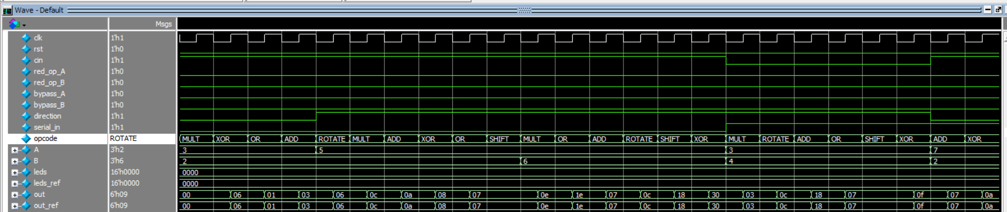

rst constraint most of the time Inactive



red_op_A is active while opcode is ADD 🡺 Invalid case 🡺 leds blink and out = zero

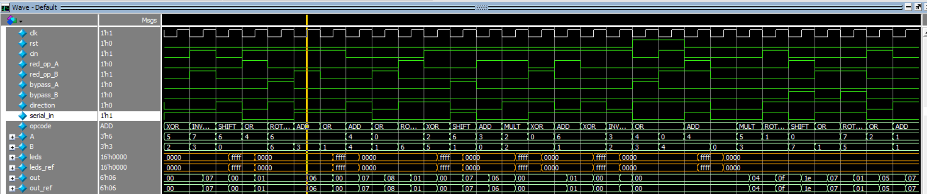

Opcode = Invalid case

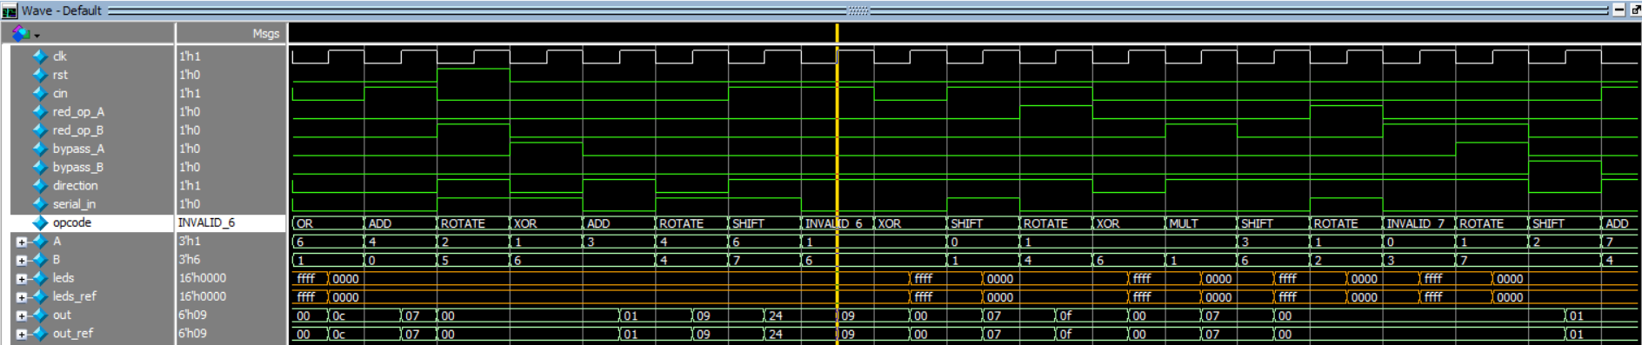

Valid Opcode Cases

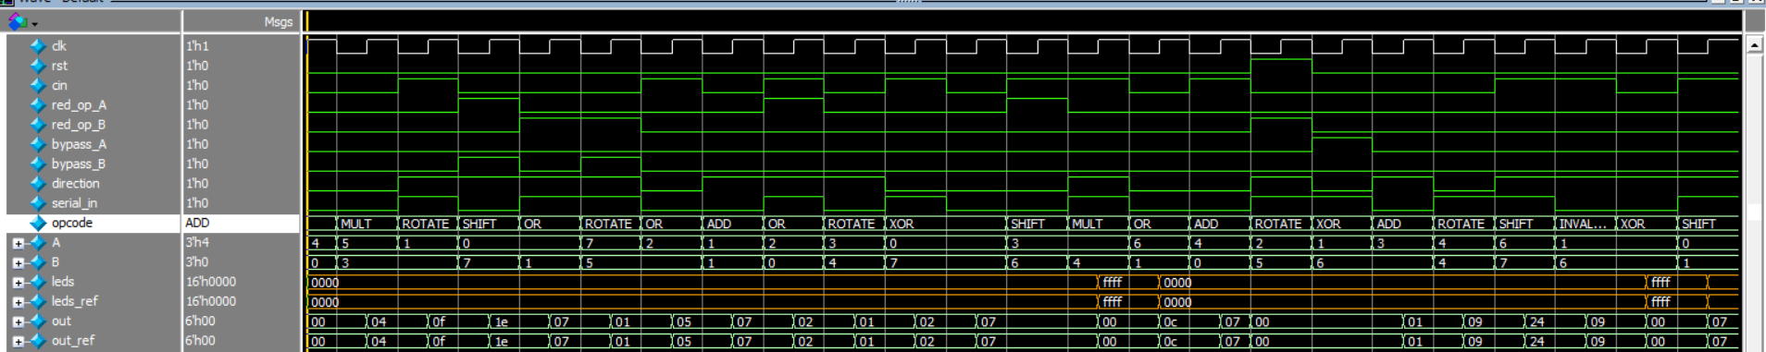

Bypass_A

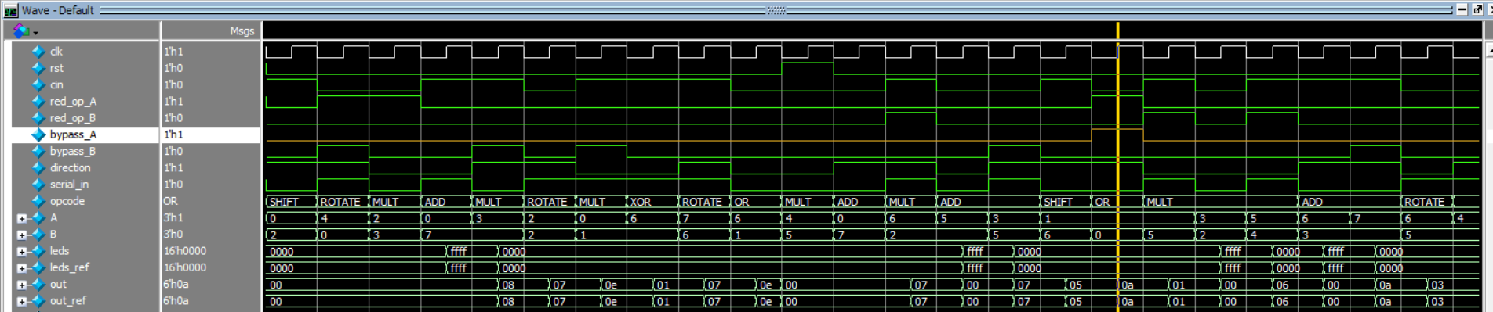

Opcode = OR, red_op_B active

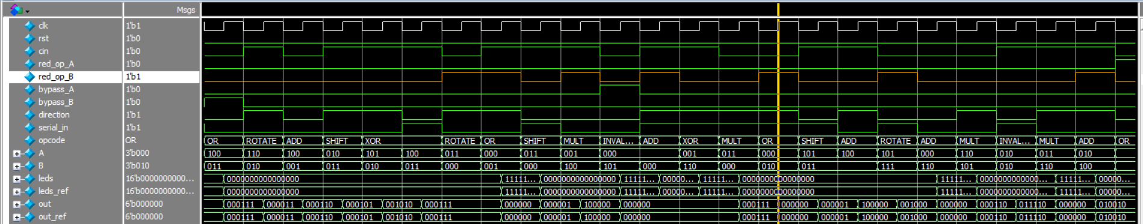

Opcode = OR, red_op_A active

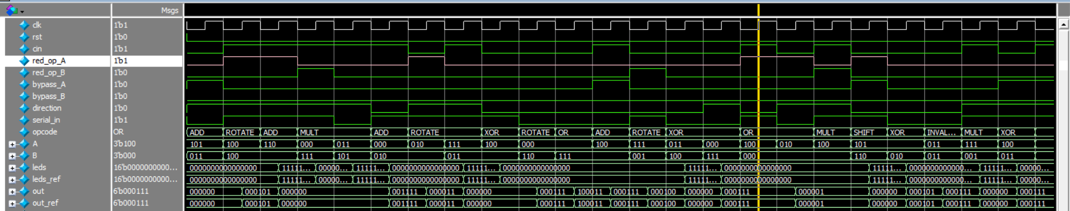

**Code Coverage HTML report**

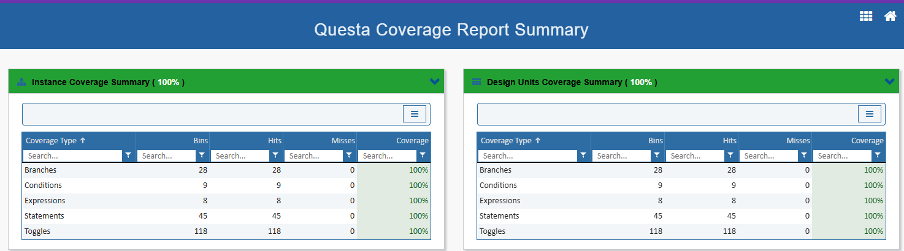

**Code Coverage txt report**

* Branches

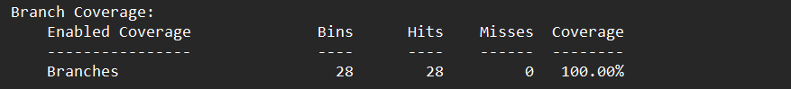

* Conditions

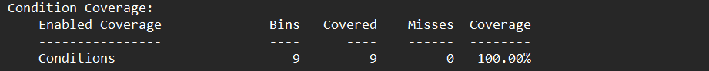

* Expression

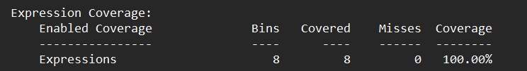

* Statement

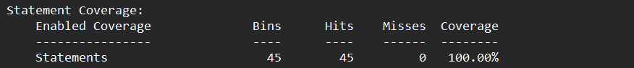

* Toggles

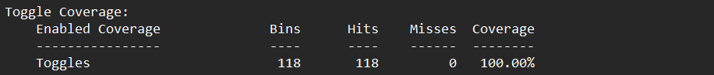

**FUNCTION_COVER report**

* Directive Coverage

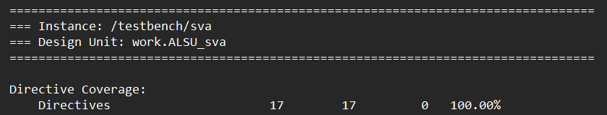

* Covergroup Coverage

