**Abdelrahman Mohamed Ali**

**UVM FIFO**

12 May, 2024

|  |  |
| --- | --- |
| **Gmail:** | [abdelrahmansalby23@gmail.com](mailto:abdelrahmansalby23@gmail.com) |
| **LinkedIn:** | [Abdelrahman Mohamed](https://www.linkedin.com/in/abdelrahman-mohamed-814a9022a/) |
| **GitHub:** | [Abdelrahman1810](https://github.com/Abdelrahman1810?tab=repositories) |

**Bug report**

|  |  |  |  |
| --- | --- | --- | --- |
| Label | Where in code | Explain | How FIX |
| invalid_opcode | Line 23 | opcode_reg[3]  is out of range | Replace opcode_reg[3]  With opcode_reg[1] |
| Blinking Leds | Line42 | Bypass is lead signal,  If Bypass then we ignore invalid Cases | The condition of (if):  Bug: invalid  FIX: invalid and not bupass |
| Checking invaled for out - bypass | Line 56 🡪 58 | Bypass is lead signal,  If Bypass then we ignore invalid Cases | Checking for bypass first |
| Case to check opcode | Line 65 | Case should check register opcode not input opcode | case(opcode_reg), instead of:  case(opcode) |
| opcode == 3’h0 | Line 68 🡪 74 | When opcode==0,  Should OR not AND | Use (|) instead of (&) |
| opcode == 3’h1 | Line 78 🡪 84 | When opcode==1,  Should XOR not OR | Use (^) instead of (|) |

|  |
| --- |
| assign invalid_opcode = opcode_reg[2] & opcode_reg[3]; // Bug  assign invalid_opcode = opcode_reg[2] & opcode_reg[0]; // Fix |
| if (invalid) // Bug      if (invalid && !(bypass_A_reg || bypass_B_reg)) // FIX |
| if (invalid)  // Bug          out <= 0; // Bug      else if (bypass_A_reg && bypass_B_reg)        out <= (INPUT_PRIORITY == "A")? A_reg: B_reg;      else if (bypass_A_reg)        out <= A_reg;      else if (bypass_B_reg)        out <= B_reg;      if (bypass_A_reg && bypass_B_reg)        out <= (INPUT_PRIORITY == "A")? A_reg: B_reg;      else if (bypass_A_reg)        out <= A_reg;      else if (bypass_B_reg)        out <= B_reg;      else if (invalid)  // FIX          out <= 0; // FIX |
| case (opcode) // Bug          case (opcode_reg) // FIX |
| &A_reg: &B_reg; // Bug  out <= &A_reg; // Bug   out <= &B_reg; // Bug  out <= A_reg & B_reg; // Bug  ---------------  |A_reg: |B_reg; // FIX  out <= |A_reg; // FIX  out <= |B_reg; // FIX  out <= A_reg | B_reg; // FIX  --------------- |
| |A_reg: |B_reg; // Bug  out <= |A_reg; // Bug  out <= |B_reg; // Bug  out <= A_reg | B_reg; // Bug  ^A_reg: ^B_reg; // Fix  out <= ^A_reg; // Fix  out <= ^B_reg; // Fix  out <= A_reg ^ B_reg; // Fix |

**/// Do file**

vlib work

vlog -coveropt 3 +cover +acc {shared_pkg\shared_pkg.sv}

###

vlog -coveropt 3 +cover +acc {Interface\interface.sv}

vlog -coveropt 3 +cover +acc {Interface\ALSU_ref.sv}

###

vlog -coveropt 3 +cover +acc {DUT\ALSU.sv}

vlog -coveropt 3 +cover +acc {DUT\assertion.sv}

###

vlog -coveropt 3 +cover +acc {objects\configration.sv}

vlog -coveropt 3 +cover +acc {objects\sequence_Items\sequenceItem.sv}

vlog -coveropt 3 +cover +acc {objects\sequence_Items\sequenceItem_Valid.sv}

vlog -coveropt 3 +cover +acc {objects\ALSU_sequence\ALSU_reset_sequence.sv}

vlog -coveropt 3 +cover +acc {objects\ALSU_sequence\ALSU_main_sequence.sv}

###

vlog -coveropt 3 +cover +acc {UVM\Test\env\agent\driver\driver.sv}

vlog -coveropt 3 +cover +acc {UVM\Test\env\agent\monitor\monitor.sv}

vlog -coveropt 3 +cover +acc {UVM\Test\env\agent\sequencer\sequencer.sv}

vlog -coveropt 3 +cover +acc {UVM\Test\env\agent\agent.sv}

###

vlog -coveropt 3 +cover +acc {UVM\Test\env\coverage_collector\coverage_collector.sv}

vlog -coveropt 3 +cover +acc {UVM\Test\env\scoreboard\scoreboard.sv}

vlog -coveropt 3 +cover +acc {UVM\Test\env\env.sv}

###

vlog -coveropt 3 +cover +acc {UVM\Test\test.sv}

vlog -coveropt 3 +cover +acc {UVM\top.sv}

#vsim -voptargs=+acc work.top -classdebug -uvmcontrol=all

vsim +UVM_VERBOSITY=UVM_LOW -voptargs=+acc work.top -classdebug -uvmcontrol=all -cover

add wave -position insertpoint sim:/top/intf/*

add wave -radix hexadecimal sim:/top/intf/out

add wave -radix hexadecimal sim:/top/intf/out_ref

add wave -color Orchid -radix hexadecimal sim:/top/intf/leds

add wave -color gold   -radix hexadecimal sim:/top/intf/leds_ref

run -all

#quit -sim

**/// shared_pkg**

`timescale 1ps/1ps

package shared_pkg;

import uvm_pkg::*;

`include "uvm_macros.svh"

parameter INPUT_PRIORITY = "A";

parameter FULL_ADDER = "ON";

typedef enum reg [2:0] {OR, XOR, ADD, MULT, SHIFT, ROTATE, INVALID_6, INVALID_7} opcode_e;

parameter MAXPOS = 3;

parameter ZERO = 0;

parameter MAXNEG = -4;

parameter HOBBIT_LOOP = 1000;

parameter DWARF_LOOP = 10_000;

parameter HUMAN_LOOP = 20_000;

parameter GIANT_LOOP = 30_000;

bit alwaysValid = 0;

int RESET_DIST = 5;

endpackage

**/// interface**

`timescale 1ps/1ps

import shared_pkg::*;

interface ALSU_interface(input bit clk);

logic rst, cin, red_op_A, red_op_B, bypass_A, bypass_B, direction, serial_in;

opcode_e opcode;

logic signed [2:0] A, B;

logic [15:0] leds;

logic [5:0] out;

logic [15:0] leds_ref;

logic [5:0] out_ref;

bit inputs_are_driven;

endinterface //ALSU_interface

**/// ALSU_ref**

import shared_pkg::*;

module ALSU_ref (A, B, cin, serial_in, red_op_A, red_op_B, opcode, bypass_A, bypass_B, clk, rst, direction, leds, out);

input clk, rst, cin, red_op_A, red_op_B, bypass_A, bypass_B, direction, serial_in;

//input opcode_e opcode;

input [2:0] opcode;

input signed [2:0] A, B;

output reg [15:0] leds;

output reg [5:0] out;

reg cin_reg, red_op_A_reg, red_op_B_reg, bypass_A_reg, bypass_B_reg, direction_reg, serial_in_reg;

reg [2:0] A_reg, B_reg;

reg [2:0] opcode_reg;

wire invalid, invalid_c1, invalid_c2;

assign invalid_c1 = (opcode_reg == 6 || opcode_reg == 7);

assign invalid_c2 = (red_op_A_reg || red_op_B_reg) && (opcode_reg != 0 && opcode_reg != 1);

assign invalid = invalid_c1 || invalid_c2;

always @(posedge clk or posedge rst) begin

    if (rst) begin

        out <= 0;

        leds <= 0;

        cin_reg <= 0;

        red_op_A_reg <= 0;

        red_op_B_reg <= 0;

        bypass_A_reg <= 0;

        bypass_B_reg <= 0;

        direction_reg <= 0;

        serial_in_reg <= 0;

        opcode_reg <= 0;

        A_reg <= 0;

        B_reg <= 0;

    end

    else begin

        if (invalid&&!(bypass_A_reg || bypass_B_reg)) leds <= ~leds;

        else leds <= 0;

        cin_reg <= cin;

        red_op_A_reg <= red_op_A;

        red_op_B_reg <= red_op_B;

        bypass_A_reg <= bypass_A;

        bypass_B_reg <= bypass_B;

        direction_reg <= direction;

        serial_in_reg <= serial_in;

        opcode_reg <= opcode;

        A_reg <= A;

        B_reg <= B;

        if (bypass_A_reg && bypass_B_reg)

            out <= (INPUT_PRIORITY=="A")? A_reg:B_reg;

        else if (bypass_A_reg)

            out <= A_reg;

        else if (bypass_B_reg)

            out <= B_reg;

        else if (invalid)

            out <= 0;

        else if (opcode_reg == 0) begin

            if (red_op_A_reg && red_op_B_reg)

                out <= (INPUT_PRIORITY=="A")? (|A_reg):(|B_reg);

            else if (red_op_A_reg)

                out <= |A_reg;

            else if (red_op_B_reg)

                out <= |B_reg;

            else

                out <= A_reg|B_reg;

        end

        else if (opcode_reg == 1) begin

            if (red_op_A_reg && red_op_B_reg)

                out <= (INPUT_PRIORITY=="A")? (^A_reg):(^B_reg);

            else

                out <= (red_op_A_reg)? (^A_reg): (red_op_B_reg)? (^B_reg):(A_reg^B_reg);

        end

        else if (opcode_reg == 2)

            out <= (FULL_ADDER=="ON")? (A_reg + B_reg + cin_reg):(A_reg + B_reg);

        else if (opcode_reg == 3)

            out <= A_reg * B_reg;

        else if (opcode_reg == 4) begin

            if (direction_reg)

                out <= {out[4:0], serial_in_reg};

            else

                out <= {serial_in_reg, out[5:1]};

        end

        else if (opcode_reg == 5) begin

            if (direction_reg)

                out <= {out[4:0],out[5]};

            else

                out <= {out[0],out[5:1]};

        end

    end

end

endmodule

**/// ALSU after FIX**

////////////////////////////////////////////////////////////////////////////////

// Author: Kareem Waseem

// Course: Digital Verification using SV & UVM

//

// Description: ALSU Design

//

////////////////////////////////////////////////////////////////////////////////

import shared_pkg::*;

module ALSU(A, B, cin, serial_in, red_op_A, red_op_B, opcode, bypass_A, bypass_B, clk, rst, direction, leds, out);

input clk, rst, cin, red_op_A, red_op_B, bypass_A, bypass_B, direction, serial_in;

input [2:0] opcode;

input signed [2:0] A, B;

output reg [15:0] leds;

output reg [5:0] out;

reg cin_reg, red_op_A_reg, red_op_B_reg, bypass_A_reg, bypass_B_reg, direction_reg, serial_in_reg;

reg [2:0] opcode_reg, A_reg, B_reg;

wire invalid_red_op, invalid_opcode, invalid;

assign invalid_red_op = (red_op_A_reg | red_op_B_reg) & (opcode_reg[1] | opcode_reg[2]);

assign invalid_opcode = opcode_reg[1] & opcode_reg[2]; // Fix

assign invalid = invalid_red_op | invalid_opcode;

always @(posedge clk or posedge rst) begin

  if(rst) begin

    leds <= 0;

    out <= 0;

    cin_reg <= 0;

    red_op_B_reg <= 0;

    red_op_A_reg <= 0;

    bypass_B_reg <= 0;

    bypass_A_reg <= 0;

    direction_reg <= 0;

    serial_in_reg <= 0;

    opcode_reg <= 0;

    A_reg <= 0;

    B_reg <= 0;

  end

  else begin

    if (invalid && !(bypass_A_reg || bypass_B_reg)) // FIX

      leds <= ~leds;

    else

      leds <= 0;

    cin_reg <= cin;

    red_op_B_reg <= red_op_B;

    red_op_A_reg <= red_op_A;

    bypass_B_reg <= bypass_B;

    bypass_A_reg <= bypass_A;

    direction_reg <= direction;

    serial_in_reg <= serial_in;

    opcode_reg <= opcode;

    A_reg <= A;

    B_reg <= B;

    if (bypass_A_reg && bypass_B_reg)

      out <= (INPUT_PRIORITY == "A")? A_reg: B_reg;

    else if (bypass_A_reg)

      out <= A_reg;

    else if (bypass_B_reg)

      out <= B_reg;

    else if (invalid)  // FIX

        out <= 0; // FIX

    else begin

        case (opcode_reg) // FIX

          3'h0: begin

            if (red_op_A_reg && red_op_B_reg)

              out = (INPUT_PRIORITY == "A")? |A_reg: |B_reg; // FIX

            else if (red_op_A_reg)

              out <= |A_reg; // FIX

            else if (red_op_B_reg)

              out <= |B_reg; // FIX

            else

              out <= A_reg | B_reg; // FIX

          end

          3'h1: begin

            if (red_op_A_reg && red_op_B_reg)

              out <= (INPUT_PRIORITY == "A")? ^A_reg: ^B_reg; // Fix

            else if (red_op_A_reg)

              out <= ^A_reg; // Fix

            else if (red_op_B_reg)

              out <= ^B_reg; // Fix

            else

              out <= A_reg ^ B_reg; // Fix

          end

          3'h2: begin

            if (FULL_ADDER == "ON")

              out <= A_reg + B_reg + cin_reg;

            else

              out <= A_reg + B_reg;

          end

          3'h3: out <= A_reg * B_reg;

          3'h4: begin

            if (direction_reg)

              out <= {out[4:0], serial_in_reg};

            else

              out <= {serial_in_reg, out[5:1]};

          end

          3'h5: begin

            if (direction_reg)

              out <= {out[4:0], out[5]};

            else

              out <= {out[0], out[5:1]};

          end

        endcase

    end

  end

end

endmodule

**/// assertion**

import shared_pkg::*;

`define reset disable iff(rst)

module ALSU_sva(A, B, cin, serial_in, red_op_A, red_op_B, opcode, bypass_A, bypass_B, clk, rst, direction, leds, out);

input bit clk;

input logic rst, cin, red_op_A, red_op_B, bypass_A, bypass_B, direction, serial_in;

input [2:0] opcode;

input logic signed [2:0] A, B;

input logic [15:0] leds;

input logic [5:0] out;

////////////////////////////////////////////////////////

// this variable to make writing assertion more easer //

////////////////////////////////////////////////////////

bit isBypass, InvalidOP, bitwise;

assign isBypass = bypass_A | bypass_B;

assign InvalidOP = opcode==6 | opcode==7;

assign bitwise = opcode==0 | opcode==1;

assign isRed = red_op_B | red_op_A;

///////////////////////////////////

// assertion of bypass operation //

///////////////////////////////////

bypass_A_assert: assert property (@(posedge clk) `reset bypass_A |-> ##2 out==$past(A,2));

bypass_B_assert: assert property (@(posedge clk) `reset (bypass_B && !bypass_A) |-> ##2 out==$past(B,2));

//////////////////////////////////////

// assertion of reduction operation //

//////////////////////////////////////

sequence redValid(red, op,red2);

    (red && !isBypass && opcode==op && !red2);

endsequence

redA_OR_assert: assert property (@(posedge clk) `reset redValid(red_op_A,0,0)        |-> ##2 out==|($past(A,2)));

redB_OR_assert: assert property (@(posedge clk) `reset redValid(red_op_B,0,red_op_A) |-> ##2 out==|($past(B,2)));

redA_XR_assert: assert property (@(posedge clk) `reset redValid(red_op_A,1,0)        |-> ##2 out==^($past(A,2)));

redB_XR_assert: assert property (@(posedge clk) `reset redValid(red_op_B,1,red_op_A) |-> ##2 out==^($past(B,2)));

////////////////////////////////

// assertion of invalid cases //

////////////////////////////////

sequence Invalid_seq;

    ((isRed && !isBypass && !bitwise) || (InvalidOP && !isBypass));

endsequence

Invalid_assert: assert property (@(posedge clk) `reset Invalid_seq |-> ##[0:2](out==0 && leds=='hffff));

////////////////////////////////////////

// assertion when opcode always valid //

////////////////////////////////////////

always_comb begin : assert_alwaysValid

  if (alwaysValid) begin

    alwValid_opcode_assert:  assert final (!InvalidOP);

    alwZero_bypass_A_assert: assert final (!bypass_A);

    alwZero_bypass_B_assert: assert final (!bypass_B);

    alwZero_red_op_A_assert: assert final (!red_op_A);

    alwZero_red_op_B_assert: assert final (!red_op_B);

  end

end

/////////////////////

// reset assertion //

/////////////////////

always_comb begin : reset_assertion

    if (rst) begin

        rst_out_assert: assert final (out==0);

        rst_leds_assert: assert final (leds==0);

    end

end

//////////////////////////////////////////////////////////////////

// assertion for opcode Valid cases without bypass or reduction //

//////////////////////////////////////////////////////////////////

sequence sh_ro(op, dir);

    (opcode==op && dir && !isRed && !isBypass);

endsequence

sequence op_assert(op);

  (!isBypass && !isRed && opcode==op);

endsequence

OR_assert:   assert property (@(posedge clk) `reset op_assert(0) |-> ##2  out== $past(A,2) | $past(B,2) );

XOR_assert:  assert property (@(posedge clk) `reset op_assert(1) |-> ##2  out==($past(A,2)^$past(B,2)) );

add_assert:  assert property (@(posedge clk) `reset op_assert(2) |-> ##2  out==($past(A,2)+$past(B,2)+$past(cin,2)) );

mult_assert: assert property (@(posedge clk) `reset op_assert(3) |-> ##2  out==($past(A,2)*$past(B,2)) );

shiftL_assert: assert property (@(posedge clk) `reset sh_ro(4, direction) |-> ##2  out=={$past(out[4:0]), $past(serial_in,2)} );

shiftR_assert: assert property (@(posedge clk) `reset sh_ro(4, !direction) |-> ##2  out=={$past(serial_in,2), $past(out[5:1])} );

rotateL_assert: assert property (@(posedge clk) `reset sh_ro(5, direction) |-> ##2  out=={$past(out[4:0]), $past(out[5])} );

rotateR_assert: assert property (@(posedge clk) `reset sh_ro(5, !direction) |-> ##2  out=={$past(out[0]), $past(out[5:1])} );

**/// Cover directives**

/////////////////////////////////////////////////////////////////////////////

//////////////////////////          cover          //////////////////////////

/////////////////////////////////////////////////////////////////////////////

///////////////////////////////

// cover of bypass operation //

///////////////////////////////

bypass_A_cover: cover property (@(posedge clk) `reset bypass_A |-> ##2 out==$past(A,2));

bypass_B_cover: cover property (@(posedge clk) `reset (bypass_B && !bypass_A) |-> ##2 out==$past(B,2));

//////////////////////////////////

// cover of reduction operation //

//////////////////////////////////

redA_OR_cover: cover property (@(posedge clk) `reset redValid(red_op_A,0,0)        |-> ##2 out==|($past(A,2)));

redB_OR_cover: cover property (@(posedge clk) `reset redValid(red_op_B,0,red_op_A) |-> ##2 out==|($past(B,2)));

redA_XR_cover: cover property (@(posedge clk) `reset redValid(red_op_A,1,0)        |-> ##2 out==^($past(A,2)));

redB_XR_cover: cover property (@(posedge clk) `reset redValid(red_op_B,1,red_op_A) |-> ##2 out==^($past(B,2)));

////////////////////////////

// cover of invalid cases //

////////////////////////////

Invalid_cover: cover property (@(posedge clk) `reset Invalid_seq |-> ##[0:2](out==0 && leds=='hffff));

////////////////////////////////////

// cover when opcode always valid //

////////////////////////////////////

always_comb begin : cover_alwaysValid

  if (alwaysValid) begin

    alwValid_opcode_cover:  cover final (!InvalidOP);

    alwZero_bypass_A_cover: cover final (!bypass_A);

    alwZero_bypass_B_cover: cover final (!bypass_B);

    alwZero_red_op_A_cover: cover final (!red_op_A);

    alwZero_red_op_B_cover: cover final (!red_op_B);

  end

end

/////////////////

// reset cover //

/////////////////

always_comb begin : reset_cover

    if (rst) begin

        rst_out_cover: cover final (out==0);

        rst_leds_cover: cover final (leds==0);

    end

end

//////////////////////////////////////////////////////////////

// cover for opcode Valid cases without bypass or reduction //

//////////////////////////////////////////////////////////////

OR_cover:   cover property (@(posedge clk) `reset op_assert(0) |-> ##2  out== $past(A,2) | $past(B,2) );

XOR_cover:  cover property (@(posedge clk) `reset op_assert(1) |-> ##2  out==($past(A,2) ^ $past(B,2)) );

add_cover:  cover property (@(posedge clk) `reset op_assert(2) |-> ##2  out==($past(A,2) + $past(B,2) + $past(cin,2)) );

mult_cover: cover property (@(posedge clk) `reset op_assert(3) |-> ##2  out==($past(A,2) * $past(B,2)) );

shiftL_cover: cover property (@(posedge clk) `reset sh_ro(4, direction) |-> ##2  out=={$past(out[4:0]), $past(serial_in,2)} );

shiftR_cover: cover property (@(posedge clk) `reset sh_ro(4, !direction) |-> ##2  out=={$past(serial_in,2), $past(out[5:1])} );

rotateL_cover: cover property (@(posedge clk) `reset sh_ro(5, direction) |-> ##2  out=={$past(out[4:0]), $past(out[5])} );

rotateR_cover: cover property (@(posedge clk) `reset sh_ro(5, !direction) |-> ##2  out=={$past(out[0]), $past(out[5:1])} );

endmodule

**/// configuration**

`timescale 1ps/1ps

package config_pkg;

import shared_pkg::*;

import uvm_pkg::*;

`include "uvm_macros.svh"

// Configration class

class ALSU_config extends uvm_object;

    `uvm_object_utils(ALSU_config)

    virtual ALSU_interface v_if;

    function new(string name = "ALSU_config");

        super.new(name);

    endfunction //new()

endclass //ALSU_config

endpackage

**/// sequenceItem (Valid and Invalid)**

package sequenceItem_pkg;

import shared_pkg::*;

import uvm_pkg::*;

`include "uvm_macros.svh"

`define create_obj(type, name) type::type_id::create(name, this);

// Sequence Item class Valid and Invalid

class ALSU_sequenceItem extends uvm_sequence_item;

    `uvm_object_utils(ALSU_sequenceItem)

    logic clk;

    rand logic rst, cin, red_op_A, red_op_B, bypass_A, bypass_B, direction, serial_in;

    rand opcode_e opcode;

    rand logic signed [2:0] A, B;

    logic [15:0] leds;

    logic [5:0] out;

    logic [15:0] leds_ref;

    logic [5:0] out_ref;

    function new(string name = "ALSU_sequenceItem");

        super.new(name);

    endfunction //new()

    // built in function

    function string convert2string();

        return $sformatf("%s, rst = %0d, A = %0d, B = %0d cin = %0d, red_op_A = %0d, red_op_B = %0d, bypass_A = %0d, bypass_B = %0d,

        direction = %0d, serial_in = %0d \n out = %0d, out_ref = 0%0d ",

        super.convert2string(), rst, A, B, cin, red_op_A, red_op_B, bypass_A, bypass_B, direction, serial_in, out, out_ref

        );

    endfunction

    // my function to print ALSU inputs and outputs

    function string convert2string_stim();

        return $sformatf("rst = %0d, opcode = %0s, cin = %0d, red_op_A = %0d, red_op_B = %0d, bypass_A = %0d, bypass_B = %0d,

        direction = %0d, serial_in = %0d \n out = %0d",

        rst, opcode, cin, red_op_A, red_op_B, bypass_A, bypass_B, direction, serial_in, out

        );

    endfunction

    /////// ////// ////// ////// //////

    //       Constraint block        //

    ////// /////// ///// /////// //////

    constraint rules1_7 {

        //rst constraint

            rst dist {0:=100-RESET_DIST, 1:=RESET_DIST};

        // Invalid cases constraint

            opcode dist {INVALID_6:=5, INVALID_7:=5, [0:5]:/90};

        // A & B constraint when opcode is ADD or MULT

            (opcode == MULT || opcode == ADD) -> A dist {MAXPOS:=20, ZERO:=10, MAXNEG:=20, [MAXNEG+1:MAXPOS-1]:/50};

            (opcode == MULT || opcode == ADD) -> B dist {MAXPOS:=20, ZERO:=10, MAXNEG:=20, [MAXNEG+1:MAXPOS-1]:/50};

        // A & B constraint when opcode is OR or XOR and red_op_A is high

            ((opcode==XOR || opcode==OR) && red_op_A) -> A dist {3'b001:=30, 3'b010:=30, 3'b100:=30, [MAXNEG+1:MAXPOS-1]:/10};

            ((opcode==XOR || opcode==OR) && red_op_A) -> B == 0;

        // A & B constraint when opcode is OR or XOR and red_op_B is high

            ((opcode==XOR || opcode==OR) && red_op_B) -> A == 0;

            ((opcode==XOR || opcode==OR) && red_op_B) -> B dist {3'b001:=30, 3'b010:=30, 3'b100:=30, [MAXNEG+1:MAXPOS-1]:/10};

        //  Do not constraint the inputs A or B when the operation is shift or rotate

        // it's achieved by default after the 2,3 and 4 Constraint achieved

        // bypass constraint

            bypass_A dist {0:=90, 1:=10};

            bypass_B dist {0:=90, 1:=10};

        // red_op constraint

            red_op_A dist {0:=80, 1:=20};

            red_op_B dist {0:=80, 1:=20};

        // A & B constraint when opcode is OR or XOR and red_op is low

            ((opcode==XOR || opcode==OR) && ~red_op_A && ~red_op_B) -> A == ~B;

    }

    rand opcode_e arr [6];

    constraint rules_8 {

        foreach(arr[i])

            arr[i] inside {OR, XOR, ADD, MULT, SHIFT, ROTATE};

        unique {arr};

        //foreach(arr[i])

    }

    constraint MAKE_bypass_red_rst_ZERO {

        rst == 0;

        bypass_A == 0; bypass_B == 0;

        red_op_A == 0; red_op_B == 0;

    }

    constraint INPUT_PRIORITY_CONS {

        red_op_A == red_op_B;

        bypass_A == bypass_B;

    }

endclass //ALSU_sequenceItem extends uvm_sequence_item

**/// sequenceItem (Valid Only)**

package sequenceItem_valid_pkg;

import sequenceItem_pkg::*;

import shared_pkg::*;

import uvm_pkg::*;

`include "uvm_macros.svh"

`define create_obj(type, name) type::type_id::create(name, this);

// Sequence Item class Valid Cases Only

class ALSU_sequenceItem_valid extends ALSU_sequenceItem;

    `uvm_object_utils(ALSU_sequenceItem_valid)

    function new(string name = "ALSU_sequenceItem_valid");

        super.new(name);

    endfunction //new()

    /////// ////// ////// ////// //////

    //       Constraint block        //

    ////// /////// ///// /////// //////

    constraint rules1_7 {

    //rst constraint

        rst dist {0:=100-RESET_DIST, 1:=RESET_DIST};

    // make opcode always valid

        //opcode dist {INVALID_6:=5, INVALID_7:=5, [0:5]:/90};

        opcode inside {OR, XOR, ADD, MULT, SHIFT, ROTATE};

        // to avoid invalid cases

        if (opcode==OR||opcode==XOR)

            red_op_A dist {0:=90, 1:=10};

        else

            red_op_A == 0;

        if (opcode==OR||opcode==XOR)

            red_op_B dist {0:=90, 1:=10};

        else

            red_op_B == 0;

    // A & B constraint when opcode is ADD or MULT

        (opcode == MULT || opcode == ADD) -> A dist {MAXPOS:=20, ZERO:=10, MAXNEG:=20, [MAXNEG+1:MAXPOS-1]:/50};

        (opcode == MULT || opcode == ADD) -> B dist {MAXPOS:=20, ZERO:=10, MAXNEG:=20, [MAXNEG+1:MAXPOS-1]:/50};

    // A & B constraint when opcode is OR or XOR and red_op_A is high

        ((opcode==XOR || opcode==OR) && red_op_A) -> A dist {3'b001:=30, 3'b010:=30, 3'b100:=30, [MAXNEG+1:MAXPOS-1]:/10};

        ((opcode==XOR || opcode==OR) && red_op_A) -> B == 0;

    // A & B constraint when opcode is OR or XOR and red_op_B is high

        ((opcode==XOR || opcode==OR) && red_op_B) -> A == 0;

        ((opcode==XOR || opcode==OR) && red_op_B) -> B dist {3'b001:=30, 3'b010:=30, 3'b100:=30, [MAXNEG+1:MAXPOS-1]:/10};

    //  Do not constraint the inputs A or B when the operation is shift or rotate

    // it's achieved by default after the 2,3 and 4 Constraint achieved

    // bypass constraint

        bypass_A dist {0:=90, 1:=10};

        bypass_B dist {0:=90, 1:=10};

    // A & B constraint when opcode is OR or XOR and red_op is low

        ((opcode==XOR || opcode==OR) && ~red_op_A && ~red_op_B) -> A == ~B;

    }

endclass //ALSU_sequenceItem_valid extends uvm_sequence_item

endpackage

**/// ALSU_reset_sequence**

`timescale 1ps/1ps

package rst_sequence_pkg;

import shared_pkg::*;

import sequenceItem_pkg::*;

import uvm_pkg::*;

`include "uvm_macros.svh"

`define create_obj(type, name) type::type_id::create(name);

class ALSU_reset_sequence extends uvm_sequence #(ALSU_sequenceItem);

    `uvm_object_utils(ALSU_reset_sequence)

    function new(string name = "ALSU_reset_sequence");

        super.new(name);

    endfunction //new()

    ALSU_sequenceItem item;

    // Main task

    task body;

        // Creat seq_item

        item = `create_obj(ALSU_sequenceItem, "item")

        item.A = 0; item.B = 0; item.opcode = OR;

        item.cin = 0; item.serial_in = 0; item.direction = 0;

        item.bypass_A = 0; item.bypass_B = 0;

        item.red_op_A = 0; item.red_op_B = 0;

        start_item(item);

        item.rst = 1;

        finish_item(item);

    endtask

endclass //ALSU_reset_sequence extends uvm_sequence #(ALSU_sequenceItem)

endpackage

**/// ALSU_main_sequence**

`timescale 1ps/1ps

package main_sequence_pkg;

import shared_pkg::*;

import uvm_pkg::*;

import sequenceItem_pkg::*;

`include "uvm_macros.svh"

`define create_obj(type, name) type::type_id::create(name);

class ALSU_main_sequence extends uvm_sequence #(ALSU_sequenceItem);

    `uvm_object_utils(ALSU_main_sequence)

    function new(string name = "ALSU_main_sequence");

        super.new(name);

    endfunction //new()

    ALSU_sequenceItem item;

    // Main task

    task body();

        repeat(GIANT_LOOP) begin

            item = `create_obj(ALSU_sequenceItem, "item")  // Creat seq_item

            // edit constraint mode

            item.constraint_mode(0);

            item.rules1_7.constraint_mode(1);

            start_item(item);

            assert (item.randomize());

            finish_item(item);

        end

        repeat(HOBBIT_LOOP) begin

            item = `create_obj(ALSU_sequenceItem, "item")  // Creat seq_item

            // edit constraint mode

            item.constraint_mode(0);

            item.INPUT_PRIORITY_CONS.constraint_mode(1);

            start_item(item);

            assert (item.randomize());

            finish_item(item);

        end

        // make opcode onley valid

        alwaysValid = 1;

        repeat(DWARF_LOOP) begin

            item = `create_obj(ALSU_sequenceItem, "item")  // Creat seq_item

        // edit constraint mode

            item.constraint_mode(0);

            item.rules_8.constraint_mode(1);

            item.MAKE_bypass_red_rst_ZERO.constraint_mode(1);

        // randomization

            assert (item.randomize());

        // loop for opcode

            foreach(item.arr[i]) begin

                start_item(item);

                item.opcode = item.arr[i];

                finish_item(item);

            end

        end

    endtask

endclass //ALSU_main_sequence extends uvm_sequence #(ALSU_sequenceItem)

endpackage

**/// driver**

`timescale 1ps/1ps

package driver_pkg;

import shared_pkg::*;

import sequenceItem_pkg::*;

import uvm_pkg::*;

`include "uvm_macros.svh"

`define create_obj(type, name) type::type_id::create(name);

// driver class

class ALSU_driver extends uvm_driver #(ALSU_sequenceItem);

    `uvm_component_utils(ALSU_driver)

    virtual ALSU_interface v_if;

    ALSU_sequenceItem stim_seq_item;

    function new(string name = "ALSU_driver", uvm_component parent = null);

        super.new(name, parent);

    endfunction //new()

    task run_phase(uvm_phase phase);

        super.run_phase(phase);

        forever begin

            //v_if.inputs_are_driven = 0;

            stim_seq_item = `create_obj(ALSU_sequenceItem, "stim_seq_item")

            seq_item_port.get_next_item(stim_seq_item);

        // assigned inputs to interface

            v_if.A = stim_seq_item.A;

            v_if.B = stim_seq_item.B;

            v_if.cin = stim_seq_item.cin;

            v_if.serial_in = stim_seq_item.serial_in;

            v_if.red_op_A = stim_seq_item.red_op_A;

            v_if.red_op_B = stim_seq_item.red_op_B;

            v_if.bypass_A = stim_seq_item.bypass_A;

            v_if.bypass_B = stim_seq_item.bypass_B;

            v_if.clk = stim_seq_item.clk;

            v_if.rst = stim_seq_item.rst;

            v_if.direction = stim_seq_item.direction;

        // assigned opcode tp interface

            v_if.opcode = stim_seq_item.opcode;

            v_if.inputs_are_driven = 0;

            @(negedge v_if.clk);

        // assigned outputs to driver

            stim_seq_item.leds = v_if.leds;

            stim_seq_item.out = v_if.out;

        // assigned refrence to driver

            stim_seq_item.leds_ref = v_if.leds_ref;

            stim_seq_item.out_ref = v_if.out_ref;

            seq_item_port.item_done();

            v_if.inputs_are_driven = 1;

            `uvm_info("run_phase_driver", stim_seq_item.convert2string_stim(), UVM_HIGH)

        end

    endtask //run_phase

endclass //ALSU_driver extends uvm_driver

endpackage

**/// sequencer**

package sequencer_pkg;

import uvm_pkg::*;

import sequenceItem_pkg::*;

`include "uvm_macros.svh"

`define create_obj(type, name) type::type_id::create(name, this);

// sequencer class

class sequencer extends uvm_sequencer #(ALSU_sequenceItem);

    `uvm_component_utils(sequencer)

    function new(string name = "sequencer", uvm_component parent = null);

        super.new(name, parent);

    endfunction //new()

endclass //sequencer extends uvm_sequencer #(ALSU_sequenceItem)

endpackage

**/// monitor**

package monitor_pkg;

import shared_pkg::*;

import sequenceItem_pkg::*;

import uvm_pkg::*;

`include "uvm_macros.svh"

`define create_obj(type, name) type::type_id::create(name);

// monitor

class ALSU_monitor extends uvm_monitor;

    `uvm_component_utils(ALSU_monitor)

    virtual ALSU_interface v_if;

    ALSU_sequenceItem mon_seq_item;

    uvm_analysis_port #(ALSU_sequenceItem) mon_port; // monitor is a port

    function new(string name = "ALSU_monitor", uvm_component parent = null);

        super.new(name, parent);

    endfunction //new()

    function void build_phase(uvm_phase phase);

        super.build_phase(phase);

        mon_port = new("mon_port", this);

    endfunction

    task run_phase(uvm_phase phase);

      super.run_phase(phase);

      forever begin

        mon_seq_item = `create_obj(ALSU_sequenceItem, "mon_seq_item")

        @(negedge v_if.clk);

        // assigned inputs to monitor

            mon_seq_item.A = v_if.A;

            mon_seq_item.B = v_if.B;

            mon_seq_item.cin = v_if.cin;

            mon_seq_item.serial_in = v_if.serial_in;

            mon_seq_item.red_op_A = v_if.red_op_A;

            mon_seq_item.red_op_B = v_if.red_op_B;

            mon_seq_item.bypass_A = v_if.bypass_A;

            mon_seq_item.bypass_B = v_if.bypass_B;

            mon_seq_item.clk = v_if.clk;

            mon_seq_item.rst = v_if.rst;

            mon_seq_item.direction = v_if.direction;

        // assigned outputs to monitor

            mon_seq_item.leds = v_if.leds;

            mon_seq_item.out = v_if.out;

        // assigned outputs to monitor

            mon_seq_item.leds_ref = v_if.leds_ref;

            mon_seq_item.out_ref = v_if.out_ref;

        // assigned opcode tp monitor

            mon_seq_item.opcode = opcode_e'(v_if.opcode);

        mon_port.write(mon_seq_item); // that's mean that monitor will send the data

        `uvm_info("run_phase_monitor", mon_seq_item.convert2string_stim(), UVM_FULL)

      end

    endtask //run_pha

endclass //ALSU_monitor extends uvm_monitor

endpackage

**/// agent**

package agent_pkg;

import shared_pkg::*;

import config_pkg::*;

import driver_pkg::*;

import sequencer_pkg::*;

import sequenceItem_pkg::*;

import monitor_pkg::*;

import uvm_pkg::*;

`include "uvm_macros.svh"

`define create_obj(type, name) type::type_id::create(name, this);

// agent class

class ALSU_agent extends uvm_agent;

    `uvm_component_utils(ALSU_agent)

    sequencer sqr; // mange data transfer

    ALSU_driver drv; // inside agent

    ALSU_monitor mon; // inside agent

    ALSU_config cfg; // get the data of interface

    uvm_analysis_port #(ALSU_sequenceItem) agt_port; // agent is a port

    function new(string name = "ALSU_agent", uvm_component parent = null);

        super.new(name, parent);

    endfunction //new()

    function void build_phase(uvm_phase phase);

        super.build_phase(phase);

        if (!uvm_config_db#(ALSU_config)::get(this, "", "CFG", cfg))

            `uvm_fatal("build_phase", "DRIVER - Unable to get config");

        sqr = `create_obj(sequencer, "sqr")

        drv = `create_obj(ALSU_driver, "drv")

        mon = `create_obj(ALSU_monitor, "mon")

        agt_port = new("agt_port", this);

    endfunction

    function void connect_phase(uvm_phase phase);

        drv.v_if = cfg.v_if;

        mon.v_if = cfg.v_if;

        drv.seq_item_port.connect(sqr.seq_item_export);

        mon.mon_port.connect(agt_port);

    endfunction //connect_phase

endclass //ALSU_agent extends uvm_agent

endpackage

**/// coverage_collector**

package coverage_collector_pkg;

import agent_pkg::*;

import shared_pkg::*;

import sequencer_pkg::*;

import sequenceItem_pkg::*;

import uvm_pkg::*;

`include "uvm_macros.svh"

class ALSU_coverage extends uvm_component;

    `uvm_component_utils(ALSU_coverage)

    uvm_analysis_export #(ALSU_sequenceItem) cov_export; // coverage export

    uvm_tlm_analysis_fifo #(ALSU_sequenceItem) cov_fifo; // coverage fifo

    ALSU_sequenceItem cov_seq_item;

    //////////////////////////////////

    //      begin Coverage Group    //

    //////////////////////////////////

    covergroup cvr_gp;

        // input A bins

            A_cp: coverpoint cov_seq_item.A {

                bins A_data_0 = {ZERO};

                bins A_data_max = {MAXPOS};

                bins A_data_min = {MAXNEG};

                bins A_data_default = default;

                bins A_data_[] = {001, 010, 100};

            }

        // input B bins

            B_cp: coverpoint cov_seq_item.B {

                bins B_data_0 = {ZERO};

                bins B_data_max = {MAXPOS};

                bins B_data_min = {MAXNEG};

                bins B_data_default = default;

                bins B_data_[] = {001, 010, 100};

            }

        // cover point for reduction operation red_op

            op_A_cp: coverpoint cov_seq_item.red_op_A {

                bins one = {1};

                bins zero = {0};

            }

            op_B_cp: coverpoint cov_seq_item.red_op_B {

                bins one = {1};

                bins zero = {0};

            }

        // Crossing to satsfied the data_walkingones of A and B

            A_walk: cross A_cp, op_A_cp {

                option.cross_auto_bin_max = 0;

                bins A_data_walkingones = binsof(A_cp.A_data_) && binsof(op_A_cp.one);

            }

            B_walk: cross B_cp, op_A_cp, op_B_cp {

                option.cross_auto_bin_max = 0;

                bins B_data_walkingones = (binsof(B_cp.B_data_)

                                          && binsof(op_A_cp.zero)

                                          && binsof(op_B_cp.one));

            }

        // cover point for opcode (ALU)

            ALU_cp: coverpoint cov_seq_item.opcode {

                bins Bins_shift[] = {SHIFT, ROTATE};

                bins Bins_arith[] = {ADD, MULT};

                bins Bins_bitwise[] = {OR, XOR};//

                bins Bins_invalid = {INVALID_6, INVALID_7};

                bins Bins_trans = (0 => 1 => 2 => 3 => 4 => 5);

            }

        // cover point for c_in

            cin_cp: coverpoint cov_seq_item.cin;

        // cover point for serial_in

            serial_cp: coverpoint cov_seq_item.serial_in;

        // cover point for direction

            direction_cp: coverpoint cov_seq_item.direction;

        // Cross coverage between ALU_cp and A and B

            ALU_A: cross ALU_cp, A_cp {

                option.cross_auto_bin_max = 0;

                bins arith_permutations = binsof(ALU_cp.Bins_arith) && binsof(A_cp) intersect{ZERO, MAXPOS, MAXNEG};

            }

            ALU_B: cross ALU_cp, B_cp {

                option.cross_auto_bin_max = 0;

                bins arith_permutations = binsof(ALU_cp.Bins_arith) && binsof(B_cp) intersect{ZERO, MAXPOS, MAXNEG};

            }

        // Cross coverage between ALU_cp and cin_cp

            ALU_cin: cross ALU_cp, cin_cp {

                option.cross_auto_bin_max = 0;

                bins add_cin = binsof(ALU_cp) intersect{ADD};

            }

        // Cross coverage between ALU_cp and serial_cp

            ALU_serial: cross ALU_cp, serial_cp {

                option.cross_auto_bin_max = 0;

                bins shift_serial = binsof(ALU_cp) intersect{SHIFT};

            }

        // Cross coverage between ALU_cp and direction_cp

            ALU_direction: cross ALU_cp, direction_cp {

                option.cross_auto_bin_max = 0;

                bins sh_ro_direction = binsof(ALU_cp.Bins_shift);

            }

        // Cross coverage ALU = {OR,XOR}, red_op_A = 1, A = data_walk, B = 0

            A_data_walk_OR_XOR: cross ALU_cp, A_walk, op_A_cp, B_cp {

                option.cross_auto_bin_max = 0;

                bins A_walk_OR_XOR = (binsof(ALU_cp.Bins_bitwise)

                                   && binsof(A_walk.A_data_walkingones)

                                   && binsof(op_A_cp.one)

                                   && binsof(B_cp.B_data_0));

            }

        // Cross coverage ALU = {OR,XOR}, red_op_A = 1, A = data_walk, B = 0

            B_data_walk_OR_XOR: cross ALU_cp, B_walk, op_B_cp, A_cp {

                option.cross_auto_bin_max = 0;

                bins B_walk_OR_XOR = (binsof(ALU_cp.Bins_bitwise)

                                   && binsof(B_walk.B_data_walkingones)

                                   && binsof(op_B_cp.one)

                                   && binsof(A_cp.A_data_0));

            }

        // Cross coverage Invalid case 2 red_op

            Invalid_red_op: cross ALU_cp, op_A_cp, op_B_cp {

                option.cross_auto_bin_max = 0;

                bins Invalid_reduction = (binsof(ALU_cp.Bins_bitwise)

                                         && (binsof(op_A_cp.one) || binsof(op_B_cp.one)));

            }

        // Invalid case with reduction operation

            reduction_invalid: cross ALU_cp, op_A_cp, op_B_cp {

                option.cross_auto_bin_max = 0;

                bins invalid_red_op = (binsof(ALU_cp) intersect{!OR, !XOR} && (binsof(op_A_cp.one)||binsof(op_B_cp.one)));

            }

        // cover point rst

            rst_cp: coverpoint cov_seq_item.rst;

        // Cross coverage red_op_A and red_op_B

            red_op_High_cross: cross op_A_cp, op_B_cp;

    endgroup

    ///////////////////////////////////

    //      finish Coverage Group    //

    ///////////////////////////////////

    function new(string name = "ALSU_coverage", uvm_component parent = null);

        super.new(name, parent);

        cvr_gp = new();

    endfunction //new()

    function void build_phase(uvm_phase phase);

        super.build_phase(phase);

        cov_export = new("cov_export", this);

        cov_fifo = new("cov_fifo", this);

    endfunction

    function void connect_phase(uvm_phase phase);

        super.connect_phase(phase);

        cov_export.connect(cov_fifo.analysis_export);

    endfunction

    task run_phase(uvm_phase phase);

        super.run_phase(phase);

        forever begin

            cov_fifo.get(cov_seq_item);

            cvr_gp.sample();

        end

    endtask

endclass //ALSU_coverage extends uvm_component

endpackage

**/// scoreboard**

package scoreboard_pkg;

import agent_pkg::*;

import shared_pkg::*;

import sequenceItem_pkg::*;

import uvm_pkg::*;

`include "uvm_macros.svh"

`define create_obj(type, name) type::type_id::create(name, this);

class ALSU_scoreboard extends uvm_scoreboard;

    `uvm_component_utils(ALSU_scoreboard)

    uvm_analysis_export #(ALSU_sequenceItem) sb_export; // scoreboard export

    uvm_tlm_analysis_fifo #(ALSU_sequenceItem) sb_fifo; // scoreboard fifo

    ALSU_sequenceItem sb_seq_item;

    // refrence output

    logic [15:0] leds_ref;

    logic [5:0] out_ref;

    // error and correct counter

    int correct_counter = 0;

    int error_counter = 0;

    function new(string name = "ALSU_scoreboard", uvm_component parent = null);

        super.new(name, parent);

    endfunction //new()

    function void build_phase(uvm_phase phase);

        super.build_phase(phase);

        sb_export = new("sb_export", this);

        sb_fifo = new("sb_fifo", this);

    endfunction

    function void connect_phase(uvm_phase phase);

        super.connect_phase(phase);

        sb_export.connect(sb_fifo.analysis_export);

    endfunction

    task run_phase(uvm_phase phase);

        super.run_phase(phase);

        forever begin

            sb_fifo.get(sb_seq_item);

            //// Checking //////

            Checking_task(sb_seq_item);

        end

    endtask

    task Checking_task(ALSU_sequenceItem chk_item);

        if (chk_item.out != chk_item.out_ref || chk_item.leds != chk_item.leds_ref) begin

            error_counter++;

            `uvm_error("scoreboard",$sformatf("%0s\nout_ref = %0d,",chk_item.convert2string(), chk_item.out_ref))

        end else begin

            correct_counter++;

        end

    endtask //Checking_task

    function void report_phase(uvm_phase phase);

        super.report_phase(phase);

        `uvm_info("report_phase", $sformatf("Total correct transaction: %0d", correct_counter), UVM_LOW)

        `uvm_info("report_phase", $sformatf("Total faild transaction: %0d", error_counter), UVM_LOW)

    endfunction

endclass //ALSU_scoreboard extends uvm_scoreboard

endpackage

**/// env**

`timescale 1ps/1ps

package env_pkg;

import shared_pkg::*;

import scoreboard_pkg::*;

import coverage_collector_pkg::*;

import agent_pkg::*;

import uvm_pkg::*;

`include "uvm_macros.svh"

`define create_obj(type, name) type::type_id::create(name, this);

// Environment class

class ALSU_env extends uvm_env;

    `uvm_component_utils(ALSU_env)

    ALSU_scoreboard sb;

    ALSU_coverage cov;

    ALSU_agent agt;

    // declare new() function of parent uvm_env

    function new(string name = "ALSU_env", uvm_component parent = null);

        super.new(name, parent);

    endfunction //new()

    // build phase function and send the parameter phase to parent uvm_env

    function void build_phase(uvm_phase phase);

        super.build_phase(phase);

        // create scoreboard, coverage and agent

        // if we have more than one I should change name (first parameter)

        agt = `create_obj(ALSU_agent, "agt")

        sb = `create_obj(ALSU_scoreboard, "sb")

        cov = `create_obj(ALSU_coverage, "cov")

        // Override the default instantiation of ALSU_sequenceItem objects with ALSU_sequenceItem_valid objects

        //uvm_factory::set_default_create_ "ALSU_sequenceItem", () => ALSU_sequenceItem_valid::type_id::create();

    endfunction

    function void connect_phase(uvm_phase phase);

        agt.agt_port.connect(sb.sb_export);   // why we connect with export directly why not fifo first

        agt.agt_port.connect(cov.cov_export); // why we connect with export directly why not fifo first

    endfunction

endclass //ALSU_env extends uvm_env

endpackage

**/// test**

package test_pkg;

import shared_pkg::*;

import env_pkg::*;

import config_pkg::*;

import main_sequence_pkg::*;

import rst_sequence_pkg::*;

import sequenceItem_pkg::*;

import sequenceItem_valid_pkg::*;

import uvm_pkg::*;

`include "uvm_macros.svh"

`define create_obj(type, name) type::type_id::create(name, this);

class ALSU_test extends uvm_test;

    `uvm_component_utils(ALSU_test)

    ALSU_env env;

    ALSU_config cfg;

    ALSU_reset_sequence rst_seq;

    ALSU_main_sequence main_seq;

    // declare new() function of parent uvm_test

    function new(string name = "ALSU_test", uvm_component parent = null);

        super.new(name, parent);

    endfunction //new()

    // build phase function and send the parameter phase to parent uvm_test

        function void build_phase(uvm_phase phase);

            uvm_factory factory = uvm_factory::get();

            super.build_phase(phase);

            set_type_override_by_type(ALSU_sequenceItem::get_type(), ALSU_sequenceItem_valid::get_type());

            factory.print();

            env = `create_obj(ALSU_env, "env");

            cfg = `create_obj(ALSU_config, "cfg");

            rst_seq = `create_obj(ALSU_reset_sequence, "rst_seq")

            main_seq = `create_obj(ALSU_main_sequence, "main_seq")

             if (!uvm_config_db#(virtual ALSU_interface)::get(this, "", "INTERFACE", cfg.v_if))

                    `uvm_fatal("build_phase", "TEST - Unable to get config");

            uvm_config_db#(ALSU_config)::set(this, "*", "CFG", cfg);

        endfunction

    // run phase function to create UVM env

        task run_phase(uvm_phase phase);

            super.run_phase(phase);

            // raise and drop to start and finish of ALSU_test

            phase.raise_objection(this);

            // ONLY SHOW IF +UVM_VERBOSITY=UVM_DEBUG

            #1; `uvm_info("run_phase", "Inside the slaby test DEBUG", UVM_DEBUG)

            ////////////////////

            //    stimulus    //

            ////////////////////

            // rst seq

            `uvm_info("run_phase", "ALSU reset seq start", UVM_MEDIUM)

            rst_seq.start(env.agt.sqr);

            `uvm_info("run_phase", "ALSU reset seq finish", UVM_MEDIUM)

            // Main seq

            `uvm_info("run_phase", "ALSU main seq start", UVM_MEDIUM)

            main_seq.start(env.agt.sqr);

            `uvm_info("run_phase", "ALSU reset seq finish", UVM_MEDIUM)

            phase.drop_objection(this);

        endtask

endclass //ALSU_test extends uvm_test

endpackage

**/// top**

`timescale 1ps/1ps

import uvm_pkg::*;

`include "uvm_macros.svh"

import test_pkg::*;

module top ();

    bit clk;

    initial begin

        forever #1 clk = ~clk;

    end

    ALSU_interface intf (clk);

    ALSU DUT (

        intf.A, intf.B, intf.cin, intf.serial_in, intf.red_op_A,

        intf.red_op_B, intf.opcode, intf.bypass_A, intf.bypass_B,

        intf.clk, intf.rst, intf.direction, intf.leds, intf.out

    );

    ALSU_ref GLD (

        intf.A, intf.B, intf.cin, intf.serial_in, intf.red_op_A,

        intf.red_op_B, intf.opcode, intf.bypass_A, intf.bypass_B,

        intf.clk, intf.rst, intf.direction, intf.leds_ref, intf.out_ref

    );

    bind ALSU ALSU_sva ALSU_sva_inst(

        A, B, cin, serial_in, red_op_A, red_op_B,

        opcode, bypass_A, bypass_B, clk, rst, direction, leds, out

    );

    initial begin

        uvm_config_db#(virtual ALSU_interface)::set(null, "uvm_test_top", "INTERFACE", intf);

        run_test("ALSU_test");

    end

endmodule

2. Simulate the top module. Take a screenshot of the UVM report to use it in your PDF.

* UVM Report

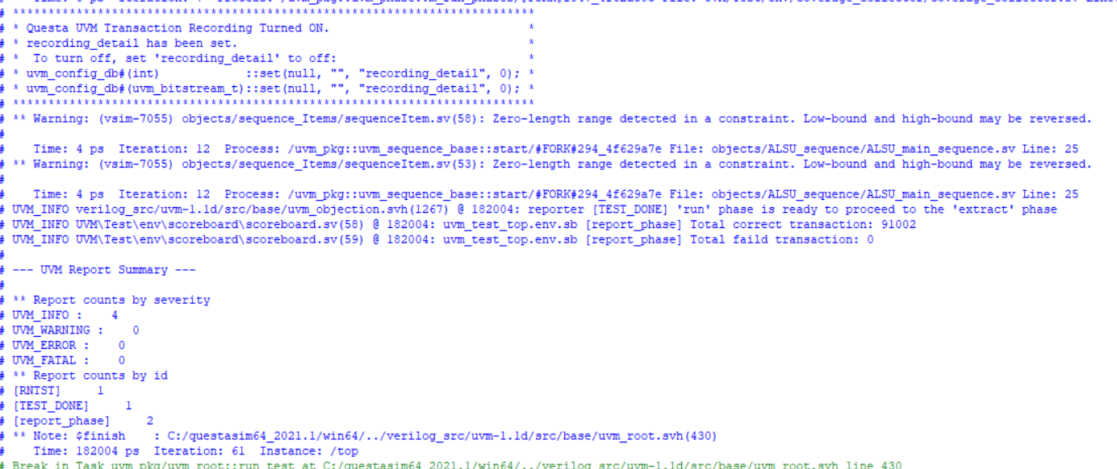

* Constraint of rule 8 🡺 make opcode only valid and unique values

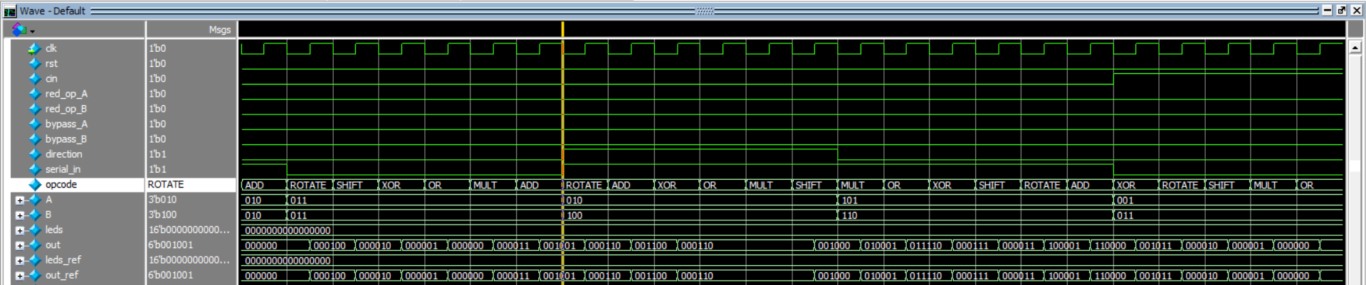

* Constraint reset most of the time is inactive

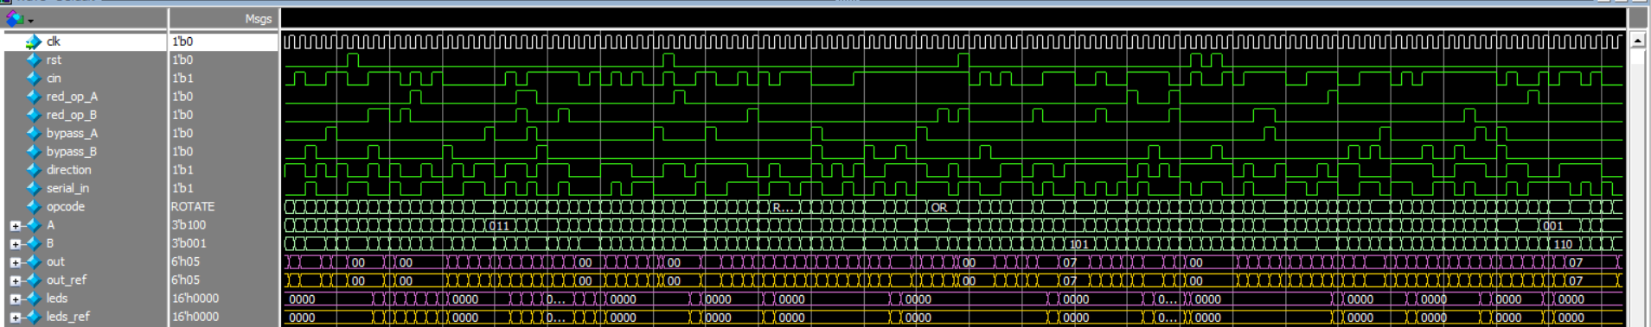

* Invalid reduction

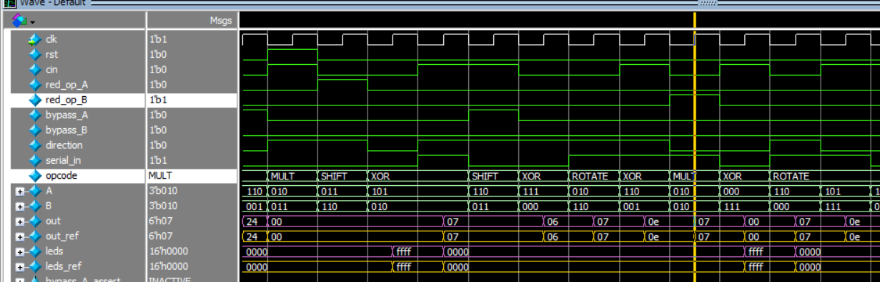

* Invalid opcode

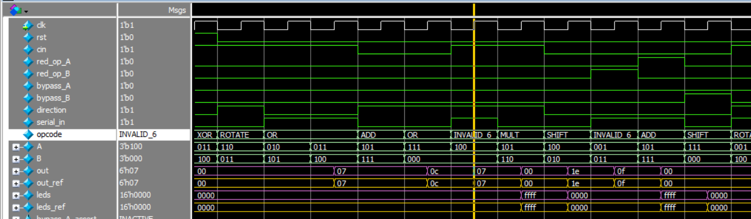

|  |  |  |
| --- | --- | --- |
| **- OR** | **- XOR** | **- ADD** |
| **- MULT** | **- SHIFT** | **- ROTATE** |

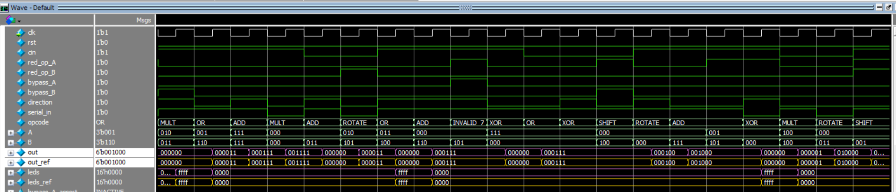

3. Add the signals of the interface to wave and make sure that the inputs are driven. Take a screenshot and add it to your PDF.

Do file:

add wave -position insertpoint sim:/top/intf/*

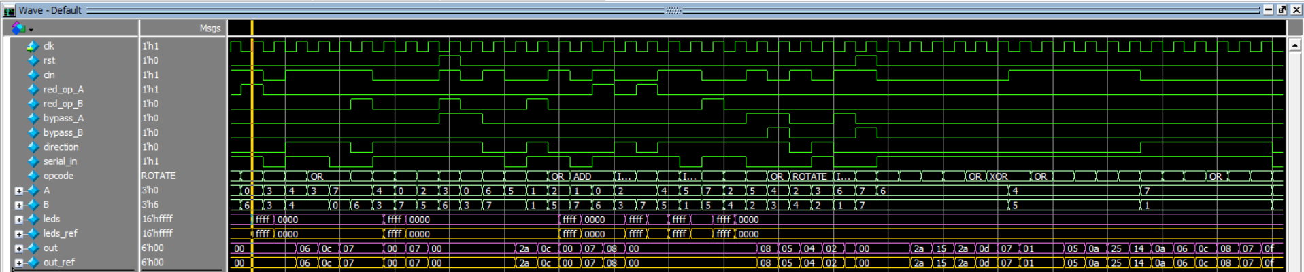

4. Take screenshots of the code coverage, functional coverage, sequential domain (assertions) coverage for ALSU

* Assertion

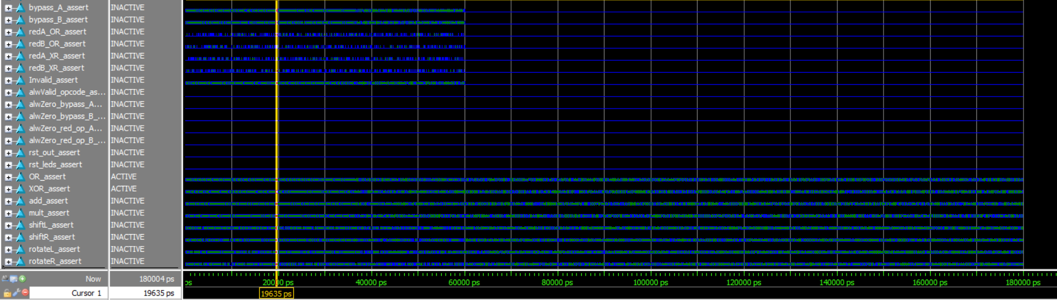

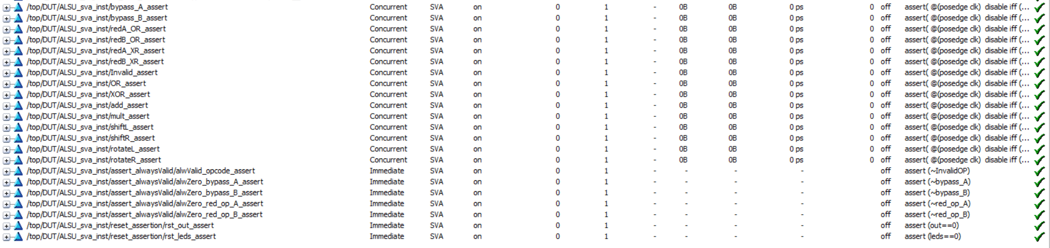

* Coverage directives

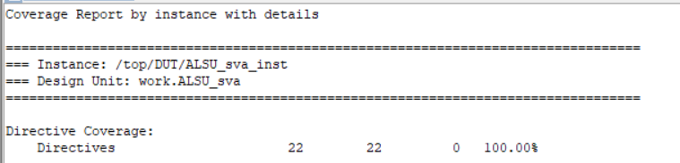

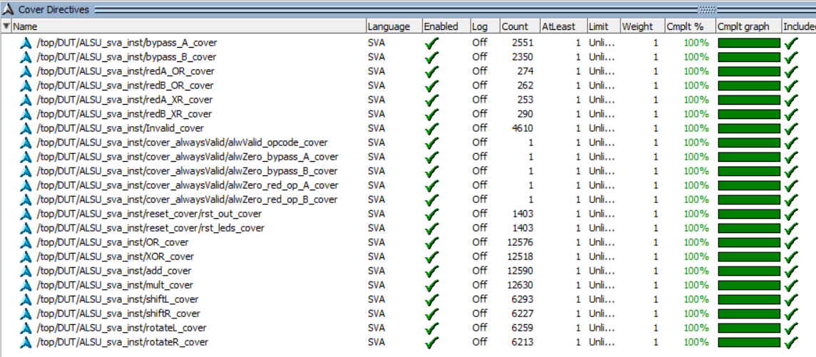

* Coverage

1. Questa Group Coverage

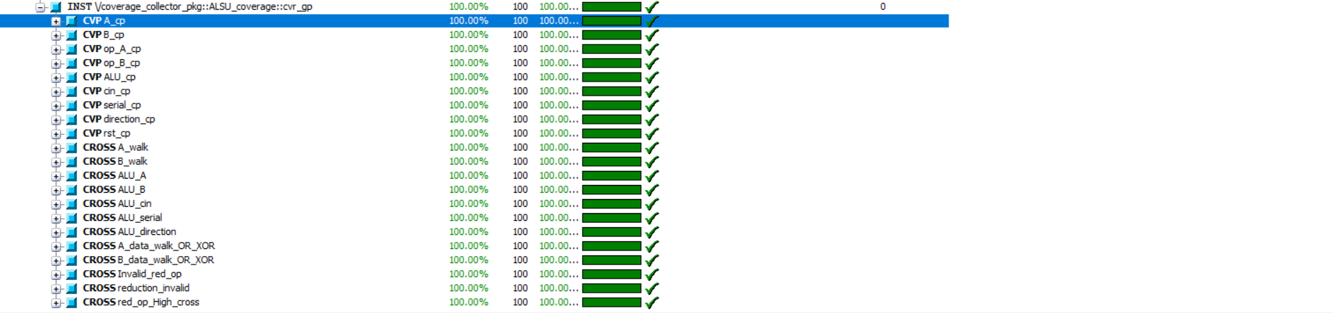

2. Functional coverage



3. Code coverage

* HTML report

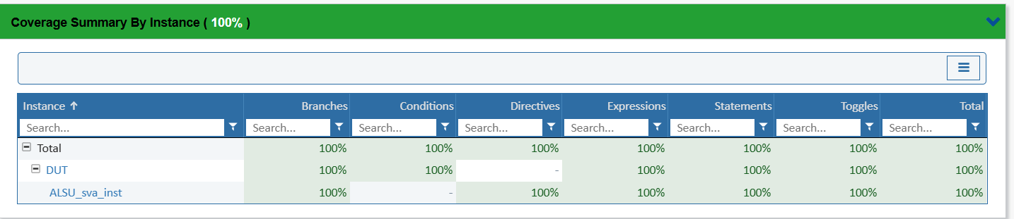

* Txt report
  + Branch Coverage

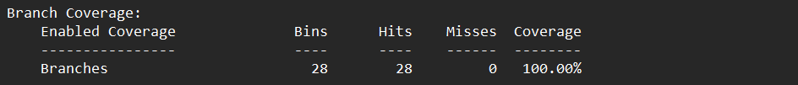

* + Condition Coverage

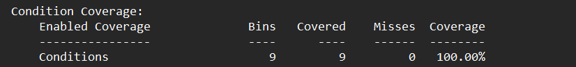

* + Expression Coverage

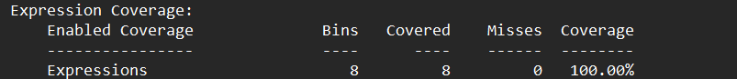

* + Statement Coverage

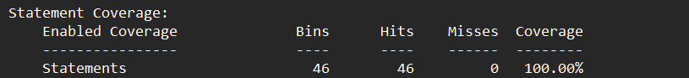

* + Toggle Coverage

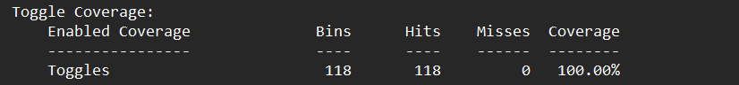

4. Sequential domain coverage





**///// using factory property to override only valid sequencs, Leds never get blink/////**

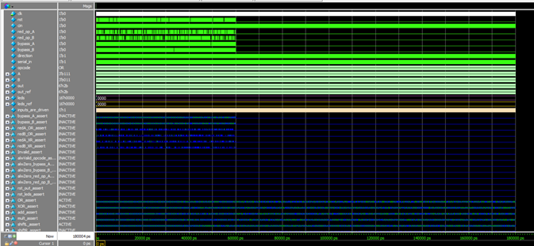

**/// All cover directives were covered but the Invalid one.**

C:\Users\abdel\AppData\Local\Microsoft\Windows\Clipboard\HistoryData\{0B039DF7-3245-46AF-9973-CDA9F973228B}\{0AB48B66-BD76-4647-A459-B70EDB3BF296}\ResourceMap\{C74EAE1B-8D87-4A35-9E74-8134BEB17BBD}

**////   Code**

        function void build_phase(uvm_phase phase);

            uvm_factory factory = uvm_factory::get();

            super.build_phase(phase);

            set_type_override_by_type(ALSU_sequenceItem::get_type(), ALSU_sequenceItem_valid::get_type());

            factory.print();

**/// Factory report**

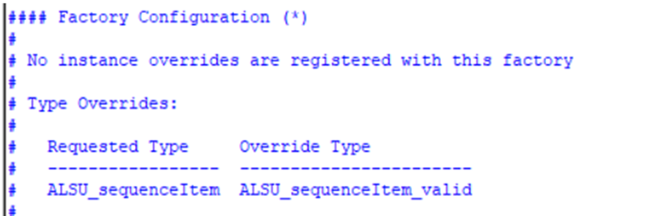

**///  without the override method call, Leds blink then No blink (Valid and Invalid cases) ///**

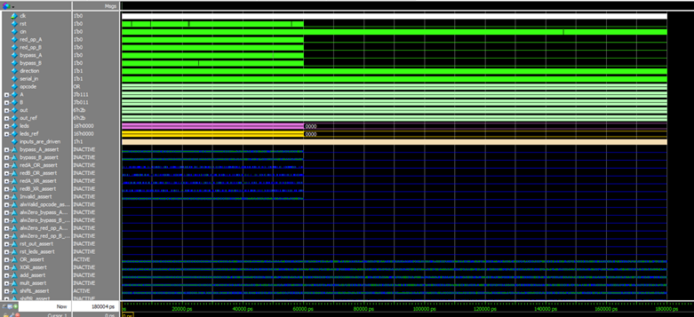

**/// Invalid cases was covered**

**C:\Users\abdel\AppData\Local\Microsoft\Windows\Clipboard\HistoryData\{0B039DF7-3245-46AF-9973-CDA9F973228B}\{0AB48B66-BD76-4647-A459-B70EDB3BF296}\ResourceMap\{42FB69F3-A950-4996-A7B5-AF0F9B158D43}**

**/// Code**

        function void build_phase(uvm_phase phase);

            uvm_factory factory = uvm_factory::get();

            super.build_phase(phase);

            //set_type_override_by_type(ALSU_sequenceItem::get_type(), ALSU_sequenceItem_valid::get_type());

            factory.print();

**/// Factory report**

