TAXONOMY & SITEMAP OF SAND AND DUST STORM (SDS) FORECASTING METHODOLOGIES
Technical Synthesis: Traditional Forecasting vs. Multi-Scale Dynamics vs. Proposed Machine Learning & Deep Learning Architecture (LSTM + Transformer + GNN)
Master of Engineering • Academic Supervisor Dossier
EXECUTIVE RESEARCH SUMMARY
This dossier synthesizes the complete taxonomic classification of sand and dust storm forecasting paradigms identified across global meteorological literature and the research proposal for Riyadh, Saudi Arabia. It details the scientific limitations of traditional Numerical Weather Prediction (NWP), establishes a tri-dimensional scale taxonomy (Small, Medium, Large), and outlines the updated research modeling framework: combining Tree Ensembles (Line A) with a Deep Learning triad—LSTM (temporal sequence memory), Transformer (multi-head self-attention), and Spatio-Temporal GNNs (14-node directional corridor advection)—integrated with GIS spatial geostatistics and SPSS/AMOS socioeconomic behavioral science.

1. Visual Taxonomy & Hierarchy Sitemap
The following publication-grade sitemap visually maps the hierarchy from traditional physical paradigms, through multi-scale environmental dynamics, to the proposed machine learning and deep learning methodologies:
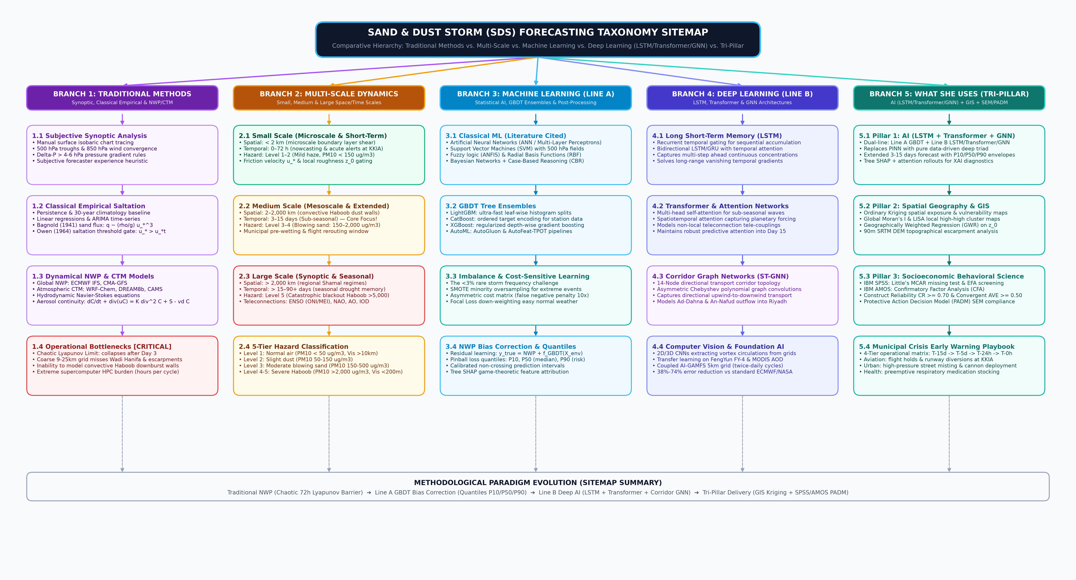
Figure 1: Full-Spectrum Sitemap Taxonomy of Sand & Dust Storm Forecasting Paradigms (Draw.io Export).

2. Traditional Forecasting Methods & Their Failure Modes
Historically, sandstorm forecasting has relied on three foundational, non-learning paradigms:
• Synoptic Subjective Weather Analysis: Forecasters manually inspect daily surface isobaric charts, upper-air potential fields (500 hPa geopotential troughs, 850 hPa low-level jets), and regional pressure gradient rules (e.g., Delta-P > 4-6 hPa across northern deserts driving Shamal winds).
• Classical Empirical Saltation Physics: Physical transport formulas dating from Bagnold (1941) sand transport flux (scaling with the cube of friction velocity q ~ u_*^3) and Owen (1964) saltation threshold gating (u_* > u_*t), with Gillette (1979) damp soil moisture bridging corrections.
• Dynamical Numerical Weather Prediction (NWP) & Chemistry-Transport Models (CTMs): Discretized integration of atmospheric Navier-Stokes fluid equations and aerosol advection-diffusion-deposition PDEs (ECMWF IFS, CMA-GFS, WRF-Chem, DREAM8b, Copernicus CAMS).
Critical Operational Bottlenecks: Traditional NWP models suffer from the chaotic Lyapunov Horizon limit (T_Lyap ~ 72 hours / Day 3), beyond which deterministic error growth diverges exponentially. Furthermore, coarse grid resolutions (9-25 km) fail to resolve sub-grid orographic channeling through narrow corridors (such as Jabal Tuwaiq and Wadi Hanifa in Riyadh), cannot simulate rapid convective Haboob downburst walls, and demand massive supercomputer compute cycles that prevent agile real-time emergency cycle updates.

3. Multi-Scale Taxonomic Classification (Small, Medium, Large)
Sand and dust storms operate across three intertwined dimensions:
• Small Scale (Microscale & Short-Term): Spatial extent < 2 km (boundary layer turbulence, local saltation, urban canyons); temporal horizon 0–72 hours (nowcasting, flight runway holds at KKIA); hazard level 1–2 (mild haze, PM10 < 150 ug/m3).
• Medium Scale (Mesoscale & Extended-Range): Spatial extent 2–2,000 km (convective Haboob dust walls, Ad-Dahna / An-Nafud corridor channeling); temporal horizon 3–15 days (sub-seasonal)—the primary scientific innovation frontier of this dissertation; hazard level 3–4 (blowing sand to severe storm, PM10: 150–2,000 ug/m3).
• Large Scale (Synoptic-Macro & Seasonal): Spatial extent > 2,000 km (regional Shamal regimes, transboundary Rub' al Khali plumes); temporal horizon > 15–90+ days (seasonal drought memory, planetary teleconnections: ENSO, NAO, AO, IOD); hazard level 5 (catastrophic blackout Haboob, PM10 > 5,000 ug/m3).

4. Machine Learning & GBDT Post-Processing (Main Line A)
To correct systematic NWP drifts without incurring supercomputer costs, Main Line A establishes an ensemble post-processing framework:
• Gradient Boosting Ensembles: LightGBM (ultra-fast leaf-wise histogram splits), CatBoost (ordered target encoding for categorical station and wind sector features without target leakage), and XGBoost (regularized depth-wise splits).
• Rare Class Imbalance Optimization: Because severe dust storms occur on <3% of annual days, standard ML exhibits severe negative bias. This is resolved via SMOTE synthetic oversampling, asymmetric cost matrices (10x penalty on false negatives), and Focal Loss.
• Quantile Uncertainty Envelopes: Minimized via Pinball Loss to output calibrated, non-crossing prediction intervals: P10 (optimistic), P50 (median), and P90 (risk-averse threshold).
• Explainable AI (Tree SHAP): Game-theoretic feature attribution isolating exact physical trigger thresholds (e.g., 10m wind speed crossing 8.5 m/s combined with topsoil moisture < 0.08 m3/m3).

5. Deep Learning Spatiotemporal Architecture (Main Line B)
In accordance with updated methodological designs, Main Line B replaces differential PDE loss regularization (PINN) with an advanced pure data-driven Deep Learning Triad specifically tailored for atmospheric spatiotemporal sequences:
• 1. Long Short-Term Memory (LSTM): Recurrent temporal gating (input, forget, and output gates) modeling sequential dust mass accumulation and dispersion across consecutive hourly time-steps.
• 2. Spatiotemporal Transformers: Multi-head self-attention mechanisms capturing long-range planetary wave trains and sub-seasonal teleconnections, maintaining high predictive skill across the extended 3–15 day horizon without vanishing gradients.
• 3. Spatio-Temporal Graph Neural Networks (ST-GNN): A 14-node directional graph topology linking upstream desert source basins (An-Nafud, Ad-Dahna) with downstream receptor stations in Riyadh. Uses 3-support asymmetric Chebyshev polynomial graph convolutions to simulate physical directional advection driven by prevailing northwest Shamal winds.
• 4. Coupled AI-GAMFS Vision Backbone: Ingests 5km gridded multi-channel tensors ([B, 3, 32, 32]: MODIS AOD, 10m U-wind, 10m V-wind) with twice-daily operational updates, matching or exceeding international general circulation models.

6. Tri-Pillar Integration & Socioeconomic Delivery
To bridge the gap between meteorological engineering and public emergency management, the research couples three pillars:
• Pillar 1 (Meteorological AI): Line A GBDT ensembles + Line B deep triad (LSTM, Transformer, ST-GNN).
• Pillar 2 (Spatial GIS Geography): Ordinary Kriging spatial exposure interpolation, Global Moran's I spatial autocorrelation, LISA local high-high risk clustering, and Geographically Weighted Regression (GWR) on surface roughness z_0.
• Pillar 3 (Socioeconomic Behavioral Science): IBM SPSS data hygiene (Little's MCAR missing test, Mahalanobis D2 multivariate outlier audit, EFA) and IBM AMOS Confirmatory Factor Analysis (CFA; CR >= 0.70, AVE >= 0.50) modeling the Protective Action Decision Model (PADM) structural equation model.
• 4-Tier Municipal Playbook: Translating probability envelopes into concrete actions across T-15d (sub-seasonal outlook), T-5d (pre-disaster highway misting & airline rerouting), T-24h (runway holds & hospital alerts), and T-0h (lockdown).

7. Master Methodological Comparison Matrix
Dimension | Traditional Methods | Machine Learning (Line A) | Deep Learning (Line B - Updated)
Core Models | ECMWF IFS, WRF-Chem, Bagnold flux | LightGBM, CatBoost, XGBoost | LSTM, Transformer, ST-GNN, AI-GAMFS
Primary Role | Hydrodynamic baseline simulation | Statistical NWP bias correction | End-to-end spatiotemporal corridor prediction
Extended Horizon (3-15d) | Rapid skill collapse after Day 3 | Calibrated quantiles (P10/P50/P90) | High skill via self-attention & graph advection
Spatial Resolution | Coarse 9–25 km grid | Station-level local downscaling | 5 km grid + 14-node directional corridor graph
Extreme Storm Handling | Underestimates sudden spikes | SMOTE + Cost-Sensitive Focal Loss | Spatiotemporal attention on moving fronts
Explainability | High theoretical physics, low XAI | Tree SHAP exact feature attribution | Attention rollouts & graph edge weights
Societal Link | Disconnected from social response | Probability input to municipal playbooks | Coupled with GIS Kriging & AMOS SEM (PADM)

