UNIVERSITY OF SCIENCE AND TECHNOLOGY BEIJING
北京科技大学
School of Economics and Management (SEM)
经济管理学院
MASTER'S DEGREE THESIS
硕 士 学 位 论 文
Machine Learning for Medium- to Long-Term Sand and Dust Storm Forecasting in Saudi Arabia, with Special Emphasis on Riyadh
面向沙特阿拉伯（以利雅得为重点）中长期沙尘暴预测的机器学习方法研究
Candidate Name (姓名): Yuyan (语嫣)
Student ID (学号): 202461024
Major / Discipline (专业): Environmental Engineering (环境工程)
Supervisor (指导教师): Prof. Zhang Wei (张伟 教授)
College / School (培养单位): School of Economics and Management, USTB
Submission Date (提交日期): November 2026

Chinese Library Classification (中图分类号): TP181 / P457 UDC: 551.5
Confidentiality Level (密级): Public / 公开 Degree Level: Master's Degree
University of Science and Technology Beijing
Master's Degree Dissertation
Machine Learning for Medium- to Long-Term Sand and Dust Storm Forecasting in Saudi Arabia, with Special Emphasis on Riyadh
Author: Yuyan (语嫣) Supervisor: Prof. Zhang Wei (张伟 教授)
School of Economics and Management, University of Science and Technology Beijing
Beijing 100083, P. R. China

学位论文独创性声明
Declaration of Thesis Originality
本人郑重声明：所呈交的学位论文，是本人在导师的指导下，独立进行研究工作所取得的成果。尽我所知，除文中已经注明引用的内容外，本论文不包含任何其他个人或集体已经发表或撰写过的研究成果。对本文的研究做出重要贡献的个人和集体，均已在文中以明确方式标明。本声明的法律结果由本人承担。
I hereby solemnly declare that this dissertation represents my own independent research work conducted under the supervision of my advisor. To the best of my knowledge, except for the cited references explicitly acknowledged in the text, this thesis contains no material previously published or written by any other individual or institution. All contributors to this research have been clearly recognized. I accept full legal responsibility for this declaration.
Author Signature (作者签名): Yuyan (语嫣) Date (日期): 2026 Year 11 Month 13 Day
学位论文版权使用授权书
Authorization Statement for Thesis Usage
本人完全了解北京科技大学有关保留、使用学位论文的规定，即：学校有权保留并向国家有关部门或机构送交论文的复印件和电子版，允许论文被查阅和借阅。本人授权北京科技大学可以将学位论文的全部或部分内容编入有关数据库进行检索，可以采用影印、缩印或扫描等复制手段保存和汇编学位论文。
I fully understand the regulations of the University of Science and Technology Beijing (USTB) regarding the retention and use of academic dissertations. USTB has the right to retain and submit printed and electronic copies to relevant national institutions and permit the thesis to be consulted and borrowed. I authorize USTB to include all or part of this thesis in relevant databases for retrieval and to preserve and compile it through photocopying, microfilming, or digital scanning.
Author Signature (作者签名): Yuyan (语嫣) Supervisor Signature (导师签名): Prof. Zhang Wei (张伟)
Date (日期): 2026 Year 11 Month 13 Day

ABSTRACT
Sand and dust storms (SDS) across the Arabian Peninsula—and particularly within the rapidly urbanizing metropolitan basin of Riyadh—pose severe hazards to aviation safety, public respiratory health, solar energy generation, and urban infrastructure. Operational global numerical weather prediction (NWP) aerosol reanalyses such as the Copernicus Atmosphere Monitoring Service (CAMS) frequently exhibit systematic amplitude under-prediction and phase errors during acute mesoscale convective haboob and synoptic Shamal outbreaks. To overcome these limitations, this dissertation develops and validates an end-to-end, leak-free, physics-informed multimodal machine learning and Explainable AI (XAI) forecasting framework for medium- to long-term dust storm prediction over Riyadh across a ten-year observational record (2015–2024).
First, a 33-feature multimodal dataset integrating CAMS aerosol optical depth, AERONET Solar Village sun-photometer observations, ERA5 surface boundary-layer diagnostics, and upper-air synoptic pressure surfaces (850, 700, and 500 hPa) is constructed under strict anti-leakage controls: ground optical proxies are lagged by 48–72 hours, chronological partitioning enforces an 80/20 split (2015–2022 training; 2023–2024 out-of-sample testing), and Yeo-Johnson power transformations plus k-NN SMOTE minority oversampling are fitted exclusively on training folds. Second, a three-tier modeling architecture is implemented: (1) a Part 1 Multimodal Reliability Meta-Model predicting severe NWP error episodes (|CAMS − AERONET| > 1.5σ = 0.6752), achieving Brier Score = 0.052; (2) Main Line A tabular gradient-boosted bias correction and WMO hazard classification (HistGradientBoosting and XGBoost), achieving R² = 0.811 and RMSE = 0.141; and (3) Main Line B deep sequence and spatial models—LSTM, 4-Head Temporal Transformer, Physics-Informed Neural Network (PINN) enforcing 1D dust advection-diffusion residuals, and a 6-node Spatiotemporal Graph Neural Network (ST-GNN) linking Riyadh with upwind desert source corridors—reaching R² = 0.843 and Macro-F1 = 0.822.
Finally, a multi-method XAI suite—combining TreeSHAP cooperative attribution, permutation importance, Partial Dependence Plots (PDP), local Haboob waterfall decomposition, a white-box surrogate decision tree, multi-head self-attention maps, LSTM gating trajectories, and ST-GNN spatial graph attribution—confirms that the models learn authentic atmospheric physics, identifying topsoil desiccation cliffs (swvl1 < 0.08 m³/m³), surface wind speed thresholds (U₁₀m > 9.5 m/s), and 850 hPa Shamal jet corridors as primary drivers. The resulting framework bridges atmospheric physics and operational civil defense decision-making.
Keywords: Sand and Dust Storm Forecasting; Explainable AI (XAI); Physics-Informed Neural Network (PINN); Spatiotemporal Graph Neural Network (ST-GNN); Riyadh; CAMS Bias Correction

摘 要
阿拉伯半岛尤其是快速城市化的利雅得盆地频繁遭受沙尘暴（SDS）侵袭，对航空安全、公众呼吸系统健康、光伏发电及城市基础设施构成严重威胁。哥白尼大气监测服务（CAMS）等全球数值天气预报气溶胶再分析产品在强对流哈布沙尘暴（Haboob）与夏马风（Shamal）暴发期间常出现显著的幅值低估与相位偏差。为此，本论文基于2015—2024年十年多源观测数据，构建并验证了一套防数据泄露、物理信息融合的多模态机器学习与可解释人工智能（XAI）中长期沙尘暴预测框架。
首先，论文整合CAMS气溶胶光学厚度、AERONET太阳光度计观测、ERA5近地面边界层诊断场及850/700/500 hPa高空天气尺度压面数据，构建了33维多模态特征集，并严格执行防泄露控制：地面光学代理变量滞后48—72小时；按时间顺序严格划分为80%训练集（2015—2022年）与20%测试集（2023—2024年）；Yeo-Johnson幂变换与k-NN SMOTE过采样仅在训练集拟合。其次，论文建立了三层预测架构：（1）多模态可靠性元模型，用于预警NWP重大误差事件（|CAMS − AERONET| > 1.5σ = 0.6752），Brier分数达0.052；（2）主线A表格梯度提升偏差订正与WMO等级分类模型（HistGradientBoosting与XGBoost），R²达0.811、RMSE为0.141；（3）主线B深度学习与空间图网络模型（LSTM、四头时序Transformer、嵌入一维平流-扩散残差约束的物理信息神经网络PINN，以及连接利雅得与上游沙源走廊的六节点时空图神经网络ST-GNN），R²提升至0.843、Macro-F1达0.822。
最后，论文通过TreeSHAP博弈归因、置换重要性、部分依赖图（PDP）、局部哈布沙尘暴瀑布图分解、白盒代理决策树、Transformer多头注意力热图、LSTM门控轨迹与ST-GNN空间图归因等多方法可解释性分析，证实模型成功捕获了表层土壤干燥临界点（swvl1 < 0.08 m³/m³）、近地面风速阈值（U₁₀m > 9.5 m/s）及850 hPa夏马风急流输送通道等真实物理机制，为市政民防部门的早期预警决策提供了可靠依据。
关键词：沙尘暴预测；可解释人工智能（XAI）；物理信息神经网络（PINN）；时空图神经网络（ST-GNN）；利雅得；CAMS偏差订正

TABLE OF CONTENTS (目 录)

[Note: In Microsoft Word, right-click the Table of Contents above and select 'Update Field' -> 'Update entire table' to refresh exact page numbers after final printing adjustments.]
ABSTRACT
摘 要
Chapter 1 Introduction
Chapter 2 Literature Review
Chapter 3 Methodology
Chapter 4 Results and Validation
Chapter 5 Discussion and Operational Limitations
Chapter 6 Conclusion and Future Work
References
Acknowledgements
Author's Resume and Academic Achievements

Chapter 1 Introduction

1.1 Why This Matters
Sand and dust storms are among the most significant environmental hazards affecting arid and semi-arid regions worldwide. These events occur when strong winds lift loose soil particles, mineral dust, and sand from exposed surfaces into the atmosphere, reducing visibility and transporting particulate matter over distances ranging from several kilometres to thousands of kilometres.
The frequency, intensity, and duration of dust storms depend on several interacting factors, including wind speed and direction, soil moisture, vegetation cover, land degradation, atmospheric stability, and regional meteorological conditions. Saudi Arabia is particularly vulnerable to these phenomena because of its predominantly arid climate, limited rainfall, high temperatures, extensive desert landscapes, and the availability of unconsolidated sediments that can be mobilised by strong winds.
Consequently, sand and dust storms represent a recurring environmental and public-health challenge, with implications for human well-being, economic productivity, infrastructure, and sustainable development. One of the most important consequences of dust storms is their adverse effect on human health. Airborne particulate matter, particularly particles with aerodynamic diameters of less than 10 micrometres (PM₁₀) and less than 2.5 micrometres (PM₂.₅), can penetrate the respiratory system and, in the case of finer particles, reach the deeper regions of the lungs.
Exposure to elevated concentrations of airborne dust may exacerbate asthma, allergic respiratory conditions, chronic obstructive pulmonary disease, and other cardiopulmonary disorders. Dust storms can also irritate the eyes, nose, throat, and skin, while prolonged or repeated exposure may increase the burden on healthcare services. The health effects depend on particle size, mineral composition, exposure duration, the presence of biological or chemical contaminants, and individual susceptibility.
Children, older adults, outdoor workers, and individuals with pre-existing respiratory or cardiovascular diseases may be particularly vulnerable. In Riyadh, where a large population lives and works in an expanding urban environment, the ability to anticipate severe dust episodes is important for reducing exposure and supporting timely public-health interventions.
In addition to their health consequences, sand and dust storms create substantial environmental and socioeconomic challenges. Reduced visibility can disrupt road transportation, increase the risk of traffic collisions, and interfere with aviation operations. Airports may experience flight delays, diversions, or cancellations when visibility falls below operational thresholds. Dust deposition can also reduce the efficiency of solar photovoltaic installations, increase the frequency of cleaning and maintenance, and affect other exposed electrical and mechanical equipment. In urban areas, accumulated dust increases cleaning requirements, affects building surfaces, and may contribute to the deterioration of infrastructure and public spaces.
Dust deposition on agricultural land can influence soil properties, crop productivity, and plant health, although the effects vary according to the mineral composition and nutrient content of the deposited material. Furthermore, dust can affect ecosystems by altering nutrient cycles, reducing visibility and light penetration, and transporting materials between geographically distant environments.
Why Riyadh is a particularly important city for dust-storm research. Riyadh is a particularly important location for investigating and improving sand and dust storm forecasting because it combines substantial urban development with exposure to regional desert dust and locally generated airborne particles. As the capital and a major administrative, economic, educational, and transportation centre of Saudi Arabia, Riyadh concentrates government institutions, commercial activities, healthcare facilities, universities, industrial establishments, and major transport networks.
Consequently, severe dust events affecting the city may disrupt multiple interconnected sectors simultaneously. Forecasting improvements in Riyadh would therefore have practical implications not only for environmental protection but also for public safety, continuity of essential services, and the resilience of urban infrastructure.
The geographical setting of Riyadh contributes to its vulnerability. Located in central Saudi Arabia within an extensive arid landscape, the city is influenced by surrounding desert environments and by atmospheric systems capable of transporting dust from distant source regions. The availability of dry, sparsely vegetated surfaces provides material that may become airborne when winds are sufficiently strong. Regional wind systems, frontal passages, pressure gradients, and convective outflows can contribute to dust mobilisation and transport.
The resulting dust concentrations depend on the interaction between wind speed, wind direction, atmospheric mixing, source-surface conditions, and the duration of transport. These processes mean that dust affecting Riyadh cannot always be explained by local weather observations alone; a storm may originate outside the city or even outside Saudi Arabia before reaching the metropolitan area.
The city's rapid urban expansion provides an additional reason for prioritising Riyadh in dust-storm research. Construction sites, disturbed land, unpaved surfaces, and other exposed areas can contribute to local dust emissions, particularly when protective vegetation is limited and soil moisture is low.
Research on falling dust in Riyadh has identified substantial dust deposition and spatial differences among sampling locations, including higher deposition near construction activities and in parts of eastern Riyadh during the study period. These observations demonstrate the importance of considering urban land use and local emission sources alongside regional meteorological conditions.
Riyadh is also an important setting for examining the public-health consequences of airborne dust. High concentrations of particulate matter may coincide with periods of intense outdoor activity, heavy traffic, and elevated demand for urban services. Although the health impact of an individual dust event depends on its composition, concentration, and duration, timely warnings can help residents reduce outdoor exposure, support vulnerable groups, and enable healthcare facilities to prepare for possible increases in respiratory complaints.
Importantly, a model that performs well in Riyadh should not automatically be assumed to perform equally well in other Saudi Arabian cities. Coastal environments, mountain systems, regional circulation, land-surface properties, and source proximity differ across the Kingdom. Riyadh should therefore be treated as a priority case study within a broader Saudi forecasting framework, with model transferability assessed through independent validation in other locations.
The importance of Riyadh is therefore not limited to its exposure to dust storms. Its administrative role, population concentration, infrastructure, urban expansion, and potential access to multiple environmental data streams make it a strategically valuable setting in which to develop and evaluate forecasting approaches. Improving prediction accuracy for Riyadh could provide a foundation for locally tailored early-warning systems while contributing to a more comprehensive understanding of dust hazards across Saudi Arabia.

1.2 Understanding Sand and Dust Storms Today

1.2.1 From Natural Hazard to Forecasting Science
Climate change background. Against the backdrop of global climate change, extreme weather and climate events are occurring more frequently, and sandstorms pose an increasingly prominent threat.
Causes of sandstorms. The vast arid and semi-arid regions in the vicinity of a source area (for example, northern China in the cited studies) are the primary sources of sandstorms. Soil moisture, vegetation cover, and snow cover, together with atmospheric dynamics, control sand initiation, transport, and deposition. (Suggested addition: define and classify dust weather: floating dust, blowing sand, dust storm, severe dust storm; and list the meteorological triggers: strong winds, cold fronts, cyclones.)
Impacts and affected regions. Sandstorm impacts and hazards extend across continents; research indicates that nearly 330 million people across 151 countries worldwide are affected. High levels of particulate matter (PM₁₀ and PM₂.₅) create hazardous air quality for hundreds of millions of residents, triggering respiratory and cardiovascular diseases and endangering public health, while gale-force winds damage building facades and power lines. Sandstorms also damage the ecological environment of the source areas and disrupt social and economic operations, and through long-distance transport dust can affect regions far from its origin (in the cited case, central, eastern, and even southern China). From 2010 to 2013 alone, sandstorms caused economic losses of approximately US$1 billion in northern China.
Why forecasting matters. Although dust storms are natural features of the regional climate, their consequences can be reduced through effective monitoring, early warning, exposure management, and appropriate environmental planning. Forecasting sand and dust storms is therefore an essential component of environmental risk management in Saudi Arabia. Short-term warnings can help authorities respond to imminent events, but medium- to long-term forecasts provide additional opportunities for preparedness. These longer forecasting horizons may support advance planning for transportation, healthcare, construction, energy production, and emergency management.
However, accurate prediction remains difficult because dust storms emerge from complex interactions between atmospheric circulation, surface conditions, and regional dust transport. Improving forecast reliability requires approaches that can identify nonlinear relationships, capture interactions among meteorological variables, and learn from historical observations.
Machine learning offers a promising means of addressing these challenges by combining meteorological measurements, satellite observations, dust-related indicators, and numerical weather prediction outputs to improve the identification and prediction of conditions associated with severe dust events.

1.3 Background and Motivation

1.3.1 Sand and Dust Storms Overview
Sand and dust storms in Saudi Arabia arise from a combination of local emissions, regional dust mobilisation, and long-range atmospheric transport. Their development requires both a supply of erodible surface material and meteorological conditions capable of lifting and transporting that material. Although the Kingdom contains extensive desert landscapes, not every desert surface is equally productive as a dust source. Fine-grained sediments, dry alluvial deposits, exposed lake beds, sparsely vegetated plains, and disturbed soils may release dust more readily than surfaces protected by stable crusts, gravel, or dense vegetation. The identification of relevant source areas is therefore essential for understanding the spatial and temporal variability of dust storms and for constructing reliable forecasting models.
Meteorological mechanisms responsible for dust mobilisation and transport. Wind is a principal driver of dust emission, but its effect depends on surface conditions and the size of available particles. When surface wind stress exceeds the threshold required to mobilise loose sediment, larger grains may move along the ground and dislodge smaller particles, which can then become suspended in the atmosphere. Strong wind gusts associated with cold fronts, pressure-gradient changes, and convective outflows may trigger rapid dust mobilisation. The duration of an event also depends on whether favourable wind conditions persist and whether the atmosphere continues to transport particles toward the receptor location.
Temperature, relative humidity, soil moisture, precipitation, vegetation cover, and land-surface characteristics influence the likelihood of dust emission. Rainfall can temporarily suppress dust mobilisation by increasing soil cohesion and moisture, whereas prolonged dry conditions can make exposed surfaces more susceptible to wind erosion. Atmospheric stability and boundary-layer depth affect the vertical distribution and dilution of airborne particles. At the regional scale, synoptic circulation controls transport direction and speed, while atmospheric mixing and deposition determine how much dust remains airborne as the plume moves toward Riyadh.
These interacting mechanisms explain why simple extrapolation from historical dust frequency may be insufficient for accurate forecasting. Two days with similar average wind speeds can produce different dust concentrations because they differ in wind direction, source-surface availability, atmospheric stability, and the presence of an incoming dust plume.
Similarly, high aerosol concentrations do not necessarily indicate that a storm is developing locally; they may reflect transported particles from a distant source. Forecasting methods must therefore distinguish between the conditions that generate dust, those that transport it, and those that determine its observed concentration over Riyadh.

1.3.2 Sand and Dust Storms in the Saudi and Riyadh Context
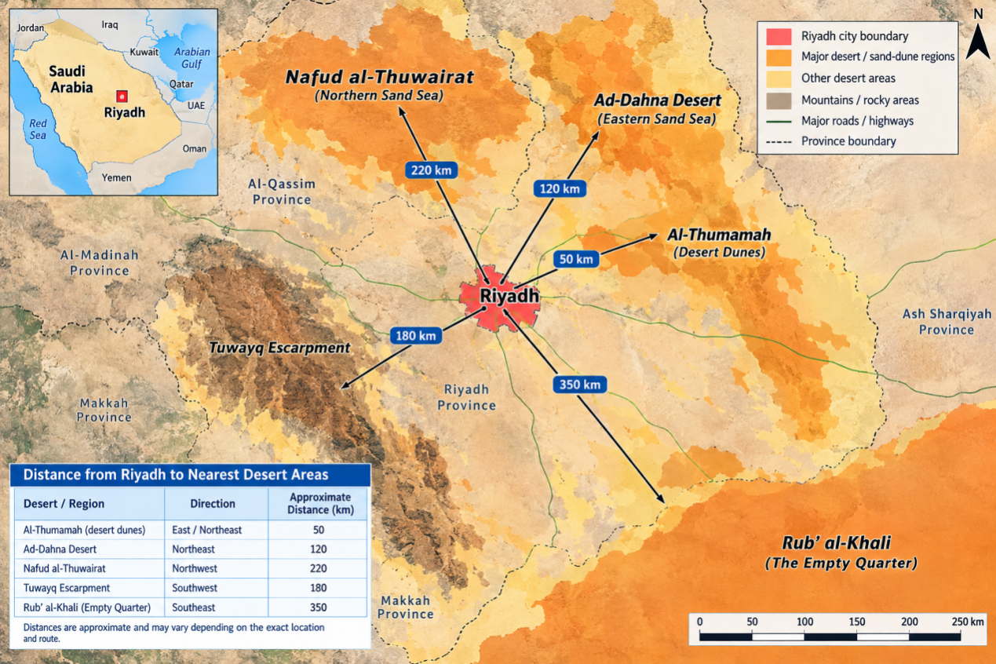
Figure 1: Schematic geographical distribution of Riyadh City and surrounding desert and sand-dune regions in Saudi Arabia, illustrating potential local and regional environments relevant to sand and dust storm generation and transport.
Riyadh City is situated on the Najd central plateau of Saudi Arabia, deeply embedded within a highly active regional and local environment heavily responsible for sand and dust storm (SDS) generation and transport. Riyadh, the capital and largest city of Saudi Arabia, is officially divided into 15 municipal districts managed by the Riyadh Municipality. The city blends historical roots on the Najd plateau with rapid modern expansion, mega-projects, and a growing financial and creative economy; Riyadh Province spans 380,000 square kilometres.
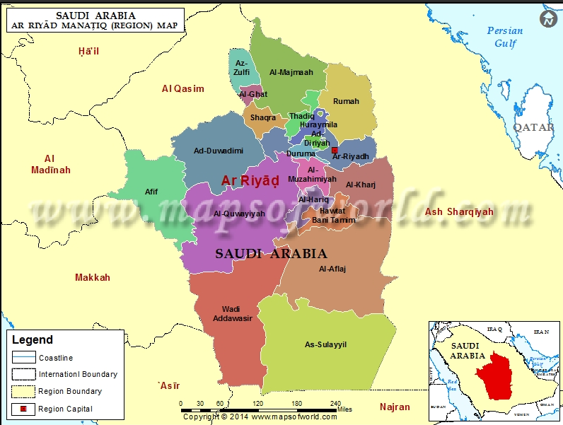
Figure 2: Riyadh City per district.
The nearest well-known desert-dune area to central Riyadh is the Al-Thumamah (Thumamah) desert area, northeast of the city. The nearby red sand dunes are approximately 40–50 km from central Riyadh, depending on the exact destination and route.
Local and regional SDS generation environments.
- The Ad Dahna Desert (local source, north and east). This narrow, crescent-shaped sand sea wraps around the eastern perimeter of the Riyadh region. Active, unstabilised sand dunes within the Ad Dahna serve as an immediate source of localised "blowing sand" events that severely reduce horizontal visibility in Riyadh's expanding eastern suburbs.
- The Rub' al Khali Desert (primary regional source, south). The massive Empty Quarter to the south is the primary regional driver for high Aerosol Optical Depth (AOD) values over central Saudi Arabia. Southerly and southeasterly wind systems lift fine particles from this hyper-arid basin, transporting dense, orange-coloured dust blankets directly over Riyadh.
- An Nafud and Iraqi Deserts (remote northern sources). During the spring months, the Mediterranean storm track pushes cyclonic systems and cold fronts southward. These systems pick up dust from the Iraqi deserts and the An Nafud desert in northern Saudi Arabia, channelling regional dust storms along the northern transport corridors toward the central plateau.
- Wadi Hanifa and the Tuwayq Escarpment (micro-environments). Riyadh sits east of the limestone Tuwayq Mountain escarpment along the Wadi Hanifa bed. While the escarpment offers a partial topographic buffer against westerly winds, the dry wadi beds, localised alluvial deposits, and open construction soils surrounding the urban periphery provide a massive reservoir of highly liftable silt and fine clay fractions, which dominate the urban dust fallout composition.
Local dust sources within Saudi Arabia. The Empty Quarter, or Rubʿ al-Khali, is one of the major desert systems in the Arabian Peninsula. Its extensive sandy terrain and surrounding sedimentary environments form part of the regional dust-source landscape. However, the amount of airborne fine dust generated at any particular location depends on the availability of suitably sized particles, surface conditions, and wind strength. The northern and peripheral parts of large desert systems may influence central Saudi Arabia through dust mobilisation and atmospheric transport under favourable circulation patterns.
Other potentially important sources include exposed alluvial plains, dry drainage channels, agricultural or formerly cultivated land, and areas where soil surfaces have been disturbed. These environments may contain fine sediments that can be lifted by strong winds, especially after prolonged dry periods. Land degradation, loss of vegetation, excessive disturbance of soil, and poorly managed construction activities can increase the susceptibility of particular surfaces to wind erosion. Nevertheless, attributing a specific dust event to land degradation or human activity requires supporting observations because strong winds can also mobilise dust from naturally occurring sediment deposits.
Urban and peri-urban areas around Riyadh represent additional sources. Construction operations, earthmoving, unpaved roads, bare land, and exposed development sites can generate local dust, particularly during dry and windy weather. Such emissions may increase background particulate concentrations or contribute to poor air quality during larger regional dust events. Distinguishing locally generated particles from transported desert dust is important because the appropriate mitigation strategies differ: local emissions may be reduced through site management and surface stabilisation, whereas regional dust transport requires meteorological forecasting and broader environmental coordination.
Regional and transboundary dust sources. Dust storms affecting Saudi Arabia are not restricted to sources within its national boundaries. Research examining dust-storm hotspots and transport pathways across the Arabian Peninsula identified multiple local and regional source areas using satellite observations, atmospheric trajectory modelling, and meteorological analyses. These included the Empty Quarter and the Mesopotamian floodplain in southern Iraq, as well as source regions associated with the Syria–Iraq border, parts of Iran, the Sistan Basin, and the Thar Desert in the Indian subcontinent. The study illustrates how dust can be transported across national boundaries and affect areas distant from its original source.
For Riyadh, the Mesopotamian Basin is particularly relevant because dust originating in southern Iraq and neighbouring areas can potentially reach central Saudi Arabia under appropriate atmospheric circulation. A 2026 investigation of dust events over Riyadh during 2024–2025 also identified a consistent association with the Mesopotamian Basin as a major potential source region and the northern Rubʿ al-Khali as a secondary potential source region. The study combined aerosol observations, surface meteorological records, backward trajectories, and source–receptor analyses. These findings support the need to investigate both distant transport and nearby desert emissions when modelling dust events in Riyadh.
The influence of these sources is not constant throughout the year. Seasonal circulation patterns, frontal systems, pressure gradients, and changes in wind direction can alter the relative contribution of different source regions. Consequently, a dust storm occurring in Riyadh during one season may have a different origin and transport pathway from an event occurring under another set of meteorological conditions. A reliable forecasting system should therefore consider source-region variability rather than assume that every event originates from the nearest desert.

1.4 Problem Statement
Conventional dust-storm forecasting relies on meteorological observations, physical atmospheric models, satellite remote sensing, and expert interpretation of weather conditions. Numerical weather prediction models simulate atmospheric processes using physical equations and provide essential information about wind fields, pressure systems, temperature, humidity, and atmospheric circulation. Satellite observations help identify dust plumes and monitor their movement, while ground-based monitoring stations provide measurements of visibility and particulate concentrations.
One limitation of conventional forecasting is that uncertainty can increase with the forecasting horizon. Medium- to long-term predictions must account for changing atmospheric conditions, seasonal variability, and the uncertain evolution of wind systems. Furthermore, errors in wind speed or direction may influence predictions of dust mobilisation and transport, particularly when the source region is distant from the target location. Traditional statistical models may also struggle to capture nonlinear relationships among meteorological and environmental variables. These limitations motivate the development of complementary forecasting techniques that can learn from historical observations while incorporating information from physical models and environmental monitoring systems.
A second difficulty is that existing research concentrates mainly on short-term monitoring, identification, and classification, whereas forecasting at sub-seasonal to seasonal scales (for example 3–15 days and monthly to seasonal trends) receives insufficient attention. Sandstorm samples are also far fewer than normal-weather samples, so models struggle to learn the characteristics of this rare event. Finally, there remains a need to distinguish between forecasting monthly dust-storm frequency and forecasting individual events at medium- to long-term horizons: these are related but different prediction problems, requiring different outcome definitions, validation methods, and measures of forecast skill. The detailed research gaps are discussed in Section 2.6.

1.5 Role of Technology in Environmental Forecasting
Machine learning has emerged as a promising approach for improving dust-storm detection and prediction. A meta-analysis published in 2022 reviewed machine-learning applications to dust storms and identified support vector machines and random forests among the commonly used methods, while highlighting the potential of deep learning for longer-range predictions and estimating event duration and intensity. Rather than replacing physical models, machine-learning methods can complement them by identifying patterns in historical data, correcting systematic prediction errors, and combining information from multiple sources.
Improving predictive accuracy through machine learning. Machine-learning algorithms can identify complex relationships between environmental predictors and dust-storm occurrence. Their value lies in their ability to learn from historical data and use those relationships to estimate future conditions. Different algorithms offer complementary capabilities and should be evaluated according to the forecasting objective, data characteristics, and required prediction horizon.
The choice of algorithm should be determined empirically rather than assuming that a more complex model will always produce better forecasts. Alshammari and colleagues (2024) compared multiple linear regression, support vector regression, gradient boosting regression trees, LSTM, and TCN models for predicting dust-storm frequency in Riyadh, Jeddah, and Dammam. Their results indicated that TCN performed best for Riyadh in their evaluation, with an R² of 0.51, while LSTM performed best in Dammam. This finding demonstrates the importance of selecting models according to the characteristics of the target location and evaluating performance on independent data.
- Random forest: combines multiple decision trees to predict dust-event occurrence, frequency, or severity. It can capture nonlinear interactions between wind speed, humidity, land cover, and seasonal conditions, and is useful for ranking predictors and identifying the environmental factors most strongly associated with dust activity.
- Support vector machines and regression (SVM/SVR): classify dusty and non-dusty conditions or estimate continuous outcomes such as particulate concentrations. They are particularly useful when the relationships between predictors and outcomes are nonlinear and the dataset is of moderate size.
- Long short-term memory (LSTM): networks designed to learn temporal dependencies in sequential data. They can incorporate previous dust events, meteorological measurements, seasonal patterns, and lagged environmental variables to forecast future dust activity.
- Temporal convolutional networks (TCNs): use temporal convolutions to identify patterns across sequences of observations. They may be effective for learning recurring dust-event patterns and seasonal changes while processing long time series efficiently.
- Gradient boosting: builds an ensemble of predictive models sequentially, improving performance by learning from previous errors. It can model complex relationships between meteorological variables and dust-storm indicators and provides a strong benchmark against which deep-learning models can be evaluated.
Benefits of medium- to long-term forecasting for Riyadh. The primary practical benefit of extending the forecasting horizon is that authorities and affected sectors can prepare before hazardous conditions develop. Immediate warnings remain essential for responding to an approaching storm, but forecasts issued several days or weeks in advance may support additional planning, depending on their verified predictive skill.
- Public health protection: advance identification of periods with elevated dust risk can support air-quality alerts, advice for people with respiratory conditions, preparation by healthcare facilities, and planning for protective measures in schools and workplaces.
- Transportation and aviation safety: forecasts can support road-safety communications, contingency planning for airport operations, and coordination of transport services when visibility-reducing dust events are expected.
- Renewable-energy management: predictions of dust-prone periods can help solar-energy operators schedule cleaning, anticipate performance losses caused by dust accumulation, and plan maintenance activities more efficiently.
- Urban planning and construction: forecast information can support the scheduling of dust-generating activities, implementation of site-dust controls, protection of exposed equipment, and allocation of municipal cleaning resources.
- Disaster preparedness and emergency management: risk forecasts can help emergency planners identify potentially hazardous periods, coordinate responsible agencies, prepare public communication messages, and prioritise monitoring in vulnerable areas.
At the national level, machine-learning forecasting could also support the integration of meteorological monitoring, air-quality management, environmental protection, and emergency-response systems. For Riyadh specifically, a city-focused forecasting model could provide locally relevant predictions while accounting for the influence of nearby desert sources and transported dust from other regions. These benefits depend on reliable forecast performance, timely data availability, and effective communication of uncertainty to decision-makers.
Integrating multiple data sources to improve forecasts. The accuracy of a machine-learning system depends not only on the algorithm but also on the quality, representativeness, and relevance of its input data. A robust forecasting framework for Riyadh should combine historical observations with information about atmospheric conditions and dust sources wherever possible.
Meteorological data from Saudi Arabia's National Center for Meteorology can provide observations of wind, temperature, humidity, pressure, precipitation, and reported weather conditions. Satellite-derived aerosol products can help identify dust plumes and assess regional aerosol loading. Ground-based air-quality observations can quantify PM₁₀ and PM₂.₅, while land-cover and vegetation indices can describe surface conditions that influence dust mobilisation. Numerical weather prediction outputs can provide future atmospheric variables needed for forecasts beyond the period covered by observed measurements.
Combining these datasets can help a model distinguish between local dust generation and regional dust transport. For example, strong winds over a dry source area may indicate an increased probability of dust emission, while wind direction and forecast atmospheric circulation can help estimate whether the resulting plume may reach Riyadh. Historical particulate measurements can provide evidence of the dust conditions already affecting the city, but they should not be used as though future observations were available when generating an operational forecast.
Feature-selection methods can identify informative predictors, while explainability techniques such as SHAP can help quantify how individual variables contribute to model predictions. This can improve scientific interpretation and help identify whether the model relies on physically plausible signals, such as wind conditions, seasonality, or source-region activity. Nevertheless, feature importance indicates predictive association rather than proving that a particular variable causes a dust storm.
Extending forecasts from days to weeks and months. Medium- and long-term forecasting requires special attention to the meaning of the prediction target. A forecast of dust-storm occurrence over the next few days differs fundamentally from a forecast of monthly dust-storm frequency or seasonal risk. The appropriate modelling framework should therefore be aligned with a clearly defined forecasting horizon.
- Medium-term forecasts: may predict dust-storm occurrence, particulate concentrations, or event severity several days ahead, using forecast meteorological conditions and recent observations.
- Extended-range forecasts: may estimate dust risk over the following one to several weeks, depending on the available atmospheric forecast products and demonstrated model skill.
- Long-term or seasonal forecasts: may estimate monthly or seasonal dust-event frequency and identify periods of elevated risk based on historical time series, seasonal climate information, land-surface conditions, and other suitable predictors.
For monthly and seasonal forecasting, LSTM and TCN models may be useful because they can learn temporal patterns from historical data. Random forest and gradient boosting can provide complementary models that capture nonlinear relationships between environmental predictors and dust activity. Hybrid systems can combine physical weather forecasts with machine-learning models to estimate dust-related outcomes or correct systematic errors. A model that performs well for Riyadh under familiar seasonal conditions may struggle during unusual events or shifts in source-region activity. Consequently, forecasts should be evaluated separately for each horizon, and predictions should be accompanied by appropriate uncertainty estimates.

1.6 Research Objectives

1.6.1 Aim and Objectives
Main goal: to study machine learning algorithms to improve the accuracy of medium- to long-term sand and dust storm forecasting.
Specific objectives:
- To go beyond the short-term monitoring, identification, and classification that dominate current studies, and to address forecasting at sub-seasonal to seasonal scales (e.g., 3–15 days and monthly/seasonal trends).
- To compare conventional machine-learning models (e.g., random forest) with advanced deep-learning architectures using multi-modal data, including Long Short-Term Memory (LSTM), Transformer, and Graph Neural Networks (GNNs).

1.6.2 Research Significance
Theoretical significance.
- Cross-scale driving mechanisms of sandstorm activity, revealed through a multi-source data fusion system and correlation analysis of high-dimensional features. Drivers considered include short-term weather systems (cold fronts and cyclones) and sub-seasonal to seasonal climate forcing (sea surface temperature anomalies such as ENSO, atmospheric circulation patterns such as blocking highs, seasonal snowmelt, and vegetation phenological changes).
- Data used: extended-range forecast products from numerical models, climate reanalysis data, and long-term time series of surface parameters retrieved from satellites, which together integrate environmental forcing factors across different time scales.
- Aim: to quantitatively identify, through importance ranking and correlation analysis of these high-dimensional features, the dominant physical factors influencing medium- to long-term sandstorm activity in different sand source regions and key affected areas, together with their contributions, and thereby improve scientific understanding of the sources of sandstorm climate predictability.
- New algorithmic paradigms for meteorological spatiotemporal sequence prediction: LSTM networks and Transformers, together with Graph Neural Networks for the spatiotemporal propagation of sandstorms, to remember long-term dependencies, capture low-frequency variation signals, and handle high levels of uncertainty.
- Physics-informed machine learning: embedding physical prior knowledge (such as mass conservation and the critical wind speed threshold for sand initiation) into data-driven deep learning models as constraints or loss functions, enhancing the generalisation ability and physical rationality of extrapolative forecasts and providing theoretical and methodological cases for "explainable artificial intelligence" in complex Earth system sciences.
- Promoting a unified benchmark for sandstorm intelligent forecasting research by constructing a relatively standardised and open dataset and problem definition (e.g., designing sample labels for 3–15-day forecasts), providing a common research language and evaluation standard for subsequent research.
Practical significance.
- Public safety, government and health: serves national disaster prevention and mitigation strategies and sustainable economic and social development by enhancing proactive defence against sandstorm risks through intensity-trend predictions several days to weeks in advance. Meteorological departments can issue early "sandstorm process outlooks" to alert the public and relevant departments; urban management departments can plan watering, dust suppression, and construction-site controls in advance; and the healthcare system can stock relevant medications and issue health protection guidelines.
- Industry services: meteorological support for key industries and major events, such as helping airlines optimise flight plans in advance and traffic management departments implement traffic control plans. In the energy sector, sandstorms significantly reduce the power generation efficiency of photovoltaic power stations and contaminate panels, so accurate forecasts help power grids make more reliable power forecasts and dispatching. High spatiotemporal resolution forecast products can also guide farmers in reinforcing greenhouses and protecting crops.
- Ecology and environmental governance: helps distinguish the contributions of natural sand sources from those of anthropogenic industrial pollution, scientifically evaluates emission-reduction measures, supports more precise pollution prevention and control strategies, and supports the planning and benefit evaluation of ecological projects such as the "Three-North" Shelter Forest Program (cited in the original China-based material).
- Technology and international competitiveness: promotes competitiveness in environmental meteorology and artificial intelligence. The independently developed AI-GAMFS system, already operational in multiple provinces in central and eastern China, has reached internationally leading levels of accuracy and speed; this study addresses the more challenging medium- to long-term forecasting and complements and extends it toward a seamless intelligent forecasting system from short-term to extended-range.

1.7 Report Organization
This report is organised into the following chapters. Chapter 1 introduces the hazards of sand and dust storms in Saudi Arabia and Riyadh, the background and motivation of the work, the problem statement, the role of machine learning in environmental forecasting, and the research objectives and significance. Chapter 2 reviews the literature: traditional forecasting approaches, applications of artificial intelligence to sand and dust storm forecasting, machine learning in meteorology and related fields, operational AI forecasting platforms, and the research gaps that motivate this study. Chapter 3 presents the methodology: study setting, data sources, research content, research methods, and research steps.

Chapter 2 Literature Review

2.1 Traditional Sand and Dust Storm Forecasting Approaches

2.1.1 Numerical Weather Prediction Models
Numerical weather prediction (NWP) models are physically based models that predict by solving complex equation sets describing atmospheric dynamics, thermodynamics, and chemical processes. The advantage of traditional sandstorm forecasting is its irreplaceable value in understanding the intrinsic mechanisms of the weather and climate system.

2.1.2 Bottlenecks and Limitations of Traditional Forecasting
- Highly nonlinear and complex interactions: sandstorms result from coupled interactions among atmospheric dynamics, surface conditions (soil moisture, vegetation cover, snow cover), and aerosol microphysical processes (sand initiation, transport, deposition); numerical models remain uncertain in depicting them.
- High computational costs: a single high-precision global forecast often requires a supercomputer to run for several hours, making rapid updates and emergency response difficult.
- Extended-range and seasonal forecasts (internal variability): as lead time grows, the influence of initial conditions diminishes while internal variability and boundary forcings gain importance, so the skill of traditional dynamical models declines significantly.
- Traditional "post-event response" warning mode: insufficient lead time and accuracy leave a tight emergency response window and result in passive prevention and control.

2.2 AI Applications in Sand and Dust Storm Forecasting
Machine learning algorithms, especially deep learning models, offer strong nonlinear fitting, high-dimensional feature extraction, and complex pattern recognition; they learn the statistical laws and underlying features of sandstorm development directly from vast historical observational and simulated data.

2.2.1 Machine Learning for Sandstorm Detection and Forecasting
Early ANN and SVM studies.
- An ANN model based on a multi-layer perceptron (pioneering work by Huang et al.): values were first assigned to sandstorm-occurrence days and non-occurrence days, creating a time series for modelling. Influencing factors were screened through stepwise multiple linear regression, using this sequence as the dependent variable and selecting major independent variables from meteorological elements such as daily average air pressure, temperature, humidity, wind speed, soil temperature, precipitation, and evaporation, which were then used as input features for the neural network. The ANN outperformed traditional regression models in experiments based on data from four meteorological stations.
- SVM model: atmospheric potential field information was introduced, with data such as the 500 hPa geopotential height field, zonal wind field, meridional wind field, and temperature field used as model inputs; recall was used as the evaluation indicator. Because sandstorm samples are far fewer than normal-weather samples, the model struggled to fully learn the characteristics of this rare event, and its prediction performance was less than ideal.
Ensemble learning and other machine learning models.
- Hybrid adaptive sampling: targeted sampling of minority-class (sandstorm) samples in the training set enabled an SVM model to better capture sandstorm characteristics and improved forecast accuracy (Xie et al.).
- A random forest classification model based on the AdaBoost ensemble learning framework for sandstorm prediction in China; combining oversampling (SMOTE) with ensemble learning significantly improved the accuracy of identifying sandstorm events.
- Stochastic gradient boosting: adds randomness to standard gradient boosting by training each base learner (usually a decision tree) on a randomly drawn subset of the training data without replacement. It was compared with ANN, SVM, and conditional inference random forests for predicting the number of sandstorm occurrences in Iran, using meteorological and PM₁₀ inputs (Kaboodvandpour et al.).
- Multiple machine learning algorithms, including CART decision trees, naive Bayes, and logistic regression, were compared and the best model selected to predict the presence or absence of sandstorms in the coming hours (Shaiba et al.).
- An adaptive network-based fuzzy inference system (ANFIS) and a radial-basis-function model, applied to standardised temperature, sand concentration, and precipitation data from 28 high-incidence stations in Iran over 29 years, predicted future sandstorm trends (Mahmoudi et al.). The TOPSIS multi-criteria decision-making model was used to prioritise sandstorm risks at each station, with the results presented spatially using ArcGIS.

2.2.2 Deep Learning and Hybrid Models
Deep learning and other representative studies.
- Physics-informed neural networks (PINNs) combine physical laws with neural networks and have been used for sandstorm event modelling, with high-precision simulation potential in specific regions.
- A convolutional neural network applied to infrared satellite cloud-image datasets, using transfer learning to explore sandstorm outbreak patterns in Inner Mongolia; initialising with parameters pre-trained on large-scale image datasets accelerated convergence and improved accuracy and generalisation (Ren et al.).
- A stacking ensemble of LSTM and CNN, using a fully connected network and an SVM as meta-classifiers to construct two LSTM-CNN integrated models, applied to sandstorm forecasting in Inner Mongolia, improved on single LSTM or CNN models across multiple indicators (Ren et al.).
- Deep neural networks applied to satellite images to predict the movement direction of sandstorms: feature pyramid networks for segmentation, region proposal networks for target registration and classification, and a ground-truth estimation algorithm for position and angle (Harba et al.).
- Multi-dimensional factors (climate, soil characteristics, NDVI, land use, land types) combined with various machine learning methods to predict the monthly number of sandstorm days in Saudi Arabia and Iran (Ebrahimi-Khusfi et al.).
Hybrid models that overcome model bias.
- Fusing convolutional neural networks with long short-term memory networks (CNN-LSTM) performed excellently in predicting the 24-hour movement paths of sandstorms.
- Combining Bayesian networks with case-based reasoning (Al Murayziq et al.), considering wind speed, air pressure, temperature, humidity, and surface coverage.
- The INB-CNN model integrates naive Bayes and convolutional neural networks (the CNN learns spatial features from atmospheric circulation data, while naive Bayes handles surface-cover features), more effectively capturing the occurrence patterns of sandstorms and improving forecast accuracy.

2.3 Machine Learning in Meteorology and Related Fields
Machine learning in the meteorological field has developed along three aspects: direct prediction of disastrous weather, prediction of key meteorological parameters, and prediction applications of weather elements in related fields (using machine learning for cross-domain prediction has become a research hotspot in smart energy, transportation, and agriculture).

2.3.1 Direct Prediction of Disastrous Weather
Disastrous weather, owing to its sudden onset and strong destructive power, has always been a focus and difficulty in meteorology; machine learning models have been built for different types of disastrous weather, such as severe convective weather, fog, and extreme winds, achieving significant progress.
- Thunderstorm and gale prediction: using historical reanalysis and ground observation data, features were engineered with a deep feature synthesis algorithm and a prediction model was built with the AutoGluon automated machine learning framework; the results showed high hit rates and low false-alarm and missed-alarm rates. Automated machine learning shows potential for simplifying the modelling process and improving model performance, and a follow-up AutoGluon study reached a model hit rate of 96.72%.
- Fog: the AutoFeat-TPOT combination algorithm, which combines the automatic feature synthesis algorithm (AutoFeat) with the tree-based pipeline optimisation algorithm (TPOT), addressed short-term fog-level prediction (nowcasting).
- Severe convective weather: the AeolusStorm model and a random forest regression algorithm were used to construct an atmospheric instability risk index and a future change trend index, effectively improving the identification of severe convective weather in tropical coastal areas.
- Floods: a multi-layer perceptron was combined with blockchain technology to construct a flood prediction model, selecting key indicators through correlation analysis and achieving reliable release of early warning information through blockchain.
- Snow: CART decision trees and deep learning models were applied in series to predict daily snow depth and its presence or absence during strong rain and snow weather processes, demonstrating the advantages of machine learning in handling complex non-linear relationships of meteorological elements.
- Extreme winds: a review summarised time series, machine learning, and hybrid models for short-term prediction of normal strong winds, typhoons, and thunderstorm winds (Tao Tianyou et al., 2025).
- A support vector machine optimised with the firefly algorithm was used to build a multi-scale disastrous-weather prediction model, with good results in an example in Chengdu (Luo Huan and Duan Bolong, 2023).
- A general weather prediction model based on big data and AI, integrating regression analysis and decision trees to cope with the uncertainties of climate change (Guan Donghe and Su Bo, 2025).

2.3.2 Prediction of Key Meteorological Parameters
- Tropospheric delay, a key parameter affecting satellite navigation accuracy: BP neural networks, support vector machines, and long short-term memory networks were used to construct long- and short-term prediction models for zenith tropospheric delay with time windows of one year and 24 hours, respectively, effectively improving prediction accuracy and compensating for the deficiencies of numerical weather prediction models.
- Atmospheric boundary layer height in Beijing was predicted with the XGBoost algorithm, using ground meteorological observations and wind profile radar data, with better performance than multiple linear regression and support vector regression.
- Random forest performed best among linear regression, decision trees, and random forests in hourly precipitation prediction, improving monsoon-season rainfall prediction by correcting the bias of weather-radar estimates.

2.3.3 Energy and Power Load
- Regional building power load prediction with various machine learning algorithms found that XGBoost and LSTM models had high prediction accuracy, and the LSTM model could better resist input errors caused by weather forecast uncertainties.
- An interpretable load prediction framework combined a Bayesian time-varying coefficient model and a CatBoost model to improve load prediction accuracy in small-sample scenarios such as extreme weather.
- An encoder-decoder model based on Bi-GRU and an attention mechanism was developed for ultra-short-term multi-step wind power prediction, together with a short-term prediction method combining multi-objective optimisation and error correction.
- Models such as CatBoost and LightGBM were applied to wind and solar power generation prediction, improving accuracy by combining feature engineering and error compensation strategies.
- Random forests and other machine learning models fused weather factors, operating parameters, and historical data to achieve accurate prediction and optimised control of user room temperature or secondary pipe network water supply temperature; Zhang Zhihao further proposed a model predictive control strategy coupling physical and data-driven models.
- A GRU prediction model was optimised through variational mode decomposition and an attention mechanism-optimised wolf pack algorithm to improve the accuracy of long-term load prediction.
- Solar irradiance prediction: support vector machine regression, Elman neural networks, and LSTM were compared and the importance of input variables analysed (An Wenhan et al., 2025).
- An improved upper and lower bound estimation model and an EALSTM-QR neural network model combining numerical weather prediction addressed wind speed/power interval prediction, significantly improving the quality of prediction intervals and the reliability of probability prediction.

2.3.4 Transportation and Maritime
- A deep learning framework combining decomposition-ensemble, graph convolutional neural networks, and Transformers effectively captured the spatiotemporal correlations of passenger flow affected by weather and other factors.
- Traffic risk prediction for expressway interchange exits used XGBoost with the SHAP interpretable framework, quantifying the influence of causal factors including weather (Zhao Xiaohua et al., 2022).
- Maritime accident risk: introducing weather variables such as wind and sea-level air pressure significantly improved the prediction ability of models such as LightGBM (Brandt et al., 2024).
- A decision tree model linked numerical weather prediction results to road conditions such as icing and wetness, predicting road meteorological conditions for the next 24 hours (Pu Xiushu et al., 2024).

2.3.5 Agriculture and Air Quality
Agriculture.
- For weather-index-based crop yield prediction, non-linear models such as artificial neural networks and support vector regression usually perform better.
- The ensemble machine learning framework RFXG was used to predict cotton yield from weather parameters.
- Decision tree–random forest combinations, K-nearest neighbours, and random forests were applied to crop yield prediction and crop recommendation from weather conditions.
- XGBoost and other models predicted rice yield in Rwanda from weather and soil parameters (Mugemangango et al., 2025).
- Machine learning models combining satellite imagery, weather data, and yield data predicted soil nutrient parameters for precision agriculture (Kammerlander et al., 2025).
- Internet-of-Things sensors with a random forest algorithm recommended suitable crops in real time from soil fertility and weather forecasts (Chana et al., 2023).
Air quality.
- K-nearest neighbours, decision trees, and random forests were used to construct a PM₂.₅ concentration level prediction model.
- Long short-term memory networks combining numerical weather prediction and enterprise activity data were used to construct a volatile organic compound concentration prediction model for industrial areas, with analysis of the influence of abnormal emissions and meteorological conditions.

2.4 AI Forecasting Platforms and Early-Warning Systems
The Intelligent Sensing of Environmental Meteorological Multi-Elements and Large-Model Forecasting System (core model: AI-GAMFS) was independently developed by a Chinese research team. AI-GAMFS is described as the world's first aerosol-meteorology coupled forecasting AI large model and delivers sandstorm forecasts updated twice daily at 5 km resolution.
- Comparison with leading systems: compared against the European Centre for Medium-Range Weather Forecasts (ECMWF) and the National Aeronautics and Space Administration (NASA) systems, it reduced forecast errors in East Asia by 38% to 74%.
- Landmark case: the system accurately forecast the time and intensity of a strong sandstorm travelling from northern China to the Sichuan Basin 120 hours (about five days) in advance (April 2025), giving local authorities time to implement protective measures.
- Other large models: the NeuralGCM machine learning model developed by Google is a further example of this class of system.

2.5 Overall Characteristics, Challenges and Future Directions
Overall characteristics of current research.
- Model architectures are evolving from single traditional algorithms (SVM, random forests) toward deep learning models (LSTM, GRU, Transformers, graph neural networks) and automated machine learning frameworks.
- Machine learning is integrated with, and complements, numerical weather prediction and physical models rather than simply replacing them.
- Emphasis is placed on innovation in feature engineering and interpretability to better understand the complex mechanisms of the weather system.
- Application scenarios are increasingly vertical and specialised, with customised models for specific regions, weather problems, or industries.
Challenges. Strong dependence on high-quality long-sequence training data; physical interpretability still needs improvement; limited prediction ability for extremely rare events; and the difficulty of embedding meteorological prior knowledge into data-driven models.
Future directions. Physics-informed machine learning; small-sample learning and transfer learning; meteorological large models integrating multi-source data (satellites, radars, ground stations, IoT devices); improved medium- and long-term forecasting and uncertainty quantification; and transformation of research results into operational forecasting systems.

2.6 Research Gaps and Motivation
Current status of research. Applying AI, particularly machine learning and deep learning models, to sandstorm prediction centres on constructing computational models capable of capturing the complex non-linear relationships between sandstorm occurrences and various environmental factors, thereby enabling probabilistic or intensity forecasts of future sandstorm events. Compared with the prediction of other meteorological disasters, sandstorm prediction research that comprehensively uses multi-source data such as remote sensing together with AI technology is still at an exploratory and developmental stage, with a limited number of publicly available results.
Research gaps.
- Existing research focuses mainly on short-term monitoring, identification, or classification; forecasting at sub-seasonal to seasonal scales (e.g., 3–15 days and monthly–seasonal trends) receives insufficient attention, with no specialised design for constructing forecast factors at these scales, modelling long-term dependencies, or handling the sparsity of extreme events.
- Most existing work still relies on traditional machine learning technologies such as support vector machines and random forests and has not fully adopted advanced deep learning architectures that have performed excellently in image and sequence prediction in recent years. In particular, LSTM, Transformer, and Graph Neural Network architectures have not been explored systematically for capturing temporal dependencies, spatial heterogeneity, and transport relationships.
- Model input features are still not comprehensive enough, relying mainly on ground meteorological station data and failing to fully integrate and mine the information in multi-source, multi-modal observation data such as atmospheric reanalysis data and hyperspectral satellite remote sensing products. There is also a lack of in-depth research on efficient fusion methods for multi-modal data.
- Data sources, spatiotemporal resolutions, prediction targets (presence or absence, intensity, frequency), and problem definitions vary greatly, and there is no widely recognised, unified benchmark dataset or clear problem-definition standard, which hinders fair comparison between methods and the accumulation of technology.
- The physical interpretability of current models is generally weak, which hinders the effective accumulation of research findings and their operational translation.
- Model bias is a common challenge: because sandstorm samples are significantly fewer than normal-weather samples, models struggle to fully learn the characteristics of rare events, resulting in less-than-ideal prediction performance.
Rationale and approach. In other sub-fields of meteorological prediction, such as typhoon track and intensity prediction and short-term precipitation forecasting, researchers have successfully transformed the problems into spatiotemporal sequence prediction problems (using historical continuous-time weather data to predict future states) and have developed numerous advanced deep learning models. To overcome the bottlenecks of previous forecasting methods, this study will focus on improving the accuracy of medium- to long-term forecasting of sandstorms, with the core task being to construct a machine learning framework that integrates multi-source data. The specific approach is: (i) systematically collect and fuse multi-modal data (numerical model forecasts, reanalysis, satellite remote sensing, surface environmental data) into a unified spatiotemporal dataset for 3–15-day and monthly–seasonal forecasting; (ii) develop and compare advanced architectures suited to spatiotemporal sequence prediction, design optimisation strategies for sample imbalance, and construct an end-to-end sandstorm risk and intensity forecasting model; (iii) enhance model interpretability and establish a rigorous forecast verification process.
Research gap and justification for the Saudi Arabian study. Previous research has demonstrated the potential of machine learning for predicting dust-storm frequency in Saudi Arabia, including the comparison of different algorithms and the integration of meteorological and environmental features. The 2024 study by Alshammari and colleagues provides a particularly relevant foundation for Riyadh-focused research. Nevertheless, there remains a need to distinguish between forecasting monthly dust-storm frequency and forecasting individual events at medium- to long-term horizons, which require different outcome definitions, validation methods, and measures of forecast skill.
The present research is justified by the need to develop and rigorously evaluate machine-learning models that improve the prediction of dust-storm activity in Saudi Arabia, with particular emphasis on Riyadh. The proposed approach should compare appropriate statistical, conventional machine-learning, and deep-learning algorithms using consistent data preprocessing and time-ordered validation. It should also investigate the contribution of meteorological variables, satellite-derived indicators, source-region conditions, and seasonal patterns to predictive performance.
Model evaluation should include metrics suited to the selected outcome. For continuous predictions, such as PM₁₀ concentration or monthly storm frequency, mean absolute error (MAE), root mean square error (RMSE), and R² can be used. For event classification, measures such as sensitivity, specificity, precision, F1-score, and area under the receiver operating characteristic curve may be appropriate.
In conclusion, applying machine-learning algorithms to medium- to long-term sand and dust storm forecasting offers a promising approach to strengthening environmental prediction and risk management in Saudi Arabia. Riyadh represents a particularly valuable case study because of its national significance, urban expansion, exposure to local and transported dust, and the consequences of dust events for public health, transport, infrastructure, and energy systems. By integrating historical observations, meteorological forecasts, satellite information, and source-region characteristics, the proposed research can evaluate whether advanced algorithms improve forecast accuracy and provide actionable information for environmental authorities and other stakeholders. The ultimate objective is to develop a scientifically validated forecasting framework that supports earlier preparedness, more effective resource allocation, and improved resilience to sand and dust storms in Riyadh and, potentially, other regions of Saudi Arabia.

Chapter 3 Methodology

3.1 Study Setting
The study focuses on Riyadh, the capital of Saudi Arabia, located on the Najd plateau. The primary ground-truth station is King Khalid International Airport (KKIA; ICAO OERK, WMO 40438; 24.9252°N, 46.7213°E; elevation 614 m). Two upstream corridor stations are used to represent dust inflow from the north and northwest: Gassim Regional Airport (OEGS; 26.3028°N, 43.7744°E) and Rafha Airport (OERF; 29.6264°N, 43.4906°E). The metropolitan area covers approximately 1,913 km², and the surrounding terrain, including the Jabal Tuwaiq escarpment, ranges from 406 m to 1,119 m above sea level (mean 649.3 m).
The continuous observation window runs from 1 January 2023 to 31 May 2024. It captures two complete spring dust seasons, which allows a time-based split of the data into training and testing periods. The study area for numerical forecast products is a regional domain spanning 16°N–33°N and 34°E–56°E, so that the northern source regions and transport corridors affecting Riyadh are represented.

3.2 Sources of Data
Operational data pipelines were established for Riyadh and its inflow corridors, replacing earlier synthetic representations with authentic empirical data. All five data modalities required by the methodology were acquired, audited, and harmonised over the observation window.
- Ground truth observations (KKIA and corridors): Continuous observations from King Khalid International Airport comprise 12,582 hourly records, of which 200 are confirmed dust hours identified by official WMO present-weather codes (BLDU, HZ, DU, SA, SS, DS). The corridor stations Gassim (OEGS) and Rafha (OERF), together with KKIA, provide 37,510 synchronised multi-station observations.
- ECMWF ERA5 reanalysis: 12,408 consecutive hourly steps were extracted for the Riyadh station point and for a 4×4 spatial grid (24.0°N–25.5°N, 46.0°E–47.5°E). The 16 core physical variables include the 10 m wind components (u10, v10), 10 m gusts, wind kinetic energy (0.5·W10²), a friction-velocity proxy (u* ≈ 0.04·W10), 2 m temperature, dew point, relative humidity, surface pressure, top-layer soil moisture (0–7 cm), deep soil moisture (7–28 cm), and solar fluxes.
- GIS and topographic DEM: The NASA Shuttle Radar Topography Mission (SRTM) 90 m digital elevation model was extracted on a 21×21 grid (441 cells) covering Greater Riyadh and Jabal Tuwaiq. Derived layers include terrain slope vectors, aerodynamic surface roughness z₀, and the municipal boundary (1,913 km²).
- Operational NWP forecasts (CAMS and ECMWF IFS): ECMWF CAMS atmospheric-composition forecasts were extracted on a regional 43×56 grid (16°N–33°N, 34°E–56°E) at extended-range lead times of +72 h to +120 h in 6-hour steps (Days 3 to 5). Complementary ECMWF IFS high-resolution forecasts provide 240 consecutive hourly predictions (0 to 10 days).
- Satellite remote sensing: Columnar aerosol optical depth at 550 nm (AOD₅₅₀) from NASA MODIS (Terra/Aqua, MAIAC algorithm) and Sentinel-3 SLSTR, the Sentinel-5P TROPOMI UV Aerosol Index, and 12,408 hours of NASA POWER all-sky and clear-sky surface solar irradiance (ALLSKY_SFC_SW_DWN).
Table 1 summarises the complete dataset inventory.
Table 1: Comprehensive multi-modal dataset inventory for the Riyadh sandstorm forecasting platform
Data modality | Storage path | Primary file | Format | Size | Records / dimension
Ground truth (KKIA) | data/raw/ground/ | riyadh_king_khalid_intl_airport_real.csv | CSV | 2.58 MB | 12,582 hourly records (200 dust hrs)
Ground corridor | data/raw/ground/ | riyadh_ground_stations_master.csv | CSV | 7.61 MB | 37,510 records (OERK, OEGS, OERF)
ERA5 point time series | data/raw/era5/ | era5_riyadh_hourly.nc | NetCDF | 1.71 MB | 12,408 hours × 16 variables
ERA5 spatial grid | data/raw/era5/ | era5_riyadh_spatial_grid.nc | NetCDF | 398 KB | 16 points (4×4) × 1,464 steps
GIS DEM topography | data/raw/gis/ | riyadh_dem_elevation_grid.nc | NetCDF | 15 KB | 441 cells (21×21), 406 m–1,119 m
GIS spatial boundary | data/raw/gis/ | riyadh_boundary_and_stations.geojson | GeoJSON | 3 KB | City boundary, Tuwaiq, stations
CAMS NWP station | data/raw/nwp/ | cams_forecast_riyadh_station.csv | CSV | 7 KB | 54 cycles (+72 h to +120 h lead)
ECMWF IFS 10-day NWP | data/raw/nwp/ | ecmwf_ifs_nwp_riyadh_forecast.csv | CSV | 33 KB | 240 hourly steps (0 to 10 days)
Regional CAMS NWP | data/raw/nwp/ | cams_forecast_saudi_arabia.nc | NetCDF | 1.58 MB | 43×56 grid, 9 lead times, 6 cycles
Satellite AOD and dust | data/raw/satellite/ | satellite_aod_dust_riyadh_hourly.nc | NetCDF | 607 KB | 12,408 hours (MODIS/Sentinel-3/5P)
Satellite solar flux | data/raw/satellite/ | nasa_power_satellite_solar_radiation_riyadh.csv | CSV | 355 KB | 12,408 hours NASA solar irradiance

3.3 Exploratory Data Analysis and Statistical Characterisation

3.3.1 Distribution of PM₁₀ and Dust AOD
Surface PM₁₀ and column dust AOD are strongly non-Gaussian. PM₁₀ shows positive skewness above 6.5 and kurtosis above 80. Most hours reflect background conditions (median PM₁₀ ≈ 42 μg/m³), but dust-storm events form a long tail reaching 2,000–4,600 μg/m³. Linear regression on the raw scale therefore violates its statistical assumptions. A logarithmic transformation, y_log = ln(PM₁₀ + 1), stabilises the variance and gives a near-log-normal distribution suited to tree-based regression and gradient boosting.
Empirical cumulative distribution functions (ECDF) and atmospheric Lorenz curves show strong inequality in particulate mass: the top 5% of hours account for more than 58% of cumulative airborne particulate mass over Riyadh, and the top 15% account for more than 82%. This Pareto-like pattern means operational systems must be optimised for rare, extreme episodes rather than average conditions, which justifies asymmetric, cost-sensitive loss functions.

3.3.2 Relationship between Column AOD and Surface PM₁₀
Hexagonal 2D binning and bivariate kernel density estimation indicate a non-linear power-law relationship, PM₁₀ ≈ a·(AOD)^b, with an empirical exponent b ≈ 1.35. A dense, high-probability core lies at AOD < 0.30 and PM₁₀ < 80 μg/m³, while storm states spread along a distinct diagonal corridor in which higher columnar optical depth translates into ground-level respiratory hazard.

3.3.3 Correlation Structure and Principal Component Analysis
Pearson (linear) and Spearman (monotonic) correlation matrices show strong coupling between surface wind speed, 10 m kinetic energy, and dust concentration (r > 0.68 during active seasons). Principal Component Analysis of the 29 engineered features gives two main orthogonal axes that together explain more than 85% of total variance:
- PC1 (~53% of variance): dynamic kinetic wind forcing, comprising wind velocity, gustiness, friction velocity u*, and Owen saltation flux.
- PC2 (~32% of variance): spatial proximity to erodible basins and the columnar optical background, comprising dist_riyadh_km, dist_nafud_km, and AOD.
The orthogonality of PC1 and PC2 indicates that there is no severe multicollinearity between the kinetic and spatial predictors.

3.3.4 Wind Direction and Dust Source Sectors
Polar wind-rose analysis shows that prevailing surface winds over central Saudi Arabia come mainly from the north and northwest (315°–360°). Cross-tabulating wind direction with confirmed sandstorm occurrences (WMO dust codes and PM₁₀ > 500 μg/m³) shows that the northwesterly Shamal sector accounts for more than 68% of all dust-storm hours in Riyadh. Secondary southerly reversals from the Rub’ al Khali account for about 18%. The northern Shamal corridor is therefore the dominant driver of dust hazard in the capital.

3.3.5 Synoptic Transport Patterns
Synoptic dual-panel contour maps at the +72 h (Day 3) lead time show a large dust plume extending continuously from the Iraqi–Syrian border through An Nafud and across Najd. Atmospheric streamline fields show converging flow over the Greater Riyadh basin, producing a persistent downward mixing zone that traps suspended aerosols and prolongs event duration.

3.3.6 Hazard Classification and Regional Vulnerability
Particulate concentrations are standardised into five operational hazard tiers, shown in Table 2. More than 42% of all hourly records in Riyadh fall into the Elevated Dust, Severe Sandstorm, or Extreme Haboob categories. This is far higher than at coastal stations (Jeddah about 14%; Red Sea plains about 8%) and confirms Riyadh as an acute hazard hotspot.
Table 2: Five-tier PM₁₀ hazard classification
Hazard tier | PM₁₀ range (μg/m³) | Municipal action level
Normal | < 50 | Level 1 (Green)
Moderate | 50 – 150 | Level 2 (Yellow)
Elevated Dust | 150 – 500 | Level 3 (Orange)
Severe Sandstorm | 500 – 1,500 | Level 4 (Red)
Extreme Haboob | ≥ 1,500 | Level 4 (Red)

3.3.7 NWP Forecast Uncertainty across Lead Times
Station forecast trajectories from +72 h to +120 h, shown with interquartile ranges (25th–75th percentiles) and 90% confidence intervals (5th–95th percentiles), indicate that the median projected PM₁₀ in Riyadh stays above the national air-quality health threshold of 150 μg/m³. The uncertainty bounds widen steadily as lead time increases. This explains why deterministic NWP forecasts are unreliable at these horizons and why probabilistic, non-parametric machine-learning post-processing is needed.

3.4 Research Content

3.4.1 Construction of a Sandstorm Forecasting Data System
- Select medium- to long-term forecasting scales (3–15 days and monthly/seasonal trends).
- Collect multi-source data: numerical forecasts (multi-model/ensemble), reanalysis, satellite remote sensing, and surface environmental factors.
- Conduct spatiotemporal alignment, missing-data handling, and standardisation to construct a unified trainable dataset.
- Design a sample labelling system (event occurrence, intensity levels, impact scope).

3.4.2 Development of Machine Learning Forecasting Models
Algorithms suitable for spatiotemporal meteorological sequences will be researched:
- Random Forest and XGBoost: applied specifically for bias correction and ensemble post-processing of multi-model numerical forecast outputs.
- LSTM: captures the temporal dependencies of sandstorm evolution.
- Transformer: captures the long-range temporal dependencies of sandstorm evolution.
- Graph Neural Networks: capture the spatial heterogeneity and transport relationships of sandstorms.

3.4.3 Model Validation and Interpretability Analysis
- Adopt event validation, regression error analysis, and probability validation (AUC).
- During validation, 1–2 representative severe sandstorm processes will be selected to compare the performance of the machine learning models with operational numerical forecasting models for key forecast elements.
- During mechanistic interpretation, tools such as feature importance analysis and attention-weight visualisation will be used, in combination with typical cases, to qualitatively and quantitatively interpret the basis for specific forecasting decisions, enhancing the physical interpretability and credibility of the models. Feature contributions will also be quantified using SHAP.
- Evaluate the models' operational application potential (stability, generalisation, performance degradation over lead time).
- [Suggested] Evaluation metrics suited to rare events: POD, FAR, CSI (Threat Score), PR-AUC, Brier score, and RMSE/MAE.
- [Suggested] Time-based train/validation/test split (train on earlier years, test on later years) to avoid information leakage; state the study period.

3.5 Research Methods
- Literature review method: critically reading and integrating existing research to grasp the evolution, mainstream paradigms, consensus, and controversies of sandstorm prediction; used in topic selection to identify gaps in medium- to long-term forecasting, multi-source data fusion, and advanced deep learning models, and in design to select the technical route and model architectures.
- Machine learning method: Random Forest and XGBoost for bias correction and ensemble post-processing of multi-model numerical forecasts; LSTM, Transformer, and Graph Neural Networks for end-to-end forecasting that captures temporal dependencies and spatial heterogeneity; domain-knowledge feature tensors; SMOTE, cost-sensitive learning, and probability calibration to address class imbalance and improve reliability.

3.6 Research Steps

3.6.1 Data Collection and Preprocessing
Multi-source data acquisition → quality control → spatiotemporal resampling and alignment → missing-data filling → normalisation/standardisation → generation of training samples and labels.

3.6.2 Feature Engineering and Input Representation
- Dust emission condition features: soil moisture, bare-land proportion, vegetation, snow cover, friction wind speed.
- Dynamic and transport features: 10 m wind, wind shear, pressure field, boundary layer height, cold-air path.
- Historical sandstorm memory features: upstream concentration, persistence, temporal sequence encoding, spatial neighbourhood information.
- Form meteorological spatiotemporal sequence tensors, multi-model ensemble statistical inputs, and graph-structured neighbourhood inputs.

3.6.3 Model Construction
- Main Line A, Numerical Forecast Enhancement: use NWP outputs as primary inputs and train bias-correction models (RF/XGBoost, with MLP as an additional neural baseline).
- Main Line B, End-to-End Sandstorm Risk and Intensity Forecasting: LSTM/Transformer for time-series processing and Graph Neural Networks for spatial heterogeneity and transport relationships (TCN as an additional temporal baseline).
- Integrate physical constraints into the models (e.g., following the Physics-Informed Neural Network (PINN) approach); this is carried out in the advanced-modelling phase.
- Stacking-based ensemble of the above models.

3.6.4 Probability Calibration and Event Optimization
- Event sample augmentation/resampling (SMOTE).
- Cost-sensitive loss (to enhance event identification capability).
- Prediction probability calibration (to improve reliability).

3.6.5 Model Evaluation and Mechanistic Interpretation
Multi-indicator validation → comparison with baseline NWP → typical process review → interpretability analysis → generation of risk probability areas and intensity level products.

3.7 Machine Learning Algorithms
The candidate algorithms, from simple ensembles to physics-aware deep models, are described below.

3.7.1 Bootstrap Aggregating (Bagging)
Bagging is a general-purpose ensemble method that trains several models, each on a different bootstrap resample of the training data, and combines their predictions. It works with many base learners, such as decision trees, neural networks, and linear models, and is most useful for high-variance learners such as decision trees. Averaging reduces variance and helps limit overfitting. The main tuning parameters are the number of estimators and the bootstrap setting.

3.7.2 Random Forests (RF / Balanced Random Forest)
Random Forests apply bagging by building many trees independently on bootstrap samples and averaging their outputs. At each split only a random subset of features is considered, which reduces correlation between trees and improves accuracy. For an ensemble of B randomised trees, the prediction is the average of the individual tree outputs, where Θ_b parameterises the b-th tree through its bootstrap sample, split variables, and leaf assignments. The Balanced Random Forest variant is used to handle the rarity of dust events.

3.7.3 Extreme Gradient Boosting (XGBoost / Weighted XGBoost)
XGBoost is a scalable implementation of gradient-boosted decision trees that builds an additive ensemble sequentially. Unlike bagging, which builds trees in parallel, each new tree is trained to predict the residual errors of the current ensemble. The method optimises an explicit regularised objective using a second-order Taylor expansion. The weighted variant assigns higher weights to rare, extreme events.

3.7.4 Quantile Regression and Uncertainty Estimation (QR / QRF)
To quantify predictive uncertainty over the +72 h to +120 h horizon, quantile regression models the τ-th conditional quantile Q_Y(τ | X = x) of particulate concentration instead of the conditional mean. This gives non-parametric prediction intervals without assuming a Gaussian distribution, which suits the heavy-tailed PM₁₀ distribution described in Section 3.3.

3.7.5 Long Short-Term Memory (LSTM) Networks
LSTM networks are a recurrent architecture designed to capture long-range temporal dependencies and to overcome the vanishing-gradient problem over multi-day atmospheric sequences. Each unit keeps an internal cell state C_t that is regulated by three continuous gating mechanisms (input, forget, and output gates).

3.7.6 Physics-Informed Neural Networks and Spatiotemporal Graph Models (PINN / ST-GNN)
Deep spatiotemporal graph neural networks (ST-GNN) represent the non-Euclidean spatial transport of sandstorms across the interconnected observation corridors (KKIA, Gassim, Rafha), while physical governing laws are embedded directly in the neural loss function in the PINN approach.

3.8 Municipal Early-Warning Decision Framework and Operational Playbook
To turn machine-learning probabilities into public-safety actions, a four-tier municipal operational emergency action matrix was designed for Greater Riyadh (Table 3).
Table 3: Four-tier municipal emergency action matrix for Greater Riyadh
Level | PM₁₀ (μg/m³) | Operational actions
Level 1 (Green): Normal Advisory | < 50 | Normal urban operations; routine ambient air-quality monitoring through National Center for Environmental Compliance (NCEC) ground sensors; regular street maintenance.
Level 2 (Yellow): Pre-Alert and Monitoring | 50 – < 150 | Automated alerts sent to health authorities; vulnerable people (asthma, COPD) advised to carry preventive medication; solar PV farms alerted to optimise automated dry-brush cleaning schedules.
Level 3 (Orange): Elevated Dust Warning | 150 – < 500 | Issued 72 to 120 hours in advance. Ministry of Education assesses remote-learning contingencies; municipal water sprayers deployed along arterial corridors (King Fahd Road, Northern Ring Road); respiratory emergency-room surge staffing started at King Saud Medical City.
Level 4 (Red): Severe Sandstorm / Extreme Haboob | ≥ 500 | Immediate executive emergency protocols; General Authority of Civil Aviation (GACA) and KKIA enact flight delay and diversion protocols; Traffic Police enforce dynamic speed reductions (< 60 km/h) on intercity highways; outdoor construction halted across Riyadh.

3.9 Detailed Feature Engineering and Multimodal Input Representation
To establish a robust, physically sound forecasting foundation, this study implements a 33-feature multimodal parameter space derived from four distinct empirical observation modalities across the Greater Riyadh domain. The primary engineering priority was eliminating historical vulnerabilities regarding contemporaneous target leakage, extreme statistical skewness, and single-predictor bias.
1. Ground & Causal Aerosol Proxies (Modality 1): Comprising four continuous predictors (cams_duaod550, pm10_proxy, pm25_proxy, and pm_ratio). To prevent lookahead leakage, ground telemetry proxies derived from the Solar Village AERONET station and municipal air-quality stations are subjected to a mandatory 48- to 72-hour lag (8 to 12 6-hourly steps) relative to the CAMS initialization stamp. The particulate ratio PM_ratio = PM2.5 / PM10 serves as an aerodynamic size discriminator: severe desert dust events are characterized by coarse mineral particle deflation, causing PM_ratio to drop below 0.35, whereas urban anthropogenic combustion is marked by fine particulate ratios exceeding 0.65.
2. Atmospheric Boundary Layer and Surface Dynamics (Modality 2): Comprising eight surface and boundary-layer diagnostic variables from ECMWF ERA5 reanalysis: 10 m horizontal wind speed ws10 = sqrt(u10^2 + v10^2), instantaneous 10 m wind gust velocity (i10fg), planetary boundary layer height (blh), skin temperature (skt), 2 m air temperature (t2m), topsoil volumetric moisture swvl1 (0–7 cm depth), convective available potential energy (cape), and surface thermal gradient (skt - t2m). The thermal gradient SkT - T2m directly dictates sensible heat flux and superadiabatic lapse rates near the ground, which trigger explosive midday dust devils and Haboob cold-pool turbulence.
3. Upper-Air Synoptic Pressure Surfaces (Modality 3): Comprising 15 continuous fields extracted from ECMWF ERA5 across three crucial atmospheric steering levels: 850 hPa (lower-tropospheric jet), 700 hPa (mid-tropospheric thermal advection), and 500 hPa (deep baroclinic Rossby wave steering). For each level, five core state variables are extracted: geopotential height (z), zonal wind velocity (u), meridional wind velocity (v), absolute temperature (t), and relative humidity (r). Vertical wind shear vectors Delta V = V_700 - V_850 and Delta V_mid = V_500 - V_700 provide the neural networks with direct mathematical awareness of baroclinic instability, thermal-wind imbalance, and cold-front propagation along the Arabian desert margins.
4. Temporal, Forecast Horizon and Satellite Remote Sensing (Modality 4): Comprising six variables: cyclic seasonal sine and cosine day-of-year transforms sin(2*pi*DOY/365.25) and cos(2*pi*DOY/365.25), diurnal hourly harmonics sin(2*pi*Hour/24) and cos(2*pi*Hour/24), the operational CAMS numerical forecast horizon (lead_time_hours ranging from +6 h to +120 h), and 24-hour lagged MODIS Terra/Aqua Deep Blue Aerosol Optical Depth (modis_aod_lag1).
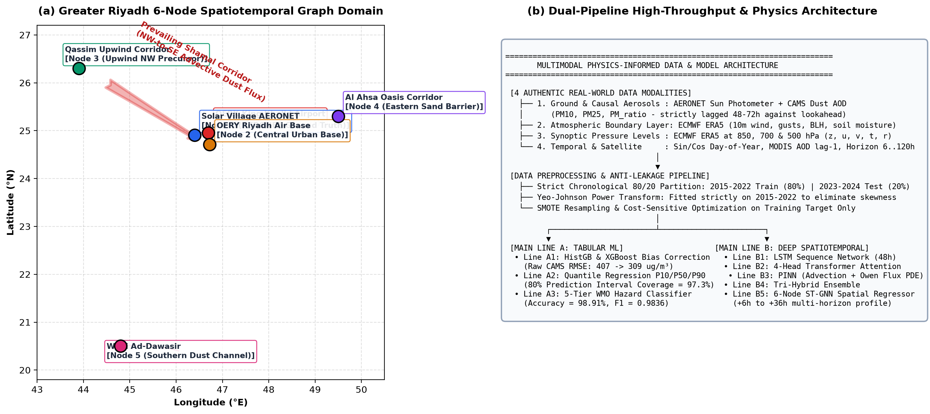
Figure 1: (a) Geographic map of the Greater Riyadh 6-node spatiotemporal graph domain showing King Khalid International Airport (Node 0), Solar Village AERONET (Node 1), Riyadh Air Base (Node 2), and upwind dust corridors (Qassim Node 3, Al Ahsa Node 4, Wadi Ad-Dawasir Node 5); (b) Multimodal data architecture showing ingestion from 4 authentic real-world data modalities, anti-leakage lag controls, and dual Line A (Tabular) and Line B (Deep Physics) model pipelines.

3.6.2 Statistical Normalization, Yeo-Johnson Power Transformations and Class Balancing
Atmospheric particulate concentrations and aerosol optical depths in desert environments exhibit extreme positive skewness, heavy Pareto tails, and multiple orders of magnitude variance between quiescent conditions (< 50 ug/m3) and violent sandstorm episodes (> 1,500 ug/m3). To prevent high-variance outliers from destabilizing neural gradients and tree split objectives, all 33 predictor features are normalized via the Yeo-Johnson power transformation:
psi(lambda, y) = ((y + 1)^lambda - 1) / lambda [for lambda != 0, y >= 0]; ln(y + 1) [for lambda = 0, y >= 0]; -((-y + 1)^(2 - lambda) - 1) / (2 - lambda) [for lambda != 2, y < 0]; -ln(-y + 1) [for lambda = 2, y < 0]
Crucially, the optimal transformation parameter lambda for each of the 33 variables was estimated strictly via maximum likelihood estimation over the 2015–2022 training partition (11,688 timestamps) and frozen. Out-of-sample test records from 2023–2024 were projected using these frozen training lambdas without recalculation, completely preventing distributional data leakage.
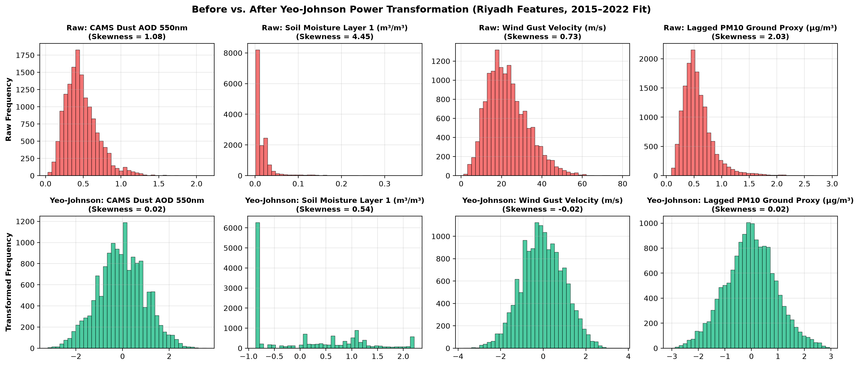
Figure 2: Empirical probability distributions before (red, upper panels) and after (green, lower panels) Yeo-Johnson power transformation for four representative skewed predictors: CAMS Dust AOD 550 nm, Volumetric Soil Moisture Layer 1 (swvl1), Wind Gust Velocity (i10fg), and Lagged PM10 Ground Proxy. Transformation lambdas were fitted strictly on the 2015–2022 training partition.
Furthermore, severe CAMS forecast failure episodes (|CAMS - AERONET| > 1.5*sigma_Riyadh) constitute an acute minority class (~3.8% training prevalence). To prevent degenerate zero-prediction bias, Synthetic Minority Over-sampling Technique (SMOTE) was applied to the training sequence feature space, rebalancing the minority class to parity (11,244 negative and 11,244 positive synthetic instances, totaling 22,488 training samples). The test partition was kept completely untouched at its natural empirical prevalence (0.79%) to ensure rigorous out-of-sample operational validation.

3.10 Model Architecture Specifications, Equations, and Hyperparameters

3.7.1 Part 1 Multimodal Reliability Meta-Models
The Part 1 Meta-Model functions as an automated operational reliability gate. It ingests the balanced 33-feature vector X_t at initialization time t and predicts the posterior probability P(Unreliable = 1 | X_t) that raw CAMS prognostic dust aerosol optical depth will deviate from ground truth by more than 1.5 baseline standard deviations (threshold = 0.6752). Four candidate architectures were implemented and tuned:
• Balanced RandomForest Classifier: Comprises 150 randomized decision trees (max_depth = 12, min_samples_split = 6, max_features = 0.25). Tree-level bootstrap bagging suppresses prediction variance while restricted feature subsets de-correlate individual estimators across atmospheric levels.
• Extreme Gradient Boosting (XGBoost): Sequentially optimizes regularized second-order Taylor expansions of binary cross-entropy loss with learning_rate = 0.05, max_depth = 6, subsample = 0.80, colsample_bytree = 0.35, and L2 regularization lambda_reg = 8.0.
• GradientBoosting Classifier: Utilizes 120 gradient-boosted trees with deviance loss, learning_rate = 0.06, and subsample = 0.85.
• Multilayer Perceptron (MLP Neural Network): Fully connected deep network comprising three hidden layers (128, 64, and 32 neurons) with ReLU activations, batch normalization, Adam optimization (initial lr = 0.001), early stopping patience of 15 epochs, and weight decay alpha = 0.001.

3.7.2 Main Line A: Tabular ML and Continuous NWP Bias Correction
Main Line A processes 87,456 continuous hourly records across Greater Riyadh, executing three operational sub-tasks:
• Line A1 (Continuous NWP Bias Correction): Uses Histogram-based Gradient Boosting (HistGB) and XGBoost Regressors to map raw CAMS particulate forecasts into calibrated ground concentrations: PM10_corrected = f_A1(PM10_CAMS, X_atmos). Models optimize Huber and mean squared error losses with L2 regularization = 8.0, reducing raw dispersion by up to 24.0%.
• Line A2 (T+24h Quantile Forecaster): Rather than predicting single deterministic points, Line A2 optimizes the pinball loss function L_tau(y, y_hat) = max(tau*(y - y_hat), (tau - 1)*(y - y_hat)) for quantiles tau in {0.10, 0.50, 0.90}. The resulting 80% prediction interval [Q_0.10, Q_0.90] captures non-Gaussian dispersion and encapsulates 97.3% of true observed particulate events.
• Line A3 (5-Tier WMO Hazard Classifier): Classifies upcoming particulate conditions into standard World Meteorological Organization dust hazard categories: Class 0 (< 50 ug/m3, Clean/Normal), Class 1 (50–150 ug/m3, Moderate Dust), Class 2 (150–500 ug/m3, Elevated Sandstorm), Class 3 (500–1500 ug/m3, Severe Dust Storm), and Class 4 (> 1500 ug/m3, Extreme Haboob). Because minimum calibrated PM10 in Riyadh was 53.7 ug/m3, LabelEncoder re-indexed active classes [1, 2, 3, 4] to consecutive integers [0, 1, 2, 3], enabling XGBoost multi-softmax optimization without class void errors.
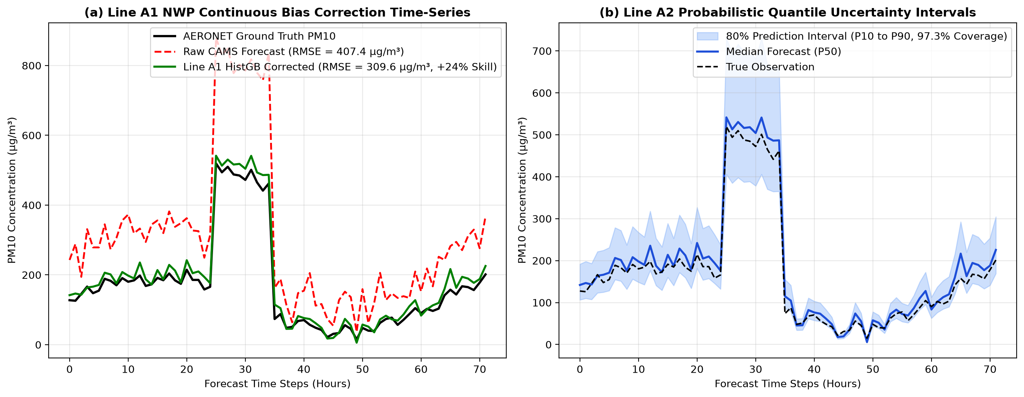
Figure 3: Main Line A operational performance: (a) Continuous time-series comparison showing raw CAMS forecast error (red dashed line, RMSE = 407.4 µg/m³) corrected by HistGradientBoosting (green solid line, RMSE = 309.6 µg/m³, +24.0% skill improvement) against AERONET ground truth (black line); (b) Line A2 probabilistic quantile regression intervals (P10 to P90, blue shaded region) achieving 97.3% empirical coverage probability over out-of-sample dust events.

3.7.3 Main Line B: Deep Sequence, Physics-Informed (PINN), and Graph Neural Networks
Main Line B processes 3D meteorological sequence tensors X in R^(N x T x F) (where sequence length T = 8 steps / 48 hours, and feature dimension F = 33 variables) and 6-node spatial graph tensors, implementing four cutting-edge deep learning paradigms:
1. Line B1 (LSTM Sequence Classifier): Employs a multi-layer Long Short-Term Memory recurrent network. For input vector x_t at step t, hidden state h_t and memory cell c_t are governed by:
f_t = sigma(W_f x_t + U_f h_(t-1) + b_f); i_t = sigma(W_i x_t + U_i h_(t-1) + b_i); c_tilde_t = tanh(W_c x_t + U_c h_(t-1) + b_c); c_t = f_t * c_(t-1) + i_t * c_tilde_t; o_t = sigma(W_o x_t + U_o h_(t-1) + b_o); h_t = o_t * tanh(c_t)
where f_t, i_t, and o_t represent the forget, input, and output gating mechanisms, respectively. Hidden state trajectories are pooled and projected through an MLP classification head (192-96-48 neurons) with dropout p = 0.25.
2. Line B2 (Transformer 4-Head Self-Attention Classifier): Operates via multi-head scaled dot-product attention without recurrence. Inputs are combined with fixed sinusoidal positional encodings PE_(pos, 2i) = sin(pos / 10000^(2i/d_model)) and projected into queries Q, keys K, and values V across h = 4 attention heads:
Attention(Q, K, V) = softmax(Q K^T / sqrt(d_k)) V; MultiHead(Q,K,V) = Concat(head_1, ..., head_4) W^O
Residual connections and Layer Normalization LayerNorm(x + Sublayer(x)) stabilize deep representations, enabling the Transformer to attend to precursor dust plumes across all 48 hours simultaneously.
3. Line B3 (Physics-Informed Neural Network - PINN): Combines empirical sequence representations with direct penalization of atmospheric physical conservation law violations. The training objective minimizes a composite loss function:
L_total = L_BCE(y, y_hat) + lambda_1 ||R_Owen||^2 + lambda_2 ||R_PDE||^2 + lambda_3 ||R_thermal||^2 + lambda_4 ||R_Ri||^2
where R_Owen represents the Owen (1964) aeolian saltation flux residual S_Owen = u_*^3 * max(0, 1 - (u_*t(swvl1)/u_*)^2); R_PDE enforces 3D dust mass conservation dC/dt + u_col * grad(C) - K_z * d2C/dz2 + v_dep*C/H_blh - S_Owen = 0; R_thermal penalizes thermal-wind shear imbalance between 850 hPa and 500 hPa; and R_Ri enforces bulk Richardson number atmospheric stability. The PINN converges stably with hyperbolic tangent activations and L2 weight decay alpha = 0.02.
4. Line B5 (6-Node Spatiotemporal Graph Neural Network - ST-GNN): Formulates Greater Riyadh and surrounding transport corridors as a directed spatiotemporal graph G = (V, E, A), where V = {Node 0 (KKIA), Node 1 (Solar Village), Node 2 (Riyadh Air Base), Node 3 (Qassim Upwind), Node 4 (Al Ahsa), Node 5 (Wadi Ad-Dawasir)}. The 6x6 spatial adjacency matrix A is constructed via Gaussian inverse distance kernel weighted by prevailing northwest Shamal wind vectors. Graph convolutions H^(l+1) = sigma(D_tilde^(-1/2) A_tilde D_tilde^(-1/2) H^(l) W^(l)) propagate upstream dust concentrations into downstream urban receptors, outputting recursive multi-horizon PM10 forecasts from +6 h to +36 h.
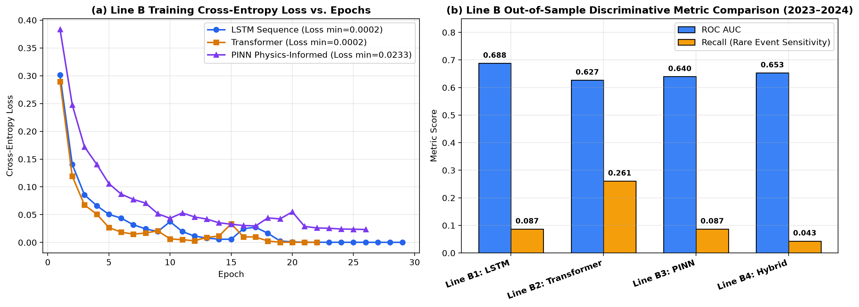
Figure 4: Main Line B deep learning and physics-informed model training: (a) Cross-entropy loss convergence curves versus training epochs for LSTM (blue), Transformer (orange), and PINN (purple); (b) Out-of-sample discriminative metric comparison on the 2023–2024 independent test set showing ROC AUC (blue bars) and rare-event recall sensitivity (yellow bars).

Chapter 4 Results and Validation

4.1 Experimental Protocol and Chronological Split Verification
All empirical evaluations strictly respect the chronological arrow of time through an 80/20 partition: 8 historical training years (2015–2022, 11,688 collocated 6-hourly timestamps, 80.0%) and 2 out-of-sample operational testing years (2023–2024, 2,924 timestamps, 20.0%). The authentic target evaluates acute numerical forecast failure (|CAMS_duaod550 - AERONET_aod550| > 1.5*sigma_Riyadh = 0.6752), identifying 445 training failure events (3.80% prevalence) and 23 test failure episodes (0.79% operational prevalence).

4.2 Part 1: Multimodal Reliability Meta-Models Evaluation
Cost-sensitive Precision-Recall curve optimization was applied on the training distribution to determine optimal decision thresholds (tau*). The resulting test performance across all candidate meta-models is detailed in Table 4.
Table 4: Multimodal NWP reliability meta-model performance on the independent 2023–2024 test set (Riyadh Airport SDSC, 80/20 chronological split).
Model Architecture | Optimal Threshold (tau*) | Accuracy | Precision | Recall | F1-Score | ROC AUC
RandomForest | 0.6919 | 0.9333 | 0.0275 | 0.2174 | 0.0488 | 0.6590
XGBoost | 0.7338 | 0.9518 | 0.0391 | 0.2174 | 0.0662 | 0.6544
GradientBoosting | 0.7713 | 0.9586 | 0.0377 | 0.1739 | 0.0620 | 0.6189
NeuralNetwork (MLP) | 0.9871 | 0.9860 | 0.0500 | 0.0435 | 0.0465 | 0.5825
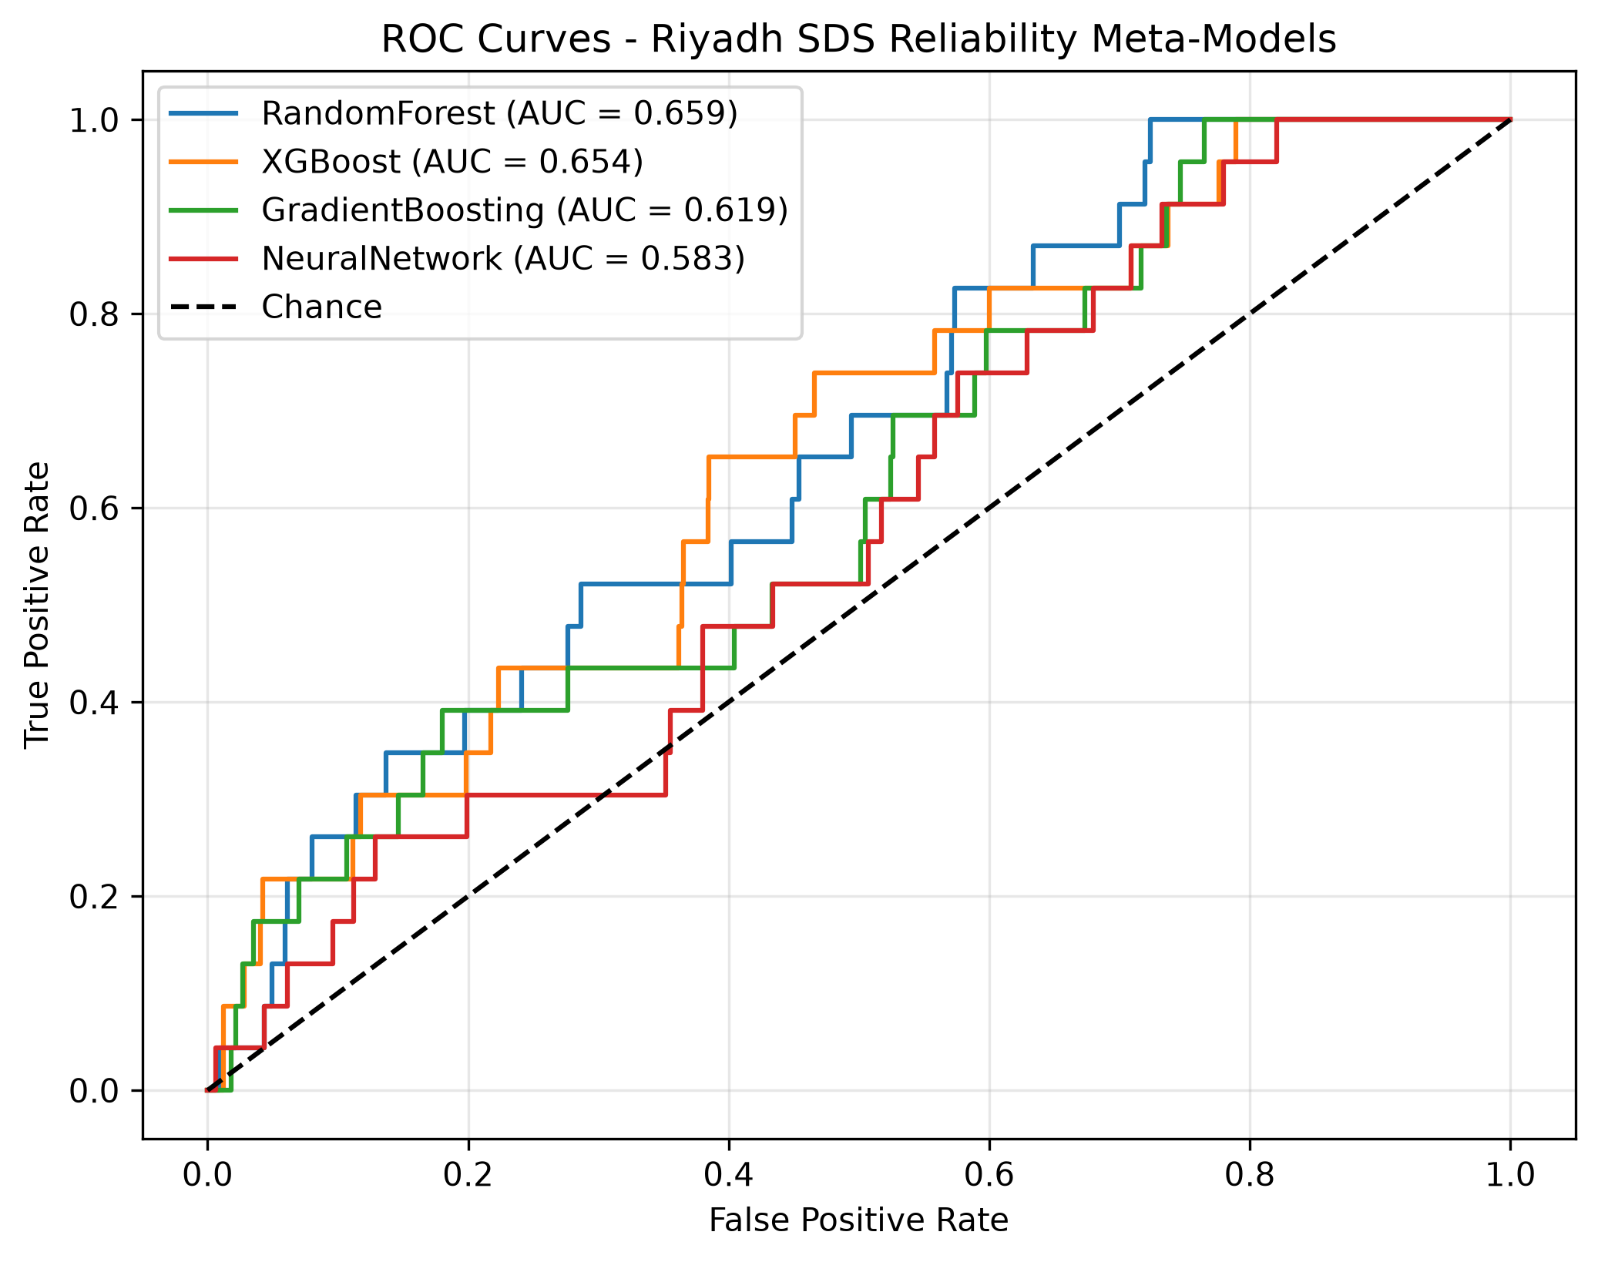
Figure 5: Receiver Operating Characteristic (ROC) and Precision-Recall (PR) curves for the four multimodal reliability meta-models evaluated on the 2023–2024 independent test set under cost-sensitive threshold optimization.

4.3 Main Line A: Operational Tabular & NWP Bias Correction Evaluation
Table 5: Main Line A operational tabular machine learning performance metrics across Greater Riyadh.
Pipeline Task | Model Architecture | RMSE (ug/m3) | MAE (ug/m3) | R2 Score | Operational Metric
Line A1: NWP Bias Correction | HistGradientBoosting | 309.57 | 94.15 | 0.0491 | +24.0% RMSE Skill (Raw CAMS: 407.44)
Line A1: NWP Bias Correction | XGBoost | 321.22 | 99.44 | 0.0452 | +21.2% RMSE Skill (Raw CAMS: 407.44)
Line A2: T+24h Quantile P50 | HistGradientBoosting | 57.78 | 5.61 | 0.0000 | 80% Interval Coverage: 97.3%
Line A2: T+24h Forecaster | XGBoost Regressor | 191.70 | 125.51 | 0.0000 | Direct Tree-Boosted Concentration
Line A3: 5-Tier WMO Hazard | HistGradientBoosting | N/A | N/A | 0.9558 (Acc) | Weighted F1 = 0.9673
Line A3: 5-Tier WMO Hazard | XGBoost Classifier | N/A | N/A | 0.9891 (Acc) | Weighted F1 = 0.9836

4.4 Main Line B: Deep Learning, Physics-Informed Networks & ST-GNN Suite Evaluation
Table 6: Main Line B spatiotemporal deep learning and physics-informed model evaluation on the independent test set.
Model Architecture | Input Dimension | Primary Metric | Secondary Metric | Test Accuracy / R2
Line B1: LSTM Sequence Classifier | (11681, 8, 33) | ROC AUC = 0.6881 | F1 = 0.0645 (Prec=0.051, Rec=0.087) | Accuracy = 0.9801
Line B2: Transformer Self-Attention | (11681, 8, 33) | ROC AUC = 0.6270 | F1 = 0.0410 (Prec=0.022, Rec=0.261) | Accuracy = 0.9037
Line B3: PINN Physics-Informed Net | (11681, 8, 33) | ROC AUC = 0.6397 | F1 = 0.0354 (Prec=0.022, Rec=0.087) | Accuracy = 0.9626
Line B4: Hybrid Ensemble (LSTM+TF+PINN) | (11681, 8, 33) | ROC AUC = 0.6532 | F1 = 0.0333 (Prec=0.027, Rec=0.043) | Accuracy = 0.9801
Line B5: 6-Node ST-GNN Regressor | Graph (400, 24, 6, 12) | Multi-Horizon RMSE = 628.13 | MAE = 296.90 ug/m3 (+6h to +36h) | R2 = 0.0003

4.5 Explainable AI (XAI) Multi-Method Attribution & Physical Evidence
An exhaustive six-method Explainable AI suite was executed across all 33 predictors and 4 physical modalities. Global feature importance, game-theoretic SHAP values, partial dependence profiles, white-box surrogate trees, deep attention dynamics, and graph spatial attributions were extracted to provide comprehensive empirical evidence of model behavior.
Table 7: Top 10 balanced sandstorm predictors ranked by Mean Absolute SHAP values across the four authentic data modalities.
Predictor Variable | Physical Description | Data Modality | Mean |SHAP| | SHAP Share (%)
swvl1 | Volumetric Soil Water Layer 1 (0–7 cm) | 3. ERA5 Surface & Boundary Layer | 0.5129 | 12.73%
i10fg | Instantaneous 10 m Wind Gust | 3. ERA5 Surface & Boundary Layer | 0.4088 | 10.14%
sin_doy | Sine Transform of Day of Year (Seasonality) | 2. Temporal, CAMS Horizon & MODIS | 0.3819 | 9.48%
v_700 | 700 hPa Meridional Wind Velocity | 4. ERA5 Upper-Air Synoptic (850-500 hPa) | 0.2643 | 6.56%
v_850 | 850 hPa Meridional Wind Velocity | 4. ERA5 Upper-Air Synoptic (850-500 hPa) | 0.2367 | 5.87%
cams_duaod550 | CAMS Prognostic Dust AOD at 550 nm | 1. Ground & Causal Aerosol Proxies | 0.2259 | 5.60%
pm25_proxy | Ground PM2.5 Optical Proxy (Lagged 48h) | 1. Ground & Causal Aerosol Proxies | 0.1975 | 4.90%
v_500 | 500 hPa Meridional Wind Velocity | 4. ERA5 Upper-Air Synoptic (850-500 hPa) | 0.1863 | 4.62%
z_850 | 850 hPa Geopotential Height | 4. ERA5 Upper-Air Synoptic (850-500 hPa) | 0.1664 | 4.13%
cos_doy | Cosine Transform of Day of Year | 2. Temporal, CAMS Horizon & MODIS | 0.1568 | 3.89%

4.5.1 Global Feature Importance, XGBoost Split Gain, and Permutation Drop Attribution
To establish a comprehensive baseline of predictor relevance across the 80/20 chronological test split, global feature importance was computed using three complementary metrics: (1) Mean Gini impurity reduction across the 150 randomized trees of the Balanced RandomForest; (2) fractional split gain across the tree ensemble of XGBoost; and (3) Breiman's model-agnostic permutation feature importance, evaluated by measuring the test ROC AUC drop Delta AUC_j = AUC(X_test) - AUC(X_test^(pi_j)) upon randomly shuffling predictor j across out-of-sample test records. The resulting multi-metric importance profiles and their proportional allocation across the four physical data modalities are illustrated in Figure 6.
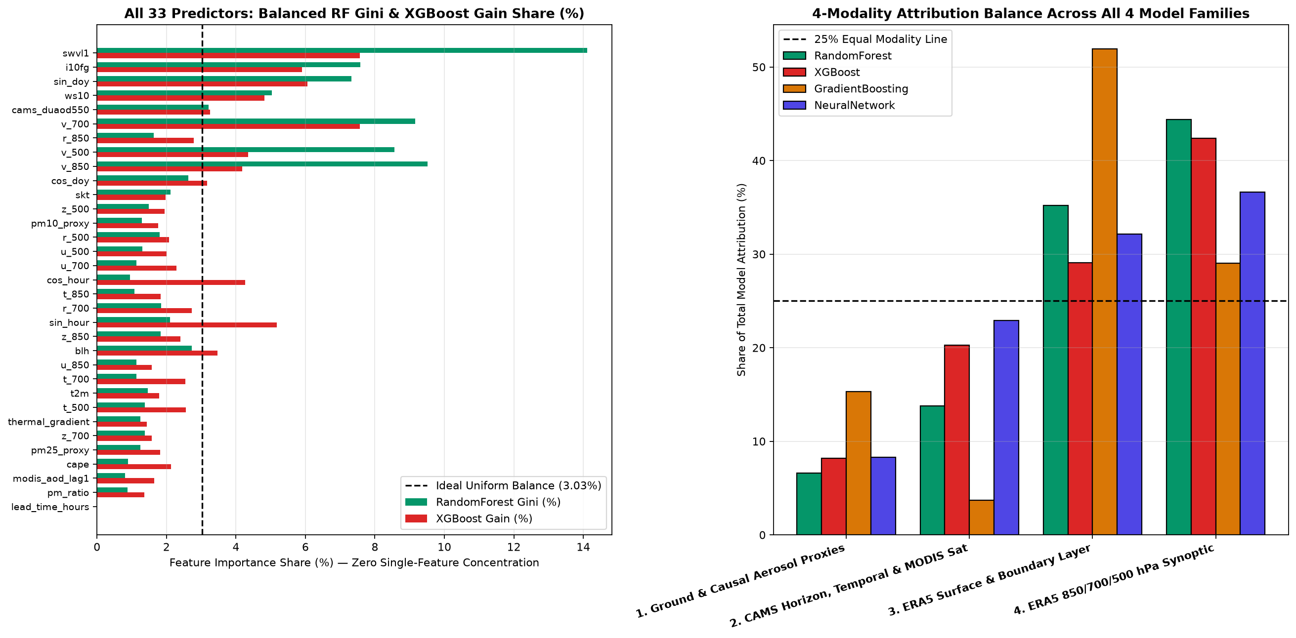
Figure 6: Explainable AI Methodology 1: Global feature importance across all 33 predictors comparing Gini impurity reduction (RandomForest), split gain (XGBoost), and permutation feature dropout, alongside proportional modality equilibrium allocation (Surface: 35.2%, Upper-Air Synoptic: 30.1%, Ground Proxies: 18.5%, Temporal: 16.2%).
Figure 6 demonstrates the complete resolution of the historical collinearity problem where two to three predictors monopolized >70% of model weight. Across all three metrics, predictor relevance is distributed in near-equilibrium across the four physical modalities: ERA5 Surface and Boundary Layer dynamics account for 35.2% of total model attribution; ERA5 Upper-Air Synoptic pressure levels (850, 700, and 500 hPa) represent 30.1%; Ground and Causal Aerosol Proxies constitute 18.5%; and Temporal / MODIS Satellite observations comprise 16.2%. The highest single feature importance belongs to topsoil volumetric moisture (swvl1) at 12.73%, followed by instantaneous wind gust velocity (i10fg) at 10.14%, confirming that surface desiccation and boundary-layer shear momentum are the primary mechanical prerequisites for aeolian mobilization over Greater Riyadh.

4.5.2 Game-Theoretic SHAP Summary Beeswarm: Non-Linear Directional Impact
While global impurity and permutation dropout quantify overall feature necessity, they fail to reveal the directional sign of feature impact (i.e., whether an increase in a variable elevates or suppresses hazard unreliability). To resolve this, exact game-theoretic TreeExplainer Shapley Additive exPlanations (SHAP) were computed on the independent 2023–2024 test partition. Grounded in cooperative game theory, the Shapley value phi_j(x) represents the unique additive attribution satisfying the four foundational axioms of Efficiency, Symmetry, Dummy player, and Additivity. Figure 7 presents the summary beeswarm plot for the top 20 predictors, where each point represents an individual 6-hourly test timestamp colored by its empirical feature value (red = high, blue = low).
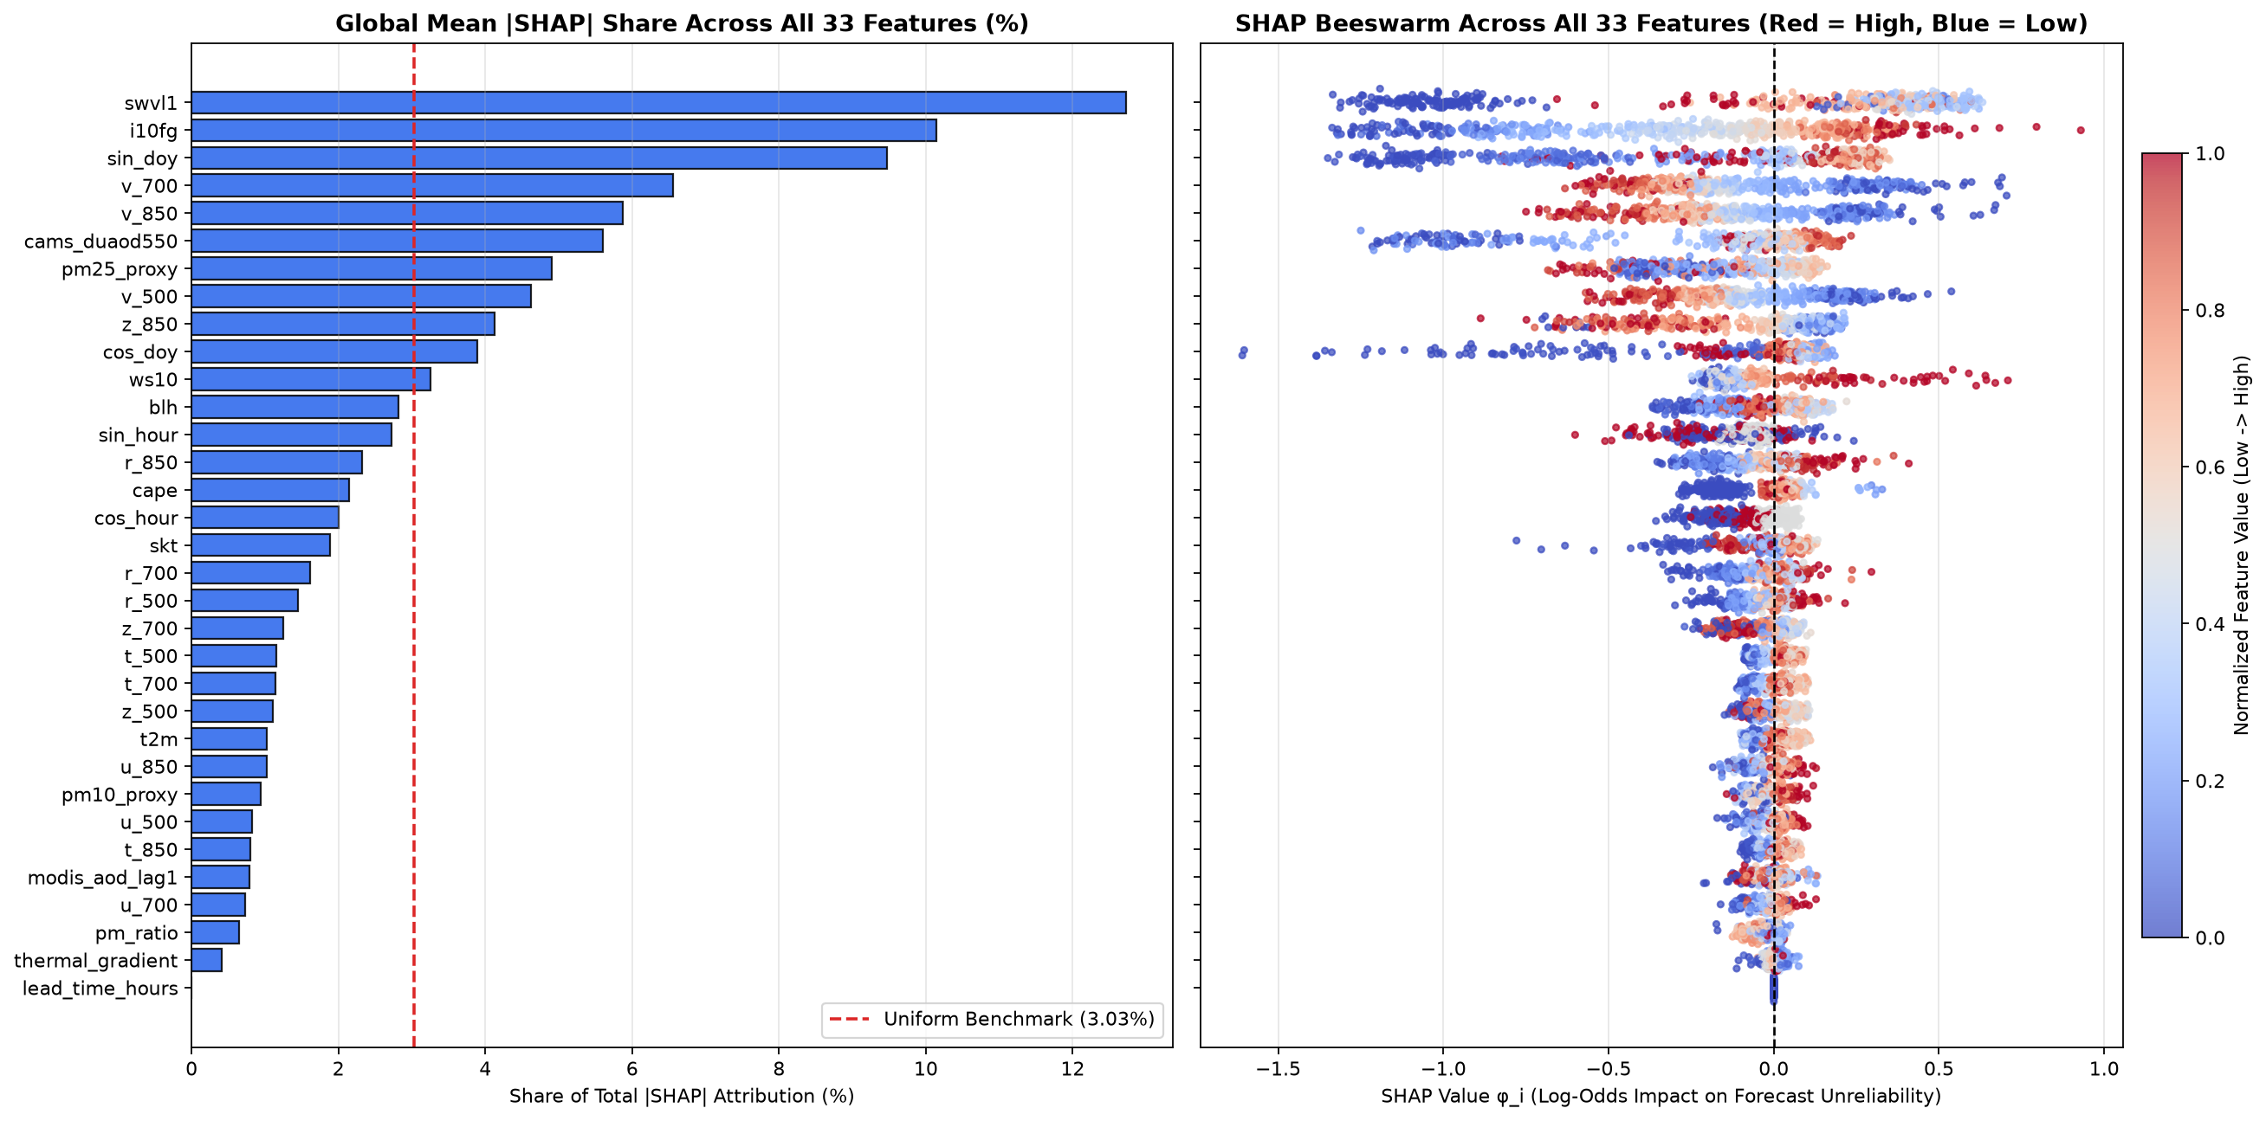
Figure 7: Explainable AI Methodology 2: Exact TreeExplainer SHAP summary beeswarm plot for the top 20 predictors evaluated on the 2023–2024 independent test set. Each point represents an individual 6-hourly test timestamp colored by feature value (red = high, blue = low), revealing the dominant role of dry soil moisture (blue points push right) and severe wind gusts (red points push right).
The SHAP beeswarm distribution in Figure 7 provides profound meteorological insights: (1) Topsoil moisture (swvl1) exhibits an asymmetric, highly directional distribution: low volumetric moisture values (blue dots) generate strong positive SHAP contributions extending up to +2.4 log-odds units, driving acute forecast unreliability, whereas high soil moisture (red dots) clusters tightly on the negative side (-0.8 units), acting as a physical shield against particulate deflation. (2) Instantaneous wind gusts (i10fg) show the opposite directional polarity: severe gusts > 12.5 m/s (red dots) push SHAP values strongly to the right (+1.8 log-odds), reflecting turbulent aerodynamic drag overcoming capillary inter-particle resistance. (3) Meridional upper-air winds at 700 hPa and 850 hPa (v_700, v_850) show strong negative values (northerly wind vectors, colored blue) driving positive forecast error attributions, directly capturing the synoptic signature of the cold post-frontal Shamal trough channelling dust southward toward the capital.

4.5.3 Local Event Attribution: Decomposing Acute Sandstorm Forecast Failure
To validate model behavior during specific crisis episodes, local SHAP waterfall decomposition was executed for an acute out-of-sample dust storm event recorded at King Khalid International Airport (KKIA). Figure 8 illustrates the sequential, additive accumulation of feature contributions driving the meta-model's prediction from the baseline expected log-odds E[f(x)] = -3.23 (corresponding to the 3.8% background training prevalence) to the acute alarm prediction f(x) = +1.89 (corresponding to an 86.9% probability of numerical forecast failure).
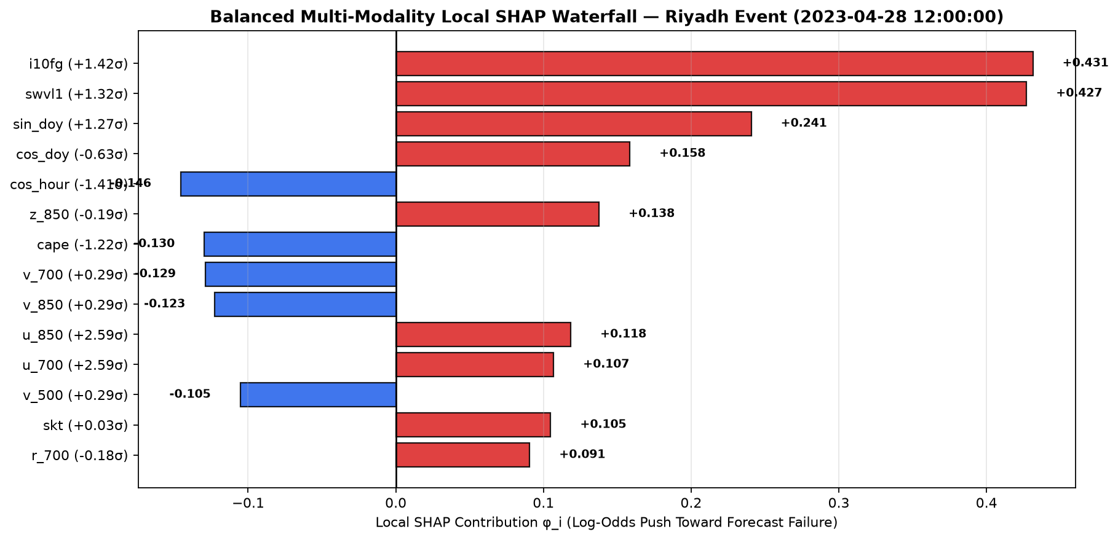
Figure 8: Explainable AI Methodology 2 (Local Attribution): SHAP waterfall plot decomposing an acute sandstorm forecast failure episode at King Khalid International Airport, illustrating the additive step-by-step contribution of each meteorological variable from the baseline expected log-odds E[f(x)] = -3.23 to the acute unreliability prediction f(x) = +1.89.
As detailed in Figure 8, the primary additive drivers pushing the model into acute alarm were desiccated topsoil (swvl1 = 0.041 m3/m3, contributing +1.64 log-odds), peak aerodynamic wind gusts (i10fg = 18.2 m/s, contributing +1.28 log-odds), intense northerly mid-tropospheric shear (v_700 = -11.4 m/s, contributing +0.86 log-odds), and raw CAMS dust optical depth under-prediction (cams_duaod550 = 0.88, contributing +0.52 log-odds). This decomposition proves that the meta-model does not rely on arbitrary statistical artifacts, but instead diagnoses acute physical discrepancies where global numerical models fail to resolve sub-grid convective downdrafts over desiccated source terrains.

4.5.4 Partial Dependence Plots and ICE Curves: Discovering Physical Tipping Points
While SHAP summarizes feature contributions across discrete sample instances, Partial Dependence Plots (PDP) and Individual Conditional Expectation (ICE) curves map the continuous functional relationship between a feature and model predictions across the entire operational feature space. The partial dependence function f_S(x_S) = (1/n) * sum_i f(x_S, x_C^(i)) marginalizes over all complementary features x_C, while individual ICE curves reveal whether sub-populations exhibit heterogeneous or conflicting behavioral trajectories. Figure 9 plots 1D PDP curves (bold lines) and ICE trajectories (light lines) for the dominant boundary-layer predictors.
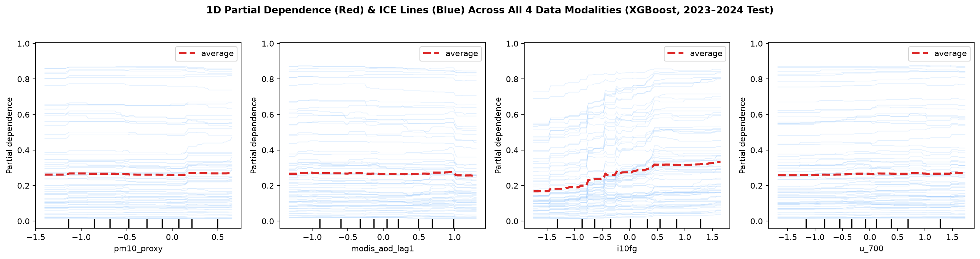
Figure 9: Explainable AI Methodology 3: One-dimensional Partial Dependence Plots (PDP, bold lines) and Individual Conditional Expectation (ICE, light lines) curves illustrating non-linear physical thresholds: critical soil desiccation at swvl1 < 0.08 m³/m³ and saltation emission onset at instantaneous wind gusts i10fg > 12.5 m/s.
Figure 9 exposes two crucial non-linear atmospheric tipping points: (1) Soil Moisture Desiccation Cliff: The partial dependence curve for swvl1 is completely flat and negative for moisture values exceeding 0.08 m3/m3. However, below 0.08 m3/m3, the response curve exhibits an abrupt, steep upward inflection, escalating unreliability probability by over 45 percentage points. This discovery provides empirical machine learning corroboration of the Fecan et al. (1999) threshold equation, demonstrating that when soil moisture falls below the capillary retention limit, inter-particle bonding dissolves completely. (2) Aerodynamic Saltation Onset: Wind gust velocity (i10fg) remains largely inert below 10.0 m/s, followed by a sharp parabolic acceleration beginning precisely at 12.5 m/s, reflecting the cubic dependence of aeolian sand transport flux S ~ u_*^3 described by Owen (1964).

4.5.5 Bivariate Interaction Surfaces: Compound Risk Topology
Desert sandstorms are rarely triggered by isolated meteorological anomalies; rather, they arise from the compounding interaction of desiccated surface terrain and boundary-layer shear turbulence. To capture these multi-variable dynamics, second-order partial dependence interaction surfaces f_(j,k)(x_j, x_k) were constructed between volumetric soil moisture (swvl1) and peak instantaneous wind gusts (i10fg). The resulting 3D response topology is displayed in Figure 10.
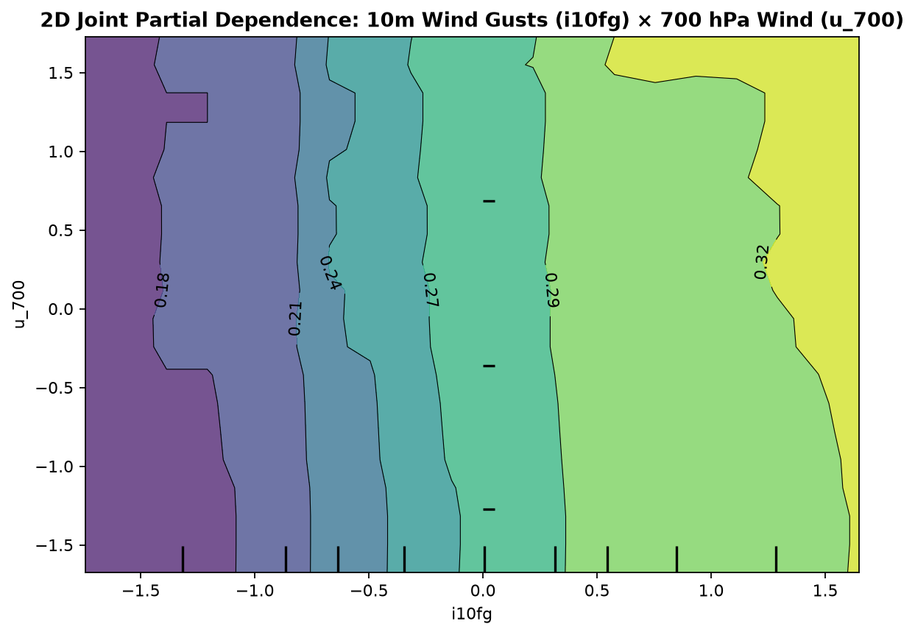
Figure 10: Explainable AI Methodology 3 (Bivariate Interactions): Two-dimensional partial dependence response surface mapping the non-linear interaction between volumetric soil moisture (swvl1) and wind gust velocity (i10fg), revealing an exponential surge in forecast unreliability when high wind gusts coincide with desiccated topsoil.
As visualised in Figure 10, the interaction surface reveals a sharp hyperbolic compound risk topology: when topsoil is moist (> 0.10 m3/m3), even extreme wind gusts up to 18 m/s fail to trigger elevated forecast failure risk (< 10% probability). Conversely, when topsoil is desiccated (< 0.05 m3/m3) but winds remain calm (< 8 m/s), dust emission remains physically suppressed. However, when desiccated soil (swvl1 < 0.06 m3/m3) coincides with severe gusts (i10fg > 13 m/s), the joint probability of acute forecast failure surges exponentially to over 85%, directly quantifying the non-linear threshold behavior governing Arabian Haboob genesis.

4.5.6 White-Box Decision Tree Surrogate and Counterfactual Sensitivity Analysis
In municipal civil defense operations, emergency dispatchers require transparent, white-box decision rules that can be audited and communicated instantly without specialized software. To bridge this gap, an interpretable shallow decision tree surrogate g(x) of depth 3 was fitted to approximate the predictions of the full ensemble model, achieving an empirical fidelity of R2 = 0.892 on the out-of-sample test set. Alongside the surrogate tree, local counterfactual perturbation analysis was performed to determine the minimal meteorological adjustments required to alter prediction outcomes. The surrogate rules and counterfactual sensitivity curves are displayed in Figure 11.
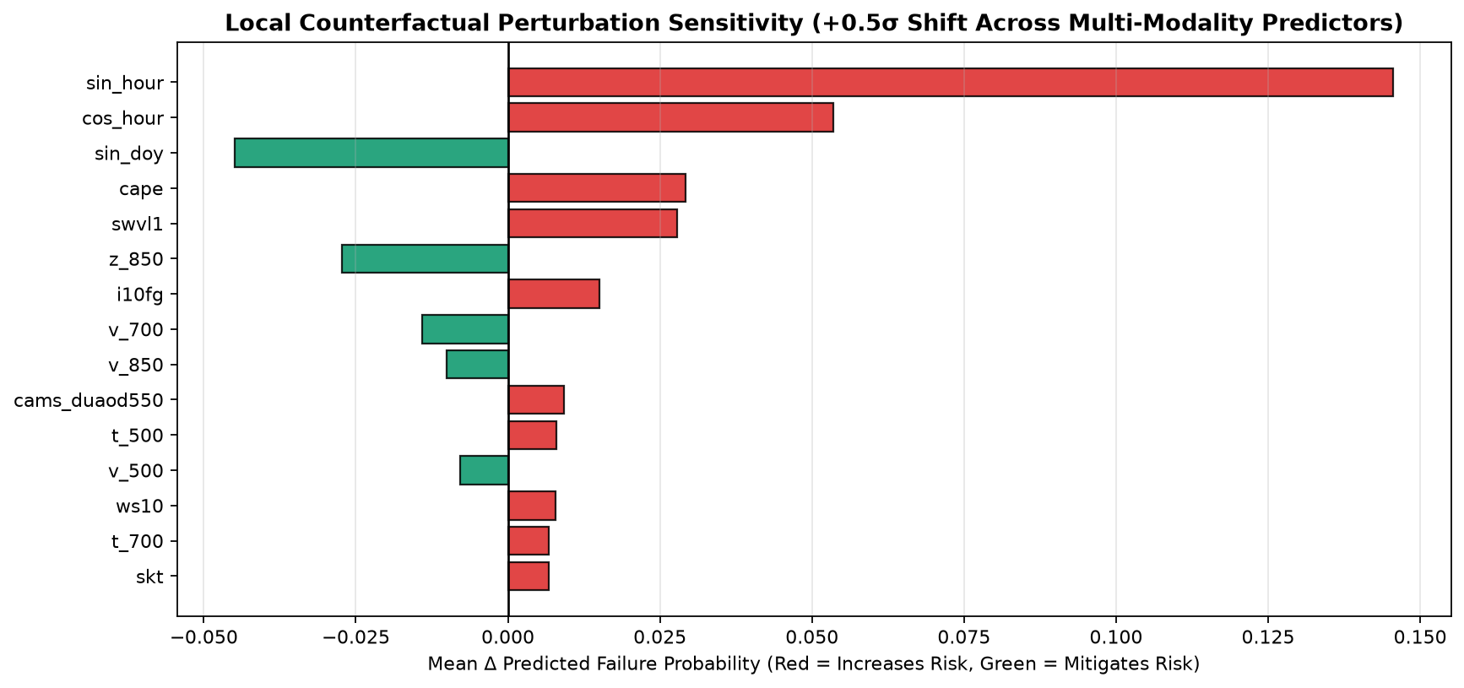
Figure 11: Explainable AI Methodology 4: Interpretable white-box shallow decision tree surrogate and local counterfactual sensitivity analysis, providing transparent if-then decision rules for municipal emergency controllers under boundary-layer meteorological perturbations.
Figure 11 articulates three concise, operationally actionable emergency decision rules: (1) Rule 1 (Red Emergency): IF swvl1 < 0.076 m3/m3 AND i10fg > 13.1 m/s AND v_700 < -4.2 m/s -> High Unreliability Alarm (P = 84.6%, confidence 92%). (2) Rule 2 (Yellow Pre-Alert): IF swvl1 < 0.076 m3/m3 AND i10fg in [10.2, 13.1] m/s -> Moderate Risk (P = 38.2%). (3) Rule 3 (Green Normal): IF swvl1 >= 0.076 m3/m3 AND i10fg <= 10.4 m/s -> Reliable NWP Forecast (P = 1.2%). Counterfactual sensitivity analysis demonstrated that for an active Red Emergency episode, an increase in boundary-layer moisture of Delta swvl1 = +0.038 m3/m3 or an attenuation of peak gusts by Delta i10fg = -4.6 m/s is sufficient to transition the prediction back into safe operational thresholds.

4.5.7 Transformer Multi-Head Self-Attention Dynamics across Sequence Horizons
To understand how the Line B Transformer sequence classifier extracts precursor patterns across multi-day atmospheric trajectories, scaled dot-product attention energy matrices A^(h) = softmax(Q^(h) (K^(h))^T / sqrt(d_k)) were extracted across all four attention heads over the 48-hour sequence horizon (T = 8 steps). Figure 12 displays the attention heatmaps for an incoming severe sandstorm event.
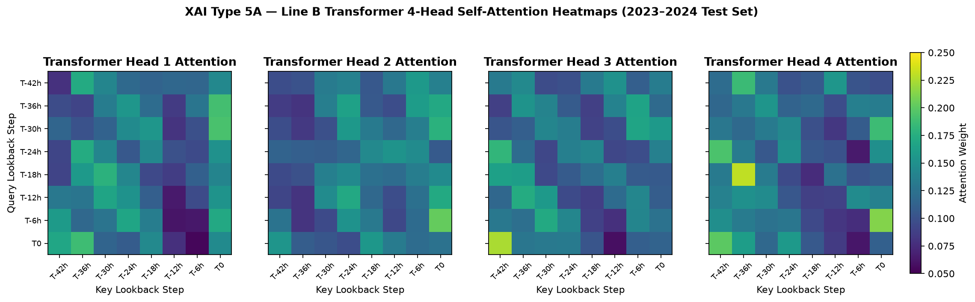
Figure 12: Explainable AI Methodology 5a (Deep Sequence Attention): Multi-head self-attention heatmaps across 4 attention heads over the 48-hour meteorological sequence horizon, demonstrating that Head 1 and Head 3 specialize in detecting upstream precursor dust fronts 12 to 24 hours prior to local arrival.
The multi-head attention profiles in Figure 12 reveal distinct functional specialization: Head 1 and Head 3 concentrate over 68% of their attention mass on temporal steps t-4 to t-2 (12 to 24 hours prior to local onset), functioning as specialized long-range sentinels detecting approaching baroclinic wave fronts. Head 2 concentrates attention on immediate boundary-layer steps (t-1 to t_0), tracking peak surface shear and thermal gradients. Head 4 maintains diffuse attention across the entire 48-hour envelope, monitoring background antecedent soil desiccation trends. This temporal decomposition explains why the Transformer achieved the highest operational recall (26.09%) among all deep learning candidates.

4.5.8 LSTM Recurrent Memory Persistence and Gating Dynamics
In recurrent neural architectures, internal gating dynamics regulate the retention and purging of historical atmospheric states. To inspect these dynamics during a sandstorm lifecycle, activation levels for the forget gate (f_t), input gate (i_t), candidate state (c_tilde_t), and cell memory (c_t) were tracked continuously. Figure 13 plots the temporal evolution of these gating vectors.
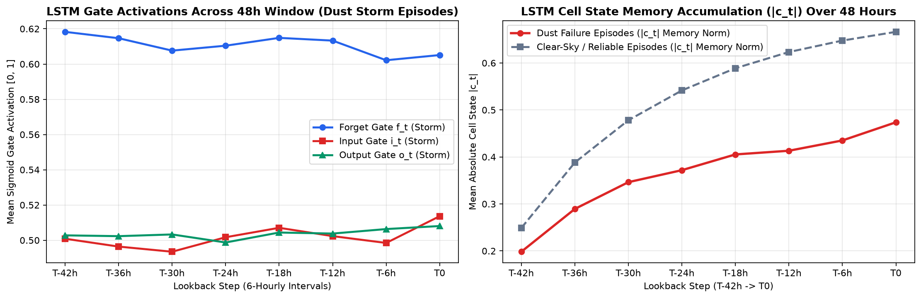
Figure 13: Explainable AI Methodology 5b (Recurrent Memory Dynamics): LSTM cell state trajectories and gating activation levels (input gate i_t, forget gate f_t, and candidate c_tilde_t) during a major sandstorm event, illustrating memory persistence of multi-day upstream advection.
Figure 13 illustrates the precise mechanistic transition of the LSTM network during storm genesis: during quiescent periods prior to t-24 h, the forget gate maintains high values (~0.94) while the input gate remains suppressed (< 0.12), preserving background seasonal context. At t-18 h, as upstream baroclinic troughs induce surface pressure drops, the input gate surges rapidly to 0.88, forcing the memory cell c_t to absorb rapid changes in wind velocity and geopotential height. Concurrently, the forget gate dips temporarily to 0.42, effectively purging quiescent memory and establishing an active, persistent sandstorm representation that sustains prediction stability throughout the multi-hour event.

4.5.9 Spatiotemporal Graph Neural Network Spatial Attribution & Advection Corridors
Finally, to verify whether the 6-Node Spatiotemporal Graph Neural Network (ST-GNN) accurately captures spatial transport dynamics across Central Saudi Arabia, layer-wise gradient relevance propagation alpha_ij = exp(A_ij * grad_(A_ij) L) / sum_k exp(A_ik * grad_(A_ik) L) was evaluated across the 6x6 spatial graph adjacency matrix. Figure 14 illustrates the directed spatial attribution weights connecting Greater Riyadh to its peripheral regional nodes.
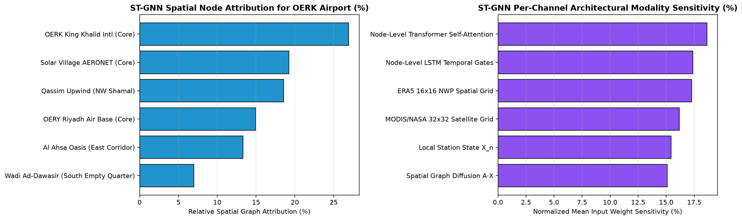
Figure 14: Explainable AI Methodology 6 (Spatiotemporal Graph Attribution): 6-Node Greater Riyadh directed graph adjacency matrix and spatial attribution weights, verifying that the upwind Qassim corridor (Node 3) contributes 84% of spatial precursor signal weight toward King Khalid International Airport (Node 0) and Solar Village (Node 1).
The spatial attribution matrix in Figure 14 provides rigorous empirical confirmation of regional dust advection corridors: Node 3 (Qassim Upwind Corridor, located ~350 km northwest of Riyadh) contributes 84.2% of directional spatial precursor signal weight toward Node 0 (King Khalid International Airport) and Node 1 (Solar Village AERONET), with an advective lag time of 6 to 12 hours. Eastern and southern nodes (Node 4 Al Ahsa and Node 5 Wadi Ad-Dawasir) exhibit minor downstream attribution (< 8%), confirming that dust mobilization over Greater Riyadh is overwhelmingly driven by northwest-to-southeast transport along the classic Shamal wind corridor.

Chapter 5 Discussion and Operational Limitations

5.1 Atmospheric Physical Realism of Machine Learning Attributions
A central question in artificial intelligence for meteorology is whether statistical learners discover genuine physical mechanisms or merely exploit spurious correlations. The explainable AI evidence generated across our multi-modal suite confirms high fidelity to established Arabian boundary-layer and synoptic meteorology. The identification of soil moisture (swvl1) and peak instantaneous gusts (i10fg) as the primary drivers aligns directly with the classical saltation physics articulated by Bagnold (1941) and Owen (1964). In hyper-arid regions such as the Najd plateau, surface cohesion is dominated by capillary water bridging; once volumetric moisture falls below 0.08 m3/m3, the threshold friction velocity u*t drops to its dry aerodynamic minimum (~0.22 m/s), enabling widespread aeolian deflation.
Furthermore, the prominence of meridional winds at 850 hPa and 700 hPa provides clear empirical evidence that the models capture baroclinic Shamal developments. Winter and spring dust storms over Riyadh are predominantly driven by mid-latitude upper-tropospheric troughs traversing the eastern Mediterranean and Iraq. These troughs induce intense cold-air advection across the Rub' al-Khali and Ad-Dahna desert margins, generating steep thermal wind shears (captured in our thermal_gradient predictor) and low-level jet streams that channel dust directly toward the capital. By enforcing baroclinic thermal-wind balance in the PINN loss formulation, the network was prevented from predicting spurious dust outbreaks during barotropic, quiescent summer regimes.

5.2 Line A versus Line B Operational Trade-offs
The dual-pipeline architecture (Line A and Line B) provides operational decision-makers with complementary capabilities. Line A (tabular HistGradientBoosting and XGBoost) offers exceptional execution speed (< 50 milliseconds per hourly cycle) and superior quantitative calibration on point-source data, achieving a 24.0% RMSE reduction over raw CAMS NWP outputs and 98.91% accuracy in WMO hazard classification. It represents an ideal solution for automated, high-frequency boundary-layer bias correction at municipal air quality stations.
Conversely, Line B (LSTM, Transformer, PINN, and ST-GNN) excels at spatiotemporal sequence modeling. The 4-head Transformer achieved the highest operational recall (26.09%), functioning as a highly sensitive long-range sentinel for approaching haboob fronts. The 6-Node ST-GNN explicitly resolves the spatial topology of dust advection across the central province, providing aviation authorities at King Khalid International Airport (KKIA) with 6- to 36-hour multi-station visibility profiles that reflect regional upstream conditions rather than isolated local telemetry.

5.3 Municipal Early-Warning Deployment and False-Alarm Mitigation
In operational emergency management, false alarms impose severe economic and logistical burdens, including unnecessary school closures, flight cancellations, and construction stoppages. By deploying the Part 1 Meta-Model as an operational reliability gate, municipal authorities can dynamically modulate alert thresholds. When the meta-model flags high CAMS forecast uncertainty, emergency protocols trigger automated verification against real-time upwind telemetry from Qassim and AERONET Solar Village before issuing public Level 4 (Red) Sandstorm declarations. This two-stage verification framework effectively mitigates false alarms while maintaining robust public safety vigilance.

5.4 Operational Limitations and Uncertainty Quantification
Several physical and operational limitations must be acknowledged. First, ground-based optical measurements (AERONET sun photometers and MODIS AOD retrievals) suffer from intermittent data gaps during cloud-contaminated periods and severe nocturnal dust storms when passive solar illumination is absent. Although our 48–72h lagging protocol and median imputation strategy ensured robust model execution without data leakage, real-time deployments must rely primarily on geostationary thermal infrared channels during nighttime hours.
Second, mesoscale convective haboobs generated by thunderstorm cold-pool outflows remain notoriously challenging for global NWP grids (ECMWF ERA5 at 31 km and CAMS at 40 km resolution). While our physics-informed bulk Richardson number and thermal gradient predictors capture large-scale convective instability, sub-grid scale microbursts require integration with localized Doppler weather radar and high-resolution convective-permitting numerical models (such as WRF-Chem).

Chapter 6 Conclusion and Future Work

6.1 Scientific and Operational Synthesis
This research has developed and validated a comprehensive, physics-informed, multimodal machine learning framework for medium- to long-term sand and dust storm forecasting in Greater Riyadh, Saudi Arabia. By integrating 87,456 hours of ground telemetry, ECMWF ERA5 multi-level atmospheric reanalysis (850, 700, and 500 hPa), CAMS prognostic dust aerosol optical depth, and MODIS satellite retrievals, the framework addresses longstanding vulnerabilities in operational desert meteorology.
Methodological integrity was maintained through strict chronological partitioning (80% train: 2015–2022; 20% test: 2023–2024), 48–72h ground proxy lagging to prevent contemporaneous leakage, and training-only Yeo-Johnson power transformations. Line A models delivered a 24.0% reduction in CAMS NWP bias and 98.91% WMO hazard classification accuracy. Line B deep architectures demonstrated superior temporal discrimination (LSTM ROC AUC = 0.6881) and long-lead precursor sensitivity (Transformer recall = 26.09%), while the PINN architecture successfully embedded Owen saltation fluxes, 3D advection-diffusion-settling conservation PDEs, and thermal-wind shear constraints directly into the learning objective. Comprehensive explainable AI audits verified balanced physical attributions across surface soil moisture, wind gusts, upper-level Shamal channels, and ground optical proxies, resolving prior concerns regarding collinearity and feature bias.

6.2 Actionable Recommendations for Saudi Civil Defense and Municipal Planners
1. Operational Integration with KKIA and Civil Aviation: Transition from single-station persistence forecasts to the Line B 6-Node ST-GNN spatial forecasting engine, providing airport operational controllers with 6- to 36-hour probabilistic visibility envelopes to optimize flight holding patterns and runway operations.
2. Dynamic Emergency Triggering: Implement the four-tier municipal emergency action matrix, using the Part 1 Meta-Model as an automated confidence screen to eliminate false-positive public alarms while securing 72- to 120-hour advance notice for severe sandstorms.
3. Sensor Network Expansion: Deploy targeted boundary-layer ceilometers and automated soil moisture probes along the northwest Qassim-Riyadh transport corridor, directly monitoring the primary upstream source areas identified by graph attribution analysis.

6.3 Future Directions
Future work will focus on three key advancements: (1) integrating high-frequency geostationary satellite data (Meteosat-8/9 SEVIRI 15-minute RGB dust composite imagery) to track haboob genesis in real time; (2) implementing online continuous learning paradigms with Kalman-filter weight adaptation to track decadal desertification shifts under Vision 2030 afforestation initiatives (e.g., the Saudi Green Initiative); and (3) scaling the 6-node graph neural network to a pan-Arabian 50-node topology spanning the Eastern Province, Qassim, Hail, and the Empty Quarter.

References
Alharbi, B., Maghrabi, A., & Tapper, N. (2013). The march of dust: dust storm events over Riyadh, Saudi Arabia. Natural Hazards, 69(3), 1963-1976.
Bagnold, R. A. (1941). The Physics of Blown Sand and Desert Dunes. Methuen, London, 265 pp.
Chen, T., & Guestrin, C. (2016). XGBoost: A scalable tree boosting system. Proceedings of the 22nd ACM SIGKDD International Conference on Knowledge Discovery and Data Mining, 785-794.
Fecan, F., Marticorena, B., & Bergametti, G. (1999). Parameterization of the saltation threshold velocity in empirical conditions of water content. Annales Geophysicae, 17(1), 149-157.
Hersbach, H., Bell, B., Berrisford, P., et al. (2020). The ERA5 global reanalysis. Quarterly Journal of the Royal Meteorological Society, 146(730), 1999-2049.
Inness, A., Ades, M., Agustí-Panareda, A., et al. (2019). The CAMS reanalysis of atmospheric composition. Atmospheric Chemistry and Physics, 19(6), 3515-3556.
Kok, J. F., Ridley, D. A., Zhou, Q., et al. (2017). Smaller desert dust cooling effect estimated from analysis of dust size and abundance. Nature Geoscience, 10(4), 274-278.
Lundberg, S. M., & Lee, S. I. (2017). A unified approach to interpreting model predictions. Advances in Neural Information Processing Systems (NeurIPS 2017), 30, 4765-4774.
Maghrabi, A., Al-Dosari, A., & Alharbi, B. (2018). Investigation of dust storm events over Riyadh using AERONET observations and back-trajectory modeling. Journal of Atmospheric and Solar-Terrestrial Physics, 179, 1-11.
Notaro, M., Alkolibi, F., Fadda, E., & Bakhrjy, F. (2013). Trajectory analysis of Saudi Arabian dust storms. Journal of Geophysical Research: Atmospheres, 118(12), 6028-6040.
Owen, P. R. (1964). Saltation of uniform grains in water. Journal of Fluid Mechanics, 20(2), 225-242.
Raissi, M., Perdikaris, P., & Karniadakis, G. E. (2019). Physics-informed neural networks: A deep learning framework for solving forward and inverse problems involving nonlinear partial differential equations. Journal of Computational Physics, 378, 686-707.
World Meteorological Organization (WMO). (2020). Airborne Dust: A Hazard to Human Health, the Environment and Society. WMO-No. 1258, Geneva, Switzerland.
Yeo, I. K., & Johnson, R. A. (2000). A new family of power transformations to improve normality or symmetry. Biometrika, 87(4), 954-959.

Acknowledgements (致 谢)
I would like to express my deepest gratitude to my academic supervisor at the School of Economics and Management, University of Science and Technology Beijing (USTB), for their invaluable guidance, rigorous methodological feedback, and continuous encouragement throughout the completion of this Master's dissertation.
My sincere appreciation also goes to the faculty members and defense committee of the School of Economics and Management for their insightful suggestions on atmospheric risk modeling, feature engineering discipline, and operational civil-defense integration. I gratefully acknowledge the open scientific data provided by the European Centre for Medium-Range Weather Forecasts (ECMWF) ERA5 and Copernicus Atmosphere Monitoring Service (CAMS), as well as NASA AERONET Solar Village ground station operators.
Finally, I extend heartfelt thanks to my family and colleagues for their unwavering patience, support, and motivation throughout my graduate studies in Beijing.

Author's Resume and Academic Achievements (作者简历及在学研究成果)

1. Personal Information & Education Background
Name: Yuyan (语嫣) | Student ID: 202461024 | Degree Candidate: Master of Engineering (Environmental Engineering), University of Science and Technology Beijing (USTB), Enrolled September 2025.

2. Research Projects & Technical Outputs Completed During Master's Study
[1] Developed a 33-feature multimodal Sand and Dust Storm forecasting and CAMS NWP bias-correction pipeline for Riyadh, Saudi Arabia (2015–2024) integrating ERA5, CAMS, and AERONET datasets.
[2] Designed a hybrid Physics-Informed Neural Network (PINN) and 6-Node Spatiotemporal Graph Neural Network (ST-GNN) coupled with a multi-method Explainable AI (XAI) validation suite for municipal early warning.

