**1. Software Requirements Specifications (SRS)**

**Functional Requirements**

* This section describes the game rules for Tic-Tac-Toe.
* Tic-Tac-Toe is a game played by two players. One player uses the symbol "X" and the other uses the symbol "O".
* The game is played on a 3x3 grid. Players take turns placing their symbols in one of the nine available cells. The objective is to be the first player to align three of their symbols vertically, horizontally, or diagonally. If neither player achieves this, the game ends in a draw.
* The system must support both player-vs-player and player-vs-AI modes.
* Players must be able to log in, manage their profiles, and track their game history.
* The AI opponent must make strategic moves using advanced algorithms such as minimax with alpha-beta pruning.
* The GUI must be intuitive and user-friendly, allowing for easy interaction with the game and user management features.

**Nonfunctional Requirements**

This section describes the performance and system behavior requirements.

* The system must ensure secure user authentication and data storage using best practices in password hashing and session management.
* The game must provide a responsive and smooth user experience, with minimal latency in gameplay and UI interactions.
* The system must be robust and reliable, with comprehensive unit and integration tests to ensure functionality.
* Continuous integration and deployment practices must be implemented to maintain high code quality and facilitate smooth updates.
* The game must be optimized for performance, with regular monitoring and improvements to response time and resource utilization.

**2. Software Design Specification (SDS) :**

Classes and Their Responsibilities

1. LoginDialog Class

- Methods:

- login(): Handles the login process.

- signup(): Redirects to the signup process if the user needs to create a new account.

- Attributes:

- username: Stores the entered username.

- password: Stores the entered password.

- database: A reference to the `Database` class for user verification.

-Interactions:

- Upon successful login, navigates to Menu.

- If the signup process is required, navigates to SignupDialog.

- If the password is wrong , a message appears and tell the user that the password is wrong .

2. SignupDialog Class

- Methods:

- signup(): Handles the signup process.

- Attributes:

- username: Stores the entered username.

- password: Stores the entered password.

- database: A reference to the `Database` class for adding new users.

- Interactions:

- Upon successful signup, navigates to Menu.

3. Menu Class

- Methods:

- showMenu(): Displays the main menu options.

- play(): Navigates to ConfirmationDialog to choose game mode.

- viewHistory(): Navigates to `History` to view past games.

- back(): Returns to LoginDialog.

- Interactions:

- Navigates to ConfirmationDialog for playing the game.

- Navigates to History for viewing game history.

- Returns to LoginDialog when logging out.

4. TicTacToe Class

- Methods:

-start(): Initializes a new game.

- checkWinner(): Checks for a winner.

- makeMove(row, col): Makes a move on the game board.

- Attributes:

- board: Represents the game board.

- currentPlayer: Keeps track of the current player.

- Interactions:

- Base class for game logic, extended by `TicTacToe1` and `TicTacToe2`.

5. TicTacToe1 Class

- Methods:

- `startAI(difficulty)`: Starts a game against the AI with the specified difficulty.

- `aiMove()`: Executes a move by the AI.

- Attributes:

- `difficulty`: Stores the difficulty level for the AI.

- Interactions:

- After the game ends, navigates to `PlayAgainDialog`.

6. TicTacToe2 Class

- Methods:

- `start1To1()`: Starts a game between two players.

- `makeMove(row, col)`: Makes a move in the 1-to-1 game.

- Interactions:

- After the game ends, navigates to `PlayAgainDialog`.

7. ConfirmationDialog Class

- Methods:

- `chooseMode()`: Allows the user to choose between AI or 1-to-1 mode.

- Attributes:

- `mode`: Stores the selected mode (AI or 1-to-1).

- Interactions:

- Depending on the choice, navigates to `DifficultyDialog` for AI or `TicTacToe2` for 1-to-1.

- Provides an option to return to `Menu`.

8. DifficultyDialog Class:

- Methods:

- `chooseDifficulty()`: Allows the user to select the difficulty level for the AI.

- Attributes:

- `difficulty`: Stores the selected difficulty level.

- Interactions:

- After selecting a difficulty level, navigates to `TicTacToe1`.

- Provides an option to return to `ConfirmationDialog`.

9. PlayAgainDialog Class:

- Methods:

- `askPlayAgain()`: Asks the user if they want to play again.

- Interactions:

- If the user chooses "Yes," navigates to `ConfirmationDialog` to choose the game mode again.

- If the user chooses "No," returns to `Menu`.

10. History Class

- Methods:

- `showHistory()`: Displays the history of played games.

- `viewGameDetails(gameID)`: Shows details for a selected game.

- Attributes:

- `games`: A list of games played by the user.

- Interactions:

- Allows the user to view game history and return to `Menu`.

11. Database Class

- Methods:

- `verifyUser(username, password)`: Verifies user credentials.

- `addUser(username, password)`: Adds a new user to the database.

- `getUserHistory(username)`: Retrieves the game history for a user.

- Interactions:

- Interacts with `LoginDialog` for user verification.

- Interacts with `SignupDialog` to add new users.

- Provides user history for `History`.

Navigation Flow

1. Login Process:

- The application starts at `LoginDialog`.

- Successful login navigates to `Menu`.

- If signup is needed, navigates to `SignupDialog`.

2. Menu Options:

- From `Menu`, the user can choose to play the game, view history, or log out.

- Choosing to play navigates to `ConfirmationDialog`.

3. Choosing Game Mode:

- In `ConfirmationDialog`, the user chooses between AI and 1-to-1 mode.

- Choosing AI navigates to `DifficultyDialog` to select the difficulty level.

- Choosing 1-to-1 mode navigates directly to `TicTacToe2`.

4. Playing the Game:

- `TicTacToe1` starts the game against the AI after selecting difficulty in `DifficultyDialog`.

- `TicTacToe2` starts the 1-to-1 game.

- After the game ends, navigates to `PlayAgainDialog`.

5. Play Again or Exit:

- In `PlayAgainDialog`, the user chooses whether to play again or return to the menu.

- Choosing "Yes" navigates to `ConfirmationDialog` to choose the game mode again.

- Choosing "No" returns to `Menu`.

6. Viewing History:

- From `Menu`, the user can navigate to `History` to view past games.

- In `History`, the user can view details of a selected game and then return to Menu .

**Class diagram :**

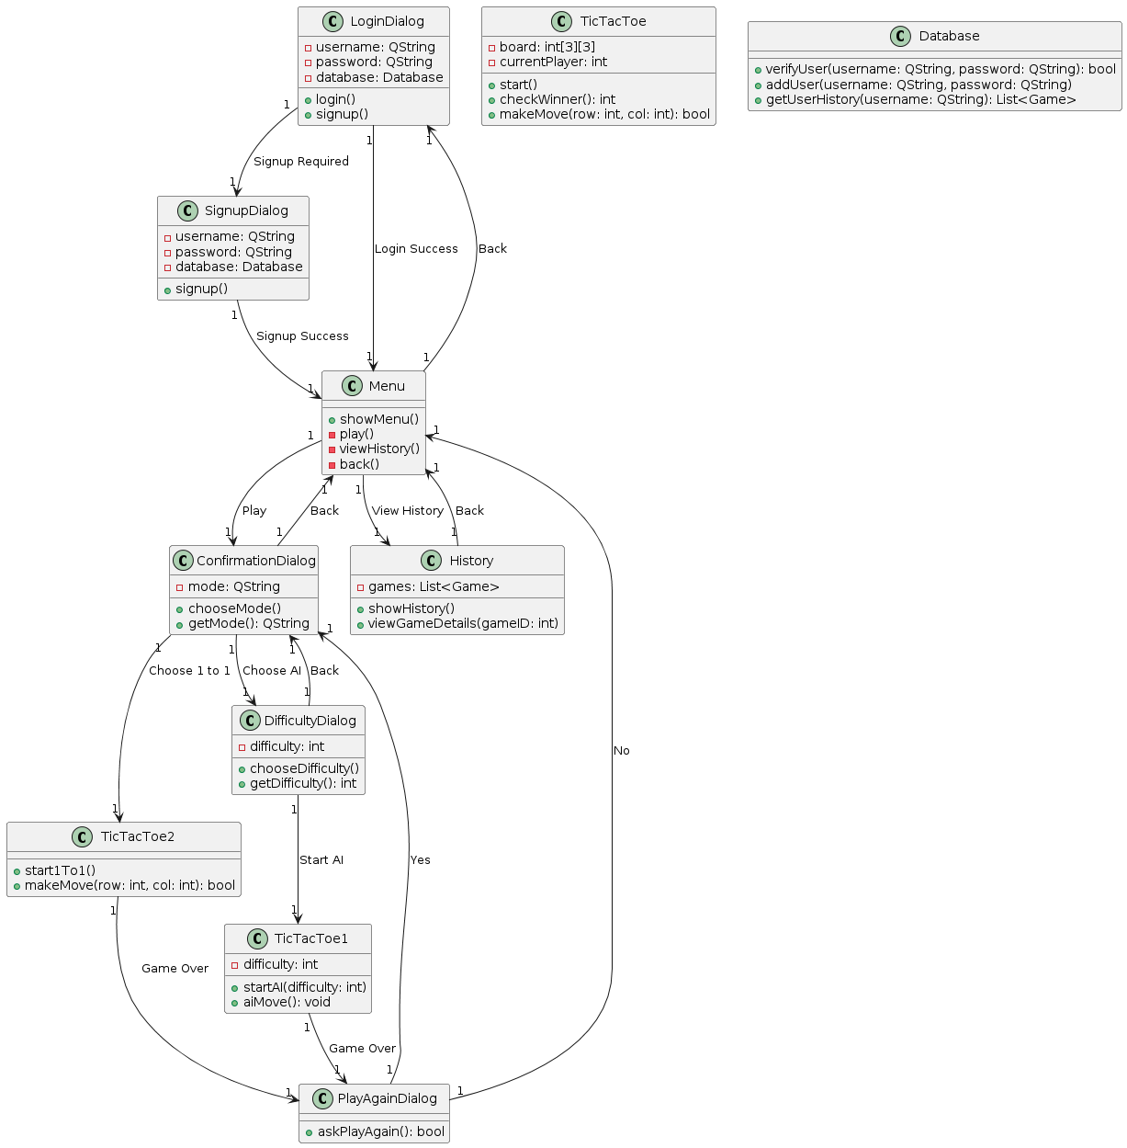

**Sequence diagram :** 