



The Egyptian E-Learning University

Faculty of Computers and Information Technology

Department of Information Technology

*Final Year Project*

**E-commerce Website Supports AI**

***Authors:***  ***Supervisors:***

* Eng/ Amr Ahmed Safy Mohamed (Team Leader) 2000926 Dr/ Enas Farouk

Eng/ Mohamed Saeed

* Eng/ Omnya Hamdy Elsayed Ahmed 2001048
* Eng/ Abdelrahman Saad Abdelaziz Aboshama 2000837
* Eng/ Moustafa Saad Eldin Sayed Hefny Mohamed 1900710
* Eng/ Ahmed Khaled Rushdi Freig 1900795
* Eng/ Mohamed Ahmed Mohamed Mohamed 1800498

Table of Contents

Introduction 3

Diagrams 5

Use Case Diagram 5

Sequence Diagram 6

Registration flowchart 7

Login flowchart 7

Order Flowchart 8

ER Diagram 9

Demo 10

HTML 13

CSS 15

JavaScript 17

PHP 19

Artificial Intelligence 21

History of artificial intelligence 22

What is artificial intelligence? 24

Classifications of artificial intelligence 24

Application fields of artificial intelligence technology 26

World leaders of artificial intelligence 31

The benefits of artificial intelligence in business 33

Artificial Intelligence in E-Commerce 38

The growth of artificial intelligence in e-commerce: Amazon case 38

Applications of Artificial Intelligence in E-Commerce 40

Chatbot in our E-Commerce Website 42

Recommendation system of our E-Commerce website 47

Future Work 51

References 52

# **Introduction**

What is E-Commerce?

E-commerce, short for electronic commerce, is like having a virtual shopping mall right at your fingertips. It's all about buying and selling goods and services online. Just think about all the stuff you can buy on websites like Amazon, eBay, or even directly from brands' websites—that's e-commerce in action!

Why is E-Commerce Important?

E-commerce has completely changed the way we shop. Instead of having to go to physical stores, we can now shop from the comfort of our homes or even on the go using our phones. It's super convenient and saves us time and effort. Plus, it opens up a whole world of products and services from all over the globe, giving us more choices than ever before.

How Does E-Commerce Work?

Ever wondered how those online shops actually work? Here's a simplified explanation:

1. The Online Store: This is like the digital storefront where you browse and buy stuff. It's where you see all the products, read about them, and decide what you want to buy.
2. Adding to Cart: Just like in a physical store where you put items in your shopping cart, in e-commerce, you click a button to add items to your virtual shopping cart.
3. Checkout: When you're done shopping, you go to the checkout. Here, you provide your shipping address, payment details, and any other necessary information to complete the purchase.
4. Payment Processing: Once you've entered your payment details, the e-commerce system securely processes your payment. It makes sure everything is legit and then charges your card or transfers money from your account.
5. Order Fulfilment: After the payment is processed, the e-commerce system sends a notification to the seller, letting them know that you've made a purchase. The seller then gets the item ready for shipping and sends it to you.
6. Delivery: Finally, the item is delivered to your doorstep. Depending on where you live and the shipping method chosen, it might take a few days or even just a few hours for your order to arrive.

E-commerce has revolutionized the way we shop, making it easier, more convenient, and more accessible than ever before. Whether you're buying clothes, electronics, groceries, or even services like booking flights or ordering food, e-commerce has something for everyone. So, next time you're shopping online, remember all the behind-the-scenes magic that makes it all possible!

# **Diagrams**

## **Use Case Diagram**

## **Sequence Diagram**

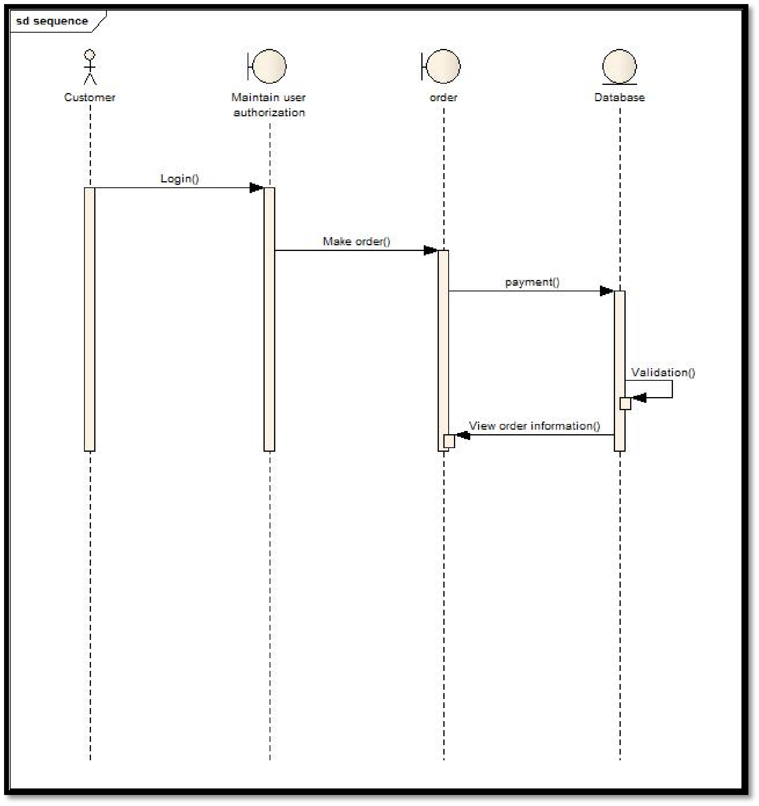

## **Registration flowchart**

**Login flowchart**  
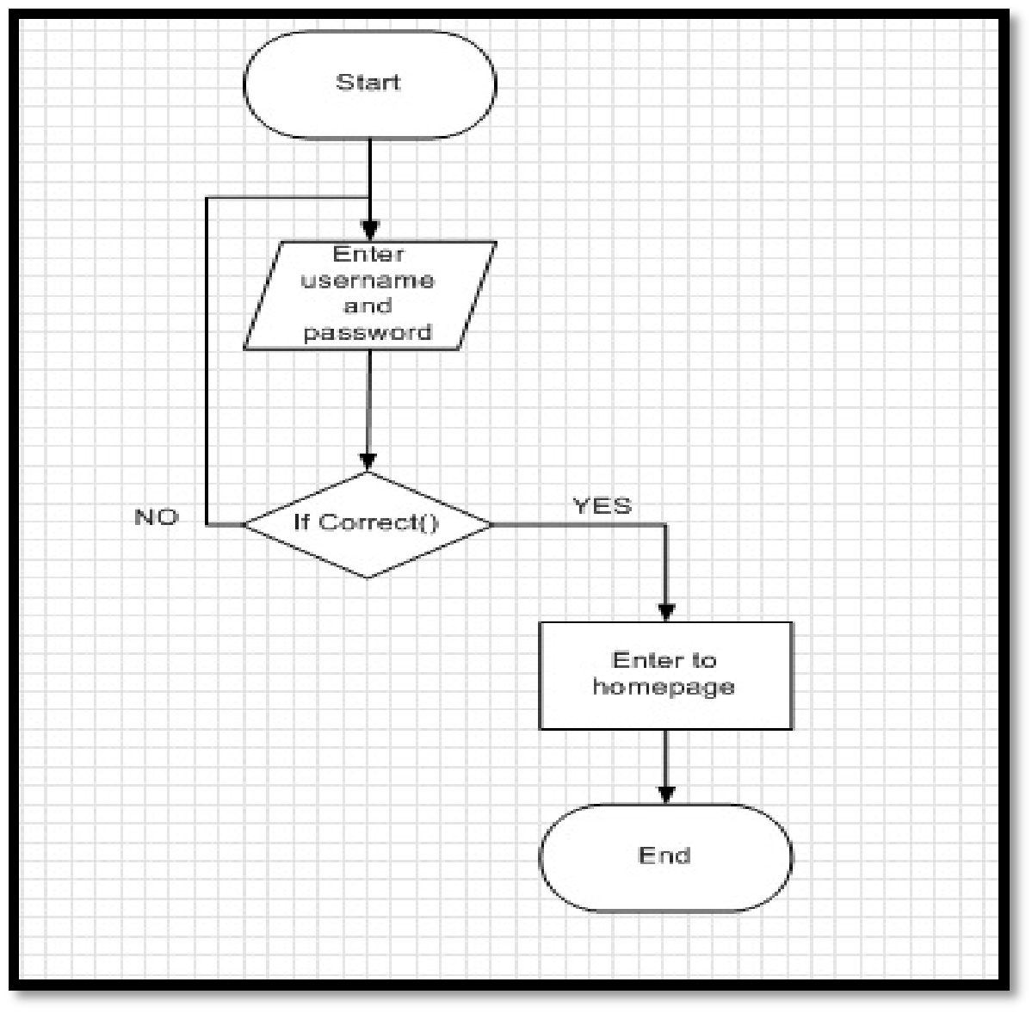

## **Order Flowchart**

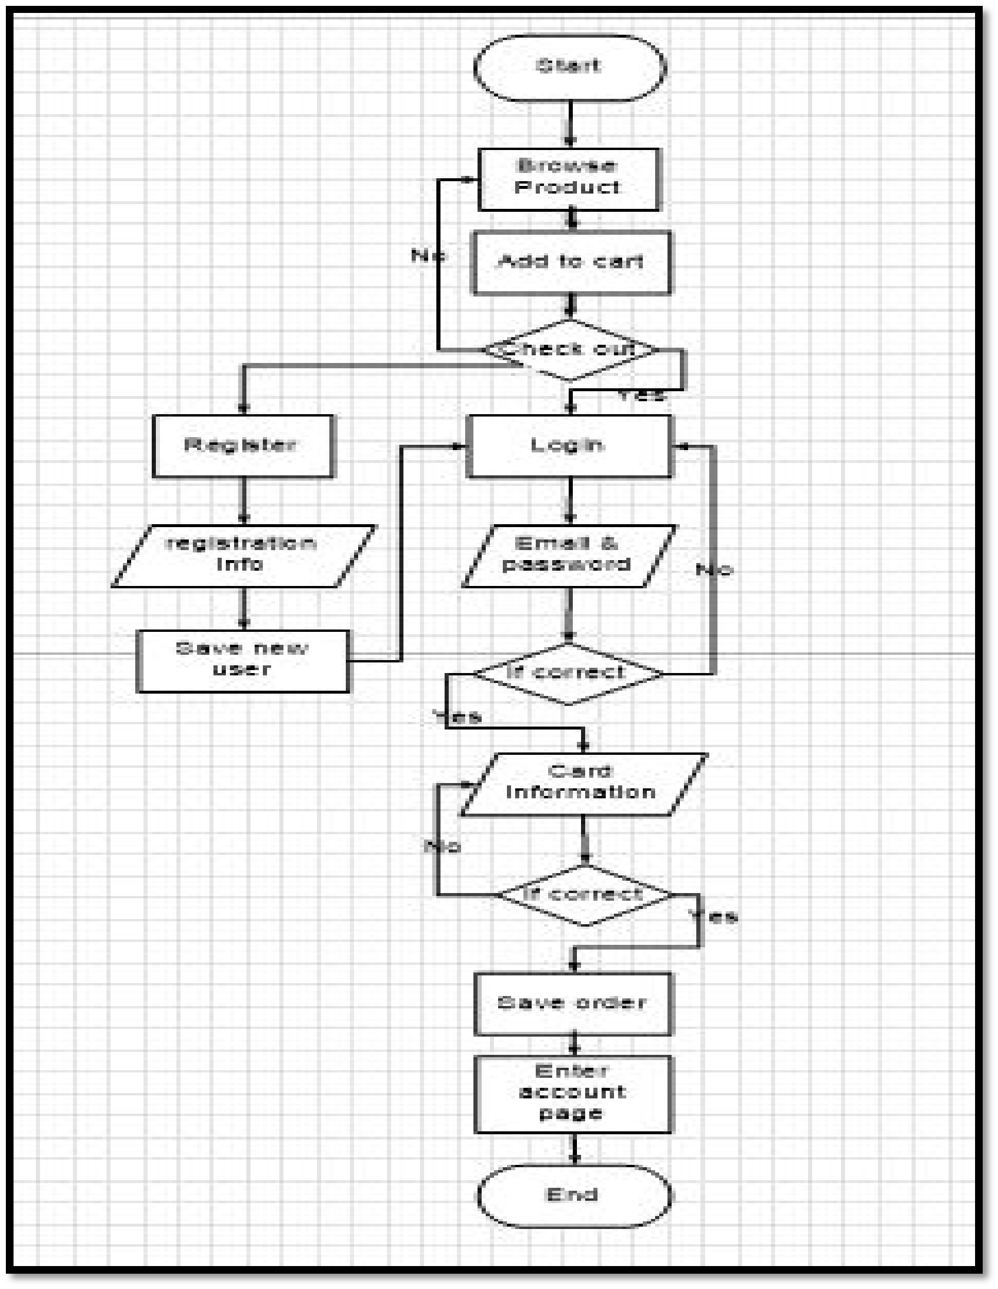

## **ER Diagram**

# **Demo**

**Login Page**

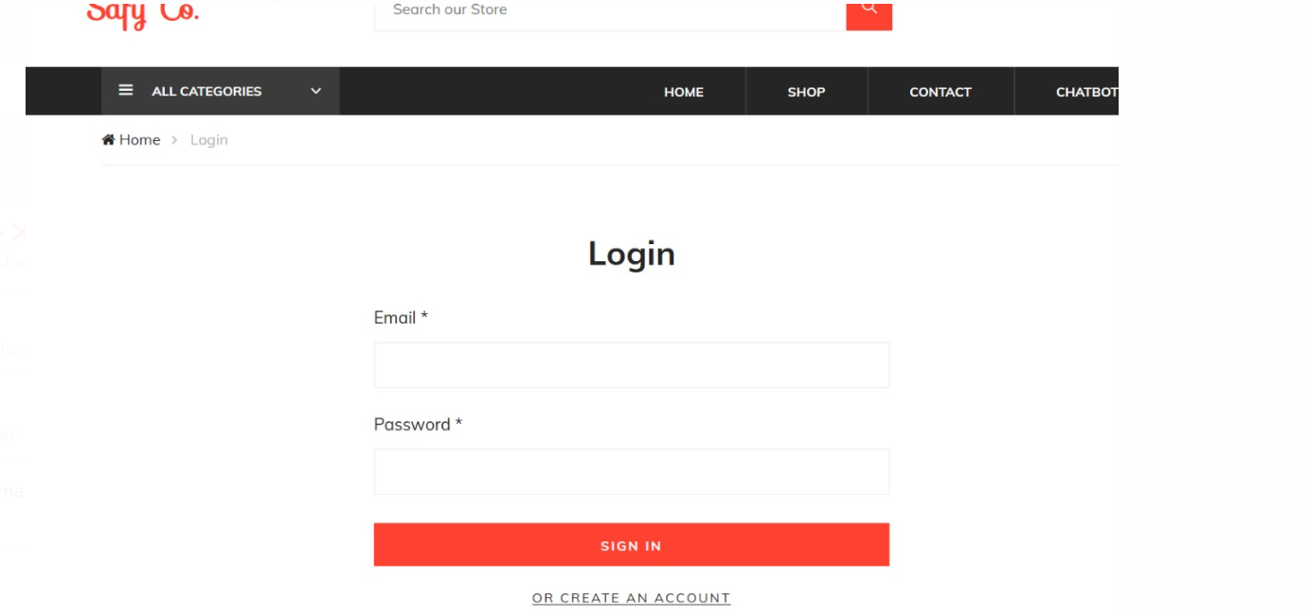

**Shopping page**

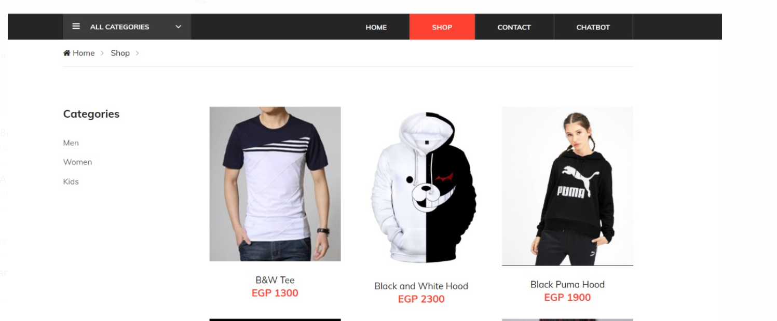

**Orders page**

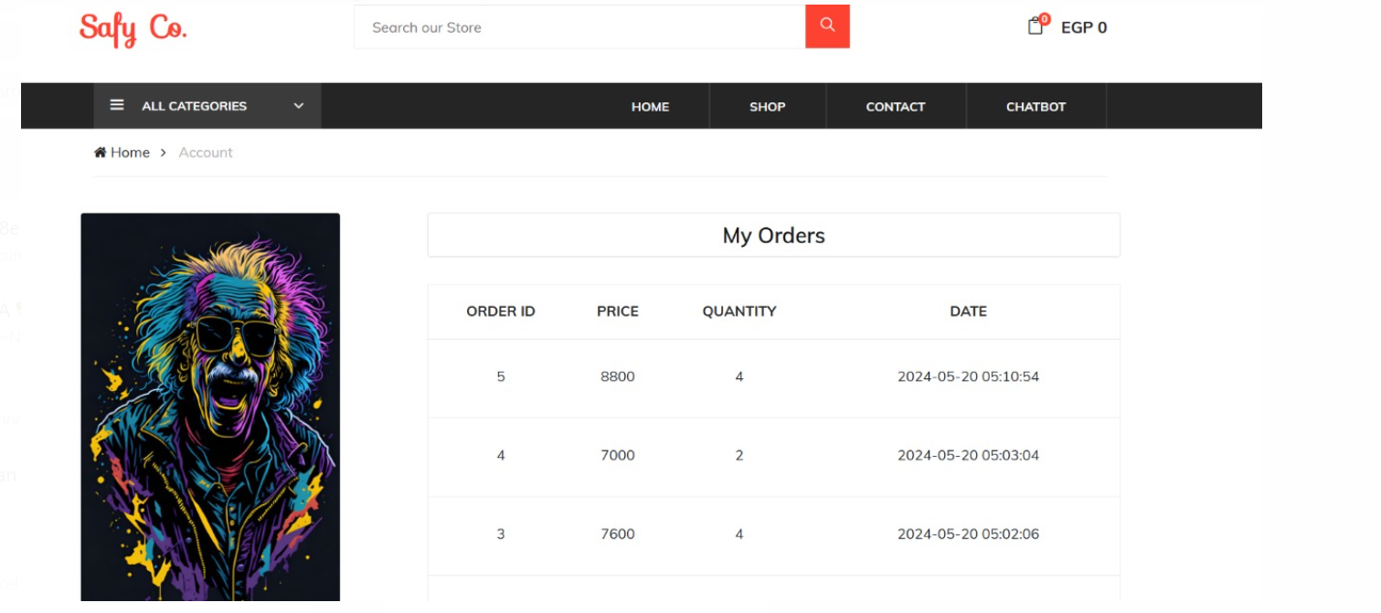

**Home page**



**Contact us**

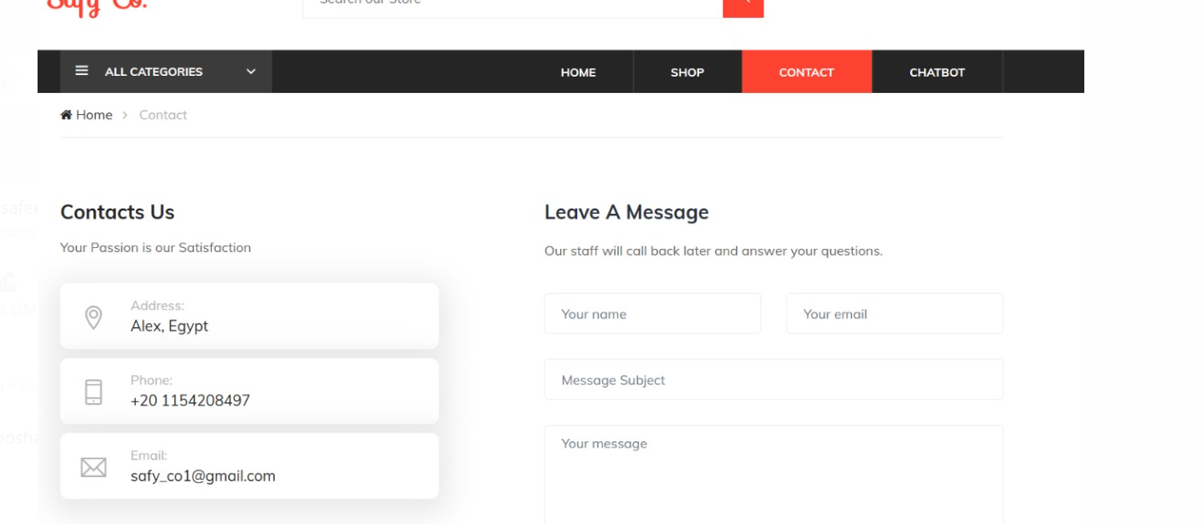

# **HTML**

HTML, short for Hypertext Markup Language, serves as the foundation of the World Wide Web, providing the structure and framework for creating web pages. In this document, we'll delve into the myriad benefits of HTML and how it empowers developers to build dynamic, interactive, and accessible web experiences.

**1. Simplicity and Ease of Use**

HTML's syntax is straightforward and easy to learn, making it accessible to developers of all skill levels. Its tag-based structure, with elements denoted by opening and closing tags, facilitates rapid development and simplifies the process of creating web pages.

**2. Platform Independence**

HTML is platform-independent, meaning it can be rendered and interpreted consistently across different devices, browsers, and operating systems. This ensures a seamless and consistent user experience regardless of the device or platform being used to access the web page.

**3. Semantic Structure**

HTML offers a semantic structure that enhances the accessibility, searchability, and maintainability of web content. Semantic HTML elements such as <header>, <footer>, <nav>, and <article> provide meaningful context and improve the organization and readability of web pages.

**4. Compatibility with Other Technologies**

HTML seamlessly integrates with other web technologies, including CSS (Cascading Style Sheets) for styling and layout, and JavaScript for interactivity and dynamic behavior. This interoperability enables developers to create rich, multimedia web experiences by combining HTML with complementary technologies.

**5. Accessibility**

HTML supports accessibility features such as alt text for images, semantic markup for screen readers, and keyboard navigation for users with disabilities. By adhering to accessibility best practices, developers can ensure that web content is inclusive and accessible to all users, regardless of their abilities or assistive technologies.

**6. SEO Benefits**

HTML's semantic structure and well-defined elements contribute to search engine optimization (SEO) efforts. Search engines can crawl and index HTML content more effectively, leading to improved visibility and ranking in search engine results pages (SERPs).

**7. Scalability and Flexibility**

HTML is highly scalable and flexible, allowing developers to create web pages of varying complexity, from simple static websites to dynamic web applications. Its modular structure enables developers to add, remove, or modify elements easily, facilitating rapid iteration and updates.

**8. Wide Adoption and Community Support**

HTML is one of the most widely adopted technologies on the web, with a vast community of developers, resources, and documentation available. This widespread adoption ensures continuity, support, and innovation within the HTML ecosystem, empowering developers to create cutting-edge web experiences.

# **CSS**

Cascading Style Sheets (CSS) are the unsung heroes of web design, providing the means to transform plain HTML into visually stunning and interactive web pages. In this document, we'll explore the multifaceted benefits of CSS and how it empowers designers to create beautiful, responsive, and user-friendly websites.

**1. Styling and Layout Control**

CSS enables designers to control the visual presentation and layout of web pages with precision and flexibility. By defining styles for HTML elements, such as fonts, colors, margins, and padding, CSS allows designers to create visually cohesive and aesthetically pleasing designs.

**2. Separation of Content and Presentation**

One of the key principles of web design is the separation of content and presentation. CSS facilitates this separation by allowing designers to define styles in external style sheets, which can be applied to multiple web pages. This promotes consistency, maintainability, and scalability in web design projects.

**3. Responsive Design**

With the proliferation of mobile devices and varying screen sizes, responsive design has become essential for ensuring a seamless user experience across devices. CSS features such as media queries enable designers to create responsive layouts that adapt to different viewport sizes, ensuring readability and usability on desktops, tablets, and smartphones.

**4. Cross-Browser Compatibility**

CSS helps ensure cross-browser compatibility by providing a standardized way to style and layout web pages. While different browsers may render HTML slightly differently, CSS provides a consistent set of styling rules that ensure a uniform appearance across browsers, enhancing the user experience and accessibility of web content.

**5. Animation and Interactivity**

CSS enables designers to add animation and interactivity to web pages without relying on JavaScript or third-party plugins. CSS animations, transitions, and keyframes allow designers to create visually engaging effects, such as fade-ins, slideshows, and hover effects, enhancing user engagement and immersion.

**6. Accessibility**

CSS plays a crucial role in enhancing the accessibility of web content for users with disabilities. By defining styles that improve readability, contrast, and navigation, designers can create web pages that are more accessible to users with visual impairments or cognitive disabilities, ensuring inclusivity and equal access to information.

**7. Performance Optimization**

CSS optimization techniques, such as minification and compression, help improve the performance of web pages by reducing file size and minimizing load times. By optimizing CSS code, designers can enhance the speed and responsiveness of websites, resulting in a smoother browsing experience for users.

**8. Community and Resources**

CSS benefits from a vibrant community of designers, developers, and resources, including online tutorials, forums, and libraries. This rich ecosystem fosters collaboration, innovation, and continuous learning, empowering designers to stay up-to-date with the latest trends and best practices in web design.

# **JavaScript**

JavaScript is the dynamic, client-side scripting language that powers interactivity and functionality on the web. In this document, we'll explore the transformative capabilities of JavaScript and its role in creating engaging, interactive, and responsive web experiences.

**1. Dynamic Content and Interaction**

JavaScript enables developers to create dynamic, interactive web pages that respond to user actions in real-time. With JavaScript, developers can manipulate HTML elements, update content dynamically, handle user input, and create engaging user interfaces that enhance the overall browsing experience.

**2. Event Handling**

JavaScript provides a powerful event handling mechanism that allows developers to respond to user interactions, such as clicks, mouse movements, keyboard inputs, and form submissions. By attaching event listeners to HTML elements, developers can trigger JavaScript functions that perform actions based on user events, enabling rich interactivity and responsiveness.

**3. DOM Manipulation**

One of JavaScript's key strengths is its ability to manipulate the Document Object Model (DOM), the structured representation of a web page's content. With JavaScript, developers can dynamically create, modify, and delete DOM elements, update styles, attributes, and content, and respond to changes in the DOM structure, enabling dynamic and responsive web applications.

**4. Asynchronous Programming**

JavaScript supports asynchronous programming, allowing developers to execute tasks concurrently without blocking the main execution thread. This is achieved through features such as callbacks, promises, and async/await syntax, which enable developers to handle asynchronous operations, such as fetching data from servers, processing user input, and performing animations, without freezing the user interface.

**5. Browser Compatibility**

JavaScript is supported by all modern web browsers, making it a ubiquitous language for client-side web development. With consistent support across browsers, developers can rely on JavaScript to deliver consistent, cross-browser experiences that work seamlessly on desktops, tablets, and smartphones, ensuring broad accessibility and compatibility for users.

**6. Libraries and Frameworks**

JavaScript ecosystem boasts a vast array of libraries and frameworks that streamline web development and provide pre-built solutions for common tasks. Libraries like jQuery simplify DOM manipulation and event handling, while frameworks like React, Angular, and Vue.js provide robust tools for building scalable, component-based web applications.

**7. Server-Side Development**

JavaScript isn't limited to client-side development; it's also used for server-side development through platforms like Node.js. With Node.js, developers can build fast, scalable, and efficient server-side applications using JavaScript, leveraging a single language and ecosystem for both client and server-side development.

**8. Community and Resources**

JavaScript benefits from a thriving community of developers, resources, and documentation. Online forums, tutorials, and open-source projects abound, providing developers with a wealth of knowledge, support, and collaboration opportunities. This vibrant ecosystem fosters innovation, learning, and continuous improvement in JavaScript development.

# **PHP**

PHP, which stands for Hypertext Preprocessor, is a server-side scripting language widely used for web development. In this document, we'll delve into the versatility and power of PHP and how it enables developers to build dynamic, data-driven web applications.

**1. Server-Side Scripting**

PHP is primarily used for server-side scripting, meaning that PHP code is executed on the server before the resulting HTML is sent to the client's web browser. This enables developers to perform server-side tasks, such as accessing databases, processing form data, and generating dynamic content, while keeping sensitive code hidden from users.

**2. Dynamic Content Generation**

One of PHP's key strengths is its ability to generate dynamic content based on user input, database queries, or other external factors. With PHP, developers can embed PHP code directly within HTML pages, allowing for dynamic rendering of content, such as user profiles, product listings, and news articles, based on changing data or user interactions.

**3. Database Integration**

PHP seamlessly integrates with databases, such as MySQL, PostgreSQL, and SQLite, enabling developers to store and retrieve data dynamically. PHP's database functions and extensions allow developers to execute SQL queries, fetch data from databases, and manipulate database records, facilitating the development of robust, data-driven web applications.

**4. Form Handling**

PHP simplifies form handling by providing built-in functions for processing form data submitted by users. Developers can use PHP to validate form inputs, sanitize data to prevent security vulnerabilities, and process form submissions, such as user registrations, contact inquiries, and e-commerce transactions, before storing or processing them further.

**5. Session Management**

PHP offers session management capabilities, allowing developers to create and manage user sessions to track user interactions and maintain state across multiple page requests. Sessions enable features such as user authentication, shopping carts, and personalized user experiences by storing user-specific data server-side between page requests.

**6. Content Management Systems (CMS)**

PHP powers many popular content management systems, such as WordPress, Joomla, and Drupal, which enable users to create, manage, and publish web content without requiring extensive technical expertise. These CMS platforms leverage PHP's flexibility and extensibility to provide customizable, feature-rich solutions for website creation and management.

**7. Frameworks and Libraries**

PHP benefits from a rich ecosystem of frameworks and libraries that streamline web development and provide reusable components and modules for common tasks. Frameworks like Laravel, Symfony, and CodeIgniter offer MVC architecture, routing, templating, and other features that simplify and accelerate the development of PHP web applications.

**8. Community and Support**

PHP enjoys a large and active community of developers, forums, tutorials, and documentation resources. This vibrant community fosters collaboration, knowledge sharing, and continuous improvement in PHP development, providing developers with support, guidance, and opportunities for learning and growth.

PHP is a versatile and powerful language that empowers developers to build dynamic, data-driven web applications. From server-side scripting and database integration to form handling and session management, PHP offers a comprehensive set of features and capabilities that drive innovation and creativity in web development.

# **Artificial Intelligence**

Artificial intelligence helps to develop intelligence in software and machines and create some abilities for them to think and act like a human. The development of artificial intelligence is past creative ability with different diverse procedures and strategies to execute the equivalent. In business, its techniques bring many benefits for a company such as improving customers’ decision-making, predicting the revenue correctly, reducing expenses as well as increasing customers’ purchasing experience. Through this thesis, people can now understand what artificial intelligence is, its history and main styles of it as well as some outstanding practical applications in theoretical parts.

This study aims fundamentally at the issue of whether artificial intelligence applications have entered the business, especially in the e-commerce industry. The point of this thesis is to clarify if artificial intelligence has had an essential and gradual effect on e-retailers with an iconic e-retailer company, Amazon. This thesis also introduces which kind of artificial intelligence techniques are utilized today in e-commerce with high- light applications from Amazon. In addition, artificial intelligence not only has played an important role to enhance the customer service for the company in e-commerce but also helped improve their yearly profit by creating more effective online shopping strategy campaigns and achieve client goals by learning their needs and expectations. Besides, the thesis also focuses on how Finnish companies have responded to the ascent of artificial intelligence and what Finland will do for artificial intelligence in the future.

Artificial intelligence (AI) is revolutionizing various industries, and e-commerce is no exception. By harnessing the power of AI, e-commerce systems can deliver personalized shopping experiences, optimize operations, and drive business growth. This exploration delves into the integration of AI in e-commerce systems, its applications, benefits, and challenges.

## **History of artificial intelligence**

The historical backdrop of artificial intelligence is very fascinating and begun around 100 years ago. The Czech writer Karel Čapek introduced a science fiction play that was called Rossumovi Univerzální Roboti (Rossum’s Universal Robots), known as R.U.R in the year 1920. The robots in R.U.R. first worked for the people, however then there was robot disobedience which prompts the eradication of humankind. The play is very fascinating, in light of various reason. First, it is presenting the term robot, even though it does not actually speak the advanced thought of robots. Next, it is additionally recounting the account of the for- mation of robots, so some sort of computerized, which initially is by all accounts a constructive outcome to the people, however later on the will be the robot disobedience which danger the entire human race. (Schultebraucks 2017.)

Alan Turing, a noted British computer scientist worked to break the “Enigma” code which utilized German armies to send messages safely during World War II. Alan Turing and his group made the Bombe machine that was utilized to decode Enigma's messages. The Enigma and Bombe Machines established the frame- works for Machine Learning. As indicated by Turing, a machine that could chat with people without the people realizing that it is a machine would win the "imitation game" and could be said to be “intelligence”. (Ray 2018.)

In 1956, John MacCarthy, an American computer scientist invented the word “Artificial Intelligence” when he organized the Dartmouth Conference. Research focuses sprung up over the United States to investigate the capability of artificial intelligence. Analysts Allen Newell and Herbert Simon were instrumental in ad- vancing artificial intelligence as a field of software engineering that could change the world. In the 1950s, a machine known as Ferranti Mark 1 effectively utilized a calculation to master checkers and also John McCarthy, regularly known as the father of artificial intelligence, built up the LISP programming dialect

which wound up critical in machine learning. In the late 1960s, PC researchers dealt with Machine Vision Learning and creating machine learning in robots. WABOT-1, the main 'insightful' humanoid robot, was worked in Japan in 1972. Between the 1970s and 1990s, computer scientists managed an intense deficiency of subsidizing for artificial intelligence inquire about. These years wound up known as the “Artificial intelligence Winters” known as “AI Winters”. (Ray 2018.)

In the 1980s neural systems turned out to be generally utilized and "The Society of Mind" a hypothetical depiction of the aggregate personality, was distributed by Marvin Minsky. In the 1990s, artificial intelli- gence took noteworthy improvements in territories, for example, machine learning, computer-generated reality and in amusements. A chess program expands on artificial intelligence won the chess big showdown and the primary independent mechanical autonomy hardware framework "Sojourner" was conveyed on the surface of Mars by NASA. Intelligent robot pets turned out to be financially accessible, Stanford's self- ruling vehicle, Stanley, won DARPA Grand Challenge race and The Nomad robot investigated the remote districts of Antarctica searching for shooting star tests amid the early long periods of the 21st. (Tekoäly 2018.)

Some artificial intelligence financing evaporated when the dotcom bubble burst in the mid-2000s. However, machine learning proceeded with its walk, to a great extent because of upgrades in PC equipment. Enter- prises and governments effectively utilized machine learning strategies in tight areas. Exponential gains in PC handling force and capacity enabled organizations to store immense, and crunch, tremendous amounts of information out of the blue. In the previous 15 years, Amazon, Google, Baidu, and others utilized machine figuring out how to their gigantic business advantage. Other than preparing client information to compre- hend customer conduct, these organizations have kept on chipping away at PC vision, common dialect han- dling, and an entire host of other artificial intelligence applications. Machine learning is currently implanted in a considerable lot of the online administrations we utilize. (Ray 2018.)

## **What is artificial intelligence****?**

Artificial intelligent (AI) is an area of computer science dedicated the creation by machine that related to work and respond like human intelligence. These processes include learning, planning, and problem-solving. The major target of artificial intelligence is to make expert systems- the frameworks which show the conduct, learning, illustrate, clarify, and counsel its clients. The second goal is to implement human intelligence in machines that are making frameworks about comprehend, thinking, learning and respond like human’s action. Nowadays, artificial intelligence has become a crucial part of the technology industry. (Aws Amazon 2018; Best Tech Guru 2016.)

## **Classifications of artificial intelligence**

According to Bonden A. Margaret (2016), artificial intelligence has two major targets: technological and scientific. In the first aim, artificial intelligence has used to get useful things done and the other one is that using artificial intelligence in both models and concepts to solve questions about humans and other living things. (Bonden 2016.)

Technological artificial intelligence includes Narrow artificial intelligence and General artificial intelli- gence. Narrow artificial intelligence is intelligent systems what people can see around in computers. It fo- cuses on solving one problem that has been learned and taught to handle some specific tasks without being programmed obviously how to do. This kind of machine insight is clear in the vision-acknowledgment frameworks on self-driving vehicles, in the voice recognition of Siri virtual function on the iPhone Apple, and in the suggestion motors, the recommend items customers may depend on what they purchased previ- ously. There are countless applications for narrow artificial intelligence such as reacting to basic client ben- efit inquiries, coordinating with other clever frameworks to do undertakings like booking a lodging at an appropriate time and area, helping radiologists to spot potential tumors in X-rays, hailing unseemly sub- stance web-based, identifying mileage in lifts from information accumulated by Internet of Things, the run- down continues endlessly. (Heath 2018.)

General artificial intelligence is a different system that focuses on solving a wide range of problems. This system is the kind of adaptable intellect found in people and adjusting quickly of insight fit for figuring out how to complete incomprehensibly extraordinary undertakings, anything from haircutting to building spreadsheets, or to reason about a wide assortment of themes dependent on its gathered understanding. (Heath 2018.)

Between the year 2012 and 2013, a gathering of artificial intelligence specialists and analysts directed a review and detailed that Artificial General Intelligence (AGI) would be increased from 2040 until 2050 about 50 percent in this period. Creating AGI by 2075 was evaluated to have a 90 percent probability. A few specialists trust that those projections are savagely idealistic and trust that AGI is hundreds of years away, due to our restricted comprehension of the human mind. (Heath 2018.)

Scientific artificial intelligence is based on its functionality and known as relative machines, limited memory, theory of mind and self-awareness. Relative machines are one of the essential types of machine learning. It is known as Deep Blue, the IBM chess program that beat Garry Kasparov during the 1990s. (Kumar 2018.)

Limited memory is the systems that can use past encounters to educate future choices. A portion of the basic leadership works in self-driving vehicles are structured along these lines. Perceptions advise activities oc- curring not long from now, for example, a vehicle moving to another lane. These perceptions are not stored for all time. (TechTarget 2018a.)

Theory of mind is the phenomenon to be able to understand that others have their very own convictions, wants, and expectations that affect the choices they make. Although there is a lot of improvement in this area, this sort of AI does not yet exist. (Kumar 2018.)

Self-awareness is artificial frameworks have a feeling of self, have cognizance. Machines with mindfulness comprehend their present state and can utilize the data to derive what others are feeling. Like the theory of mind, this kind of AI does not yet exist. (TechTarget 2018a.)

## **Application fields of artificial intelligence technology**

Computerized reasoning performs undertakings in a smart way (assignments are executed as we people do) and along these lines, it creates higher exactness, effectiveness, and efficiency for the general framework. Machines do not become weary of working and as they do not have feelings. In addition, the machines are not influenced by any such sentiments or feelings by which people are influenced and, in this manner, the throughput of machines having knowledge is a lot higher. Knowledge in such machines is known for the capacity to apply rationale and produce a productive and precise yield for the final client. This insight into the artificial intelligence framework is dictated by the learning present in the model (artificial intelligence consciousness framework is manufactured utilizing a numerical model) at first as preparation information. Further, this information is then used to perform different errands which enable the client to show signs of improvement results. (Duniya 2019.)

Due to artificial intelligence working systems, there are significantly six application that incorporated into the umbrella of the artificial intelligence fields in figure 1 below. The six fields are the ones which are presently the trendy expression in the business and organizations and enormous enterprises are currently attempting to make utilization of it and server buyers in a vastly improved manner. The six fields are as per the following:



Artificial Intelligence

Robotics

Expert Systems

Natural Language Processing

Computer Visions

Image Processing and Multimedia Analysis

Machine Learning

FIGURE 1. Main fields of artificial intelligence (Adapted from Karazeev 2018.)

Machine learning (ML) has used algorithm tools that enables software applications to more correctly in predicting results without being explicitly programmed. The purpose of machine learning is to create algo- rithms that can accept input data and use analysis systems to forecast output data. (TechTarget 2018a)

There are various ways that machine learning is influencing organizations in business. One of the practical applications of machine learning in business that will help increase the client experience at the same time helping reduce company expenses. In addition, it also helps the company predict customer purchasing be- havior. The customer goes to the Amazon website (PICTURE 1) and searches for the fantasy novel book such as Harry Potter. Next, they can see the sentence “Customers who bought this item also bought”. Am- azon.com uses machine learning systems to show and recommend other items from other customers who have the same interest in Harry Potter. (Ayehu 2018; PerceptionBox 2018.)



PICTURE 1. Amazon website (Taken by the author from Amazon website 2019.)

Natural language processing (NLP) is a part of artificial intelligence consciousness that enables the machine to understand, translated and control human interaction. NLP draws from numerous controls, including software engineering and computational phonetics, in its interest to fill the hole between human correspond- ence and machine understanding. (SAS 2019.)

In business, chatbots are one of the newest practical application of natural language processing. Chatbots streamline usefulness by coordinating in projects like Slack, Skype, and Microsoft Teams. When they ini- tially went ahead of the scene, chatbots were shopper confronting. For instance, when people type the word "pizza" into Google search, a Pizza's bot (Domino or Pizza online) would ask to receive your request (Bell 2017.)

Robotics is the field that includes the utilization of equipment and programming segments where both equip- ment and programming participate together as well as gives a framework that enables the client to play out their tasks. Robots are utilized these days in assembling ventures where the work is performed quicker, much precisely and much productively. (Duniya 2019.)

Amazon is popular for utilizing robots around 30,000 of them - inside its dissemination focuses, having gained mechanical autonomy organization Kiva in 2012. When robots get less expensive and progressively skilled, we can hope to see developing numbers go with the same pattern. The major duties these kinds of robots have are choosing products on racks, transporting them around stockrooms (which can signify many, numerous miles voyaged every day), pressing them into boxes and stacking them onto vans. (Jee 2016.)

Expert systems are the program of a computer that utilizes artificial intelligence advances to mimic the judgment and conduct of a human or an association that has master learning and involvement in a specific field. Furthermore, these systems have assumed an extensive job in numerous ventures incorporating into monetary administrations, social insurance, client benefit, broadcast communications, transportation, com- puter games, assembling, flight, and composed correspondence. (TechTarget 2018b.)

American Express Company as known as Amex is a good example for using expert systems. The company utilizes a specialist framework to help its credit approval staff sort through information from upwards of 13 information bases. A credit card from American Express has no set spending limit. That point is crucial for competing with other bank and financial companies. However, deciding the credit level for every client represents a difficult business challenge. Every time when the client makes a large number of buying prod- ucts, the dealer phones AMEX to empower the charge. The AMEX worker at that point needs to make a

careful decision. Approval demands outside the typical purchasing behavior require a look of the infor- mation bases for more data. The assistant of authorizer will look for and suggest to the individual who settles on the approval choice. The whole procedure takes just seconds. The trading is still on the phone. (Harvard Business Review 2018.)

Computer vision is an area of software engineering that takes a shot at empowering computers to see, dis- tinguish and process pictures similarly that human vision does, and afterward give proper yield. It resembles bestowing human knowledge and impulses to a computer. However, it is a troublesome assignment to em- power computers to perceive pictures of various items. It is also firmly connected with computerized rea- soning, as the computer must translate what it sees, and after that perform proper investigation or act as needs are. (Technopedia 2019.)

Mashgin-a startup company is working as a self-checkout store without checkout stations or cashiers by using computer vision, deep learning and 3D remaking to figure out and examine many products simulta- neously with no barcodes. The company states that by using computer vision systems, they can save the checkout time by up to ten times. Their major clients are cafeterias and eating halls managed by Compass Group. (InData Lads 2018.)

Image processing and multimedia analysis are the ascents in information, user experience with content data as well as with mixed media information too which is as pictures, sound, recordings and considerably more. To comprehend this mixed media information, people have to use pictures for preparing and interactive media examination. The handling calculations process the information inside and endeavor to understand what the information may contain and what data it will pass on. By utilizing this and understanding what the interactive media information needs to state, they can make it helpful for some crucial purposes where a picture is checked. (Duniya 2019.)

Pinterest-phone app which is a highlight example for using image processing and multimedia analysis. This app is working by image recognition to help customers can buy things what they see in real life. The customers just take a picture by a Pinterest app on their phone and the Pinterest will show the buyers the items from their searching. For example, if customer snaps the chair from their friend’s house, Pinterest will show you many purchasing websites that have similar and correct with the item buyers are looking for. (Sterne 2017.)

## **World leaders of artificial intelligence**

There is no doubt that artificial intelligence is increasing quicker than ever. From 2010, artificial intelligence has developed with the rate of practically 60 percent in annual development. Due to the number of research papers published annually, there are five leading countries in artificial intelligence technology innovation as can be seen in figure 3.

The top country in the list is China, which is known as a huge manufacturing country. As indicated by the Times Higher Education website, in the year period from 2011 to 2015, China distributed papers and mate- rials on artificial intelligence, which nearly twice as much as the US, more than 41000 papers. The Chinese government stands emphatically behind artificial intelligence selection. A year ago, they declared their ex- pectation to wind up "a vital world focus of artificial intelligence advancement" by 2030. At that point, there are organizations like Alibaba, Tencent, and Baidu. From web-based business to self-driving vehicles or web indexes, artificial intelligence will be a successful key in their achievement. Totally, they are worth approximately 1 trillion US dollar as can be seen in figure 2. (Jacobsen 2018.)

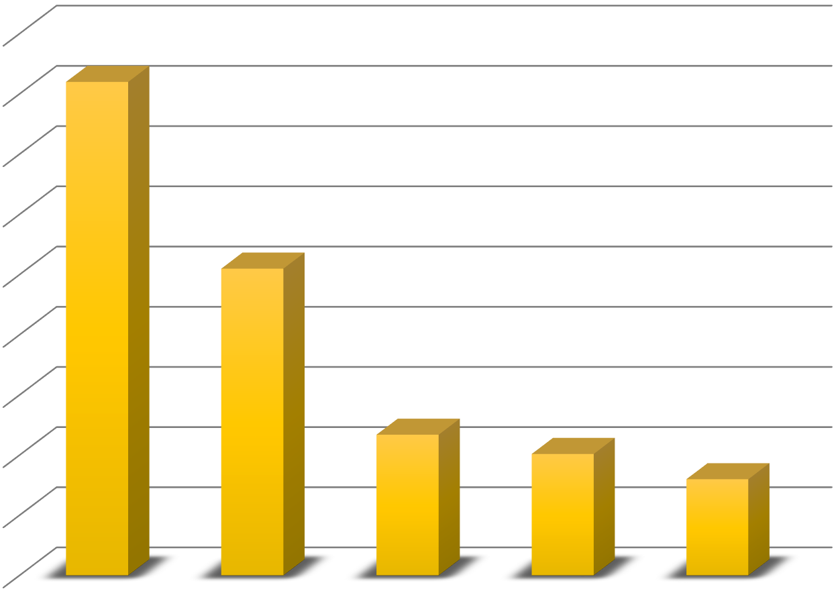

**Global Leaders of AI base on publised papers**

45000

40000

35000

30000

25000

20000

15000

10000

5000

0

China

USA

Japan

UK

Germany

FIGURE 2. Global leaders of artificial intelligence based on published papers (Adapted from Jacobsen 2018.)

The second rank of artificial intelligence leading countries is the United States of America based on the aspect of papers distributed. In the period 2011 to 2015, according to The Times Higher Education, the US distributed right around 25,500 papers in artificial intelligence. In addition, the US positions as one of the best nations with the most artificial intelligence organizations, which more than 1000 organizations and US$10 billion in investment, the US is probably going to end up an artificial intelligence superpower. They are also many popularity artificial intelligence companies like Amazon, Google, Facebook, Microsoft, and IBM. The US in the country that publish a large number of papers, materials as well as invest huge money in artificial intelligence. (Jacobsen 2018.)

Based on the Times Higher Education rankings, Japan is in the third position. There is no surprise that Japan published around 11700 papers and materials in artificial intelligence annually. Because of the going down of workers and facing with old population, therefore artificial intelligence is a crucial role in the Japanese economy. Indeed, more than 50 percent of work performances in Japan could be robotized and automated. (Jacobsen 2018.)

The United Kingdom and Germany are in the fourth and fifth position, with distributed research papers about 10100 and 8000 respectively. Like China, both countries the UK and Germany have plans for be- coming a leading hub of artificial intelligence. Germany, similar to Japan, is additionally encountering a working populace decay. Also, it also has a high computerization potential, remaining at 47.9 percent. Its solid industry capacities joined with incredible organizations and great instruction make it a prolific ground for artificial intelligence. (Jacobsen 2018.)

## **The benefits of artificial intelligence in business**

Artificial Intelligence is presently being utilized to analyze and understand the clients base on their behavior and experience when purchasing products. Artificial intelligence examinations enormous measures of social purchasing behavior and the level of interesting in the products that can connect with the company and help them know more their customers and can predict the items they will buy in the future according to custom- ers’ performance and preference. (Raconteur 2017.)

Tony Maile, who is a European retail leader at IBM Watson, stated that Artificial Intelligence is a quick- moving field, which shows the better approaching for retailers to make shopping without any trouble. Mod- ern Cognitive systems can interact, learn, and understand in the same way to an individual. The North Face – an outdoor clothing company, which is the employer of IBM Watson, now use cognitive computing ser- vice to enhance their virtual shopping associate (PICTURE 2). Artificial Intelligence helps their clients purchasing online with correct outfits, due to the series of questions when, where and what for the customers will use them. (Reed 2017.)

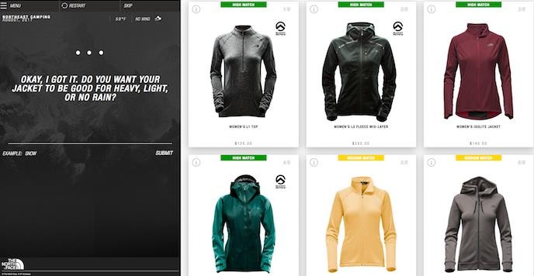

PICTURE 2. The North Face: using IBM Watson to find suitable items (Reed 2017.)

By using machine learning, Macy - a department store chain in America, has built up a shopping partner in smartphones. Therefore, the clients can shop and explore the store where they are in more convenient and easier, and they can also send questions, for example, the location of the store nearby them, when the prod- ucts are in stock or which size of the items they have, etc. (Raconteur 2017.)

Artificial intelligence can be used not only selling items but also solving the problem for clients. Besides, artificial intelligence also helps to target advertising more accurately and effectively. Retailers can look at past standards of conduct and tailor offers in like manner. We are in a time where cognitive systems can be instructed by the most experienced workers and this information can be made accessible to all staff and clients straightforwardly.

It is functioning admirably for membership administrations, for example, Stitch Fix and Birchbox, which move and minister garments and excellence items separately. These web-based business stores have in- stalled artificial intelligence techniques to be as a virtual individual for customers who do not have the time or tendency to shop.

CoverGirl - a makeup branch in America, is presenting the world's first influencer chatbot dependent on artificial intelligence, called the KalaniBot (PICTURE 3). When using KalaniBot, fans and customers can communicate in a chatbot adaptation of Kalani Hilliker, an American model and television character. As a result, she has more 14 times of discussions with the chatbot than with a normal post by Ms. Hilliker, 91 % positive assessment, about 17 messages for every discussion. In addition, KalaniBot will get more brilliant with utilizing and is intended to communicate conversationally like the genuine individual, learning about fans, asking a series of questions and giving CoverGirl coupon downloads. (Hall 2016.)

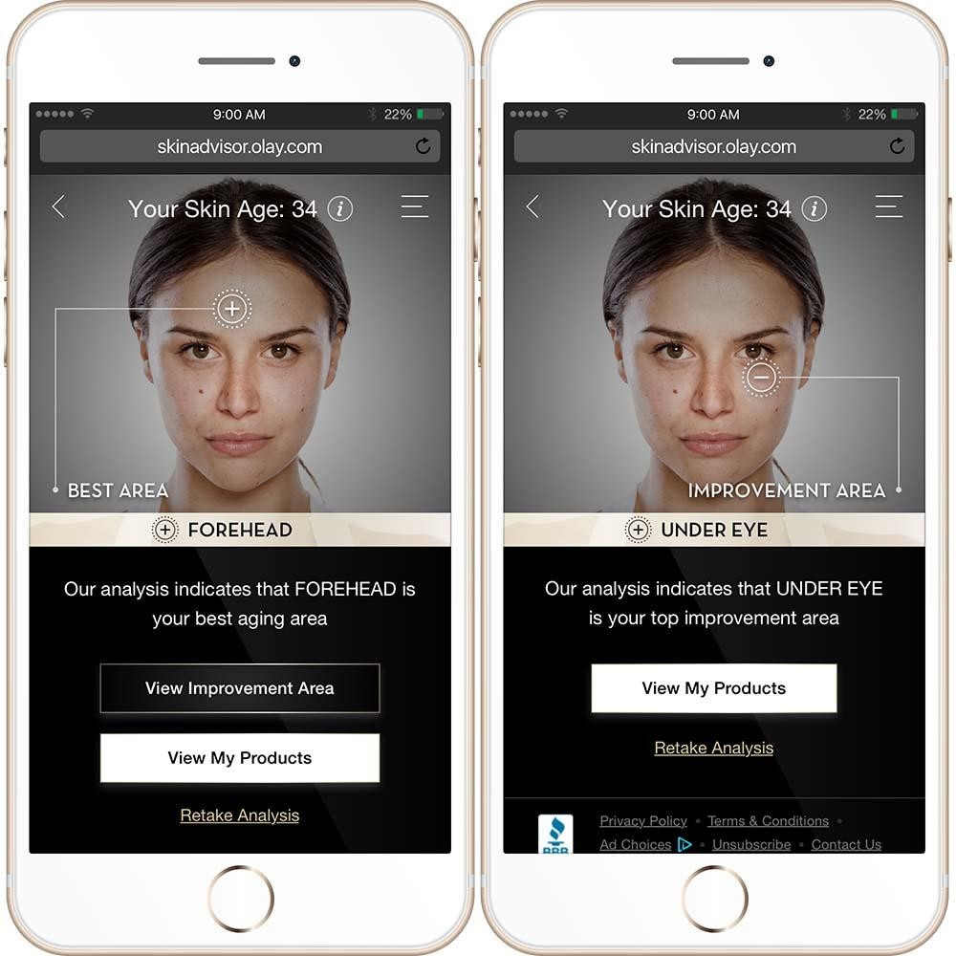

PICTURE 3. CoverGirl's Chatbot (Hall 2016.)

The next benefit of artificial intelligence is the concentration of personalization, where companies are selling items based on individual tastes. For example, Olay-a skincare brand of Procter & Gamble, (PICTURE 4) using deep-learning technology as their adviser to support and help clients discover the items most appro- priate to their individual skincare needs. (Raconteur 2017.)

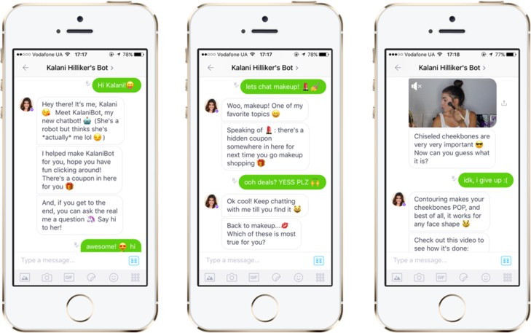

PICTURE 4. Olay’s skin advisor (Srikanth 2018.)

## **Artificial Intelligence in E-Commerce**

Artificial intelligence has been developed and executed in different areas, especially in e-commerce. The innovation of artificial intelligence has impressed everybody to get more attention to merchant online business. Amazon.com, one of the biggest international online retailers, that turned into a highlighted example of e-commerce.

This chapter will show how Amazon has used artificial intelligence in e-commerce; how Amazon’s customers have achieved better experience and expectation when purchasing online through artificial intelligence in e-commerce techniques; and new changes of Amazon to carry out online business.

## **The growth of artificial intelligence in e-commerce: Amazon case**

The development of artificial intelligence is presently increasing significantly, and this innovation has im- proved the e-commerce industry with new advancements. More than 70 percent of business trust that artificial intelligence has brought more benefits for online markets from now to the future. Amazon.com is successful in using artificial intelligence in e-retail sales of electronics and other products. The company also offered computing services, user electronics, digital text, and local services in groceries and daily buy- ing. The applications of artificial intelligence in e-commerce help Amazon boost its profits, improve productivities and enhance customers purchasing online performances. According to The Statistics Portal (FIG- URE 3), in 2018, the yearly net sales of Amazon.com were over 230 billion dollars. (Statista 2018a.)



2004 2005 2006 2007 2008 2009 2010 2011 2012 2013 2014 2016 2017 2018

0

34

48

24.5

19.2

15

8.5 10.7

7

61.1

50

74.5

89

100

136

150

178

200

233

250

**Net sales revenue of Amazon from 2004 to 2018 ( in billion U.S. dollars)**

FIGURE 3. Net sales of Amazon between 2004 and 2018 (Adapted from Statista 2018b.)

**The highlights of artificial intelligence in e-commerce**

This part will present the most common usage of artificial intelligence in e-commerce to get better customer’s merchant performance, more satisfying in purchasing goods and services, improve business competitiveness and customer loyalty. Some applications from Amazon.com – an international biggest retailer in online markets will be shown in this section too.

## **Applications of Artificial Intelligence in E-Commerce**

1. **Personalized Recommendations**: AI algorithms analyze user behavior, purchase history, and preferences to generate personalized product recommendations. By understanding individual preferences, e-commerce platforms can enhance user engagement and increase conversion rates.
2. **Predictive Analytics**: AI-powered predictive analytics forecast consumer trends, demand patterns, and inventory needs. This enables businesses to optimize inventory management, anticipate customer needs, and ensure product availability, thereby minimizing stockouts and maximizing sales.
3. **Chatbots and Virtual Assistants**: AI-driven chatbots and virtual assistants provide personalized customer support, answer inquiries, and assist with product recommendations and order tracking. They offer round-the-clock assistance, streamline customer interactions, and improve overall satisfaction.
4. **Visual Search**: AI-enabled visual search allows users to search for products using images rather than text. By analyzing visual attributes and similarities, e-commerce systems can deliver accurate search results and enhance the shopping experience for users.
5. **Fraud Detection and Prevention**: AI algorithms detect fraudulent activities, such as payment fraud and account takeover, by analyzing transaction patterns and user behavior. This helps mitigate risks, protect sensitive information, and ensure secure transactions for both businesses and consumers.

**Benefits of AI in E-Commerce**

1. **Enhanced Personalization**: AI-driven personalization tailors product recommendations, marketing messages, and shopping experiences to individual preferences, increasing user engagement and loyalty.
2. **Improved Operational Efficiency**: AI automates routine tasks, such as inventory management, customer support, and marketing campaigns, freeing up resources and enabling businesses to focus on strategic initiatives.
3. **Increased Sales and Revenue**: Personalized recommendations, predictive analytics, and targeted marketing campaigns driven by AI algorithms boost sales, maximize conversion rates, and drive revenue growth for e-commerce businesses.
4. **Enhanced Customer Experience**: AI-powered chatbots and virtual assistants provide instant support, streamline interactions, and offer personalized assistance, enhancing the overall customer experience and satisfaction.
5. **Competitive Advantage**: E-commerce businesses that leverage AI gain a competitive edge by delivering superior personalized experiences, optimizing operations, and staying ahead of market trends and customer preferences.

**Challenges and Considerations**

1. **Data Privacy and Security**: AI algorithms rely on vast amounts of data, raising concerns about data privacy, security, and ethical use. E-commerce businesses must prioritize data protection measures and ensure compliance with regulations such as GDPR.
2. **Algorithmic Bias and Fairness**: AI algorithms may exhibit bias or discrimination based on factors such as race, gender, or socioeconomic status. E-commerce businesses must implement measures to mitigate bias, promote fairness, and ensure inclusivity in their AI systems.
3. **Integration and Implementation Costs**: Integrating AI into e-commerce systems requires significant investment in technology, infrastructure, and talent. Businesses must carefully assess the costs and benefits of AI adoption and develop a comprehensive strategy for implementation.
4. **User Acceptance and Trust**: AI-driven personalization and recommendations may raise concerns about privacy invasion or manipulation among users. E-commerce businesses must be transparent about their AI algorithms, provide opt-in/opt-out mechanisms, and build trust with users through ethical use of AI.

Artificial intelligence holds immense potential to transform e-commerce, offering personalized experiences, operational efficiency, and competitive advantages. By harnessing the power of AI-driven insights and automation, e-commerce businesses can optimize processes, enhance customer engagement, and drive growth in an increasingly competitive digital marketplace. However, addressing challenges such as data privacy, algorithmic bias, and user trust is crucial to realizing the full potential of AI in e-commerce systems.

# Chatbot in our E-Commerce Website

In the fast-paced world of e-commerce, providing exceptional customer service and personalized assistance is paramount to success. Chatbots have emerged as invaluable tools in e-commerce systems, offering real-time support, personalized recommendations, and seamless interactions with customers. This exploration delves into the integration of chatbots in e-commerce systems, their functionalities, benefits, and implications for businesses and consumers alike.

Chatbot is a computer program that allows conversational performances, engaging purchasing more highly by text and voice. It is popularly used in mobile phone, internet browsers, or internet chat rooms. Besides, by using deep learning systems like natural language processing systems, or automatic voice recognition,

chatbots can imitate people’s interaction that can be found in virtual assistant systems, customer services, call center, etc. (Aws 2019.)

Chatbot also has many advantages for users such as improving customer engagement. A successful client experience can be a critical differentiator for a business. Chatbot can be sent into the channels that your clients and prospects are now connected with, like Facebook Messenger, so you can contact them in well- known conditions to react to their purchasing favorites quicker and catch up their needs and expectations. Next, chatbot is a very flexible function for the customer to buy products in the online market because it can respond to customers’ voice and text by their language. They also help the company to reduce execution time and improve business efficiencies. (Aws 2019.)

Amazon Lex (PICTURE 5) is a highlight example of a chatbot service that is created by Amazon to help customers connect with call center. It is made for conversational equipment into any application which can use text and voice. Amazon Lex uses deep learning functions of automatic voice recognition in advanced for changing voice to text, and natural language understanding system to perceive the meaning of the text, to allow the customer to make applications with attracting user experiences. This system allows customers to clarify new types of items made through conversational interfaces. It can be used in different cases such as connect to enterprise applications to receive marketing data, or customer can read their banking information, or calling Amazon contact center.

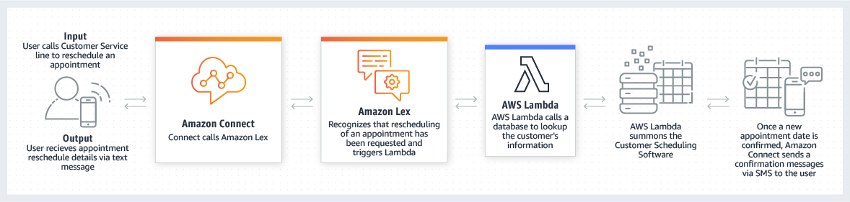

PICTURE 5. Using Amazon Lex for calling center bots (Aws Amazon Lex 2019.)

When using Amazon Lex, the customer can plan for appointments, change name or password, and request- ing purchasing history from Amazon account. (PICTURE 6) These chatbots can recognize customer’s speech and comprehend customer’s meaning without requesting customer answers any specific questions. In addition, it facilitates the procedure of daily individual activities, for example, booking hotel rooms or doctor appointments, order books or personal stuff from users ‘mobile phones, internet browsers. (Aws Amazon Lex 2019.)

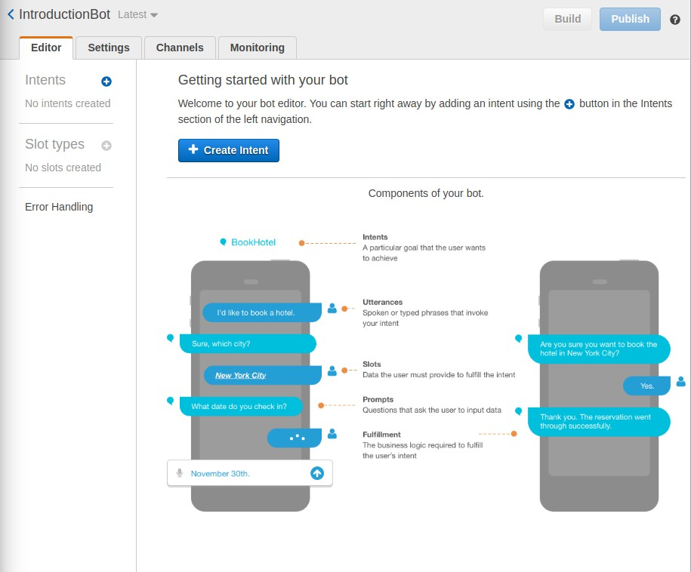

PICTURE 6. Amazon Lex Chatbots (William 2018.)

Chatbots in e-commerce systems serve as virtual assistants, leveraging artificial intelligence (AI) and natural language processing (NLP) technologies to engage with customers in conversational interactions. These interactions encompass various aspects of the customer journey, including product inquiries, order tracking, assistance with purchases, and post-sales support. Key functionalities of chatbots in e-commerce systems include:

1. **Product Recommendations**: Leveraging customer data and browsing history, chatbots deliver personalized product recommendations tailored to individual preferences and interests. By analyzing user behavior and purchase patterns, chatbots enhance product discoverability and increase conversion rates.
2. **Order Management**: Chatbots assist customers with order management tasks, such as tracking shipments, updating delivery status, and modifying orders. They provide real-time updates and notifications, keeping customers informed and engaged throughout the fulfillment process.
3. **Feedback Collection**: Chatbots solicit feedback from customers regarding their shopping experience, product preferences, and satisfaction levels. They gather user input through conversational surveys, sentiment analysis, and feedback loops, enabling businesses to improve their products, services, and overall customer experience.

**Benefits of Chatbots in E-Commerce Systems**

1. **Improved Customer Engagement**: Chatbots facilitate personalized interactions with customers, addressing their inquiries, providing recommendations, and offering assistance in real-time. By enhancing engagement and responsiveness, chatbots foster stronger connections with customers and increase brand loyalty.
2. **Efficient Customer Service**: Chatbots streamline customer service operations by automating routine inquiries and support tasks. They handle a wide range of queries simultaneously, reducing wait times, minimizing human intervention, and optimizing resource allocation within customer support teams.
3. **Enhanced User Experience**: Chatbots offer seamless and intuitive user experiences, guiding customers through the shopping journey with personalized recommendations and timely assistance. They simplify complex processes, such as product search and order management, making the e-commerce experience more convenient and enjoyable for users.
4. **Scalability and Cost Efficiency**: Chatbots scale effortlessly to accommodate fluctuations in customer demand, handling high volumes of inquiries efficiently and cost-effectively. They reduce the need for human intervention in customer support, minimizing staffing requirements and operational expenses for e-commerce businesses.

Chatbots have become indispensable assets in e-commerce systems, empowering businesses to deliver superior customer experiences, drive sales, and stay competitive in a rapidly evolving market. By leveraging AI-powered chatbots, e-commerce businesses can engage with customers effectively, provide personalized assistance, and build lasting relationships that drive loyalty and growth. As technology continues to advance, the integration of chatbots in e-commerce systems will play an increasingly pivotal role in shaping the future of online retail.

We have decided to first implement the chatbot as a series of FAQ questions as it would be cost and resource heavy on the website and cause lags, and we will definitely be improving it in future work to come to optimize it better and add artificial intelligence.

**What is an FAQ?**

FAQs (Frequently Asked Questions) are a compilation of common questions and their corresponding answers that users typically ask about a product, service, or topic.

**Why Use FAQ for Chatbots?**

* **Efficiency**: Quickly provides users with answers to common questions.
* **Consistency**: Ensures uniformity in the information provided to users.
* **User Satisfaction**: Reduces wait time and improves user experience by delivering immediate responses.

# Recommendation system of our E-Commerce website

In the bustling digital marketplace, where countless products vie for attention, our recommendation system serves as a guiding beacon, helping users discover relevant items tailored to their preferences and interests. This document delves into the intricacies of our recommendation system, its architecture, algorithms, and the user experience it delivers.

Our recommendation system is powered by a blend of machine learning algorithms, data analytics, and user behaviour analysis. It operates on the principle of collaborative filtering, leveraging insights from user interactions, purchase history, and browsing behaviour to generate personalized recommendations. The system encompasses the following components:

A recommendation engine is a tool that filters the data by using algorithms and suggests popular products for customers. Based on the previous client purchasing performances, it will suggest items which the clients may probably purchase. (Sharma 2018.)

Amazon created Amazon Personalize as a recommendation engine system that can improve the suggestion items for customers based on their shopping online experiences. In Amazon Personalize, customers can give an activity stream from their performances such as purchasing information, page views and the products they want to suggest to the others like books, music, cosmetics or videos. Besides, buyers can also provide more information such as age, gender, geographic area, etc. The system will store, examine and identify customers’ data, and then it will select correct algorithms. Finally, it will optimize a personalization template that is customized for customers’ data. (Aws Amazon Personalize 2019.)

In Amazon.com page as can be seen in picture 7, by clicking on the link “Your Recommendations”, it will lead the customers to a place where they can see the suggestions by items offering, ranking of items and which products are recommended. Besides, Amazon shopping cart recommendation which offers clients item recommendations dependent on the products in their shopping basket.

1. **Data Collection and Pre-processing**: We collect and pre-process vast amounts of data, including user profiles, product attributes, ratings, and interactions. This data serves as the foundation for training our recommendation models and extracting meaningful insights.
2. **Algorithm Selection and Training**: Our recommendation system employs a variety of algorithms, including collaborative filtering, content-based filtering, and hybrid approaches. These algorithms are trained on historical data to predict user preferences and generate personalized recommendations.
3. **Real-time Recommendation Generation**: Using sophisticated machine learning models, our recommendation system dynamically generates recommendations in real-time based on user input, context, and browsing behaviour. Recommendations are continuously updated and refined to ensure relevance and accuracy.
4. **Integration with User Interface**: The recommendations seamlessly integrate with the user interface of our e-commerce website, appearing as personalized suggestions on product pages, homepages, and in recommendation widgets. Users can easily explore recommended items and make informed purchase decisions.

**Key Features of Our Recommendation System**

1. **Personalization**: Our recommendation system delivers personalized recommendations tailored to each user's preferences, browsing history, and purchase behavior. By understanding individual preferences, we enhance user engagement and satisfaction.
2. **Diverse Recommendations**: We offer a diverse range of recommendations, including product suggestions, related items, best sellers, and trending products. This ensures a varied shopping experience and encourages exploration across different product categories.
3. **Contextual Recommendations**: Our recommendation system takes into account contextual information, such as the user's current browsing session, location, and device, to deliver relevant and timely recommendations. This contextualization enhances the user experience and increases the likelihood of conversion.
4. **Feedback Mechanisms**: We provide users with the ability to provide feedback on recommended items, such as ratings, likes, and dislikes. This feedback is incorporated into our recommendation models to refine future recommendations and improve their accuracy.

**Benefits of Our Recommendation System**

1. **Increased Sales and Conversions**: Our recommendation system drives sales and conversions by showcasing relevant products to users, increasing their likelihood of making a purchase.
2. **Enhanced User Engagement**: Personalized recommendations capture users' interest and encourage them to explore additional products, leading to longer browsing sessions and increased engagement with our platform.
3. **Improved User Satisfaction**: By delivering relevant and personalized recommendations, we enhance the overall shopping experience for users, increasing satisfaction and fostering loyalty to our brand.
4. **Optimized Inventory Management**: Our recommendation system helps optimize inventory management by promoting products with higher demand and increasing their visibility to users.

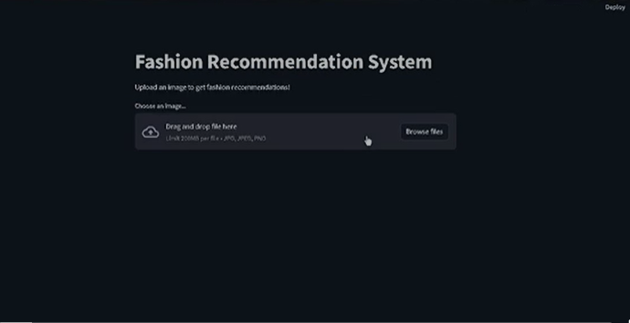

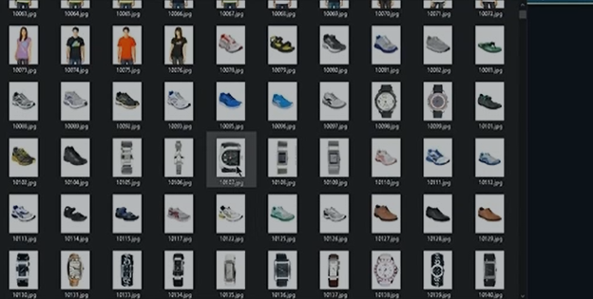

# Future Work

We hope to improve our future work by:

**Enhanced User Experience:** Explore ways to improve the overall user experience on the platform, such as implementing a more intuitive interface or enhancing search functionality.

**Mobile App:** Ensure the platform is optimized for mobile devices, given the increasing trend of shopping on smartphones and tablets, we hope to develop our own mobile application that is compatible with all mobiles

**Integration with Third-Party Tools:** Explore opportunities to integrate with third-party tools or services to enhance the functionality of the E-Commerce platform, such as integrating with CRM systems or analytics tools.

**Expanded Payment Options:** Research and incorporate additional payment options to cater to a broader range of customers, such as digital wallets or alternative payment methods.

**Enhanced Security Measures:** Constantly monitor and improve security protocols to safeguard customer data and prevent potential cyber threats, for example we might consider using Homomorphic encryption in the future.

**International Expansion:** Plan for the scalability of the platform to cater to international markets, which may involve language translations, currency conversions, and complying with different regulations.

**Feedback Mechanisms:** Implement feedback mechanisms to gather insights from customers and use the data to continuously improve the platform based on customer preferences and suggestions.

**AI and Automation:** We aim to improve our chatbot and our recommendation system to the best and latest of the AI updates to be always up to date.

These ideas and potential future developments can show stakeholders that the E-Commerce platform is forward-thinking and adaptable to meet the changing needs of the market and customers.

# References

Aws Amazon Lex. 2019. Amazon Lex. Available: https://aws.amazon.com/lex/. Accessed on May 6th, 2019.

Aws Amazon Personalize. 2019. Amazon Personalize. Available: <https://aws.amazon.com/personalize/> Accessed on April 8th, 2019.

Aws Amazon. 2018. What is AI? Available: <https://aws.amazon.com/vi/machine-learning/what-is-ai/> Ac- cessed on January 8th, 2019.

Aws. 2019. What is a Chatbot? Available: <https://aws.amazon.com/what-is-a-chatbot/> Accessed on April 8th, 2019.

Ayehu. 2018. 5 Practical Business Applications for Machine Learning. Available: [https://ayehu.com/blog-](https://ayehu.com/blog-practical-applications-machine-learning/) [practical-applications-machine-learning/](https://ayehu.com/blog-practical-applications-machine-learning/) Accessed on March 15th, 2019.

Bell, T. 2017. 4 business applications for natural language processing. Available: [https://www.cio.com/ar-](https://www.cio.com/article/3241814/4-business-applications-for-natural-language-processing.html) [ticle/3241814/4-business-applications-for-natural-language-processing.html](https://www.cio.com/article/3241814/4-business-applications-for-natural-language-processing.html) Accessed on March 15th, 2019.

Best Tech Guru. 2016. Available: [https://www.besttechguru.com/future-technology-explained-what-is-](https://www.besttechguru.com/future-technology-explained-what-is-artificial-intelligence/) [artificial-intelligence/](https://www.besttechguru.com/future-technology-explained-what-is-artificial-intelligence/) Accessed on April 14th, 2019.

Bonden, M. 2016. AI: its nature and future. 1 edition. Oxford: Oxford University Press.

Dbrain. 2018. 7 ways you can use artificial intelligence for business. Available: [https://hackernoon.com/7-](https://hackernoon.com/7-ways-you-can-use-artificial-intelligence-for-explosive-business-growth-528e8f557b97) [ways-you-can-use-artificial-intelligence-for-explosive-business-growth-528e8f557b97.](https://hackernoon.com/7-ways-you-can-use-artificial-intelligence-for-explosive-business-growth-528e8f557b97) Accessed on March 15th, 2019.

Duniya. 2019. Techno World. Available: [http://technoitworld.com/5-artificial-intelligence-fields-chang-](http://technoitworld.com/5-artificial-intelligence-fields-changing-way-things-work/) [ing-way-things-work/](http://technoitworld.com/5-artificial-intelligence-fields-changing-way-things-work/) Access on January 16th, 2019.

Elements of AI. 2018. Welcome to the Elements of Artificial Intelligence free online course. Available on the website: <https://www.elementsofai.com/> Accessed on January 25th, 2019.

Forsdick, S. 2018. Amazon future: Moving beyond e-commerce, onto the high-street and into our homes Available: https:/[/www.compelo.com/](http://www.compelo.com/amazon-future)a[mazon-future.](http://www.compelo.com/amazon-future) Accessed on April 12th, 2019.

Hall, E. 2016. Covergirl's influencer chatbot is smart, funny and responsive. Available: [https://ad-](https://adage.com/article/digital/covergirl-chatbot/307052/) [age.com/article/digital/covergirl-chatbot/307052/](https://adage.com/article/digital/covergirl-chatbot/307052/). Accessed on 8th February 2019.

Harvard Business Review. 2018. Putting Expert Systems to Work. Available: [https://hbr.org/1988/03/put-](https://hbr.org/1988/03/putting-expert-systems-to-work) [ting-expert-systems-to-work](https://hbr.org/1988/03/putting-expert-systems-to-work) Accessed on March 22nd, 2019.

Heath, N. 2018. What is AI? Everything you need to know about Artificial Intelligence. Available: <https://www.zdnet.com/article/what-is-ai-everything-you-need-to-know-about-artificial-intelligence/> Ac- cessed on January 8th, 2019.

InData Lads. 2018. The Most Exciting Applications of Computer Vision across Industries. Available: [https://indatalabs.com/blog/data-science/applications-computer-vision-across-industries?cli_ac-](https://indatalabs.com/blog/data-science/applications-computer-vision-across-industries?cli_action=1553281809.252) [tion=1553281809.252.](https://indatalabs.com/blog/data-science/applications-computer-vision-across-industries?cli_action=1553281809.252) Accessed on March 22nd, 2019.

Jacobsen, B. 2018. Future Proof. 5 Countries Leading the Way in AI. Available: [https://www.futuresplat-](https://www.futuresplatform.com/blog/5-countries-leading-way-ai-artificial-intelligence-machine-learning) [form.com/blog/5-countries-leading-way-ai-artificial-intelligence-machine-learning](https://www.futuresplatform.com/blog/5-countries-leading-way-ai-artificial-intelligence-machine-learning) Accessed on January 25th, 2019.

Jee, C. 2016. Uses of robotics in business: How will robots be used in future? Available: [https://www.techworld.com/picture-gallery/apps-wearables/uses-of-robotics-in-business-how-will-robots-](https://www.techworld.com/picture-gallery/apps-wearables/uses-of-robotics-in-business-how-will-robots-be-used-in-future-3649782/) [be-used-in-future-3649782/](https://www.techworld.com/picture-gallery/apps-wearables/uses-of-robotics-in-business-how-will-robots-be-used-in-future-3649782/) Accessed on March 15th, 2019.

Karazeev, A. 2018. What is better, computer vision or the artificial intelligence field? Available on the website: <https://www.quora.com/What-is-better-computer-vision-or-the-artificial-intelligence-field>. Ac- cessed on January 9th, 2019.

Kumar, C. 2018. Artificial Intelligence: Definition, Types, Examples, Technologies. Available: [https://medium.com/@chethankumargn/artificial-intelligence-definition-types-examples-technologies-](https://medium.com/%40chethankumargn/artificial-intelligence-definition-types-examples-technologies-962ea75c7b9b) [962ea75c7b9b](https://medium.com/%40chethankumargn/artificial-intelligence-definition-types-examples-technologies-962ea75c7b9b) Accessed on January 8th, 2019.

Linden, G. Smith, B. York, J. 2003. Industry report [https://www.cs.umd.edu/~samir/498/Amazon-Recom-](https://www.cs.umd.edu/~samir/498/Amazon-Recommendations.pdf) [mendations.pdf.](https://www.cs.umd.edu/~samir/498/Amazon-Recommendations.pdf) Accessed on April 8th, 2019.

Magneto. 2018. Revolution of Artificial Intelligence in E-Commerce 2019 – Infographic. Available: [https://magnetoitsolutions.com/infographic/ecommerce-artificial-intelli-](https://magnetoitsolutions.com/infographic/ecommerce-artificial-intelligence?fbclid=IwAR313mAkikGyIM28maxgYhQzeWpJvY8hUHcUwn5eDDgo_z37q-26JFLzJlY) [gence?fbclid=IwAR313mAkikGyIM28maxgYhQzeWpJvY8hUHcUwn5eDDgo_z37q-26JFLzJlY](https://magnetoitsolutions.com/infographic/ecommerce-artificial-intelligence?fbclid=IwAR313mAkikGyIM28maxgYhQzeWpJvY8hUHcUwn5eDDgo_z37q-26JFLzJlY) Ac- cessed on April 8th, 2019.

Masters blog. 2017. How to Develop a Personal Shopper App Based on Artificial Intelligence. Available: [https://medium.com/master-of-code-global/how-to-develop-a-personal-shopper-app-powered-by-data-in-](https://medium.com/master-of-code-global/how-to-develop-a-personal-shopper-app-powered-by-data-intelligence-and-humans-4dc8787a957) [telligence-and-humans-4dc8787a957.](https://medium.com/master-of-code-global/how-to-develop-a-personal-shopper-app-powered-by-data-intelligence-and-humans-4dc8787a957) Accessed on April 14th, 2019.

Microsoft and PwC. 2018. Uncovering AI in Finland. Available: [https://cdn2.hub-](https://cdn2.hubspot.net/hubfs/2185773/Julkaisut/uncovering-ai-in-finland.pdf) [spot.net/hubfs/2185773/Julkaisut/uncovering-ai-in-finland.pdf.](https://cdn2.hubspot.net/hubfs/2185773/Julkaisut/uncovering-ai-in-finland.pdf) Accessed on April 14th, 2019.

PerceptionBox. 2018. Available: [https://hackernoon.com/inspiring-examples-of-machine-learning-usage-](https://hackernoon.com/inspiring-examples-of-machine-learning-usage-in-business-7c6d60cde06e) [in-business-7c6d60cde06e.](https://hackernoon.com/inspiring-examples-of-machine-learning-usage-in-business-7c6d60cde06e) Accessed on March 15th, 2019.

Pofahl, A. 2018. AI in Ecommerce: How Can Artificial Intelligence Empower Online Businesses. Availa- ble: [https://labs.ebanx.com/en/marketing/ai-in-ecommerce-how-can-artificial-intelligence-empower-](https://labs.ebanx.com/en/marketing/ai-in-ecommerce-how-can-artificial-intelligence-empower-online-businesses/) [online-businesses/](https://labs.ebanx.com/en/marketing/ai-in-ecommerce-how-can-artificial-intelligence-empower-online-businesses/) Accessed on April 14th, 2019.

Raconteur. 2017. Artificial intelligence for business. Available: [https://s3.amazo-](https://s3.amazonaws.com/cdn.ayasdi.com/wp-content/uploads/2017/05/09112500/ai-for-business-special-report-2017.pdf) [naws.com/cdn.ayasdi.com/wp-content/uploads/2017/05/09112500/ai-for-business-special-report-](https://s3.amazonaws.com/cdn.ayasdi.com/wp-content/uploads/2017/05/09112500/ai-for-business-special-report-2017.pdf) [2017.pdf.](https://s3.amazonaws.com/cdn.ayasdi.com/wp-content/uploads/2017/05/09112500/ai-for-business-special-report-2017.pdf) Accessed on April 14th, 2019.

Ray, S. 2018. History of AI. Available: <https://towardsdatascience.com/history-of-ai-484a86fc16ef>. Ac- cessed December 2nd, 2018.

Reed, N. 2017. How Online Merchants Use Artificial Intelligence to Sell. Available on: [https://com-](https://commandc.com/merchants-use-artificial-intelligence-selling/) [mandc.com/merchants-use-artificial-intelligence-selling/](https://commandc.com/merchants-use-artificial-intelligence-selling/) Accessed on April 14th, 2019.

Robles, P. 2018. China plans to be a world leader in Artificial Intelligence by 2030. Available on: <https://multimedia.scmp.com/news/china/article/2166148/china-2025-artificial-intelligence/index.html>. Accessed on April 14th, 2019.

Rouse, M. 2019. Available on the TechTarget website: [https://searchenterpriseai.techtarget.com/defini-](https://searchenterpriseai.techtarget.com/definition/machine-learning-ML) [tion/machine-learning-ML.](https://searchenterpriseai.techtarget.com/definition/machine-learning-ML) Accessed on January 18th, 2019.

SAS. 2019. Natural Language Processing. Available: [https://www.sas.com/en_us/insights/analytics/what-](https://www.sas.com/en_us/insights/analytics/what-is-natural-language-processing-nlp.html) [is-natural-language-processing-nlp.html.](https://www.sas.com/en_us/insights/analytics/what-is-natural-language-processing-nlp.html) Accessed on January 18th, 2019.

Schultebraucks, L. 2017. A short history of Artificial Intelligence. Available: <https://dev.to/lschultebraucks/a-short-history-of-artificial-intelligence-7hm>. Accessed on December 2nd, 2018.

Sharma, P. 2018. Comprehensive Guide to build a Recommendation Engine from scratch (in Python). Available: [https://www.analyticsvidhya.com/blog/2018/06/comprehensive-guide-recommendation-en-](https://www.analyticsvidhya.com/blog/2018/06/comprehensive-guide-recommendation-engine-python/) [gine-python/](https://www.analyticsvidhya.com/blog/2018/06/comprehensive-guide-recommendation-engine-python/) Accessed on April 8th, 2019.

Shead, S. 2017. Amazon now has 45,000 robots in its warehouses. Available: [https://www.busi-](https://www.businessinsider.com/amazons-robot-army-has-grown-by-50-2017-1?r=US&IR=T&IR=T) [nessinsider.com/amazons-robot-army-has-grown-by-50-2017-1?r=US&IR=T&IR=T.](https://www.businessinsider.com/amazons-robot-army-has-grown-by-50-2017-1?r=US&IR=T&IR=T) Accessed on April 12th, 2019.

Srikanth. 2018. Artificial Intelligence Based Skin Advisor from Olay. Available: [https://www.techiex-](https://www.techiexpert.com/artificial-intelligence-based-skin-advisor-olay/) [pert.com/artificial-intelligence-based-skin-advisor-olay/](https://www.techiexpert.com/artificial-intelligence-based-skin-advisor-olay/) Accessed on 8th February 2019.

Statista. 2018a. Amazon - Statistics & Facts. Available: <https://www.statista.com/topics/846/amazon/> Ac- cessed on April 12th, 2019.

Statista. 2018b. Annual net revenue of Amazon. Available: [https://www.statista.com/statistics/266282/an-](https://www.statista.com/statistics/266282/annual-net-revenue-of-amazoncom/) [nual-net-revenue-of-amazoncom/](https://www.statista.com/statistics/266282/annual-net-revenue-of-amazoncom/) Accessed on April 12th, 2019.

Sterne, J. 2017. Artificial Intelligence for Marketing: Practical Applications. 1 edition. United States: Wiley and SAS Business Series.

Techopedia. 2018. Computer vision. Available: [https://www.techopedia.com/definition/32309/computer-](https://www.techopedia.com/definition/32309/computer-vision) [vision](https://www.techopedia.com/definition/32309/computer-vision) Accessed on January 18th,

TechTarget. 2018a. AI (artificial intelligence). [https://searchenterpriseai.techtarget.com/definition/AI-Ar-](https://searchenterpriseai.techtarget.com/definition/AI-Artificial-Intelligence) [tificial-Intelligence](https://searchenterpriseai.techtarget.com/definition/AI-Artificial-Intelligence) Accessed on January 8th, 2019.

TechTarget. 2018b. Expert system. Available on: [https://searchenterpriseai.techtarget.com/definition/ex-](https://searchenterpriseai.techtarget.com/definition/expert-system) [pert-system](https://searchenterpriseai.techtarget.com/definition/expert-system) Accessed on January 18th, 2019.

Tekoaly. History of Artificial Intelligence. Available: https://xn--tekoly-eua.info/tekoaly_historia/ Ac cessed on December 2nd, 2018.

Williams, S. 2018. Say Hello to Your Own Amazon Lex Chatbot. Available: [https://tutori-](https://tutorials.botsfloor.com/say-hello-to-your-own-amazon-lex-chat-bot-9f22e7a0f9b0) [als.botsfloor.com/say-hello-to-your-own-amazon-lex-chat-bot-9f22e7a0f9b0](https://tutorials.botsfloor.com/say-hello-to-your-own-amazon-lex-chat-bot-9f22e7a0f9b0) Accessed on April 8th, 2019.

Wingfield, N. 2017. As Amazon Pushes Forward with Robots, Workers Find New Roles. Available: <https://www.nytimes.com/2017/09/10/technology/amazon-robots-workers.html>. Accessed on April 14th, 2019.