| Name | ID |
| --- | --- |
| عز الدين أحمد صابر محمد | 20200325 |
| مصطفى عمر محمد | 20200542 |
| أحمد هاني إبراهيم | 20200054 |
| عبد الرحمن رمضان ابو العلا ابو العلا جغل | 20200284 |

**nursing agent**

**Problem definition and planning:**

* Delivering packages on the hospital floor from the store to the rooms.

**Environment type:**

* Accessible => since the agent has complete, accurate and up-to-date information about the environment’s state (# rooms, their location, location of packages and their names).
* Deterministic => there is no uncertainty about the state that will result from performing an action.
* Episodic => the agent can decide what action to perform based only on the current episode.
* Static => the environment remain unchanged except for the performance of actions by the agent.
* Discrete => the environment has states and actions have a finite number of distinct values (left, right, forward, backward, etc...).

**Agent type:**

* Proactive agent (goal directed).

**PEAS:**

* Performance measure:
  + The number of packages delivered correctly.
  + The time taken to deliver.
* Environment:
  + hospital’s floor , rooms , store , patients , doctors.
* Actuators:
  + wheels, cart , hands.
* Sensors:
  + camera, package scanner , infrared wall sensors , infrared door sensors.

**Initial state:**

* The agent starts in the store unloaded.

**Goal test:**

* The agent returns to the store empty once more.

**Actions:**

* Each state has exactly 6 actions:   
  {move forward denoted as (F), move backwards denoted as (B), move right denoted as (R), move left denoted as (L) Put the package denoted as (P), Grab the package denoted as (G)}

**Path costs:**

* Each move or action has a cost of 1.
* Note that the floor is divided into 2 sections each parallel to 2 rooms.

**Transition model:**

* + - The agent can’t do the following in the store when unloaded (L),(R),(B),(P) but can do (G) and become loaded, (F) and head to the floor.
    - The agent can’t do the following in the store when loaded (L),(R),(B),(G) but can do (F) and head to the floor,(P) and become unloaded.
    - The agent can’t do the following in room 1 and room 2 (leftmost rooms) when loaded (F),(B),(L),(G) but can do (R) and head to the floor,(P) and deload.
    - The agent can’t do the following in room 1 and room 2 (leftmost rooms) when unloaded (F),(B),(L),(P) but can do (G) and load,(R) and head to the floor.
    - The agent can’t do the following in room 3 and room 4 (rightmost rooms) when unloaded (F),(B),(P),(R) but can do (G) and load,(L) and head to the floor.
    - The agent can’t do the following when in room 3 and room 4 (rightmost rooms) when loaded (F),(B),(G),(R) but can do (L) and head to the floor ,(P) and deload.
    - The agent can’t do the following when in the upper section of the floor (P),(G) but can do (R) and head to room 3,(L) and head to room 1,(F) and head to the lower floor,(B) and head back to the store.
    - The agent can’t do the following when in the lower section of the floor (F),(P),(G) but can do (R) and head to room 4,(L) and head to room 2,(B) and go back to the upper floor.

**A solution from initial state to goal state:**

* To load the packages from the store.
* Move forward to the upper section of the floor.
* Move left to room 1.
* Put down the room’s package.
* Move right to the upper section of the floor.
* Move right to room 3.
* Put down the room’s package.
* Move left to the upper section of the floor.
* Move forward to the lower section of the floor.
* Move left to room 2.
* Put down the room’s package
* Move right to the lower section of the floor.
* Move right to room 4.
* Put down the room’s package
* Move left to the lower section of the floor.
* Move backwards to the upper section of the floor.
* Move backwards to the store.

State graph:

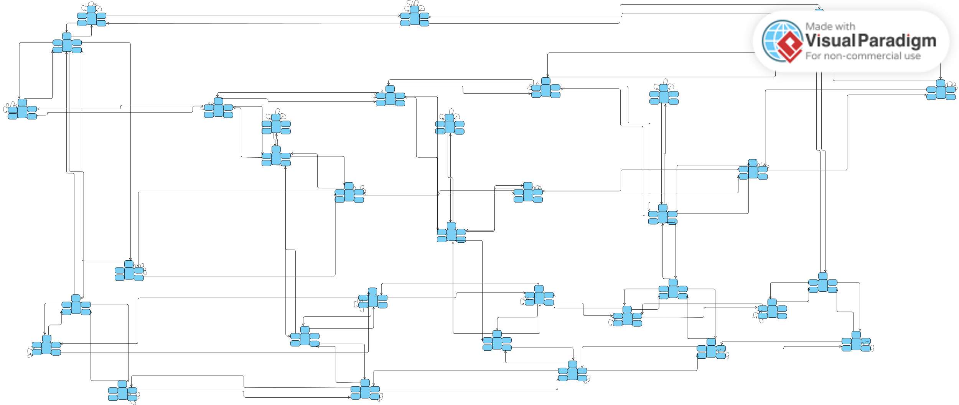

(In the discussion we’ll explain on an svg version that we can zoom in through)