**Session 2**

**Alphabets Word Example**

**N** / **n N**oseI have a big **n**ose.

**O** / **o O**range I eat an **o**range.

**P** / **p P**encil I write with a **p**encil.

**Q** / **q Q**uiet I am **q**uiet in the class.

**R** / **r R**ed The flowe**r** is **r**ed.

|  |  |  |
| --- | --- | --- |
| **S**/**s** | **S**un | The **s**un is far. |
| **T**/**t** | **T**able | I si**t** on **t**he **t**able. |
| **U**/**u** | **U**p | Stand **u**p. |
| **V**/**v** | **V**isit | I **v**isit my friend. |
| **W**/**w** | **W**hite | The jacket is **w**hite. |
| **X**/**x** | **X** ray | I do **X** ray. |
| **Y**/**y** | **Y**ellow | The sun is **y**ellow |
| **Z**/**z** | **Z**oo | The **z**oo is in Gi**z**a |

**EX1: Fill the gaps:**

* I …………. ………………… .
* Girls …………….. in the ………………. .
* I am …. ………….. ………. .
* The ……………… is ……… .
* I …………. a big …………… .
* I ……….. an …………………. .
* I …………. with a ……………… .
* I am ………… in the …………….. .
* The ………….. is ……….. .
* I sit on the table.
* Stand ….
* The ….. is in Giza.
* The ….. is far.
* The sun is ……
* I do …..
* The jacket is …...
* I …… my friend.

for Mr we say "Mister"  
for Mrs we say "Misses"  
for Miss we say "Miss"  
for Ms we say "Mizz"

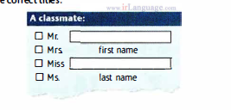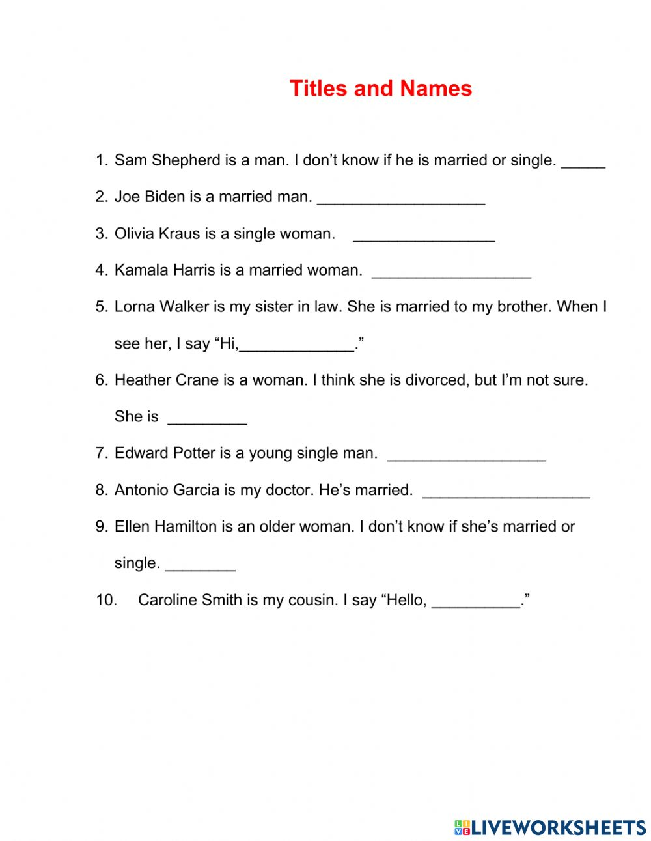****

| **Common** |  | **Proper** |
| --- | --- | --- |
| *boy* | *⇒* | *Ahmed* |
| *Girl* | *⇒* | *Sara* |
| *river* | *⇒* | *Nile River* |
| *car* | *⇒* | *Ford* |
| *doctor* | *⇒* | *Doctor Adam* |
| *City* | *⇒* | *Cairo* |
| *Café* | *⇒* | *Starbucks* |
|  |  |  |

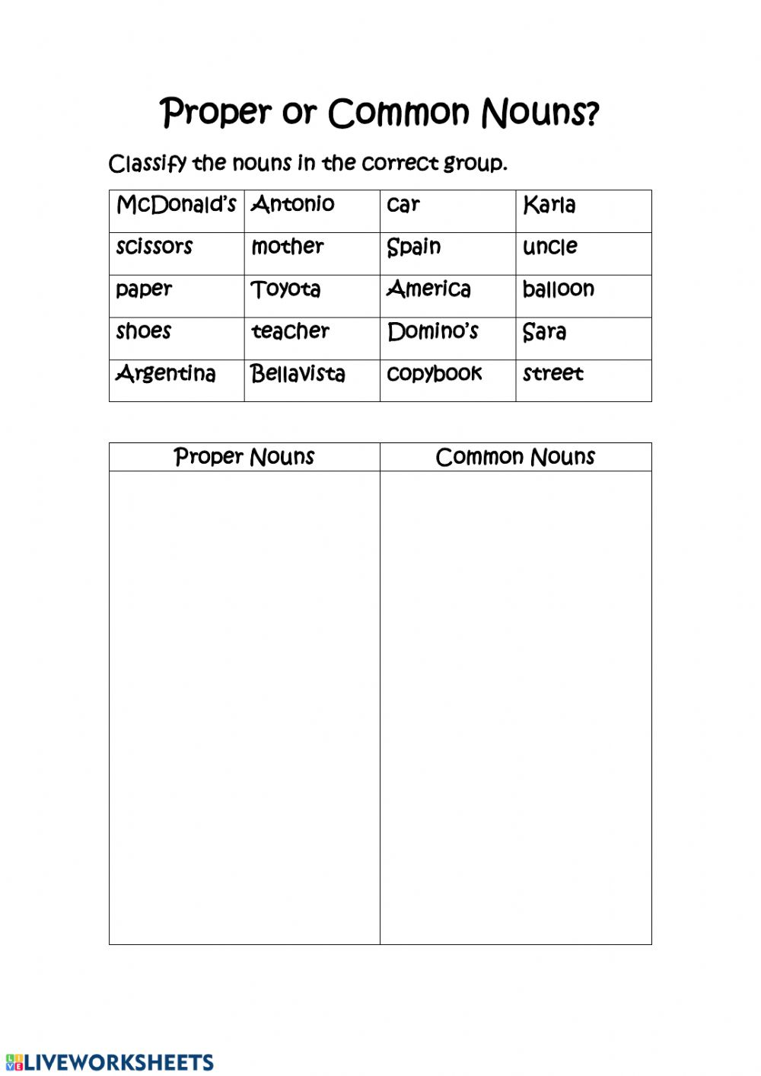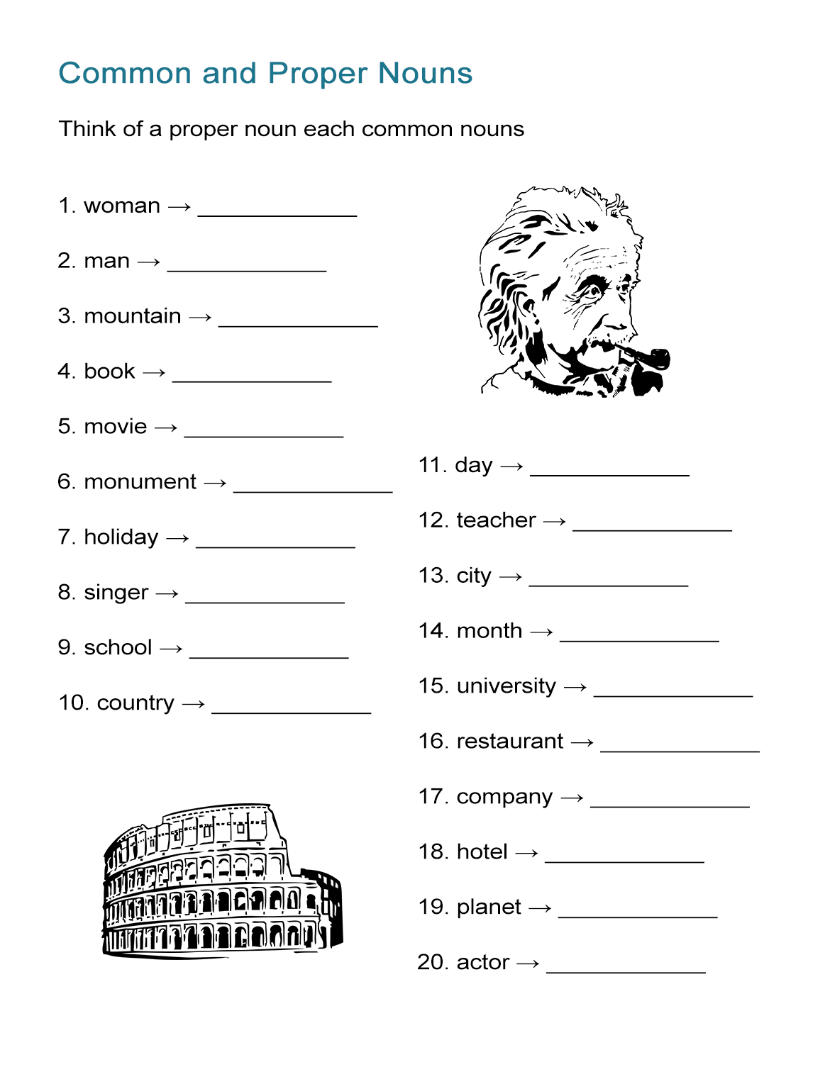

Vocabulary

|  |  |  |  |
| --- | --- | --- | --- |
| ***Word*** | | ***Picture*** | ***Example*** |
| Pen [n] | |  | I write with the **pen**. |
| Go [v] | |  | I **go** to school. |
| Open &  Close[v] | |  | Close the door – open the book |
| Library [n] | |  | I read in the **library**. |
| Drink[v] | |  | I **drink** juice. |
| Friend [n] | |  | Ayah and Omar are **friends**. |
| play [v] | |  | Samaya plays at school. |
| ball [n] | |  | They play foot**ball**. |
| Sky [n] | |  | The sun is in the **sky**. |
| Die & live [v] | |  | I **live** in Cairo and I will **die** in Cairo. |
| Brown [n] | |  | The door is **brown**. |
| Cat [n] | |  | I love **cats**. |
| Blue [n] | |  | The sky is **blue**. |
| Time [n] | |  | What is the **time**? |
| Black [n] | |  | The sky is **black** at night. |
|  |