# Introduction

Recently, a lot of Syrian restaurants opened in Greater Cairo, Egypt, as more and more Syrian people came to Egypt because of the civil war in Syria. The Syrian food gained a lot of attention and admiration from Egyptians to a degree that many Egyptians launched new Syrian food restaurants. However, there exist a lot of districts in Greater Cairo that still prefer traditional Egyptian restaurants.

# Problem

What are the districts of Greater Cairo that are likely to be suitable for a new series of Syrian restaurants, and what are the districts that are likely to discourage this?

# **Data**

the names of the districts of Greater Cairo and their population statistics are scrapped from the internet. This page contains data on names of Greater Cairo district, population over years, areas in km and many other information: <https://www.citypopulation.de/php/egypt-greatercairo.php>

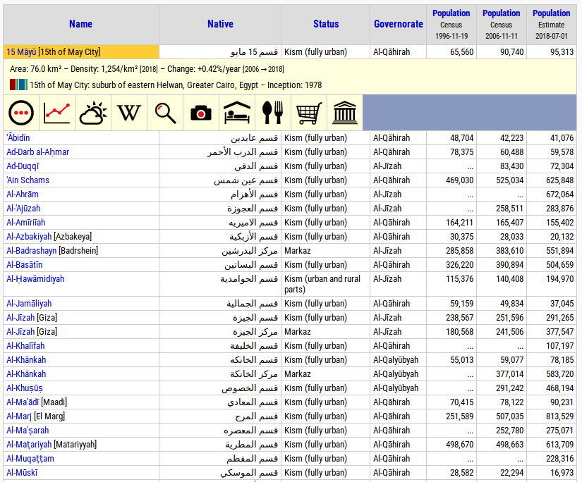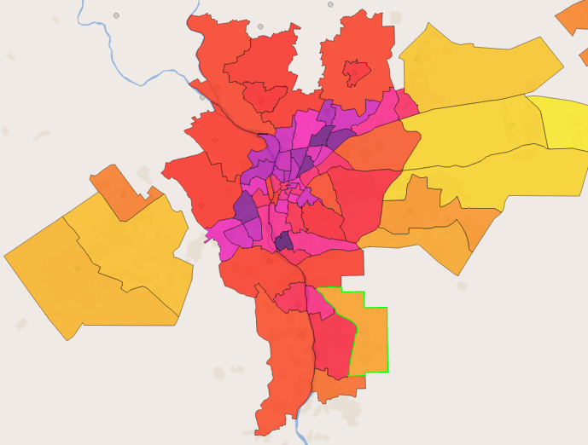

The location of each district in terms of attitude and longitude are retrieved using geocoding service and APIs. LocationIQ is one of the free geocoding services, that takes an address and returns the location: <https://locationiq.com/>

Foursquare City Guide, commonly known as Foursquare, is a local search-and-discovery service which provides personalized recommendations of places to go near a user's current location based on users' previous browsing history and check-in history, as well as browsing all the venues in a location. Venues data are collected using Foursquare APIs: <https://foursquare.com/>

# Approach

* Collect Greater Cairo data and clean it
* Get the location data for each dostrict
* Using FourSquare API we will find all Syrian and Egyptian venues for each neighborhood.
* Based on the ratio of Syrian to Egyptian restaurants, and population density of the district, classify each one whether it is a good recommendation for new Syrian business, neutral, or bad.
* Visualize the results on a map of greater cairo

The districts are clustered using kmeans technique into 3 clusters: Highly recommended districts, Slightly recommended districts, and Not recommended districts.

# Results

These results are obtained from the previous analysis

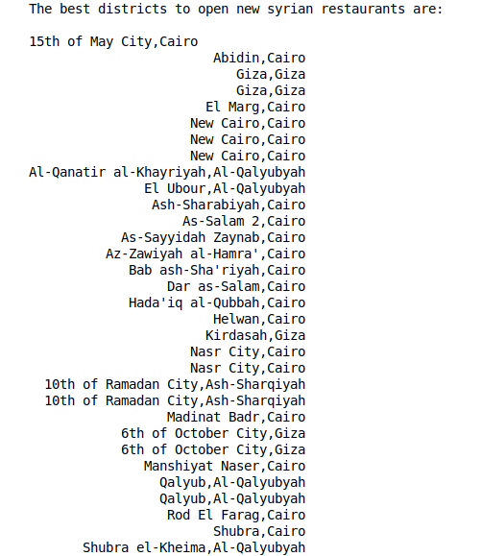

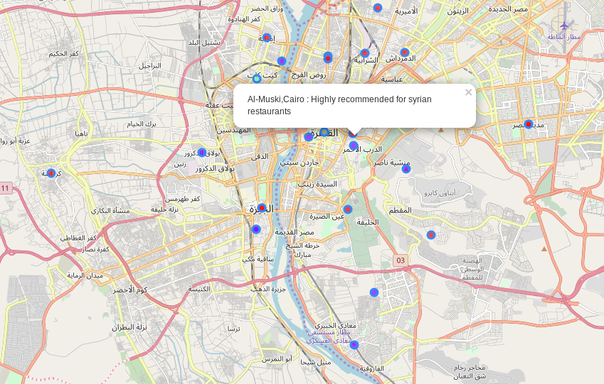

# Discussion

The results showed that the algorithm determined the cluster of each district by combining the number of existing Syrian restaurants, Egyptian restaurants, and population. Whether the district is low or high in population by a threshold and the number of both types of restaurants are comparable or slightly different, it is put in the low recommendation cluster. whether district is low or high in population and the number of Egyptian restaurants is much higher, it is not recommended. If it is high in population and the numbers are comparable, it is a high recommendation … etc.

