**Procedures**

* **Insert_New_Customer** – Adds a new customer to the **Customers** table using provided details such as customer ID, company name, contact information, address, and phone/fax numbers.

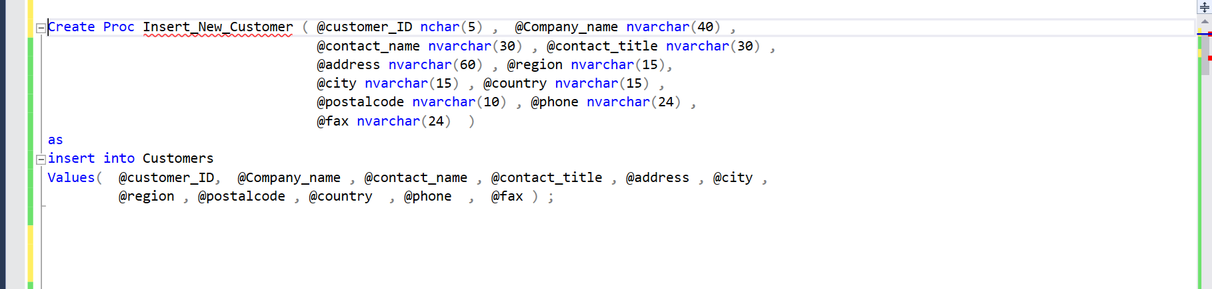

* **Insert_New_Product** – Inserts a new product into the **Products** table, including product name, supplier ID, category ID, quantity per unit, unit price, stock levels, reorder level, and whether the product is discontinued.

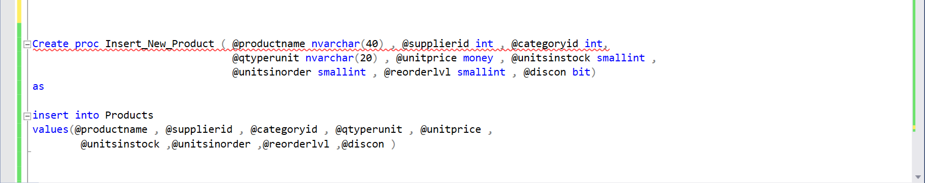

* **Insert_New_Order** – Creates a new order in the **Orders** table with customer ID, employee ID, shipper ID, shipping details, and freight cost. It also retrieves the shipper's name from the **Shippers** table and assigns an estimated shipping date.

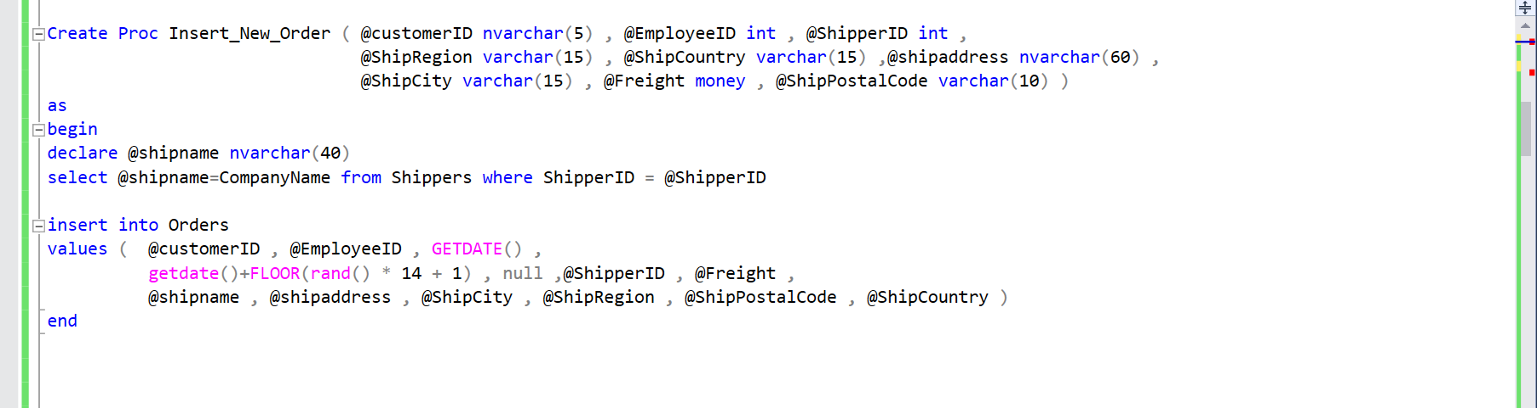

* **Update_ShipDate_Order** – Updates the shipping date of an existing order in the **Orders** table based on the provided order ID and ship date.

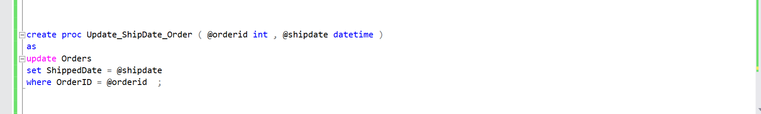

* **Insert_Order_Detail** – Adds a new order detail entry into the **Order Details** table, including product ID, quantity, discount, and unit price, which is fetched from the **Products** table.

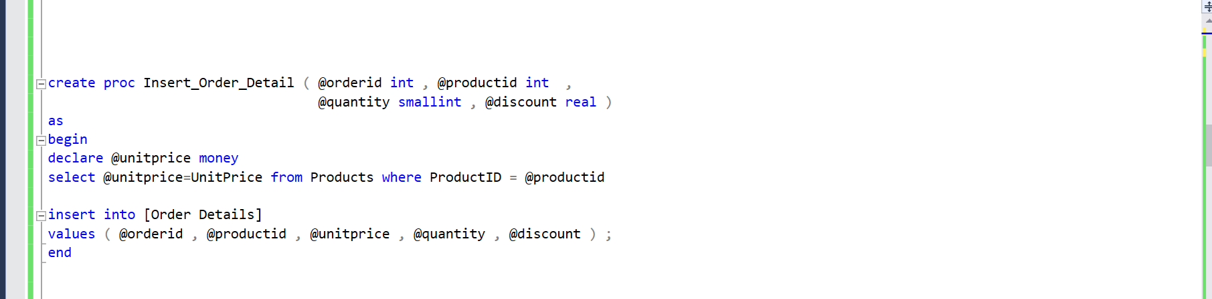

* **Get_Orders_by_Customer** – Retrieves all orders placed by a specific customer, identified by their customer ID, from the **Orders** table.

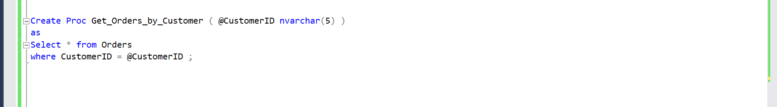

* **Get_Order_Details_by_OrderID** – Fetches all details of a given order, including products, quantity, and discounts, from the **Order Details** table based on the order ID.

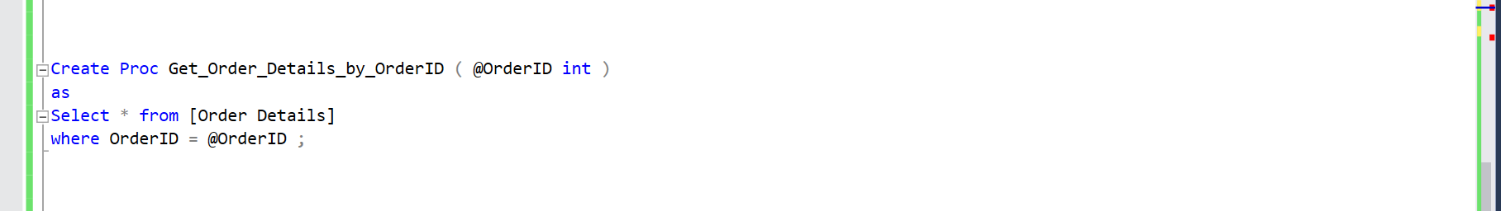

* **Calculate_Total_Sales_by_Employee** – Computes the total sales made by a specific employee by summing up order freight costs and total product costs from the **Orders** and **Order Details** tables.

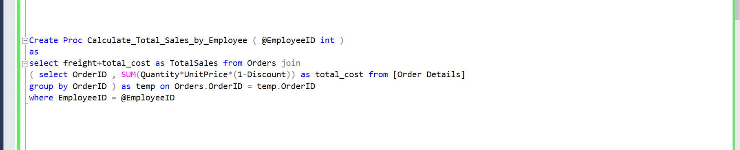

* **Get_Products_by_Category** – Returns a list of all products that belong to a specific category by joining the **Products** and **Categories** tables based on the category name.

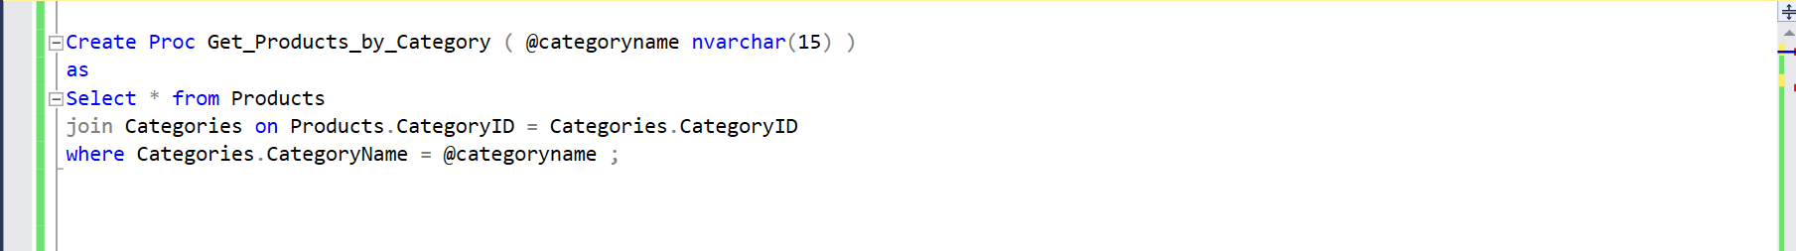

* **Get_Orders_Shipped_By_Specific_Shipper** – Retrieves all orders that were shipped using a specific shipping company by matching the shipper's company name in the **Shippers** table.

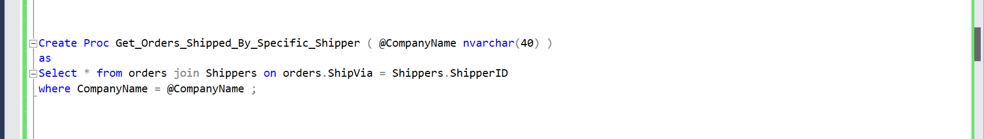

* **Get_Customers_By_Country** – Counts and returns the total number of customers from a specific country by filtering the **Customers** table based on the country name.

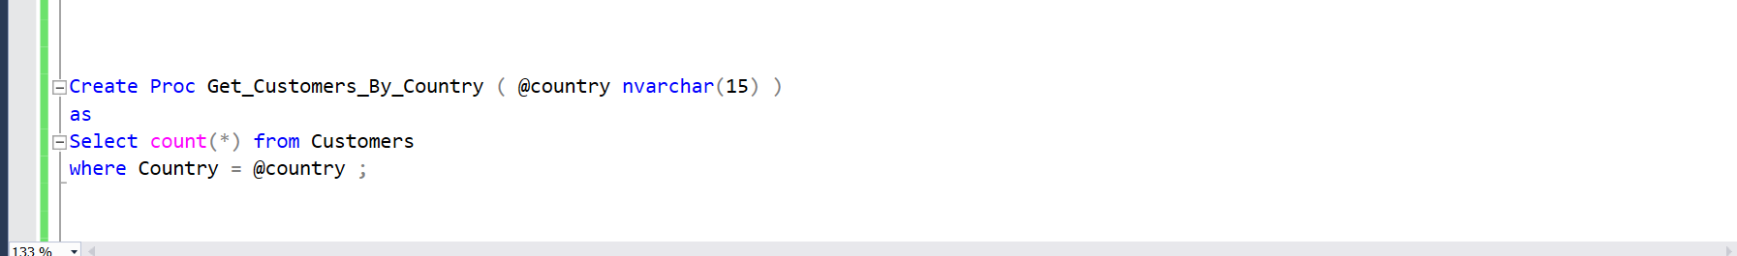

* **Get_Products_Out_Of_Stock** – Retrieves a list of all products that currently have zero stock from the **Products** table.

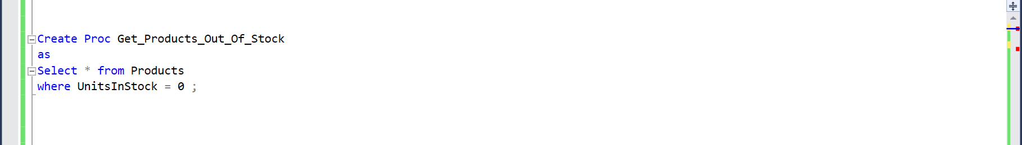

* **Get_Orders_Placed_In_Specific_Date_Range** – Returns all orders that were placed within a specified date range by filtering records from the **Orders** table based on order date.

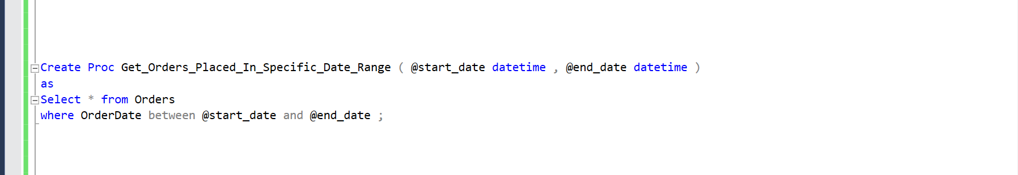

* **Delete_Order** – Deletes an order and all its associated details from the **Orders** and **Order Details** tables based on the order ID.

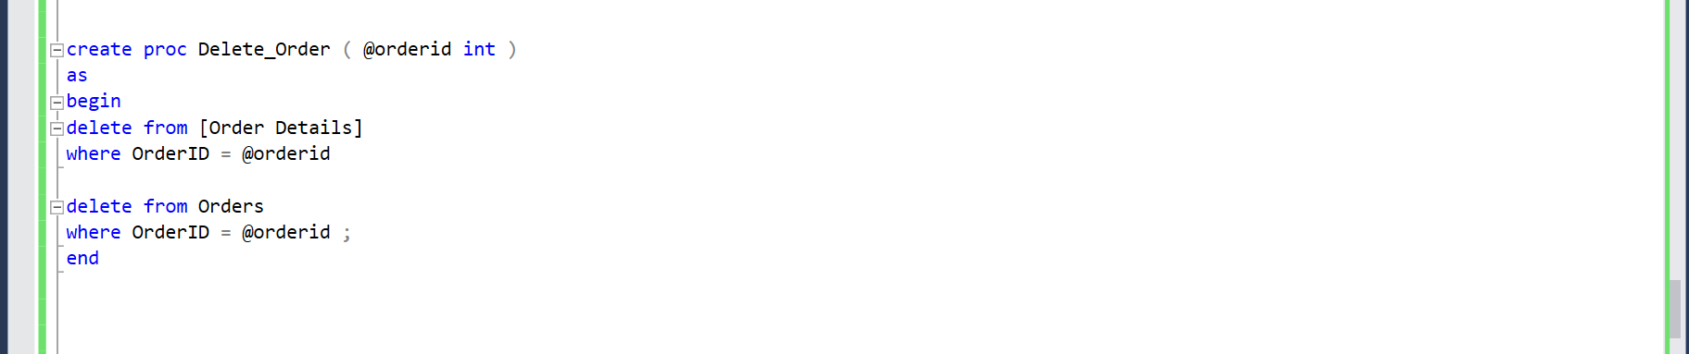

* **Delete_Order_Detail** – Removes a specific product from an order in the **Order Details** table by using the order ID and product ID.

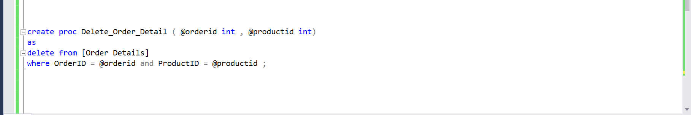

* **Get_Order_Sales_By_Month** – Calculates and returns the total sales for a given year and month by summing up freight costs and product sales from the **Orders** and **Order Details** tables.

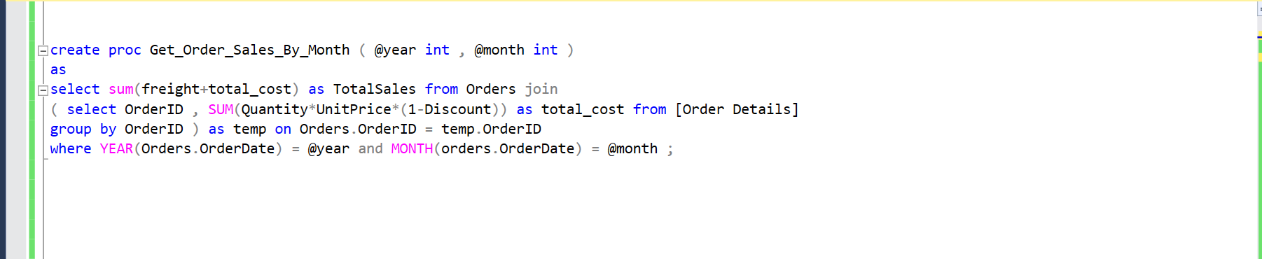

* **Get_Total_Revenue_By_Category** – Computes the total revenue for each product category by summing up the sales of all products in the **Order Details** table and grouping them by category.

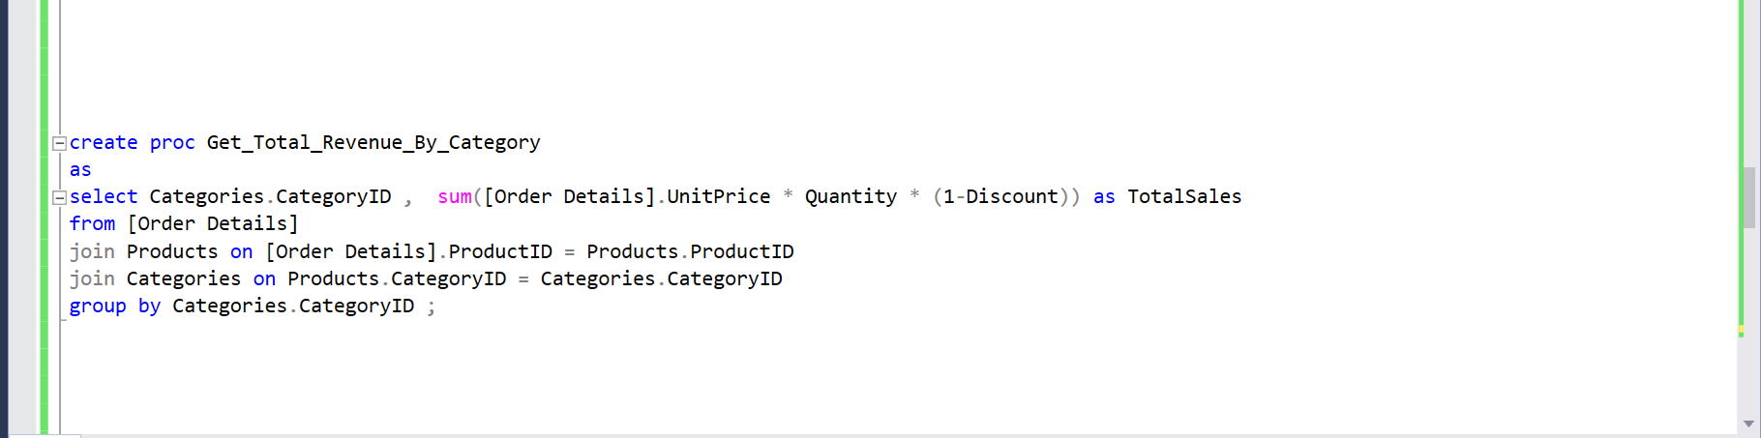

* **Get_Order_Status** – Determines the current status of an order. If the order has not been shipped, it returns **"In Process"**; if it has been shipped, it returns **"Shipped"**; otherwise, it returns **"Unknown"**.

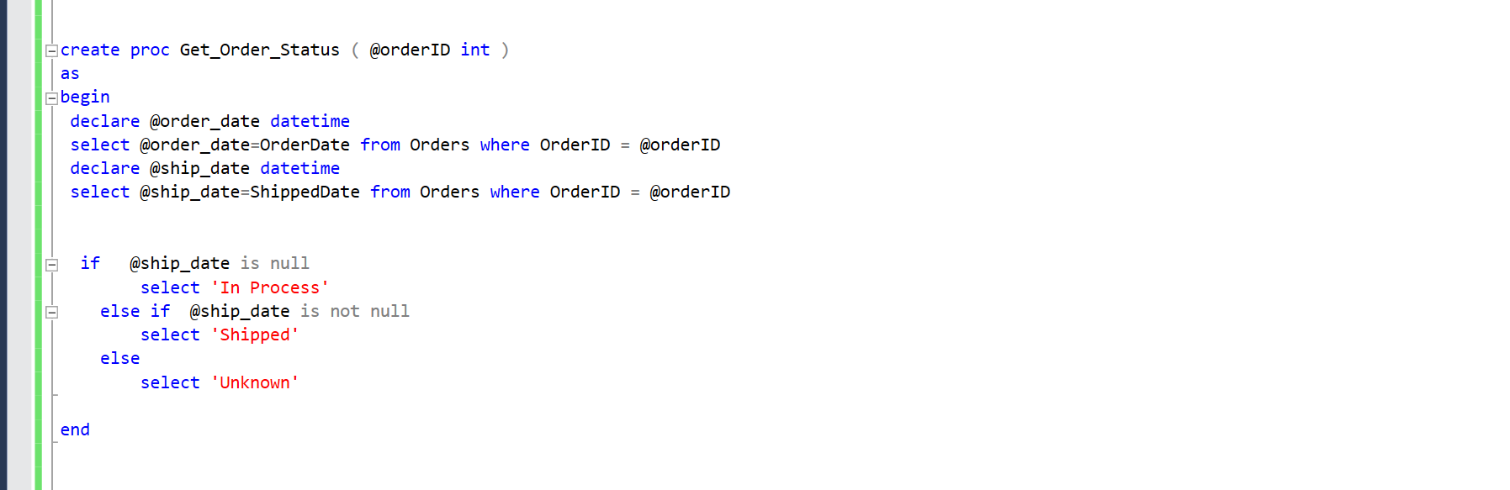

* **get_inactive_customers** – Identifies customers who have not placed any orders within the last given number of months by comparing the most recent order dates.

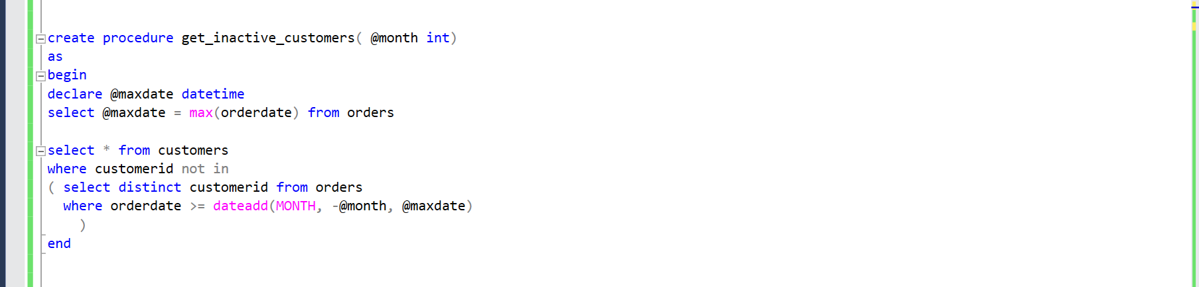

* **CheckStock** – Checks if a product has enough available stock for a requested quantity. If sufficient stock is available, it confirms availability; otherwise, it returns a message indicating the current available quantity.

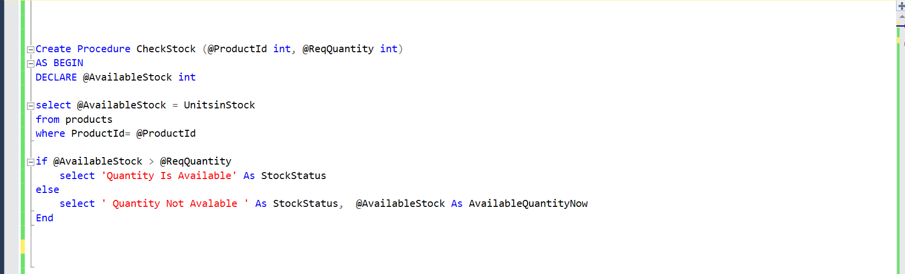

**Views**

* + **Customer_Order_History** – Displays the total sales for each customer by summing up order freight costs and product sales from the Orders and Order Details tables.

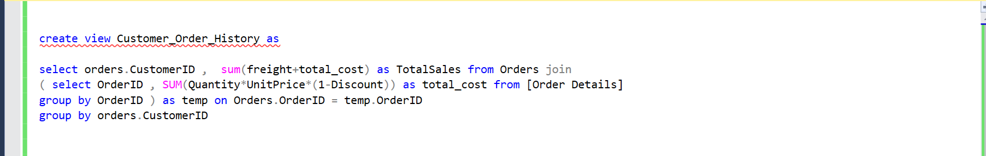

* + **Employees_Performance** – Shows employee performance by calculating the total sales handled by each employee, including order freight and product sales. Employees are listed by their full name and sorted by employee ID.

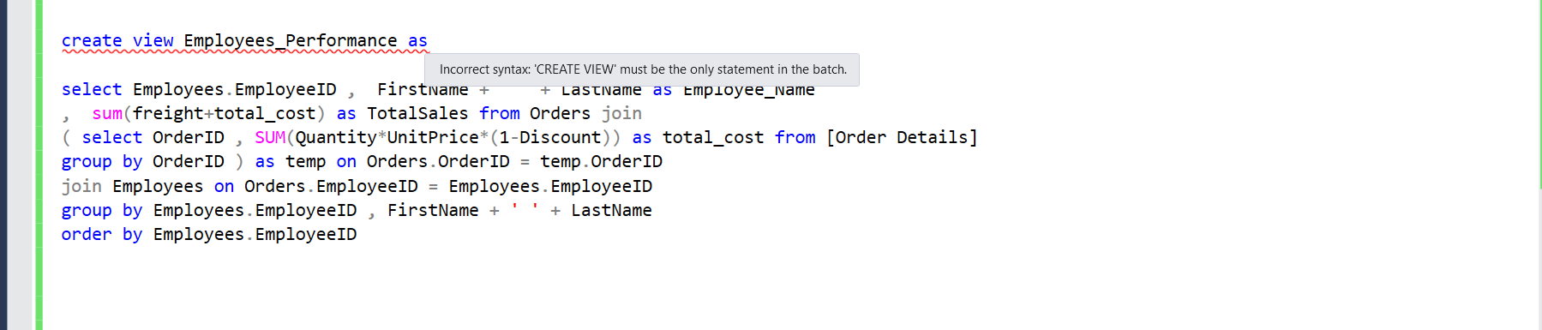

* + **Supplier_Product_List** – Provides a list of suppliers and their respective products, including supplier ID, company name, product ID, product name, and available stock. The results are ordered by supplier ID.

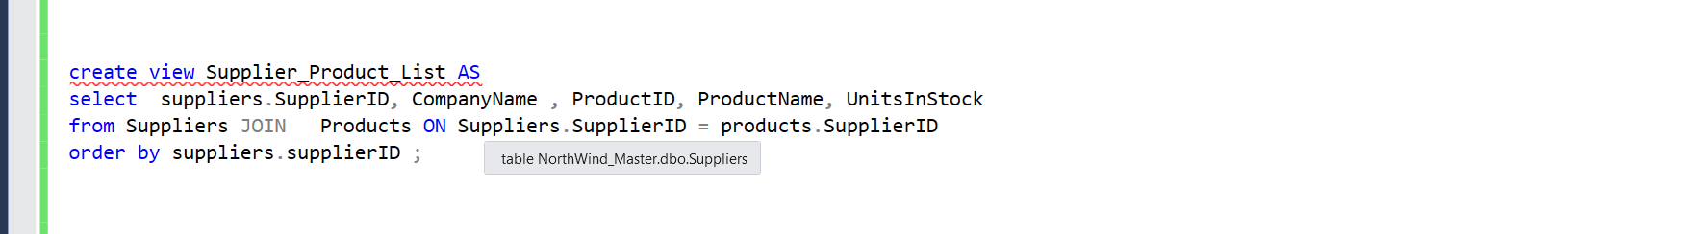

* + **Top_Selling_Products** – Displays the top 10 best-selling products based on total sales revenue. It includes product ID, product name, total sales amount, and the number of orders each product was included in. The results are sorted in descending order of total sales.

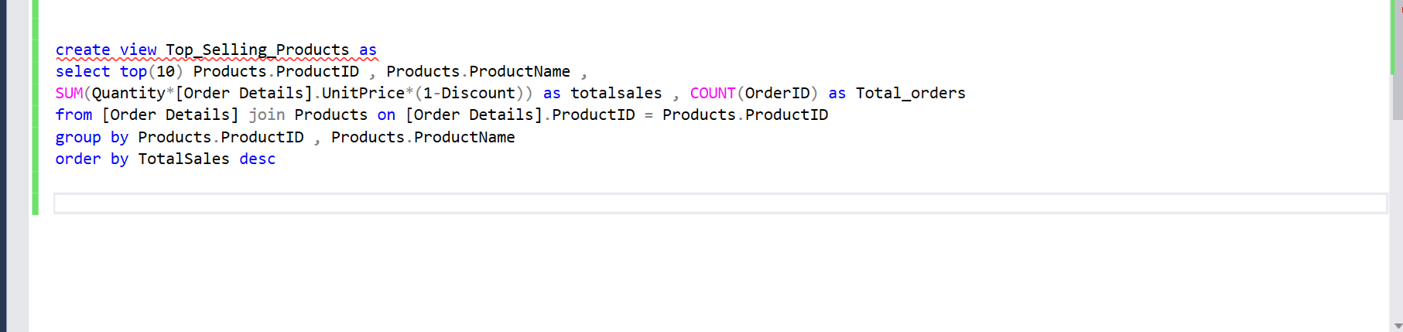

**Triggers**

### **Trg_Check_Stock_Before_Order -** This trigger ensures that an order cannot be placed if the requested quantity of a product exceeds the available stock.

