Conservation of Mechanical Energy in a Vertical Spring
1 Objectives
1- Verifying Hooke’s law and determining the Spring Coefficient k.
2- Demonstrating and Verifying the conservation of Mechanical Energy using a Vertical Spring.
2 Theory
As shown in the figure below , a spring is attached vertically, the length of the spring is L. There is 3 positions the spring can be in:
(a) It’s Natural Equilibrium position, with no masses hanged on it . the spring takes it’s natural length L.
(b) A mass m is hanged on the spring , it will be stretched with a displacement s to it’s Equilibrium position. There is two forces at that position : The grav itational force downwards F = mg and the Hooke’s force upwards F = −ks where k is called the spring Coefficient . Since the net force is 0 at that position then the forces will be equal
mg = ks
(c) The spring is stretched downwards with displacement x from the Equi librium position. At that point the energy is the summation of the gravita tional potential energy = −mgx and the elastic potential energy stored in the spring=¹₂k(s + x)², while the kinetic energy is 0..
When released, it will oscillate around the Equilibrium position, converting potential energy to kinetic energy and vice versa.
The total energy at Equilibrium position will be summation of kinetic energy=¹₂mv² and the elastic potential energy stored in the spring=¹₂ks² where v is the speed.
Based on this , and using of Conservation of Mechanical energy, we can drive a 1
relation between the speed vand displacement x as done below. 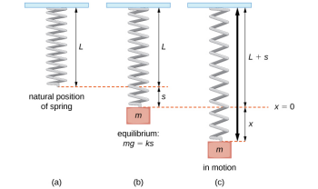₂k(s + x)² _{− mgx =}¹₂mv² ₊¹₂ks²
1
₂ks² ₊¹₂kx² ⁺✄✄✄¹₂^{k}_{✁2sx − mgx =}¹₂mv² +
1
₂kx² + ✚✚❃mg
1 ₂ks²
1
_{ksx − mgx =}¹₂mv²
₂kx² ⁺✘mgx✘ ⁻✘mgx✘ ₌¹₂mv² 1
v =
^{r}k
_{m}x
2
3 Setup
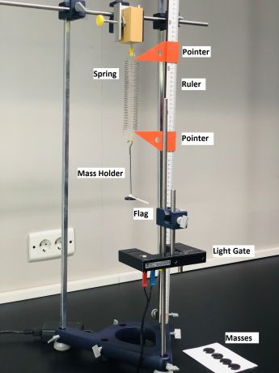3
4 Tasks
4.1 Task 1 : Verification of Hooke’s law and computing the spring coefficient k
1- Adjust the higher orange pointer on the ruler at the bottom of the spring in the position of it’s natural equilibrium (i.e spring without the holder).
2- Hang the holder on the spring , Adjust the lower orange pointer at the bottom of the spring , and get the displacement from the difference between the two pointers. Repeat the step 3 trials
3- Repeat steps 1 and 2 for added masses 10,20,30,40 gm, and compute the average displacements and their uncertainties.
4- Draw the graph between the displacement and mass to get the spring co efficient k.
4.2 Task 2 : Relation between Speed and Displacement from equilibrium position with constant Mass
1- Put a constant mass on the holder 20 gm + 10 gm the mass of the holder, and attach the plastic flag to the holder.
2- Measure the diameter of the flag using a suitable measuring device .
3- Adjust the position of the light gate to equilibrium position, ensure this by checking that the flag cuts the gate at this position (i.e the gate always gives a reading at that position).
4- Use the ruler and the orange pointers on it to determine the Displacement 1 cm from the equilibrium position, the higher pointer at the center of the gate and the lower one at Displacement 1 cm from it.
5- Gently stretch the spring downwards from the holder with the determined displacement in step 4. A way to do so is to move the higher orange pointer away, rotate the ruler 90 degrees then stretch the spring until it touches the lower orange pointer.
Precautions: - Ensure the orange pointer doesn’t change from it’s position when the flag touches it.
- The spring must be stretched vertically, ensure so by looking per pendicular on it from the side.
4
6- Reset the gate and then release the spring as gently as possible (to avoid any extra force or movement of the flag in dimensions other than the vertical) , then Measure the time with which the flag cuts the light gate.
7- Repeat steps 4 to 6 three trials, and compute the average time and it’s un certainty. Using the flag diameter and the average time to compute the average instantaneous speed of the flag at the equilibrium position and it’s uncertainty.
8- Repeat steps 4 to 7 for Displacements 2 ,3,4, and 5 cm.
9- Draw the graph between the stretched displacement and the instantaneous speed ( with their error bars) , determine the slope and compare it with the theoretical value of the slope (use k from task 1).
4.3 Task 3 Relation between Speed and Mass with con stant Displacement from equilibrium
1- Repeat steps 1 to 6 in the previous task at constant Displacement 2 cm from the equilibrium position for masses 10,20,30,40,50 gm ( the holder alone is 10 gm ). Adjust the position of the gate each time to the equilibrium position
2-Draw the graph between ¹_{m} and V²( with their error bars) , determine the slope and compare it with the theoretical value of the theoretical value of the slope (use k from task 1).
5

