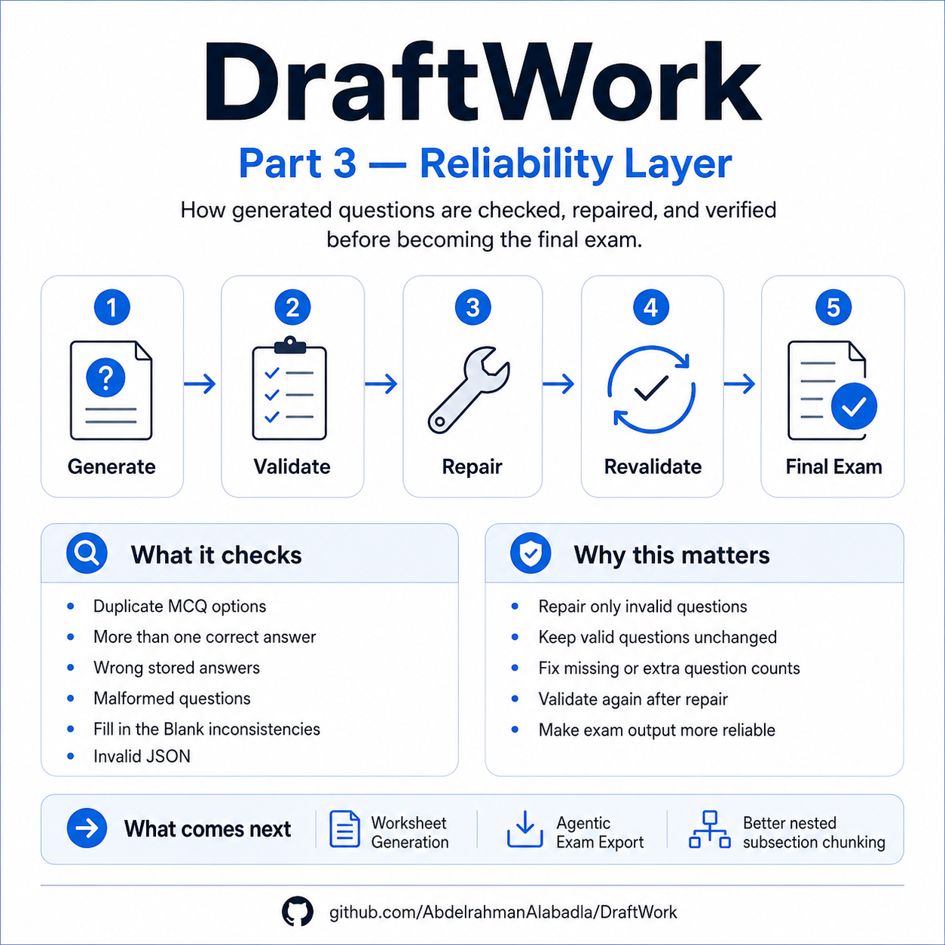 | IT Exam  Model 1 | 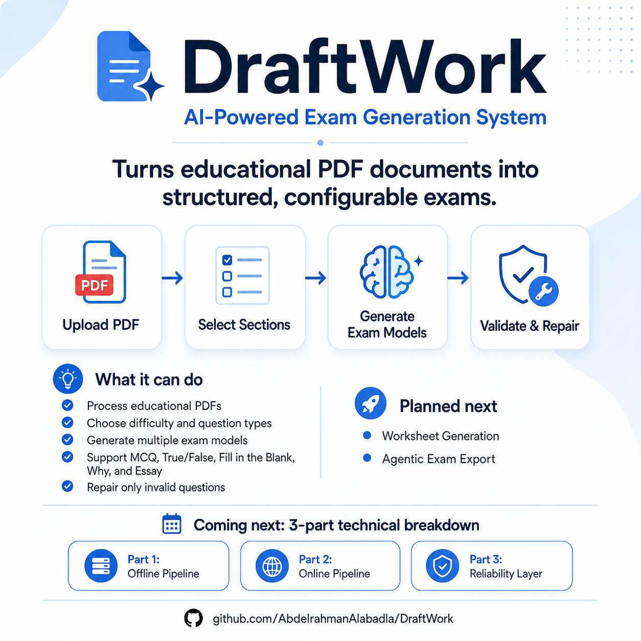
Class: Grade 12 | Duration: 45 min | Date: 2026-08-28 | Teacher: Mr. Khalid
Student Name: ______________________________________ Class: ______________

Multiple Choice Questions
Q1. Which of the following is an example of static data?
A. Live sports results | B. UK weather map updated daily
C. Column headings for a football league table | D. News feeds on a mobile phone app

Q2. What is the main difference between direct and indirect data sources?
A. Direct data is always more accurate than indirect data | B. Indirect data is collected for a different purpose
C. Direct data cannot be used for any other purpose | D. Indirect data is stored in the same format as direct data

Q3. What is the purpose of coding data?
A. To increase file size for storage | B. To represent data using numbers or symbols for identification
C. To encrypt sensitive information | D. To store text in a more readable format

Q4. What is the bit rate of a sound file with a sample rate of 44.1 kHz, bit depth of 16 and two channels?
A. 88.2 kbps | B. 1.4 mbps
C. 37 mbps | D. 1411.2 kbps

Q5. How does resolution affect video file size?
A. Higher resolution increases the number of frames per second | B. Lower resolution reduces the bit rate required for storage
C. Resolution has no effect on file size | D. Higher resolution decreases the need for compression

Q6. What is encryption?
A. A method of encoding data to make it unreadable without a key | B. A way to compress audio files without losing quality
C. A process used to store text in binary format | D. A technique for increasing file size for storage

Q7. What is the purpose of a range check in data validation?
A. To ensure that data falls within an acceptable numerical range | B. To confirm that all required fields are completed
C. To verify that data matches a specific format | D. To ensure that data is entered only once

Q8. How does SSL/TLS use symmetric keys?
A. SSL/TLS uses symmetric keys for encryption and decryption | B. SSL/TLS uses asymmetric keys for secure communication
C. Symmetric keys are used to encrypt data, while the private key is used for decryption | D. SSL/TLS does not use symmetric keys

Q9. What is the purpose of a Wi-Fi network key?
A. To allow multiple devices to connect to the same network | B. To encrypt data transmitted over the network
C. To identify and authenticate users on the network | D. To manage bandwidth usage on the network

Q10. Which of the following is a data validation rule for dates?
A. Range check | B. Format check
C. Presence check | D. Length check

Fill in the Blank
WORD BANK
decryption | dynamic data | coding | knowledge | encryption | static data | information
Q1. Data that does not normally change is called ________.
Q2. The process of representing data by assigning a code to it for classification or identification is known as ________.
Q3. To make data meaningful, it needs to be given context and transformed into ________.
Q4. The process of scrambling data so it cannot be understood without a decryption key is called ________.
Q5. Knowledge requires a person to understand what ________ is, based on their experience and knowledge base.

True / False
Q1. Static data changes automatically without user intervention. ( ) True ( ) False
Q2. Encoding is the same as encryption. ( ) True ( ) False
Q3. Lossy compression does not affect the quality of audio files. ( ) True ( ) False
Q4. Increasing the frame rate in a video will decrease its file size. ( ) True ( ) False
Q5. A presence check ensures that data is entered correctly. ( ) True ( ) False

Short Answer
Q1. Explain the difference between static and dynamic data.
____________________________________________________________________________________________
____________________________________________________________________________________________
____________________________________________________________________________________________
Q2. What is a direct data source?
____________________________________________________________________________________________
____________________________________________________________________________________________
____________________________________________________________________________________________
Q3. Why is coding data useful in computing?
____________________________________________________________________________________________
____________________________________________________________________________________________
____________________________________________________________________________________________

Essay
Q1. Discuss the importance of data validation in information systems
____________________________________________________________________________________________
____________________________________________________________________________________________
____________________________________________________________________________________________
____________________________________________________________________________________________
____________________________________________________________________________________________
____________________________________________________________________________________________
____________________________________________________________________________________________
____________________________________________________________________________________________
____________________________________________________________________________________________
____________________________________________________________________________________________
____________________________________________________________________________________________
____________________________________________________________________________________________
____________________________________________________________________________________________
____________________________________________________________________________________________
____________________________________________________________________________________________
____________________________________________________________________________________________
____________________________________________________________________________________________
____________________________________________________________________________________________
____________________________________________________________________________________________
____________________________________________________________________________________________
____________________________________________________________________________________________
____________________________________________________________________________________________

Answer Key - Model 1

Multiple Choice Questions
Q1. C
Q2. B
Q3. B
Q4. D
Q5. B
Q6. A
Q7. A
Q8. B
Q9. C
Q10. B

Fill in the Blank
Q1. static data
Q2. coding
Q3. information
Q4. encryption
Q5. information

True / False
Q1. False
Q2. False
Q3. False
Q4. False
Q5. False

Short Answer
Q1. Static data does not normally change and remains fixed, while dynamic data changes automatically without user intervention.
Q2. A direct data source is data collected for the specific purpose it will be used for, often by the person who intends to use it.
Q3. Coding data is useful because it reduces space requirements and makes information easier to store and process using numbers or symbols.

Essay
Q1. Data validation is crucial in information systems because it ensures that the data collected is accurate, relevant and complete. Without proper validation, incorrect or incomplete data can lead to poor decision-making and unreliable results. The quality of information depends on its accuracy, relevance, level of detail and completeness, which are all enhanced through effective data validation techniques. | Key points: Data validation ensures accuracy and reliability; It prevents the use of incorrect or incomplete data; Validation improves the overall quality of information

