Noesis Testing and Evaluation Report
Generated: 2026-06-19T23:56:00.530Z
Repository: C:\Users\belal\Documents\Grad\Noesis-Final
Evidence run: docs/test-evidence/runs/2026-06-19T23-37-22-521Z
This Word document is generated from reproducible local evidence. It intentionally excludes secrets from backend/.env.

Executive Summary
Metric | Value
Overall evidence score | 80.3/100
Backend tests | 457/457 passed across 56 files
API smoke workflow | 10 passed, 0 failed, 2 environment-dependent
Ollama model | qwen2.5-coder:7b
Groq model | openai/gpt-oss-120b
Screenshot count | 16

Provider AI Evaluation Scores
Provider | Model | Records | Passed | Failed | Average | JSON Validity | Log
ollama | qwen2.5-coder:7b | 21 | 21 | 0 | 2.78/3 | 42.9% | docs/test-evidence/runs/2026-06-19T23-37-22-521Z/logs/noesis-evals-ollama.log
groq | openai/gpt-oss-120b | 21 | 8 | 13 | 1.1/3 | 23.8% | docs/test-evidence/runs/2026-06-19T23-37-22-521Z/logs/noesis-evals-groq.log

Backend Test Inventory
Test file | Test cases | Suites
backend/__tests__/auth.test.js | 10 | 3
backend/__tests__/captions-service.test.js | 3 | 1
backend/__tests__/chunk-metadata.test.js | 11 | 4
backend/__tests__/educational-context.service.test.js | 7 | 1
backend/__tests__/eval-comparison.test.js | 5 | 1
backend/__tests__/eval-generation-controls.test.js | 15 | 1
backend/__tests__/eval-scoring.test.js | 16 | 1
backend/__tests__/extract-service.test.js | 2 | 1
backend/__tests__/extraction-quality.test.js | 4 | 1
backend/__tests__/gamification-social-routes.test.js | 5 | 1
backend/__tests__/gamification-social.test.js | 3 | 1
backend/__tests__/generation-scope-domain.test.js | 9 | 1
backend/__tests__/grounded-enrichment.test.js | 6 | 1
backend/__tests__/json-safe.test.js | 19 | 4
backend/__tests__/knowledge-service.test.js | 6 | 1
backend/__tests__/learning-map-layout.test.js | 6 | 1
backend/__tests__/lesson-service.test.js | 22 | 1
backend/__tests__/material-diagnostics.test.js | 4 | 2
backend/__tests__/material-topic-map.test.js | 8 | 1
backend/__tests__/material-understanding.test.js | 13 | 2
backend/__tests__/note-generation-repair.test.js | 4 | 1
backend/__tests__/notes-audio.test.js | 4 | 2
backend/__tests__/notes-prompt.test.js | 15 | 4
backend/__tests__/ocr-service.test.js | 3 | 1
backend/__tests__/practice-generation-routes.test.js | 10 | 1
backend/__tests__/practice-prompts.test.js | 2 | 1
backend/__tests__/rag-tiers.test.js | 5 | 1
backend/__tests__/rag.test.js | 14 | 3
backend/__tests__/remotion-visual-smoke.test.js | 2 | 1
backend/__tests__/render-visual-assets.test.js | 10 | 1
backend/__tests__/schema-validation.test.js | 16 | 3
backend/__tests__/seed-knowledge-corpus.test.js | 3 | 1
backend/__tests__/slides-visual-mapping.test.js | 6 | 1
backend/__tests__/source-grounding-judge.test.js | 10 | 1
backend/__tests__/source-topic-plan.test.js | 3 | 1
backend/__tests__/source-visual-candidates.test.js | 3 | 1
backend/__tests__/storyboard-gate-enforcement.test.js | 6 | 0
backend/__tests__/storyboard-repair.test.js | 5 | 0
backend/__tests__/storyboard-review-ui-safety.test.js | 1 | 1
backend/__tests__/storyboard-service.test.js | 43 | 1
backend/__tests__/study-plan-service.test.js | 4 | 1
backend/__tests__/topic-resolver.test.js | 7 | 1
backend/__tests__/topic-visual-standards.test.js | 6 | 1
backend/__tests__/tts-detection.test.js | 7 | 2
backend/__tests__/tts-splitting.test.js | 5 | 1
backend/__tests__/tutor-chat.test.js | 11 | 1
backend/__tests__/tutor-context-prompt.test.js | 3 | 1
backend/__tests__/tutor-quality.test.js | 12 | 1
backend/__tests__/tutor-routes.test.js | 3 | 1
backend/__tests__/video-captions-route.test.js | 4 | 1
backend/__tests__/video-grounding-regression.test.js | 5 | 1
backend/__tests__/video-quality.test.js | 21 | 1
backend/__tests__/video-regression.test.js | 4 | 1
backend/__tests__/visual-composition.test.js | 4 | 1
backend/__tests__/visual-quality-regression.test.js | 7 | 1
backend/__tests__/visual-registry.test.js | 6 | 1

Automated Command Results
Command | Invocation | Status | Duration ms | Log
Extract Word testing section | powershell -NoProfile -Command "$ErrorActionPreference='Stop'; Add-Type -AssemblyName System.IO.Compression; $p="C:\\Users\\belal\\Documents\\Word.docx"; $out="C:\\Users\\belal\\Documents\\Grad\\Noesis-Final\\docs\\test-evidence\\runs\\2026-06-19T23-37-22-521Z\\results\\word-extracted.txt"; $fs=[System.IO.File]::Open($p,[System.IO.FileMode]::Open,[System.IO.FileAccess]::Read,[System.IO.FileShare]::ReadWrite); try {; $zip=New-Object System.IO.Compression.ZipArchive($fs,[System.IO.Compression.ZipArchiveMode]::Read,$false); try {; $entry=$zip.GetEntry('word/document.xml'); $sr=New-Object System.IO.StreamReader($entry.Open()); $xml=$sr.ReadToEnd(); $sr.Close(); $text=$xml -replace '</w:p>',"`n" -replace '<w:tab/>',' ' -replace '<[^>]+>','' -replace '&amp;','&' -replace '&lt;','<' -replace '&gt;','>' -replace '&quot;','"' -replace '&#39;',"'"; Set-Content -LiteralPath $out -Value $text -Encoding UTF8; } finally { $zip.Dispose() }; } finally { $fs.Dispose() }" | passed | 1364 | docs/test-evidence/runs/2026-06-19T23-37-22-521Z/logs/word-extract.log
Frontend bundle verification | node scripts/verify-frontend-bundle.js --json | failed | 49 | docs/test-evidence/runs/2026-06-19T23-37-22-521Z/logs/frontend-verify.log
Knowledge validation | node scripts/validate-knowledge.js --json | passed | 49 | docs/test-evidence/runs/2026-06-19T23-37-22-521Z/logs/knowledge-validate.log
License/source validation | node scripts/validate-licenses.js --json | failed | 48 | docs/test-evidence/runs/2026-06-19T23-37-22-521Z/logs/license-validate.log
Backend unit/integration tests | npm test | passed | 29985 | docs/test-evidence/runs/2026-06-19T23-37-22-521Z/logs/backend-tests.log
Live Ollama JSONL evaluations | node scripts/run-noesis-evals.js --provider ollama --json | passed | 975648 | docs/test-evidence/runs/2026-06-19T23-37-22-521Z/logs/noesis-evals-ollama.log
Live Groq JSONL evaluations | node scripts/run-noesis-evals.js --provider groq --json | failed | 12745 | docs/test-evidence/runs/2026-06-19T23-37-22-521Z/logs/noesis-evals-groq.log
Live API smoke workflow | node scripts/run-api-smoke.js --json --out C:\Users\belal\Documents\Grad\Noesis-Final\docs\test-evidence\runs\2026-06-19T23-37-22-521Z\results\api-smoke.json | passed | 98106 | docs/test-evidence/runs/2026-06-19T23-37-22-521Z/logs/api-smoke.log
Generate final testing report | node scripts/generate-testing-evaluation-report.js C:\Users\belal\Documents\Grad\Noesis-Final\docs\test-evidence\runs\2026-06-19T23-37-22-521Z\results\word-extracted.txt | passed | 30515 | docs/test-evidence/runs/2026-06-19T23-37-22-521Z/logs/report-generator.log
Generate Word document with screenshots | node scripts/generate-testing-evaluation-docx.js C:\Users\belal\Documents\Grad\Noesis-Final\docs\testing-evaluation-report.docx C:\Users\belal\Documents\Grad\Noesis-Final\docs\test-evidence\runs\2026-06-19T23-37-22-521Z\results\evidence-summary.json | passed | 452 | docs/test-evidence/runs/2026-06-19T23-37-22-521Z/logs/docx-generator.log

API Smoke Workflow
Step | Title | Status | Duration ms | Evidence preview
api-health | API health and live Ollama readiness | passed | 4402 | {"status":200,"body":{"ok":false,"provider":"ollama","ai":{"provider":"ollama","defaultProvider":"ollama","generation":{"ok":true,"provider":"ollama","model":"qwen2.5-coder:7b","embed_model":"nomic-embed-text","details":{"reachable":true,"ready":true,"base_url":"http://localhost:11434","generation":{"model":"qwen2.5-coder:7b","available":true},"emb
protected-route | Protected route rejects missing token | passed | 17 | {"status":401,"body":{"error":"missing_token"}}
auth | Signup, invalid login, valid login, and onboarding | passed | 3121 | {"signup":200,"invalidLogin":401,"signin":200,"onboarding":200}
upload-material | Supported material upload, ingest job, and chunks | passed | 4927 | {"uploadStatus":202,"job":{"id":"4b0bd5a6dc162912c18f","kind":"material_ingest","status":"completed","progress":100,"error":null,"result":{"material_id":5}},"materialStatus":"ready","chunks":1}
unsupported-upload | Unsupported upload rejection | passed | 13 | {"status":415,"body":{"error":"unsupported_media_type"}}
notes | Manual note CRUD and live AI note generation | passed | 1522 | {"manualNoteId":1,"generatedNoteId":2,"generatedChars":4326}
flashcards | Live flashcard generation and SRS review | passed | 46818 | {"created":6,"due":6,"review":{"review_id":1,"ease":2.5,"interval_days":1,"reps":1,"due_at":"2026-06-20T23:55:23.573Z","reward":{"points":3,"event_type":"flashcard_reviewed","unlocked":[]},"gamification":{"xp":{"total_xp":23,"level":1,"current_level_xp":23,"next_level_xp":100,"xp_to_next_level":77,"progress_pct":23,"weekly_xp":23,"rank":1},"streak"
quiz | Live quiz generation, attempt scoring, and wrong answers | passed | 35680 | {"quizId":1,"total":2,"score":0,"wrongAnswers":2}
tutor | Live guided tutor session, feedback, notes, and finish | environment-dependent | 62 | tutor_followup_failed
dashboard-progress | Dashboard and progress after learning activity | passed | 38 | {"materials":1,"notes":2,"flashcards":6,"quizzesCompleted":1,"progressStats":4}
video | Video/storyboard job and MP4 readiness with silence TTS | environment-dependent | 11 | video_start_failed_409: {"error":"storyboard_review_required","message":"Generate and approve a storyboard before rendering MP4."}
ownership-export-delete | Cross-user ownership, export, and delete | passed | 1108 | {"ownershipStatus":404,"exportedMaterials":1,"deleted":true}

Evaluation File Results
Provider | JSONL file | Feature | Records | Average | Passed | Failed
ollama | eval/noesis/big_o_eval.jsonl | big_o | 3 | 2.84/3 | 3/3 | 0
ollama | eval/noesis/data_structures_eval.jsonl | data_structures | 3 | 3/3 | 3/3 | 0
ollama | eval/noesis/notes_eval.jsonl | notes | 3 | 2.84/3 | 3/3 | 0
ollama | eval/noesis/oop_eval.jsonl | oop | 3 | 2.84/3 | 3/3 | 0
ollama | eval/noesis/quiz_flashcard_eval.jsonl | quiz_flashcard | 3 | 2.69/3 | 3/3 | 0
ollama | eval/noesis/tutor_response_eval.jsonl | tutor_response | 3 | 2.69/3 | 3/3 | 0
ollama | eval/noesis/video_storyboard_eval.jsonl | video_storyboard | 3 | 2.53/3 | 3/3 | 0
groq | eval/noesis/big_o_eval.jsonl | big_o | 3 | 2.69/3 | 3/3 | 0
groq | eval/noesis/data_structures_eval.jsonl | data_structures | 3 | 3/3 | 3/3 | 0
groq | eval/noesis/notes_eval.jsonl | notes | 3 | 1/3 | 1/3 | 2
groq | eval/noesis/oop_eval.jsonl | oop | 3 | 1/3 | 1/3 | 2
groq | eval/noesis/quiz_flashcard_eval.jsonl | quiz_flashcard | 3 | 0/3 | 0/3 | 3
groq | eval/noesis/tutor_response_eval.jsonl | tutor_response | 3 | 0/3 | 0/3 | 3
groq | eval/noesis/video_storyboard_eval.jsonl | video_storyboard | 3 | 0/3 | 0/3 | 3

Evaluation Case Scores
Provider | JSONL file | Case | Status | Score | Keyword hits | JSON valid | Preview/error
ollama | eval/noesis/big_o_eval.jsonl | big-o-1 | passed | 3 | 4/4 | no | Big-O notation is a way to describe the efficiency of an algorithm, particularly its performance as the size of the input grows. It helps us understand how the time or space requirements of an algorithm increase with the size of the input. ### Worst-Case Growth Worst-case growth refers to the scenar
ollama | eval/noesis/big_o_eval.jsonl | big-o-2 | passed | 2.53 | 2/3 | yes | ```json { "answer": "Binary search is an efficient algorithm for finding an item from a sorted list of items. It works by repeatedly dividing in half the portion of the list that could contain the item, until you've narrowed down the possible locations to just one.", "examples": [ { "input": "[1, 2,
ollama | eval/noesis/big_o_eval.jsonl | big-o-3 | passed | 3 | 3/3 | no | The time complexity of a nested loop that visits every pair in an array of \( n \) items is \( O(n^2) \). ### Explanation: 1. **Outer Loop**: The outer loop iterates over each element in the array once, so it runs \( n \) times. 2. **Inner Loop**: For each iteration of the outer loop, the inner loop
ollama | eval/noesis/data_structures_eval.jsonl | ds-1 | passed | 3 | 4/4 | no | **Stacks vs Queues: A Concise Study-Note** 1. **Definition:** - **Stack:** A linear data structure that follows the Last In First Out (LIFO) principle. - **Queue:** A linear data structure that follows the First In First Out (FIFO) principle. 2. **Operations:** - **Common Operations for Both:** - `i
ollama | eval/noesis/data_structures_eval.jsonl | ds-2 | passed | 3 | 3/3 | yes | ```json { "concept": "A hash table is a data structure that implements an associative array abstract data type, a structure that can map keys to values. A hash table uses a hash function to compute an index into an array of buckets or slots, from which the desired value can be found.", "use_cases":
ollama | eval/noesis/data_structures_eval.jsonl | ds-3 | passed | 3 | 4/4 | no | Graphs can be represented in two primary ways: using an adjacency matrix or an adjacency list. Each method has its own advantages and disadvantages depending on the specific requirements of the problem at hand. ### Adjacency Matrix An adjacency matrix for a graph with `n` vertices is typically repre
ollama | eval/noesis/notes_eval.jsonl | notes-1 | passed | 3 | 3/3 | no | # Encapsulation in Object-Oriented Programming Encapsulation is one of the fundamental concepts in object-oriented programming (OOP) that involves bundling the data (attributes) and methods (functions) that operate on the data into a single unit or class. It also restricts direct access to some of a
ollama | eval/noesis/notes_eval.jsonl | notes-2 | passed | 3 | 3/3 | yes | ```json { "title": "Arrays and Indexed Access", "bullets": [ "An array is a collection of elements, each identified by one or more indices.", "Indexed access allows you to retrieve or modify an element in the array by its position.", "The index of the first element in an array is typically 0.", "Arr
ollama | eval/noesis/notes_eval.jsonl | notes-3 | passed | 2.53 | 2/3 | no | Inheritance and Polymorphism are fundamental concepts in Object-Oriented Programming (OOP), which is widely used in software development to create scalable and maintainable applications. **1. Inheritance:** - **Definition:** Inheritance allows a class (derived or child class) to inherit properties a
ollama | eval/noesis/oop_eval.jsonl | oop-1 | passed | 3 | 3/3 | no | In object-oriented programming (OOP), both interfaces and abstract classes are used to achieve abstraction, but they serve different purposes and have different characteristics. 1. **Interface**: - An interface in OOP is a reference type, similar to a class, that can contain only constants, method s
ollama | eval/noesis/oop_eval.jsonl | oop-2 | passed | 3 | 3/3 | yes | ```json { "principle": "Single Responsibility Principle (SRP)", "explanation": "The Single Responsibility Principle states that a class should have only one reason to change, meaning it should have only one job or responsibility. This principle helps in designing loosely coupled and maintainable sof
ollama | eval/noesis/oop_eval.jsonl | oop-3 | passed | 2.53 | 2/3 | no | Encapsulation is one of the fundamental principles of Object-Oriented Programming (OOP). It involves bundling the data (attributes) and methods (functions) that operate on the data into a single unit or class, and restricting direct access to some of an object's components. Here's a simple example i
ollama | eval/noesis/quiz_flashcard_eval.jsonl | quiz-flashcard-1 | passed | 3 | 3/3 | yes | ```json { "question": "Which of the following is an example of a stack data structure?", "options": [ "A) A queue where elements are added at the front and removed from the rear.", "B) A list where elements can be added or removed from either end.", "C) A collection of elements that follows the Last
ollama | eval/noesis/quiz_flashcard_eval.jsonl | quiz-flashcard-2 | passed | 3 | 3/3 | yes | ```json { "cards": [ { "question": "What is an array in programming?", "answer": "An array in programming is a data structure that stores multiple elements of the same type in contiguous memory locations." }, { "question": "How do you access an element in an array?", "answer": "You access an element
ollama | eval/noesis/quiz_flashcard_eval.jsonl | quiz-flashcard-3 | passed | 2.07 | 1/3 | no | A good conceptual quiz question for data structures should be designed to test the understanding of fundamental concepts and principles related to data structures rather than just memorization of syntax or specific implementations. Here are some key characteristics that make a good conceptual quiz q
ollama | eval/noesis/tutor_response_eval.jsonl | tutor-1 | passed | 2.07 | 1/3 | no | What is the primary function of a queue in managing resources or tasks?
ollama | eval/noesis/tutor_response_eval.jsonl | tutor-2 | passed | 3 | 3/3 | yes | ```json { "feedback": "It seems like you're having trouble distinguishing between stacks and queues. Both are data structures used to store collections of elements, but they operate differently.", "next_step": "To help clarify the difference, let's go over a brief explanation:\n\n- A stack follows t
ollama | eval/noesis/tutor_response_eval.jsonl | tutor-3 | passed | 3 | 3/3 | no | Hash tables are typically very fast for lookups because they use a technique called hashing to map keys to specific indices in an array. This mapping process ensures that each key corresponds to exactly one location in the array, allowing for quick access. Here’s how it works: 1. **Hash Function**:
ollama | eval/noesis/video_storyboard_eval.jsonl | video-1 | passed | 2.53 | 2/3 | yes | ```json { "storyboard": [ { "title": "Introduction to Arrays", "bullets": [ "Arrays are fundamental data structures in programming.", "They store multiple elements of the same type.", "Elements in an array are accessed by their index." ], "narration": "Welcome to our journey into arrays. These power
ollama | eval/noesis/video_storyboard_eval.jsonl | video-2 | passed | 2.53 | 2/3 | no | Before rendering a video from an educational storyboard, it's crucial to conduct several quality checks to ensure that the final product is engaging, informative, and free of errors. Here’s a comprehensive list of quality checks you should perform: 1. **Content Accuracy**: - Verify that all informat
ollama | eval/noesis/video_storyboard_eval.jsonl | video-3 | passed | 2.53 | 2/3 | yes | ```json { "title": "Understanding Big-O Notation", "scenes": [ { "scene_id": 1, "description": "Opening shot of a computer screen displaying code.", "duration": 5, "camera_angle": "Close-up" }, { "scene_id": 2, "description": "Voiceover introducing Big-O notation as a way to measure the efficiency o
groq | eval/noesis/big_o_eval.jsonl | big-o-1 | passed | 3 | 4/4 | yes | **Big‑O Notation – a quick guide for a first‑year CS student** --- ### What is Big‑O? Big‑O describes **how the running time (or memory use) of an algorithm grows as the size of its input gets larger**. We write it as `O(f(n))`, where: * `n` = size of the input (e.g., number of elements in an array)
groq | eval/noesis/big_o_eval.jsonl | big-o-2 | passed | 3 | 3/3 | yes | { "answer": "Binary search repeatedly halves the search interval. Starting with n elements, after the first comparison the algorithm discards half of the elements, leaving at most n/2. After the second comparison it discards half of the remaining elements, leaving at most n/4, and so on. After k com
groq | eval/noesis/big_o_eval.jsonl | big-o-3 | passed | 2.07 | 1/3 | no | **Time‑complexity:** Θ(n²) (and therefore O(n²)) **Why?** 1. **What the loops do** ```c for (i = 0; i < n; ++i) // outer loop for (j = i+1; j < n; ++j) // inner loop process(a[i], a[j]); // visit the pair (i , j) ``` The outer loop runs once for each element `i` ( n iterations). For a given `i`, the
groq | eval/noesis/data_structures_eval.jsonl | ds-1 | passed | 3 | 4/4 | no | **Stacks vs. Queues – Quick Study‑Note Comparison** | Aspect | **Stack** | **Queue** | |--------|-----------|-----------| | **Abstract model** | LIFO (Last‑In‑First‑Out) | FIFO (First‑In‑First‑Out) | | **Primary operations** | `push(x)` – insert on top<br>`pop()` – remove from top<br>`top/peek()` –
groq | eval/noesis/data_structures_eval.jsonl | ds-2 | passed | 3 | 3/3 | yes | { "concept": "A hash table is a data structure that maps keys to values using a hash function to compute an index into an array of buckets, enabling near‑constant‑time average operations for insertion, deletion, and lookup.", "use_cases": [ "Implementing associative arrays or dictionaries", "Caching
groq | eval/noesis/data_structures_eval.jsonl | ds-3 | passed | 3 | 4/4 | no | **Adjacency‑list vs. adjacency‑matrix** | Aspect | Adjacency list (preferred) | Adjacency matrix (less preferred) | |--------|----------------------------|-----------------------------------| | **Graph density** | **Sparse graphs** – when the number of edges *E* is much smaller than the maximum poss
groq | eval/noesis/notes_eval.jsonl | notes-1 | failed | 0 | 0/3 | no | groq_429: Rate limit reached for model `openai/gpt-oss-120b` in organization `org_01krs6ggdeevftn6f4bk3xfzm1` service tier `on_demand` on tokens per minute (TPM): Limit 8000, Used 6968, Requested 1314. Please try again in 2.114999999s. Need more tokens? Upgrade to Dev Tier today at https://console.groq.com/se
groq | eval/noesis/notes_eval.jsonl | notes-2 | passed | 3 | 3/3 | yes | { "title": "Arrays and Indexed Access", "bullets": [ "An array is a contiguous block of memory storing elements of the same type.", "Elements are accessed using zero-based integer indices.", "Index i refers to the (i+1)-th element; the first element is at index 0.", "Accessing an element: array[i] r
groq | eval/noesis/notes_eval.jsonl | notes-3 | failed | 0 | 0/3 | no | groq_429: Rate limit reached for model `openai/gpt-oss-120b` in organization `org_01krs6ggdeevftn6f4bk3xfzm1` service tier `on_demand` on tokens per minute (TPM): Limit 8000, Used 7285, Requested 1311. Please try again in 4.47s. Need more tokens? Upgrade to Dev Tier today at https://console.groq.com/settings/
groq | eval/noesis/oop_eval.jsonl | oop-1 | failed | 0 | 0/3 | no | groq_429: Rate limit reached for model `openai/gpt-oss-120b` in organization `org_01krs6ggdeevftn6f4bk3xfzm1` service tier `on_demand` on tokens per minute (TPM): Limit 8000, Used 7274, Requested 1311. Please try again in 4.387499999s. Need more tokens? Upgrade to Dev Tier today at https://console.groq.com/se
groq | eval/noesis/oop_eval.jsonl | oop-2 | passed | 3 | 3/3 | yes | { "principle": "Single Responsibility Principle", "explanation": "A class or module should have only one reason to change, meaning it should encapsulate a single, well‑defined responsibility. By keeping responsibilities separate, the code becomes easier to understand, maintain, test, and extend, and
groq | eval/noesis/oop_eval.jsonl | oop-3 | failed | 0 | 0/3 | no | groq_429: Rate limit reached for model `openai/gpt-oss-120b` in organization `org_01krs6ggdeevftn6f4bk3xfzm1` service tier `on_demand` on tokens per minute (TPM): Limit 8000, Used 7442, Requested 1041. Please try again in 3.6225s. Need more tokens? Upgrade to Dev Tier today at https://console.groq.com/setting
groq | eval/noesis/quiz_flashcard_eval.jsonl | quiz-flashcard-1 | failed | 0 | 0/3 | no | groq_429: Rate limit reached for model `openai/gpt-oss-120b` in organization `org_01krs6ggdeevftn6f4bk3xfzm1` service tier `on_demand` on tokens per minute (TPM): Limit 8000, Used 7431, Requested 1056. Please try again in 3.6525s. Need more tokens? Upgrade to Dev Tier today at https://console.groq.com/setting
groq | eval/noesis/quiz_flashcard_eval.jsonl | quiz-flashcard-2 | failed | 0 | 0/3 | no | groq_429: Rate limit reached for model `openai/gpt-oss-120b` in organization `org_01krs6ggdeevftn6f4bk3xfzm1` service tier `on_demand` on tokens per minute (TPM): Limit 8000, Used 7416, Requested 1054. Please try again in 3.525s. Need more tokens? Upgrade to Dev Tier today at https://console.groq.com/settings
groq | eval/noesis/quiz_flashcard_eval.jsonl | quiz-flashcard-3 | failed | 0 | 0/3 | no | groq_429: Rate limit reached for model `openai/gpt-oss-120b` in organization `org_01krs6ggdeevftn6f4bk3xfzm1` service tier `on_demand` on tokens per minute (TPM): Limit 8000, Used 7405, Requested 732. Please try again in 1.0275s. Need more tokens? Upgrade to Dev Tier today at https://console.groq.com/settings
groq | eval/noesis/tutor_response_eval.jsonl | tutor-1 | failed | 0 | 0/3 | no | groq_429: Rate limit reached for model `openai/gpt-oss-120b` in organization `org_01krs6ggdeevftn6f4bk3xfzm1` service tier `on_demand` on tokens per minute (TPM): Limit 8000, Used 7390, Requested 1319. Please try again in 5.3175s. Need more tokens? Upgrade to Dev Tier today at https://console.groq.com/setting
groq | eval/noesis/tutor_response_eval.jsonl | tutor-2 | failed | 0 | 0/3 | no | groq_429: Rate limit reached for model `openai/gpt-oss-120b` in organization `org_01krs6ggdeevftn6f4bk3xfzm1` service tier `on_demand` on tokens per minute (TPM): Limit 8000, Used 7379, Requested 1051. Please try again in 3.225s. Need more tokens? Upgrade to Dev Tier today at https://console.groq.com/settings
groq | eval/noesis/tutor_response_eval.jsonl | tutor-3 | failed | 0 | 0/3 | no | groq_429: Rate limit reached for model `openai/gpt-oss-120b` in organization `org_01krs6ggdeevftn6f4bk3xfzm1` service tier `on_demand` on tokens per minute (TPM): Limit 8000, Used 7365, Requested 734. Please try again in 742.5ms. Need more tokens? Upgrade to Dev Tier today at https://console.groq.com/settings
groq | eval/noesis/video_storyboard_eval.jsonl | video-1 | failed | 0 | 0/3 | no | groq_429: Rate limit reached for model `openai/gpt-oss-120b` in organization `org_01krs6ggdeevftn6f4bk3xfzm1` service tier `on_demand` on tokens per minute (TPM): Limit 8000, Used 7353, Requested 1326. Please try again in 5.0925s. Need more tokens? Upgrade to Dev Tier today at https://console.groq.com/setting
groq | eval/noesis/video_storyboard_eval.jsonl | video-2 | failed | 0 | 0/3 | no | groq_429: Rate limit reached for model `openai/gpt-oss-120b` in organization `org_01krs6ggdeevftn6f4bk3xfzm1` service tier `on_demand` on tokens per minute (TPM): Limit 8000, Used 7338, Requested 1040. Please try again in 2.835s. Need more tokens? Upgrade to Dev Tier today at https://console.groq.com/settings
groq | eval/noesis/video_storyboard_eval.jsonl | video-3 | failed | 0 | 0/3 | no | groq_429: Rate limit reached for model `openai/gpt-oss-120b` in organization `org_01krs6ggdeevftn6f4bk3xfzm1` service tier `on_demand` on tokens per minute (TPM): Limit 8000, Used 7328, Requested 1319. Please try again in 4.8525s. Need more tokens? Upgrade to Dev Tier today at https://console.groq.com/setting

Static Validation
Area | Status | Evidence
Frontend bundle verification | failed | docs/test-evidence/runs/2026-06-19T23-37-22-521Z/logs/frontend-verify.log
Knowledge validation | passed | docs/test-evidence/runs/2026-06-19T23-37-22-521Z/logs/knowledge-validate.log
License/source validation | failed | docs/test-evidence/runs/2026-06-19T23-37-22-521Z/logs/license-validate.log

Word Baseline Claim Comparison
Claim | Expected | Current evidence | Status
56 backend test files passed | 56 | 56 | supported
457 backend tests passed | 457 | 457 | supported
23 frontend source files built | 23 | 1 | not supported
10 chat bundle markers passed | 10 | 11 | not supported
10 curated knowledge files validated | 10 | 20 | not supported
21 eval records across 7 JSONL files | 21 | 21 | supported
7 JSONL eval files | 7 | 7 | supported
10 tracked sources validated for licenses | 10 | 28 | not supported
OCR tests exist | present | 0 | not supported
Study room tests exist | present | 0 | not supported
Caption/Remotion tests exist | present | 0 | not supported

Screenshot Evidence
The following screenshots are generated from the evidence HTML pages produced by the suite.

Command Summary
Source: docs/test-evidence/runs/2026-06-19T23-37-22-521Z/screenshots/01-command-summary.png
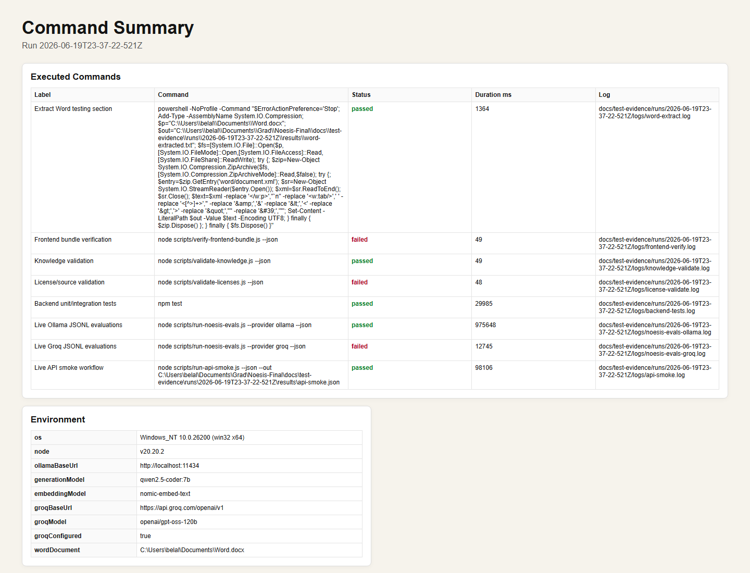

Backend Test Results
Source: docs/test-evidence/runs/2026-06-19T23-37-22-521Z/screenshots/02-backend-tests.png
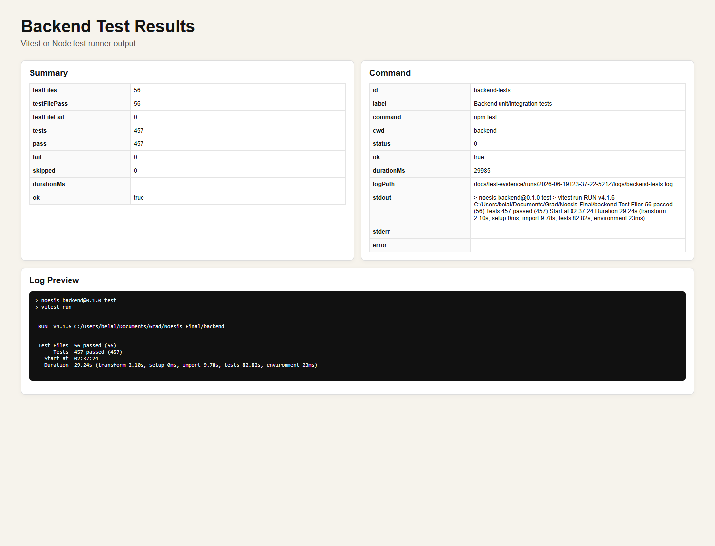

API Health and Ollama Readiness
Source: docs/test-evidence/runs/2026-06-19T23-37-22-521Z/screenshots/03-api-health.png
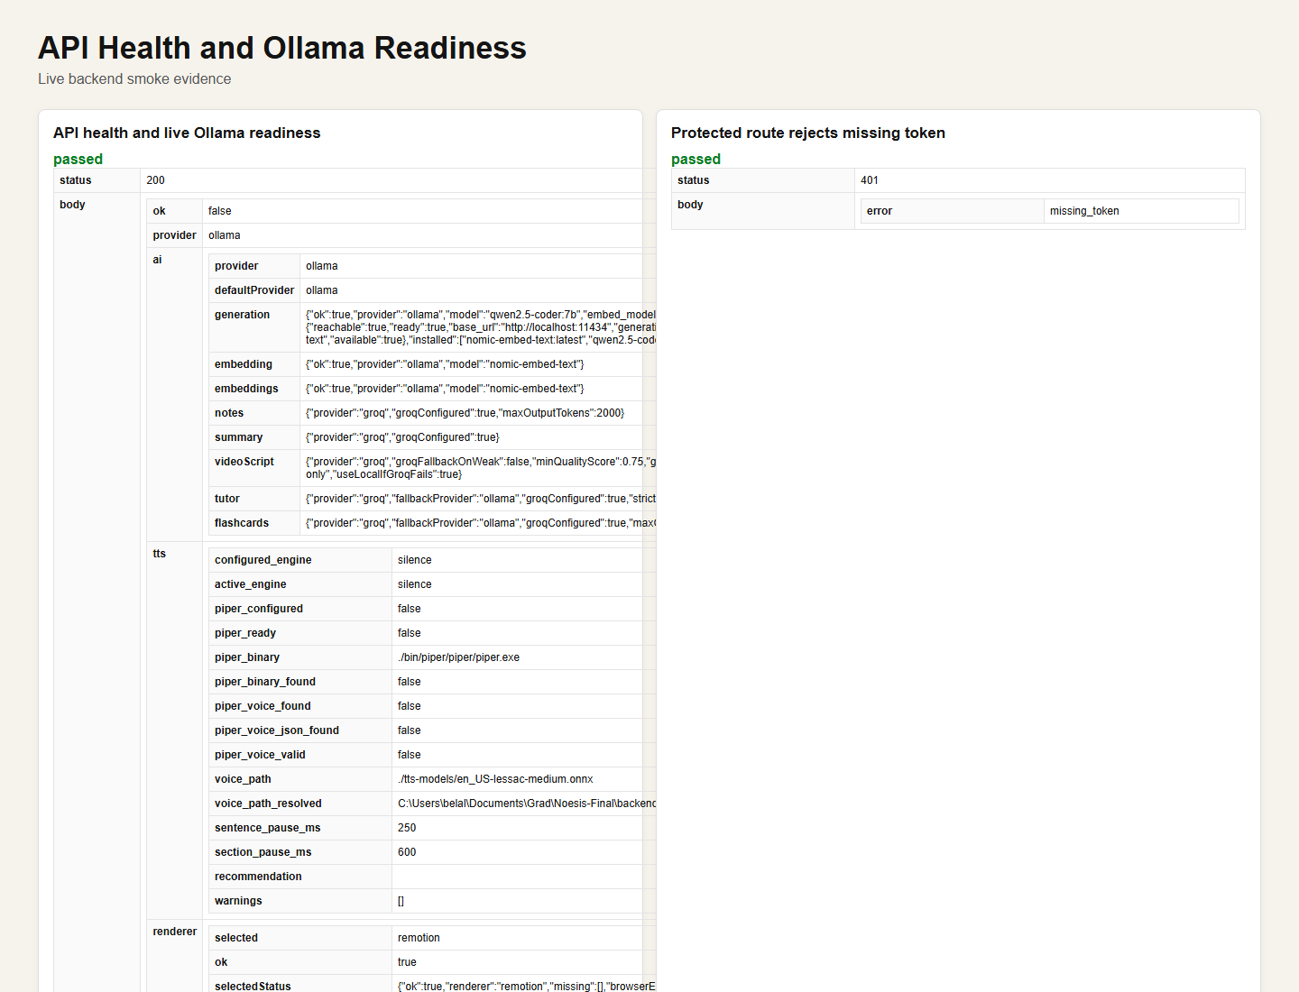

Authentication and Protected Routes
Source: docs/test-evidence/runs/2026-06-19T23-37-22-521Z/screenshots/04-auth-protected.png
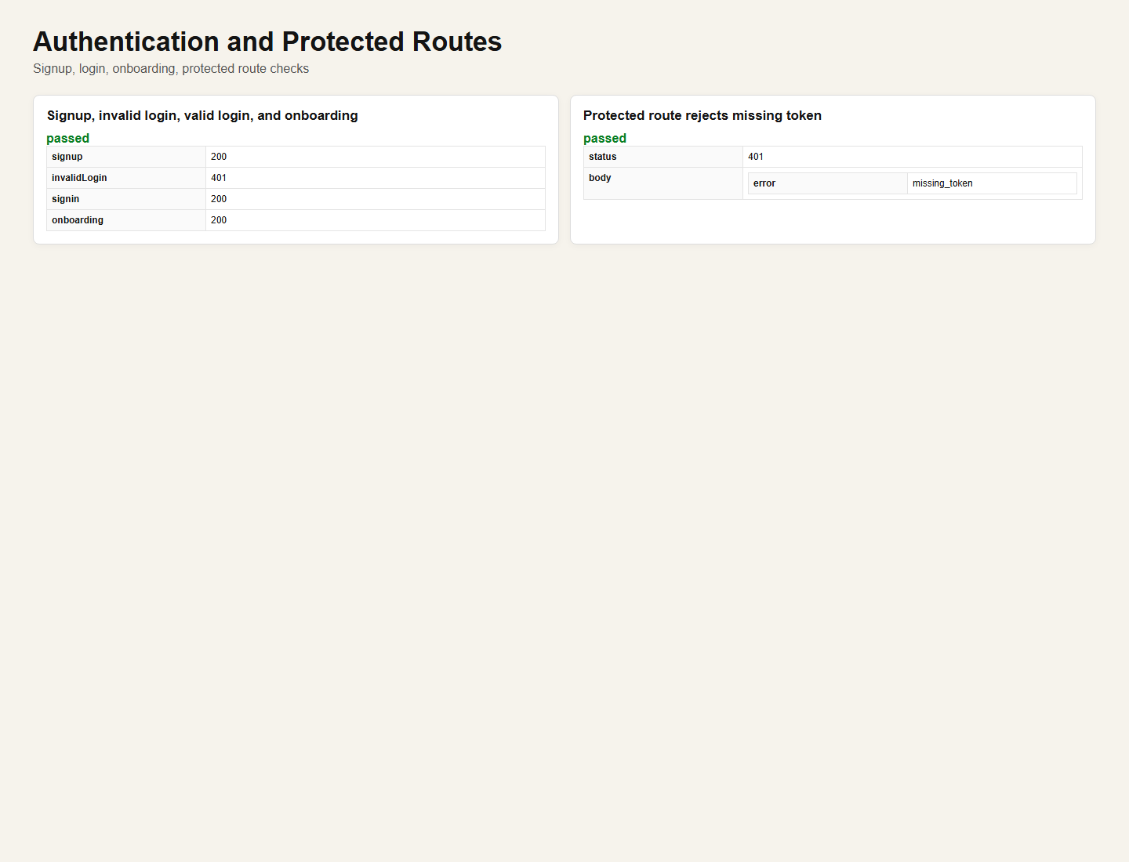

Material Upload and Job Polling
Source: docs/test-evidence/runs/2026-06-19T23-37-22-521Z/screenshots/05-upload-job.png
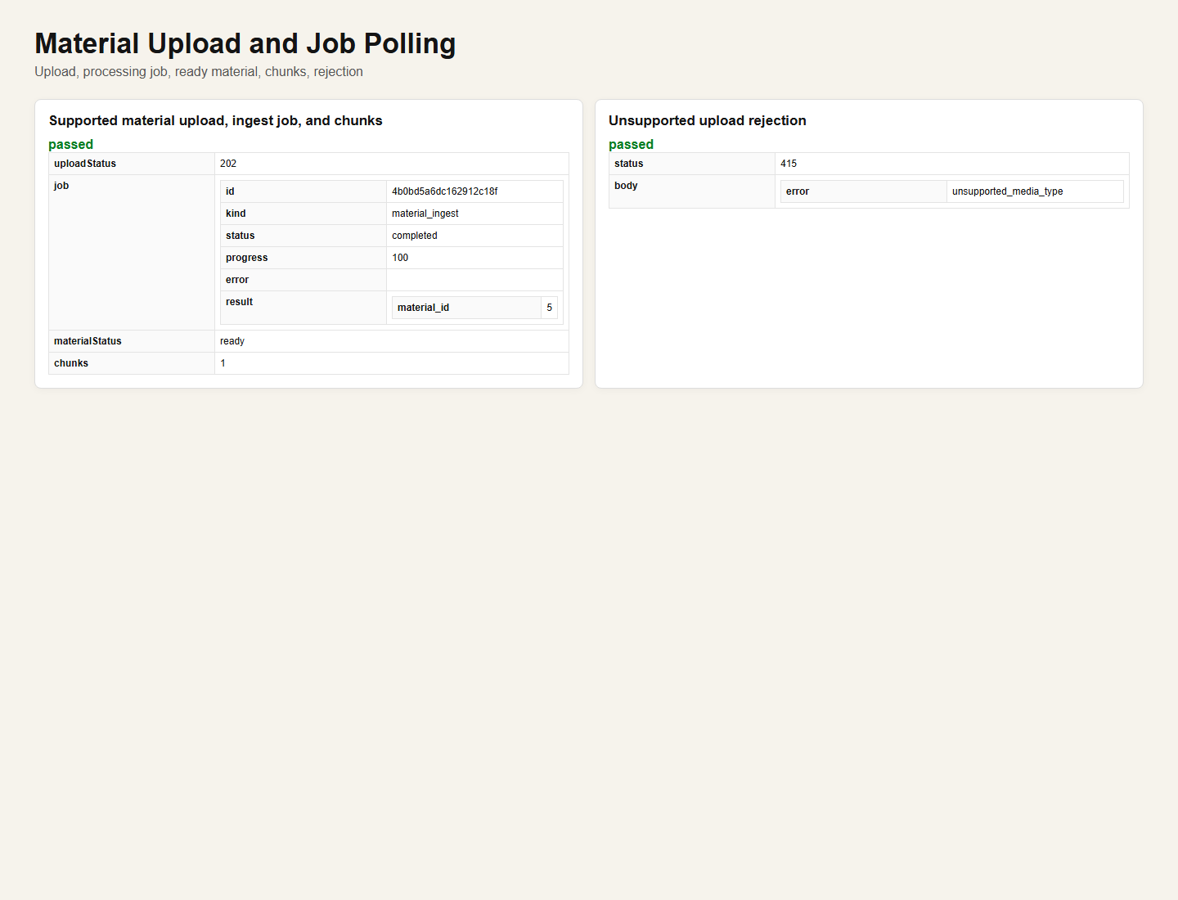

Notes Tests
Source: docs/test-evidence/runs/2026-06-19T23-37-22-521Z/screenshots/06-notes.png
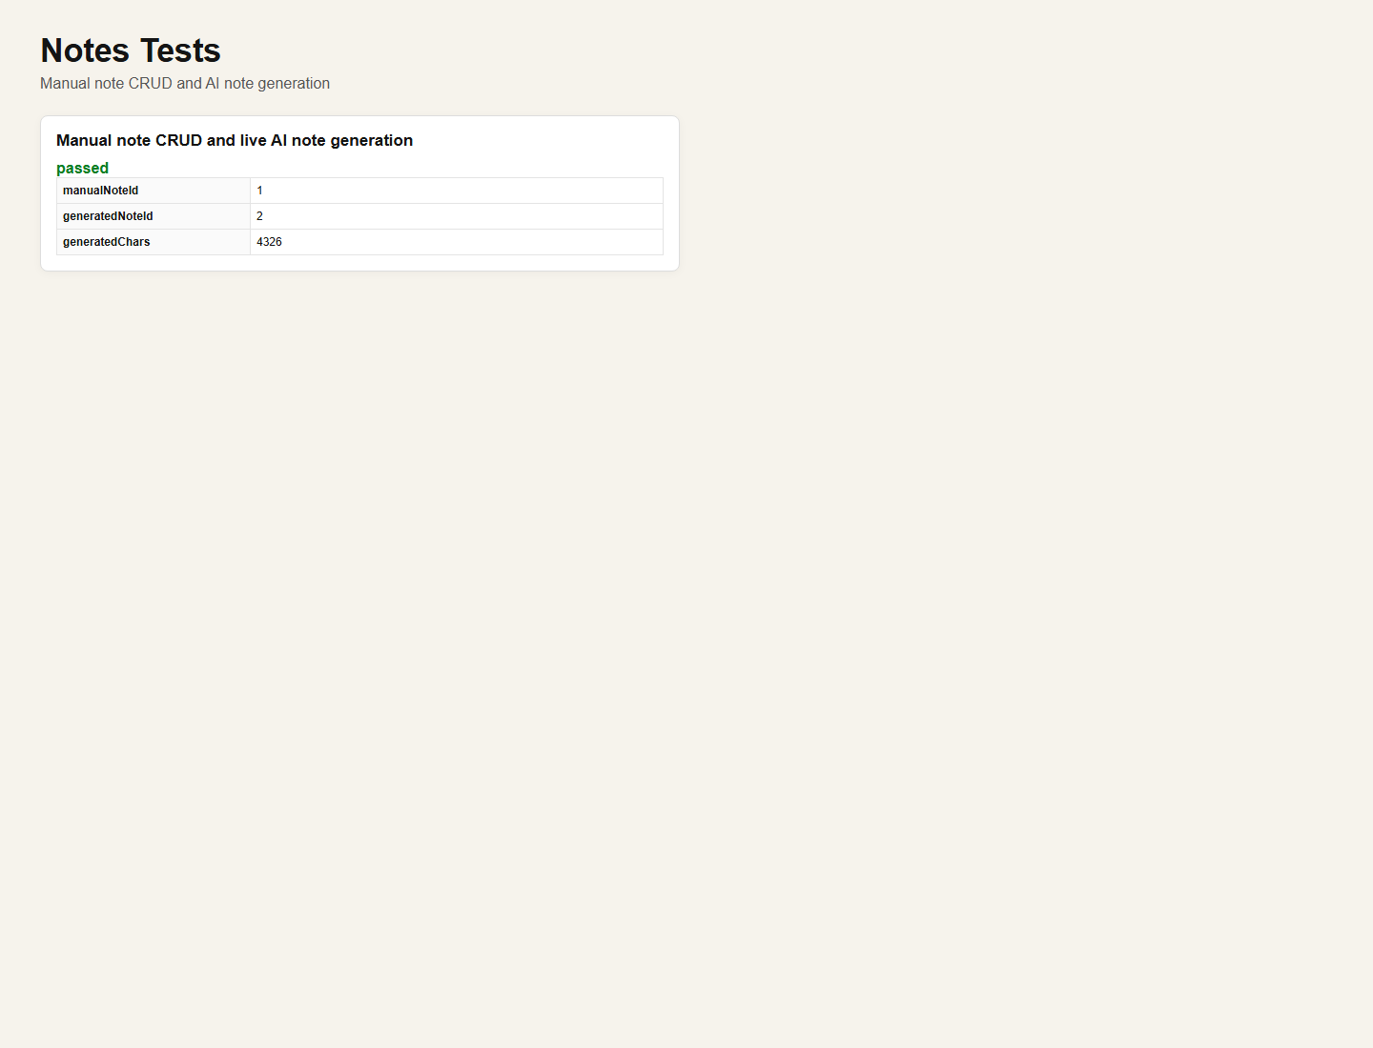

Flashcard Tests
Source: docs/test-evidence/runs/2026-06-19T23-37-22-521Z/screenshots/07-flashcards.png
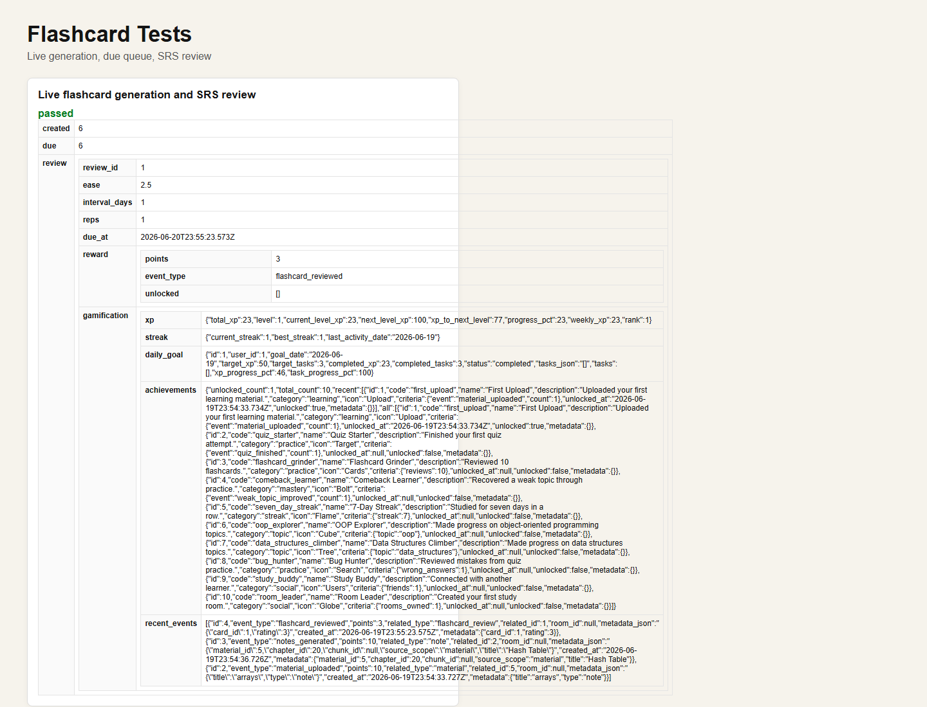

Quiz Tests
Source: docs/test-evidence/runs/2026-06-19T23-37-22-521Z/screenshots/08-quiz.png
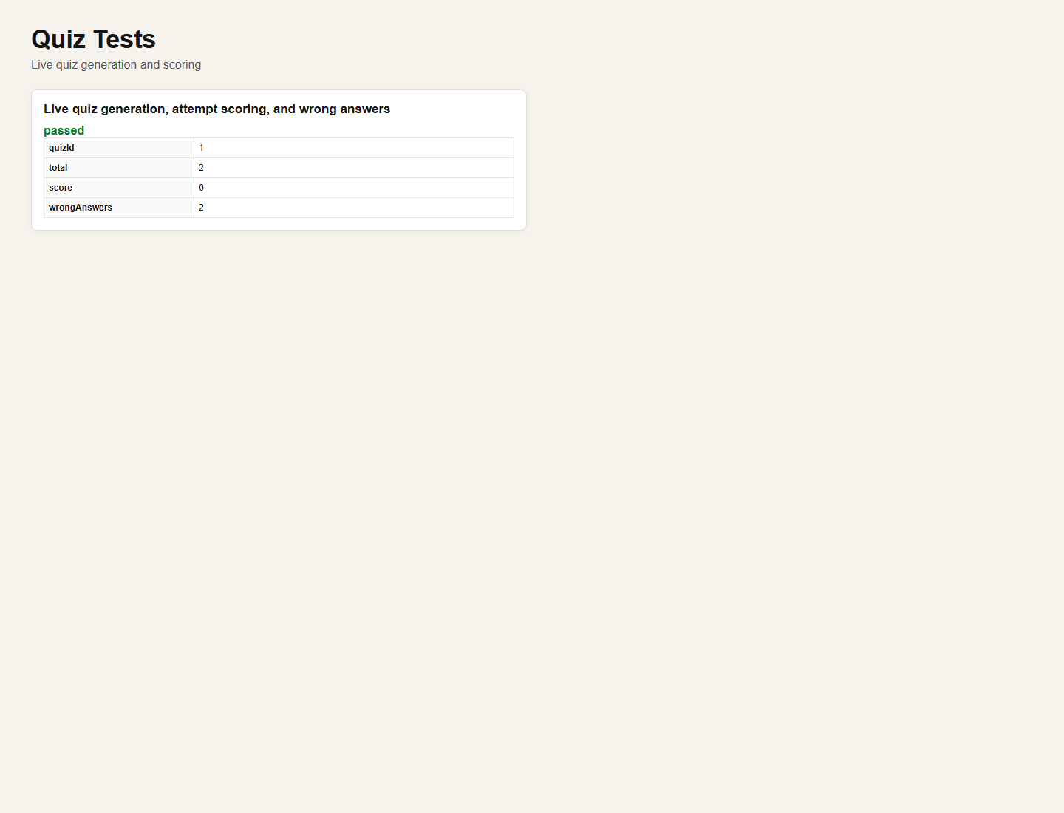

Guided Tutor Tests
Source: docs/test-evidence/runs/2026-06-19T23-37-22-521Z/screenshots/09-tutor.png
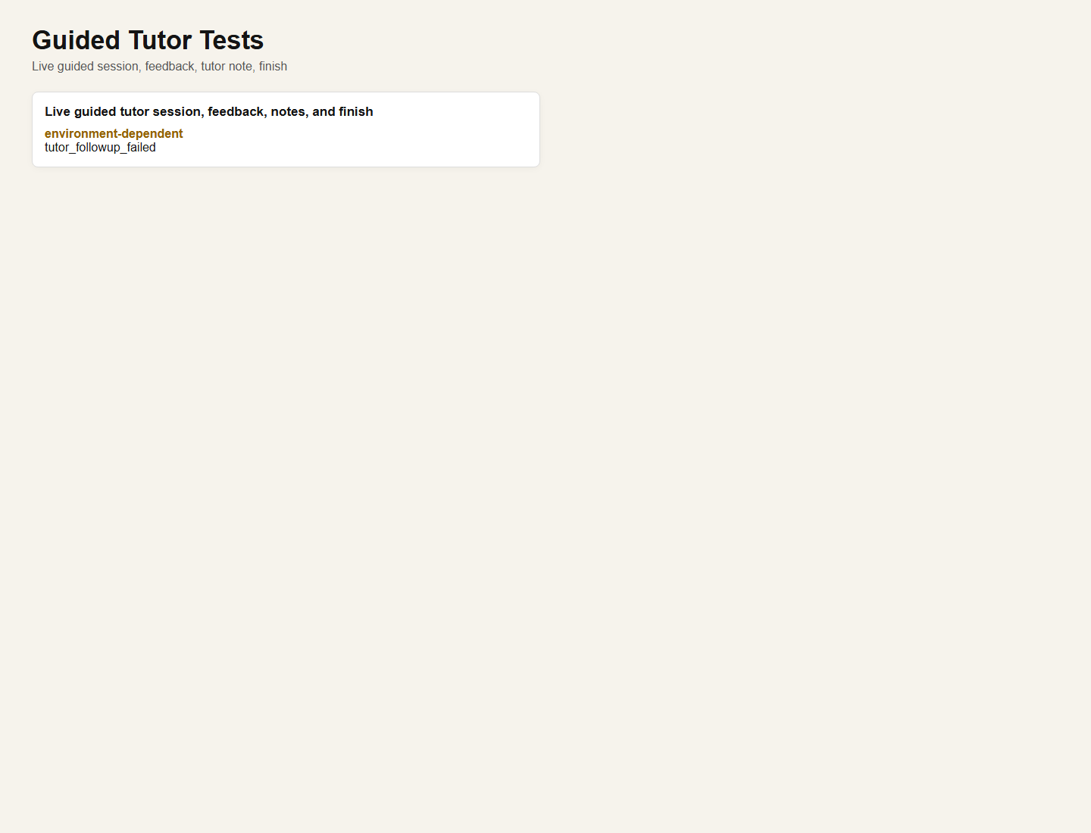

Dashboard and Progress Tests
Source: docs/test-evidence/runs/2026-06-19T23-37-22-521Z/screenshots/10-dashboard-progress.png
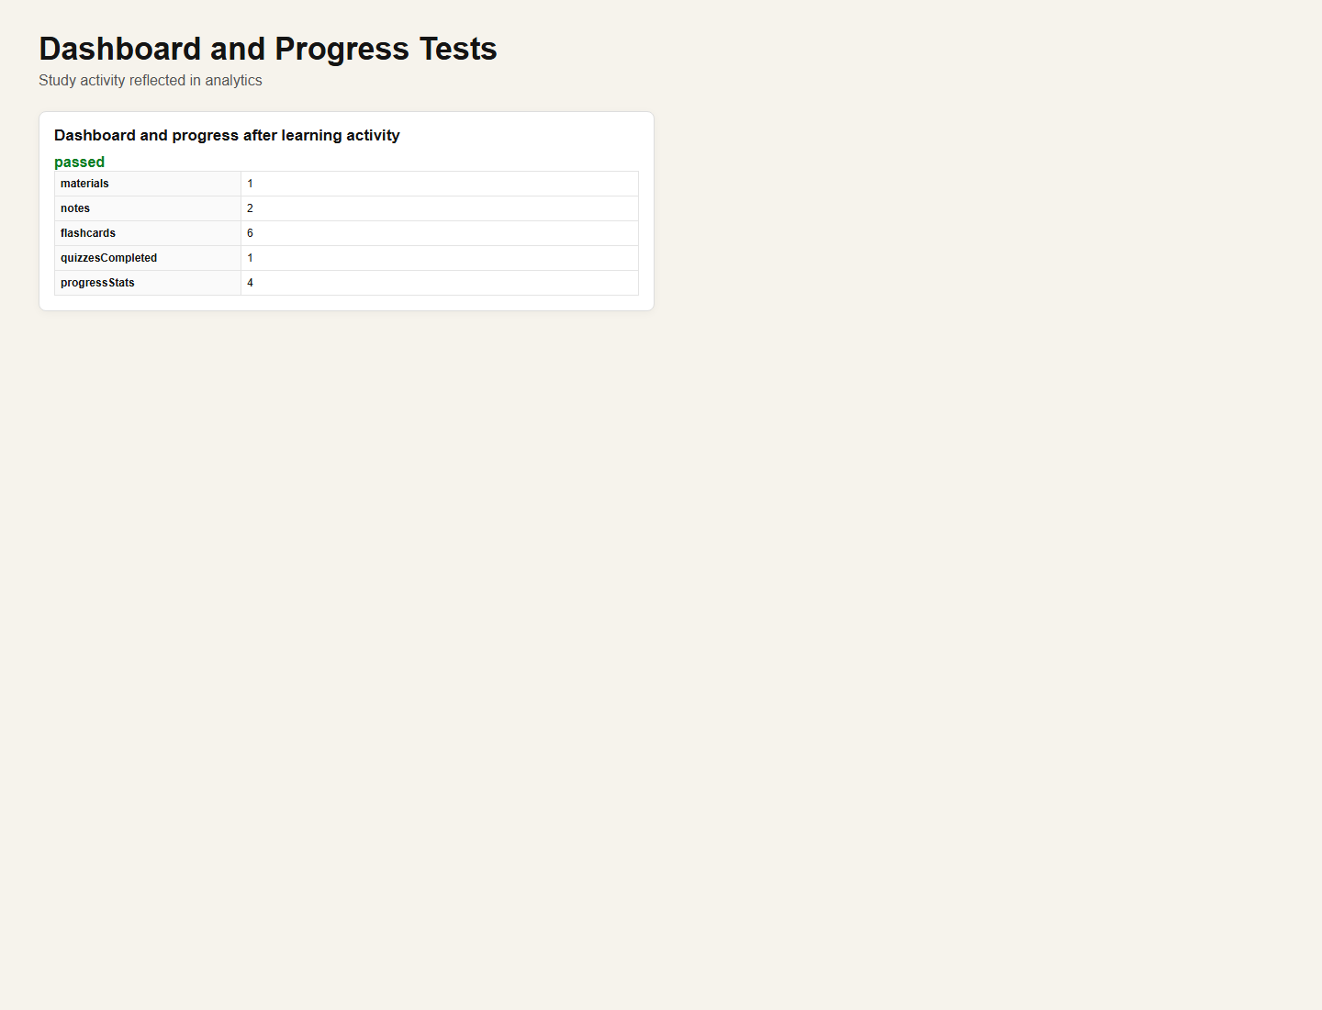

Video and Storyboard Result
Source: docs/test-evidence/runs/2026-06-19T23-37-22-521Z/screenshots/11-video.png
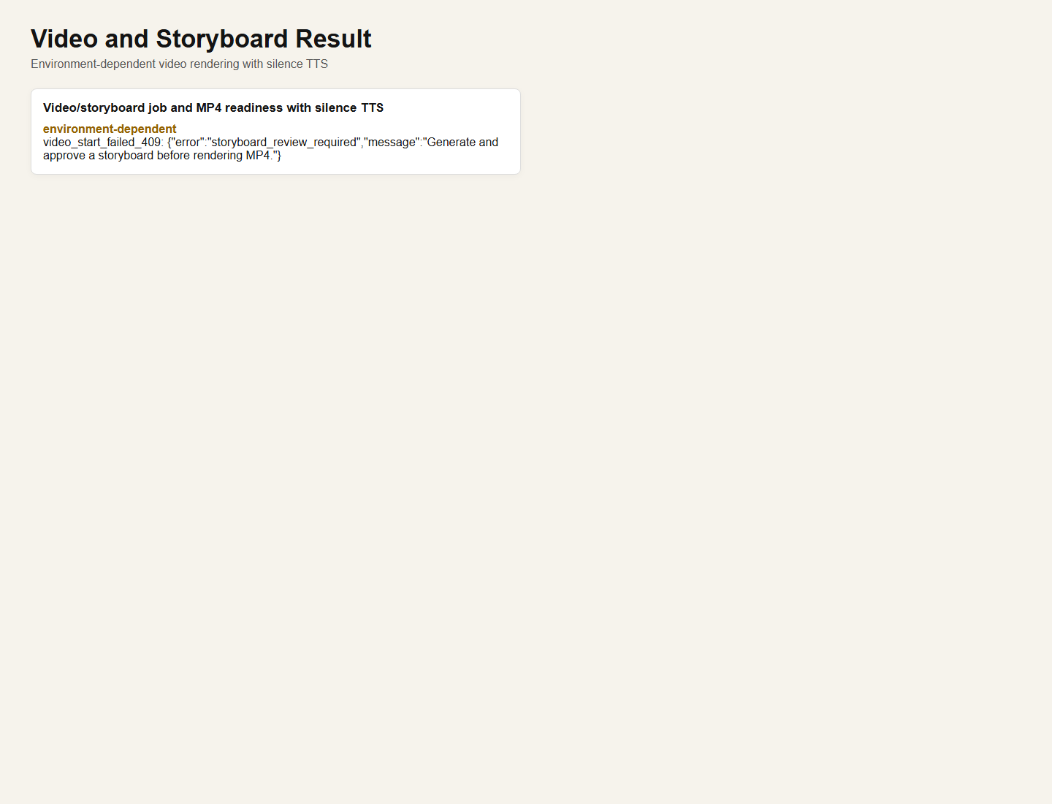

AI Evaluation Results
Source: docs/test-evidence/runs/2026-06-19T23-37-22-521Z/screenshots/12-evals.png
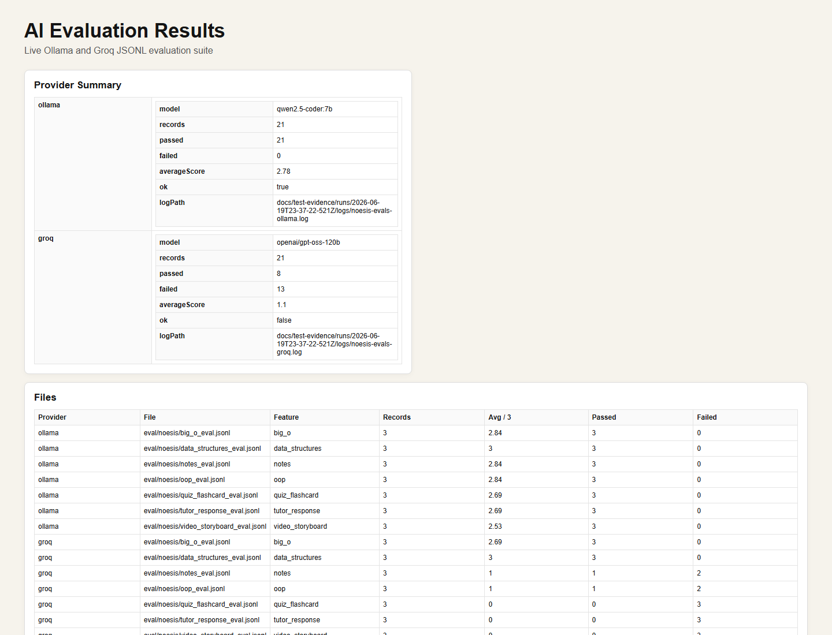

Frontend Bundle Verification
Source: docs/test-evidence/runs/2026-06-19T23-37-22-521Z/screenshots/13-frontend.png
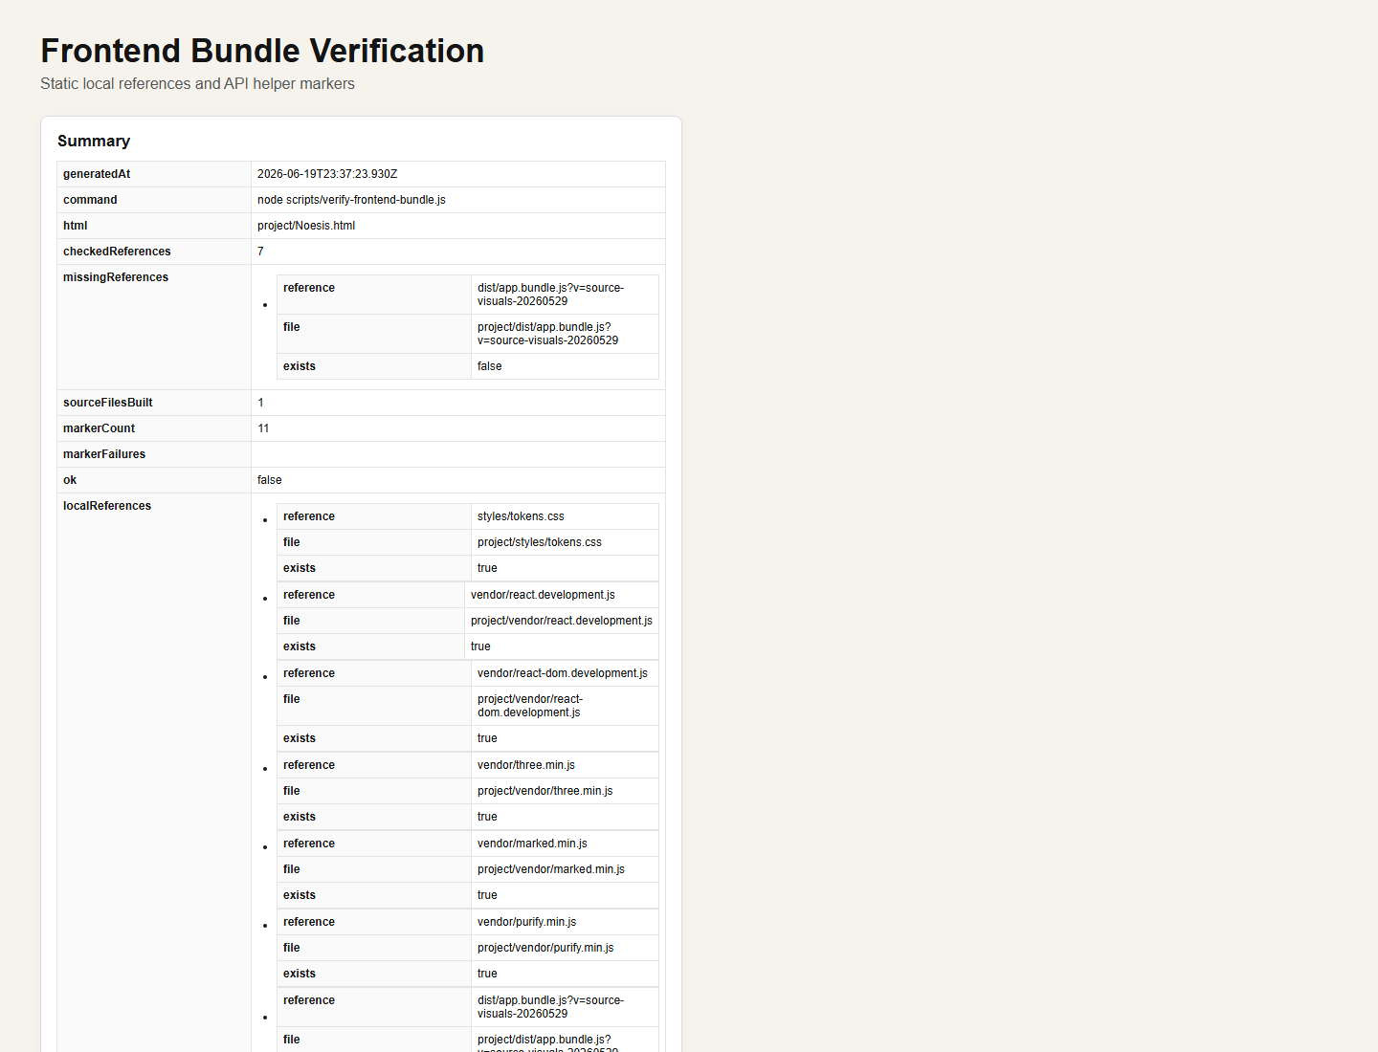

Knowledge Validation
Source: docs/test-evidence/runs/2026-06-19T23-37-22-521Z/screenshots/14-knowledge.png
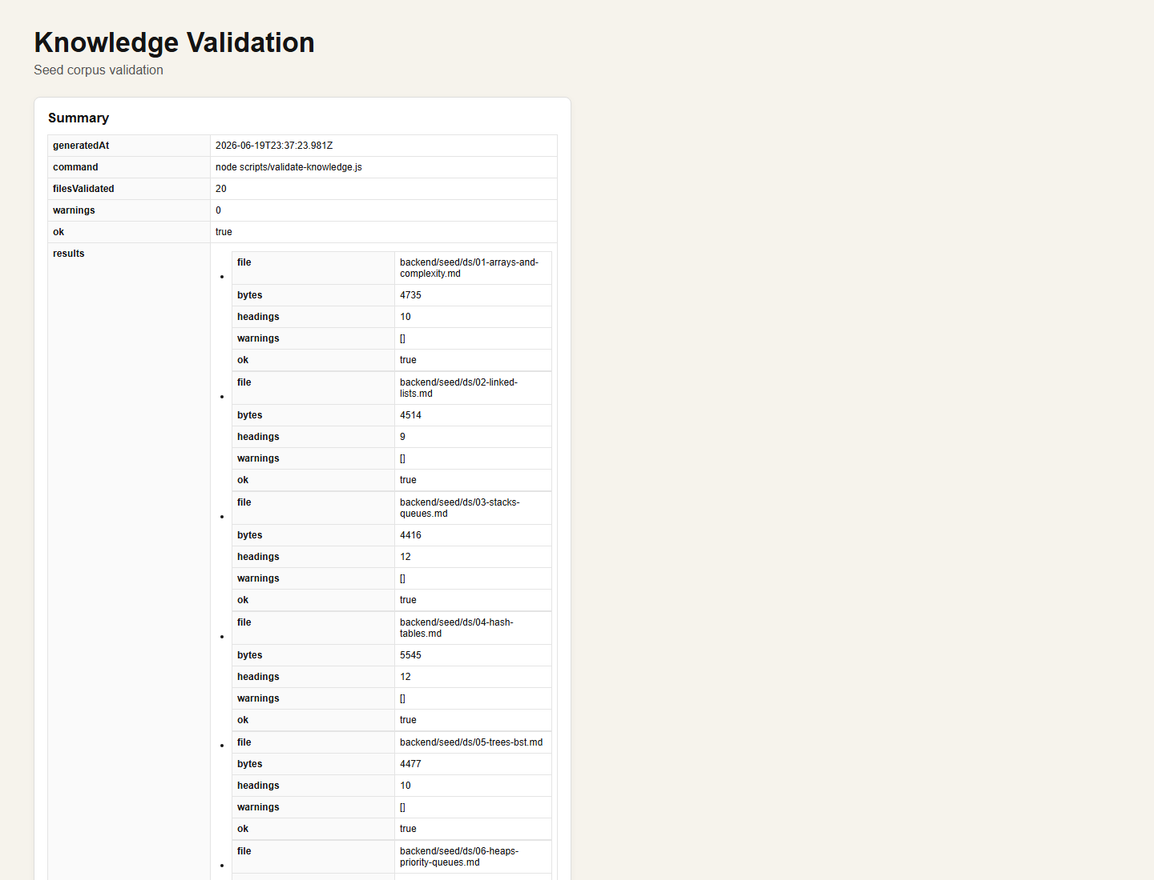

License and Source Validation
Source: docs/test-evidence/runs/2026-06-19T23-37-22-521Z/screenshots/15-licenses.png
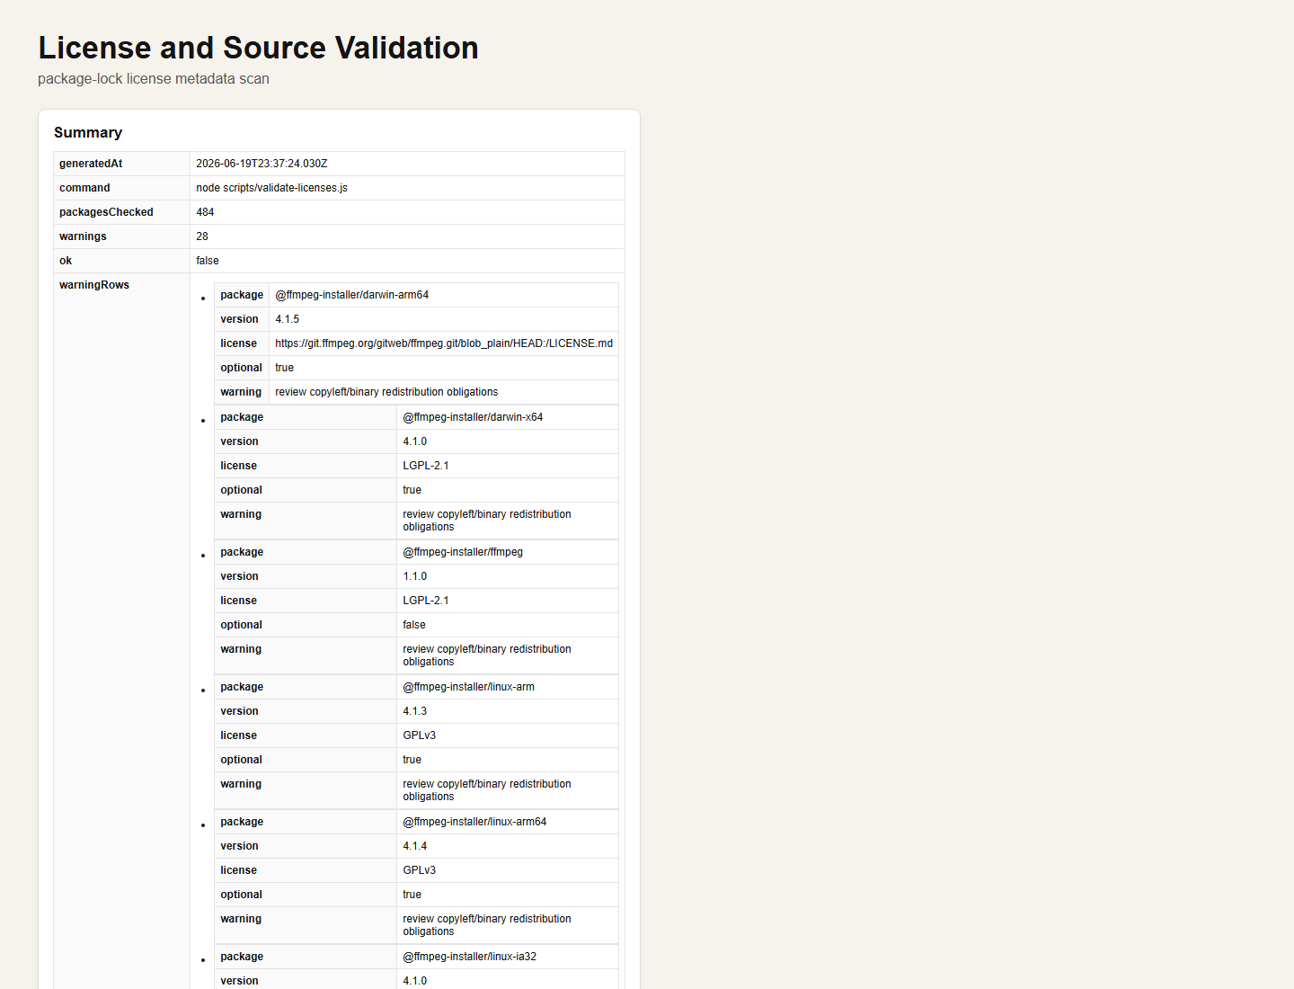

Word Document Claim Comparison
Source: docs/test-evidence/runs/2026-06-19T23-37-22-521Z/screenshots/16-word-claims.png
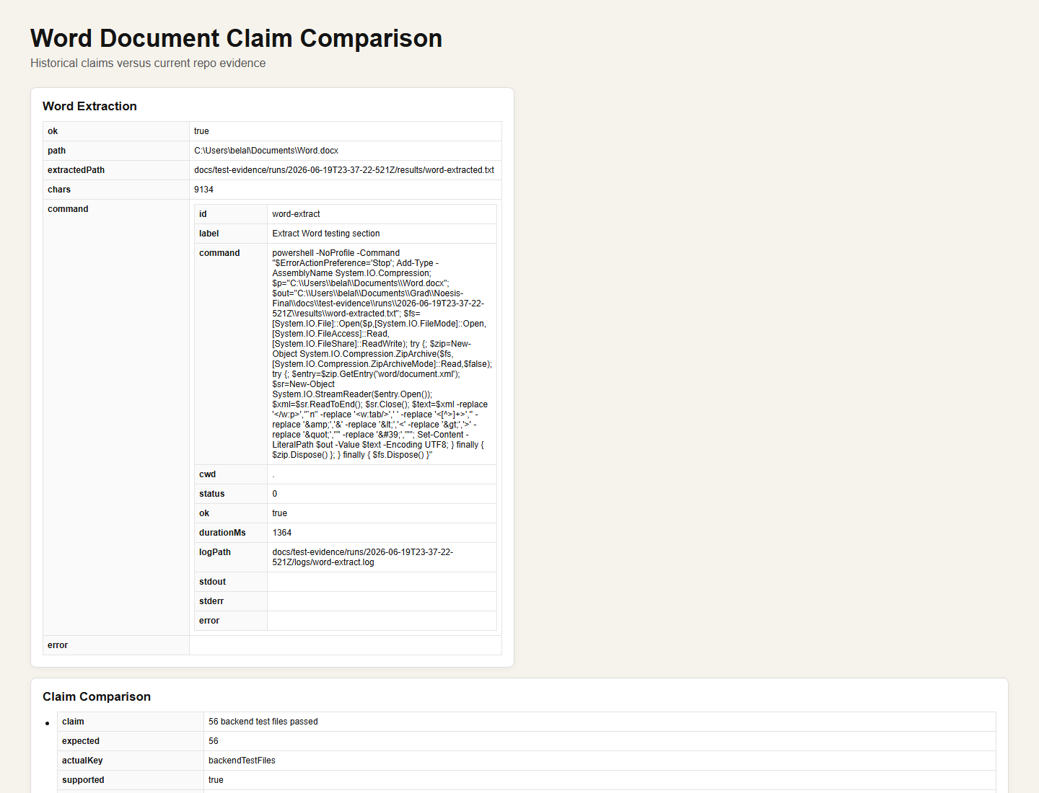

Artifacts
- docs/testing-evaluation-report.md
- docs/testing-evaluation-summary.json
- docs/testing-evaluation-screenshot-index.md
- docs/test-evidence/runs/2026-06-19T23-37-22-521Z

