1. Overview
Provide a high-level overview of the banking system, its purpose, and its components.

2. File Structure
Explain the structure of your project files and where each major component resides.

3. Classes and Structs

sClient Struct
- Purpose: Represents client information.
- Members:
  - AccountNumber: string
  - PinCode: string
  - Name: string
  - Phone: string
  - AccountBalance: double
  - MarkForDelete: bool (indicates if client is marked for deletion)

stUser Struct
- Purpose: Represents user information.
- Members:
  - UserName: string
  - Password: string
  - Permissions: int (bitmask representing user permissions)
  - MarkForDelete: bool (indicates if user is marked for deletion)

4. Functions

Utility Functions
- ConvertUsersLineToRecord: Converts a line from the users file into a stUser struct.
- ConvertRecordToLine: Converts a sClient struct into a string for file storage.
- ConvertUsersRecordToLine: Converts a stUser struct into a string for file storage.

User Management
- UserExistsByUsername: Checks if a user exists by username.
- ReadPermissionsToSet: Reads and returns user permissions from input.
- ReadNewUser: Reads user details from input and returns a stUser struct.
- LoadUsersDataFromFile: Loads user data from a file into a vector of stUser structs.
- SaveUsersDataToFile: Saves a vector of stUser structs to a file.

Client Management
- ClientExistsByAccountNumber: Checks if a client exists by account number.
- ReadNewClient: Reads client details from input and returns a sClient struct.
- LoadClientsDataFromFile: Loads client data from a file into a vector of sClient structs.
- SaveClientsDataToFile: Saves a vector of sClient structs to a file.
- FindClientByAccountNumber: Finds a client by account number.
- ChangeClientRecord: Updates client details.
- DepositBalanceToClientByAccountNumber: Deposits balance to a client's account.
- WithdrawBalanceFromClientByAccountNumber: Withdraws balance from a client's account.
- MarkClientForDeleteByAccountNumber: Marks a client for deletion.
- DeleteClientByAccountNumber: Deletes a client from the system.

Interface Functions
- Screen Display Functions: Functions for displaying various screens (e.g., ShowAllClientsScreen, ShowAddNewUsersScreen).
- Data Display Functions: Functions for displaying client and user details on the screen (e.g., PrintClientCard, PrintUserCard).

5. Permissions
- Permission Enumeration (enMainMenuePermissions): Enumerates different permissions for system operations.

6. Screens
- Screen Functions: Description of each screen function, what they display, and any permissions required to access them.

7. Data Handling
- File Handling: Explanation of how data is read from and written to files (fstream usage).

8. Error Handling
- Error Messages: Explanation of error messages and how they are displayed (ShowAccessDeniedMessage).

9. Dependencies
- External Libraries: List any external libraries or dependencies used in the project.

10. Usage Examples
- Sample Code Snippets: Provide example code snippets demonstrating how to use key functions (e.g., adding a new client, updating a user).

11. Considerations
- Security Considerations: Address any security considerations relevant to user data and permissions.
- Performance: Note any performance considerations or optimizations implemented.

12. Future Improvements
- Potential Enhancements: Suggestions for future enhancements or features to be added.

13. Authors and Version History
- Authors: List of authors who contributed to the codebase.
- Version History: Record of changes and updates made to the codebase over time.

14. Appendix
- Appendix: Additional resources or references for further reading.

Example Documentation for a Function
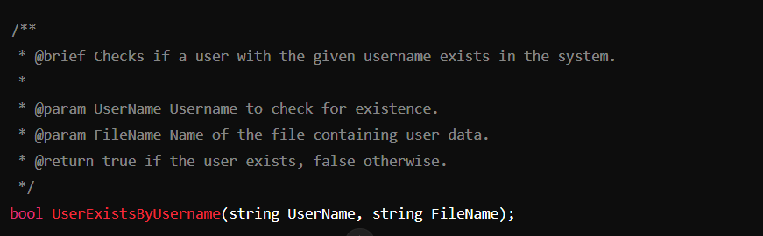

Additional Tips
- Use comments within the code to explain complex logic or algorithms.
- Include references to any relevant design documents or specifications.

