Banking System

Overview
This project is a simple console-based banking system that manages client data, including account details, deposits, withdrawals, and other transactions. The system allows the user to perform various operations such as adding new clients, updating client information, deleting clients, and viewing all clients and their total balances.

File Structure
- Clients.txt: A file where client data is stored. Each client's information is stored on a separate line in the format:

Main Components

Struct sClient
This struct represents a client with the following attributes:
- AccountNumber: string
- PinCode: string
- Name: string
- Phone: string
- AccountBalance: double
- MarkForDelete: bool (default: false)

Functions

Utility Functions
- vector<string> SplitString(string S1, string Delim)
  - Splits a string S1 by the delimiter Delim and returns a vector of substrings.
- sClient ConvertLinetoRecord(string Line, string Seperator = "#//#")
  - Converts a line from the file into an sClient struct.
- string ConvertRecordToLine(sClient Client, string Seperator = "#//#")
  - Converts an sClient struct into a formatted string for file storage.
- bool ClientExistsByAccountNumber(string AccountNumber, string FileName)
  - Checks if a client exists by AccountNumber in the given file FileName.
- sClient ReadNewClient()
  - Reads input from the user to create a new client and returns the sClient struct.
- vector<sClient> LoadClientsDataFromFile(string FileName)
  - Loads all client data from the file into a vector of sClient.
- void PrintClientRecordLine(sClient Client)
  - Prints a client's information in a formatted line.
- void PrintClientCard(sClient Client)
  - Prints a detailed card of a client's information.
- void PrintClientRecordBalanceLine(sClient Client)
  - Prints a client's balance information in a formatted line.
- bool FindClientByAccountNumber(string AccountNumber, vector<sClient> vClients, sClient& Client)
  - Finds a client by AccountNumber in a vector of clients.
- sClient ChangeClientRecord(string AccountNumber)
  - Prompts the user to enter new information for a client and returns the updated sClient struct.
- bool MarkClientForDeleteByAccountNumber(string AccountNumber, vector<sClient>& vClients)
  - Marks a client for deletion by setting MarkForDelete to true.
- vector<sClient> SaveClientsDataToFile(string FileName, vector<sClient> vClients)
  - Saves client data back to the file, excluding those marked for deletion.
- void AddDataLineToFile(string FileName, string stDataLine)
  - Appends a new line of client data to the file.
- bool DeleteClientByAccountNumber(string AccountNumber, vector<sClient>& vClients)
  - Deletes a client by AccountNumber after confirmation from the user.
- bool UpdateClientByAccountNumber(string AccountNumber, vector<sClient>& vClients)
  - Updates a client's information by AccountNumber after confirmation from the user.
- bool DepositBalanceToClientByAccountNumber(string AccountNumber, double Amount, vector<sClient>& vClients)
  - Deposits a specified Amount to the client's account by AccountNumber.
- string ReadClientAccountNumber()
  - Prompts the user to enter an account number and returns it.

Screens and Menus
- void ShowMainMenu()
  - Displays the main menu and handles user input for different options.
- void ShowTransactionsScreen()
  - Displays the transactions menu and handles user input for different transaction options.
- void ShowAllClientsScreen()
  - Displays a list of all clients.
- void ShowTotalBalancesScreen()
  - Displays the total balance of all clients.
- void ShowDeleteClientScreen()
  - Prompts the user to delete a client by account number.
- void ShowUpdateClientScreen()
  - Prompts the user to update a client's information by account number.
- void ShowAddNewClientsScreen()
  - Prompts the user to add new clients.
- void ShowFindClientScreen()
  - Prompts the user to find a client by account number.
- void ShowEndScreen()
  - Displays the end screen message.
- void ShowDepositScreen()
  - Prompts the user to deposit an amount to a client's account.
- void ShowWithdrawScreen()
  - Prompts the user to withdraw an amount from a client's account.

Helper Functions
- void GoBackToMainMenu()
  - Pauses and returns to the main menu.
- void GoBackToTransactionsMenu()
  - Pauses and returns to the transactions menu.
- short ReadMainMenuOption()
  - Reads and returns the user's choice from the main menu.
- short ReadTransactionsMenuOption()
  - Reads and returns the user's choice from the transactions menu.
- void PerformMainMenuOption(enMainMenuOptions MainMenuOption)
  - Executes the chosen main menu option.
- void PerformTransactionsMenuOption(enTransactionsMenuOptions TransactionsMenuOptions)
  - Executes the chosen transactions menu option.

Enums
- enum enTransactionsMenuOptions { eDeposit = 1, eWithdraw = 2, eTotalBalances = 3, eMainMenu = 4 }
  - Represents the options for the transactions menu.
- enum enMainMenuOptions { eListClients = 1, eAddNewClient = 2, eDeleteClient = 3, eUpdateClient = 4, eFindClient = 5, eTransactions = 6, eExit = 7 }
  - Represents the options for the main menu.

Main Function
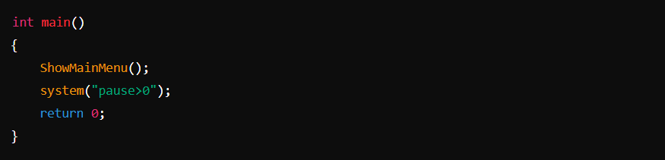
The main function initializes the program by showing the main menu and waits for user input to proceed.

Usage
- Compile the program using a C++ compiler.
- Run the executable to start the program.
- Follow the on-screen instructions to navigate through the menus and perform various operations such as adding, deleting, updating, and viewing clients, as well as performing transactions like deposits and withdrawals.

Notes
- The system uses a text file Clients.txt to store client data.
- Ensure the Clients.txt file is in the same directory as the executable.
- The system("cls") and system("pause>0") commands are used to clear the screen and pause the program, respectively. These may need to be adjusted or removed based on the operating system and development environment.

