Documentation for Client Management System

Overview
This C++ program manages client data stored in a text file named Clients.txt. It provides functionality to add, delete, update, find, and list clients using a command-line interface.

Data Structure
The program uses a struct to represent a client:
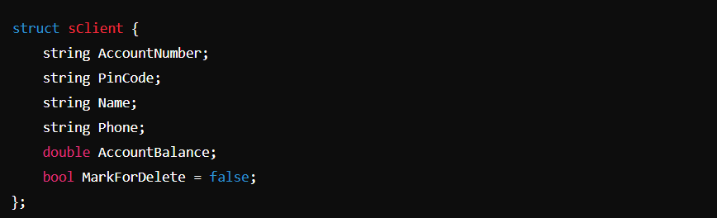

Constants
- ClientsFileName: The name of the file storing client data.

Functions

Utility Functions
- vector<string> SplitString(const string &S1, const string &Delim)
  - Splits a string S1 using the delimiter Delim and returns a vector of substrings.
- sClient ConvertLinetoRecord(const string &Line, const string &Seperator = "#//#")
  - Converts a line of text to a sClient struct.
- string ConvertRecordToLine(const sClient &Client, const string &Seperator = "#//#")
  - Converts a sClient struct to a line of text.
- bool ClientExistsByAccountNumber(const string &AccountNumber, const string &FileName)
  - Checks if a client with a given account number exists in the file.

Client Input/Output Functions
- sClient ReadNewClient()
  - Reads new client details from the user.
- vector<sClient> LoadCleintsDataFromFile(const string &FileName)
  - Loads client data from a file into a vector of sClient.
- void PrintClientRecordLine(const sClient &Client)
  - Prints a client's details in a formatted manner.
- void PrintClientCard(const sClient &Client)
  - Prints detailed client information.
- bool FindClientByAccountNumber(const string &AccountNumber, const vector<sClient> &vClients, sClient &Client)
  - Finds a client by account number in a vector of clients.
- sClient ChangeClientRecord(const string &AccountNumber)
  - Changes the details of a client.
- bool MarkClientForDeleteByAccountNumber(const string &AccountNumber, vector<sClient> &vClients)
  - Marks a client for deletion by account number.
- void SaveCleintsDataToFile(const string &FileName, const vector<sClient> &vClients)
  - Saves client data to a file.
- void AddDataLineToFile(const string &FileName, const string &stDataLine)
  - Adds a line of data to the file.
- string ReadClientAccountNumber()
  - Prompts the user to enter an account number.

Screen Functions
- void ShowAllClientsScreen()
  - Displays all clients.
- void AddNewClient()
  - Adds a new client to the file.
- void AddNewClients()
  - Adds multiple new clients.
- bool DeleteClientByAccountNumber(const string &AccountNumber, vector<sClient> &vClients)
  - Deletes a client by account number.
- bool UpdateClientByAccountNumber(const string &AccountNumber, vector<sClient> &vClients)
  - Updates client information by account number.
- void ShowDeleteClientScreen()
  - Displays the delete client screen.
- void ShowUpdateClientScreen()
  - Displays the update client screen.
- void ShowAddNewClientsScreen()
  - Displays the add new clients screen.
- void ShowFindClientScreen()
  - Displays the find client screen.
- void ShowEndScreen()
  - Displays the end screen.

Main Menu Functions
- void GoBackToMainMenue()
  - Prompts the user to return to the main menu.
- short ReadMainMenueOption()
  - Reads the user's choice from the main menu.
- void PerfromMainMenueOption(enMainMenueOptions MainMenueOption)
  - Performs the action based on the user's choice.
- void ShowMainMenue()
  - Displays the main menu.

Enum
- enum enMainMenueOptions
  - Enumeration for main menu options: eListClients, eAddNewClient, eDeleteClient, eUpdateClient, eFindClient, eExit.

Main Function
- int main()
  - Entry point of the program. Shows the main menu and waits for user input.

Usage
- Compile the program using a C++ compiler.
- Run the executable.
- Use the main menu to navigate through the options:
  - List all clients.
  - Add a new client.
  - Delete a client.
  - Update client information.
  - Find a client by account number.
  - Exit the program.

Notes
- Ensure Clients.txt exists in the same directory as the executable.
- The program uses system("cls") and system("pause>0") for screen clearing and pausing, which are specific to Windows OS. For cross-platform compatibility, replace these with appropriate alternatives.

