Radar output:

Part C

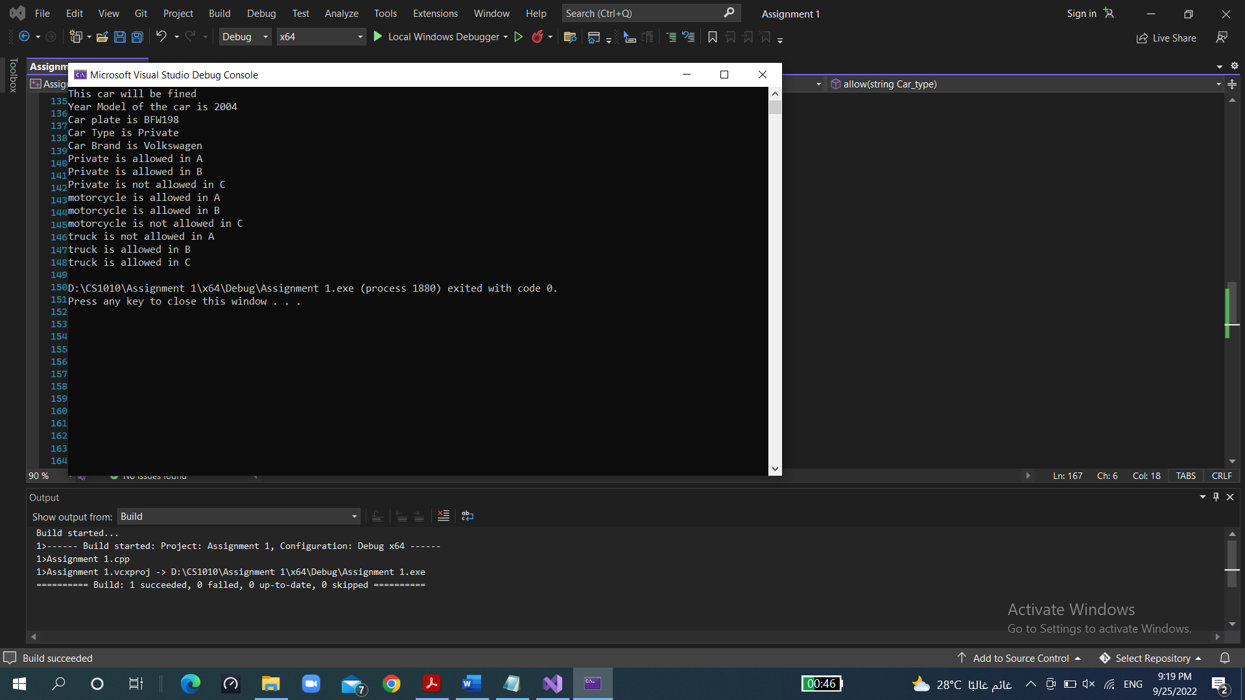

Last part

