2/6/2020
SOFTWARE REQUIREMENTS SPECIFICATION
EYE TRACKER
Version 1.0 approved

Prepared by:
Ahmed Mohamed Ahmed Abd-El-Hafez
Abd-El-Rahman Hassan Mohamed Hassan
Omar Ayman Mahfouz
Moamen Ahmed Mostafa
Supervisor:
Prof/Taysir Hassan
Table of Contents
Introduction 1
Purpose 1
Product Scope 1
Actors 1
References 1
Overall Description 1
Product Perspective 1
Product Functions 2
User Classes and Characteristics 2
Operating Environment 2
Design and Implementation Constraints 2
User Documentation 2
Assumptions and Dependencies 2
System Requirements specifications. 3
Functional Requirements 3
Mange Virtual Keyboard 3
Mange Eye Tracker 3
Mange Word Suggestion 3
Eye Control mouse 3
Text to speech 3
Non-Functional Requirements 3
Performance Requirements 3
Safety and Security Requirements 4
Reliability 4
Other Software Quality Attributes 4
System Design 5
UML Use Case Diagram 5
Class diagram 6
Implementation 7
Eye-Tracking-: gaze ratio 7
Eyemovement 8
Eye-aspect-ratio-method 8
maxIn10Frames method: 8
Virtual Keyboard 9
Curser Tracker 10
Controller 11
Word Suggestion 20
Timeline/Gantt chart 22

Revision History
Name | Date | Reason for Changes | Version
Initiation | 2/2/2020 |  | 1.0
Version 2 | 9/8/2020 | Adding word prediction, mouse controller | 2.0

Introduction
The following section provides an overview of the software requirements specifications (SRS) for the Eye Tracker’s system.

Purpose
The purpose of SRS is to determine both functional and non-functional requirements of Eye Tracker System.
Also, the document provides an overall description about the Eye Tracker System with UML analysis models.

Product Scope
- Helping paralyzed users who can’t control their bodies and have a problem with dealing with the real world.
- people who preferer using their eyes to control their computer.

Actors
Software admin | Someone who is responsible for maintaining, updating and checking errors of the software.
System user | Someone who use the application.

References
python: https://www.youtube.com/watch?v=rfscVS0vtbw
Opencv-python: 1) https://opencv.org/
2) https://pysource.com/
Aurélien Géron Hands On Machine Learning with Scikit Learn Keras and Tensorflow Concepts, Tools and Techniques to Build Intelligent Systems

Overall Description
This section will give an overview of the whole system. The system will be explained in its context to
show how the system interacts with other systems and introduce the basic functionality of it. It will also
describe what type of stakeholders that will use the system and what functionality is available for each
type. At last, the constraints and assumptions for the system will be presented.

Product Perspective
This system merges various hardware like (mouse and computer camera) and software elements.

Product Functions
- System user will be able to write on the virtual keyboard using his eyes
- System user will be able to control mouse using his eyes.
- System user will be able to use text-to-speech feature.
- System user will be provided with next word prediction, auto-complete and auto-correction.

User Classes and Characteristics
There are two types of users that interacts with the system
- System admin: responsible for maintaining, updating and checking errors of the software.
- System user: control keyboard and mouse using his eyes.

Operating Environment
- System requirement -Hardware:
  - CPU: at least Dual core.
  - Space: Minimum of 500 MB.
  - Ram: Minimum 4 GB
  - Camera: at least 2 Megapixel

Design and Implementation Constraints
High quality camera.
Good source of light

User Documentation
The user simply needs to open the software and attaches his camera to start using the software with his eyes, to write or move the mouse cursor around

Assumptions and Dependencies
One assumption about the software is that it will be always used on desktop computers or laptops so all the actors included in the software should be aware of the computers.
There must be a source of light for the Eye detection.

System Requirements specifications.

Functional Requirements

Mange Virtual Keyboard
- The system must allow the user to type any key from the virtual keyboard
- Virtual keyboard must support US English language.
- Virtual keyboard must support context hint
- Virtual keyboard must support eye contact.

Mange Eye Tracker
- System must support a cursor that can be controlled by eye movement.
- System must detect the position of the gaze (eye pupil).
- System must clear all the Nosie around the gaze (eye pupil).

Mange Word Suggestion
- System mush show 5 words suggestion for the word that the user trying to type
- System must show the most recent 5 words

Eye Control mouse
- System must detect the position of the gaze and set the mouse coordinates according to the detected position of the gaze.

Text to speech
- System must give the option to convert the text to voice.

Non-Functional Requirements
Non-Functional requirements are requirements that specify criteria for the developed system.
This can be used to judge the operation of the system, rather than specific behaviors. This is contrasted with functional requirements that define the specific behaviors of function of the system.

Performance Requirements
- The system must response to the keyboard pressing operation in less than 1 millisecond.
- The system should be compatible with windows (7, 8, 10) and Linux.
- The system must response to the mouse operations in less than 1 millisecond.
- The system should be reliable.
- There must be a light source for Eye detection.

Safety and Security Requirements
System cannot affect, harm, damage to user.
It also cannot damage user’s computer while accessing the system over a network.

Reliability
System should be designed in modular manner to ease in software maintenance. By designing modularly, we can reduce coupling allowing each module to perform a specific function.
The program should be reliable and provide catching of exceptions, so the unintended results don’t occur such as system crashes, or data validation failures

Other Software Quality Attributes
The system should have user-friendly interface.

System Design

UML Use Case Diagram
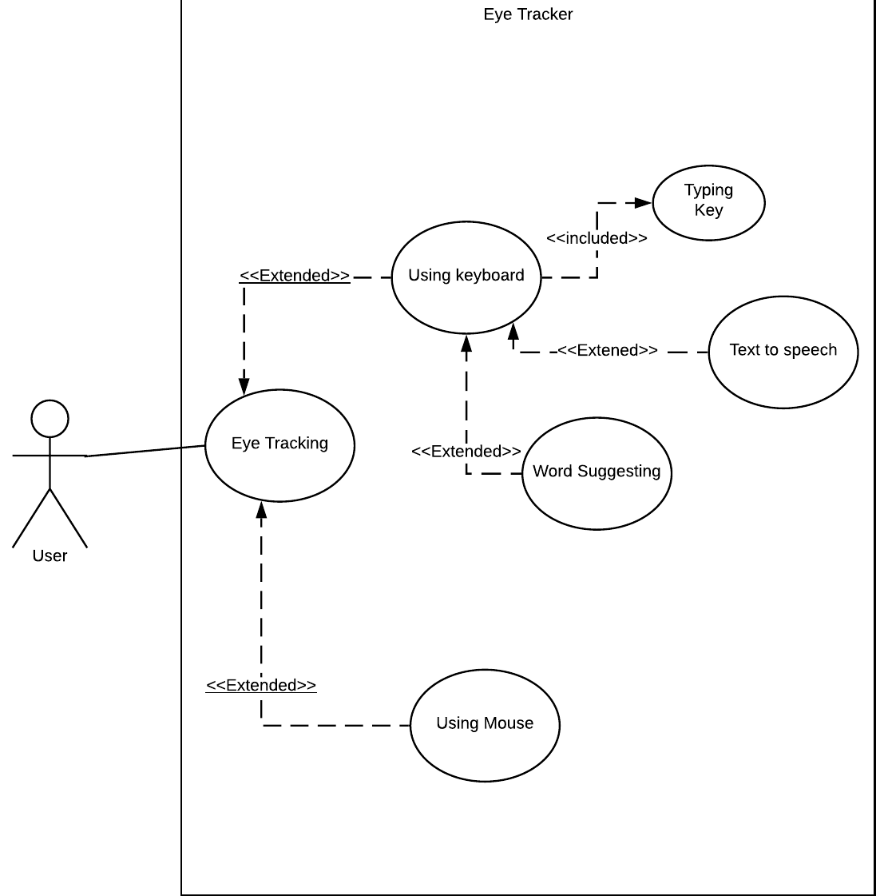

Class diagram
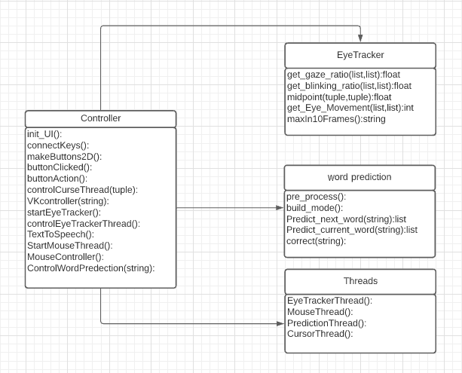

Implementation

Eye-Tracking-: gaze ratio
We need to get the gaze ration for each eye
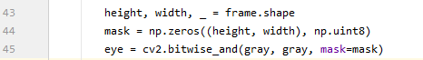
Then we need to get the black and white image for the eye
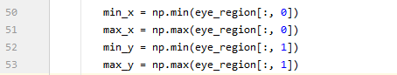
Then we get the height and width of the eye by getting left most point, right most point, lower point and highest point
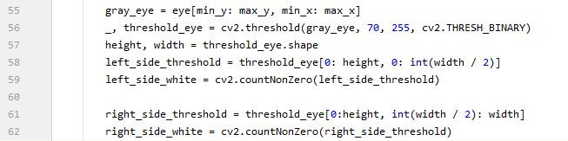
Using the black & white image, we can detect the Gaze location which can be detect in one of 3 places:
Center, Left or Right.
To do so we will count number of white pixels for the left side and number of white pixels for the right side.
Finally, we return the ratio that will help us to get the exact location of the eye.

Eye movement
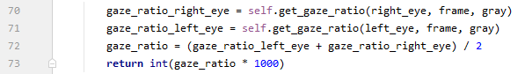

Get the ratio for both eyes the right and left and then return the average between the ratios.

Eye-aspect-ratio-method
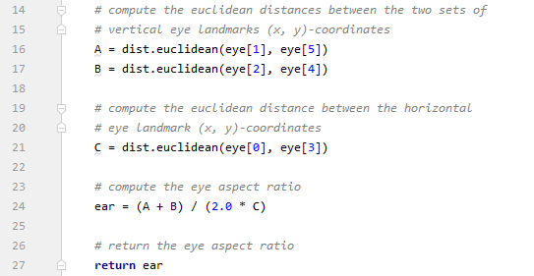
We use the formula (A + B) / (2.0 * C) to get the blinking ratio such that each eye has 6 points that surround it.

maxIn10Frames method:
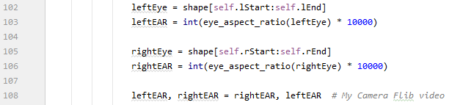
First, we get the left eye landmarks and base them to the eye_aspect_ratio method which will return the blinking ratio of the left eye.
Second, we get right eye as same as the left eye, but we change the landmark points

Virtual Keyboard
Is a QMainWindow designed by QDesigner.
We added 8 horizontal layouts first for textEdit to show words written by user, second made for word suggestion and text-To-Speech buttons and others for simulate normal keyboard.
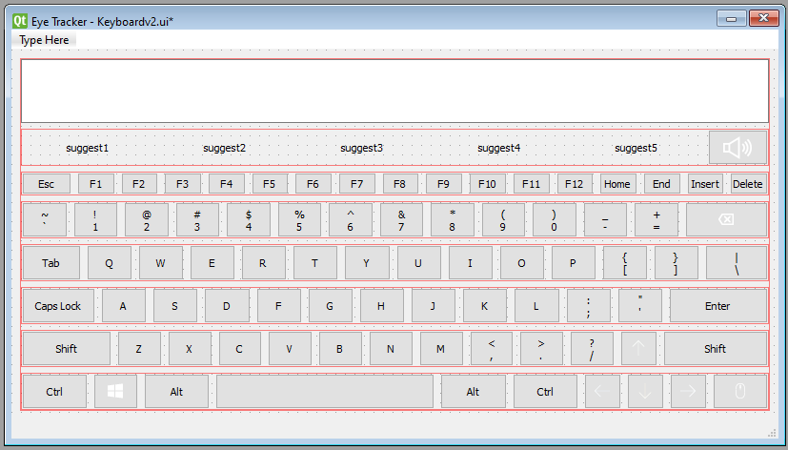
And we added some CSS commands to fix style with Qdarkstyle module used in Controller.
Convert UI file generated by Qdesigner to python file:
After convert to python file generate class called “UI_MainWindow” contains two methods
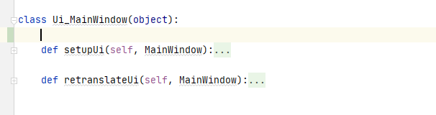

Curser Tracker
this class work in parallel with VK to simulate Eye tracker commands.
Inherit from QThread to work as thread in Controller, it takes list of list called (two_d_buttons) from controller to know the row and the column of the curser
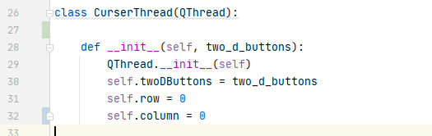
Then we make pyqtsignal to know the chosen key and previous chosen key
Know we write the run method for curser thread
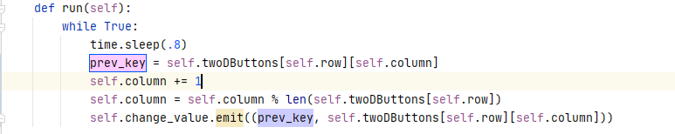
In this method we make infinity loop to make curser run in parallel with VK
Time.sleep(.8): is the speed of the curser.
Then we store the previous key then make curser go to other key by increase the column of previous key
And fix position.
Then we emit prev_key and current key to thread signal
This signal send to controller to mark chosen key and manage the curser Tracker

Controller
IS the main class of the project that control and manage VK, ET, MT, CT, TTS, WP: (Virtual Keyboard), (Eye Tracker), (Mouse Tracker), (Curser Tracker), (Test to speech), (Word Prediction).
First, we write the constructor to define super, attributes and methods.
Attributes
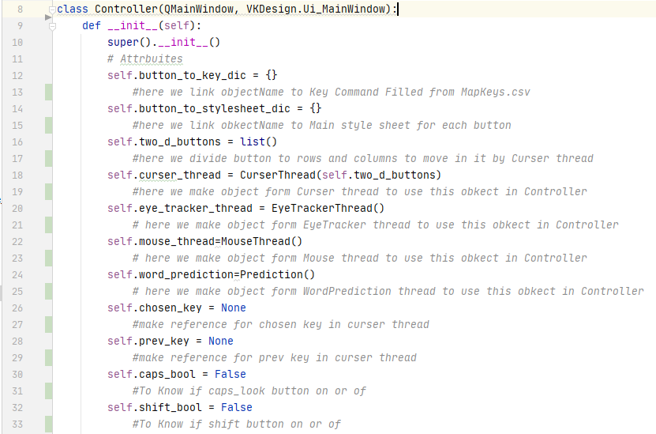

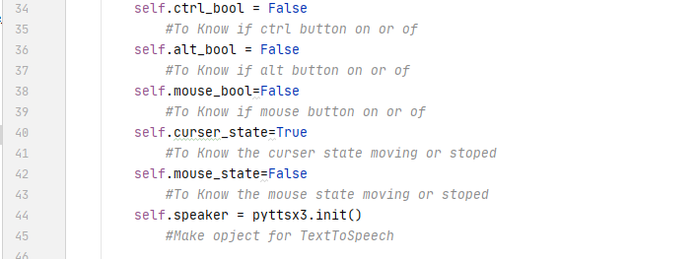

Methods:
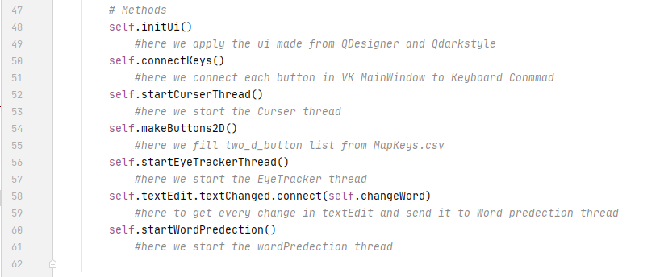
InitUi method
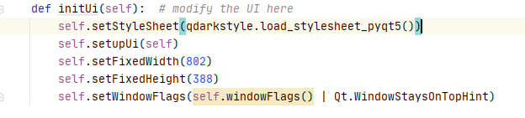
.Here we add qdarkstyle module and VK design to QmainWindow of controller
.fix the width and height of QmainWindow
.make VK show over all other apps

connect Keys Method:
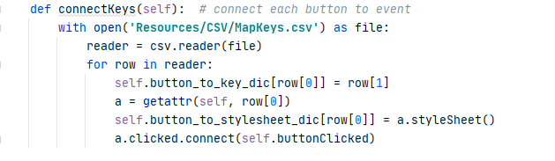
Here we extract data from MapKeys.csv and use getattr method to loop over all buttons in VK then give each button clicked event, and store the initial style for every button in
button_to_stylesheet dictionray

makeButtons2D method:
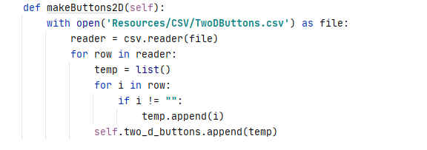

Here we extract data from TwoDButtons.csv and store them in two_d_buttons.
buttonClicked method:
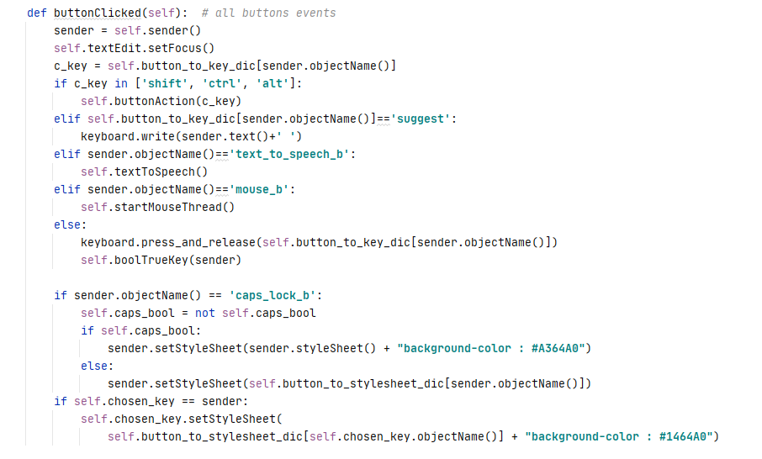

This method called from connectButtons method:

When button clicked then use keyboard module to press
this button and handle control buttons and its style after clicked

boolTrueKey method:
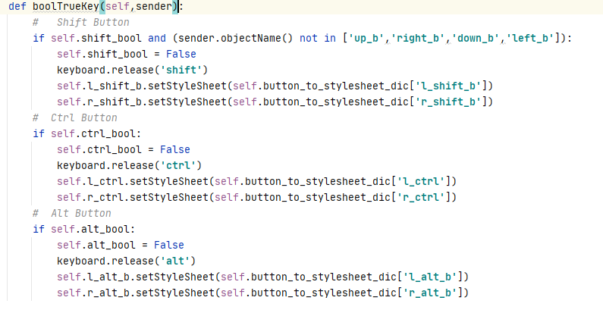

Used in buttonclicked method to handle shift,alt,ctrl buttons style when press and release

buttonAction
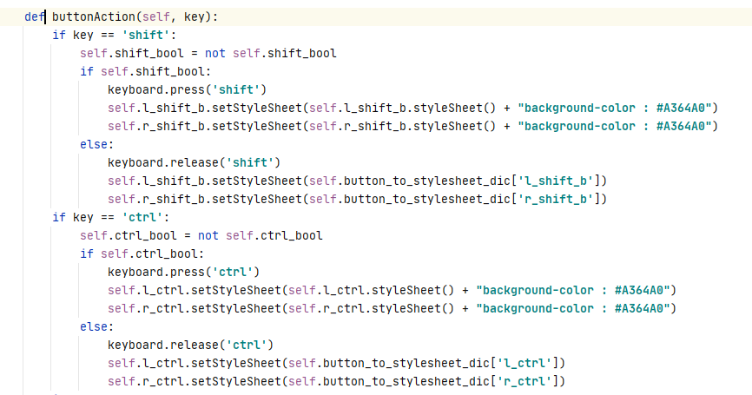
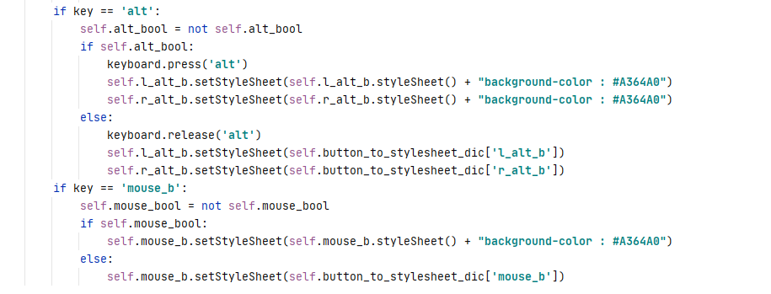
Used in buttonClicked method manage alt, shift, ctrl, mouse buttons

startCurserThread
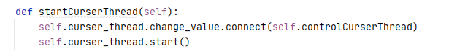
Here we connect the signal from curser thread to control curser thread method and start the thread

controlCurserThread
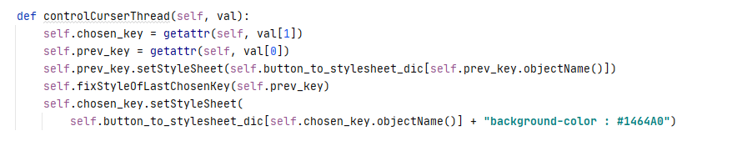
Get the chosen key and prev from thread and fix its stylesheet

vkController
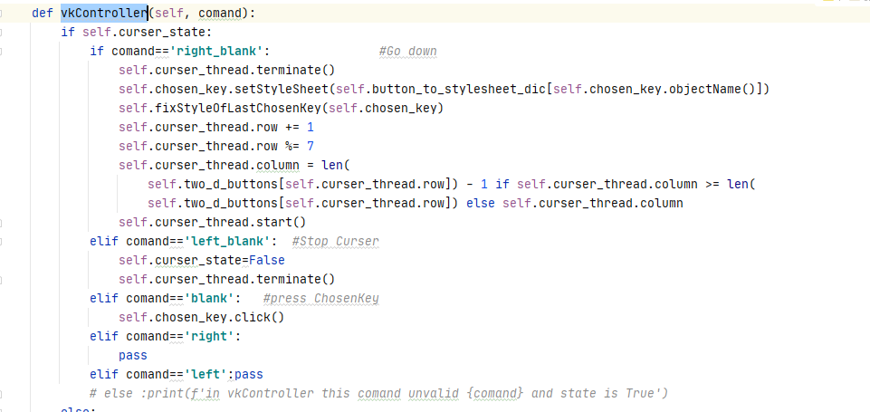
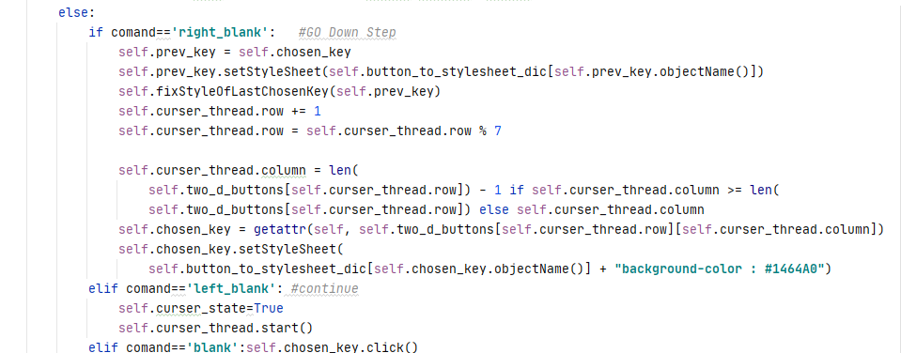
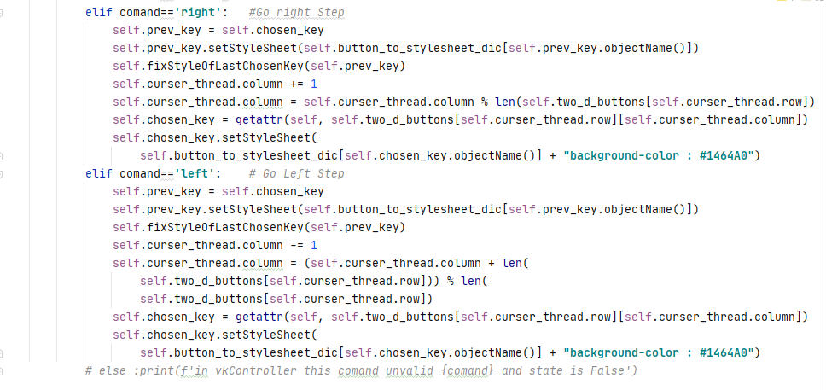
Here we take commands from eye tracker and use this commands to manage VK and CT

fixStyleOfLastChosenKey:
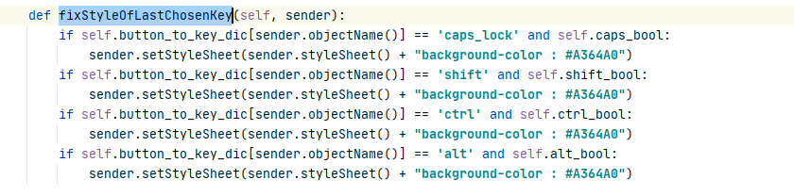
Used to fix the style of prev key after curser tracker

startEyeTrackerThread:
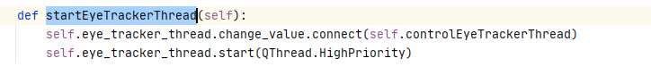
Here we send value in eye tracker signal to controlEyeTrackerThread and start thread
controlEyeTrackerThread:
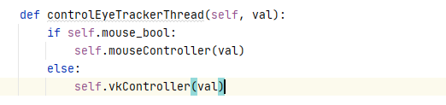

Here we send the command from Eye Tracker to VKController or mouseController
textToSpeech
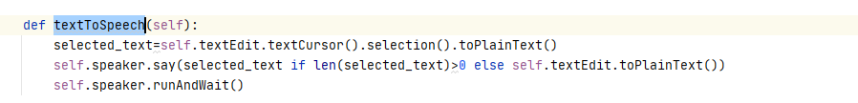

Here we convert text from selected text in textEdit or all str in it and send convert them to voice
startMouseThread
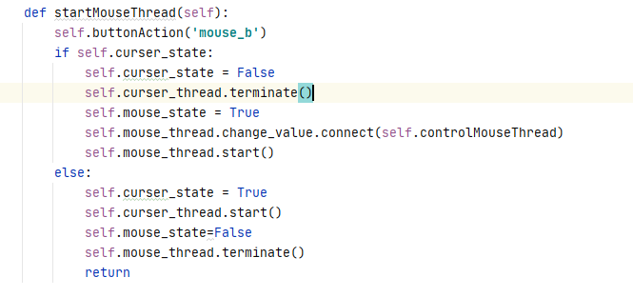
Here we stop curser tracker to start mouse or vice versa

mouseController
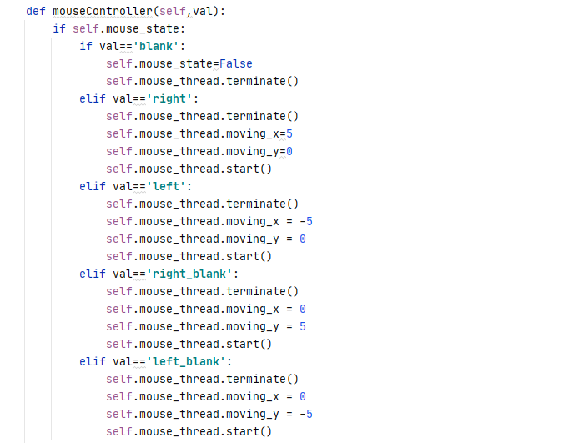

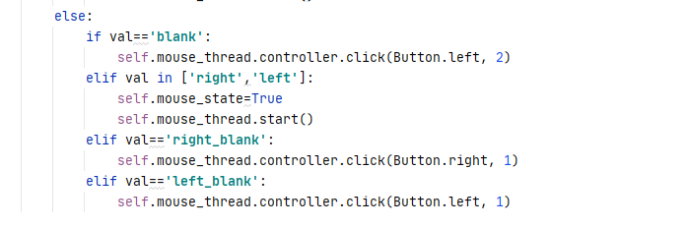
Here we take commands from eye tracker and manage the mouse with this commands
startWordPredection
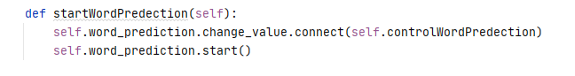
Here we start the wordPredection thread

controlWordPredection

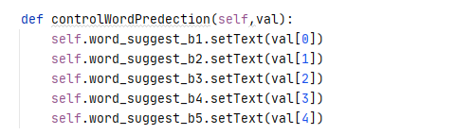
Here we take words from word prediction and add this in suggestion buttons
change Word
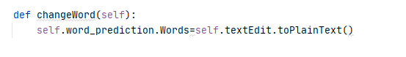
Here we connect the plain text in textEdit with word_predection thread

Word Suggestion
First we need to get text to learn from it, we decided to choose Sherlock Holmes novel
We clear the text from noises and non-English words
Divide the text into lines of 5 words
We mark the first 4 words as input and the last as input
the first 3 words as input and he 4th as output and so on
And then now we have our training input data and training output data
Ready for building the model
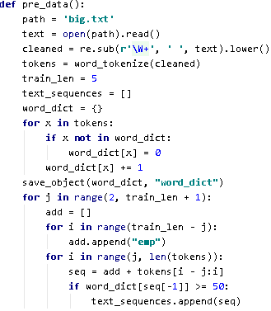
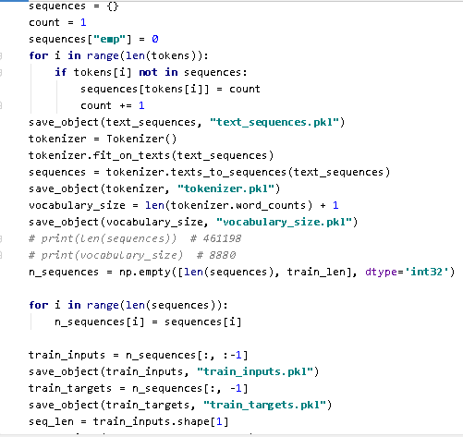
Now we build the model
we used 5 layers in our model
Embedding layer Turns positive integers (indexes) into dense vectors of fixed size.
LSTM : long short term memory to make the prediction more efficent
Dense layer: Just your regular densely-connected NN layer.

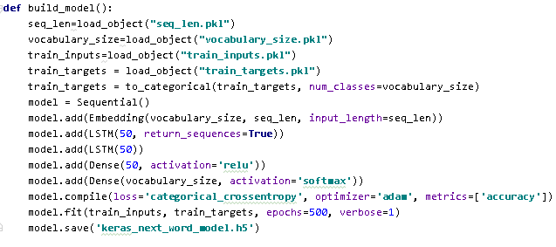

after we created, trained and saved our model
now we start using the model for prediction
we clear the text from any noises, load the model and use it to predict the given text after encoding it
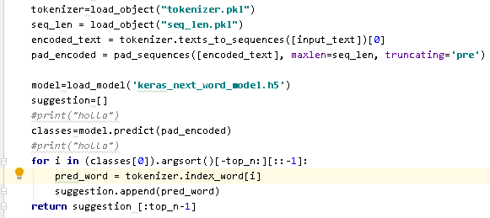

In current word prediction we get the next word prediction for the previous text
and get the closest words for the current word

Timeline/Gantt chart
