Building and Packaging Java Application with maven

Step 1: Install Apache Maven

# Refresh your package index and install Maven
sudo apt update && sudo apt install maven –y
# Verify the installation and check the version
mvn -version
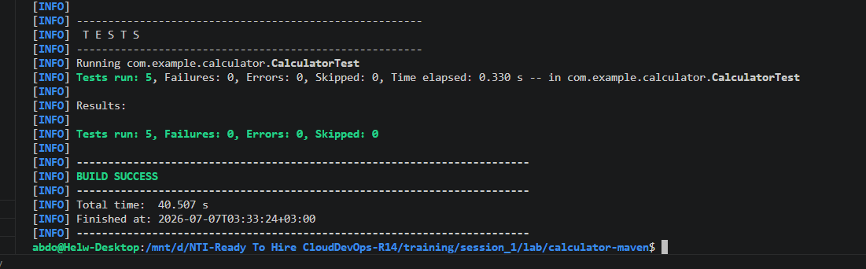

Step 2: Clone the Source Code
Navigate to your training workspace directory and clone the repository using Git:

# Clone the repository
git clone https://github.com/Ibrahim-Adel15/calculator-maven.git

# Move into the project directory
cd calculator-maven

# Optional: View the project structure using the tree command you just installed!
tree

Step 3: Run Unit Tests
In Maven, testing is a specific phase in the default build lifecycle. When you trigger the test phase, Maven compiles your source code and executes the unit tests using the Maven Surefire Plugin.

mvn test

Step 4: Build the Application (Generate Artifact)
To package the compiled code into a distributable Java Archive (.jar), run the package command.

clean to ensure you wipe out any old or corrupted artifacts from previous builds.

mvn clean package

Verify that the artifact was generated:
ll
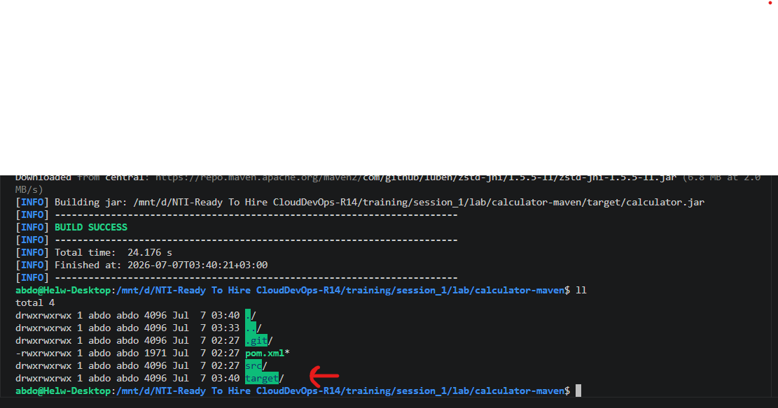

Step 5 & 6: Run and Verify the Application
Now that your application is packaged into a standard JAR file, you execute it using the Java Virtual Machine (java command).

java -jar target/calculator.jar

