3-The Secure Financial Multi-Branch Banking Hub

1. Full Topology :

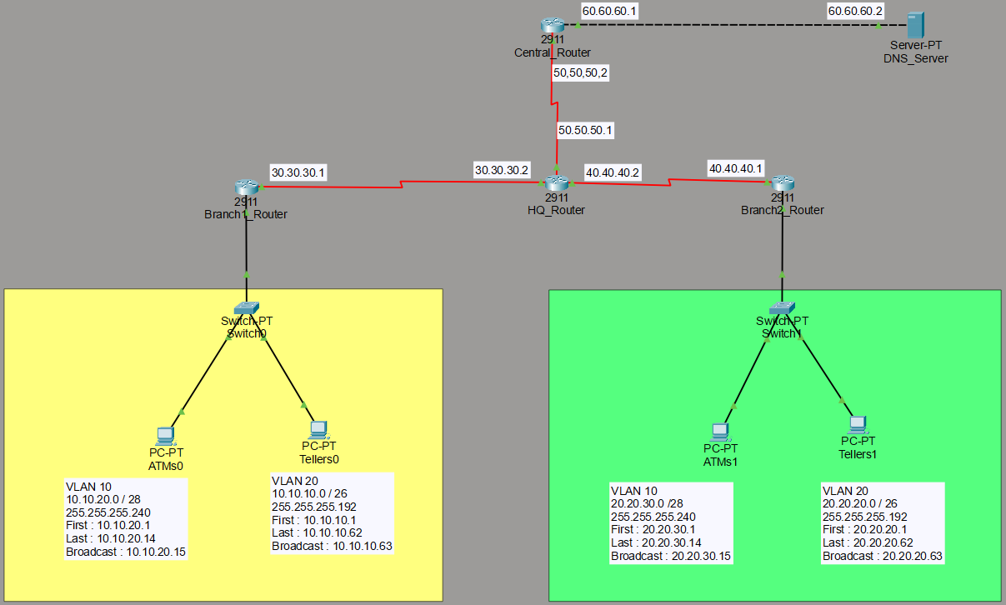

2.Successful Ping Between Networks :
2.1.ping 20.20.30.2
2.2.ping 60.60.60.2
2.3.ping 50.50.50.2
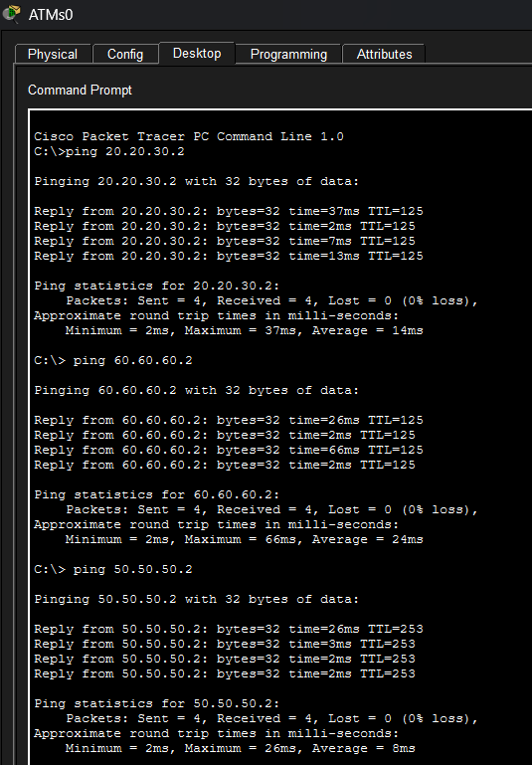

3. VLSM Addressing Table :
Subnet | Network | Subnet Mask | First IP | Last IP | Broadcast
Branch1 (Tellers) | 10.10.10.0 | 255.255.255.192 | 10.10.10.1 | 10.10.10.62 | 10.10.10.63
Branch1(ATMs) | 10.10.20.0 | 255.255.255.240 | 10.10.20.1 | 10.10.20.14 | 10.10.20.15
Branch2 (Tellers) | 20.20.20.0 | 255.255.255.192 | 20.20.20.1 | 20.20.20.62 | 20.20.20.63
Branch2 (ATMs) | 20.20.30.0 | 255.255.255.240 | 20.20.30.1 | 20.20.30.14 | 20.20.30.15
WAN B1↔HQ | 30.30.30.0 | 255.255.255.252 | 30.30.30.1 | 30.30.30.2 | 30.30.30.3
WAN B2↔HQ | 40.40.40.0 | 255.255.255.252 | 40.40.40.1 | 40.40.40.2 | 40.40.40.3
WAN HQ↔CB | 50.50.50.0 | 255.255.255.0 | 50.50.50.1 | 50.50.50.254 | 50.50.50.255
Server Network | 60.60.60.0 | 255.255.255.0 | 60.60.60.1 | 60.60.60.254 | 60.60.60.255

4. Addressing Table :
4.1. Central_Router :
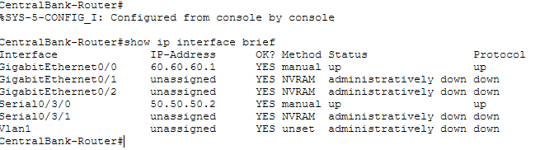

4.2. HQ_Router :
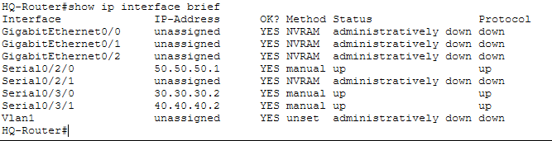

4.3. Branch1_Router :
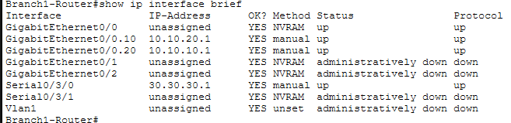

4.4. Branch2_Router :
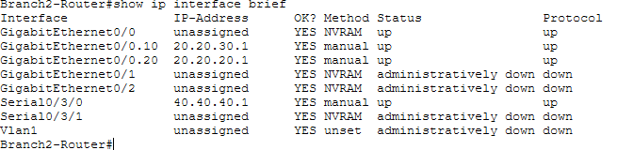

5.DHCP Pool + PC Getting IP :
5.1. Branch1_Router :
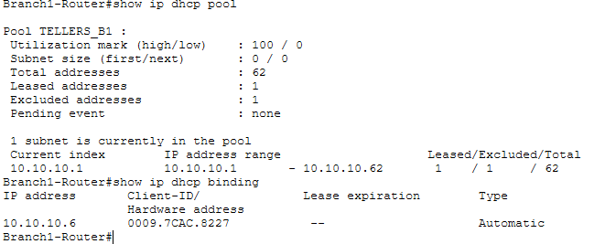

Tellers0 :
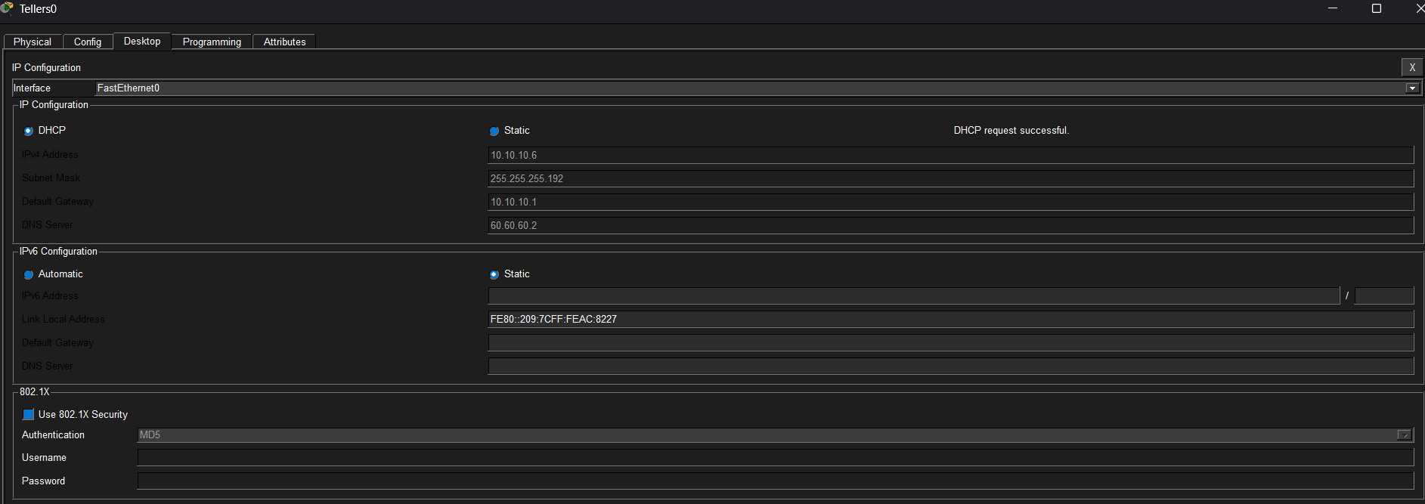
5.2. Branch2_Router :
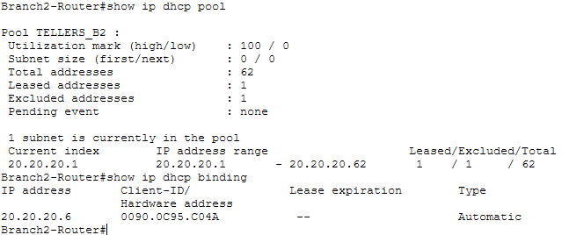

Tellers1 :
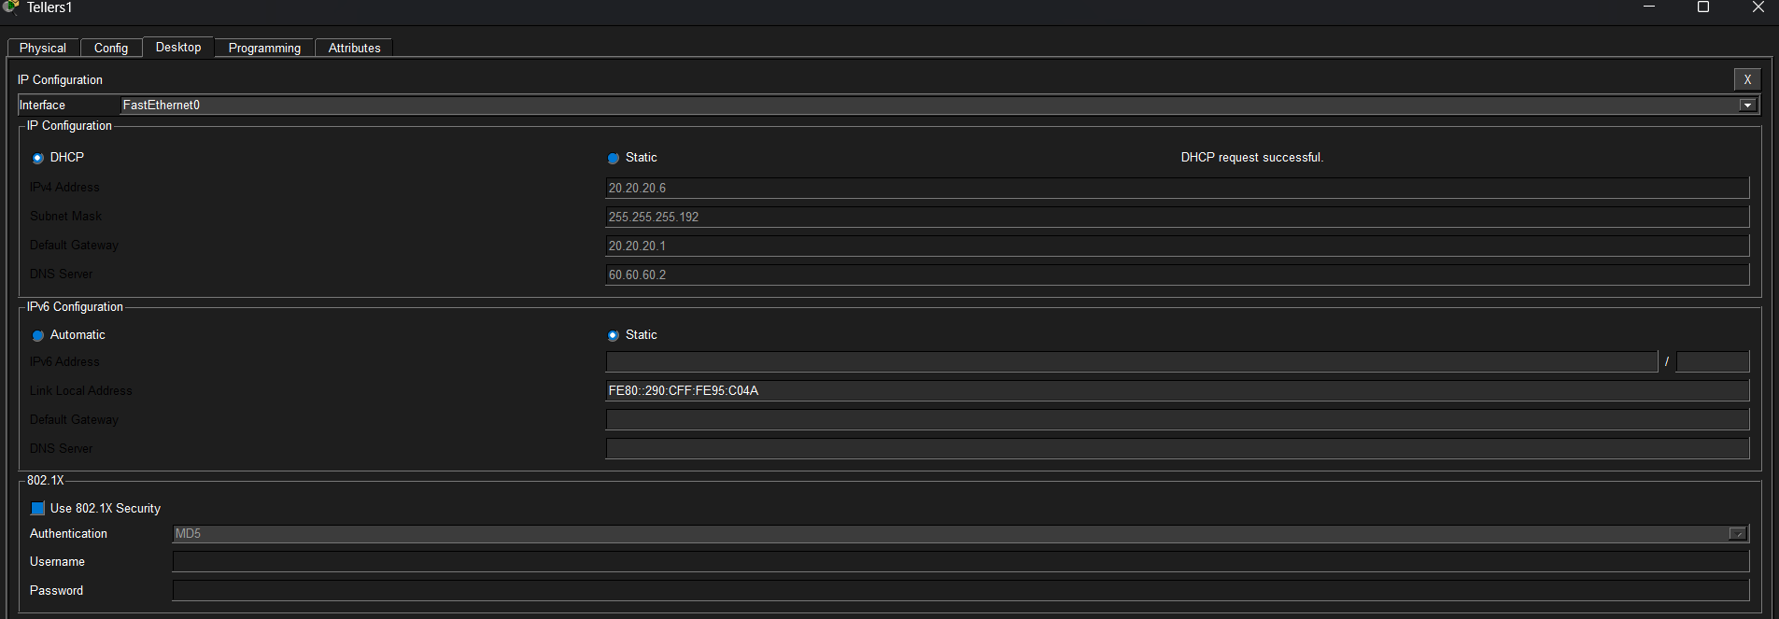
6.DNS Server :

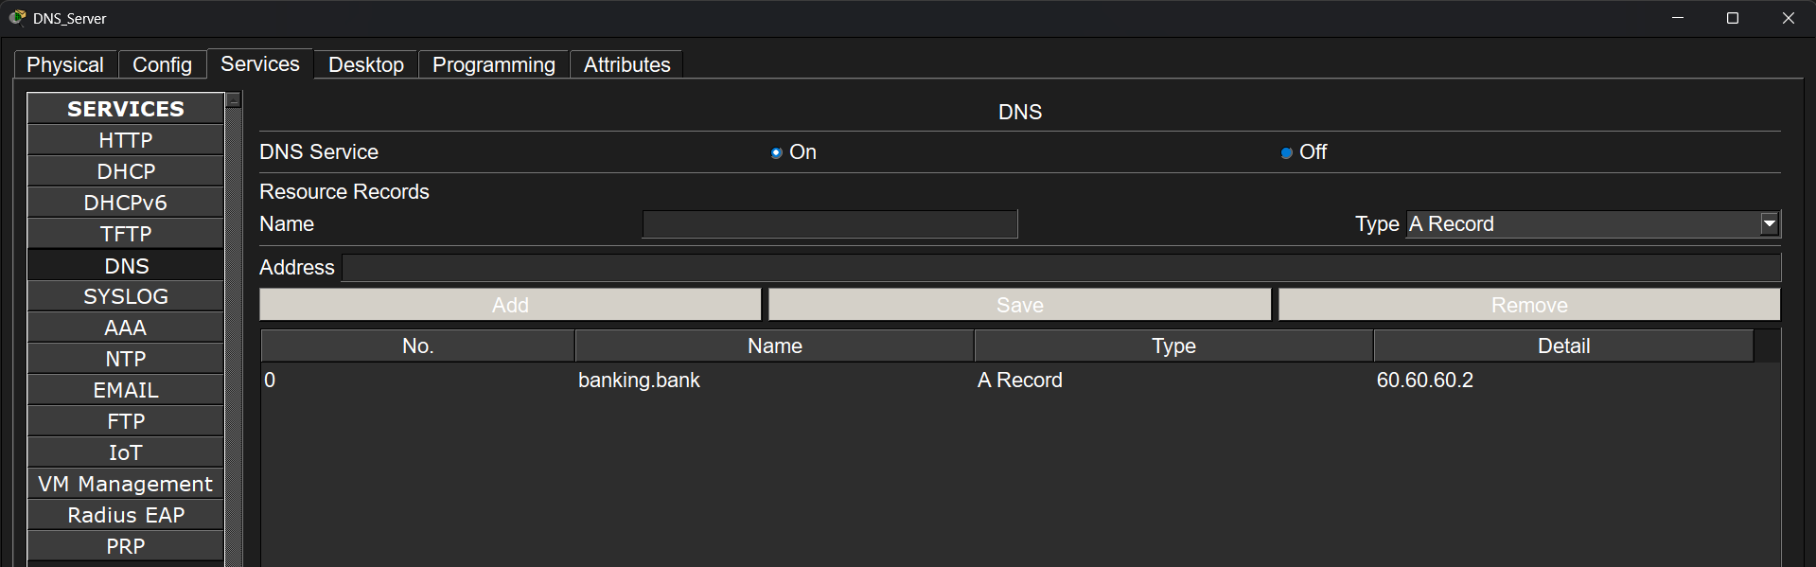

7.VLAN Table :
7.1. Switch0 (Branch1_Router) :
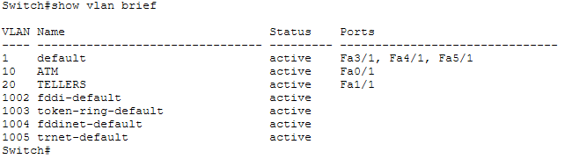

7.2. Switch1 (Branch2_Router) :
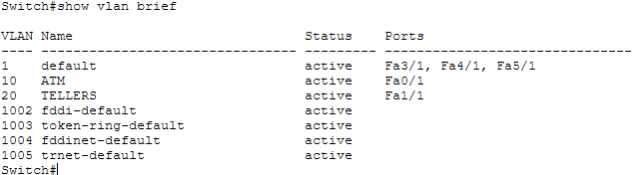

8.NAT Statistics And Translations :

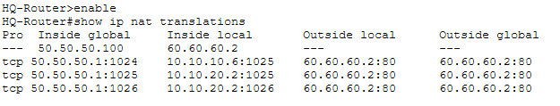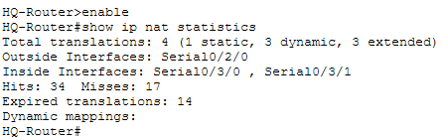

9. VPN :
9.1. Branch1_Router :
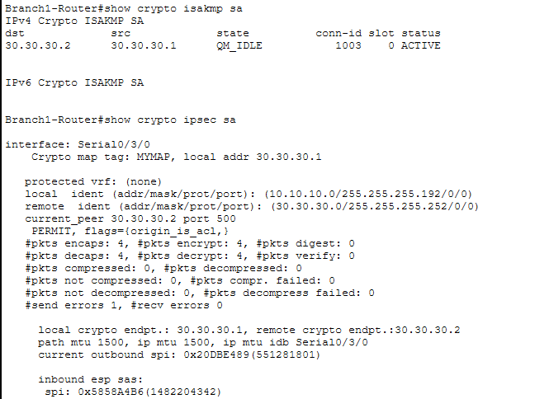

9.2. Branch2_Router :

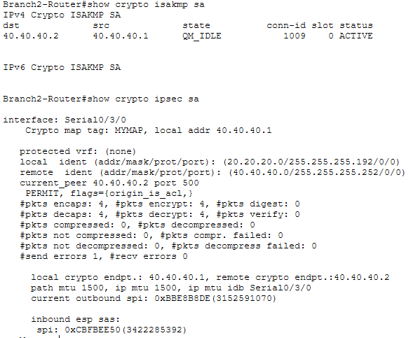

10.Static Routing :
10.1. Central_Router :
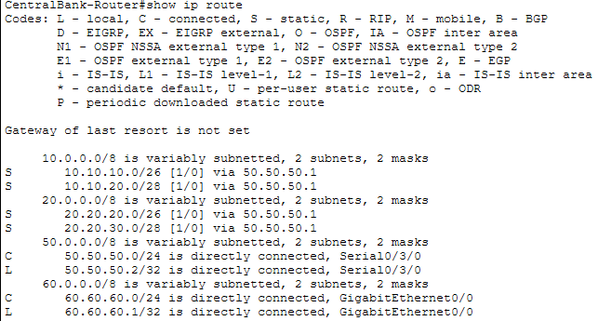

10.2. HQ_Router :
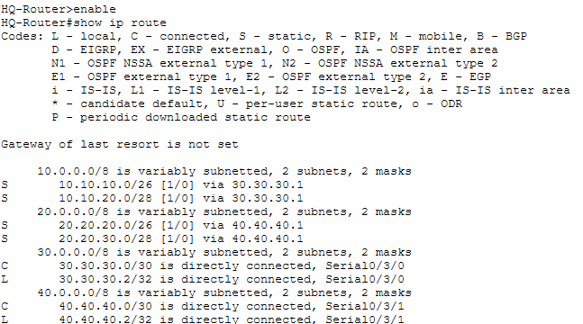
10.3. Branch1_Router :
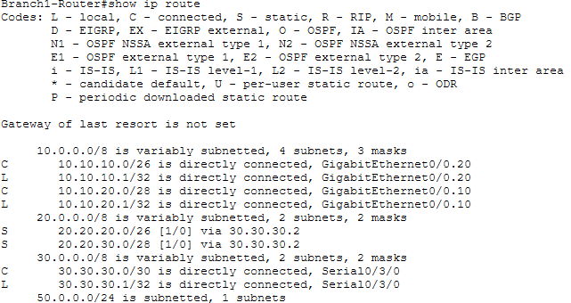

10.4. Branch2_Router :
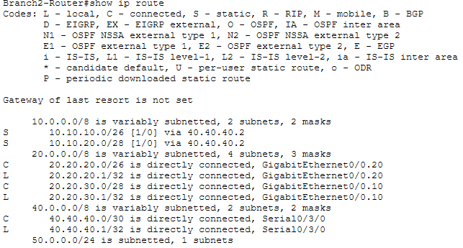
11. Web Server :
11.1.ATMs0 (Branch1_Router) :
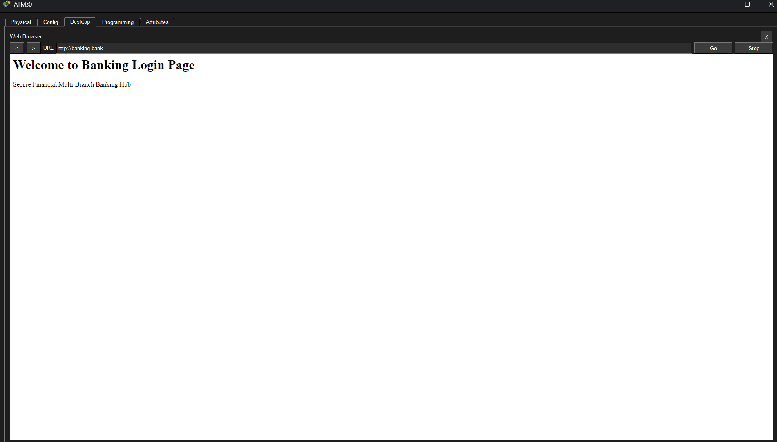

12. ICMP Testing :
12.1. Pinging from (ATMs0) to all network :
12.1.1. Tellers0 :
Ping 10.10.10.6 :
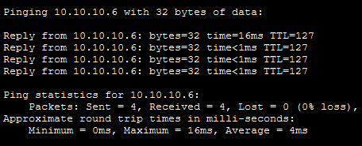

12.1.2. ATMs1 :
Ping 20.20.30.2 :
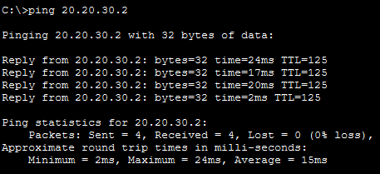
12.1.3. Tellers1 :
Ping 20.20.20.6 :
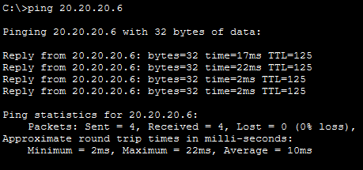

12.1.4. Central_Router :
Ping 50.50.50.2 :
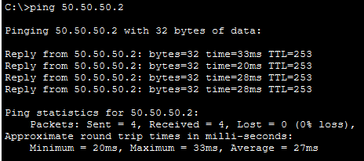
12.1.5. HQ_Router :
Ping 30.30.30.2 :
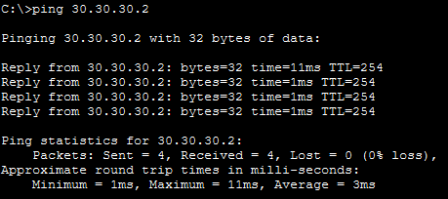

12.1.6. DNS_Server :
Ping 30.30.30.2 :
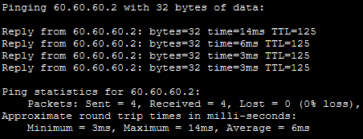

12.2. Pinging from (Tellers0) :
12.2.1. Tellers1 :
Ping 20.20.20.6 :
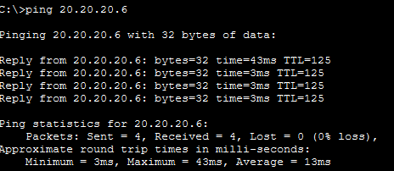

12.2.2. DNS_Server :
Ping 60.60.60.2 :
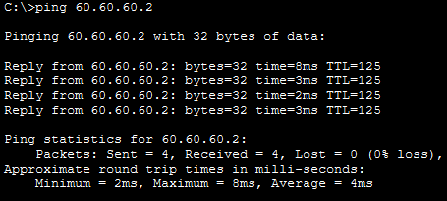
12.2.3. Web_Server :
Ping banking.bank :

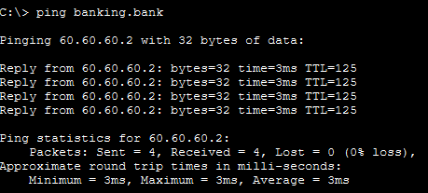

12.3. Pinging from (ATMs1) :
12.3.1. ATMs0 :
Ping 10.10.20.2 :
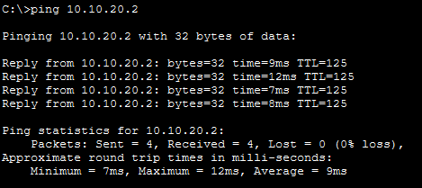

12.3.2. DNS_Server :
Ping 60.60.60.2 :
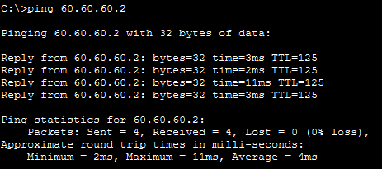
12.3.3. Central_Router :
Ping 50.50.50.2 :

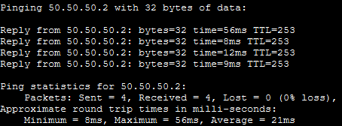

12.4. Pinging from (Teelers1) :
12.4.1. Tellers0 :
Ping 10.10.10.6 :
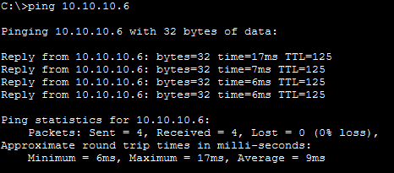

12.4.2. HQ_Router :
Ping 40.40.40.2 :
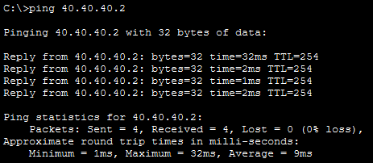
12.4.3. DNS_Server :
Ping 60.60.60.2 :

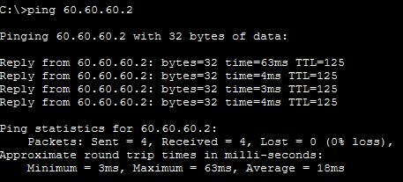

13. Pinging In Simulation Mode :
13.1. Ping ATMs0 -> DNS_Server :
13.1.1. ATMs0 -> Switch0 :
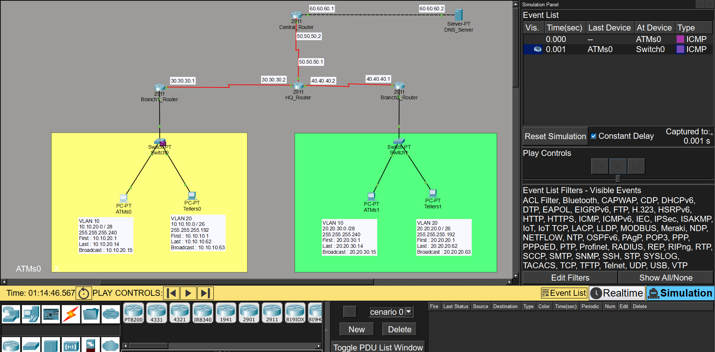

13.1.2. Switch0 -> Branch1_Router :
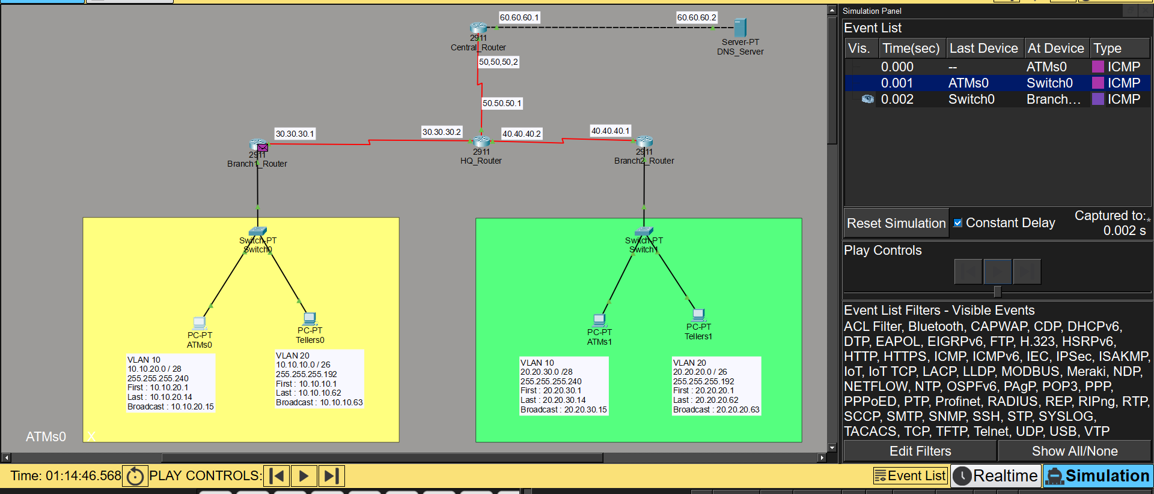

13.1.3. Branch1_Router -> HQ_Router :
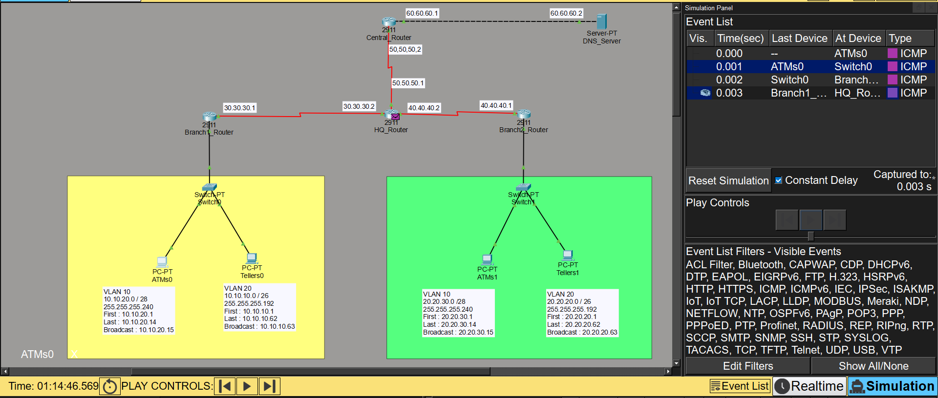

13.1.4. HQ_Router -> Central_Router :
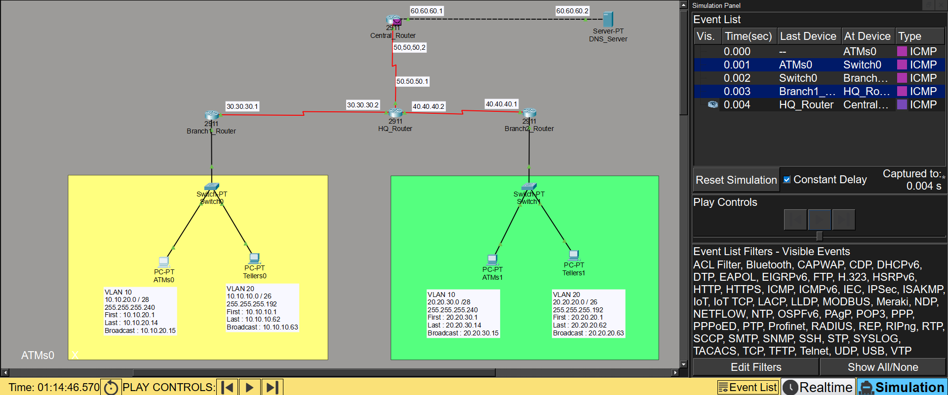
13.1.5. Central_Router -> DNS_Server :

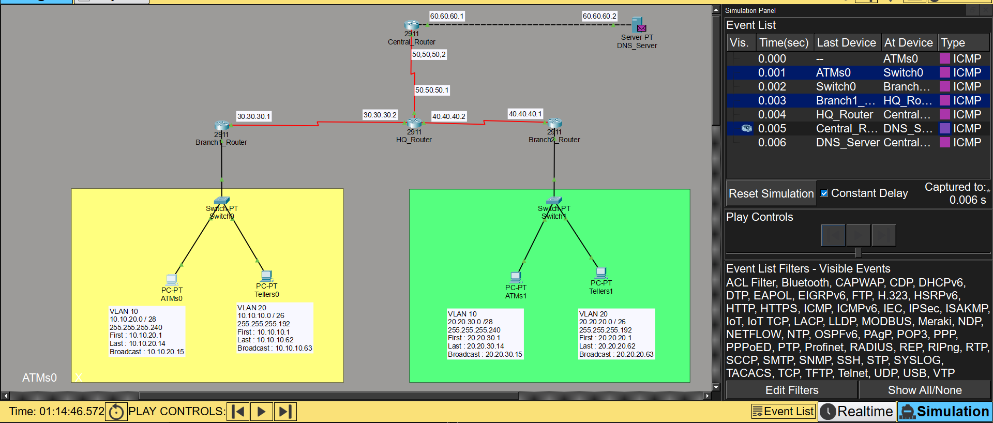

13.2.(Returns back) DNS_Server -> ATMs0 :
13.2.1. DNS_Server -> Central_Router :
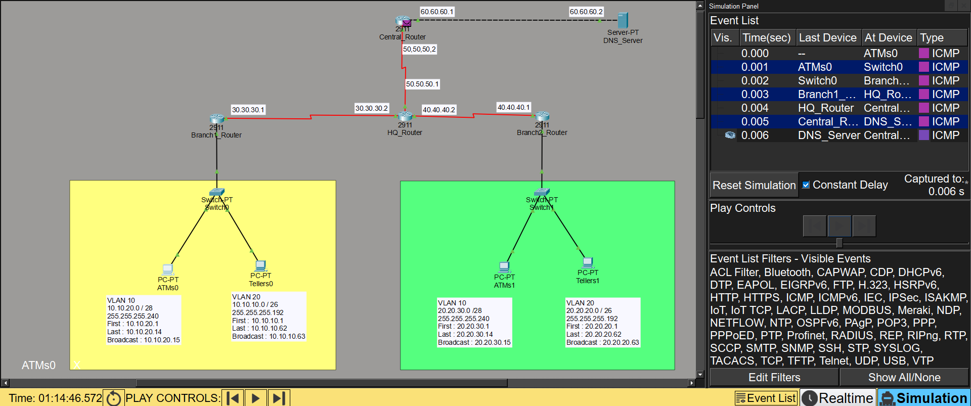

13.2.2. Central_Router -> HQ_Router :
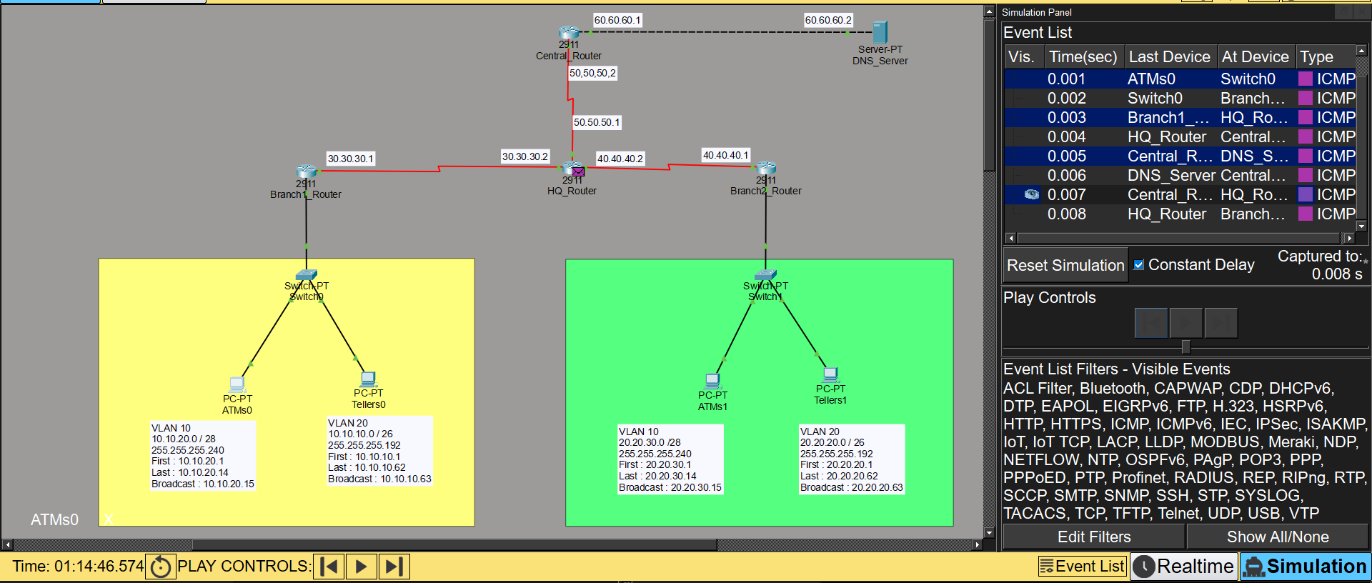
13.2.3. HQ_Router -> Bramch1_Router :
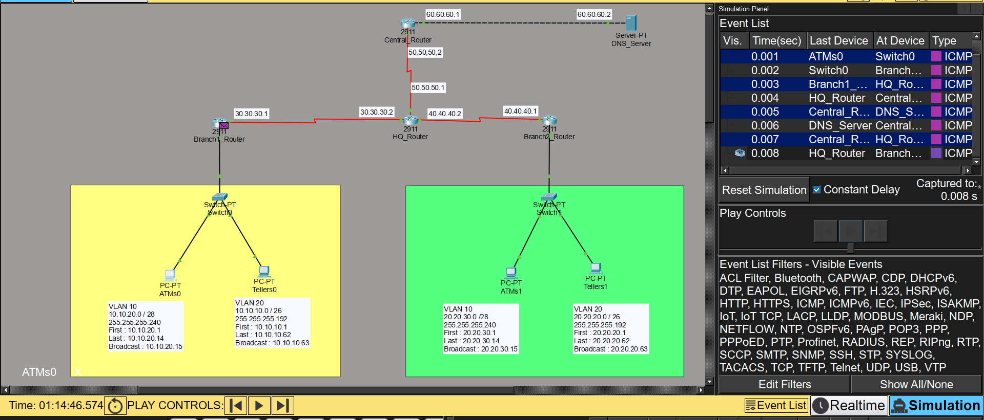

13.2.4. Bramch1_Router -> Swicth0 :
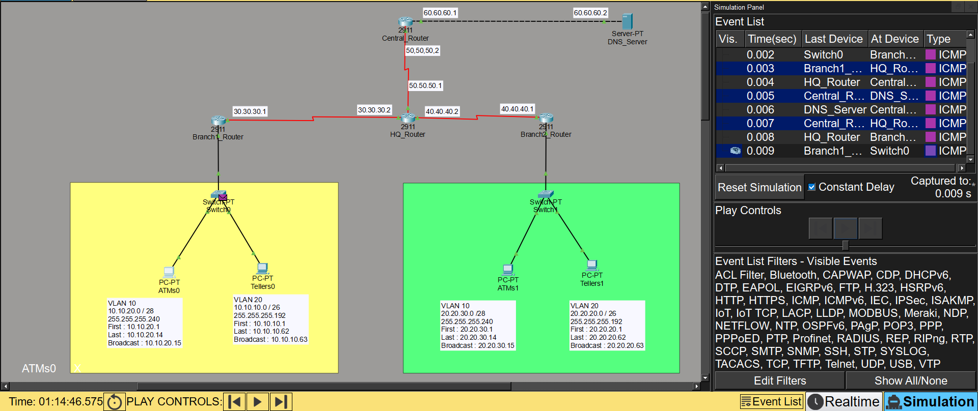
13.2.5. Swicth0-> ATMs0 (Successful):
