**Logical Model**

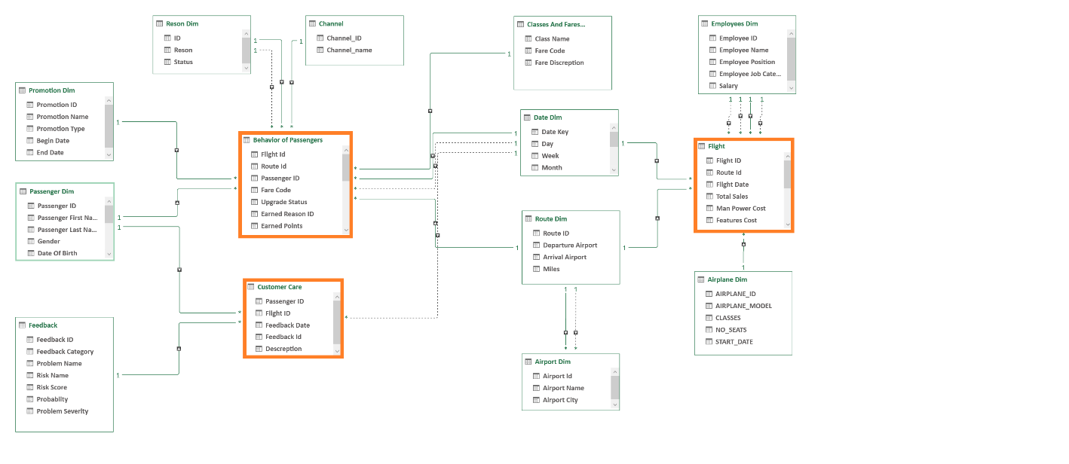

Why did we choose this Model?

As we have many Facts, we use a Galaxy schema that reduces redundancy and it’s known for high data quality and accuracy and lends to effective reporting and analytics.

What does each Component Represent?

1. Date Dim: is an essential table in a data model that allows us to analyze performance more effectively across different time periods.
2. Classes and Fares Dim: to represent the classes and fares related to them.
3. Route Dim: Describe route information and distance.
4. Passenger Dim: Describe the information about the Passengers and their Frequent Status.
5. Promotion Dim: Describe Promotion features.
6. Airplane Dim: Airplane information.
7. Employees Dim: Data about Employees at the Company.
8. Airport Dim: Airport Location.
9. Feedback: Define the feedback category and its severity.
10. Channel Dim: Define the different channels.
11. Behavior and Reservation of Passengers Fact: Behavior of the Flyers and the reservation process.
12. Customer Care Fact: Provide customer care interaction.
13. Flight Fact: Describe information and measures about the flights.
14. Reason Dim: Describe different reasons of earning or redeem points.