Video 1 - Introduction And What I Need To Learn
- CSS -> Cascade Style Sheet
- Create presentations and visuals

Video 2 - Your First Project And Syntax
- Selector{ Property: Value;}
- Selector is the element we are styling
- Property is the property we are trying to change (eg color or font-size)
- Note that semi colon is used separate one property from the next
- Instead of styling a whole element type, you can style a class. This is done using “.ClassName”, period is very important at start of name
- This can also be done for an id, however you use a # instead of a period. Note that it is not best practice to style an id.

Video 3 - Element Styling
- Comments in CSS is using /* comment */
- External styling uses <link> tag in head and uses external stylesheet
- Internal styling uses <style> tag in head and can write css code in it
- Inline styling uses the “style=” global attribute for any specific element
- CSS goes line by line, so last instance of an element styling will apply
- Note that inline styling has the highest priority and therefore will overwrite any styling done in an external or internal styling
- Note that inline styling is not best practice

Video 4 - Name Conventions And Rules
- Rule: Don’t start any identifier name with a number
- Convention: use kebab case for identifier names (classes or ids) user-test-subject
- Guide: https://elzero.org/css-formatting-guide/
- You can load multiple CSS files, note that the lower one will override the upper ones

Video 5 - Background - Color, Image, Repeat
- Background-color: color name (red, white, orange, etc.)
- Background-color: rgb(255 0 0 ) -> function to mix intensities of red green and blue
- rgb(255 0 0 / 50% ) -> this adds alpha which controls transparency
- Can also use hexadecimal code: #FF0000 -> red (00 is min and FF is max)
- Background-image: url(“”); -> place path of image within quotes (online or locally)
- Background-repeat: repeat; -> default value, this means that the image placed will be repeated to fill the background of the element as needed. If using no-repeat, it will only appear in background once!
- Use repeat-x to repeat horizontally and repeat-y to repeat vertically

Video 6 - Background - Attachment, Position, Size
- Background-attachment: scroll; -> default value, means that if size of element is so large you need to scroll, the background image will not scroll with you. Use “fixed” if you want that functionality
- Background-position: ; -> general positions use any combination of (left – center – right) and (top - center – bottom) (note that if you set only one the other will be center by default)
- Can also control position using pixels (px) or percentage (%) you write two values, first will be for horizontal and second will be for vertical. Eg: 100px 50% means you will move 100px to right and to center of page (from top to bottom)
- Background-size ;-> auto is default value, use original size of image. Cover is used so image covers the whole background (can also stretch and cut to fit new size by itself)
- Contain is used to make sure that the image is wholly visible and still enlarges or gets smaller as you change the window size (maintaining original aspect ratio). It however doesn’t mean that it will cover the whole background
- Can also use px values or % to control size

Video 7 - Padding
- Padding: ; -> gives space in any of the 4 directions top right bottom left
- The order of numbers given starts from top and goes clockwise
- If you only write 1 px value, it will apply to all 4 directions
- If you only write 2 px value, first will be for top and bottom, second will be for right and left
- If you only write 3 px value, 2nd will be for left and right
- If you want to change one specifically, use padding-“direction”:; replace “direction” by any of above directions (top right bottom left)

Video 8 - Margin
- Padding is for space within the block, margin is for space outside the block
- Padding cannot be -ve, while margin can (it can even result in part of block being out of view)
- You can use % values for padding and margin
- If you want to center your element after changing its width (considering that its default width is 100%) you can use margin: auto; -> if width given is 70% this will center the element by making left and right margins 15%.
- You can change margin in each direction by itself using direction like padding.

Video 9 - Border
- 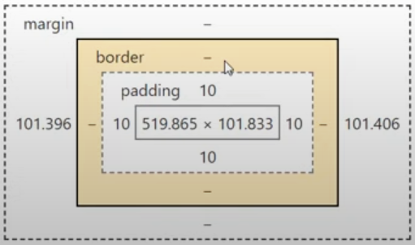
- Border-width: ; -> same rules as margin and padding
- Border-color: ;
- Border-style: solid; (many different types, common are solid and dashed)
- Note that you can control above for each border direction
- If you want to customize all of the above for all borders at same time, use shorthand property:
- Border: width style color; (eg; border: 10px solid red;)

Video 10 - Outline
- Outline: like border but is not considered part of the element (also is outside of border)
- Outline cannot control in specific directions, must control in all directions so only command is outline: width style color;

Video 11 - Display - Block, Inline Block, Inline
- Block:
  - Take full width if not specified
  - Add line break above and below
  - Respect width margin padding and height
- Inline:
  - Does not respect width or height
  - Respect padding and margin (only left and right) (upper and lower padding will appear visually but won’t take space, meaning that it can overlap with other elements above or below inline element)
  - No line breaks
  - Allow elements before and after it (i.e to its left and right)
- Inline-Block:
  - Allow elements before and after it
  - Respect padding, margin, height, width
- To change type: use display: ; (block inline or inline-block)

Video 12 - Element Visibility And Use Cases
- Display: none; hides the element by removing it entirely, meaning that other elements can take its place
- Visibility: visible or hidden; hides element but it keeps its position in the workspace

Video 13 - Grouping Multiple Selectors
- If you have selectors that have certain properties that they share their values do this:
- Eg: you have class1, class2, class3, and all paragraphs sharing a set of properties:
- .class1, .class2, .class3, p{ }

Video 14 - Nesting
- Nesting is when you want to style a specific selector that may be inside another
- For example, you want to style all paragraphs with class “special” that are inside a div
- You will do: div p.special{}
- Note that div p .special is different from div p.special -> first one will search for any element with class special that is inside a paragraph that is inside a div. Second one will search for paragraphs with class special inside a div.

Video 15 - Dimensions - Width And Height
- Min-width and max-width
- Min-width means element starts out at that width but can enlarge to greater width if needed
- Max-width means element cannot enlarge its width past that point
- This means that min-width can act as starting point of width and max-width can act as ending point (therefore creating a range)
- If using min-width only, width can enlarge upto 100%. If using max-width only, width will start at 0%
- Same rules apply to height
- Note that using width by itself will fix the width with no possibility for it to change!
- Width: fit-content; another method that fits the width of block to its content

Video 16 - Overflow - Overflow-X And Overflow-Y
- Overflow: visible; default, content will overflow out of the borders of the element
- Hidden -> any content that overflows will be hidden
- Scroll -> add scrolls (vertical and horizontal) so if overflow occurs, it will be possible to scroll and see it. This is not the best however because the scrolls will still appear(but grayed out) even if no overflow occurs
- Auto -> scrolls will only appear if overflow occurs (and only scroll of direction of overflow will appear).
- It is also possible to control overflow on width (overflow-x) and height (overflow-y) by themselves

Video 17 - Text - Color And Shadow
- Color: ;- changes text color
- Text-shadow: H-shadow V-shadow Blur Color; (eg: 0 0 0 red)
- All values are in px

Video 18 - Text - Alignment
- Text-align: left/center/right;
- Direction: ltr or rtl; (left to right or right to left)
- Vertical-align: top/middle/bottom; (used for an image)
- Top means text at top while picture bottom and vice versa. Normal is middle

Video 19 - Text - Decoration And Transform
- Text-decoration: line-through, underline, overline;
- Usually used when wanting to remove underline from a link (like an anchor tag) using text-decoration: none
- Text-transform: capitalize or uppercase and others. Try to write stuff in html normally or lowercase then use css to control transform

Video 20 - Text - Spacing
- Letter-spacing: px; -> spacing between each letter, can get negative pixel values
- Text-indent: px -> can also use -ve px
- Line-height: ; -> 1 or 100% is normal value, use numbers in range of small numbers (common line height is 1.6) to change vertical distance between each line
- Word-spacing: px; -> spacing between words instead of letters
- White-space: ; -> affects how text act when reaching end of element width. Normal means it wraps down. Nowrap means it will overflow
- Word-break: break-word or break-all; used to break/wrap a long string of characters with no spaces (meaning it is one word). Examples would be URLs or code snippets.

Video 21 - Text - Overflow And Use Cases
- Text-overflow: ellipsis; -> if text is going to overflow, replace with ellipsis

Video 22 - Inheritance
- Some of the properties set to an element will be inherited by any elements within that element (like font size, font, text align etc.)
- Inherited properties does not override any properties that were specifically set by a style sheet (even the user agent stylesheet of the browser)
- Another use is the value “inherit” for properties with px values. This makes the element inherit the property value from its parent and so we need only change the values of one element to change value for both.

Video 23 - Typography - Font Family
- Web safe fonts are those that should be available for any browser in any computer
- Font-family: font1, font2, ---, font-group; (font group is serif or sans-serif)
- Examples: Arial, Helvetica for sans-serif or “Times New Roman” for serif
- You can use fonts from the internet using <link> tag or in a different method to use it locally

Video 24 - Typography - Font Size And CSS Units
- Default font size is 16px
- Em = Time
- 1 em = 1 * inherited px size (if inherited from default, it will inherit 16px)
- Rem = root time
- 1 rem = 1* inherited px size from root (which is <html>)
- Vw = viewport width
- 1 vw = 1% of the width of the viewport
- Viewport is the size of the available browser window that you can view elements on
- This means that anything using the vw unit will dynamically change in size with the screen

Video 25 - Typography - Font Style And Variant And Weight
- Font-style: ; -> italic oblique etc.
- Font-variant: ; -> small-caps (capital letters but smaller in size)
- Font-wegiht: ; -> 100 to 900 or bold
- Not all font weights are available for each weight so it is simplest to use bold

Video 26 - Mouse Cursor
- Cursor: pointer; -> pointer is the cursor type when hovering a link or button
- By default <button> doesn’t make the curser a pointer and so must be set in stylesheet
- There is many types of cursors: grab scroll etc.

Video 27 - Float And Clear
- Imagine a scenario where you have 4 divs, each containing a product and you want to align all 4 horizontally, each taking 0.25 of the width of the screen
- The old solution is to use inline-block, which will keep them as blocks (so they don’t overlap) and at the same time allow them to appear on same line
- This is problematic however because inline-block adds extra space between two blocks that is not accounted for and cannot be planned around
- Enter float: left; -> this command gives each div the ability to “float” to the left of the screen taking any space they can.
- This command by itself is problematic because it “removes” them from the parent element, meaning that the parent element will act as if it is empty, meaning that the children floating elements will overflow
- Multiple solutions exist: increasing height of parent by force -> bad because the floating elements might also increase in height and overflow
- Another is overflow: hidden. This is also problematic because any part of the floating elements actually overflowing will not be visible and we can’t scroll to get them
- A built in solution is to use clear: both; -> (both meaning it clears both left and right floats) This removes the floating aspect of the children (while keeping the layout) and therefore they return to being inside the parent
- This can be done by using an empty element with it’s special class whose only code in css is clear: both.
- Don’t forget to put that special element within the parent of the floating children

Video 28 - Mastering The CSS Calculation
- 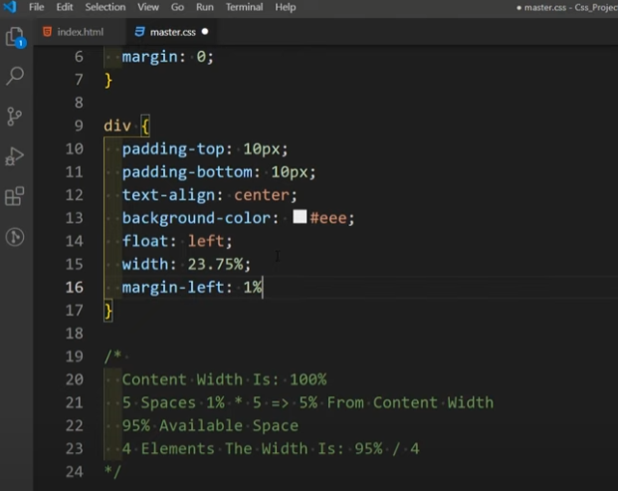
- 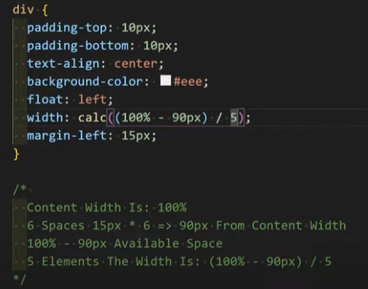
- Calc(expression) is new function used. Becareful that you need to use at least one value with a unit in the expression. (even % is a unit)
- Calculation: width = (100% - Size of 1 Gap * (N+1) – 2*Size of Padding) / N , N = number of elements

Video 29 - Opacity
- Opacity: 0 to 1; -> as it approaches zero the element (with its content be it text or image) will approach complete transparency.

Assignment 6 Notes:
- Don’t put padding in left or right sides
- When using inspect element, the width written will be of the content without the margin but the highlighted area will contain the margin
- 100% width means width of parent, doesn’t have to be page
- To set alpha value using hex code for colors: just write anything from 00 to 99 at end
- EG: #B3B3B310 -> sets alpha to 0.1

Video 30 - Position
- Position: ; -> controls how the element reacts to changes in position
- Static is the default value, making the element stay in place and not affected by position changing properties (top right bottom left)
- Relative -> moves relative to its original position
- Absolute -> moves relative to page. It does not act as part of workflow and therefore does not react to position of other elements
- If you want an element to move relative to another element (instead of the page), make the other element the parent and set its position to relative. (of course first element is still set to absolute)
- Fixed -> absolute but also moves with the screen. If you scroll down or up it will come with
- Usually used with small buttons/pop ups at bottom right of the screen which contain a helper (AI or assistant)
- Sticky -> Remains at original position but if scrolling, away from that position, will follow according to position properties
- Usually used with top nav bar that will scroll down with you when you scroll down

Video 31 - Z-Index
- Z – index controls how elements appear in the webpage
- If two elements overlap, the one with the higher z-index will take precedence and appear on top
- If not set, the z index will be as elements appear in html, those appearing later (further bottom) will have higher z index
- If an element has set z index while others don’t, it will always have higher priority (need to check this with low z index)
- If two elements have same z index, the one that appears later in html will have higher precedence
- Note that z index only works when position is set for the elements
- z index = -1 will mean it will always appear at bottom!

Video 32 - Lists Styling
- list-style-type: control shape of bullet point
- list-style-position: outside or inside; -> if li element will contain the bullet inside it or outside when customizing it
- list-style-image: url(“image”); -> replace bullet point by an image
- list-style: type position image; shorthand property
- To reset default styling: list-style: none, padding-left: 0, margin: 0,
- Some frame works have a class that does unstyling automatically like bootstrap class called “list-unstyled”

Video 33 – Table Styling
- Border-spacing: px; controls the border spacing between table elements and also between elements and table border
- It is possible to set border-spacing to zero and control borders from table elements (eg table td)
- Since we will be setting a border for the elements, there is no need to set a border for the table itself
- Instead of using th, you can use td inside thead. This has the advantage of being able to control all td using table td, and change some stuff for those in header using table thead td

Assignment 7
- Can center horizontally using left: calc(50% - 0.5 * width) or using margin: 0 auto (because autoing left and right margins will distribute them equally)
- When adjusting position of each span, it is important to note that at top and left = 0, the border of span will touch the borders of the div
- So, to get the needed position, need to subtract half the heigh from top and half the width from left. Take note the width, height and padding (but not the border).

Video 34 – Pseudo Classes
- Pseudo Classes are different states that the element you are styling can be in.
- The idea is that you can apply a certain style to an element if the element is currently at the selected state
- An example is: hovering over a link with your cursor
- If you want a different text color when hovering only, use a:hover {}
- There are many pseudoclasses such as checked (for a checkbox or radio)
- Another for links is visited (meaning you clicked on link already)
- Empty is a pseudo class meaning that the element is empty ( eg: <div></div>)
- If you want to apply a style to all empty elements (i.e not one specific element) use “:empty {}”
- Inputs have the state of “focus” meaning they are currently selected
- In google developer tool/inspec element, you can select an element and force its state (using right click)

Video 35 – Pseudo Elements - First Letter, First Line, Selection
- It is possible that you want to edit a part of the content of the element but without adding more elements in html
- Pseudo elements can allow you to edit common parts of the element using CSS without needing to put an actual element in html
- Pseudo elements differ from pseduoclasses by using double colon “::”
- ::first-letter{} allows you to format the first letter in an element
- ::first-line{} is same but for line. Note that this also dynamically changes as the viewport/screen changes (any words/letters that used to be wrapped but come back to first line after enlarging screen will also be affected by first-line styling)
- ::selection{} -> styling of content (i.e text) when double clicked. Default is blue background and white color.

Video 36 – Before, After, Content
- Before and after are pseudo elements that act as an element that was placed at the start or at end of content inside original element respectively
- For these pseudo elements, the property “content: “ must be given. If no text is needed, just place empty quotes “”.
- This can be very useful in making shapes. Making the original element relative and the pseudoelements absolute also allows in controlling the position easily.
- To make a vertical line, use any width and make height 100% and choose whatever background colour you like
- To make the head of an arrow, you can use an empty pseudo element with width and height set to zero. Each border will result in an arrowhead pointing to opposite direction of its position (eg top border will yield an arrow facing downward).
- Make sure you only color the border you need and set others to “transparent”

Video 37 – Pseudo Elements - Content And Trainings
- Use counter-increment: name-of-counter; in the parent element to count each element inside. You can choose any counter name
- To start counting, place inside the element you want counting as counter(name-of-counter). This can be used inside the “content= ;” of a pseudo element.
- You can use attr(name-of-attribute) inside content to display whatever data that attribute was holding. The attribute of course must exist for the element you are creating a pseudo element for. Can be used to create tooltips (watch video to see example)
- You can use both a pseudo class and pseudo element eg: div:hover::after
- You can also use url() in content (warning: not professional)
- A very useful application of ::before is in unordered lists. Since we usually remove original styling of lists, you can then use ::before to create your custom bullet point.

Video 38 – Vendor Prefixes
- 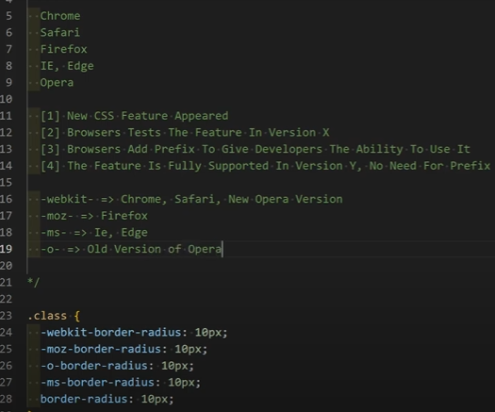
- Use caniuse.com to test if a feature is supported with no need for prefix
- Most of users use modern browsers so not needed
- Vs code addon to add the prefix (as a suggestion)
- Task runner, uses market share to add prefixes automatically

Video 39 – Border Radius
- Border-radius: 10px; -> accepts values for 4 directions!
- Adds a fillet to border -> if border-radius is ½ of both width and height -> draw circle (can use 50%)
- Directions are top-left top-right bottom-right bottom-left and we can control them individually
- If using an individual direction, you can control its radius in x and y direction!

Video 40 – Box Shadow And Examples
- Box shadow is like text shadow but for the whole element
- Box-shadow: h-shadow v-shadow blur spread color inset;
- Spread controls the spread of shadow in all directions
- Outset or inset -> means shadow is either outside element or inside element
- You can use multiple shadows in one box-shadow: shadow-set-1, shadow-set-2, shadow-set-3, etc.; -> most important thing is the comma between each shadow

Video 41 – The Box Model And Box Sizing
- Margin of child element must be included in size of parent element if you want to fit child elements horizontally
- Any padding and border will add to width and height 2x their size
- Box-sizing: content-box; -> default, adds padding and border ontop of width and height
- Box-sizing: border-box; -> padding and border included within set width and height
- If you want to apply box-sizing border box for all elements use the following code that uses * {} (* means apply to all elements)
- 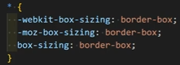

Assignment 9 Notes:
- For now, to center single line text within an element, use text-align: center to center it horizontally and line-height: =height; to center it vertically.

Video 42 – Transition
- Controls how an element transitions from one state to another
- For example, if you change margin left (i.e moving element right) when hovering take the following transitions
- Transition-duration: ; controls time it takes to reach new position (using second as s or millisecond as ms)
- Transition-delay: ; controls time before transition starts (default is zero second)
- Transition-property: all; allow controlling all possible animations/properties during a transition. It is best to only allow certain properties to have an animation. Use site that lists them all: https://developer.mozilla.org/en-US/docs/Web/CSS/CSS_animated_properties
- Eg: transition-property: margin-left, margin-top; (separate multiple properties by commas).
- Note that any property changing without being listed in transition-property will not have an animation
- Transition-timing-function: ; controls speed at different points during transition
- Default value is ease -> starts slow, accelerates, reaches peak, decelerate, ends slow
- Linear -> constant speed
- Ease-in -> starts slow then reaches max speed
- Ease-out -> starts fast then ends slow
- Shorthand form: transition: property duration delay timing-function; can control transition of multiple properties this way (each with their own set of transitions) but separated by commas.

Video 43 – !Important Declaration And Use Cases
- !important flag is set next to any property where you want to override the styling used.
- It overrides any style set (even css sheets that are further down in html, even inline styles, even properties that are further down withing same sheet)
- This is usually used when you are assigned to change styling of a webpage worked on by others, but not allowed to remove any previous styling / stylesheets set.

Video 44 – The Margin Collapse
- Margin collapse means that the margin of two elements join into one margin
- This occurs only for vertical margins
- The element of bigger margin wins, with its margin remaining at end.
- Collapse only occurs when elements are adjacent
- Nesting does not prevent collapse
- Note that during testing, I found that if two elements are nested and one is supposed to be inside the other, to prevent margin collapse (eg at top border), I needed to add border or padding to containing element.

Video 45 – CSS Variables And Trainings
- Global variable -> any property can access it
- Local variable -> only defined within scope of a property
- To define global variable -> use :root (which is the html element)
- Naming convention -> --camelCase: value;
- Use var(--variableName, Fallback value (optional))
- If using same variable name both locally and globally, the local variable takes precedence

Video 46 – Flex Box Parent - Direction, Wrap, Flow
- Flexible Box
- Display: flex
- Replaces float and its constituents (eg: overflow hidden, clear etc.)
- Flex-direction: row; default direction
- It means it flows with direction of row. Meaning that if you change direction to rtl, it will automatically change from right to left too. (in float, need to set float: right)
- Row-reverse -> opposite of direction of row
- Column or column-reverse
- Flex-wrap: nowrap; -> default value, overrides your width specifications to make sure all elements follow direction (assuming it is row)
- Wrap -> allows wrapping and therefore maintaining width
- Wrap-reverse -> wraps to top instead of bottom
- Flew-flow: direction wrap; shorthand for previous two properties

Video 47 – Flex Box Parent - Justify Content
- Justify-content: flex-start; -> default value
- Flex-end: wrapping elements start from right instead of left
- Center: wrapping elements start from center
- (Sorry, it is not only wrapping elements. Any elements placement start is governed by justify-content)
- Space-between: any space remaining after taking into account width of elements is split between the elements. Therefore only need to set width of elements
- This is as if adding margin two elements in the middle, not considering first and last elements.
- Space-around: splits remaining space around elements (so before first and after last)
- Space-evenly: splits remaining space around and between elements

Video 48 – Flex Box Parent - Align Items
- Align-items: stretch; default value. If an element has height different from other elements, other elements will stretch to reach same height. This is only if height of other elements not set.
- Flex-start flex-end and center: same as justify content but vertically’
- Using justify-content and align-items center finally makes text centered both horizontally and vertically without using text-align and line height

Video 49 – Flex Box Parent - Align Content
- Align-content: stretch; default value. Controls the space between content instead of individual items
- Has flex-start flex-end center and also has space-between/around/evenly

Video 50 – Flex Box Child - Grow, Shrink, Order
- Previous properties were written inside the parent element containing elements
- Now we will see properties for children inside flex parent
- Flex-grow: 0; default value. Can be 1, 2, 3 etc. As long as space is available, it will increase size of element to be 1x 2x 3x etc. size of other children
- Flex-shrink:1; default value. Prioritize which elements shrinks first when shrinking happens.
- Order: 0; default value. Controls position at which an element appears
- If you are trying to get an element that is further down to a place up top (eg moving element 6 to place 1 using order: 1), you need to also set the order of any previous elements to see change.
- Examples:
- The container has a fixed width of 500px.
- Item 1 has flex-grow: 1, so it will expand to take up available space.
- Item 2 has flex-grow: 2, so it will expand twice as much as Item 1.
- Item 3 has flex-grow: 0, so it won't grow at all.
- The container has a fixed width of 300px, which is not enough to accommodate the content of the items without causing overflow.
- Item 1 has flex-shrink: 2, so it will shrink more than Item 2.
- Item 2 has flex-shrink: 1 (the default), so it will shrink normally.
- Item 3 has flex-shrink: 3, so it will shrink the most.

Video 51 – Flex Box Child - Flex Basis, Flex Shorthand
- Flex-basis: px; instead of setting width and height, you can set this property as starting dimensions of an element
- Flex-basis respects max width!
- Shorthand of flex: grow shrink basis; (0 1 auto/0% are default values)
- Note that if you write flex: 5px; -> it recognizes that only basis can take css units so it will automatically set it and leave others as default
- If you set flex-grow to 1, basis is ignored if there is extra space that element can take.
- You can use display: inline-flex so that a flex container is not block style

Video 52 – Flex Box Child - Align Self, Games, Task
- Align-self: auto; default value. Follows the alignment set by parent
- You can change it so the children each has their own alignment
- Solve following: flexboxfroggy.com, flex box zombies
- Try to implement the “holy grail” web design:
- 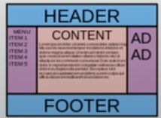

Flex Froggy Notes:
- If flex-direction is column, justify content becomes vertical and align-items horizontal
- Order can have negative integer values. Since default order value is zero, an order of -1 will send object to first place
- You can use align-content to set how multiple lines are spaced apart from each other.
- This can be confusing, but align-content determines the spacing between lines, while align-items determines how the items as a whole are aligned within the container. When there is only one line, align-content has no effect.

Video 53 – Finish Flex Froggy Game
- No extra notes

Video 54 - Filters
- Filter: grayscale(100%): black and white image
- Can be used as a cool transition where the image regains color when you hover
- Blur(4px);
- Invert(100%); -> inverts image colors
- There is a filters list for all available filters. Make sure to check if the filter is supported by browser (using can I use .com)

Video 55 – Gradients
- Background-image: linear-gradient(direction/angle, color stop 1, color stop 2, ---)
- Direction: to right, to left, to top, to bottom.
- Angle: 0 deg (eq to top) 90deg (eq to left) 180deg (eq to bottom) 270deg (eq to right)
- Can specify width each color stop takes (eg red 80%, yellow 10px, blue). If not given, it will be auto
- The “width” specified is actually the stopping point.
- An interesting use of linear-gradient is to create a border with multiple colors using a pseudo element
- 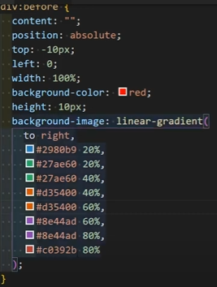
- 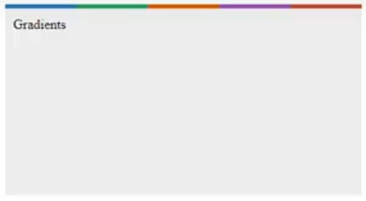

Video 56 – Pointer Events And Caret Color
- Caret-color: color; -> changes color of caret (cursor after clicking on text to edit/write)
- Pointer-event: none; -> removes any previous event of cursor on element. This can be useful for example if setting up a game where after clicking a button you don’t want it to be clickable again.

Assignment 12 Notes:
- A flex container (that is, an element with display: flex or display: inline-flex) cannot contain a ::first-letter pseudo-element, since a flex container contains flex items, not formatted lines. That's why making your p elements flex containers disables all your ::first-letter rules.
- This appears to be the classic case of using display: flex/inline-flex when you're not trying to create a flex layout within each element. For inline (or horizontal) layout of block containers, use display: inline-block, display: table-cell, or floats, instead.
- Self closing elements such as <input> and <img> cannot use pseudo elements like before and after, only containers can. (like div form p etc.)

Video 57 – Grid - Parent - Template Columns
- Gird system is made of imaginary columns that you align your page content with
- Grid system does not mean grid property. It is a method in which you set the position of content of page
- Display: grid or inline-grid (like flex or inline-flex)
- Grid-template-columns: col1px col2px col3px etc.; can use any css unit (eg 3 columns 25% 50% 25%)
- Need 4 cols with same width? Use auto auto auto auto.
- Instead of writing it 4 times, use repeat(4, auto);
- Can mix multiple units: 100px repeat(3, 50px) 25% repeat(2, auto);
- Another unit is fraction (fr). 1fr takes rest of available space
- If using more than one column with f reg: 1fr 2fr -> available space will be divided in 1:2 ratio
- What if you use fr and auto together? Fr is greedy while auto is shy. Auto will only take enough space to show content inside it. Fr will take as much as can be taken

Video 58 – Grid - Parent – Template Rows and Gaps
- Grid-template-rows: 100px; means first row will be 100px and rest will be auto. This is because rows automatically created when elements wrap around.
- Row-gap: 20px;
- Column-gap: 20px;
- Shorthand-> gap: 20px 20px; (row column)

Video 59 - Grid - Parent - Justify Content And Align Content
- Justify-content: ; -> same as flex
- Difference is that we set the column width here instead of width of each element
- Align-content: ; -> same as flex
- Note that if you set width of grids to auto: when using justify or align content flex-start / end, the elements will stop stretching to fill the empty space, meaning that the rows or columns will only take amount required to view the content.

Video 60 – Grid - Parent - Complete Layout With Template Areas
- Grid-template-areas: “logo logo nav nav nav nav nav nav nav nav”;
- Grid-area: logo;
- Grid-area: nav;
- The first line is used in the page class. And 2 others are for the logo and nav bar element. The idea is that the page was split into 10 equal columns (repeat(10, 1fr)) and so, we gave two to the logo and eight to the nav bar
- If you want one of the columns to be gap or empty: place “.” period in that spot.
- Grid-template-areas: “2x logo 8x nav” “8x cont 2x side” “10x foot”.
- Name section as cont and aside as side and footer as foot using grid-area

Video 61 – Grid - Child - Grid Column And Grid Row
- Grid-column: start / end; -> short hand for grid-column-start/end
- Eg: grid-column: 1 / 7; -> starts at col 1 and ends at col 7
- The end point is a break point so is not reached. Meaning that previous line takes only 6 columns
- Can use grid-column: span 4; -> means it will take 4 columns
- If start is higher than 1, the previous cols are called “offset” and are left empty
- Eg: grid-column: 2 / span 3; -> starts from second column and takes 3 cols
- Note: if you had set it up that there are 6 columns then used grid-column: 1 / 8;-> this will add another column and therefore break your structure
- If you instead use span, the element will either overflow or wrap instead of breaking the structure
- Grid-row: start / end; -> same as grid-column

Video 62 – Grid - Child - Grid Area And Trainings
- Grid-area: row start / column start / row end / column end
- Grid-template-areas: “head head nav nav nav” “5xcont” -> can use grid area to with name of each area given. Note that the head nav area is first row and cont area is second row.
- This was already given in video 60

Video 63 – Grid - Min, Max And Auto Fill
- Grid-template-columns: minmax(200px, 400px) repeat(2, 1fr)
- The idea is that the first column can be anywhere from 200px to 400px in width, which will depend on width of rest of columns and width of screen.
- This is useful for responsive design (which is design that accounts for different screen sizes for same webpage)
- Another useful feature for responsive design is auto-fill:
- Grid-template-columns: repeat(auto-fill, 200px) -> this will increase or decrease number of columns shown on screen depending on size of screen. A new column will be added whenever width of screen increases in factors of 200px
- Problem: if space given 450 -> this will create two columns of 200px and 50 px will be empty which is not what we want
- Solution: repeat(auto-fill, minmax(200px, 1fr)) -> the given space will be divided between 200px as minimum and 1fr as maximum. -> this will make sure that any extra space on screen will be distributed onto the columns without any column width being less than 200px.
- Search for auto-fit and new unit “ch”
- Auto-fit: It creates as many columns as possible, then collapses any columns that are empty and distributes the extra space to the columns with content. This is useful if you only want columns to appear with content inside them. Auto-fill is better if you care more about the grid structure even if new columns created are empty.
- What is the ch Unit?
- Character Width: The ch unit represents the advance measure (width) of the "0" glyph in the element's font.
- Monospace Fonts: It's most predictable and consistent when used with monospace fonts, where all characters have the same width.
- Variable-Width Fonts: In variable-width fonts, the width of the "0" character can vary, so the ch unit's value will also vary.
- Uses of the ch Unit
- Text-Based Layouts:
- It's ideal for creating layouts that are based on the average width of characters in a text block.
- You can use it to set widths and margins that are proportional to the length of text content.
- For example, you can set the width of a form input field to a certain number of ch units to ensure it can accommodate a specific number of characters.
- Limiting Line Length:
- You can use ch units to limit the line length of text, which improves readability.
- A common recommendation is to keep lines of text around 60-80 characters wide.
- Example: max-width: 80ch;
- Form Element Sizing:
- Form input fields and other form elements can be sized using ch units to ensure they are wide enough to display expected input.
- Creating Consistent Spacing:
- When working with monospace fonts, ch units can create consistent spacing between elements or text blocks.
- Example
- CSS
- p {
- max-width: 60ch; /* Limit line length to 60 characters */
- font-family: monospace; /* For consistent width */
- }

- input[type="text"] {
- width: 20ch; /* Input field for 20 characters */
- font-family: monospace;
- }
- Advantages
- Readability: Helps create text layouts with optimal line lengths.
- Proportional Sizing: Allows for sizing elements based on the average character width.
- Monospace Consistency: Provides predictable results with monospace fonts.
- Disadvantages
- Variable-Width Inconsistency: Less predictable with variable-width fonts.
- Limited Browser Support (Historically): While modern browsers have excellent support, older browsers might have had issues.

Video 64 - Finish The Grid Garden Game
- Note 1: gird-column-end can be a smaller number than grid-column-start. If start = 5 and end =2 -> will be equivalent to start=2 and end =5
- Note 2: You can use negative values for start and end. -1 for end means it will span all the columns, -2 span all columns except last, etc.
- It is important to understand that the negative value has the same meaning for both start and end. This means if you have “N” columns, -1 points to “N+1” column for both start and end.
- If you start at -1 -> it will be out of bound but if you end at -1-> it will exactly span all N columns (because the column at end doesn’t count)
- Note 3: You can use order like in flex and it will act like z-index. This is useful only if you did not explicitly specify the grid-area of the elements in the grid.
- Note 4: Shorthand for rows and columns is grid-template: rows / columns;

Assignment 13 Notes:
- Use reset-counter: counter-name initial-value; to make counter start from -1 and so it won’t count the parent div.

Video 65 – 2D Transform - Scale
- Transform: scaleX(1); -> default is 1, can control how much stretch in x direction as a factor of initial width
- Difference to width is that transform scales everything after the element is created and rendered. Meaning that the transform will scale the margin, padding, width and even the content within the element.
- Same stuff as scaleY(1);
- Shorthand: scale(inX inY);
- ScaleX(-1); -> flips object in x direction (you can use a transition to visualize it)

Video 66 – 2D Transform - Rotate
- Rotate units: deg, rad, grad and turn
- 1 turn = 360deg or about 6.28 rad or 400 grad
- Most supported/common unit is deg
- If you want to use both scale and rotate, you need to use them on same transform like this:
- 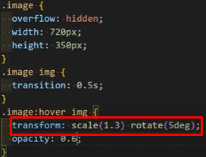

Video 67 - 2D Transform - Translate
- Transform: translate(inX, inY); can take negative values
- Translate is best for animation performance
- Translate is best with matrix instead of margin
- Translate is great when trying to position elements with position instead of margin, since you can translate using % unit meaning you don’t actually need to calculate using width or height of element
- Example: top:50% left:50% transform: translate(-50%, -50%)
- DON’T FORGET TO USE PREFIXES WITH TRANSFORM!!!!!

Video 68 – 2D Transform - Skew
- Transform: skewX(deg) or skewY(deg); -> adds a shear effect
- A 90 degree skew removes element
- Shorthand: skew(X, Y)
- Sometimes you want the background to be skewed without the text/content. This can be done by setting element to white background and contains the content, and the background will be controlled by a pseudo element with position top:0 left:0 and has all the needed properties for background (eg color, width and height 100% etc.) and skew that instead.
- Don’t forget to make z-index of the pseudo element as -1

Video 69 – 2D Transform - Matrix
- Transform: matrix(scaleX(), skewY(), skewX(), scaleY(), translateX(), translateY())
- Eg: matrix(1, 0, 0, 1, 0, 0) -> default values
- You don’t need to write units for anything inside
- The units it perceives are tan(angle) for skew and px for translate
- Note that how matrix works is that is translates first, then scales, then skews! (order matters)

Video 70 – Transform - Origin
- Transform-origin: X Y -> 2D Transform
- Transform-origin: X Y Z-> 3D Transform
- Default values are 50% 50% 0
- 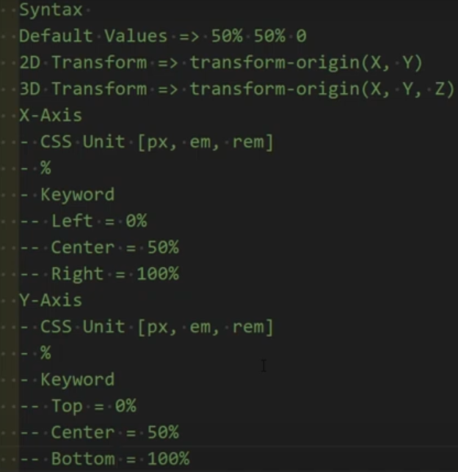
- Note that if x and y = 0, origin will be top left!

Video 71 – 3D Transform - Rotate
- rotateX, rotateY, rotateZ -> rotate around each of these axes
- rotat3d(X, Y, Z, deg) -> X Y Z can be 0 or 1 (or inbetween?)

Video 72 - 3D Transform - Translate, Perspective, Perspective Origin
- new: translateZ(px) and translate3d(X, Y, Z)
- To use Z axis, you need to set perspective of the image. This is done using perspective: px; inside the PARENT element.
- If you set perspective of 300px and translateZ 300px, it Is called vanishing point and element will disappear
- To define what movement along z-axis means, you need to define the perspective origin.
- Perspective-origin: X, Y; -> default is center center, meaning that the viewer is perpendicular to screen.
- Top left means that viewer is watching from top left perspective and therefore translation in Z will mean element will “grow” in that direction.
- Perspective sets the distance of user from screen which is why a translation = perspective means that user can no longer see the image/element

Video 73 – 3D Transform - Backface Visibility And Flip Product
- Backface-visiblity: hidden/visible; default is visible.
- Backface is as the name states the face of the element on its back
- It can be seen when you rotate the element around Y or X more than 90 degrees
- If set to hidden, there will be no backface and therefore rotating more than 90 degrees will hide the element
- By default, the children of an element will have their 3D space flattened onto the parent’s 2D plane. This means that they will be rendered incorrectly when performing 3D transformations on them.
- Using transform-style: preserve-3d; is important to preserve the 3d space of the children and will show correctly during 3D transforms
- This means that you need to set the perspective: (eg: 600px); and transform-style: preserve-3d; inside parent before doing any transformations. It is also good to set a transition: 0.5s; to show how the elements are transforming.
- The example shown in the video was an element called a “box” that has a front face and back face. The idea is that when you hover on the box, the box will rotate 180 degrees to show the back face.
- This was done by:
- first creating front face THEN back face (so back face appears initially with the higher z-index)
- Then rotating the back face 180 degrees across y – axis (while making sure that backface-visibility of BOTH faces is set to hidden)
- Then make sure that the parent element “box” has preserve-3d transform style (so that box doesn’t forget that back face was already rotated in 3d when applying transforms to box itself) and a perspective distance is set (this is needed so that the animation will appear correctly)
- Finally the hover effect is created where you rotate the “box” 180 degrees, which will show the back face.
- Multiple notes that he did was first: setting class of each face in html as “front face” and “back face”
- This is useful because it is treated as each face belongs to two classes, the face class for both and the front/back class for them respectively.
- Another thing he did is that the “box” contains no elements or background color, only that its position is relative and set up the width and height. The actual elements that render will be the faces.

Assignment 15 Notes:
- Using box-sizing: border-box inside *{} did not affect after pseudo elements. This might mean that pseudo elements are not considered part of all elements
- When centering an element using absolute positioning then transform: translate(-50%, -50%), make sure that any further transforms will still contain the translate portion (since if it is removed it will not center element anymore)

Video 74 – Animation - KeyFrames, Name, Duration
- The guy suggests that you use vendor prefixes for ANY feature that was added in CSS 3
- @keyframes animation-name { 0% (or from) {} 100% (or to) {} }
- Idea is that each value is a key frame where something different happens
- Animation-name: ; -> place animation’s name here, it can be any name
- Animation-duration: 3s; -> cannot view an animation without the duration given
- The 0% 25% 50% 75% 100% are considered percentages of the time it takes for each frame.

Video 75 - Animation - Iteration Count, Timing Function, Spinner Loading
- For spinner loading, it is better to make one side of border color as transparent instead of removing the border using border: none
- You can use rotate(0deg) and rotate(360deg) to get the spinning animation
- Animation-iteration-count: infinite; -> can set number of iterations or set it to infinite
- Animation-timing-function: ease/linear/etc.; -> like the transition timing function

Video 76 – Animation - Direction, Fill Mode, Play State, Delay
- Animation-direction: normal/reverse; -> reverse means that animation starts from ending keyframe and goes backwards
- Alternate and alternate-reverse -> alternate means forward then reverse, alternate-reverse is the opposite
- Animation-delay: Like transition provides delay before animation starts. It can be -ve value, meaning that it starts animation in the middle of it instead of at start
- Animation-fill-mode: none(default)/forwards/backwards/both; -> forwards: element copies style of final keyframe. Backwards: element copies style of initial keyframe (IF DIRECTION IS REVERSE!). Both: element copies either of initial keyframe or final keyframe according to direction of animation.
- Animation-play-state: running(default)/paused; -> common use is that an animation is paused after hovering.
- Shorthand: animation: name duration timing-function delay iteration direction; (no fill mode or play state?)
- Cubic-bezier is an important timing function to learn

Video 77 – Up And Down Loading Animation Training
- You don’t need to use a from{} in keyframes if the default state of the element is the starting state. Can just use to{} directly.
- The idea of the animation is that you have 3 circles that represent loading. This will be done by changing the opacity of each circle from 1 to 0.2, while also moving them up and down.
- This will be done by making opacity: 0.2 and transform: translate(-20px) in to{}, then direction: alternate (so that when circles get to top, it will reverse and go down again instead of teleporting).
- Extra effect is done by making delay of second circle 1/3 of duration and delay of third circle 2/3 of duration.

Assignment 16 Notes:
- In the second part of the assignment, the idea is that the outer borders either move a little slower or a little faster than the inner border, which causes the desyncing
- The way I achieved it using a single div is using before and after pseudo elements. However, since they are considered to be children of the parent div, any animation done on the div will be applied to them too
- The solution for this was to add another rotate animation to each pseudo element. This doesn’t replace the original animation, it actually increased the speed of the animation. I then made the duration of these new animations longer than 1s, which means they will have less speed added.
- This also meant that I needed to add both initial paused state and make it run when hovered for both pseudo elements.

Video 78 – CSS Selectors Reference Part 1
- .class-one.class-two means element has both of these classes which will look like this in html: “class=”class-one class-two””.
- Element.class-name -> means it will only target the element with that class. This prevents you changing styling of all elements types with same class.
- .parent > .child -> direct child. (so no grandchildren)
- 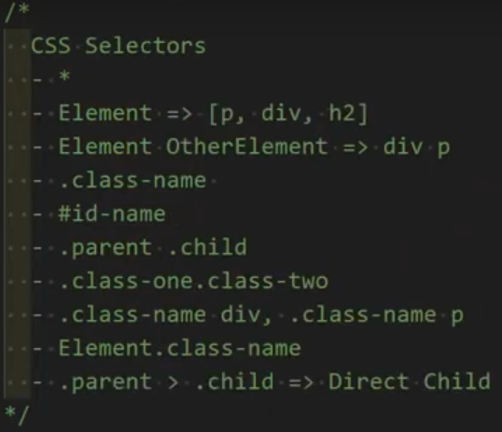

Video 79 – CSS Selectors Reference Part 2
- Element + other-element: apply styling to other element only if it is directly preceded by first element. (NOT PARENT/CHILD!!!!!)
- Element ~ other-elements: apply styling to ALL other elements that are after a first element, even if separated by different types of elements: eg: (p ~ div and you have div p div div h2 div div -> the styling will be applied to all divs except first one)
- Important to not if a div is not at same level as the p and is a child of another element, it will not apply styling
- [attribute] -> select all elements with that attribute (eg [title])
- Element[attribute] -> only select that specific element when it has that specific attribute (eg: div[title])
- [attribute=value] -> select all elements with that specific attribute equal to specific value (can also work with element[attribute])
- Eg: input[type=”submit”]
- [attribute~=value] -> contains a WORD not a STRING
- [attribute*=value] -> contains a STRING (can be part of a word)
- [attribute^=value] -> STARTS with a STRING
- 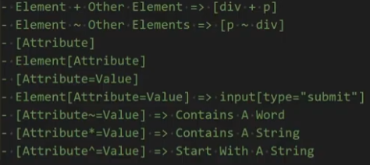

Video 80 – CSS Selectors Reference Part 3
- :first-child -> pseudoclass which selects the first child
- :last-child -> selects last child
- Element:first-of-type -> selects the first instance of the element within a nest (parent/child)
- Element:last-of-type -> selects last instance
- :only-child -> only selects the element if it is correct element AND is the only child within container
- :only-of-type -> means that container can have many children but will only select the element if it is the only one of its type in that container.
- 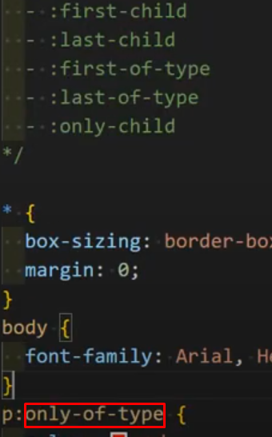

Video 81 – CSS Selectors Reference Part 4
- :not(selectors) -> eg: p:not(:first-child) -> select all paragraphs except if that paragraph is the first child. You can use all types of selectors previously given.
- :nth-child(n) -> select element if it is child number “n” of container (n=1 is first child). N doesn’t have to be a number, can use keywords even and odd. Other ways can be found in nthmaster.com
- :nth-last-child(n) -> starts counting from last child (n=1 is the last child)
- :nth-of-type(n) -> only counts those of the type of element, ignoring any other elements
- :nth-last-of-type(n)
- 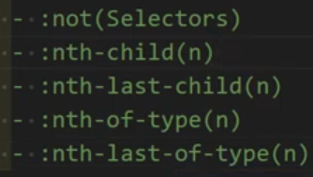

Video 82 – CSS Selectors Reference Part 5
- :root
- :checked
- Input[type=”checkbox”]:checked + label {} -> selects the label that is after a checked checkbox
- :empty
- :disabled
- :required
- :focus
- ::selection -> when selected by cursor
- ::placeholder
- 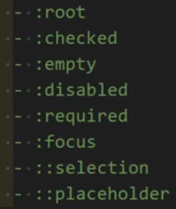

Assignment 17 Notes:
- Nth-last-of-type doesn’t only select one singular element of all elements, it is applied to each nest inside the body.
- The last assignment was a trick question. The idea is to use :not() to deselect all other elements other than required. If you only deselect first child, last child and h3, the problem will be that using :not by itself will then select and apply the style to the body and html elements, which will then pass on those styles to the not selected elements by inheritance.
- This means that if you will :not(), you need to deselect ancestors of the elements so that they don’t inherit the style.

Video 83 – Media Queries And Responsive Designs Intro
- Responsive design means that the webpage changes according to different specifications like resolution of screen and its max width
- @media condition {}, within curly braces you put in different styling (as if new stylesheet at that condition)
- Many different types of conditions. An example is print, meaning that any changes in stylesheet will only appear in the print page (using ctrl + p)
- Another example of condition is (max-width: 1000px) (don’t forget the parenthesis). This means that stylesheet is applied when width is from 0 to 1000px
- You can use operators such as “and” “or”: eg: (min-width: 1000px) and (max-width: 1400px)

Video 84 – Media Queries And Responsive Designs Standards
- You can use media query within html, by creating a new css file, using <link> tag and use media attribute this way: “media=condition”.
- Can use it in internal styling, by using <style> tag with media attribute
- One of best practices is to have the media query affecting a certain styling directly after it.
- Eg: 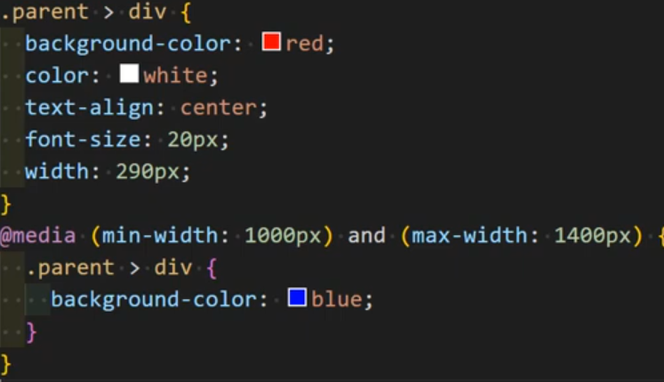
- Idea of standards is that as technology develops, new screens will have different sizes that your webpage should work with
- A chain of @media (min-width: px) is used for each screen size.
- Imagine if you have 3 screens starting at 768px, 992px, 1200px. You now want to account for smaller screen sizes than all of those (eg phones or smart watches). You can use @media (max-width: 767px) -> 1 px smaller than smallest available screen size.
- Using condition of min-width only means that any changes for smaller screen size will apply to higher screen size unless the higher screen size has changes that override it.
- If you want specific conditions that only apply for a certain screen size, need to use both min-width and max-width (with max-width being -1 of next screen size min-width).

Video 85 – Media Queries And Responsive Designs Practice
- Mobile first -> means you design on phone screen first then resize for other screens
- Any styling that applies to all screens will not be within a media query
- First, you need to add a meta to your html that concerns viewport. (shortcut is meta:vp then press tab in html)
- Then in inspect element, there will be a button next to select element button called toggle device toolbar that will simulate the view screen of different devices

Assignment 18 Notes:
- To get a line break (new line) within content of a pseudo element like after or before: use “\A” and write the following property “white-space: pre”
- If none of the media blocks you have written have their condition followed, styling will revert to default in file.
- If you want X elements to take up width of screen with a gap of Y ->
- width: calc((100% - (X – 1) * Y) / X) (-1 for space between, +1 for space around using justify-content)
- When creating a grid using grid-template-areas, it is important to note two things:
- You need to predefine the number of columns and rows beforehand (not always, but here it is a must since that default screen has already defined columns and rows)
- If you for example have 2 columns and 3 rows, and you want the elements to be divided as : one on top, two in middle, one in bottom -> you need to fill the template areas like this: “one one” “two three” “four four” -> as you see, each “” has two elements (meaning two columns) and there are three different “” (meaning three rows)
- I did the third assignment with grid, but it is possible with flex by assigning the correct width to each element (so that any element supposed to be in next row will wrap)

Video 86 – Create Your Framework
- Frameworks are prebuilt css options that have done much of the heavy lifting in creating the basic features of any webpage and then allow the developer to focus on the important stuff
- Examples are bootstrap and tailwind CSS
- An example of creating a framework: A common application to do is to center your elements within their containers. What if you need to center multiple elements, do you need to write the same 4 lines of code multiple times? The answer is no.
- Create a class styling called center-position that does the trick:
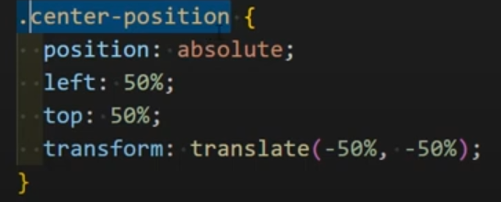
- Now for any element you want to center, you can just add that class to that element directly.
- Other examples:
- 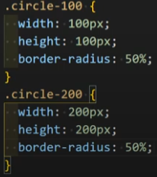
- 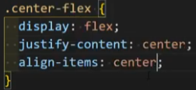
- Becareful not to create a classes for every little thing (eg: .font-bold{ font-weight: bold}), it will lead to redudantant code that is unreadable and too long when used.

Video 87 – CSS Global Values
- Inherit was discussed before
- Initial -> resets value to default value set in css (eg: display default value is actually inline)
- Color initial value differs from one browser to another
- Unset -> inherits if the property can be inherited from container but initial otherwise
- All: unset -> applies to all properties of the element
- Revert -> reverts the property to what is was in user agent stylesheet

Assignment 19 Notes:
- In the last assignment, the idea I came up with to make sure that the arrow will only show up if you use arrow class is to make the default color transparent for each direction, then make each ::after element inherit that color
- Then I put .arrow at the very end with the correct colors (so that it will have priority). Now the color will only be there if arrow is part of set of classes of element
- It is important to note that since the arrow is a pseudo element with width 0/height 0, all its space is taken from the border size, which is needed to position the arrows correctly
- To position them correctly, you subtract 2 * border size from corresponding direction (this is because eg: a left pointing arrow will require a right border, meaning that I need to move element two times (once for left border and once for right border) to position arrow outside element)
- To center the arrow, put the perpendicular direction 50%, then subtract one border size so it is centered
- The problem with this method is that the border colors of the original element will be replaced by that of the arrow since I am using inherit, so this is not the best method.
- I would have loved to be able to make the arrow color copy that of the background of the element, but I am not sure how to do it with CSS only.

Video 88 – The End And How To Master HTML And CSS
- 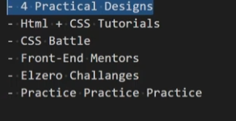
- CSS battle requires you to reach the final style with the least number of characters
- Frontendmentor.io -> gives you challenges to create actual webpages (sign in using github)
- Front end challenges: https://elzero.org/category/challenges/front-end-challenges/
- Codepen.io -> can get inspired of different kinds of designs found there
- https://elzero.org/practical-html-css/

Final Assignment Notes:
- In the ‘content:’ property of ::before or ::after, you can have multiple things like this:
- ‘content: “A” “b” “c”’ -> Abc
- This can be use with multiple counters (which is useful for example with list markers)
- ‘content: counter(1) “.” counter(2)’
- In content, you can use attr(attribute-name) to get the attribute value
- Ass 9 – Background-clip: text is used so that the background is clipped to the text instead of the border-box, allowing the background to appear through the text (by also making text transparent)

