Video 3 - First Project and First Page
- Index.html -> Usually default settings of any server lie in this file (doesn’t have to be html)
- <html></html> -> represents root of html document
- <body></body> -> Contains content of the page
- <head></head> -> Contains metadata of the page (like tab title)
  - <title></title> -> Inside head tag, sets the page title (appears on the tab)

Video 4 - Head And Nested Elements
- Metadata = data about the data, used tag will be within head
- <meta/> -> self-closing tag (no need for </meta>)
- Inside meta:
  - Charset = “UTF-8” -> symbol code for characters
  - <meta name="description" content="This Is Our Book Store"/> -> “name=” is the name of the tag, “content=” is the content of the tag.
- <style></style> -> used to put css code here
- <script></script> -> used to put javascript code here
- <link rel="stylesheet" href=""> will be taught more in css

Video 5 - Comments And Use Cases
- <!-- write comment here-->
- Ctrl+/ to comment out as usual

Assignment 1:

Q1 What is HTML
HyperText Markup Language

Q2 Code written

Q3 Yes or No
- هل ما يتم كتابته داخل ال Head يظهر داخل الصفحة أم لا؟ -> No
- هل عنصر Title له قفلة أم لا ؟ -> Yes
- هل عنصر Meta له قفلة أم لا ؟ -> No
- هل ما يتم وضعه داخل ال Description في عنصر ال Meta يظهر في الصفحة أم لا ؟ -> No

Video 6 - Doctype And Standard And Quirks Mode
- <!DOCTYPE html> -> Sets the render mode of the page to Standard mode
- If doctype not given, will default to Quirks mode
- Always write it in any page using html5

Video 7 - Headings And Use Cases
- Use h1 to h6 in tags eg: <h1></h1>
- Used in <body>
- Professionally, you only use h1 once
- Professionally, don’t use h3 before h2 (must follow hierarchy

Video 8 - Syntax And Tests
- Spaces are ignored
- Useful in organizing tags and attributes
- Value of attributes can use both single quote (‘’) or double quote (“”)
- If neither of quotes used, only the next word (or number) after the = will be taken as value, rest will be treated as other attributes

Video 9 - Paragraph Element
- <p></p>
- Used to separate difference paragraphs in the body
- Uses the block element in CSS, which means it has spaces above it and below it to separate from rest of text
- If not using paragraph tag, it is considered as inline element

Video 10 - Elements Attributes
- Global attributes and element attributes
- “class=” is a global attribute because it can be used with all types of tags
- “hidden” is another global attribute that hides the tag
- Some element attributes are rel and href for link, src and alt for image, src for video or audio

Assignment 2:
- ما هو ال السطر الذي يتم كتابته لتخبر المتصفح أن إصدار اللغة المستخدم في إنشاء الصفحة هو HTML5 ؟""
- <!DOCTYPE html>
- ما هو ال Rendering Mode الذي سوف يتبعه المتصفح إذا لم تكتب السطر الخاص بتحديد الإصدار ؟
- Quirks mode

- هل من السليم إستخدام أكثر من h1 في الصفحة جاوب بنعم أو لا ؟
- No
- لديك عنصر يحتوي على بيانات المنتج وعنوان المنتج مكتوب ب h3 هل من المنطقي وضع عنوان h2 داخل نفس المنتج أم لا؟
- No
- إلى ماذا ترمز العناصر h1, h2, h3, h4, h5, h6""
- Headings

Video 11 - Formatting Elements
- <b></b> -> Bold tag for formatting reasons
- <strong></strong> -> Also Bold but for IMPORTANT TEXT
- <i></i> and <em></em> -> italic and emphasized both have same purpose
- mark => Marked Text (Highlight)
- u => Underline
- small => Smaller text
- del => Deleted text (crossed text)
- ins => Inserted text (just newly added text)
- sub => Subscript
- sup => Superscript

Video 12 - Links - Anchor Tag
- <a></a> -> Anchor tag
- Used to place hyperlinks
- “href=” attribute will contain the link text will redirect to
- Anchor tag are inline elements not block!
- “target=” another attribute that controls how redirect to link.
- “target=_blank” will open link in new browser tab
- “title=” another attribute that shows a tooltip that describes what the anchor links to
- In href, we don’t only need to use https links in internet. You can also redirect to another page in the same folder (such as test.html)
- You can also redirect to part of text inside page. Using global attribute “id=” inside a <p> tag, write #id to get to it. EG: <p id = “bassem”> , therefore use <a href=”#bassem”>
- Final use is to use “href=mailto:your_email@mail.com”

Video 13 - Image And Deal With Paths
- Use <img src=”” alt””></img> tag
- Src = source, alt = alternate text, appears if image doesnot appear due to some error
- Src can be local or online
- In paths, “../” means you go out of current folder once (backspace)

Video 14 - Lists - UL, OL, DL
- <ul></ul> unordered list (bullet points)
- Inside list, you need list items using tag <li></li>
- Nested ul: within an <li></li> create a ul:
<li>
<ul>
<li>1</li>
<li>2</li>
</ul>
</li>
- <ol></ol> ordered list (numbers)
- Possible attributes: “reversed” (to reverse ordering)
- “start=” choose numbering starting point (for all types you need to write the starting point numerically)
- “type=” type of ordering:
  - Type = “1” -> numbers
  - Type = “A” or “a” -> letters capital or small respectively
  - Type = “I” -> roman numerals
- You can also change numbering from within list by using “value=” attribute for <li> tag
- <dl></dl> description list
- Uses <dt></dt> and <dd></dd> for each term in list
- Dt is the term itself and dd is the description for that term
- Can use multiple <dd> per a <dt>! Each will be in a newline

Video 15- Table
- <table></table>
- Can use <thead><tbody><tfoot> (for header body and footer)
- Optional, don’t need to use them all!
- Use <tr> and <td> as table row and table data cell!
- Hierarchy: <thead/thead/tfoot> then <tr> then <td> then your data
- If you use the optional tags, they will appear in correct position in output wherever they are in code.
- If not using the optional tags, need to take care when writing the ordering of the table header and its data!
- <th> instead of <td> -> called table header cells and will make the font bold and centered on google!
- <table> has “border=” attribute that sets border lines
- “cellpadding=2px” to pad cells
- These attributes are not recommended to use since you usually control table style using CSS
- <caption> tag is used as a title for the table
- <td> has attribute “colspan=” which controls how space a table cell takes. If 2, as if you merged two cells

Video 16 - Span And Break And Horizontal Rule
- <span> -> has no difference that normal body text initially (also inline element)
- It is used so that you can control the style of certain text inside a paragraph
- <br/> -> self closing tag acting as a break. It creates a newline
- <hr/> -> self closing tag that creates a horizontal separator
- Note that for self closing tags, you don’t need to write the slash with no attributes

Video 17 - Div And How To Use
- King of elements
- Div acts as a container that allows you to apply a certain style to all elements within it
- <div></div>
- To differentiate different div, use the global attribute “class=”
- Note that class can be shared by multiple elements while id must be used by a single element
- Don’t use div for text! That is what paragraph is used for.

Video 18 - HTML Entities
- Some entities that are used for coding might clash with what we require if we need it in text
- If I want to show <p> in the output of the page, need to use entities that reperesent “<” and “>”
- These entities start with “&” which is followed by the code for the symbol needed and finally end with a semi colon “;”
- “<” = “&lt;” (less than)
- “>” = “&gt;” (greater than)
- “&” = “&amp;” (ampersand)
- “©” = “&copy;” (copyright)
- Can search for all html entities list on net

Video 19 - Semantic Elements
- Before HTML 5, each space in a website was a div with its own class
- To make it more manageable, new elements were introduced that replace the div with a better naming that describes its use
- Such elements are:
- <header></header>
- <nav></nav> Navigation bar that leads you to different parts of site
- <section></section> Content of page, there can be sections within sections
- <aside></aside> Side bar, found inside a <section> element
- <article></article>
- Note that these elements, like div, can have their own classes. You don’t have to use them only as website header or section. They can be used within sections of website too.
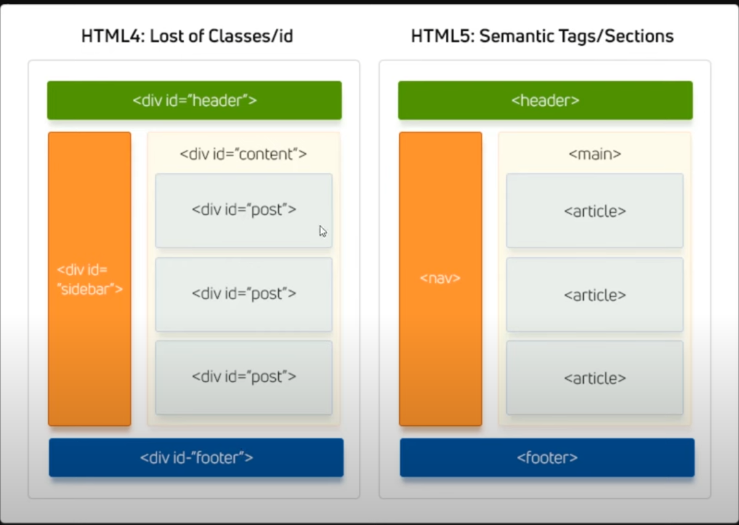

Video 20 - Layout With Div And Classes
- First is header, containing logo and list of links (usually unordered)
- Then navigation bar that contains list of links
- Then content
- Then sidebar
- Finally footer

Video 21 - Layout With Semantic Elements
- <figure></figure> used as container for image and its caption. (caption will use <figcaption></figcaption>)

Video 22 - Audio
- <audio></audio>
- Usually has attribute “src=”. However, we will instead use the <source> self closing tag
- It has two attributes: “src=” which will contain link of file
- And, “type=” attribute which will contain MIME type of file (each extension has its own MIME type)
- Using source tags instead of src attribute is better because you can include more than one source for same audio, each with different types of extensions so that if one format is not compatible with a certain browser, alternatives will be available.
- All modern browsers support mp3! (has MIME type of “audio/mpeg”)
- Certain browsers may not support the audio tag itself. You can write a message after the source tags to write a message in that case
- Useful attributes for audio tag:
  - “controls” -> displays the controls for audio file (volume, progress bar etc.)
  - “autoplay” -> plays audio automatically when visiting site (blocked in Chrome)
  - “loop” -> loops audio when it ends
  - “muted” -> audio starts out muted

Video 23 - Video
- <video></video>
- Will use same source tag with same src and type attributes
- Common extension is mp4 has MIME type of “video/mp4”
- Same idea for browsers that do not support video tag
- Useful attributes for video tag:
  - “controls” -> displays the controls for audio file (volume, progress bar etc.)
  - “autoplay” -> plays audio automatically when visiting site (blocked in Chrome)
  - “loop” -> loops audio when it ends
  - “muted” -> audio starts out muted
  - “width=” -> control width of video, write number of pixels (eg 600)
  - “height=” -> control height of video, write number of pixels (eg 400)
  - “poster=” -> write path of an image that will appear while the video is loading
  - “preload” -> Research yourself
- Another useful tag is self closing tag <track>
- It is used to add .vtt files (video text track) that are needed for subtitles or translation
- Example: <track src=”file_en.vtt” kind=”subtitles” srclang=”en” label=”English”>
- This will appear in video as captions with English as option (srclang = source language)

Video 24 - Form Part 1 - Input Types And Label
- <form></form>
- <input> -> inline element (self-closing tag)
- “type=” is attribute to select type of input, can be “text” or “password” (to hide what is written in it. “submit” is final type for submit button (which refreshes the page)
- Use <label></label> to label the input
- Make each input in its own div

Video 25 - Form Part 2 - Required, Placeholder, Value
- In a form, you can force the user to input into specific fields before being allowed to submit. This is by using the “required” attribute in input.
- Any input without the required attribute will be ignored even if left empty when pressing submit
- “placeholder=” attribute is used to write a message in the empty field for the user
- “value=” attribute is used to write a default value in the field. It can be changed to be your old email or username or whatever.
- type=”email” when used will only allow the user to submit if the correct form is written (where there is text before and after an @)

Video 26 - Form Part 3 - Action, Name, Method
- action=”” -> for <form> used to send to certain server or file eg: server.php
- name=”” -> for <input> used to classify the kind of data that will be sent to server
- method”” -> for <form> used to choose method of sending data (GET or POST).
- GET will show the sent data in the url after pressing submit

Video 27 - Form Part 4 - Hidden, Reset, Color, Range, Number
- <input> type = hidden
- Hidden input that holds a value that is sent with rest of data. It has no purpose to be seen by the user and is not supposed to be changed and so it is hidden in output (it still appears in inspect element)
- <input> type = reset
- Like submit this type converts into a button that resets all entry fields to original
- Note for reset or submit types the actual text on the button is set through “value=”
- <input> type = color
- Changes input into color palette selector (that also gets sent with data)
- <input> type = range
- Has attributes min, max, step and value(starting position)
- <input> type = number
- Also has min max step and value. It is a small field where you can select

Video 28 - Form Part 5 - ReadOnly, Disabled, Autofocus
- Attribute readonly for input will not allow you to edit a field. The info will still be sent (eg: one put in value=)
- Disabled attribute grays out the field and also prevents data from being sent
- Autofocus attribute autoselects that field at page refresh
- Minlength= attribute sets the minimum number of characters to be put in a field for it to be valid
- Maxlength= attribute prevents adding more characters than what is set

Video 29 - Form Part 6 - Radio And Checkbox
- Input types radio and checkbox
- For radio, label is placed after the button. Also you need new input per radio button
- Has attribute checked that auto selects the radio button
- To attach the label to the input (any input): put an “id=” for an input then “for=” for the corresponding label (place the id in for)
- Checkbox is same everything as radio. Only difference is that you can select more than one checkbox at same time
- When creating radio or checkbox selections, make sure to provide the name (shared between all selections) and value attributes

Video 30 - Form Part 7 - Select And Textarea
- <select></select>
- Within select use tag <option value=””>OptionName</option>
- What is in value= is what is sent when submitting
- Can categorize the options using <optgroup></optgroup>
- To name the group, use attribute “label=”
- Select has another attribute “multiple” that allows user to select more than one
- Option has an attribute “selected” so that it is auto selected when opening the page
- <textarea></textarea>
- Uses previously discussed tags such as placeholder minlength and maxlength
- Has attributes “row=” and “col=” which controls size. Later we will use CSS to control it.

Video 31 - Form Part 8 - File, Search, URL, Time
- Input type file -> allow user to upload a file to page
- Input type search -> allow user to search and delete search instantly using “x” given
- Input type url -> allow user to input a URL
- Input types date, month and time

Video 32 - Form Part 9 - Data List, Novalidate, Target
- Form attributes
- Novalidate -> does not validate any of the input fields with their given restriction. Good for testing
- Target= -> like links can use _blank so when submitting opens in a new page
- New input -> list
- <input list=”programming” name=”prog”> -> notice that we replaced “type=” by “list=”
- You then use <datalist id=”programming”></datalist> which will then be filled by option tags
- The advantage of this list is that you can actually type in it to reduce number of visible options

Video 33 - Q, BlockQuote, Wbr, Bdi, Button
- New elements
- <q></q> for quote -> like paragraph but puts text in quotes (it is also inline)
- <blockquote></blockquote> -> quote but block instead of inline
- <button>NameOfButton</button>
- <wbr> -> word break opportunity -> self closing tag that can break a long word at any point (an example is long URLs)
- <bdi></bdi>-> bi directional isolation -> used for when mixing writing types that start left to right and right to left. Writing in Arabic and English together usually result in problems that <bdi> fixes (either put Arabic text or English text inside)

Video 34 - iFrame, Pre, Code
- <code></code> -> used to contain a block of code that will be styled later using CSS
- <pre></pre> -> Pre formatted text. Keeps and spaces/tabs/newlines written in HTML into the output. Can use <code> within <pre>
- <iframe></iframe>-> used to open another webpage into current html page in a small box. The site accessed is using “src=” and size of window controlled by “width=” and “height=”
- Note that not all sites allow themselves to be used in an iframe

Video 35 - Accessibility Intro
- Install Live Server extension in vscode
- Right click on your html file and open in live server
- Inspect -> arrows (in tabs) -> lighthouse -> generate accessibility report
- Two examples are setting “lang=” attribute for <html> and having labels for forms

Video 36 - ARIA And Screen Readers
- ARIA -> Accessible Reach Internet Application
- The idea is that users with disabilities might use programs that will help them access your site
- A famous application of this is screen readers. They however need you to setup certain attributes to make the application understand what each element in the html page is supposed to be.
- It is possible that you will use one element to represent another element (the example given in the video is a div will represent a checkbox)
- Attributes to set that up are : “role=”checkbox”” “aria-checked=”true””(means that this “checkbox” will be already checked) tabindex=”0” (allows user to be able to “tab” to this element (usually only buttons or text fields can be reached using tap)) aria-labelledby=”plan1” (plan1 is the id of the label corresponding to this element. Notice that this time the label uses “id=” instead of “for=”)

Video 37 - The End And What To Do
- There are references and other courses in the elzero.org site

