MNP Service
Mobile Number Portability System — Project Documentation

1. Description
MNP Service is a full-stack application that simulates a Mobile Number Portability (MNP) workflow between telecom operators. It lets a subscriber's phone number be "ported" from the operator that currently holds it (the donor) to the operator the subscriber wants to switch to (the recipient).
The system models the real-world porting process as a request/decision flow:
- Any operator can submit a porting request for a phone number on behalf of a subscriber who wants to join them.
- The system automatically works out which operator currently holds that number (the donor), based on either the number's original prefix range or the most recent accepted porting request.
- The donor operator reviews the request and either accepts or rejects it.
- Requests that stay pending too long are automatically cancelled by a background job.
- Anyone can look up the current porting status of a phone number — who holds it today, and whether it has ever been ported.
The project is split into two independently deployable pieces:
- mnp-backend — a Spring Boot REST API that owns all business rules, validation, and persistence.
- mnp-frontend — an Angular single-page application that consumes the API and gives operators a working UI to create, view, and act on porting requests.
Both are containerized and wired together with Docker Compose, alongside a MySQL database.

2. Screenshots

Operator selection screen
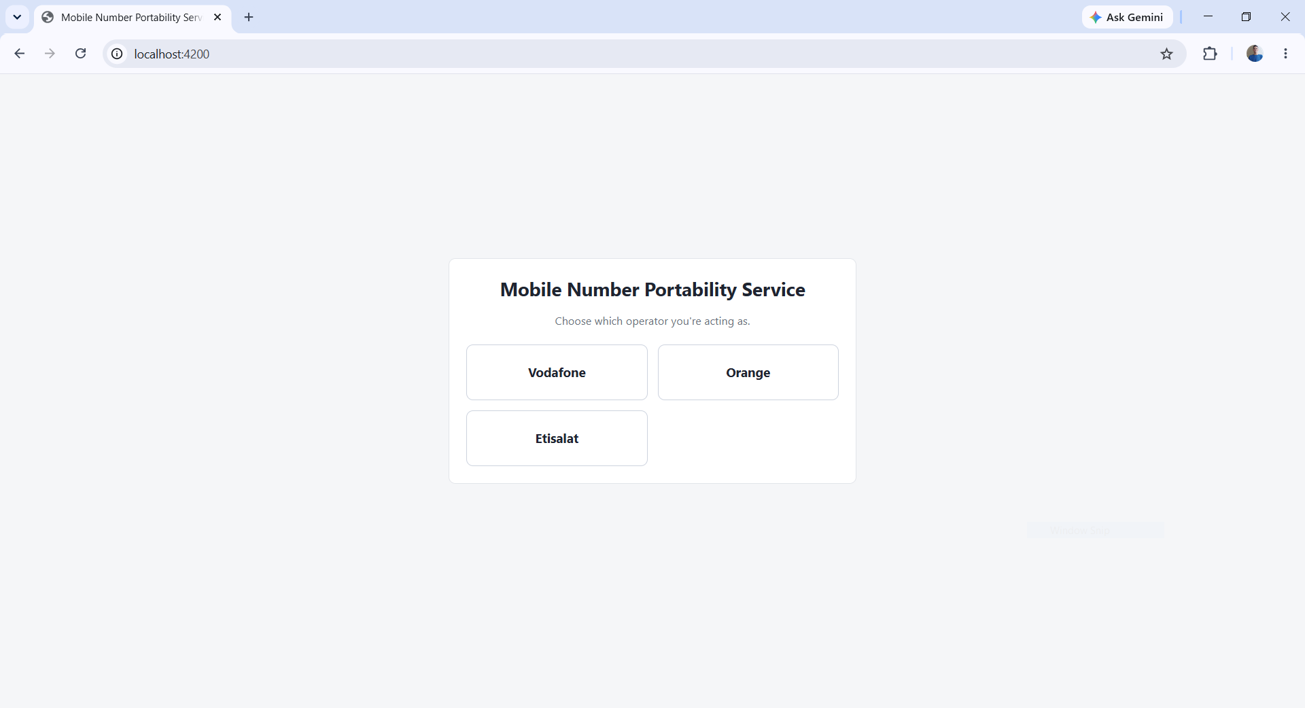

Porting requests list
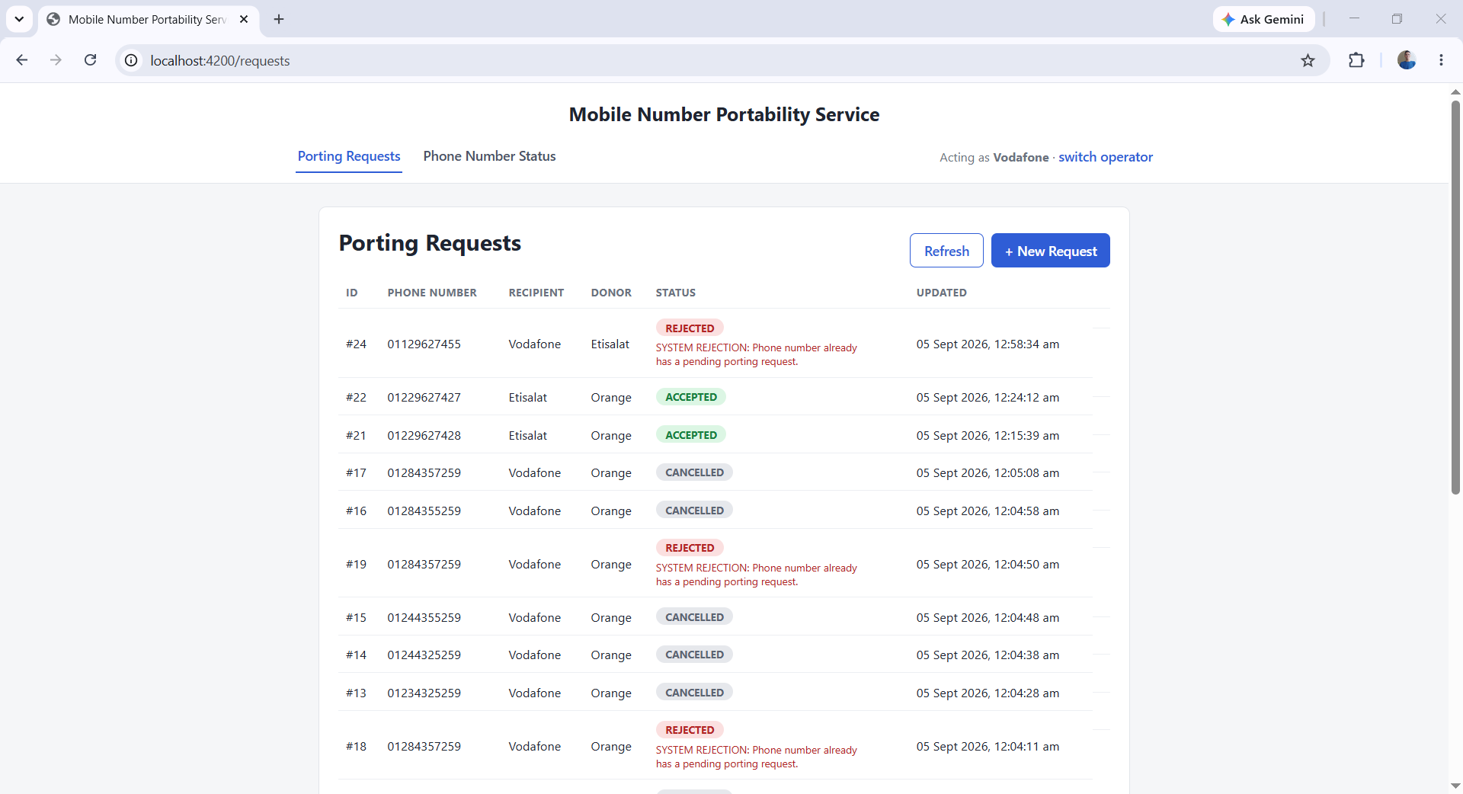

Create porting request

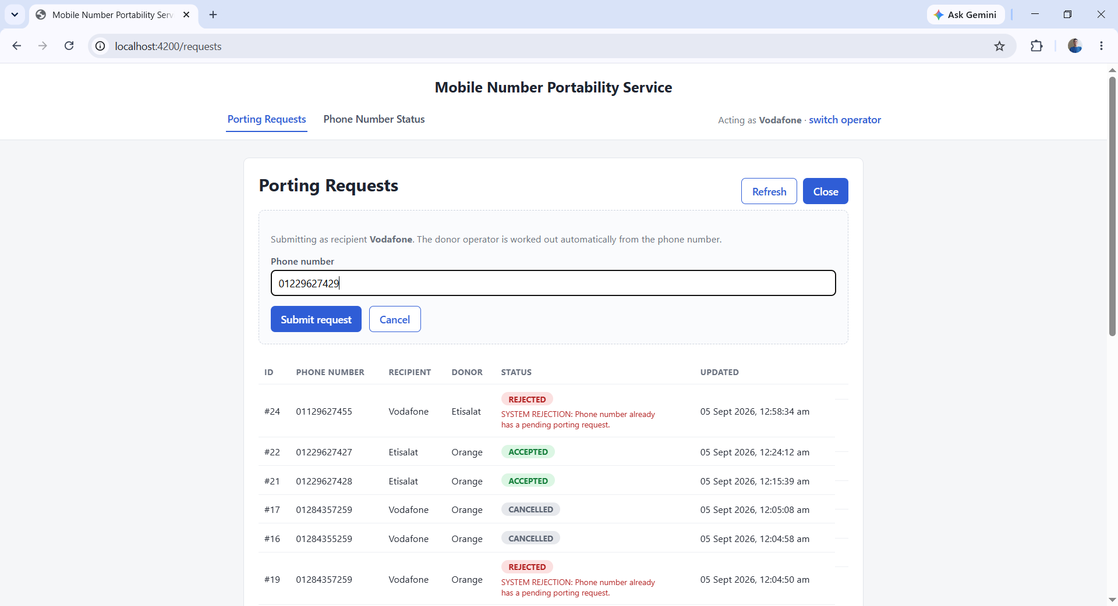

Accept porting request

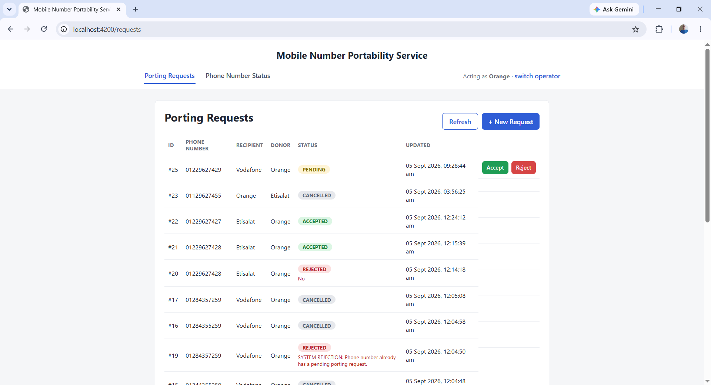
Reject porting request
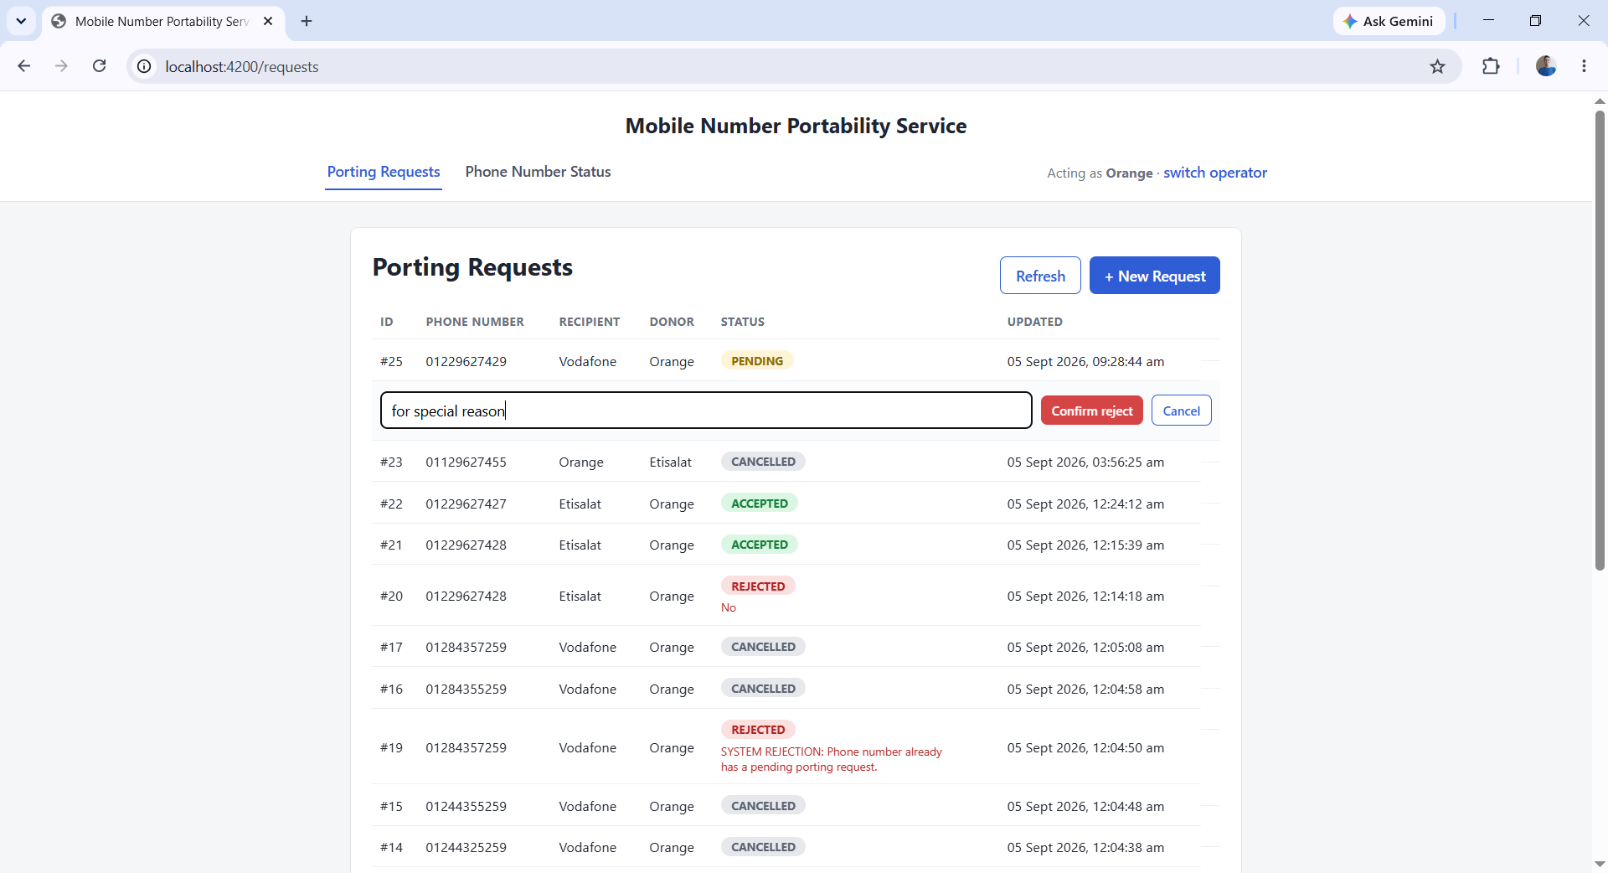
Phone number status lookup
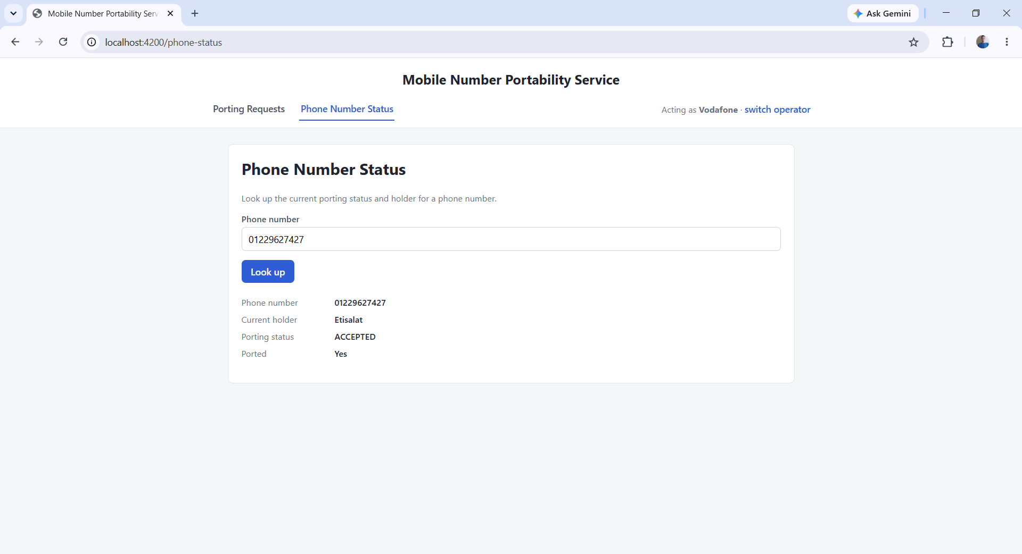

3. Technologies Used
Layer | Technology
Backend framework | Spring Boot 4.1.1 (Java 17)
Backend modules | Spring Web MVC, Spring Data JPA, Spring Security, Spring Validation
Scheduling | Spring @Scheduled (background timeout job)
Database | MySQL 8.0
DB driver | MySQL Connector/J
Frontend framework | Angular 20 (standalone components)
Frontend language | TypeScript 5.8
Frontend runtime | RxJS, Angular Forms
Web server (frontend, prod) | Nginx (reverse-proxies /api to the backend)
Containerization | Docker, Docker Compose
Build tools | Maven (backend), npm / Angular CLI (frontend)

4. Database

4.1 Entity Relationship Diagram
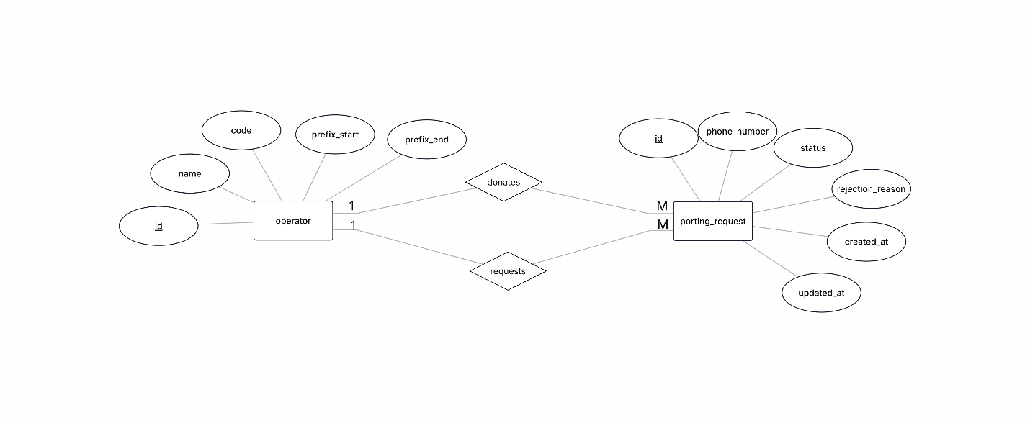
There are two entities, connected by two distinct relationships — because a porting_request row references operators twice: once as the recipient and once as the donor:
- operators REQUESTS porting_requests — one operator can request many porting requests (1 : M). This is the recipient_operator_id foreign key on porting_requests.
- operators DONATES porting_requests — one operator can donate (be the source of) many porting requests (1 : M). This is the donor_operator_id foreign key on porting_requests.
Both relationships point at the same two tables; they're kept separate because a request's donor and recipient are conceptually different roles and are validated independently (for example, a request cannot be created if the donor and recipient would be the same operator).

4.2 Entities stored in the database

operators
Column | Type | Notes
id | bigint, PK, auto-increment
name | varchar(45), unique, not null | Display name (e.g. "Vodafone")
code | varchar(45), unique, not null | Short code used in the organization request header
prefix_start | varchar(15), not null | Lower bound of the operator's original number range
prefix_end | varchar(15), not null | Upper bound of the operator's original number range

porting_requests
Column | Type | Notes
id | bigint, PK, auto-increment
phone_number | varchar(15), not null | The number being ported
status | varchar(20), not null | PENDING, ACCEPTED, REJECTED, or CANCELLED
rejection_reason | varchar(255), nullable | Set when a request is rejected (by the donor or by the system)
created_at | datetime, not null, default current_timestamp | Set once, at insert time
updated_at | datetime, not null, updates on change | Refreshed automatically on every update
recipient_operator_id | bigint, not null, FK → operators.id | The operator requesting the number
donor_operator_id | bigint, not null, FK → operators.id | The operator that currently holds the number

Indexes exist on phone_number, on the (phone_number, status, updated_at) combination (used to quickly find the latest accepted request for a number), on (status, created_at) (used by the timeout job), and on both foreign keys.

5. API Endpoints
All endpoints are prefixed with /api. Every endpoint except GET /api/operators requires an organization request header whose value is a valid operator code (e.g. vodafone, orange, etisalat) — this is how the API identifies which operator is calling it.

GET /api/operators
Returns the list of all operators. Used by the frontend to populate the operator picker before any organization header exists yet — this is the one endpoint that does not require it.
- Response 200: array of { id, name, code }.

POST /api/porting-requests
Creates a new porting request for a phone number, on behalf of the calling operator (who becomes the recipient). The donor is worked out automatically — either the operator that currently holds the number after the last accepted port, or its original owner if it has never been ported.
- Request body: { "phoneNumber": "01129627429" }
- Response 201: the created request, including its resolved donor and starting status of PENDING — unless a pending request already exists for that number, in which case the new request is saved immediately as REJECTED with a system-generated reason instead.
- Errors: 400 if the phone number fails validation, or if the calling operator already holds that number.

GET /api/porting-requests
Lists porting requests relevant to the calling operator: every request where it's the recipient, every request where it's the donor, plus every request anywhere in the system that has been ACCEPTED. Results are ordered by updatedAt, most recent first.
- Response 200: array of requests, each including id, phoneNumber, status, recipient, donor, createdAt, updatedAt, and rejectionReason.

PATCH /api/porting-requests/{id}/decision
Lets the donor operator accept or reject a pending request. Only the donor of that specific request may call this — any other operator is rejected.
- Request body: { "action": "ACCEPTED" } or { "action": "REJECTED", "rejectionReason": "..." }
- Rules enforced: the request must currently be PENDING; a rejection must include a non-blank reason; only the donor operator may decide.
- Errors: 403 if the caller isn't the donor, 400 if the request isn't pending or the action/reason is invalid, 404 if the request doesn't exist.

GET /api/phone-numbers/{phoneNumber}/status
Lookup of a number's current porting status: who holds it today, and whether it has ever been successfully ported.
- Response 200: { phoneNumber, portingStatus, isPorted, currentHolder }
- Errors: 400 if the phone number doesn't match the expected format.

6. Validation
Validation runs at multiple layers: phone numbers are checked against a strict format wherever they're accepted, required fields and lengths are enforced with standard Bean Validation annotations, and business rules (e.g. a request can't target an operator that already owns the number, duplicate pending requests are auto-rejected, only PENDING requests can be decided, only the donor may decide) are checked in the service layer. Every failure — field-level or business-rule — is caught by a single global exception handler and returned as the same consistent JSON error shape.

7. Security
There's no username/password login — identity is operator-level, established per request via an organization header naming an operator's code. A custom filter resolves that header into an authenticated Operator principal before the request reaches any controller, rejecting missing or unknown codes with 401. Authorization is then enforced per action — for example, only the donor of a request may accept or reject it, otherwise 403.
The API is stateless, CORS is restricted to the frontend's origin, and CSRF is disabled, which is standard for a stateless, header-authenticated JSON API.

8. Running the Project with Docker
The project ships with a docker-compose.yml at the repository root that brings up all three services — MySQL, the backend, and the frontend — with a single command. You do not need Java, Node, or MySQL installed locally; only Docker.

8.1 Prerequisites
- Docker and Docker Compose installed (Docker Desktop includes both).
- Ports 3307, 8080, and 4200 free on your machine.

8.2 What Docker Compose sets up
Service | Image / build | Purpose | Port
mysql | mysql:8.0 | Database. Schema and seed data load automatically from schema.sql on first startup. | 3307 → 3306
backend | built from ./mnp-backend/Dockerfile | The Spring Boot API. Waits for MySQL to report healthy before starting. | 8080
frontend | built from ./mnp-frontend/Dockerfile | The Angular app, built and served by Nginx, which also proxies /api/* to the backend. | 4200 → 80

The backend's Dockerfile is a multi-stage build: it first compiles the Spring Boot app with Maven inside a JDK image, then copies only the resulting .jar into a lean JRE image for the final container — so the shipped image doesn't carry the full JDK or build tooling.
The frontend's Dockerfile does the same idea with Node and Nginx: it builds the Angular production bundle in a Node image, then copies just the compiled static files into an Nginx image.

8.3 Step-by-step
- 1. Clone or unzip the project, so you have a folder containing docker-compose.yml, mnp-backend/, and mnp-frontend/ side by side.
- 2. Open a terminal in that root folder (the one containing docker-compose.yml).
- 3. Build and start everything:
docker compose up --build
The first run will take a few minutes — it downloads the MySQL image, builds the backend jar, and builds the Angular production bundle. Subsequent runs are much faster thanks to Docker's layer caching.
Note for whoever runs this
On the very first build, Docker Desktop sometimes drops the connection partway through with an error like “error during connect: ... EOF” while creating a container. This is a one-time Docker Desktop/engine hiccup caused by building the frontend, backend, and pulling MySQL all at once right after the engine starts — it is not a problem with the project itself.
If you hit it, split the build into two steps instead:
docker compose build
docker compose up
- 4. Wait for the services to become healthy. MySQL starts first and must pass its healthcheck before the backend container starts (depends_on: condition: service_healthy in the compose file enforces this), so the backend never tries to connect before the database is actually ready.
- 5. Once everything is up:
  - Frontend (the actual app to use): http://localhost:4200
  - Backend API directly: http://localhost:8080/api/...
  - MySQL, to inspect with a client: localhost:3307 (user springstudent, password springstudent, database mnp_db)
- 6. Stop everything with Ctrl+C, or from another terminal:
docker compose down
This stops and removes the containers but keeps your data — it's stored in the named volume mnp-mysql-data.
- 7. To wipe the database completely (e.g. to re-run the seed data from scratch), remove the volume too:
docker compose down -v

