

|  |
| --- |
| [CMPN 303] – Operating Systems |
| [Project Milestone 1] |
| [Communication and Computer Department] |

**Submitted to:**

***Dr. Mona Farouk***

***Eng. Muhammad Abdulkariim***

***Eng. Haneen Mohammed***

**Submitted in: *11/5/2022***

|  |  |
| --- | --- |
| **Abdelrahman Mohamed Ezzat** | 1190158 |
| **Ali Mohamed Ali Gad Hashish** | 1190223 |
| **Farah Mohamed Abdelfattah** | 1190176 |
| **Karim Mohamed Ahmed** | 4180299 |

**Data Structures Used:**

Priority Queue:

Used in Shortest Job First [SJF], Highest Priority First [HPF], Multi-Level Feedback Queue [MLFQ].

Circular Queue:

Used in Round Robin [RR].

**Algorithms Explanation:**

1. SJF:

Sorts the processes according to shortest remaining time, and executes the shortest one in the waiting queue.

1. HPF:

Sorts the processes according to highest priority (smallest value), and executes the one with highest priority.

1. RR:

Initially sorts the processes according to their arrival time, then gives each process its quantum, before moving on to another process.

1. MLFQ:

Sorts the processes in a priority queue, so that each group of priorities represents a queue in the real algorithm, and then starts executing the first process in the queue, and decreases it priority (increase value by one), then enqueues it once more. This ensures that it is placed in the lower-level group.

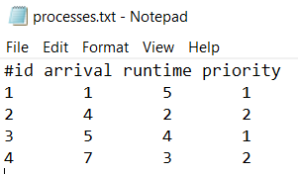Test Case and Results:

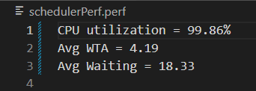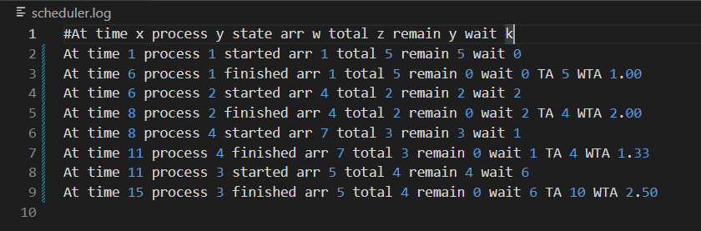SJF

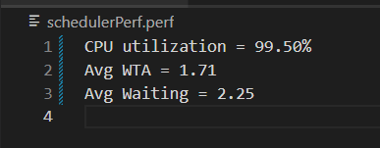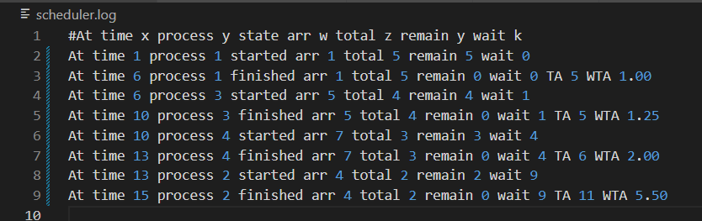 HPF

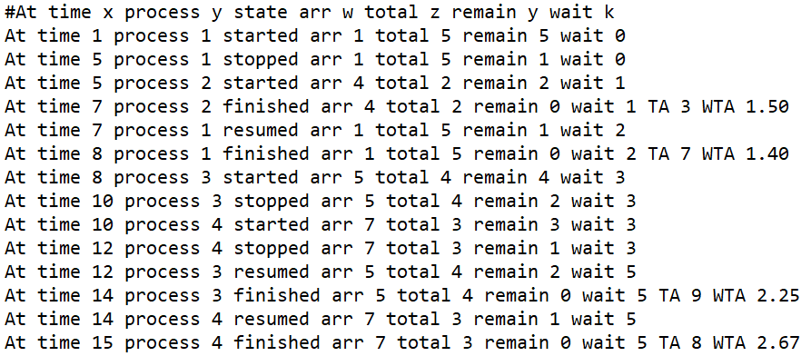RR

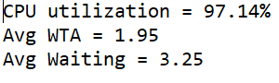

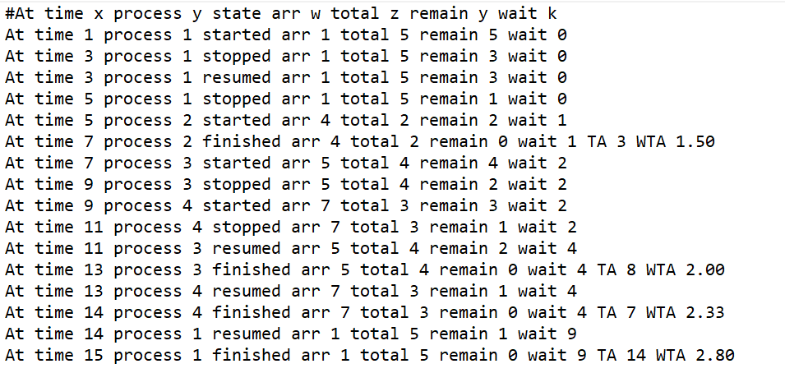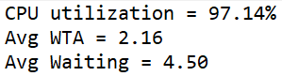MLFQ

**Assumptions:**

1. Processes are written in file ascendingly according to arrival time.
2. Ids are written in a natural order (does not really affect the code).
3. Quantum of MLFQ is 2
4. In case of 2 processes arriving in the same time, when the CPU is empty. Then the first one written in the file will be executed first, regardless of the algorithm criteria.

**Workload distribution:**

* Abdelrahman Ezzat: MLFQ
* Ali Hashish: RR
* Farah Mohamed: HPF
* Karim Mohamed: SJF