**Neural Network Task Report**

**Dataset Overview**

The dry bean dataset contains various features of different types of dry beans. For this task, we have selected three classes: BOMBAY, CALI, and SIRA. The dataset has been split into a training set and a testing set, with 30 samples for training and 20 samples for testing for each class.

**Combination Selection**

We will choose two features from the available options: **area, perimeter, majoraxislength, minoraxislength, and roundness.** The user will provide the class names and feature numbers to be used for analysis.

**Features:** [" Future 1 =AREA", "Future 2 =PERIMETER",

"Future 3 = Major Axis Length", "Future 4 = Minor Axis Length"

, "Future 5 = ROUNDNESS"]

**Classes:** ["C1 = BOMBAY", "C2 = CALI", "C3 = SIRA"]

**Perceptron Model**

Perceptron is an algorithm for Supervised Learning of single layer binary linear classifiers. Optimal weight coefficients are automatically learned. Weights are multiplied with the input features and decision is made if the neuron is fired or not.

**Screenshot 1 :**

Selected Feature 1 : **Area**

Selected Feature 2 : **Roundness**

Selected Class 1 : **Sira**

Selected Class 2 : **Bombay**

Overall Accuracy : **100%**

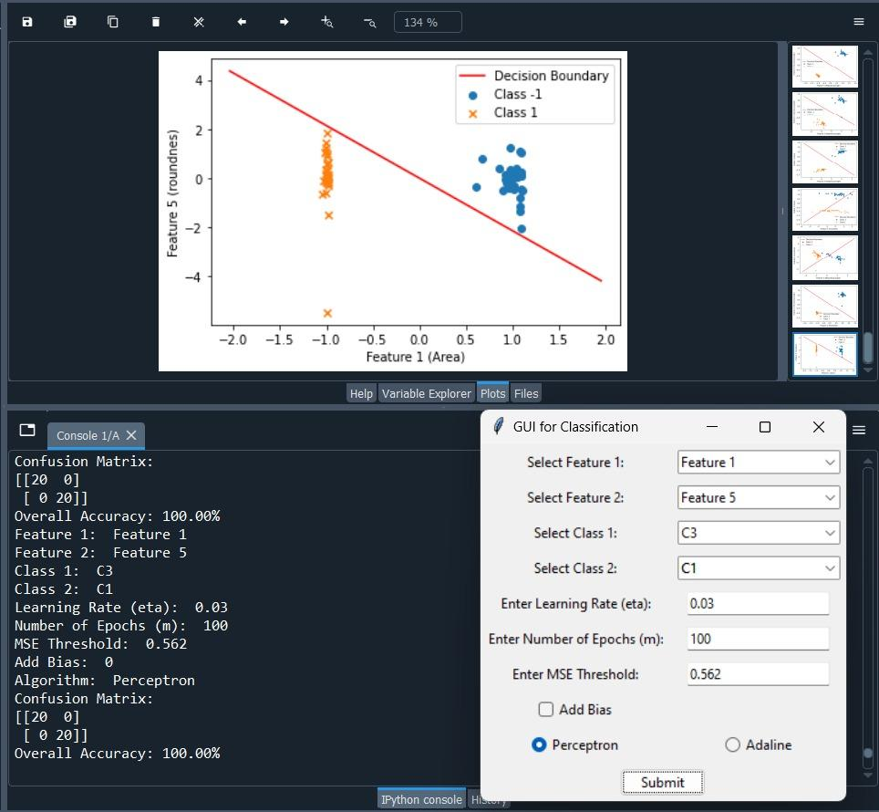

**Screenshot 2 :**

Selected Feature 1 : **Roundness**

Selected Feature 2 : **Area**

Selected Class 1 : **bombay**

Selected Class 2 : **Cali**

Overall Accuracy : **100%**

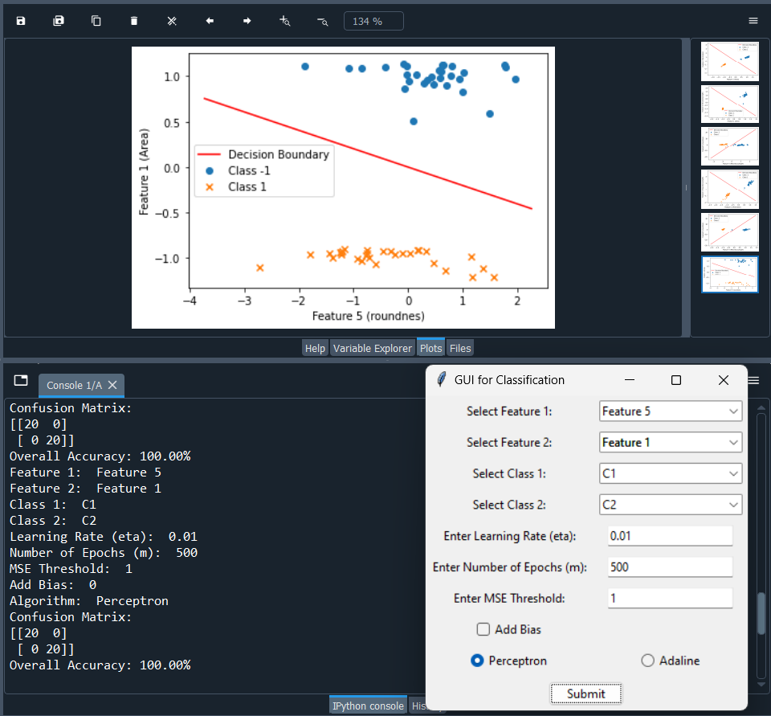

**Screenshot 3 :**

Selected Feature 1 : **MajorAxisLength**

Selected Feature 2 : **Roundness**

Selected Class 1 : **Cali**

Selected Class 2 : **Sira**

Overall Accuracy : **100%**

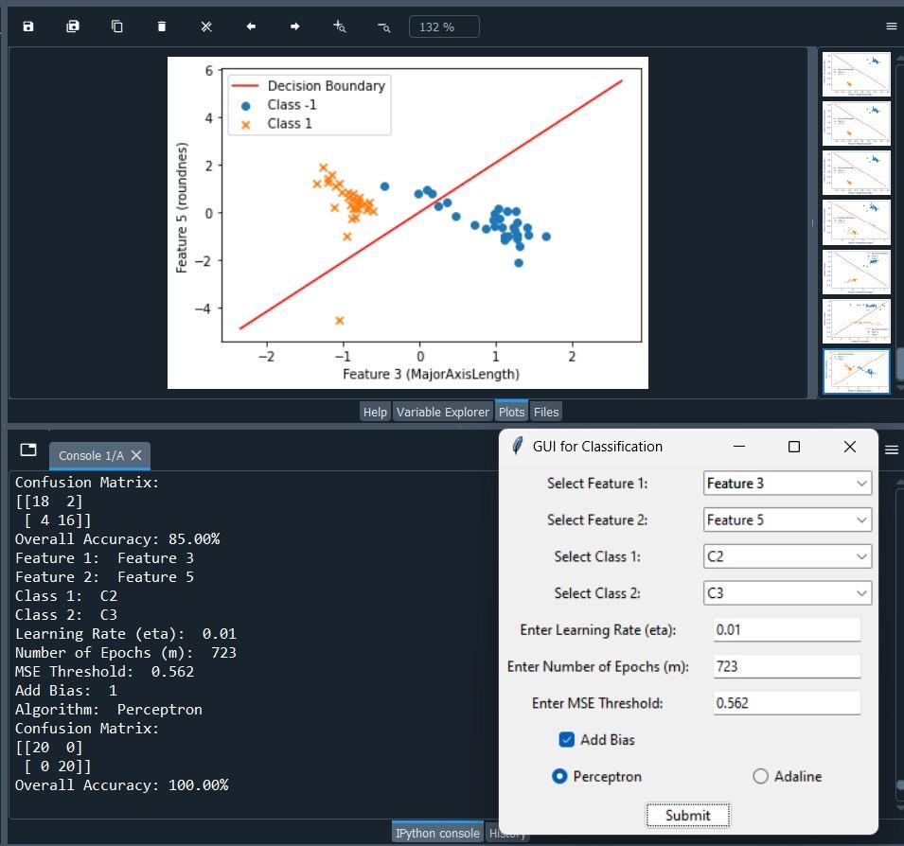

**Screenshot 4 :**

Selected Feature 1 : **Perimeter**

Selected Feature 2 : **MinorAxisLength**

Selected Class 1 : **Bombay**

Selected Class 2 : **Sira**

Overall Accuracy : **100%**

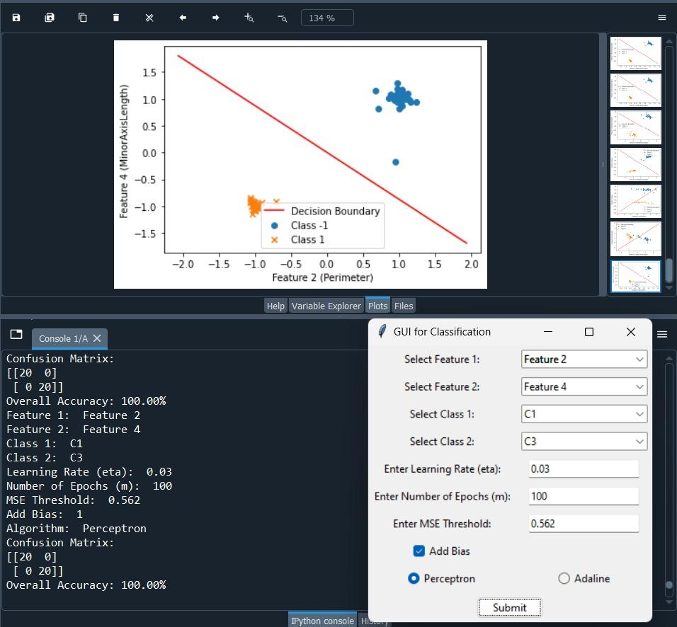

**Screenshot 5 :**

Selected Feature 1 : **Roundness**

Selected Feature 2 : **Perimeter**

Selected Class 1 : **bombay**

Selected Class 2 : **Cali**

Overall Accuracy : **87.5%**

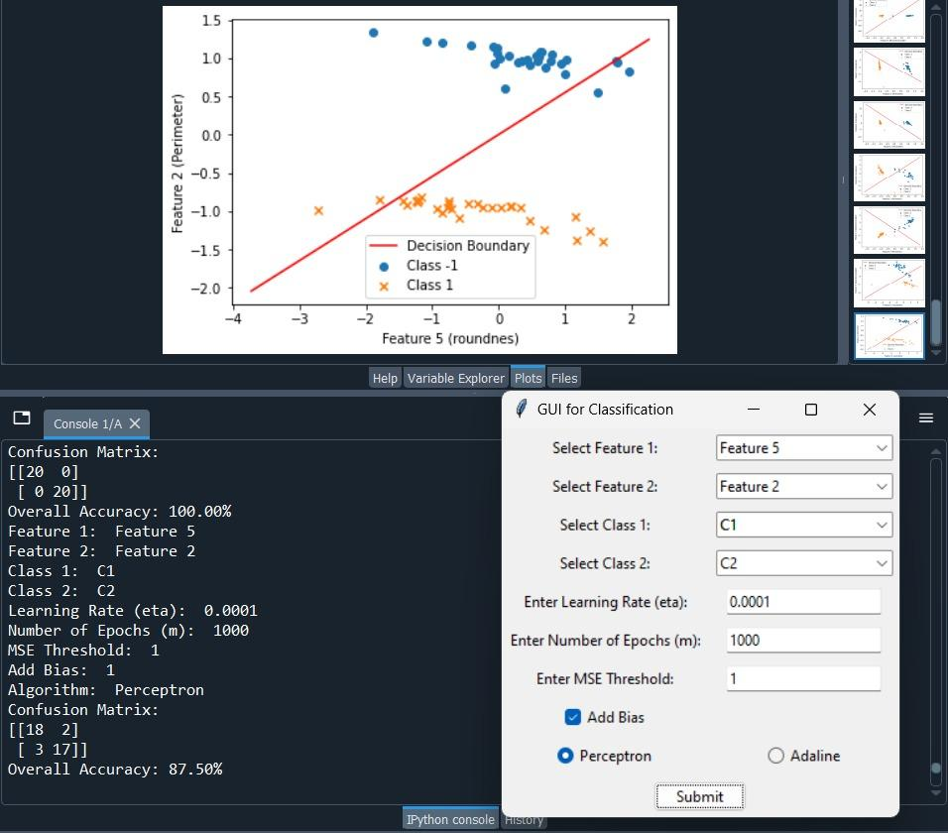

**Adaline Model**

The adaline model is an adaptive linear neuron used for binary classification. It is trained using the gradient descent algorithm to minimize the mean squared error (MSE). The model can be initialized with parameters such as learning rate, number of iterations, MSE threshold, and bias.

**Screenshot 1:**

Selected Feature 1 : **Bombay**

Selected Feature 2 : **Cali**

Selected Class 1 : **ِArea**

Selected Class 2 : **Perimeter**

Overall Accuracy : **100%**

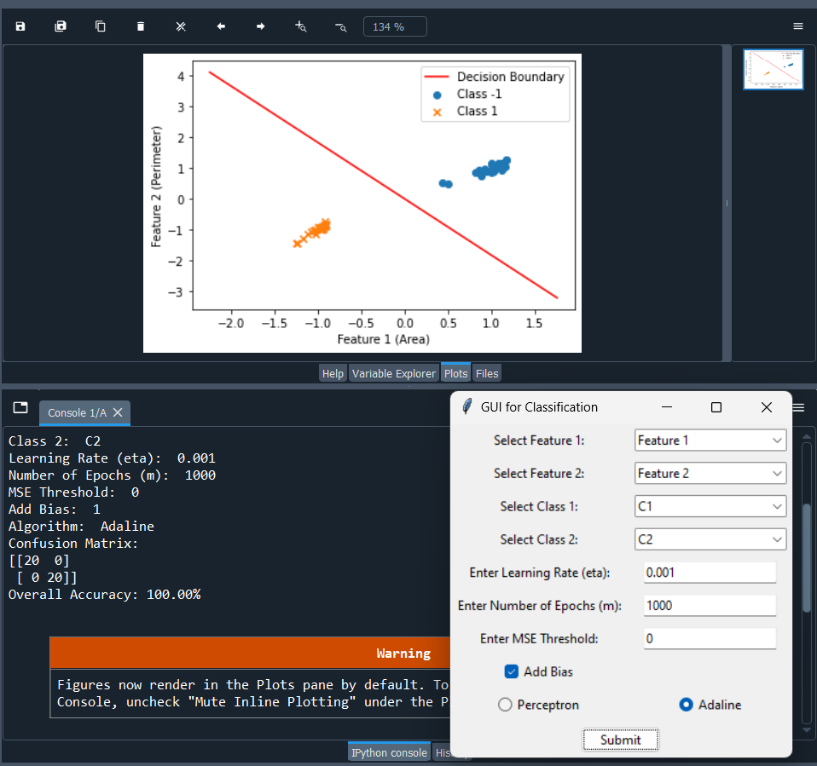

**Screenshot 2:**

Selected Feature 1 : **Area**

Selected Feature 2 : **MinorAxisLength**

Selected Class 1 : **Bombay**

Selected Class 2 : **Sira**

Overall Accuracy : **100%**

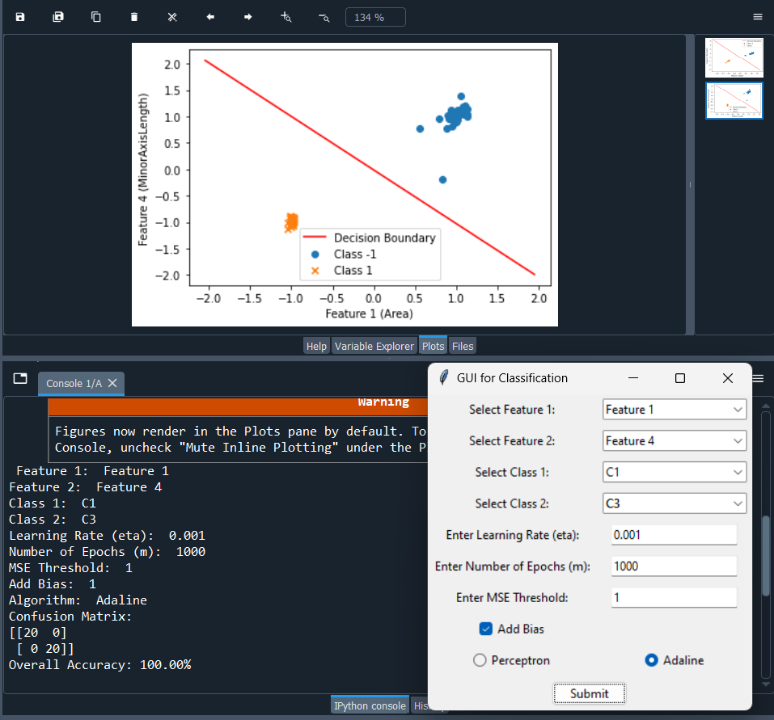

**Screenshot 3:**

Selected Feature 1 : **MinorAxisLength**

Selected Feature 2 : **Roundness**

Selected Class 1 : **Cali**

Selected Class 2 : **Sira**

Overall Accuracy : **100%**

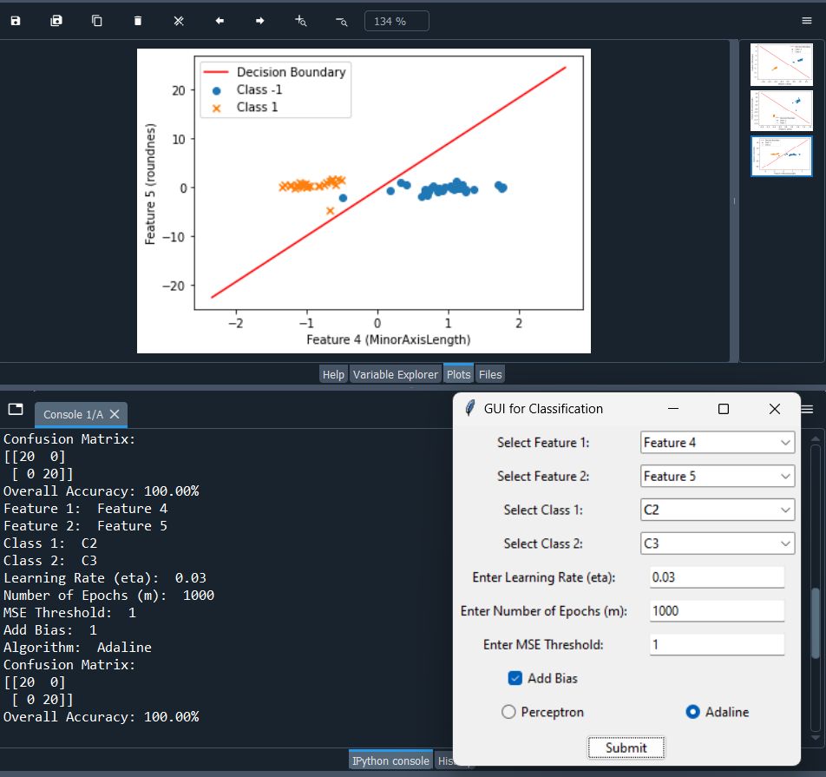

**Screenshot 4:**

Selected Feature 1 : **Perimeter**

Selected Feature 2 **: MajorAxisLength**

Selected Class 1 : **Bombay**

Selected Class 2 : **Cali**

Overall Accuracy : **100%**

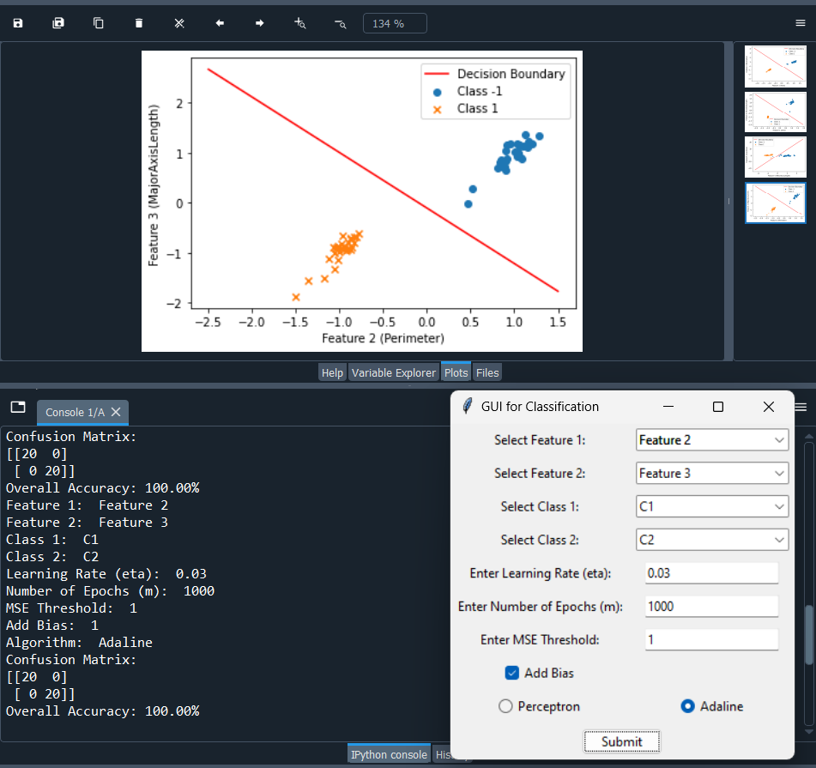

**Screenshot 5:**

Selected Feature 1 : **MinorAxisLength**

Selected Feature 2 : **Roundness**

Selected Class 1 : **Sira**

Selected Class 2 : **Bombay**

Overall Accuracy : **100%**

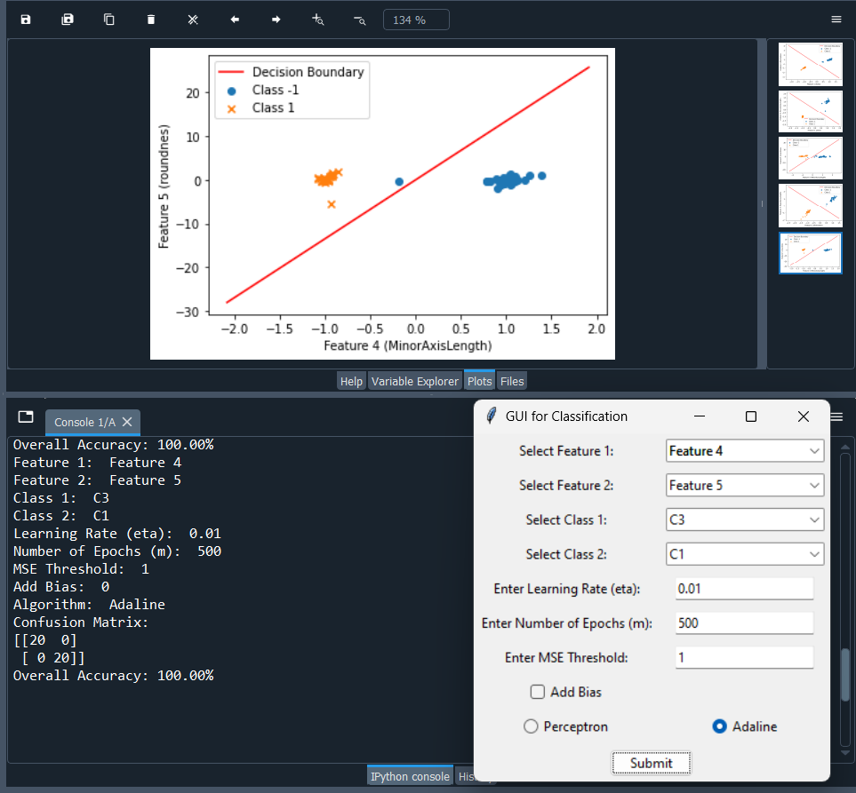

**Results and Analysis**

**For perceptron model:**  Features ' Roundness ' and 'Area' ,

Classes 'CALI' and 'BOMBAY' archives **highest accuracy** 100% with

500 epochs and MSE threshold = 1 .

**Adaline model:**  Features ' MajorAxisLength ' and 'roundness' ,

classes 'BOMBAY' and 'CALI' archives **highest** **accuracy** 100% with

500 epochs and MSE threshold = 1.

**Team member:**

|  |  |
| --- | --- |
| محمد ايمن رشدي عبد العظيم | 20201700674 |
| عبد الرحمن محي محمد رمضان | 20201700487 |
| محمد عصام علي مصطفي صبري | 20201700711 |
| فؤاد احمد سامي فؤاد الدهان | 20201700587 |
| زياد سيد عوض محمد | 20201700307 |

**Team number : 123**