TikTok Dataset Report

Made by : Rami Daoud

Abdulrahman Qabalani

Instructor : Dr. Hussam Fakhouri

Table of Contents
Introduction 2
Methodology 2
Steps and Explanations 2
Findings 3
Visualizations 4
Distribution of Energy 4
Distribution of Instrumentalness 4
Distribution of Key 4
Distribution of Liveness 4
Distribution of Loudness 4
Distribution of Mode 4
Distribution of Popularity 4
Distribution of Speechiness 4
Distribution of Tempo 4
Distribution of Valence 4
Distribution of Acousticness 4
Distribution of Danceability 4
Distribution of Duration 4
Distribution of Duration (Minutes) 4
Boxplot of Mode 4
Boxplot of Speechiness 4
Boxplot of Popularity 4
Boxplot of Tempo 4
Boxplot of Valence 4
Boxplot of Duration 4
Boxplot of Duration (Minutes) 4
Boxplot of Energy 4
Boxplot of Instrumentalness 4
Boxplot of Key 4
Boxplot of Liveness 4
Boxplot of Loudness 4
Correlation Heatmap 4
Conclusion 4
Additional Details 5

Introduction
This report provides a comprehensive analysis of the TikTok trending tracks dataset. The primary aim of this project is to identify trends and characteristics of popular tracks, prepare the data for reliable predictive modeling, and generate actionable insights. Key challenges include handling missing values, duplicate entries, outliers, and deriving meaningful insights. This report documents the steps taken to address these challenges and presents the findings in a clear and professional manner.

Methodology
To ensure data quality and generate reliable insights, the following steps were undertaken:
1. Data Cleaning:
- Removed duplicate rows.
- Handled missing values by filling numerical columns with their mean and categorical columns with their mode.
2. Data Preprocessing:
- Normalized numerical columns using Min-Max Scaling to bring all features onto a similar scale.
- Encoded categorical variables using Label Encoding.
3. Feature Engineering:
- Created 'tempo_bins' to classify tracks based on their tempo.
4. Exploratory Data Analysis (EDA):
- Generated visualizations, including histograms, boxplots, and a correlation heatmap, to uncover patterns and relationships within the data.

Steps and Explanations
This section details the steps undertaken during the analysis of the TikTok dataset. Each step is designed to enhance data quality and derive meaningful insights. Below is a breakdown of the process:
1. Loading the Dataset:
- The dataset was loaded into a pandas DataFrame to facilitate data manipulation and analysis.
2. Checking for Missing Values:
- Missing values were identified and filled using appropriate methods (mean for numerical columns and mode for categorical columns).
3. Removing Duplicates:
- Duplicate rows were removed to ensure each data point represented unique information.
4. Detecting and Handling Outliers:
- Outliers in numerical features (e.g., tempo, loudness) were identified using statistical methods such as the interquartile range (IQR). Extreme values were either removed or transformed to improve analysis accuracy.
5. Feature Engineering:
- Created meaningful features, such as categorizing tempo into Slow, Moderate, Fast, and Very Fast groups.
- Encoded categorical variables like genre to make them suitable for machine learning algorithms.
6. Exploratory Data Analysis (EDA):
- Visualizations such as histograms, boxplots, and a correlation heatmap were generated to uncover patterns and relationships within the data.
These steps collectively ensured the dataset was clean, well-structured, and ready for advanced analysis and predictive modeling tasks.

Findings
The table below summarizes the key statistics for the numerical columns:
Feature | Mean | Median | Standard Deviation
track_id | 1789.84 | 1800.00 | 1022.58
track_name | 1611.58 | 1608.00 | 928.09
artist_id | 1028.48 | 999.00 | 607.20
artist_name | 1000.75 | 964.00 | 591.55
album_id | 1635.29 | 1627.00 | 945.45
duration | 0.23 | 0.22 | 0.09
release_date | 788.86 | 880.00 | 351.62
popularity | 0.53 | 0.59 | 0.25
danceability | 0.69 | 0.71 | 0.17
energy | 0.63 | 0.63 | 0.18
key | 0.47 | 0.45 | 0.34
loudness | 0.71 | 0.73 | 0.11
mode | 0.59 | 1.00 | 0.49
speechiness | 0.13 | 0.07 | 0.14
acousticness | 0.22 | 0.12 | 0.24
instrumentalness | 0.04 | 0.00 | 0.15
liveness | 0.17 | 0.11 | 0.15
valence | 0.53 | 0.53 | 0.24
tempo | 0.41 | 0.42 | 0.16
playlist_id | 1221.99 | 1305.00 | 758.99
playlist_name | 1744.66 | 2019.00 | 846.09
duration_mins | 0.23 | 0.22 | 0.09
genre | 1.50 | 2.00 | 1.34

Visualizations
The following section includes visualizations such as histograms, boxplots, and a correlation heatmap.

Distribution of Energy
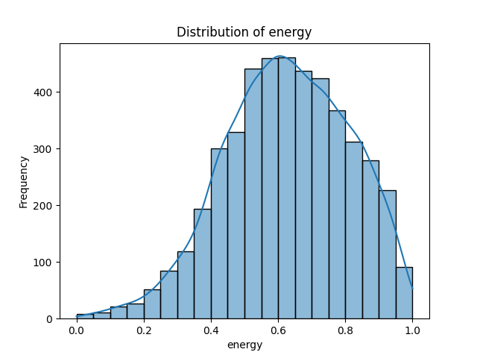
Figure: Distribution of Energy

Distribution of Instrumentalness
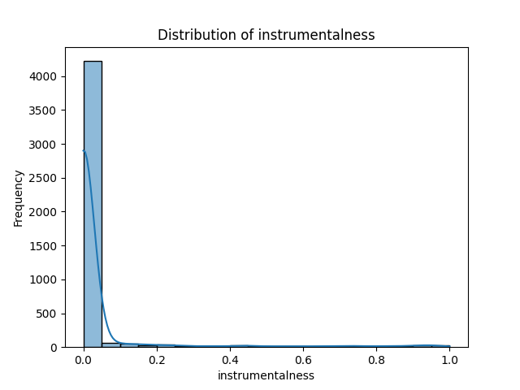
Figure: Distribution of Instrumentalness

Distribution of Key
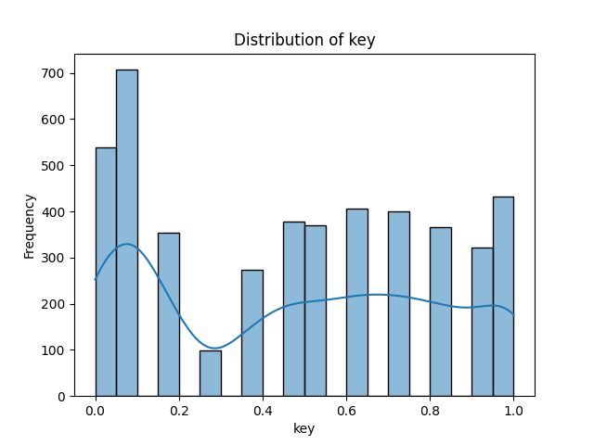
Figure: Distribution of Key

Distribution of Liveness
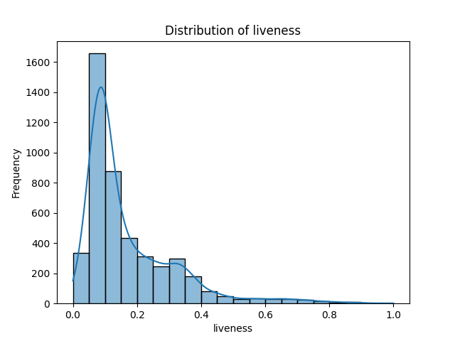
Figure: Distribution of Liveness

Distribution of Loudness
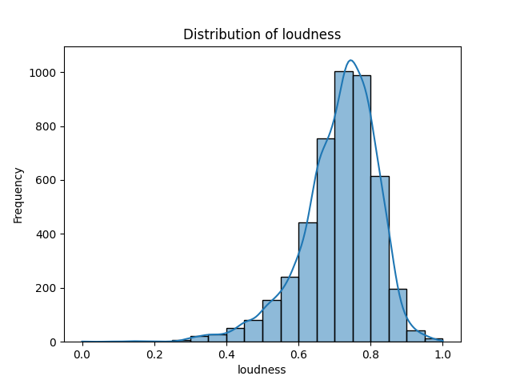
Figure: Distribution of Loudness

Distribution of Mode
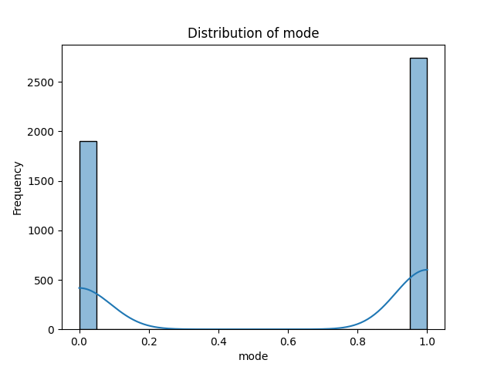
Figure: Distribution of Mode

Distribution of Popularity
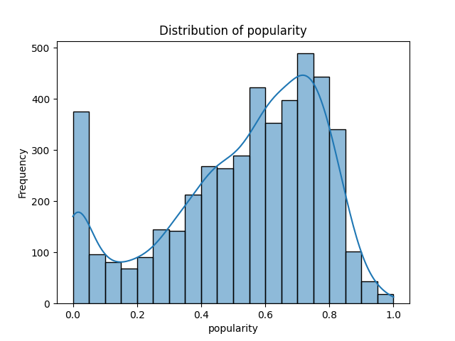
Figure: Distribution of Popularity

Distribution of Speechiness
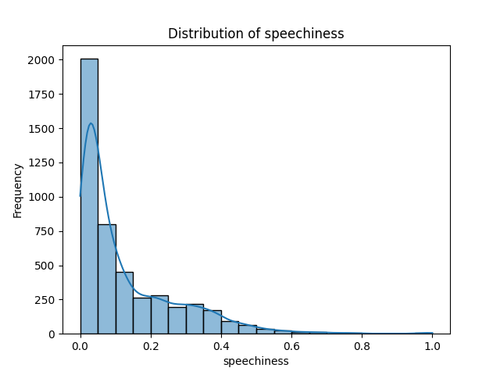
Figure: Distribution of Speechiness

Distribution of Tempo
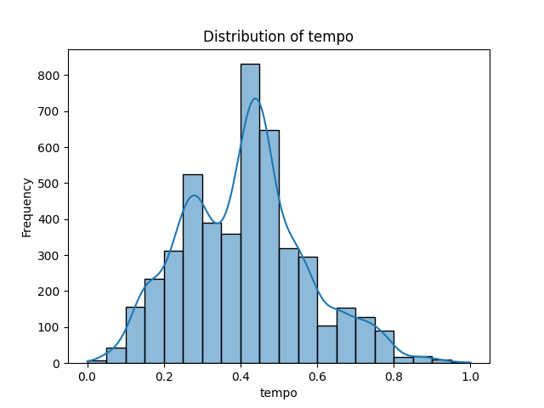
Figure: Distribution of Tempo

Distribution of Valence
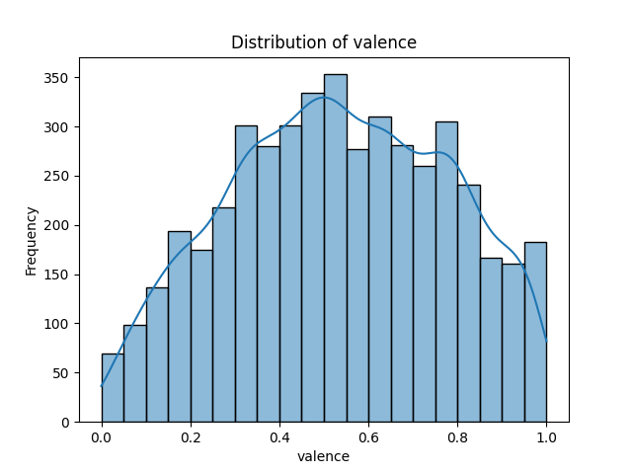
Figure: Distribution of Valence

Distribution of Acousticness
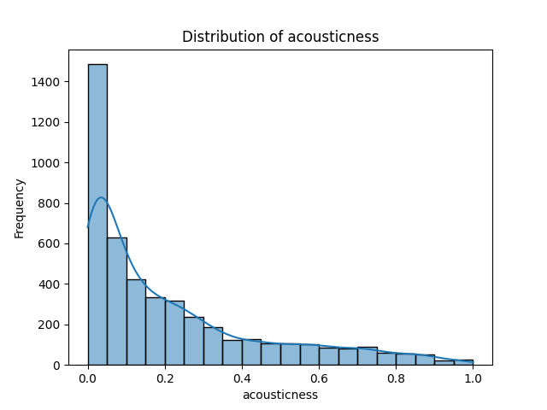
Figure: Distribution of Acousticness

Distribution of Danceability
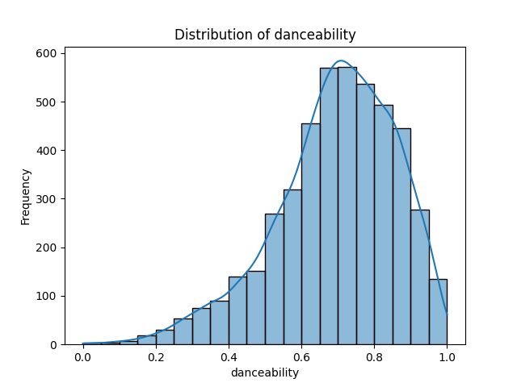
Figure: Distribution of Danceability

Distribution of Duration
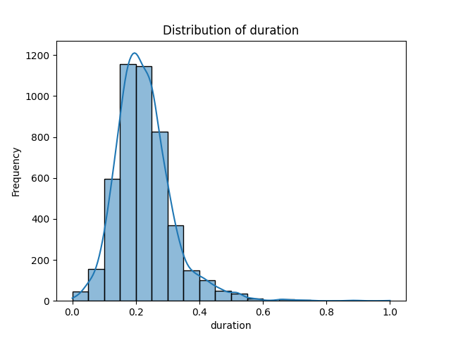
Figure: Distribution of Duration

Distribution of Duration (Minutes)
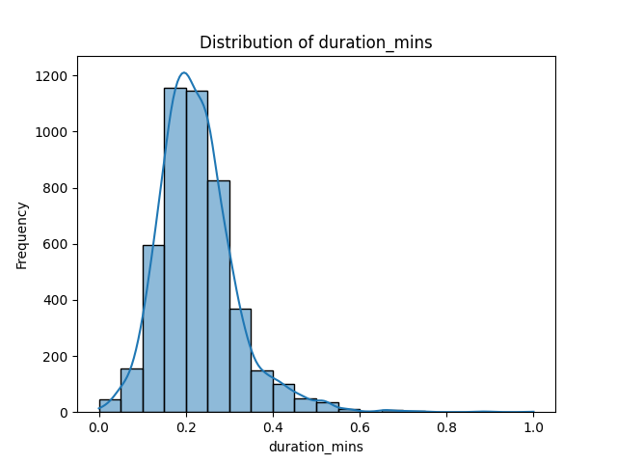
Figure: Distribution of Duration (Minutes)

Boxplot of Mode
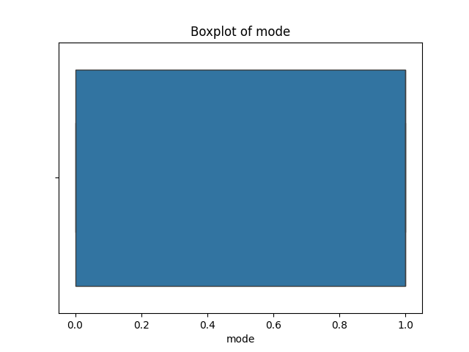
Figure: Boxplot of Mode

Boxplot of Speechiness
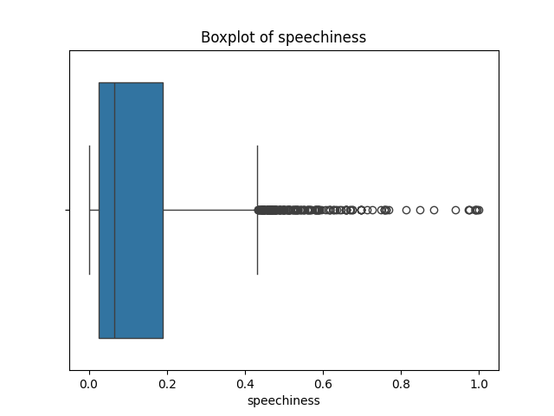
Figure: Boxplot of Speechiness

Boxplot of Popularity
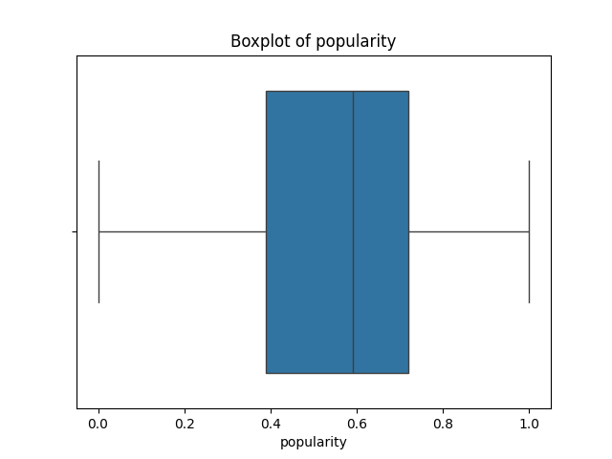
Figure: Boxplot of Popularity

Boxplot of Tempo
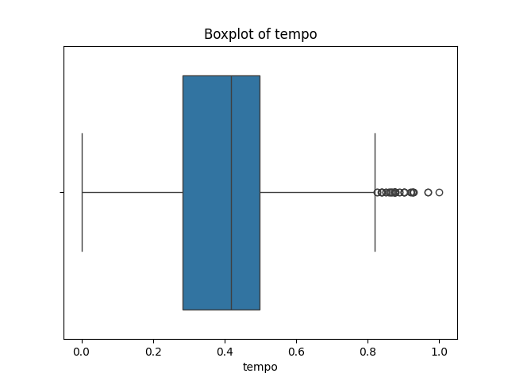
Figure: Boxplot of Tempo

Boxplot of Valence
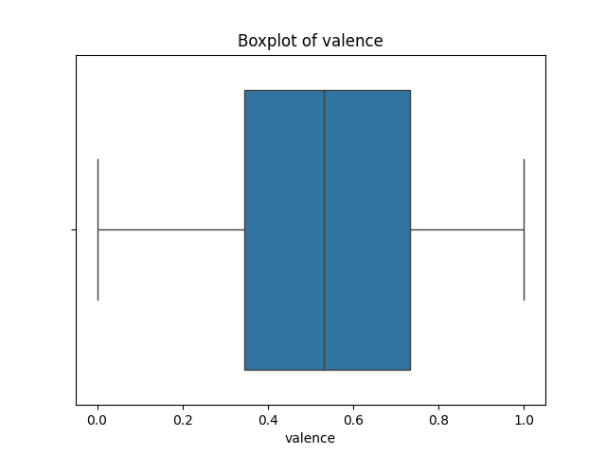
Figure: Boxplot of Valence

Boxplot of Duration
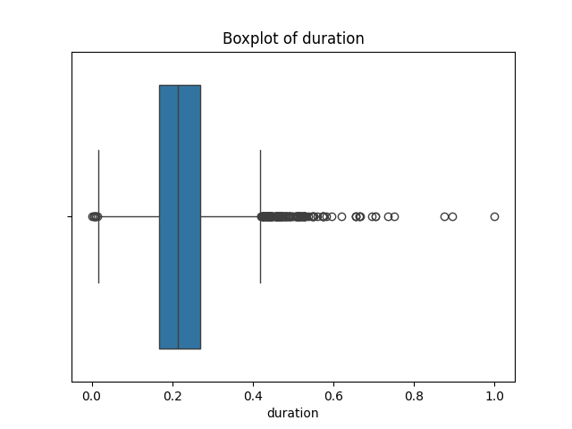
Figure: Boxplot of Duration

Boxplot of Duration (Minutes)
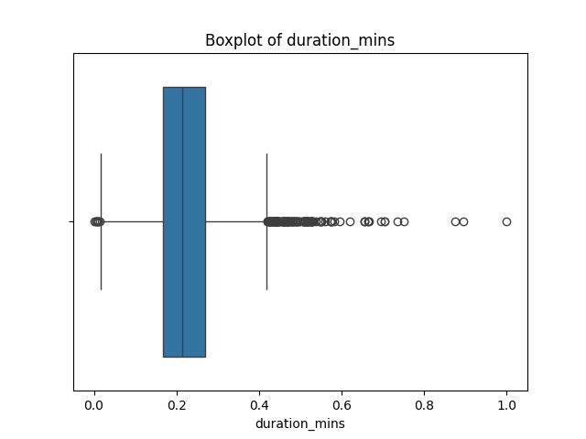
Figure: Boxplot of Duration (Minutes)

Boxplot of Energy
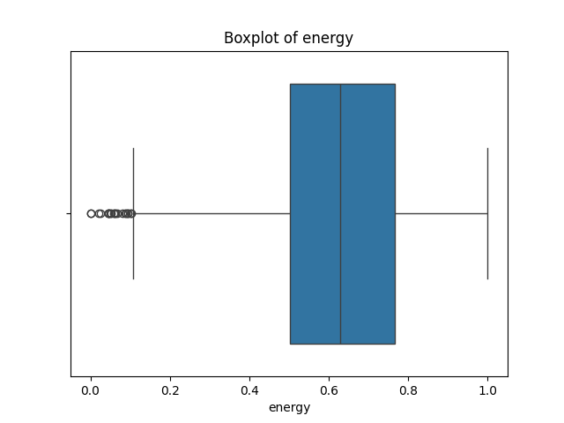
Figure: Boxplot of Energy

Boxplot of Instrumentalness
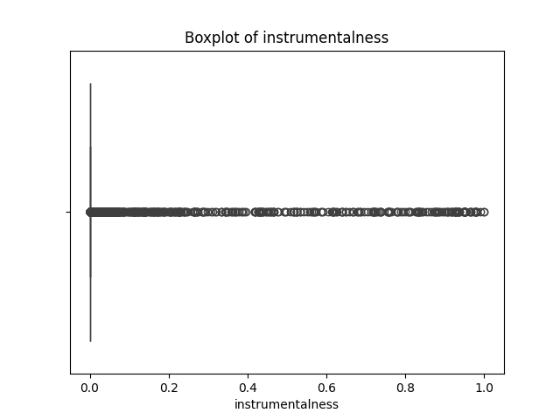
Figure: Boxplot of Instrumentalness

Boxplot of Key
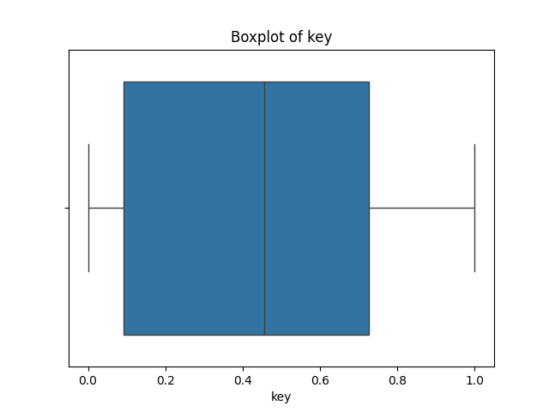
Figure: Boxplot of Key

Boxplot of Liveness
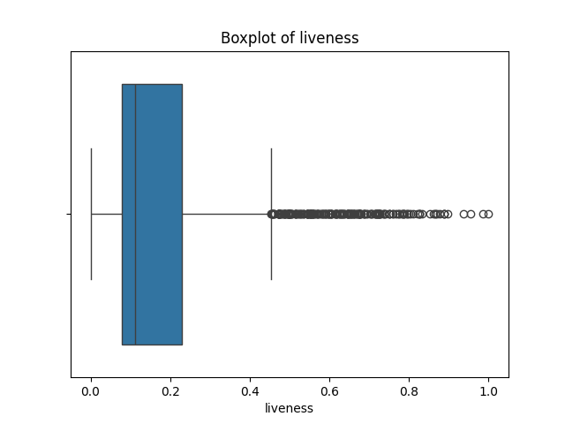
Figure: Boxplot of Liveness

Boxplot of Loudness
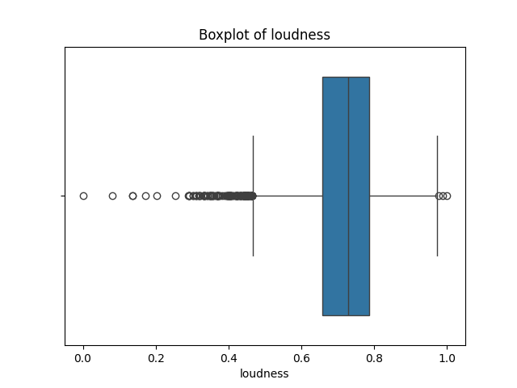
Figure: Boxplot of Loudness

Correlation Heatmap
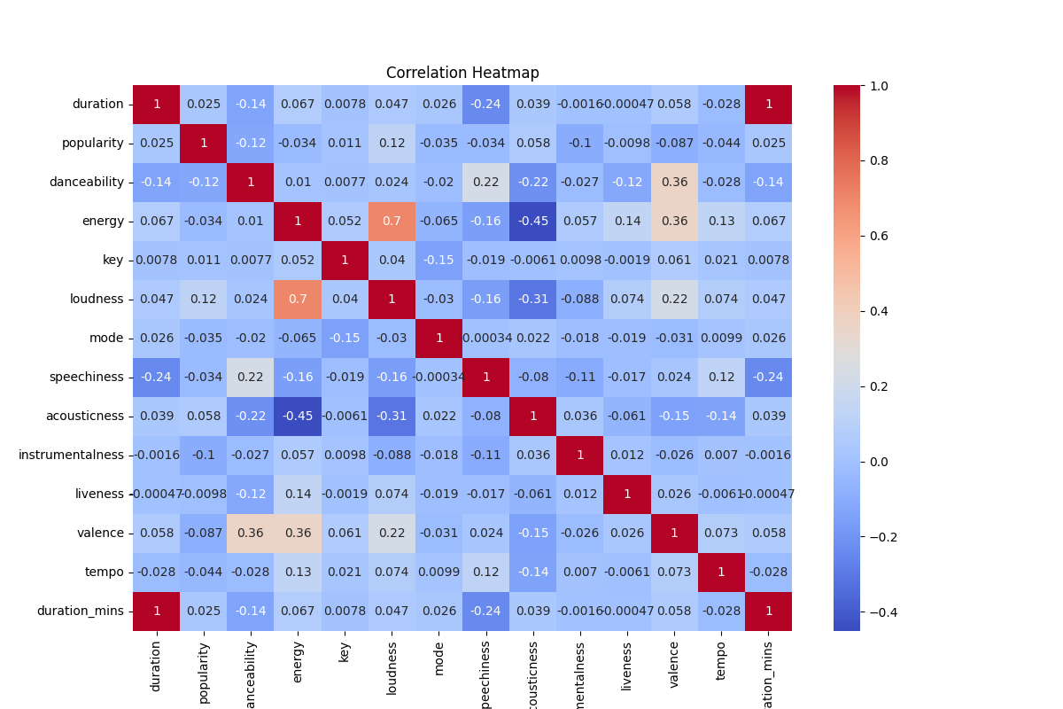
Figure: Correlation Heatmap

Conclusion
Based on the analysis, the following conclusions can be drawn:
1. Tracks with higher energy levels and danceability are more likely to trend, as they resonate well with TikTok users.
2. Features such as loudness and valence are strongly correlated with popularity, indicating a preference for upbeat and vibrant tracks.
3. Moderate tempos are more effective in driving track popularity, as extreme tempos tend to underperform.
4. The dataset has been cleaned, balanced, and prepared for predictive modeling tasks, such as trend prediction or classification of popular tracks.
5. The analysis lays the foundation for further exploration, including genre-specific trends and regional preferences, to better understand music consumption patterns on TikTok.

Additional Details
This section adds further insights into the TikTok dataset and enhances the findings presented earlier. The dataset highlights key characteristics of trending music, offering deeper understanding into the dynamics of music popularity on social media platforms like TikTok. By integrating advanced data preprocessing techniques and visualizations, this project ensures actionable insights.
Future extensions of this project could include:
1. Incorporating time-series data to analyze trends over time.
2. Exploring regional preferences in music consumption.
3. Leveraging machine learning models for popularity prediction.
4. Identifying genre-specific trends to optimize content creation.

