**Name**: Abdelrahman Abdelkader Sobhy Younis

**B.N**: 1131

**Topic**: Artificial Intelligence

**GitHub Link:** https://github.com/AbdelrahmanYounis/ECE001

**GitHub Pages:** https://abdelrahmanyounis.github.io/ECE001/

*Artificial Intelligence and its Applications:*

Artificial Intelligence ( AI ) refers to human intelligence simulation in machines which are programmed to think like humans and imitate their behavior. The term may also apply to any machine that exhibits human mind-related traits such as learning and problem-solving

there are many examples of ALs applications such as Manufacturing robots, Smart assistants, Proactive healthcare management, Disease mapping, Automated financial investing, Virtual travel booking agent, Social media monitoring, Inter-team chat tool, Conversational marketing bot and Natural Language Processing (NLP) tools.

Whether we realize it or not, artificial intelligence is all around us and playing an active role in our daily lives. Every time we open our Facebook newsfeed, do a Google search, get a product recommendation from Amazon or book a trip online, AI is lurking in the background.

**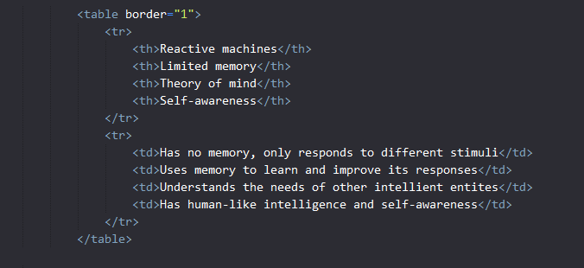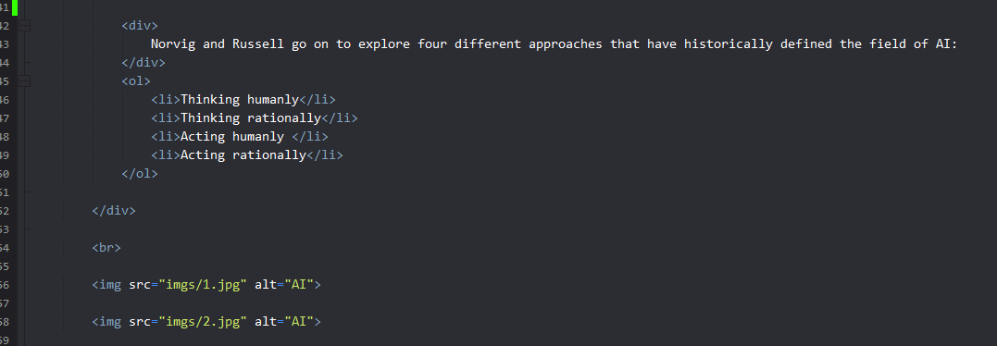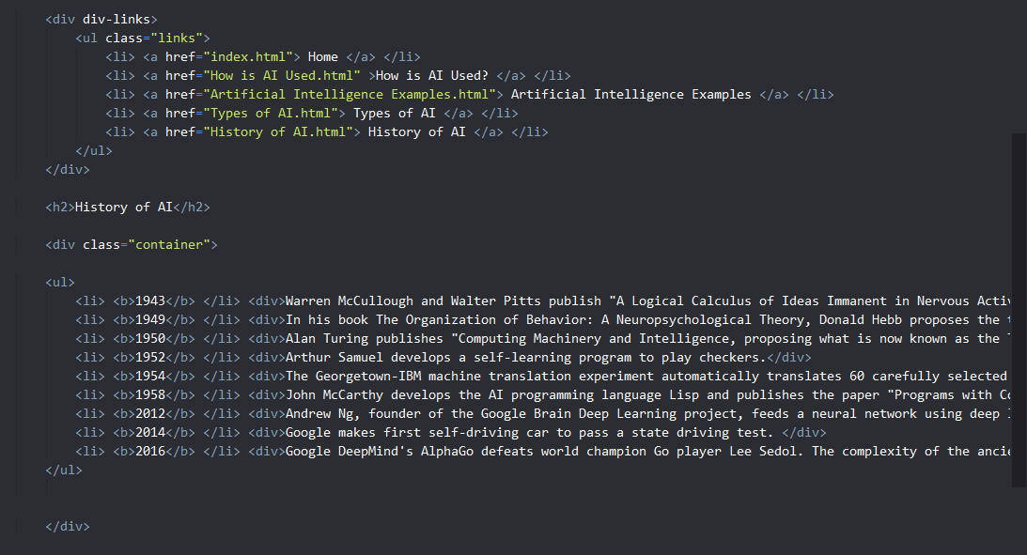***Source Code:*

*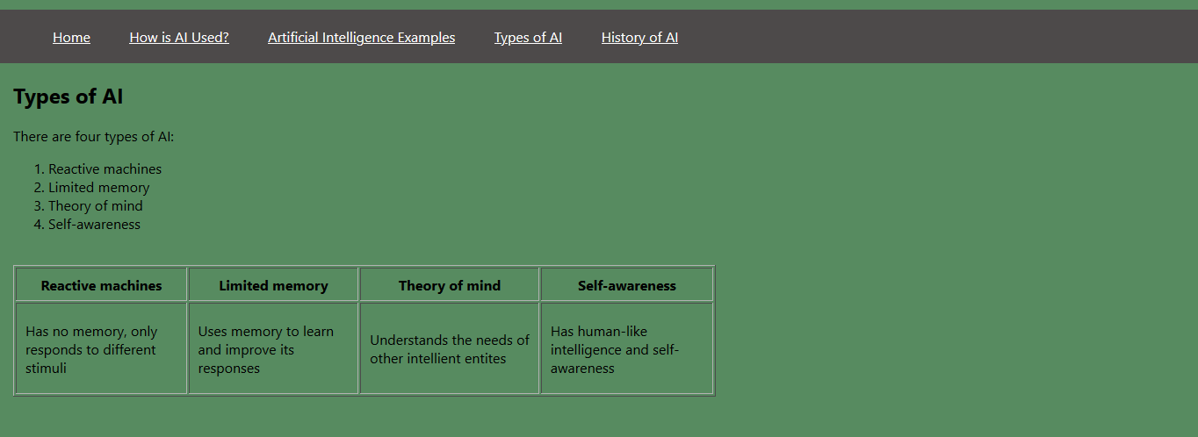Screenshots:*

