Name / Abdelrahman mohamed Nabieh Ahmed

B.N / 451

Date/ 11 / 6 / 2021

**Topic** : Internet of things

**Application Brief :**

I chose the topic of the Internet of Things because we use it in our daily lives and it is around us everywhere. The Internet of Things enables humans to effectively and easily control things closely and remotely. For example, the user can start his car engine and control it from his computer.

**Screenshots :**

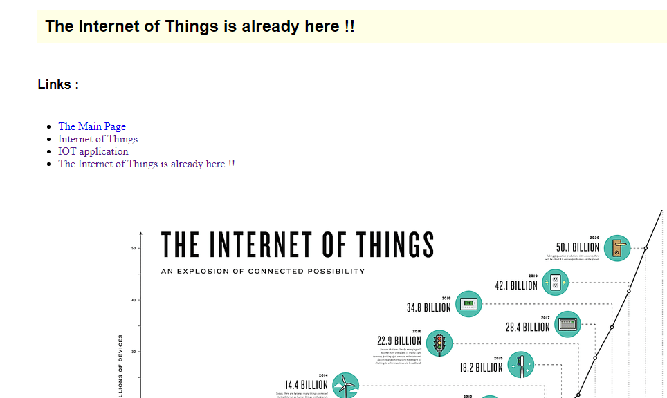

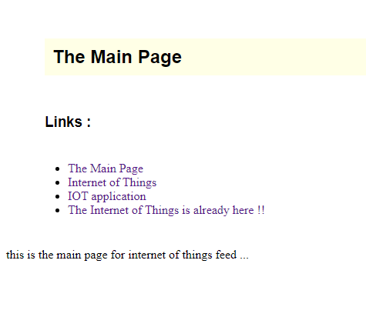

**Source code :**

