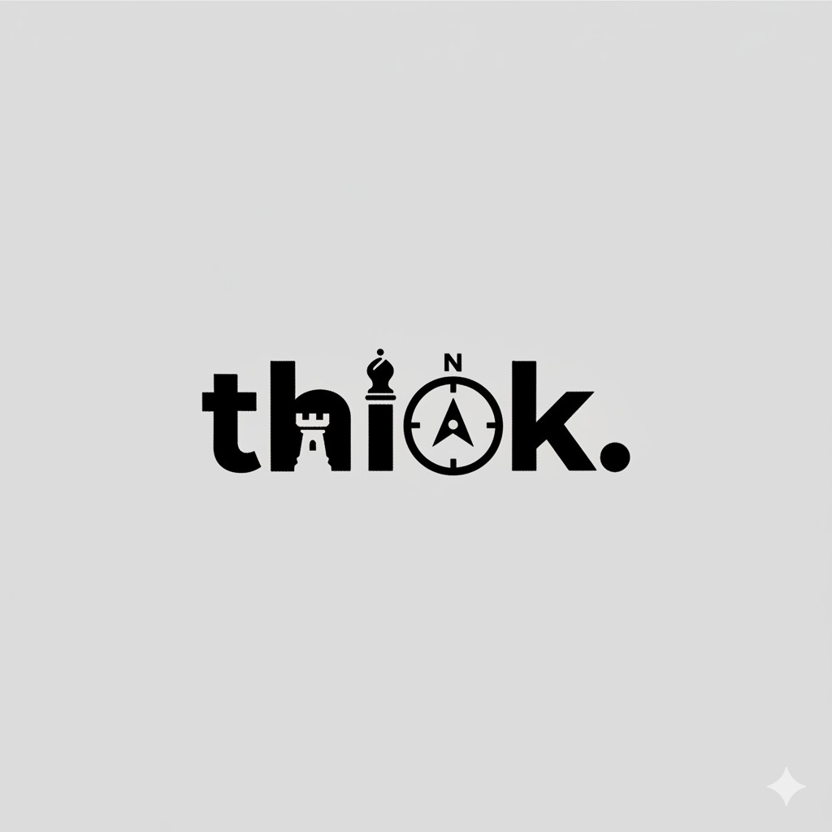

Think Creative Agency ‒ Brand Profile

# About Us

At Think Creative Agency, we don’t just market brands ̶ we build them. We are a multidisciplinary creative and marketing agency that blends strategy, design, and storytelling to help businesses grow and stand out in competitive markets. We believe that creativity without direction is chaos, and direction without creativity is noise ̶ that’s why we combine both. We don’t follow trends, we create them.

We are the team behind the spotlight ̶ the ones who make brands visible, loved, and trusted. Our agency was built on one principle: great brands don’t happen by chance, they happen by strategy. We guide our clients through the full journey ̶ from concept to campaign, from identity to impact. We understand how brands rise, what makes them win, and how to make people believe in them. Whether it’s building a name from scratch, launching a cinematic commercial, or growing a digital presence ̶ we make your brand the strongest piece on the board.

Slogan:

Think Growth,Think Deffirent.

# Vision

To lead the creative industry in the MENA region by redefining how brands grow ̶ through innovation, storytelling, and strategic intelligence.

# Mission

To help ambitious brands turn their ideas into powerful identities, their stories into connections, and their presence into performance.

# Core Values

* Strategy Before Execution ‒ every move must have purpose.
* Innovation Over Imitation ‒ we don’t follow, we redefine.
* Excellence in Every Detail ‒ from visuals to voice.
* Partnership & Trust ‒ we grow when our clients grow.
* Creativity with Results ‒ not just art, but performance.

# Our Services

Marketing Strategy & Campaigns

Strategic marketing planning that connects vision to measurable results.

Social Media Management

Managing your brand’s presence, growth, and engagement across platforms.

Video Editing & Post-Production

Crafting powerful visuals from raw materials to tell compelling stories.

Full Film Making

From idea to final cinematic release.

Branding & Identity Design

Building visual and verbal identities that define your brand.

Social Media Design

Designing scroll-stopping visuals for every platform.

Photography

Professional photography sessions that capture emotion and story.

Web & App Development

Building responsive, functional, and visually aligned digital platforms.

# Visual Identity

Colors:

* White / Off-White ‒ Base & space
* Black ‒ Strength & clarity
* Neon Blue ‒ Accent energy

Chess Symbolism:

* Knight = smart moves & strategic agility
* Castle (Rook) = foundation & stability

Design Personality:

Minimal ‒ Confident ‒ Strategic ‒ Bold

# Typography

English: Montserrat / Poppins Arabic: Cairo / Tajawal Hierarchy:

* Titles: Bold
* Subtitles: Medium
* Body: Regular

# Contact & Presence

# 📧 [hello.thinkagency@gmail.com](mailto:hello.thinkagency@gmail.com)

# 📞 +20 1020091991

# ☎️ +20 1020094409

# 📍 El Nozha El Gedida, Gesr El Suez, Cairo, Egypt

# 🌍 Operating in: Egypt – UAE – UK

# 🔗 Domains: thinkagency.net | thinkcreative.net

# Social Media Links :

# tiktok.com/@thinkagency.eg

# instagram.com/thinkagency.eg

# facebook.com/thinkcreativegency