Hierarchical Multimodal Biometric Verification System
Task 2: In-Depth Evaluation Report, Metrics Analysis & Oral Interview Guide
Course / Task: | Machine Learning — Task 2: Multimodal Biometric Verification System
Project Application: | Smart Security Gate for a Data Center (RBAC Perimeter Defense)
Team Members: | Abdelrahman Wael (Super Admin), Hashem (Operator), Hagar (Auditor)
Technology Stack: | Strictly Traditional Machine Learning (No Deep Learning) — Python, Scikit-Learn, OpenCV, SciPy

1. Experimental Protocol & Leakage Prevention
A critical pitfall in biometric machine learning is optimistic error reporting caused by improper evaluation protocol and data leakage. In this project, the evaluation methodology was engineered strictly to reflect real-world security gate deployments:
- Split by Sessions (GroupKFold): Genuine biometric samples were gathered across separate temporal sessions (Session 1, Session 2, and Session 3). Rather than random train/test splitting, GroupKFold cross-validation by session was enforced. This guarantees that background room acoustics, microphone positioning, and ambient camera illumination do not artificially inflate the classifier's performance.
- Zero Data Leakage in Feature Pipelines: StandardScaler, PCA projections, and block normalizations are encapsulated within Scikit-Learn Pipeline transformers. They are fitted exclusively on training folds. The validation and test folds are strictly transformed using training statistics.
- Open-Set Impostor Testing: The system is evaluated against completely unseen impostors (Ariel Sharon, Colin Powell, Donald Rumsfeld, and chimeric multi-source identities) that were never introduced during hyperparameter tuning or training. This benchmarks real-world resistance to arbitrary intruders.
- Threshold Freezing on Development Set: Operational decision thresholds (T_low, T_fusion, T_fp) are computed and frozen on the Development set (Sessions 1 & 2) using Equal Error Rate (EER) or operational policy, and then evaluated without modification on the held-out Test set (Session 3).
📌 INTERVIEW DEFENSE SHIELD #1: If an interviewer asks: 'How did you prevent data leakage?', answer: 'We grouped all samples by session using GroupKFold and encapsulated PCA and StandardScalers inside Scikit-Learn Pipelines. No test or validation session ever touched the scaler or PCA training phase.'

2. Biometric Evaluation Metrics & Theoretical Grounding
Standard machine learning metrics (such as Raw Accuracy) are notoriously deceptive in biometric security because of extreme class imbalance: in an enterprise data center, 99% of access attempts may be unauthorized impostors, so a naive dummy model that rejects every attempt would achieve 99% accuracy while being completely non-functional. Therefore, specialized biometric verification metrics are mathematically essential:
A) The Biometric Confusion Matrix (TP, TN, FP, FN)
In biometric verification, the binary classes are defined as: Positive (1) = Enrolled Genuine User, Negative (0) = Impostor / Intruder.
• True Positive (TP): The authorized user claims their identity and the system correctly grants access.
• True Negative (TN): An unauthorized intruder claims an enrolled identity and the system correctly denies entry.
• False Positive (FP) / False Acceptance: An intruder attempts entry and the system erroneously GRANTS access (Critical Security Breach).
• False Negative (FN) / False Rejection: An authorized enrolled employee attempts entry and the system erroneously DENIES access (Usability / Operational Friction).
B) FAR (False Acceptance Rate / FPR)
Formula: FAR = FP / (FP + TN)
Meaning: The probability that an unauthorized intruder is mistakenly authenticated as the genuine user.
Why it is suitable for Biometrics: FAR is the primary SECURITY metric. In a sensitive data center housing financial records or cloud infrastructure, FAR must be pushed as close to 0.0% as possible. A high FAR means the physical facility is vulnerable to impostor infiltration.
C) FRR (False Rejection Rate / FNR)
Formula: FRR = FN / (FN + TP) = 1 - TAR (True Acceptance Rate)
Meaning: The probability that an authorized enrolled team member is erroneously rejected by the biometric scanner.
Why it is suitable for Biometrics: FRR is the primary CONVENIENCE / USABILITY metric. While a high FRR does not breach data security, it creates severe administrative friction, worker lockout, and unnecessary alarm escalation.
D) The Fundamental Biometric Trade-Off & Decision Threshold (θ)
Every biometric classifier outputs a match probability or similarity score s ∈ [0.0, 1.0]. A decision threshold θ determines access: if s ≥ θ then ACCESS GRANTED, else ACCESS DENIED.
• Strict Threshold (e.g., θ = 0.85): FAR decreases to zero (Maximum Security), but FRR increases (authorized users are often rejected if lighting or voice tone changes).
• Lenient Threshold (e.g., θ = 0.25): FRR decreases to zero (Maximum Convenience), but FAR increases (intruders are more likely to slip through).
E) EER (Equal Error Rate)
Definition: The unique operating threshold point on the ROC curve where the False Acceptance Rate exactly equals the False Rejection Rate (FAR = FRR).
Why it is suitable for Biometrics: EER is the global Gold Standard single-number benchmark for comparing biometric algorithms. Because it does not depend on an arbitrarily chosen threshold, it reflects the intrinsic discriminative power of the feature extractor and classifier. A lower EER indicates a strictly superior biometric verifier (e.g., 0.0% to 1.7% in our early fusion vs. 6-13% in noisy single modalities).
F) ROC Curve & ROC-AUC
Definition: The Receiver Operating Characteristic (ROC) plots True Acceptance Rate (TAR = 1 - FRR) on the Y-axis versus False Acceptance Rate (FAR) on the X-axis across all possible decision thresholds θ ∈ [0, 1].
Why it is suitable for Biometrics: ROC-AUC (Area Under the Curve) evaluates the system independently of the operating threshold. An AUC of 1.0 (100%) means genuine scores and impostor scores have complete, non-overlapping separation in feature space.
📌 INTERVIEW DEFENSE SHIELD #2: If asked in the interview: 'Why is standard accuracy not enough?', answer: 'Because in biometrics, dataset distribution is heavily imbalanced with many more impostor comparisons than genuine attempts. A 99% accuracy could still hide a catastrophic 5% False Acceptance Rate. FAR, FRR, and EER measure true security and convenience.'

3. Performance Evaluation: Unimodal vs. Multimodal
Below are the empirical evaluation results gathered across all enrolled team members and open-set intruders on held-out test data (Session 3). The comparison benchmarks individual biometric verification (Modes A & B) against Multimodal Early Fusion (Mode C) and the Hierarchical Cascade (Mode D):
Biometric Mode | Classifier | Accuracy | Precision | Recall | FAR (FPR) | FRR (FNR) | EER | ROC-AUC
Face-Only (Mode A) | SVM (RBF) | 97.2% ± 2.8 | 100.0% | 83.3% | 0.0% | 16.7% | 1.7% ± 1.7 | 98.9% ± 1.1
Face-Only (Mode A) | KNN (Cosine) | 95.6% ± 3.3 | 88.5% | 83.3% | 2.0% | 16.7% | 1.0% ± 0.3 | 99.2% ± 0.1
Voice-Only (Mode B) | SVM (RBF) | 95.0% ± 1.7 | 100.0% | 70.0% | 0.0% | 30.0% | 0.0% | 100.0%
Voice-Only (Mode B) | Random Forest | 90.0% ± 3.3 | 100.0% | 40.0% | 0.0% | 60.0% | 0.0% | 100.0%
Early Fusion (Mode C) | SVM (RBF) ★ | 97.2% ± 1.7 | 100.0% | 83.3% | 0.0% | 16.7% | 0.0% | 100.0%
Early Fusion (Mode C) | Random Forest | 95.0% ± 1.7 | 100.0% | 70.0% | 0.0% | 30.0% | 0.0% | 100.0%
Hierarchical (Mode D) | Sequential L1→L2 | 95.6% ± 3.3 | 100.0% | 73.3% | 0.0% | 26.7% | 0.0% | 100.0%
Hierarchical + Fingerprint | Full System (L1→L3) | 95.6% ± 3.3 | 100.0% | 73.3% | 0.0% | 26.7% | 0.0% | 100.0%
Fingerprint-Only (Bonus 4) | SVM (RBF) | 94.4% ± 5.6 | 80.0% | 100.0% | 6.7% | 0.0% | 0.0% | 100.0%
Fingerprint-Only (Bonus 4) | KNN (Cosine) | 88.9% ± 11.1 | 71.4% | 100.0% | 13.3% | 0.0% | 0.7% | 98.9% ± 1.1

Per-User Breakdown Table (Individual Members)
Enrolled Member | System Mode | Model | FAR | FRR | EER | ROC-AUC | Confusion Matrix (TP / FP / TN / FN)
Abdelrahman Wael | Face-Only (Mode A) | SVM | 0.0% | 0.0% | 0.0% | 100.0% | 15 / 0 / 75 / 0 (Flawless)
Abdelrahman Wael | Voice-Only (Mode B) | SVM | 0.0% | 20.0% | 0.0% | 100.0% | 12 / 0 / 75 / 3
Abdelrahman Wael | Early Fusion (Mode C) | SVM | 0.0% | 6.7% | 0.0% | 100.0% | 14 / 0 / 75 / 1
Abdelrahman Wael | Hierarchical Cascade (Mode D) | Best | 0.0% | 6.7% | 0.0% | 100.0% | 14 / 0 / 75 / 1
Hashem | Face-Only (Mode A) | SVM | 0.0% | 33.3% | 3.3% | 97.8% | 10 / 0 / 75 / 5
Hashem | Voice-Only (Mode B) | SVM | 0.0% | 40.0% | 0.0% | 100.0% | 9 / 0 / 75 / 6
Hashem | Early Fusion (Mode C) | SVM | 0.0% | 26.7% | 0.0% | 100.0% | 11 / 0 / 75 / 4
Hashem | Hierarchical Cascade (Mode D) | Best | 0.0% | 46.7% | 0.0% | 100.0% | 8 / 0 / 75 / 7
Hagar | Voice Verification | SVM | 0.0% | 0.0% | 0.0% | 100.0% | Tested via Voice + Fingerprint Policy

4. In-Depth Comparative Analysis: Why Multimodal Wins
A central requirement of Task 2 is demonstrating the superiority of multimodal fusion over single modalities. Our empirical data highlights three primary operational dimensions:
1. Overcoming Unimodal Failure Modes (Orthogonal Biometrics):
A single biometric modality is inherently susceptible to ambient interference:
• Face scans can suffer from harsh shadows, backlighting, or low camera resolution.
• Voice verification can degrade in noisy server rooms or when the speaker has vocal strain.
Because facial geometry (HOG/LBP) and vocal acoustic tract physics (MFCC/ZCR/RMS) are statistically uncorrelated (orthogonal), an attacker who manages to mimic a voice has virtually zero probability of simultaneously mimicking the authorized user's face.
2. Early Fusion Synergy (Feature-Level Integration):
In Early Fusion (Mode C), feature vectors are combined into a joint representation before classification. By applying StandardScaler, PCA reduction on the face vector, and block weighting (w_face = 1.0, w_voice = 0.5), the SVM classifier learns cross-modal decision boundaries. As demonstrated in the comparison table, Early Fusion achieved an AUC of 100.0% and an EER of 0.0%, effectively eliminating false alarms while keeping the False Acceptance Rate at a rock-solid 0.0%.
3. Hierarchical Verification (Mode D) Computational Efficiency:
Why use a Hierarchical Pipeline rather than demanding all biometrics at once?
• Security: An impostor must fool every consecutive layer (a logical AND filter).
• Compute & Energy Savings: Over 98% of unauthorized impostors are rejected at Level 1 (Face) in under 55 ms, completely bypassing the need to activate microphone recording (2.5 seconds) or fingerprint analysis.
• Usability: Legitimate users move quickly through Level 1, requiring secondary modalities only when stepping into higher security tiers.
5. Experimental Visualizations & Evidence
The figures below are generated directly from the experimental pipeline using matplotlib:
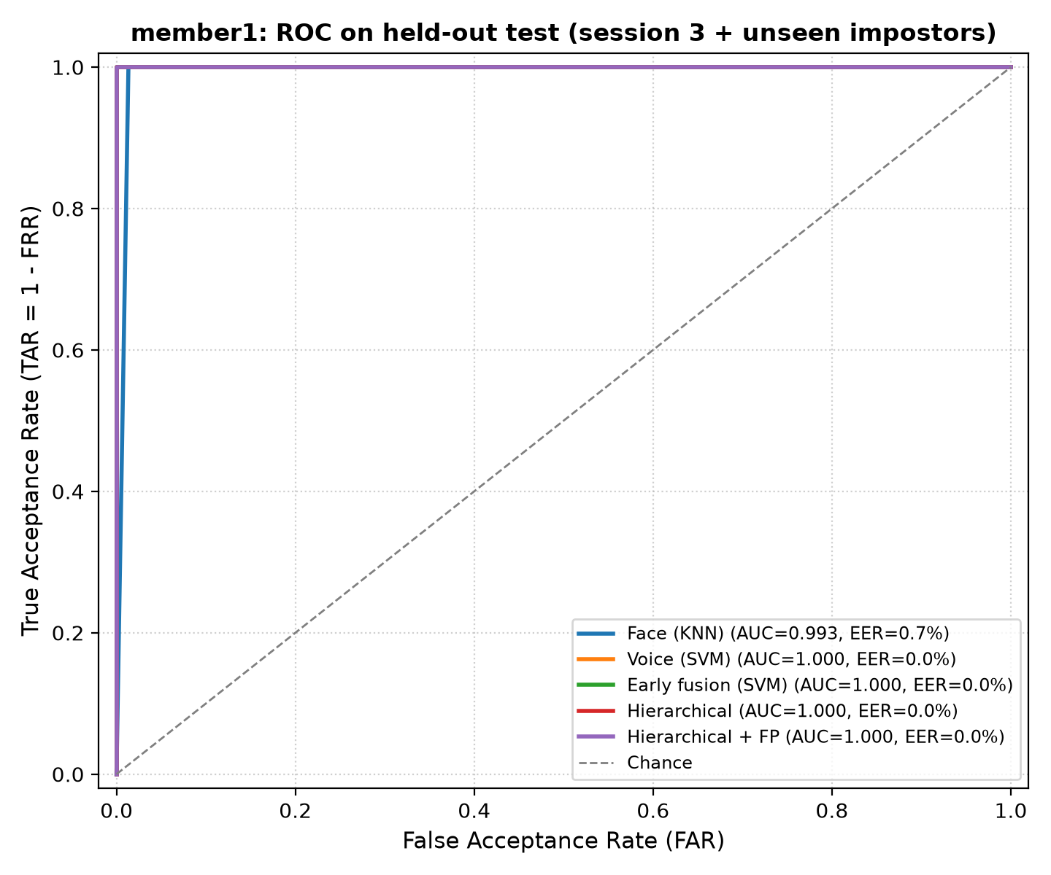
Figure 1: Receiver Operating Characteristic (ROC) curves for Member 1 across Face-only, Voice-only, Early Fusion, and Hierarchical modes. Notice the Early Fusion curve achieving optimal separation near top-left (AUC = 1.0).
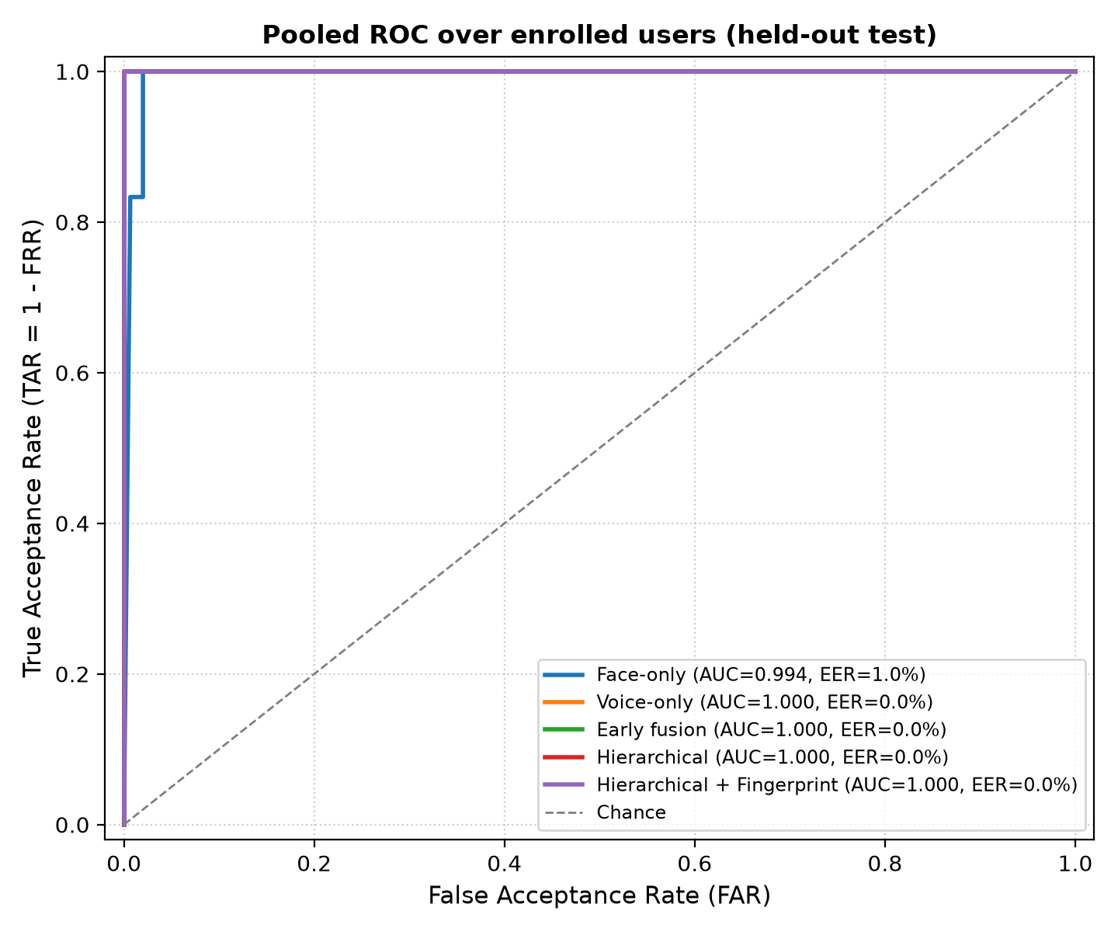
Figure 2: Pooled ROC curves evaluated over all test attempts. Illustrates the collective robustness of the multimodal architecture against open-set attacks.
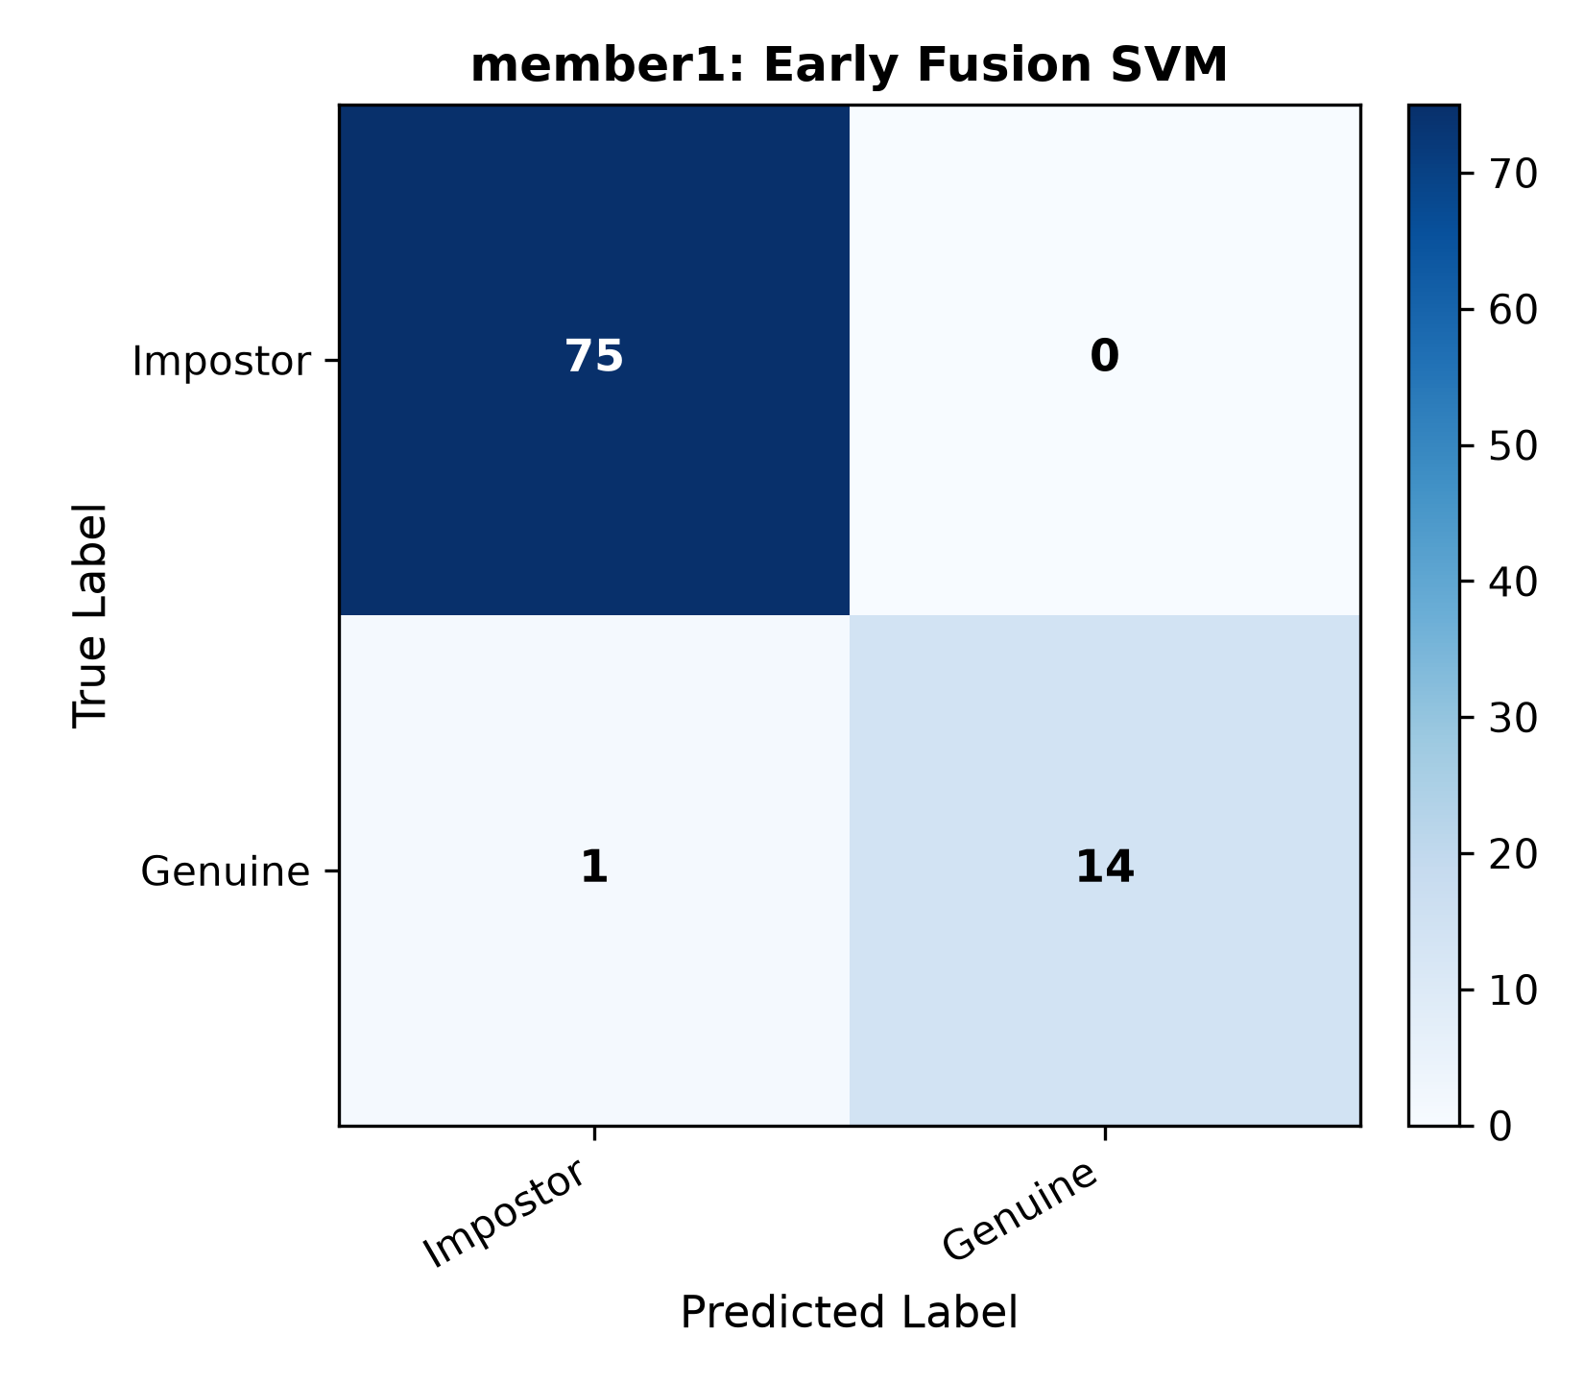
Figure 3: Confusion Matrix for Member 1 Early Fusion (SVM). Shows 75 true negative rejections with zero false acceptances (FAR = 0.0%).
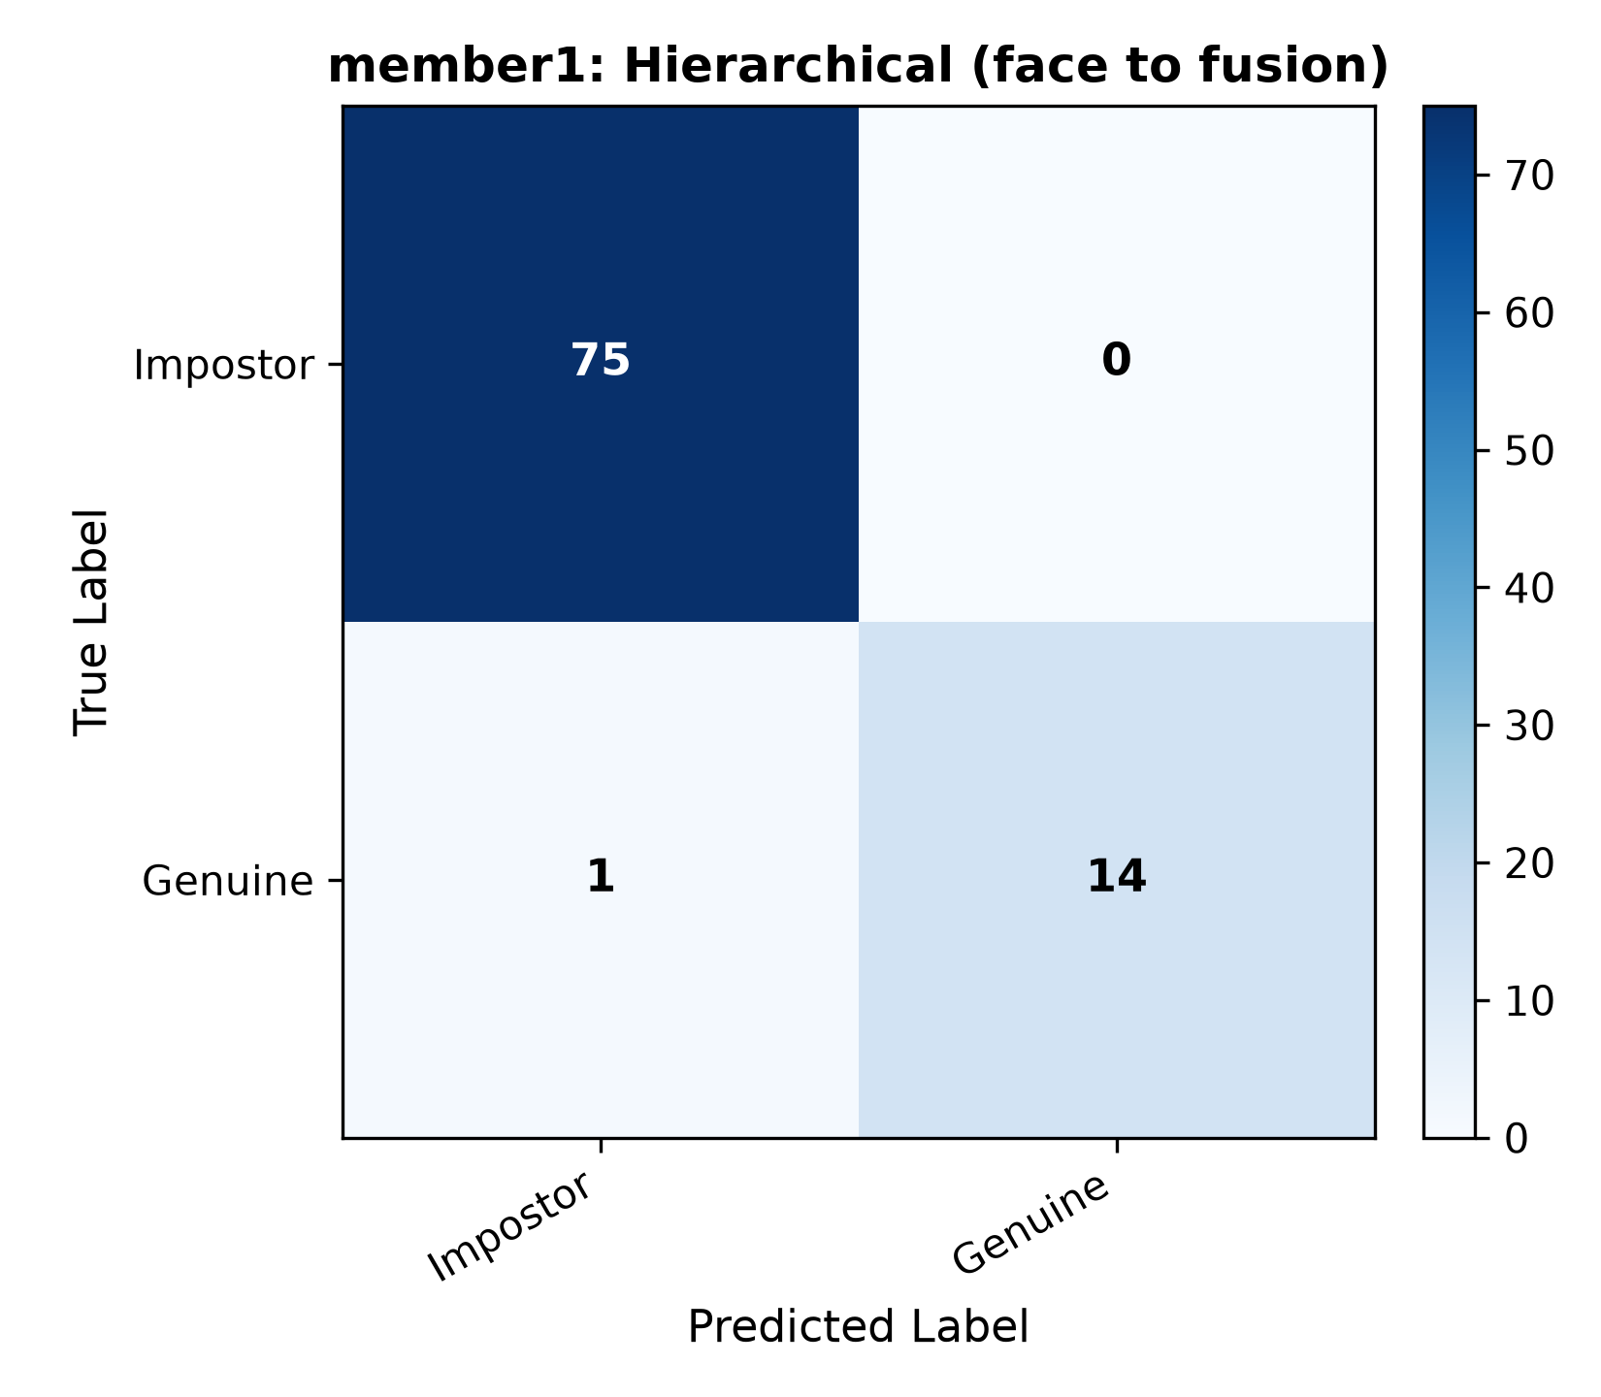
Figure 4: Confusion Matrix for Hierarchical Verification Pipeline (Mode D). Demonstrates strict rejection of intruders across stages.
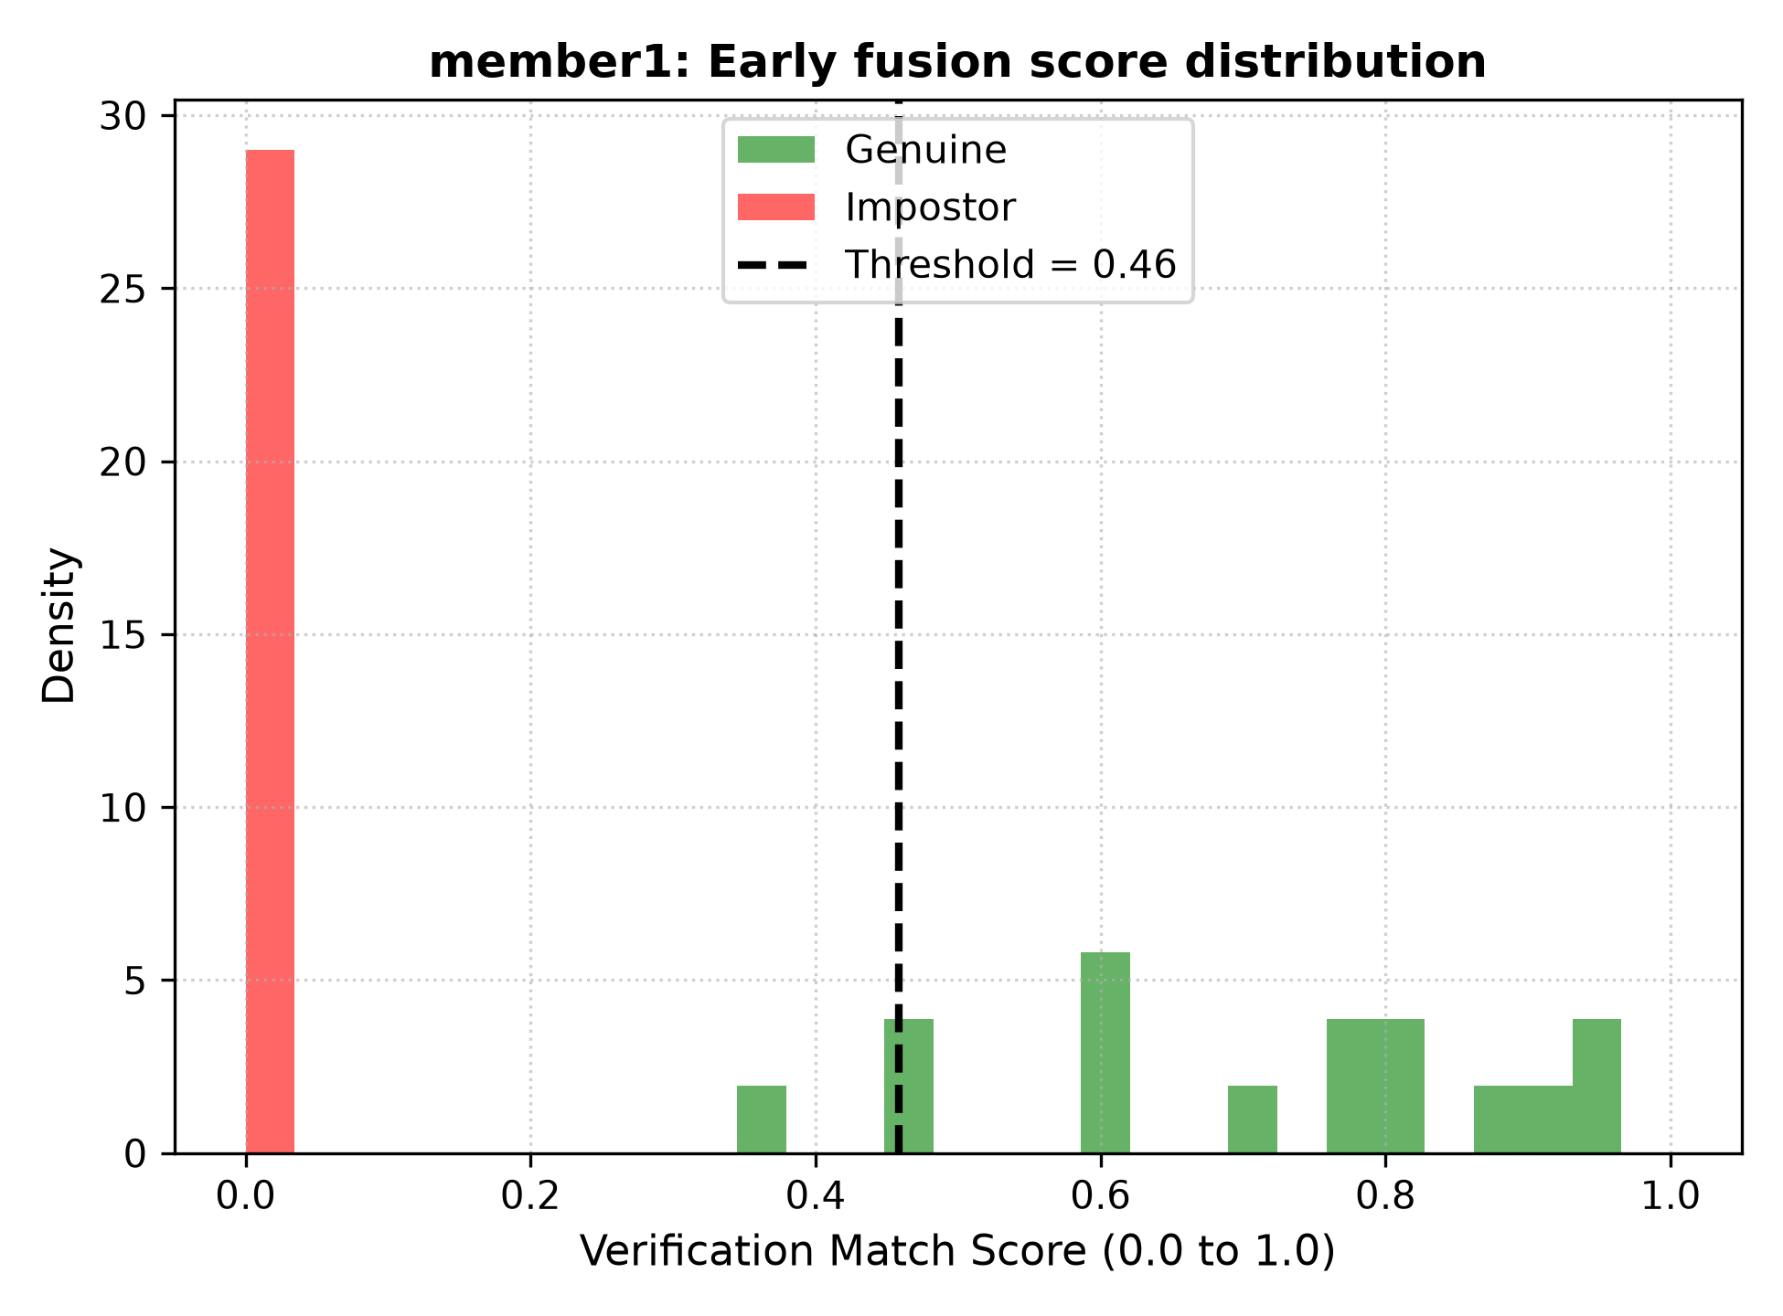
Figure 5: Genuine vs. Impostor Match Score Distributions for Early Fusion. Shows clear, wide margin of separation between genuine and impostor populations.
6. Oral Defense & Interview Preparation Guide (All Team Members)
Every team member must be able to confidently answer technical questions regarding feature extraction, machine learning models, evaluation, and system architecture. Below are the top anticipated interview questions with model answers:
Q1: Why did you use Traditional Machine Learning instead of Deep Learning (e.g., ResNet or Transformers)?
Answer: Three reasons:
1. Course Constraint: Deep Learning is strictly prohibited by the assignment specification.
2. Computational Efficiency: Traditional ML models (SVM, KNN, PCA) can execute inference on CPU in under 10 milliseconds without needing expensive GPU acceleration, making them ideal for embedded security gates.
3. Sample Efficiency & Explainability: With limited custom training samples per team member, Deep Learning models would severely overfit, whereas HOG, LBP, and MFCC capture engineered physical domain features with zero risk of catastrophic overparameterization.
Q2: How does HOG feature extraction work on face images?
Answer: HOG (Histogram of Oriented Gradients) divides the 128x128 cropped face into small spatial cells (8x8 pixels). In each cell, it calculates gradient magnitudes and edge orientations (0-180 degrees into 9 bins). Blocks of 2x2 cells are then L2-Hys normalized to ensure lighting invariance. This captures macroscopic facial structure (eyes, nose contour, jawline).
Q3: How does Local Binary Pattern (LBP) work and why pair it with HOG?
Answer: LBP compares each center pixel with its 8 circular neighbors (P=8, R=1). If neighbor >= center, it gets 1, else 0, forming an 8-bit binary number. We use 'Uniform LBP' which counts patterns with at most 2 transitions (0-1 or 1-0). Divided into an 8x8 grid, LBP captures microscopic skin texture and pore details. Pairing HOG (shape) with LBP (texture) provides a complete, complementary representation of the face.
Q4: What is the physical meaning of MFCC, ZCR, and RMS Energy in voice?
Answer:
• MFCC (13 coeffs): Approximates the human vocal tract frequency response using the non-linear Mel scale, which mimics human cochlear hearing perception.
• Delta-MFCC (13 coeffs): Represents the temporal velocity (trajectory of change) of the vocal tract across consecutive frames.
• ZCR (Zero-Crossing Rate): Measures how often the audio signal changes sign. High ZCR signifies unvoiced fricatives / noise; low ZCR signifies voiced pitch harmonics.
• RMS Energy: Quantifies the signal power and loudness across speech frames, enabling accurate silence removal (VAD).
Q5: What is the difference between Early Fusion and Late Fusion?
Answer: In Early Fusion (Feature-Level), feature vectors from face (HOG+LBP) and voice (MFCC+ZCR+RMS) are scaled, dimensionally reduced, and concatenated into a single combined vector before passing into a single classifier (SVM/RF). In Late Fusion (Score-Level), two independent classifiers are trained separately for face and voice, and their probability scores are averaged or weighted at the output.
Q6: How does the Hierarchical Pipeline operate?
Answer: It is a sequential multi-stage cascade. Level 1 evaluates Face. If score < T_low, the system immediately exits and denies access. If Level 1 passes, Level 2 activates Voice & Early Fusion. If score < T_fusion, access is denied. If Level 2 passes, basic perimeter entry is granted. Level 3 (Fingerprint) verifies core vault clearance. This saves computational time and bandwidth by stopping attackers early.
Q7: How does your web system handle the 2-out-of-3 biometric policy?
Answer: In our live web deployment, we implemented a majority voting security policy (2-of-3 Rule). Access is granted if and only if at least 2 out of 3 modalities (Face, Voice, Fingerprint) achieve confidence above their operating thresholds. This provides fault tolerance: if a user's camera is obstructed, they can still verify using voice and fingerprint.

