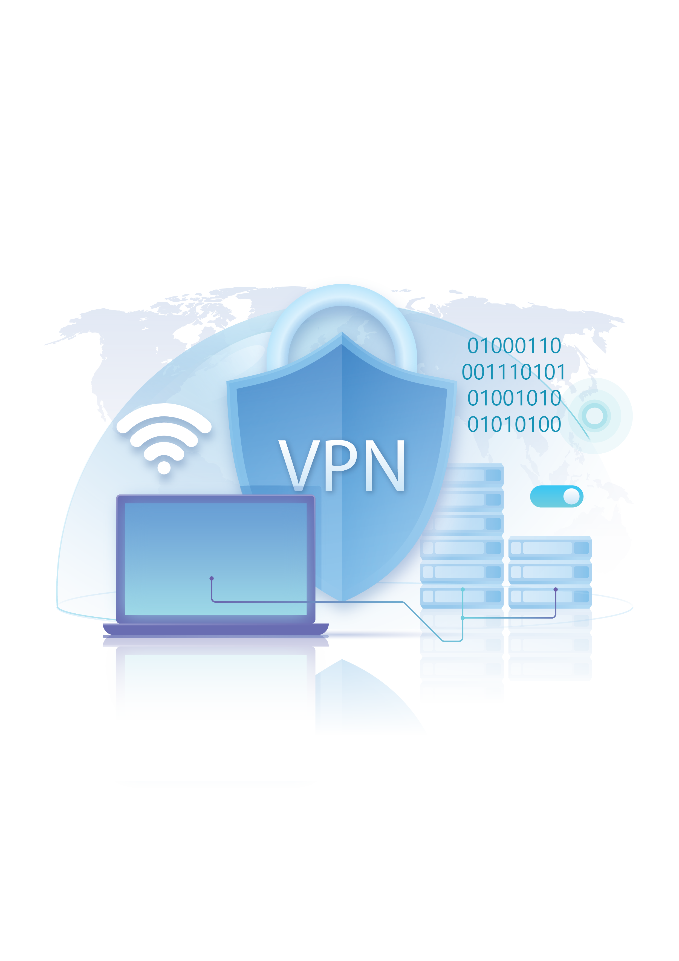


Supervised by:
Eng. Ahmed Mahmoud

Team Members:
- Abdelrhman Ahmed Abdelmonem
- Mohamed Sameh Saeed
- Hana Emad Isaac
- Roaa Mohamed Said
- Abdullah Tamer Ali
- Raghad Ashraf Ibrahim

Digital Egypt Pioneers Initiative (DEPI)

Implementing VPN Solutions Project

Fortinet Cybersecurity Engineer Track

Project 3: Implementing VPN Solutions with FortiGate
- Introduction
This report presents the implementation and analysis of Virtual Private Network (VPN) solutions using FortiGate firewalls. It explores multiple VPN technologies, including SSL VPN and IPsec VPN, as well as their integration into Software-Defined Wide Area Network (SD-WAN) environments to enhance traffic performance and reliability.
The project focuses on studying VPN concepts, designing secure and scalable network architectures, and developing step-by-step configuration procedures. Comprehensive testing and performance evaluation were conducted to verify the effectiveness of each solution. The primary objective of this work is to deliver a secure, efficient, and professionally documented VPN framework suitable for modern enterprise networks, ensuring confidentiality, integrity, and optimized connectivity across distributed environments.

- VPN Concepts and SSL VPN Configuration
- VPN Overview
A Virtual Private Network (VPN) is a secure communication technology that enables users or entire networks to connect over the public internet as if they were part of a single private network. It achieves this by creating an encrypted “tunnel” that protects data as it travels between devices or sites, preventing unauthorized access or interception. VPNs play a vital role in maintaining data confidentiality, integrity, and authentication, ensuring that sensitive information remains secure even when transmitted across untrusted networks.
In modern organizations, VPNs are widely used to allow remote employees to access internal resources safely, to connect multiple branch offices securely, and to enable encrypted communication between data centers or cloud services. By using strong encryption algorithms and authentication methods, VPNs not only enhance network security but also support flexibility and productivity, allowing users to work securely from virtually anywhere.

- Types of VPNs and Their Use Cases
Type | Description | Use Case
Remote Access VPN (Client-to-Site VPN) | Connects individual users (like employees working remotely) securely to a company’s internal network using VPN client software. | Employees accessing company resources securely from home or while traveling.
Site-to-Site VPN | Connects two or more networks (e.g., branch offices) securely over the internet. Usually implemented between routers or firewalls. | Securely connecting branch offices or remote sites to headquarters.
SSL VPN (Secure Sockets Layer VPN) | Uses HTTPS (port 443) to provide secure remote access via a web browser or client. It encrypts traffic using SSL/TLS protocols. | Users who need access without installing special VPN clients (works through browsers).
IPsec VPN (Internet Protocol Security VPN) | Uses the IPsec protocol suite to encrypt and authenticate IP packets between sites or devices. It operates at the network layer. | Permanent, secure tunnels between offices or datacenters.
MPLS VPN (Multiprotocol Label Switching VPN) | Uses service provider networks to create private paths for enterprise traffic, ensuring reliability and QoS. | Large enterprises require scalable and reliable WAN connections.
L2TP/IPsec VPN | Combines Layer 2 Tunneling Protocol with IPsec encryption. Often used for secure remote access. | Legacy systems or networks requiring layer-2 tunneling.
Cloud VPN | Extends on-premises networks securely to cloud services (AWS, Azure, etc.). | Hybrid cloud environments.

c) SSL VPN Overview
An SSL VPN allows secure remote access to a private network using a standard web browser or a lightweight VPN client.
It operates over the SSL/TLS protocol, the same technology used to secure HTTPS websites.
Because it uses port 443, SSL VPN traffic can easily pass through most firewalls and NAT devices without requiring special configuration.
SSL VPNs are ideal for organizations that want to enable secure access for remote employees, partners, or clients to internal applications, files, or systems via the internet.

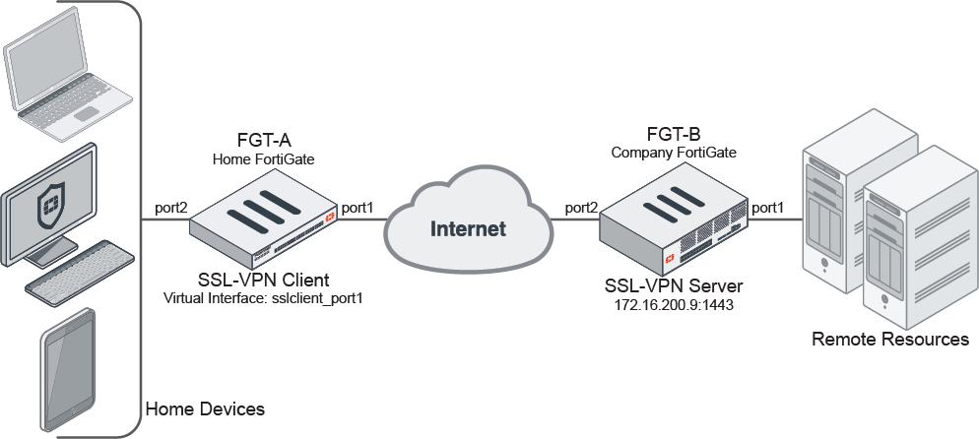

d) Why SSL VPN?
- Uses HTTPS (port 443) — easily passes through firewalls.
- Provides user-based authentication and access control.
- Doesn’t require a special client (works in browsers).
- Offers two operation modes:
  - Web Mode: Access via web portal.
  - Tunnel Mode: Full network access using VPN client (e.g., FortiClient).

e) How SSL VPN Works
- The user connects to the SSL VPN gateway (FortiGate) through a web browser or the FortiClient VPN application.
- A secure tunnel is established using SSL/TLS encryption.
- The FortiGate authenticates the user (via local credentials, LDAP, or RADIUS).
- The user gains access to internal resources based on permissions.

f) SSL VPN Modes
1. Web Mode
- Users log in via a web browser (e.g., https://<public-ip>:443).
- Access specific applications such as email, file servers, or web tools.
- Simple, clientless, and ideal for restricted access.
2. Tunnel Mode
- Requires a VPN client (FortiClient).
- Establishes a full network tunnel between the device and internal LAN.
- Suitable for IT staff or users who need wide access.

g) Advantages of SSL VPN
- Ease of Use: Browser-based and simple to deploy.
- Strong Encryption: SSL/TLS ensures data security.
- Flexible Access: Supports both web and tunnel modes.
- Firewall-Friendly: Uses standard HTTPS ports.
- Integrated Authentication: Supports LDAP, RADIUS, and 2FA.

h) Common Use Cases
- Secure access for remote employees.
- Temporary access for partners or vendors.
- Remote troubleshooting and system administration.

i) SSL VPN Configuration on FortiGate
Objective: Configure an SSL VPN to allow remote users to access internal network resources securely.
Steps:
---------------------------------------

- IPsec VPN Configuration
a) Overview
The IPsec (Internet Protocol Security) VPN is a widely used protocol suite that secures network traffic by encrypting and authenticating IP packets at the network layer (Layer 3). It provides site-to-site and remote access solutions that ensure data confidentiality, integrity, and authenticity between two or more networks.
IPsec VPNs are particularly suitable for organizations that need permanent, secure connections between branches, headquarters, or data centers.
Unlike SSL VPNs, which are typically used for individual remote access, IPsec VPNs operate transparently for entire subnets and devices.
b) How IPsec VPN Works
An IPsec VPN establishes a secure tunnel between two FortiGate devices through a two-phase process:
Phase 1 (IKE Negotiation):
  - Establishes a secure communication channel.
  - Authenticates the two VPN peers.
  - Negotiates encryption and hashing algorithms (e.g., AES, SHA).
Phase 2 (Data Encryption):
  - Defines traffic selectors (networks that will communicate).
  - Encrypts user data packets through the established tunnel.

c) Key Components
- IKE (Internet Key Exchange): Used for secure key exchange.
- ESP (Encapsulating Security Payload): Provides encryption and authentication.
- AH (Authentication Header): Ensures integrity and authenticity (used optionally).
- Transform Sets: Define algorithms for encryption and hashing.

d) IPsec Configuration Steps on FortiGate
- Objective:
Establish a secure IPsec tunnel between two FortiGate firewalls (e.g., between Head Office and Branch).
- Configuration Steps:
--------------

e) Testing and Verification
- Ping Test:
- Logs and Events:
- Tunnel Status:
f) Advantages of IPsec VPN
- Strong encryption and authentication.
- Ideal for permanent site-to-site connections.
- Transparent to users and applications.
- Supports redundancy with multiple WAN links.

4. FortiGate VPN with SD-WAN Integration

a) Overview
- SD-WAN (Software-Defined Wide Area Network) is an advanced networking technology that enhances WAN performance by intelligently directing traffic across multiple WAN connections (such as MPLS, broadband, or LTE).
Integrating SD-WAN with VPN allows FortiGate devices to dynamically select the best path for VPN traffic based on real-time performance metrics.

b) Benefits of SD-WAN Integration
- Improved VPN performance and stability.
- Intelligent traffic steering based on latency, jitter, and packet loss.
- Cost-efficient use of multiple WAN connections.
- Centralized management and visibility.

c) SD-WAN Configuration on FortiGate
- Objective:
Integrate SD-WAN with VPN tunnels to ensure optimized routing for secure connections.
- Steps:
---------------------------

d) Testing and Performance Evaluation
- Monitored latency, jitter, and bandwidth during VPN data transfer.
- Observed automatic failover between WAN links during disruptions.
- Verified consistent VPN uptime with minimal packet loss.

6. Conclusion
- This project successfully demonstrated the implementation of VPN solutions using FortiGate firewalls.
By configuring SSL VPN, IPsec VPN, and SD-WAN, the project achieved:
- Secure remote and site-to-site connectivity
- Improved network performance and reliability
- Effective utilization of multiple WAN connections
- Through rigorous testing and documentation, it was confirmed that FortiGate’s VPN and SD-WAN features provide an enterprise-grade, secure, and flexible solution for modern networking environments.

7. References
- Fortinet Documentation – FortiGate VPN Configuration Guide
- National Telecommunication Institute (NTI) – Network Security Course Notes
- RFC 4301 – Security Architecture for the Internet Protocol
- Fortinet – SD-WAN Deployment Best Practices (2024)

