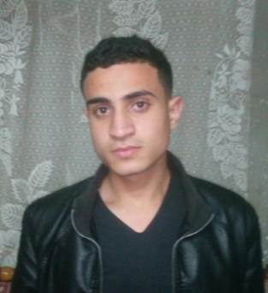

Abdelrhman Bayuomi

Javascript ,JQuery

**Ntl course**

13/2018

Facebook.com/ abdometo79@yohoo.com

Fresh front-end web develober nanodegree , 2018 benha faculty of computers and information graduation

Start web more than 2years

**E-MAIL**

Abdomet66@gmail.com

**PHONE**

01210499831

ADDRESS

Cairo , Qaha,

Full Stack Web Developer Nanodegree

* APIs
* Support multiple screen (Two pane)
* Google Maps

SKILLS

python

web

css ,html

C++

PHP ,OPP ,Laravel

Work with

**Front-end developer course by udacity**

**ITI course**

8/2017

9/2017

Certificates

Internship at ACU and Teqniea

**Front-end developer**

2017

EXPERIENCES

1/2018 graduation

**InnovEgypt**

2017

Fresh Graduation

8 / 2017 graduation

**web application**

9/2017-2/2018

2018

**Benha faculty of computers and information**

EDUCATION