


faculty of Computers and Artificial Intelligence
Beni-Suef University, Egypt

"Tutora Your Tour Guide For
Grand Egyptian Museum"

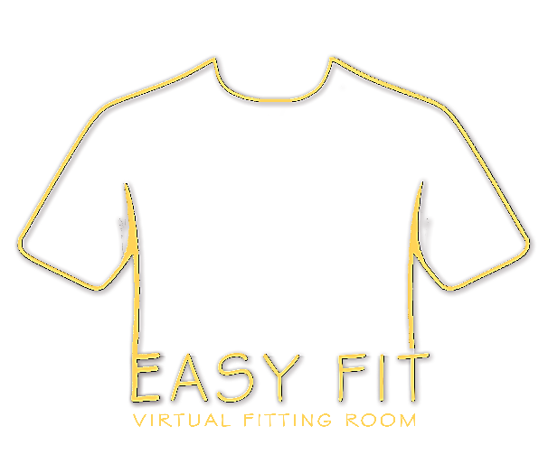
Presented by:
Abdelrhman Hassan
Ahmed Adel
Soad Atef
Sama Mahmoud
Sara Mahmoud
Aya Nasser
Rana Hamdy

Supervisor:
Prof.Dr: Hamdi Mahmoud
Assistant
Teaching Assistant: Eng. Mahmoud Khaled

Acknowledgment

First and foremost, we would like to express my deep and sincere appreciation to our supervisor, Prof.Dr (Hamdi Mahmoud) for giving us the great opportunity and strength to complete our Final Year Project under his guidance. His valuable suggestions, constructive advice, encouragements, and patience have helped us tremendously all the times during the planning and development of this project. He also provides a lot of feedback which increases the overall quality of this project. We truly appreciate his willingness to contribute his precious time to guide us with his professional knowledge and experience.
A very special thanks to Teaching Assistant (Eng. Mahmoud Khaled) for his kindness and generosity, we would not forget to remember him for his encouragement and more over for his timely support and guidance till the completion of our project work. He also provides a lot of feedback which increases the overall quality of this project. Besides, he also guided us by telling us how to build a good system. We would not have reached this phase, if it were not for his permanent support, advice, and guidance.
Furthermore, we are particularly grateful for the support and encouragement given by our family and friends throughout our entire Final Year Project. A million thanks to our parents who support us financially and emotionally. To our friends and classmates, thank you for providing advice and supporting us throughout this entire project.

Purpose of documentation
The purpose of the document is to collect and analyze all assorted ideas that have come up to define the system, its requirements with respect to consumers. Also, we shall predict and sort out how we hope this product will be used to gain a better understanding of the project, outline concepts that may be developed later, and document ideas that are being considered, but may be discarded as the product develops.

Briefly, the purpose of this document is to provide a detailed overview of our software and hardware products, its parameters, and goals. This document describes the project's target audience and its user interface, hardware, and software requirements. It defines how our client, team and audience see the product and its functionality. Nonetheless, it helps any designer and developer to assist in software delivery lifecycle (SDLC) processes.

Abstract

This work is organized as follows:
Chapter 1: addresses the overview of project, problems we have faced , objectives, and the impact of business.
Chapter 2: addresses the related work of our project and analyzes them carefully into features, benefits, Feasibility study, architecture, and components.
Chapter 3: addresses the project methodology, explains why this methodology was chosen, and concludes with a website block diagram that clarifies the system in a clear and centralized manner.
Chapter 4: addresses the project analyses and all its related diagrams as mind map, ERD, DFD, etc..
Chapter 5: addresses all the hardware details and diagrams in detail.
Chapter 6: describe the user interface of all parts of our system and testing phase of the system and user samples.
…………………………………………………………………………

List of Contents

- Chapter 1 (Introduction)
  - Introduction ……………………………………...……..………………..1
  - Problem Statement ………………………………………………………2
  - Objectives ………………………………………………………………..3
  - Software Development Lifecycle ………...……………………...............4
  - Impact in Business .……………………………...………………............6
  - Project Risk Management ………………………………………………7

- Chapter 2 (related works)
  - Introduction …………………………………………….……………..9
  - Related works ……………………....………….…..…...………….…9
  - Method of working the model ………………….…..…......…………13
  - Features ………………………………………………….……………14
  - Feasibility Study ……………………………...……………..………..15
  - Benefits ………………………………………...……………..………27
  - Project Risk Management………………………...………………...…28
  - Risk Management Process …………………………...………………28
  - Plan Risk Management ……………………………………………….29

- Chapter 3 (Project Methodology)
  - General definition and comparison …………………………………...30
  - Agile Model ………………....………………...……………………...32
  - Advantages of Agile Model ……………………………….………….32
  - Limitations of Agile Model …………………………………………..33
  - The properties of Agile Model….…………………………………….33
  - Rapid Application Development Model (RAD) ……………………...33
  - Advantages of RAD Model…………………………………………...34
  - Advantages of RAD Model…………………………………………...34
  - Chosen Methodology ………………………..…………...…………...35
  - Implementation (Final System) …….……………....………………...37

- Chapter 4 (Software Analysis and Design)
  - Project Requirement …………………...…………………………... 38
  - Project Mind Map ……………………..……………....….................42
  - Entity Relation Diagram …………..……………...……..………..…43
  - Project Software Tools and Technologies…………..…....………….49

- Chapter 5 (Device Analysis and Manufacturing)
  - Introduction …………………………………………………………57
  - Device hardware analysis …………………………………………..57
  - Microsoft Kinect SDK …………………………………………….. 58
  - LCD Advertising Screen………………………………………….....62
  - Basic Info……………………...………………………………….....63
  - Product Display…………………………….…………………….….64
  - Product Details …………………………….………………….……65
  - Product Functions ………………...……………………….………...66
  - Customize Service………………...…………………………………66
  - Product Functions ………………...…………………………………67

- Chapter 6 ( Interface Design & Testing )
  - Introduction …..…………...……………………....………………...68
  - System Database (Firebase)………………...……….........................68
  - Main Mobile Application (Flutter) …...……………....……………..70
  - Client Mobile Application (Flutter) …………………...…………….71
  - Testing user interface ……………………………..…………………76
  - Future Work …………………………………………….…..............88
  - Conclusion ……………………………..............................................89
  - Reference……………………………..………………..…………….90
…………………………………………………………………………

list of Tables

Table number Title page
Table 2.1 The research reports content summary 20
Table 2.2 Word frequency query results 21
Table 2.3 Cross tabulation of adv & dis adv of VFR types 25
Table 2.4 Cross tabulation of Sentiment toward 26
Table 4.1 Requirements of SDLC 39
Table 4.2 Versions Of Google Colaboratory 55
Table 4.3 Advantages & disadvantages of Google Colaboratory 56
Table 5.1 Basic Infor for LCD Advertising Screen 63
…………………………………………………………………………
list of Figures

Figure number Title page
Figure 1.1 Software Development Life Cycle 4
Figure 2.1 ACGPN Model Architecture 13
Figure 2.2 Pose Estimation Model 14
Figure 2.3 Cloning Image example 15
Figure 2.4 2D Virtual fitting Room 18
Figure 2.5 3D Virtual fitting Room 19
Figure 3.1 The Waterfall Model Phases 30
Figure 3.2 Agile Model process 32
Figure 3.3 Rapid Application Development Process 34
Figure 4.1 The Mind Map 42
Figure 4.2 The Context Diagram 43
Figure 4.3 Level 0 Diagram 44
Figure 4.4 The Use Case Diagram 45
Figure 4.5 The Sequence Diagram 46
Figure 4.6 The Activity Diagram 47
Figure 4.7 The Class Diagram 48
Figure 4.8 The State Diagram 49
Figure 4.9 Flutter Application Diagram 49
Figure 4.10 Bloc Management Diagram 50
Figure 4.11 Firebase Authentication Diagram 52
Figure 4.12 Cloud Firestore Diagram 53
Figure 4.13 Google Colaboratory Diagram 55
Figure 4.14 Microsoft Visio Diagram 56
Figure 5.1 Microsoft Kinect Camera 58
Figure 5.2 Hardware and Stream Provided 59
Figure 5.3 Kinect for Windows Developer Toolkit 60
Figure 5.4 Application Flow Chart 61
Figure 5.5 LCD Advertising Screen 62
Figure 5.6 Product Display 63
Figure 5.7 Product Details 64
Figure 5.8 Product Functions 65
Figure 5.9 Versions of Network 66
Figure 5.10 Types of Service 66
Figure 5.11 Size of Screens 67
…………………………………………………………………………

Chapter 1

Introduction

The Grand Egyptian Museum (GEM) is one of the most important cultural and historical landmarks worldwide. With the rapid development of technology, integrating digital solutions into such environments has become essential to enhance user experience, engagement, and accessibility.
This project presents a web-based platform designed to serve as a smart tour guide for museum visitors. The system allows users to:
- Explore artifacts and learn about ancient Egyptian history
- Book tickets online efficiently
- Purchase museum-related items from an online shop
- Interact with an AI-powered guide
- Experience 3D interactive models of artifacts
- Use a chatbot for instant assistance
Additionally, the platform includes innovative modules such as:
- Artifact detection: allows users to identify statues and objects using image recognition
- Interactive laboratory: provides activities like Write Your Name in Hieroglyphics, Turn Your Picture into a Pharaoh, and Create from Your Imagination, enhancing cultural engagement in an entertaining way
Enhancements Added:
- Opening sentence begins with an engaging statement about GEM's visitor volume and cultural significance
- Clear definition of target audience: students, families, tourists interested in Egyptian culture

1.2 Problem statement
Despite the importance of GEM, visitors face several challenges that affect their overall experience:
- Difficulty navigating the museum efficiently
- Limited access to detailed and interactive information about artifacts
- Lack of personalized guidance for understanding historical context
- No unified system combining booking, exploration, and learning
Enhancements Added:
- Data-driven example: "Surveys indicate that over 40% of museum visitors face difficulties in accessing detailed artifact information."
- Establishes a strong justification for a smart, interactive solution

1.3 Objectives
The main objective is to develop a smart, web-based system that improves the visitor experience at GEM. The system aims to:
- Provide an easy and efficient way to book tickets and plan visits
- Offer detailed and accessible information about artifacts and history
- Implement an AI-powered guide to assist users
- Integrate 3D interactive models for a more immersive experience
- Enable artifact detection and identification
- Provide chatbot support for user inquiries
- Include an online shop for purchasing museum-related products
- Enhance user engagement through interactive features such as the laboratory module
Enhancements Added (SMART Objectives):
- Reduce average online ticket booking time by 30% within 6 months
- Increase number of 3D artifacts displayed by 50% in initial deployment
- Improve user satisfaction by 25% through AI-guided interaction
- Enable accurate artifact identification with at least 90% success rate

1.4 Software Development Lifecycle

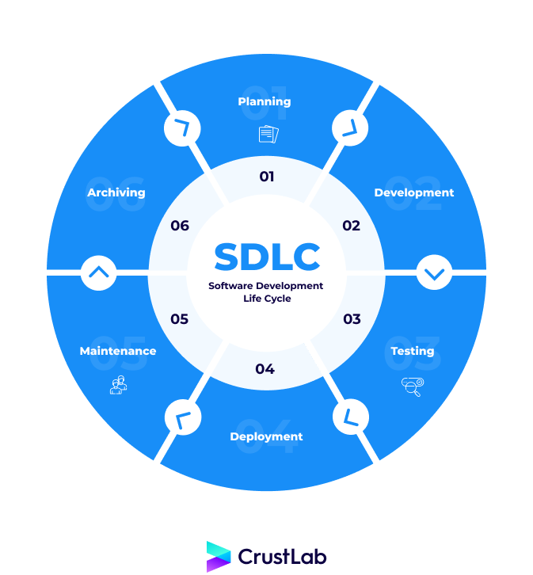
Software Development Life Cycle (SDLC) is a process used by the software industry to design, develop, and test HIGH-QUALITY software. The SDLC aims to produce a high-quality software that meets or exceeds customer expectations, reaches completion within times and cost estimates[8,9.10].
- SDLC is the abbreviation of Software Development Life Cycle.
- It is also called the Software Development Process.
- SDLC is a framework defining tasks performed at each step in the software development process.
- ISO/IEC 12207 is an international standard for software life-cycle processes. It aims to be the standard that defines all the tasks required for developing and maintaining software.
Figure 1.1: Software Development Life Cycle

Stage 1: Planning and Requirement Analysis
In this stage, the project objectives are defined, and the requirements of the system are gathered. Meetings with stakeholders are conducted to understand user needs and expectations. A feasibility study is also performed to evaluate technical, operational, and financial aspects of the project.

Stage 2: Defining Requirements
The system requirements are documented in detail, including functional requirements (what the system should do) and non-functional requirements (performance, security, usability). Clear and precise requirements ensure that the development process meets the expectations of the users and stakeholders.

Stage 3: Designing the Product Architecture
During this stage, the overall system architecture is designed. This includes designing the database, user interface, application modules, and the interaction between different components. The goal is to create a blueprint that guides the development team in building a structured and efficient system.

Stage 4: Building or Developing the Product
In this phase, the actual development of the system takes place. The front-end, back-end, AI modules, 3D interactive components, and other features are implemented according to the design specifications. Regular code reviews and version control ensure quality and maintainability.
Stage 5: Testing the Product
The system undergoes thorough testing to identify and fix any bugs or issues. This includes functional testing, usability testing, performance testing, and security testing. Feedback from testing helps improve system reliability and ensures that all requirements are met.

Stage 6: Deployment in the Market and Maintenance
Once the system is tested and approved, it is deployed for use by the end users. Continuous maintenance is performed to fix any emerging issues, update features, and improve performance. User feedback is monitored to guide future enhancements.

1.5 Impact in Business
The project has significant implications both for users and for GEM's business operations:
User Perspective:
- Provides an interactive and informative experience
- Improves accessibility to cultural content
- Increases engagement through AI and 3D modules
Business Perspective:
- Increase online ticket sales
- Boost revenue via online shop
- Improve customer satisfaction and retention
- Promote Egyptian cultural heritage globally
- Support digital transformation in the tourism sector
Enhancements Added:
- Suggested KPIs for measurement:
  - Number of online bookings per month
  - Active users on the platform
  - Average engagement time with 3D content
  - Customer satisfaction survey results

1.6 Project Risk Management

Risk management is an essential part of any software project. It involves identifying potential risks, analyzing their impact, and developing strategies to minimize or eliminate them.
Some potential risks in this project include:
- Technical challenges in integrating AI and 3D features
- Security issues related to user data and online payments
- Performance issues under high user traffic
- Possible delays in development
To mitigate these risks, proper planning, continuous testing, and the use of reliable technologies are implemented throughout the development process.
…………………………………………………………………………

Chapter 2
2.1 Introduction
This chapter reviews existing systems, studies, and technologies relevant to the Grand Egyptian Museum web platform. It provides a comprehensive understanding of previous work in museum digitalization, AI-based tour guides, 3D interactive systems, and online booking platforms. The aim is to identify best practices, gaps, and opportunities to improve the design and functionality of our system.

2.2 Related Work:
Several studies and projects have been conducted in the area of museum digital experiences:
- Virtual Museum Tours: Many museums have implemented virtual tours to allow users to explore artifacts online. These systems often provide 360-degree views, images, and basic information about exhibits.
- AI Guides and Chatbots: AI-powered guides can answer visitor questions, provide personalized recommendations, and enhance learning experiences.
- 3D Interactive Models: Interactive 3D models of artifacts and historical figures allow users to explore items in detail and understand cultural context.
- Online Ticketing and E-Commerce: Integrating ticket booking and online shopping improves accessibility and provides convenience to visitors.
By analyzing these works, we can adopt the most effective features while addressing the limitations, such as lack of personalization, limited engagement, or insufficient historical information.

2.3 Method of working of the model
The system employs a modular approach to integrate all functionalities seamlessly. The main steps include:
- User Interaction Module: Handles registration, login, ticket booking, and profile management.
- Artifact Exploration Module: Displays artifacts, provides detailed descriptions, and enables 3D interactions.
- AI Guide Module: Uses artificial intelligence to answer user queries and provide personalized suggestions.
- Laboratory Module: Allows users to write names in hieroglyphics, transform pictures into Pharaoh characters, and create custom designs inspired by ancient Egyptian art.
- Payment and Shop Module: Manages online transactions and purchases from the museum shop.
Each module communicates through a centralized web system ensuring smooth and efficient operation.
2.4 Features
The proposed system provides a set of advanced and interactive features designed to enhance the user experience and engagement with the Grand Egyptian Museum platform. These features include:
- AI Tour Guide and Chatbot
An intelligent chatbot powered by Large Language Models (LLMs) that interacts with users, answers questions, and provides personalized guidance throughout the system.
- Artifact Detection Model
A computer vision-based model that allows users to upload or capture an image of a statue or artifact, then automatically identifies it and displays its name and related information.
- Dynamic Story Generation (LLM)
A text generation model that produces a unique historical narrative about the selected artifact each time, ensuring a dynamic and engaging user experience.
- Text-to-Speech (TTS) Model
Converts the generated textual content into audio, allowing users to listen to artifact stories in an interactive way.
- Static Video Presentation
Displays a pre-designed video with historical background visuals synchronized with the generated audio to enhance storytelling.
- Hieroglyphic Name Generator
A feature that transforms the user’s name into its equivalent representation in ancient Egyptian hieroglyphics.
- Image Generation from Story
A generative AI model that converts a user-provided story or description into a visual image inspired by ancient Egyptian art.
- Pharaoh Style Image Transformation
A model that transforms a user’s uploaded image into a pharaoh-style portrait, reflecting ancient Egyptian appearance.
- Artifact Similarity Model
A recommendation model that, given a specific artifact, retrieves the top five most similar artifacts based on dynasty, historical period, and visual features.
2.5 Feasibility Study
1.Introduction
This feasibility study evaluates the practicality, effectiveness, and benefits of implementing the Grand Egyptian Museum web platform.
2. Idea and types of Implementation
The project uses a web-based solution with AI, 3D modeling, and interactive modules. The system can be accessed on desktops, laptops, and mobile devices.
3 Findings of the study
3.1 Content analysis
The study shows that visitors prefer interactive and engaging digital content over static text-based information. 3D models and AI interaction significantly increase user engagement.
3.2 Sentiment analysis
User feedback from similar digital museum platforms indicates positive sentiment towards interactive and personalized experiences, while emphasizing the importance of usability and accessibility.

4.Conclusion
The feasibility study confirms that a web-based AI and 3D interactive platform is viable, practical, and beneficial for both visitors and museum management.
2.6 Benefits
- Enhances visitor engagement and learning
- Improves accessibility to museum content
- Increases ticket sales and online shopping revenue
- Promotes Egyptian cultural heritage globally
- Provides a modern and user-friendly interface
2.7 Project Risk Management
The project faces potential risks such as:
- Technical challenges in AI and 3D integration
- Security and privacy issues related to user data
- Performance issues under high traffic
- Possible delays in development
2.8 Risk Management Process
To mitigate risks, the following steps are taken:
- Continuous monitoring of development progress
- Regular testing of system modules
- Secure handling of user data and payments
- Backup and recovery procedures for system failures
2.9 Plan Risk management:
- Identify potential risks at early stages
- Assess impact and probability of each risk
- Develop preventive measures and contingency plans
- Monitor and update risk management strategies throughout the project lifecycle
…………………………………………………………………………

chapter 3

3.1 General definition and comparison
- Software development methodologies are structured frameworks that define the process, practices, and guidelines used to plan, develop, test, and deliver software systems. Choosing the right methodology is critical to the success of any software project, as it directly impacts team collaboration, project timelines, quality, and adaptability to change.
Three of the most widely used software development methodologies are the Waterfall Model, the Agile Model, and the Rapid Application Development (RAD) Model. Each has its own strengths, limitations, and ideal use cases. The table below provides a general comparison between these three methodologies:

3.2 Agile Model:
The Agile Model is an iterative and incremental approach to software development that emphasizes flexibility, collaboration, and continuous delivery of functional software. Agile divides the project into small cycles called sprints, typically lasting two to four weeks. At the end of each sprint, a working version of the software is delivered and reviewed. Agile promotes close collaboration between the development team and stakeholders, allowing for rapid response to changing requirements. It values working software over comprehensive documentation, and customer collaboration over contract negotiation.

3.3 Advantages of the Agile Model:
- Requires active and continuous involvement from the client or stakeholders throughout the entire project. Difficult to predict the total project timeline and final cost at the beginning. Less emphasis on documentation, which can create challenges for future maintenance. May lead to scope creep if new requirements are added continuously without proper control. Requires experienced and self-organized team members to be fully effective.

3.4 Limitations of Agile Model
- Requires active and continuous involvement from the client or stakeholders throughout the entire project. Difficult to predict the total project timeline and final cost at the beginning. Less emphasis on documentation, which can create challenges for future maintenance. May lead to scope creep if new requirements are added continuously without proper control. Requires experienced and self-organized team members to be fully effective.
3.5 The properties of Agile Model:
- Iterative development: the project is divided into short, time-boxed sprints. Incremental delivery: each sprint delivers a functional increment of the software. Collaboration: continuous communication between team members and stakeholders throughout. Adaptability: requirements can be adjusted based on feedback at any stage. Customer focus: the end user is involved throughout the entire development lifecycle. Continuous improvement: the team regularly reflects on performance and improves processes between sprints.

3.6 RAD model:
Rapid Application Development (RAD) is a software development methodology that prioritizes rapid prototyping and quick feedback over long planning and testing cycles. RAD focuses on building functional prototypes early and refining them based on user input, enabling faster delivery of the final product. RAD consists of four main phases: Requirements Planning, User Design, Construction, and Cutover. It is particularly effective when project requirements are not fully defined at the start and when fast delivery is critical.
Figure 3.3 : Rapid Application Development Process
3.7 Advantages of RAD Model:
- Significantly reduces overall development time through rapid prototyping. Encourages active user participation, leading to higher satisfaction. Allows early detection of issues through continuous feedback and prototype testing. More flexible to changes compared to the Waterfall model. Increases reusability of components across different modules of the system.
3.8 Disadvantages of RAD Model:
- Not suitable for large-scale projects with complex system integrations. Requires highly skilled developers and active client involvement throughout. May compromise system scalability and performance due to focus on speed. Difficult to apply when requirements are clearly defined from the start. Risk of producing poorly structured code due to the rapid development cycles.

3.9 Chosen Methodology
After carefully evaluating the available software development methodologies, the Agile Model was selected as the most suitable approach for developing the Tutora platform for the Grand Egyptian Museum. The Tutora platform includes a wide range of advanced features such as AI-powered tour guides, artifact detection models, 3D interactive models, a dynamic story generation system, and an online ticketing and shop module. Given the complexity and diversity of these features, Agile's iterative approach allowed the development team to build, test, and refine each component independently across multiple sprints. Furthermore, Agile's flexibility enabled the team to incorporate feedback at each stage and adjust priorities based on testing results, which was particularly important when working with cutting-edge AI and 3D technologies.
Stage 1- Planning
In the planning stage, the team defined the overall vision and scope of the Tutora platform. The main objectives were established, including providing visitors with an interactive digital experience of the Grand Egyptian Museum through AI guidance, 3D artifact exploration, online booking, and an e-commerce shop. The team identified the target users — tourists, students, and museum enthusiasts — and outlined the key system modules. Initial sprints were planned, tasks were distributed among team members, and the tools and technologies required for development were selected. A risk assessment was also conducted to identify potential technical and operational challenges.

Stage 2- Design
During the design stage, the system architecture and user interface were designed to ensure a seamless and engaging user experience. The platform's modular structure was established, separating the frontend web application from the backend AI and data services. The database schema was designed to support artifact information, user profiles, ticketing, and e-commerce transactions. Wireframes and UI mockups were created to guide the frontend development. The AI modules — including the artifact detection model, story generation system, and chatbot — were architecturally planned to integrate smoothly with the main platform through well-defined APIs.

3.10 Implementation (Final System)
The final implementation of the Tutora platform was achieved through a series of Agile sprints, each focusing on a specific set of features and modules. The platform was built as a web-based application accessible on desktop and mobile devices. The core modules implemented include: the User Module for registration and profile management; the Artifact Exploration Module for browsing artifacts and interacting with 3D models; the AI Tour Guide and Chatbot Module providing real-time guidance powered by a large language model; the Artifact Detection Module using computer vision for identifying artifacts from uploaded photos; the Interactive Laboratory Module featuring Hieroglyphic Name Generator, Pharaoh Style Transformation, and Image Generation from Story; and the Ticketing and E-Commerce Module for online booking and the museum shop. Throughout development, the Agile methodology enabled the team to maintain high flexibility and continuously improve each module based on testing outcomes, resulting in a unified and user-friendly platform.

chapter 4
Software Analysis and Design

4.1 Project Requirements
Requirements define the functions, constraints, and goals of the system from the client's perspective. They are established through close consultation with customers and users to ensure that both the development team and stakeholders share a unified understanding of what the system must accomplish. Requirements form the foundation for system design, implementation, and acceptance testing.

Requirement Goals:
- Understand the requirements in appropriate detail.
- Define requirements in a manner that is clear and comprehensible to the client — whether in the form of written specifications, prototype systems, or other communication methods.
- Define requirements in a manner that is clear to the people who will design, implement, and maintain the system.
- Ensure that both the client and the development team understand all requirements and their implications throughout the project lifecycle.

Functional Requirements:
Functional requirements describe the specific functions that the system must perform. They are identified by analyzing how the system will be used and encompass the following aspects:
- Functionality — what the system does.
- Data — what data the system stores, processes, and retrieves.
- User Interfaces — how users interact with the system.

Non-Functional Requirements:
Non-functional requirements define criteria that judge the operation of the system, rather than specific behaviors. They include:
- Product Requirements — performance, reliability, portability, usability.
- Organizational Requirements — delivery schedules, training procedures, development standards.
- External Requirements — legal compliance, interoperability, marketing and public relations considerations.

Table 4.1 below presents the complete requirements of the Tutora platform, covering both functional and non-functional aspects:
Table 4.1: Requirements of Tutora Platform (GEM)

ID | Requirements |  | Date |  |  | Related Requirements | Related Stakeholders |  |  | Type
1 | User Registration & Login |  | 01/10/2024 |  |  | 1. Create registration form 2. Email/password authentication 3. Firebase Auth integration 4. Validate credentials | Developers, Users |  |  | Functional
2 | System Interface Design |  | 10/10/2024 |  |  | 1. OS: Windows, Mac, Linux 2. Frontend: HTML, CSS, JavaScript, React 3. Backend: Python (FastAPI) 4. Database: Firebase Firestore | Developers, Designer |  |  | Functional
3 | Task Distribution |  | 15/10/2024 |  |  | 1. Define main modules 2. Divide into subtasks 3. Assign to team members | Team Leader |  |  | Functional
4 | Ticket Booking Module |  | 20/10/2025 |  |  | 1. Create booking form 2. Integrate payment gateway 3. Store booking in Firebase 4. Send confirmation email | Users, Admin |  |  | Functional
5 |  | Database Setup |  | 25/10/2025 | 1. Create Firebase project 2. Configure Firestore collections 3. Define security rules 4. Set storage capacity |  |  | Developers | Functional
6 |  | Artifact Detection Model |  | 01/11/2025 | 1. Collect artifact image dataset 2. Train classification model (CNN) 3. Deploy model via API 4. Test detection accuracy ≥ 90% |  |  | Developers | Functional
7 |  | UI/UX Design |  | 10/11/2025 | 1. Research museum UI patterns 2. Sketch wireframes 3. Design color palette & icons 4. Create responsive layouts |  |  | Designer | Functional
8 |  | AI Tour Guide & Chatbot |  | 15/11/2025 | 1. Integrate LLM API 2. Define chatbot prompt structure 3. Connect to artifact database 4. Test Q&A accuracy |  |  | Developers | Functional
9 |  | Dynamic Story Generation |  | 20/11/2025 | 1. Design LLM prompt template 2. Feed artifact metadata 3. Generate unique narratives per request 4. Validate output quality |  |  | Developers | Functional
10 |  | Text-to-Speech Module |  | 25/11/2025 | 1. Select TTS engine/API 2. Convert generated story to audio 3. Sync audio with video 4. Test playback quality |  |  | Developers, Users | Functional
11 |  | Hieroglyphic Name Generator |  | 01/12/2025 | 1. Map alphabet to hieroglyphs 2. Build input form 3. Render hieroglyphic output 4. Allow download of result |  |  | Users | Functional
12 |  | Pharaoh Style Transformation |  | 05/12/2025 | 1. Collect pharaoh style dataset 2. Train image-to-image model 3. Upload user photo interface 4. Return transformed image |  |  | Developers, Users | Functional
13 |  | Image Generation from Story |  | 10/12/2025 | 1. Integrate generative AI model 2. Parse user story input 3. Generate Egyptian-style artwork 4. Display and allow download |  |  | Developers, Users | Functional
14 |  | Artifact Similarity Model |  | 15/12/2025 | 1. Extract artifact feature vectors 2. Build similarity search engine 3. Return top 5 similar artifacts 4. Display in recommendation panel |  |  | Developers | Functional
15 |  | Online Shop Module |  | 20/12/2025 | 1. Create product catalog 2. Implement cart functionality 3. Integrate secure payment 4. Manage orders in Firebase |  |  | Admin, Users | Functional
16 |  | 3D Interactive Models |  | 25/12/2025 | 1. Source/create 3D artifact models 2. Implement 3D viewer (Three.js) 3. Enable rotate/zoom interaction 4. Link to artifact detail page |  |  | Developers | Functional
17 |  | System Integration |  | 01/01/2026 | 1. Verify all modules work independently 2. Integrate frontend with backend APIs 3. Connect AI models to web platform 4. End-to-end integration testing |  |  | Developers | Functional
18 |  | Testing & QA |  | 15/01/2026 | 1. Unit testing for each module 2. Integration testing 3. User acceptance testing (UAT) 4. Performance & security testing |  |  | Developers, Users | Functional
19 |  | Performance |  | 20/01/2026 | 1. Page load under 3 seconds 2. AI model response under 5 seconds 3. Support 500+ concurrent users 4. 99.9% uptime target |  |  | Admin | Non-Functional
20 |  | Security |  | 20/01/2026 | 1. HTTPS encryption 2. Firebase authentication rules 3. Secure payment processing (PCI-DSS) 4. Data privacy compliance (GDPR) |  |  | Developers, Admin | Non-Functional

4.2. Mind Map of Project

A Mind Map is an effective visual tool used to capture, organize, and structure ideas and information. It starts from a central concept and branches outward into related topics and sub-topics, making it easier to understand the full scope of a project at a glance. Mind mapping is commonly used for brainstorming, requirements gathering, decision making, and project planning.
The Mind Map below illustrates the key components and modules of the Tutora platform for the Grand Egyptian Museum, providing a high-level overview of the system's structure and the relationships between its features.

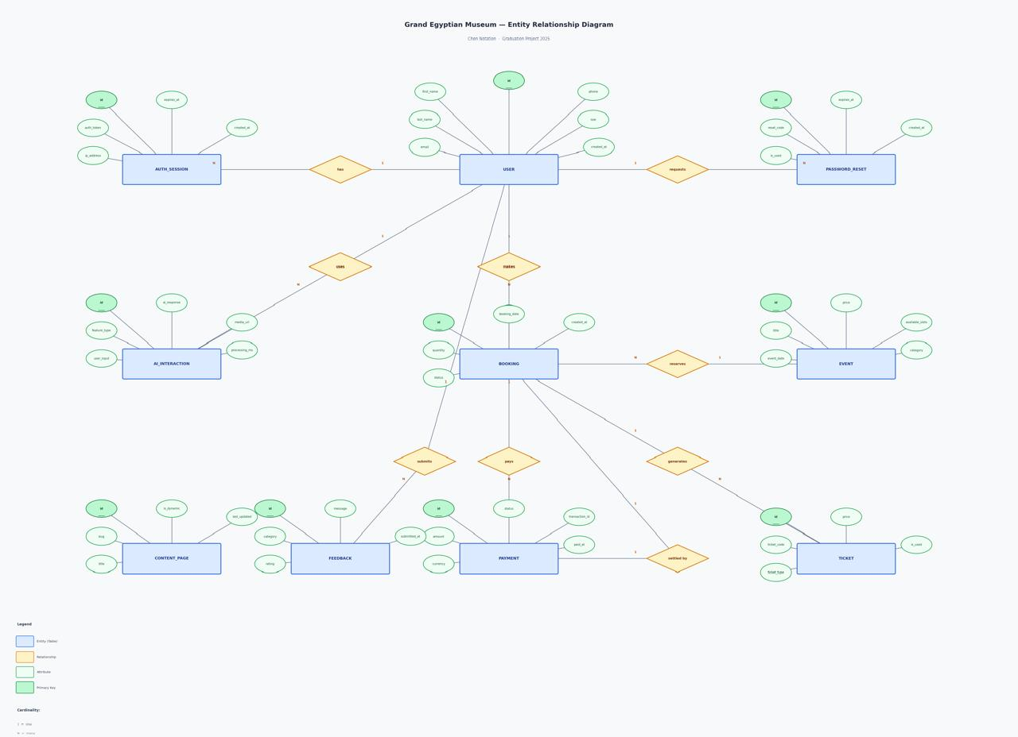
Figure 4.1 : The Mind Map

4.3 Entity Relation Diagrams
Entity Relation Diagrams (ERDs) and system diagrams are essential tools used during the software analysis and design phase. They provide visual representations of the system's structure, data flow, and behavior, enabling developers and stakeholders to understand the system clearly and accurately before implementation begins.

4.3.1 Context Diagram
A Context Diagram provides a high-level overview of the entire system. It represents the system as a single process and illustrates all the external entities — such as users, administrators, and third-party services — that interact with it. The diagram clarifies the boundaries of the system and shows the flow of information between the system and its external actors.
In the Tutora platform, the primary external entities include: the Visitor (end user), the System Administrator, the Payment Gateway, the Firebase Backend, and the AI Model Services. Each entity either provides input to or receives output from the central system.
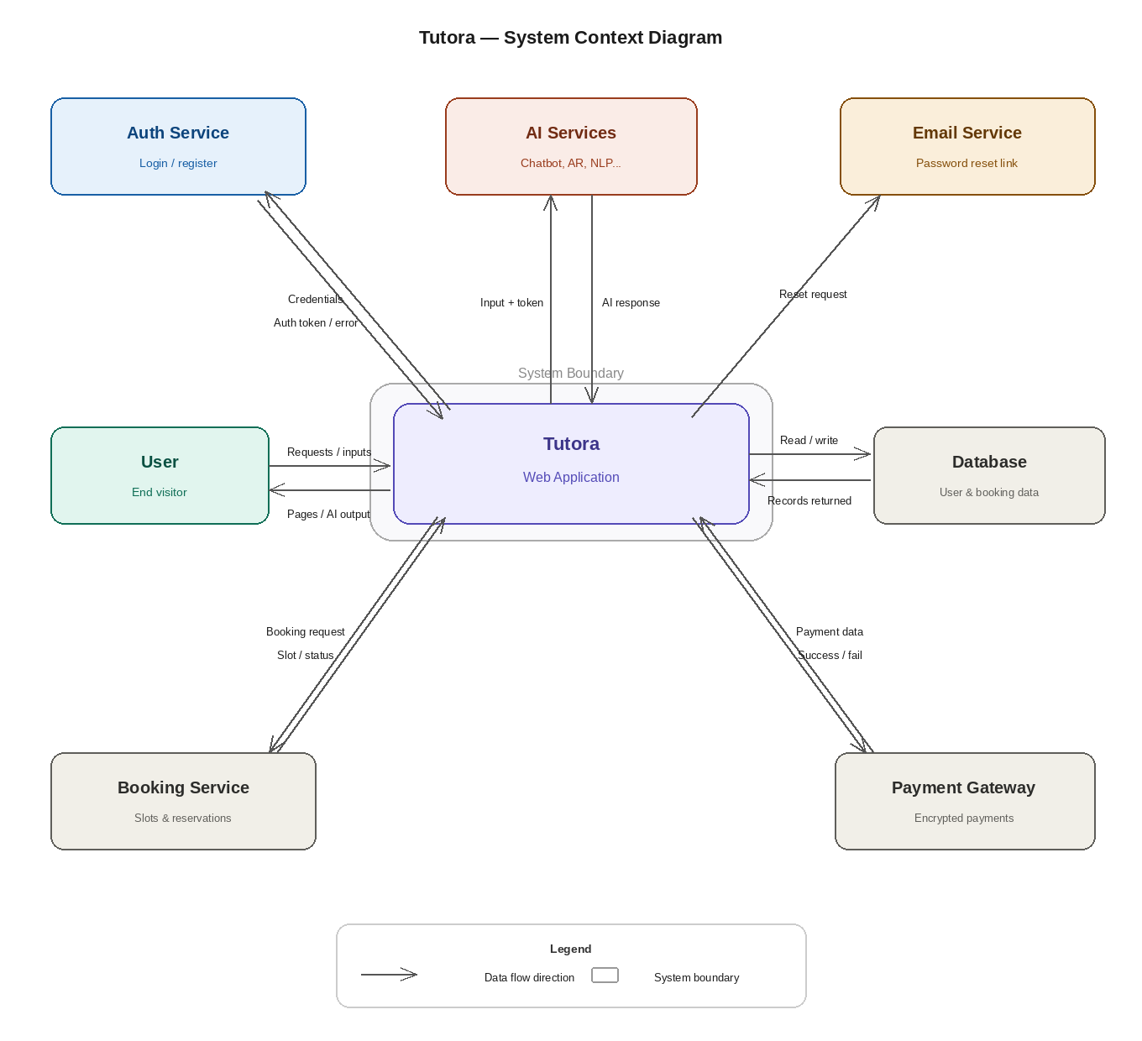
4.3.2 Level 0

am
A Level 0 Data Flow Diagram (DFD) expands the context diagram by breaking down the system into its main processes. It shows the primary functional processes of the system, the data stores involved, and the flow of data between processes and external entities. Level 0 provides an at-a-glance view of how data moves through the major subsystems.
The Tutora platform's Level 0 DFD illustrates the key processes including: User Authentication, Artifact Exploration, AI Guide Interaction, Ticket Booking, Online Shopping, and the Interactive Laboratory Module. Each process interacts with shared data stores such as the Artifact Database, User Database, and Booking Records.
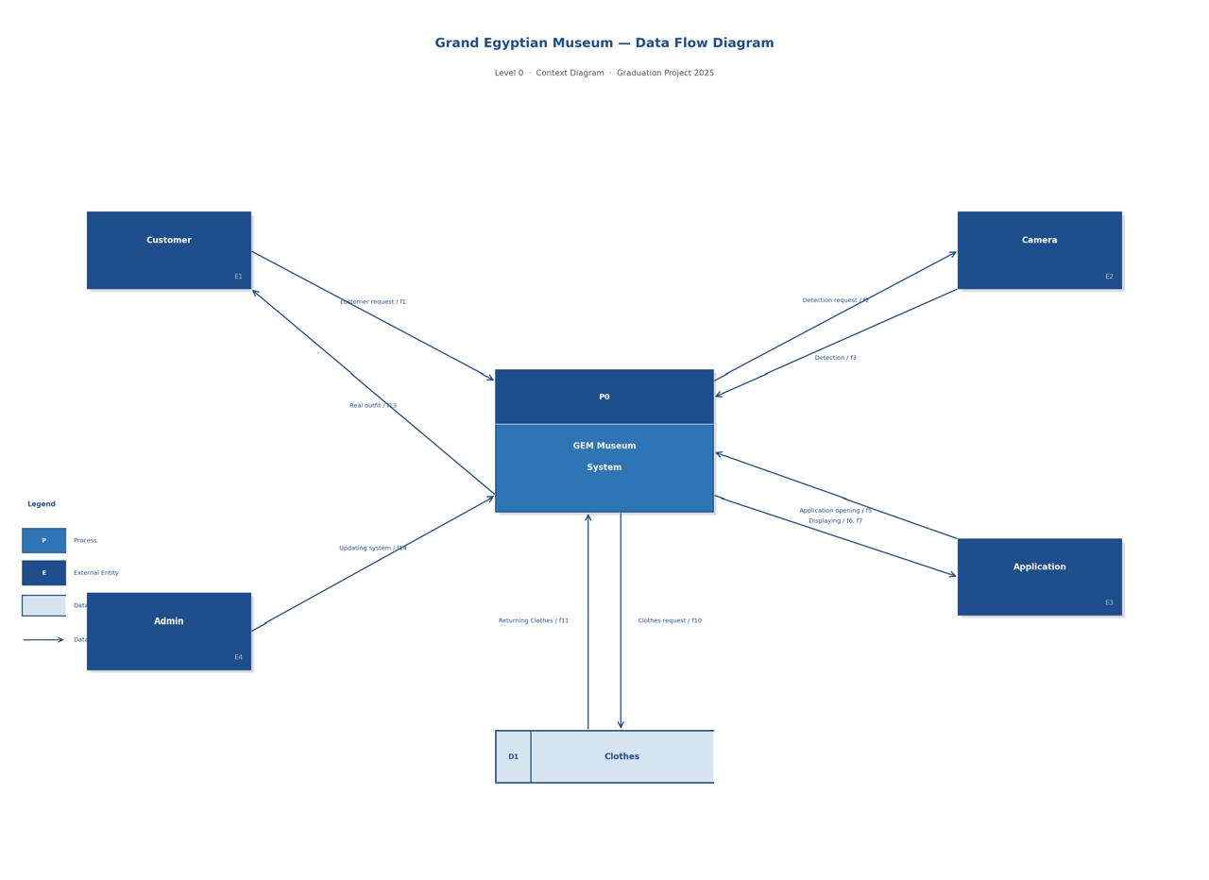

4.3.3 Use Case Diagram
A Use Case Diagram is the primary form of system requirements representation for a software system under development. It identifies all the actors who interact with the system and specifies the expected behaviors (what the system does) without detailing the method of implementation (how it does it). Use cases can be represented both textually and visually.
In the Tutora platform, the two primary actors are the Visitor (end user) and the System Administrator. The Visitor can: register and log in, explore artifacts, book tickets, use the AI tour guide and chatbot, interact with the laboratory features (Hieroglyphic Name Generator, Pharaoh Transformation, Image Generation), upload artifact images for detection, view 3D models, and purchase items from the online shop. The Administrator can: manage artifact data, manage user accounts, manage bookings, and update shop inventory.
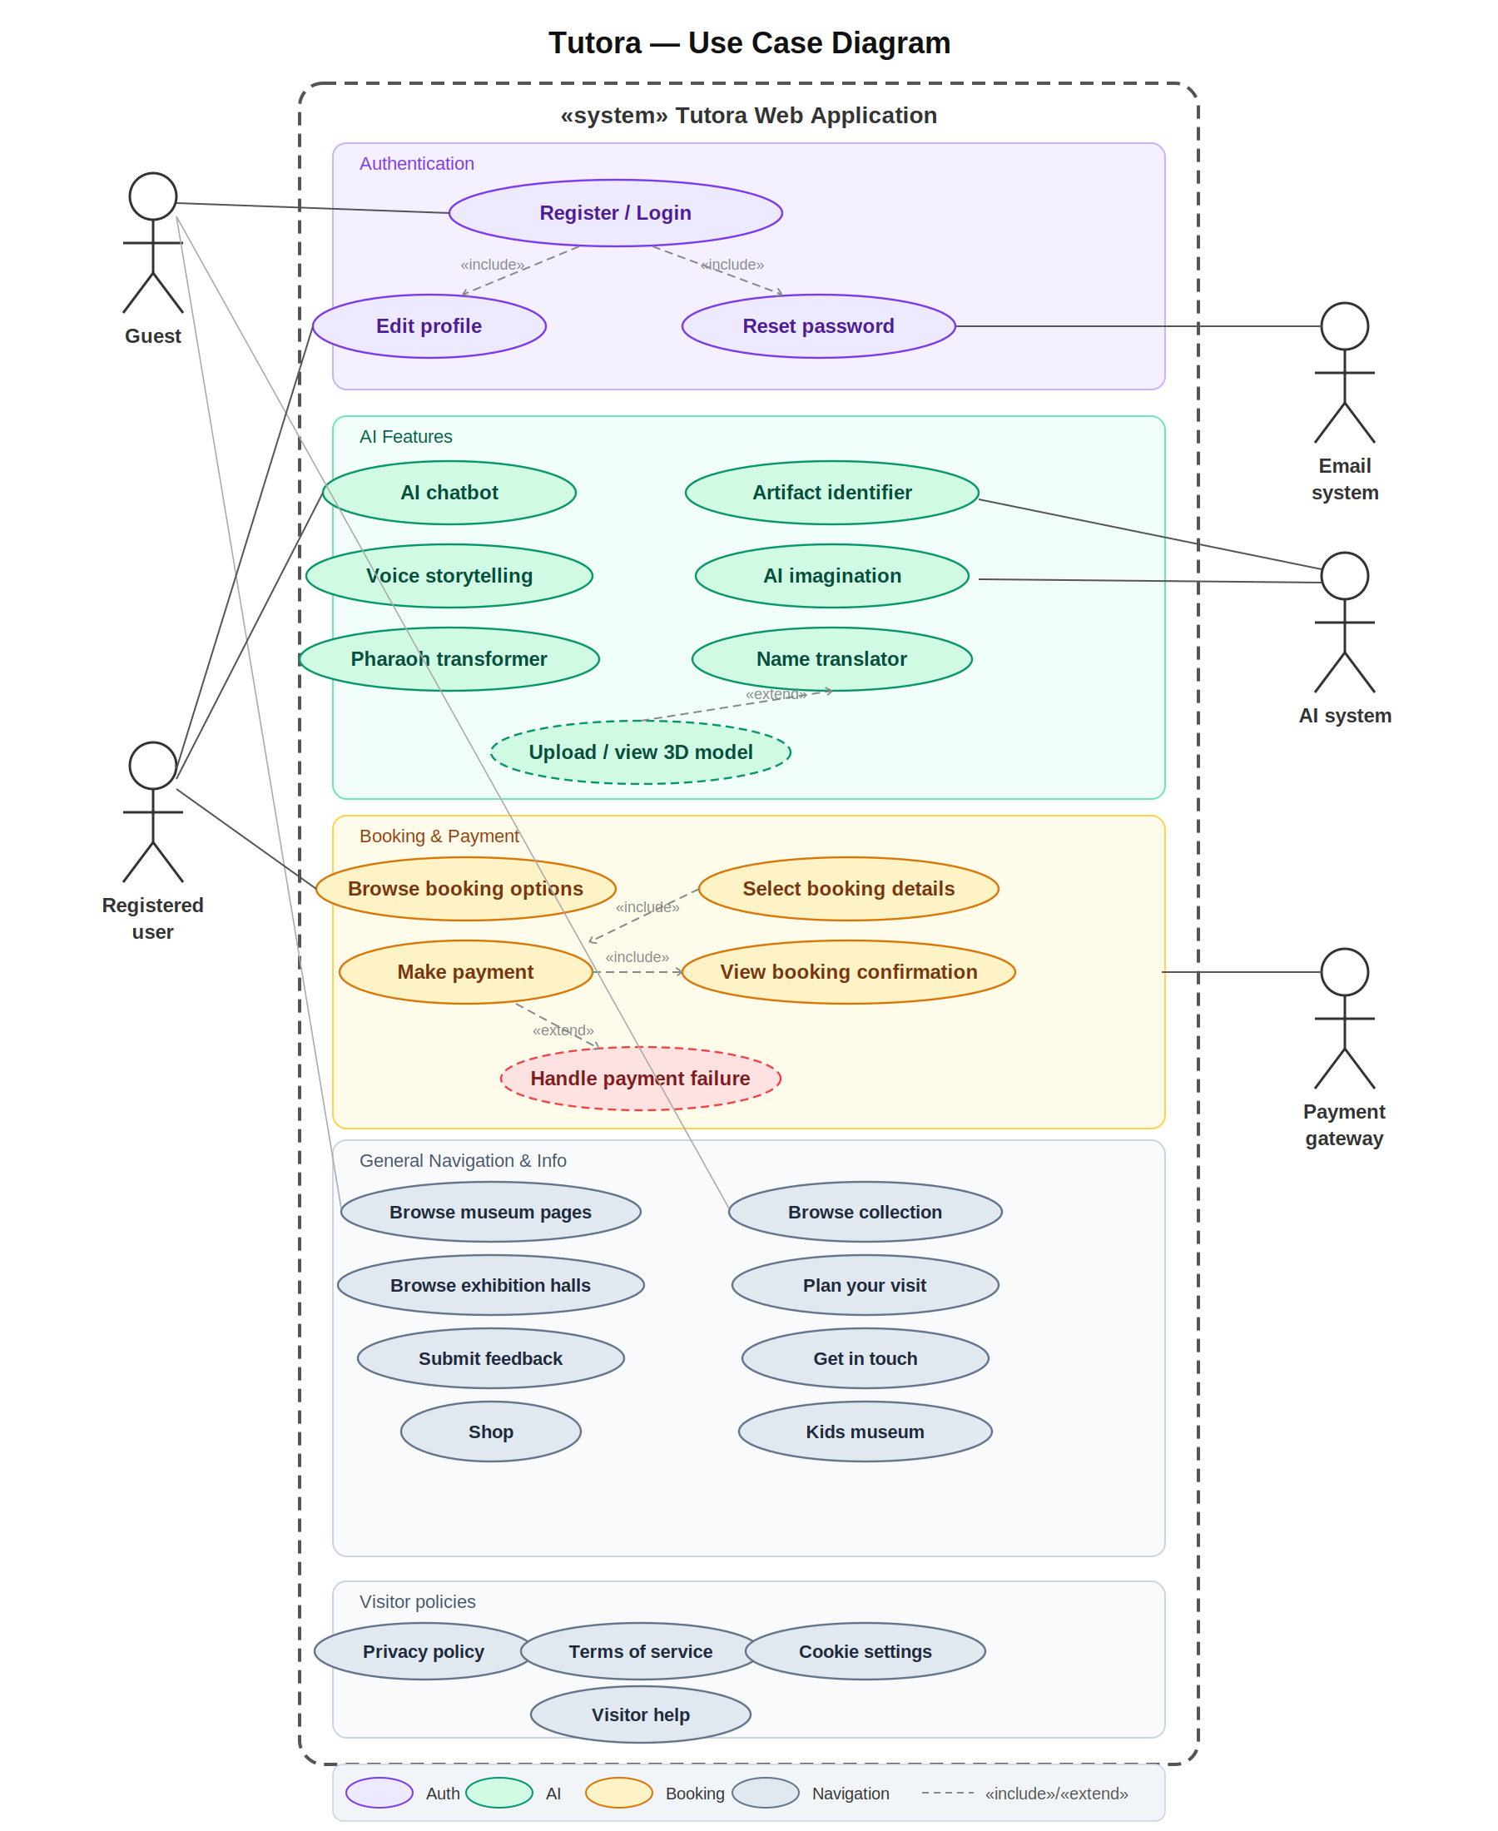

4.3.2 Sequence Diagram

A Sequence Diagram is a type of interaction diagram that describes how objects in the system interact with each other over time and in what order. It focuses on the sequence of messages exchanged between objects to accomplish a particular scenario or use case.
The Sequence Diagram for the Tutora platform illustrates the step-by-step interaction flow for the core user journey: the user initiates a request (such as artifact detection or story generation), the frontend sends the request to the backend API, the backend communicates with the AI model service, retrieves results, and returns them to the user interface for display. Each step is time-ordered to reflect the actual execution flow.
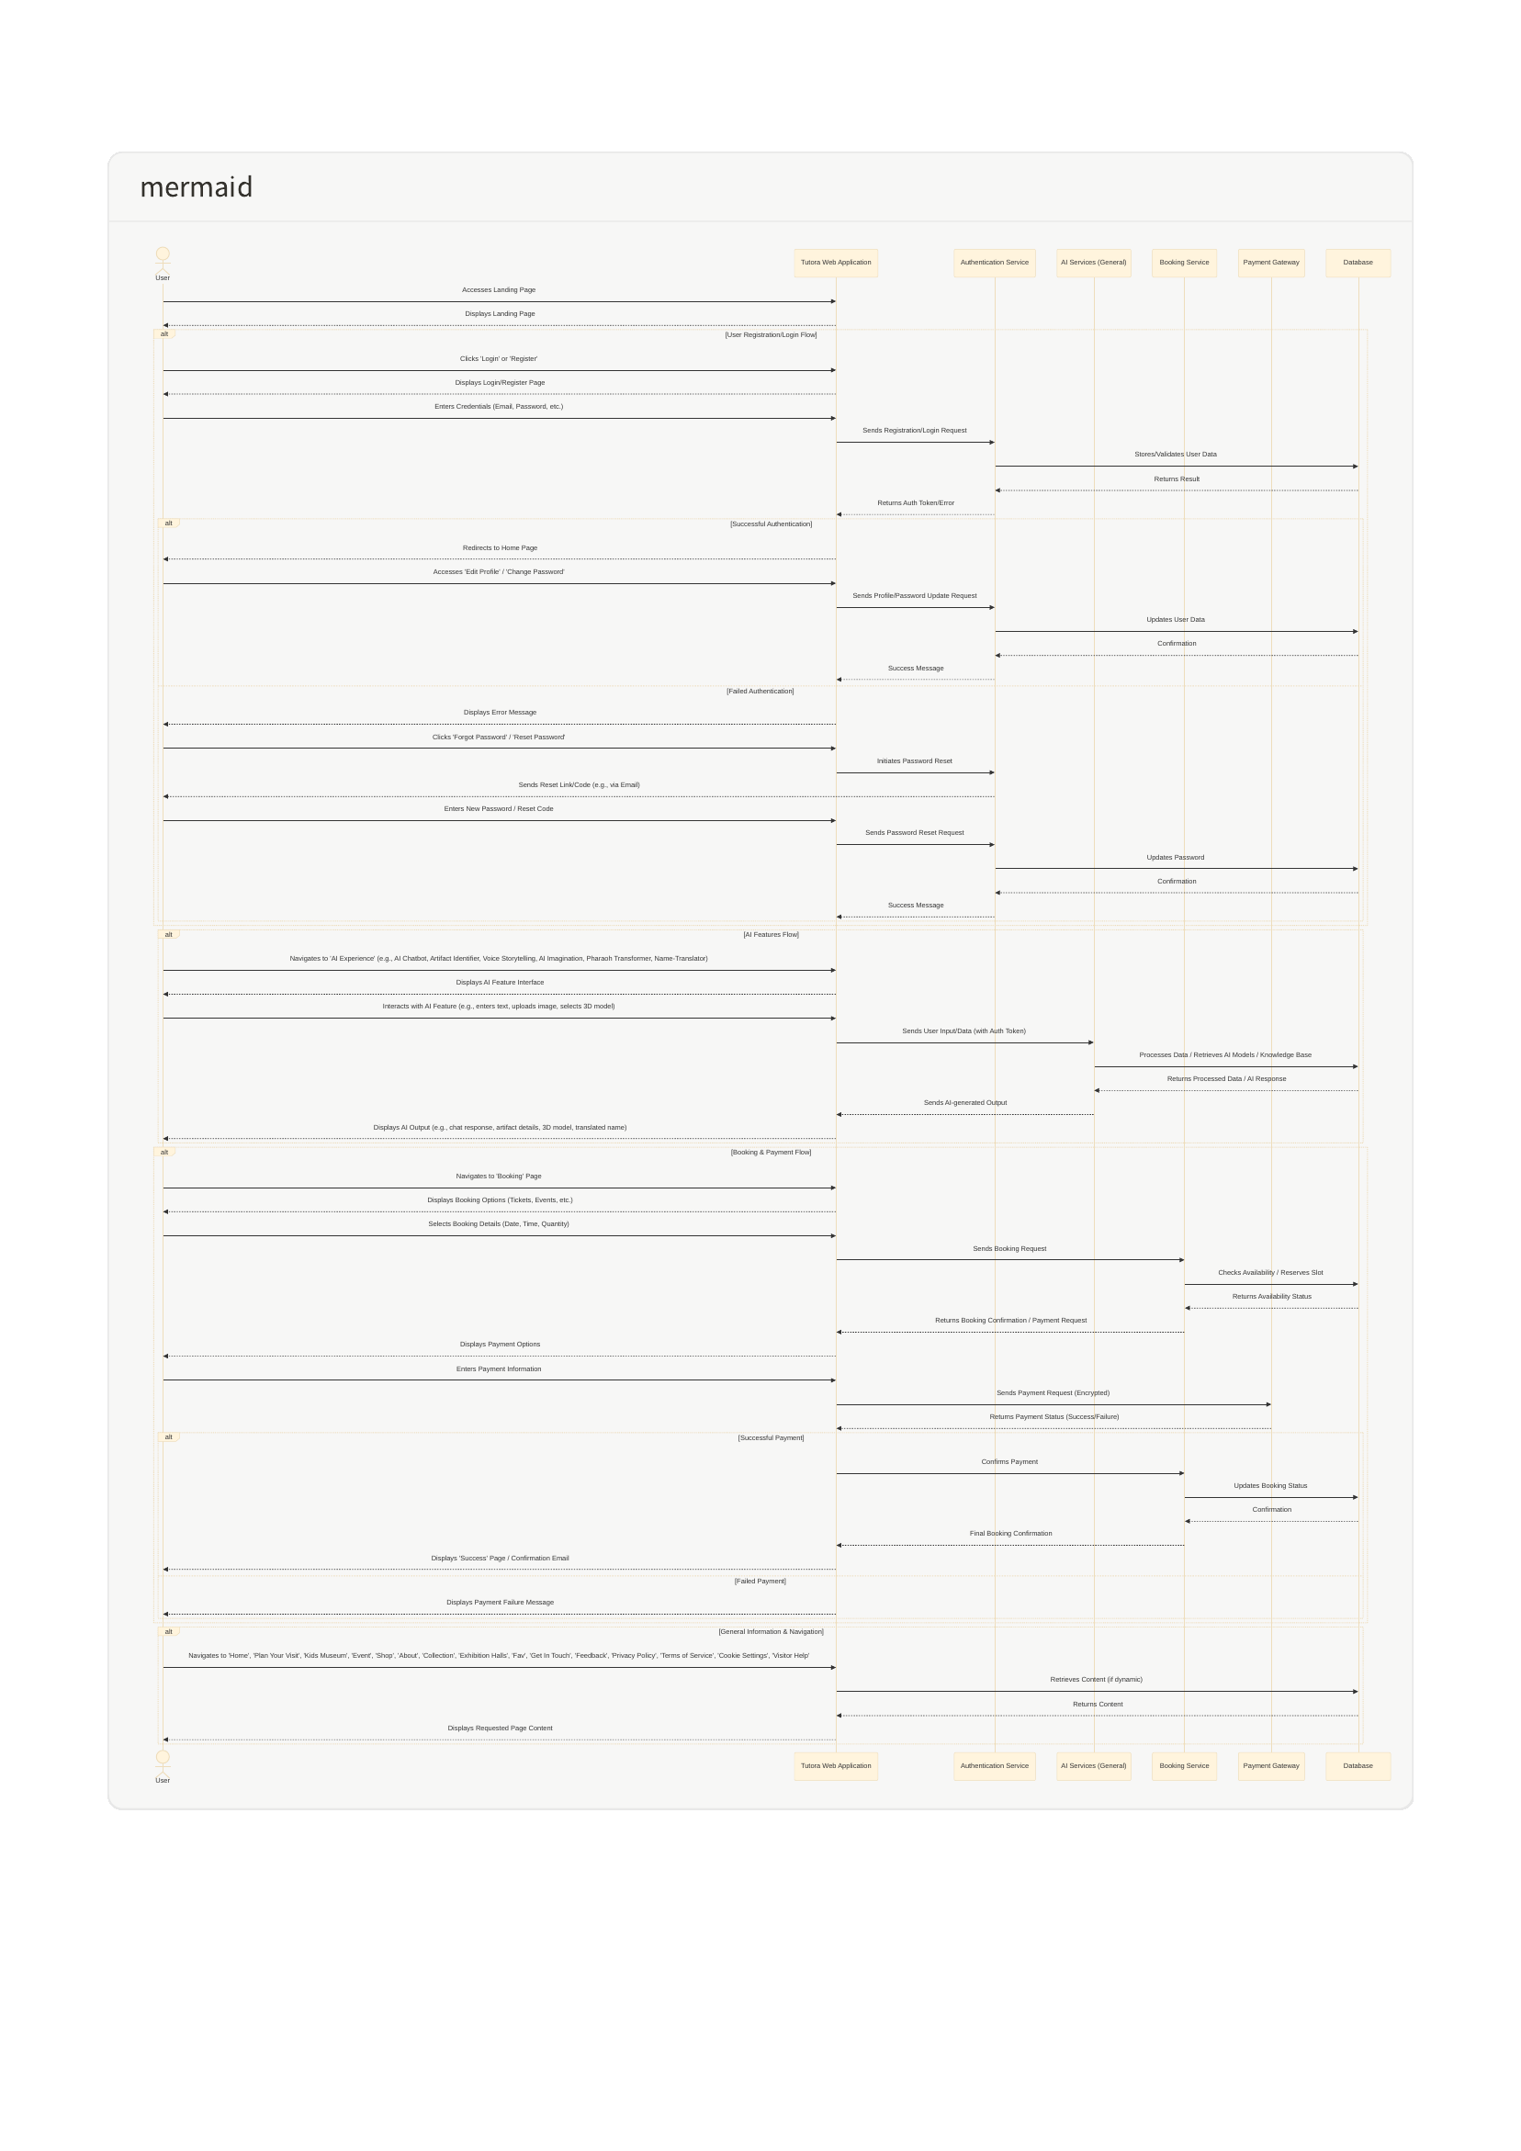4.3.4 Activity Diagram

An Activity Diagram visually represents the flow of control or the sequence of activities within a system or process. It is similar to a flowchart in that it shows decision points, parallel activities, and the order in which tasks are performed. Activity Diagrams are widely used in business process modeling and system behavior documentation.
The Activity Diagram for the Tutora platform illustrates the complete user journey — from landing on the homepage, authenticating, browsing artifacts, interacting with AI features, booking tickets, and completing a purchase — providing a clear and detailed view of the system's operational flow.
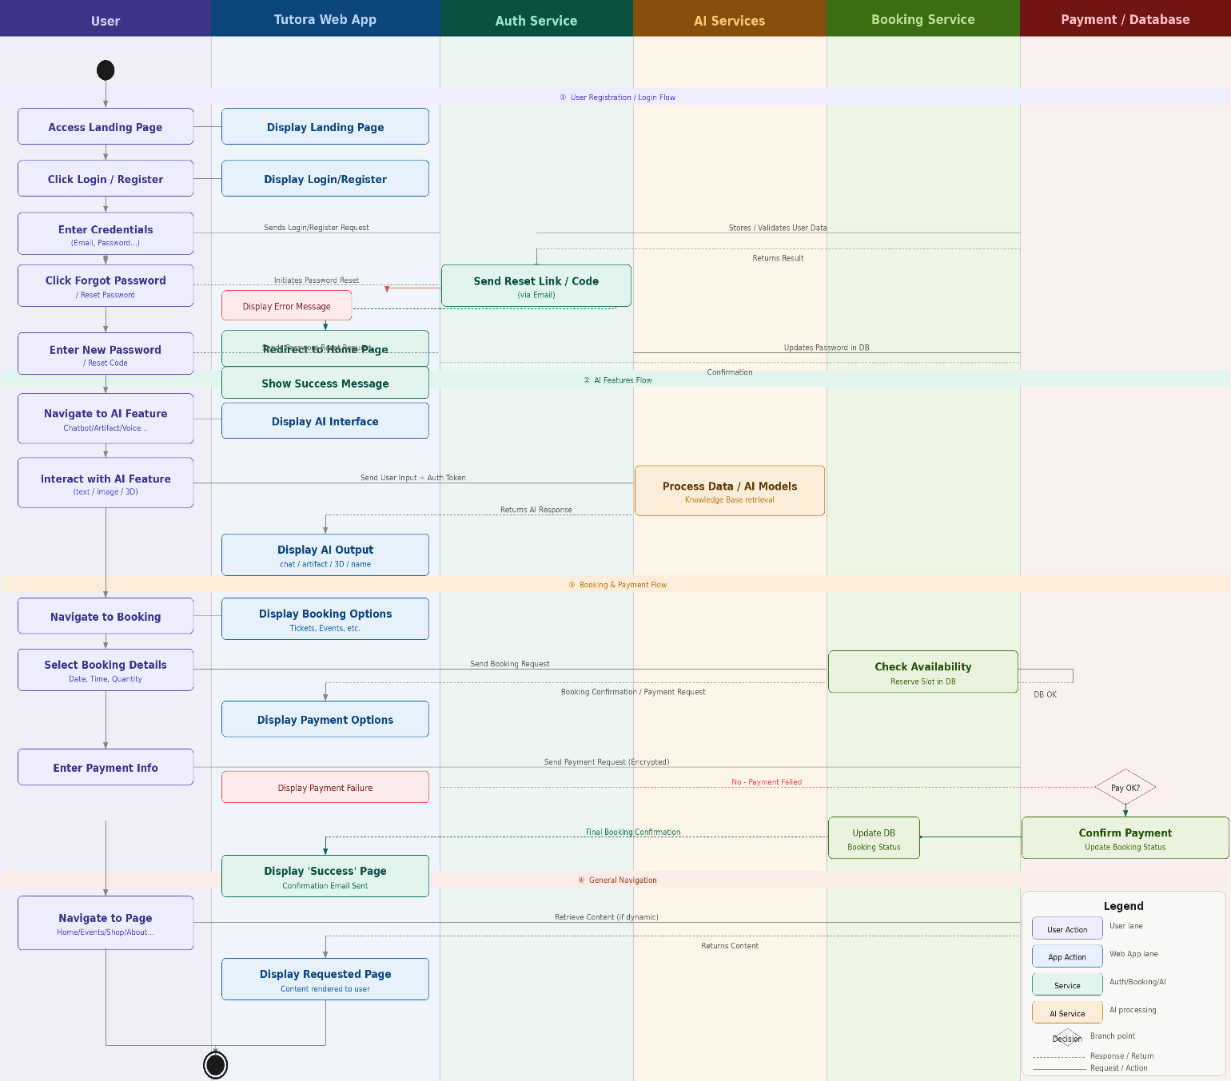

4.3.5 Class Diagram
A Class Diagram in the Unified Modeling Language (UML) is a type of static structure diagram that describes the architecture of a system by showing its classes, their attributes, operations (methods), and the relationships among objects. Class Diagrams are fundamental for object-oriented design and serve as a blueprint for system implementation.
The Class Diagram of the Tutora platform defines the main classes including: User, Artifact, Booking, Product, Order, ChatSession, and AIModel. Each class contains its relevant attributes and methods, and the diagram shows the associations, dependencies, and inheritance relationships between them.
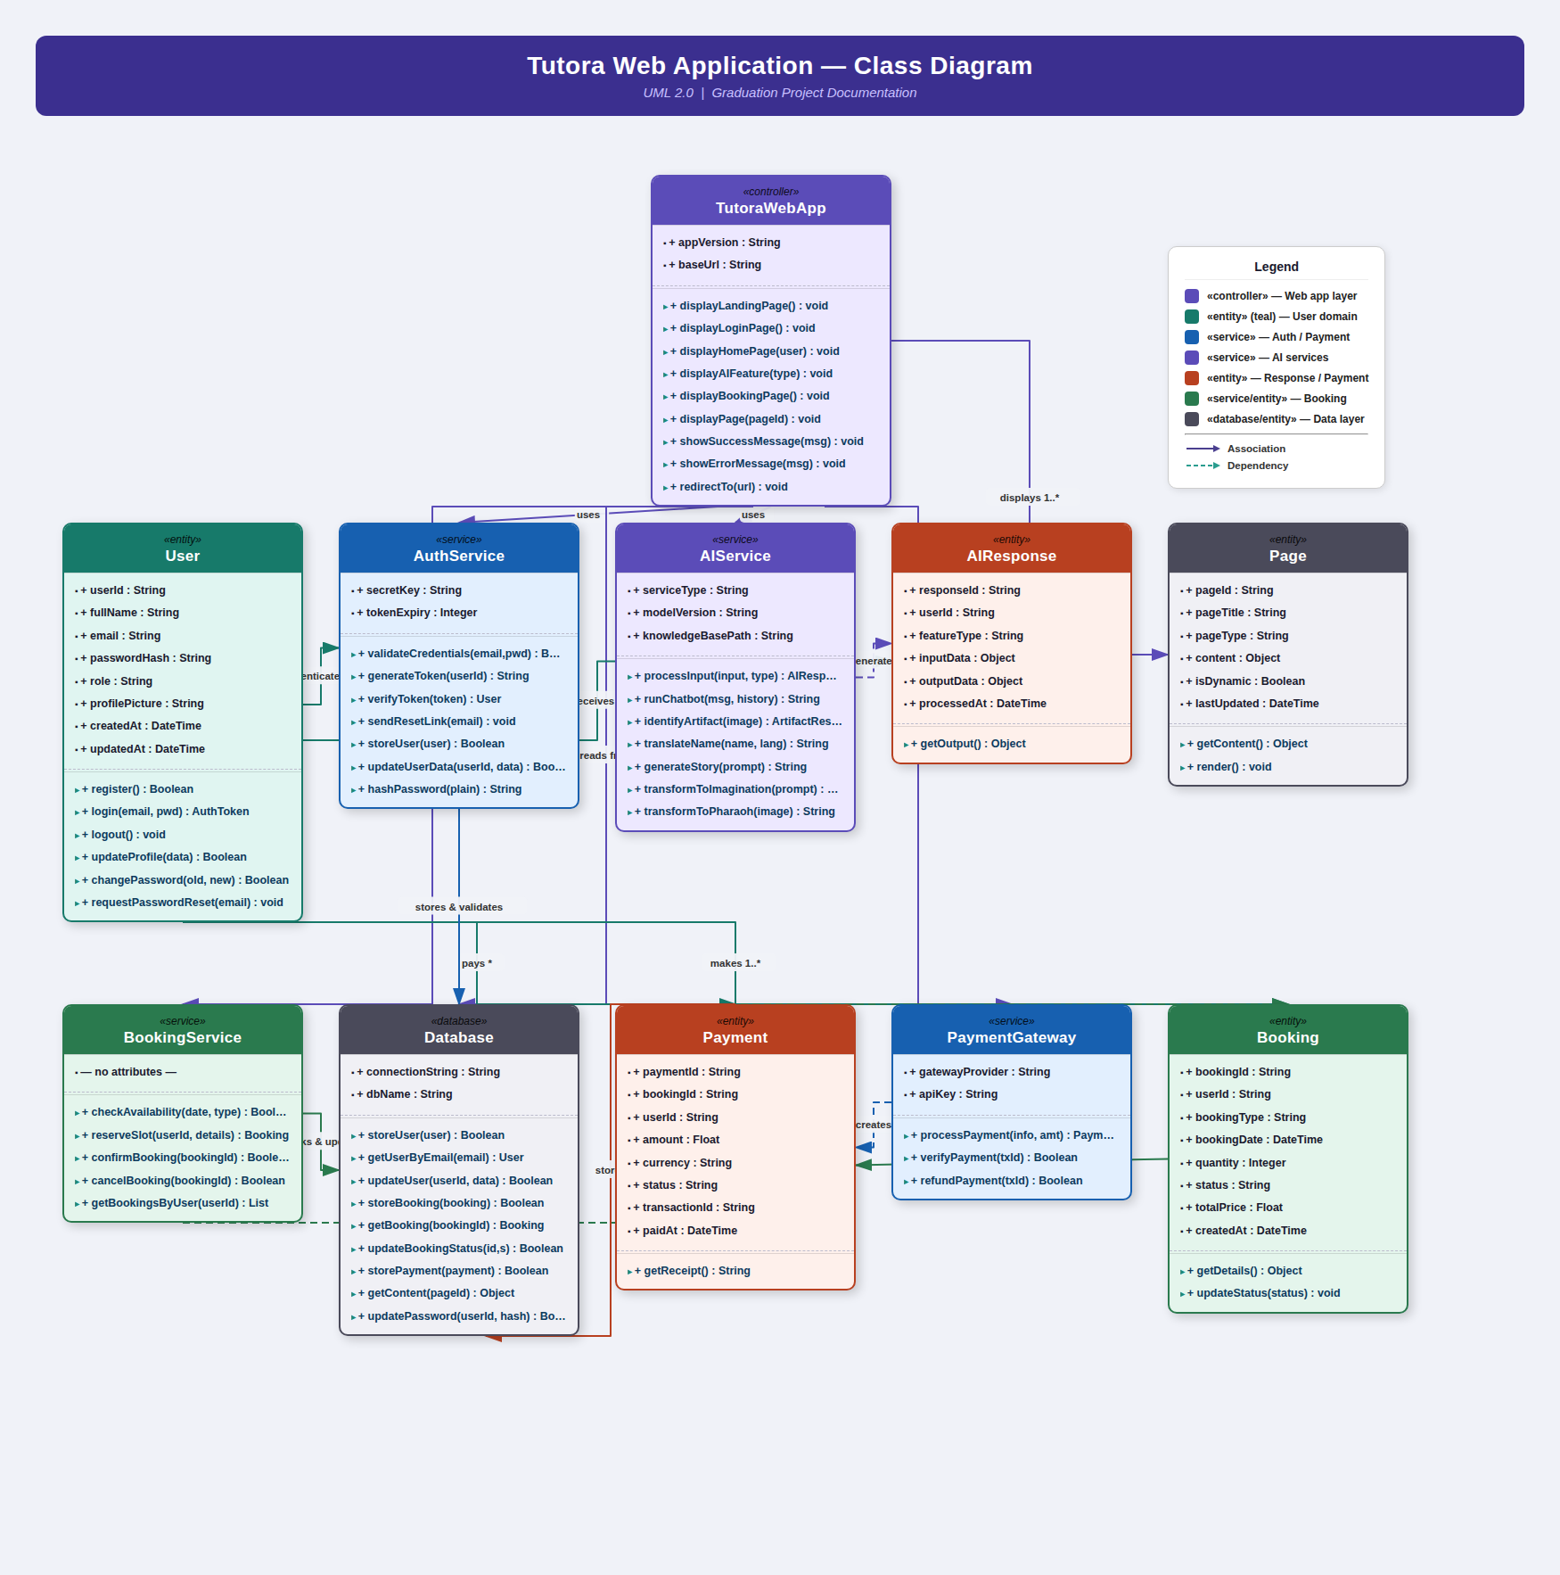
4.3.6 State Diagram

A State Diagram is used in computer science and software engineering to describe the behavior of a system by modeling its various states and the transitions between those states in response to events or inputs. It is particularly useful for representing the lifecycle of objects within the system.
The State Diagram for the Tutora platform models the lifecycle of a User Session, illustrating the transitions between states such as: Unauthenticated, Authenticated, Browsing Artifacts, Interacting with AI, Processing Booking, and Session Terminated. Each transition is triggered by a specific user action or system event.
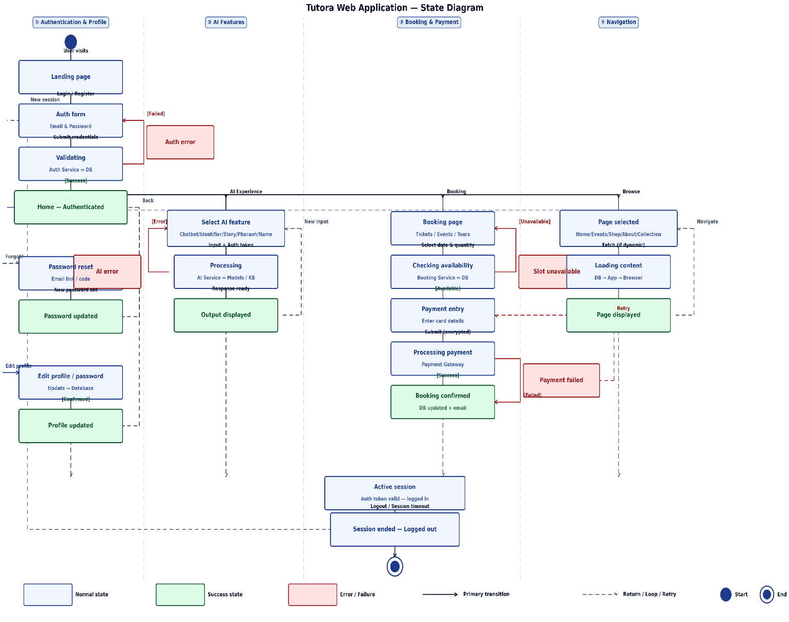

4.4 Project Software tools and Technology
………

4.4.1 Made by Google
Flutter is Google's open-source UI software development kit (SDK) designed for building natively compiled, visually attractive applications for mobile, web, and desktop from a single codebase. Flutter allows developers to write one codebase and deploy it across Android, iOS, Linux, macOS, Windows, Google Fuchsia, and the web simultaneously, significantly reducing development time and effort.

The first version of Flutter was codenamed "Sky" and ran on the Android operating system. It was unveiled at the 2015 Dart Developer Summit with the goal of rendering consistently at 120 frames per second. Flutter 1.0 was officially released on December 4, 2018 at the Flutter Live event, marking the framework's first stable release. Subsequent versions introduced major improvements: Flutter 1.12 (December 2019) brought enhanced platform support, and Flutter 1.17.0 (May 2020) added Metal API support for iOS, improving performance by approximately 50%, along with new Material widgets and network tracking tools.

In the Tutora platform, Flutter was used to develop the cross-platform frontend application, ensuring a consistent and responsive user experience across all target devices.
Figure 4.10 : Bloc Management Diagram

[ Insert Figure 4.9 Here ]

Flutter State Management — BLoC Pattern
Managing application state is a critical challenge in large-scale Flutter applications. The Business Logic Component (BLoC) pattern was adopted in the Tutora platform to effectively separate presentation logic from business logic, resulting in a codebase that is fast, testable, and highly maintainable.

BLoC was designed with three core values:
- Simple — easy to understand and usable by developers of varying skill levels.
- Powerful — enables the construction of complex, scalable applications by composing them from smaller, independent components.
- Testable — allows every aspect of the application to be tested independently, enabling confident iteration and refactoring.

BLoC regulates when state changes can occur and enforces a single, predictable way to modify state throughout the entire application. This architecture allows the development team to know the exact state of the application at any point in time, easily test every use case, record user interactions for data-driven decisions, and reuse components efficiently across modules.

[ Insert Figure 4.10 Here ]
Figure 4.10: BLoC State Management Diagram

4.4.2 Firebase
Firebase is a Backend-as-a-Service (BaaS) app development platform that provides hosted backend services such as a Realtime database, cloud storage, authentication, crash reporting, machine learning, remote configuration, and hosting for your static files.
Firebase evolved from Envolve, a prior startup founded by James Templin and Andrew Lee in 2011. Envolve provided developers an API that enables the integration of online chat functionality into their websites.
After releasing the chat service, Templin and Lee found that it was being used to pass application data that were not chat messages. Developers were using Evolve to sync application data such as game state in real time across their users. Templin and Lee decided to separate the chat system and the real-time architecture that powered it. They founded Firebase as a separate company in September 2011 and it launched to the public in April 2012.
Firebase Authentication
Firebase Authentication aims to make building secure authentication systems easy, while improving the sign-in and onboarding experience for end users. It provides an end-to-end identity solution, supporting email and password accounts, phone auth, and Google, Twitter, Facebook, and GitHub login, and more.

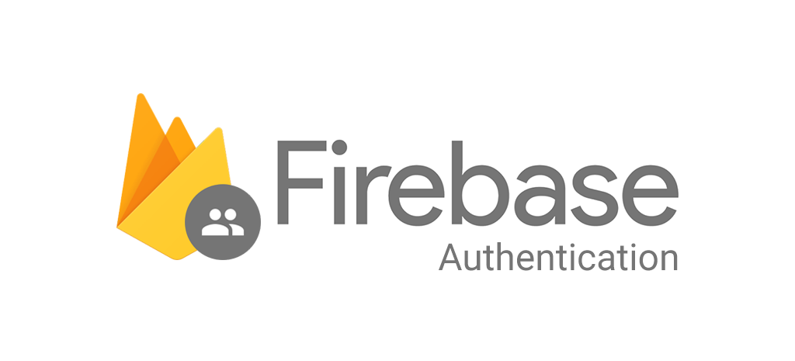
Figure 4.11 : Firebase Authentication Diagram

IOS Android Web. Firebase SDK Authentication. Email and password-based authentication. Authenticate users with their email addresses and passwords. The Firebase Authentication SDK provides methods to create and manage users that use their email addresses and passwords to sign in.
To sign a user into your app, you first get authentication credentials from the user. These credentials can be the user's email address and password, or an OAuth token from a federated identity provider. Then, you pass these credentials to the Firebase Authentication SDK. Our backend services will then verify those credentials and return a response to the client.
After a successful sign in, you can access the user's basic profile information, and you can control the user's access to data stored in other Firebase products. You can also use the provided authentication token to verify the identity of users in your own backend services.
Firebase Realtime Database
Cloud Fire store is a NoSQL document database that lets you easily work with data at a

global scale. This course will teach you the basics of Cloud Fire store, including basic syntax, adding, managing, querying, and securing data.
Figure 4.12 : Cloud Firestore Diagram

Key features of Cloud Fire store include:
- Documents and collections with powerful querying
- iOS, Android, and Web SDKs with offline data access
- Real-time data synchronization
- Automatic, multi-region data replication with strong consistency
- Node, Python, Go, and Java server SDKs

And of course, we've aimed for the simplicity and ease-of-use that is always top priority for Firebase, while still making sure that Cloud Fire store can scale to power even the largest apps. Managing app data is still hard; you must scale servers, handle intermittent connectivity, and deliver data with low latency.
Cloud Fire store optimized for app development, so you can focus on delivering value to your users and shipping better apps, faster. Cloud Fire store:
- Synchronizes data between devices in real-time. Our Android, iOS, and JavaScript SDKs sync your app data almost instantly. This makes it incredibly easy to build reactive apps, automatically sync data across devices, and build powerful collaborative features -- and if you don't need real-time sync, one-time reads are a first-class feature.
- Uses collections and documents to structure and query data. This data model is familiar and intuitive for many developers. It also allows for expressive queries. Queries scale with the size of your result set, not the size of your data set, so you'll get the same performance fetching 1 result from a set of 100, or 100,000,000.
- Enables offline data access via a powerful, on-device database. This local database means your app will function smoothly, even when your users lose connectivity. This offline mode is available on Web, iOS, and Android.
- Enables serverless development. Cloud Fire store’s client-side SDKs take care of the complex authentication and networking code you'd normally need to write yourself. Then, on the backend, we provide a powerful set of security rules so you can control access to your data. Security rules let you control which users can access which documents, and let you apply complex validation logic to your data as well. Combined, these features allow your mobile app to connect directly to your database.
- Integrates with the rest of the Firebase platform. You can easily configure Cloud Functions to run custom code whenever data is written, and our SDKs automatically integrate with Firebase Authentication, to help you get started quickly.

4.4.3 Google Colaboratory
Google Colaboratory (Colab) is a cloud-based computational environment built on Jupyter Notebooks. It allows developers and researchers to write and execute Python code directly through a web browser, with no local setup or configuration required. Colab provides free access to powerful computing resources including CPUs, GPUs, and TPUs, making it particularly well-suited for machine learning, deep learning, data analysis, and research applications.

Google Colab was used extensively in the Tutora project for the development, training, and evaluation of all AI models, including the Artifact Detection Model, the Dynamic Story Generation system, the Pharaoh Style Transformation model, and the Artifact Similarity Model. Colab's free GPU access significantly accelerated model training, while its integration with Google Drive and popular ML libraries (TensorFlow, PyTorch, Keras, OpenCV) streamlined the development workflow.

Key capabilities of Google Colab utilized in this project:
- Write and execute Python code in an interactive notebook environment.
- Import and export datasets from Google Drive and Kaggle.
- Integrate with TensorFlow, PyTorch, Keras, and OpenCV for model development.
- Share notebooks with team members for collaborative development.
- Access free GPU and TPU resources for accelerated computation.
- Use pip and apt package managers for installing additional libraries.

[ Insert Figure 4.13 Here ]
Figure 4.13: Google Colaboratory Diagram
Table 4.2 below presents the available versions of Google Colaboratory and their respective features:

Table 4.2: Versions of Google Colaboratory

Version | Resources Provided | Key Limitation
Colab Free | CPU, limited GPU/TPU, 12 GB RAM | Session limit ~12 hrs; no persistent storage
Colab Pro | Priority GPU/TPU, 25 GB RAM, longer sessions | Subscription required; no guaranteed GPU
Colab Pro+ | Background execution, 52 GB RAM, T4/A100 GPU | Higher cost; still subject to availability

Table 4.3 below summarizes the advantages and disadvantages of Google Colaboratory as used in this project:

Table 4.3: Advantages & Disadvantages of Google Colaboratory

Advantages | Disadvantages
Powerful platform for machine learning and deep learning in Python. | Does not support R or Scala programming languages.
Excellent for sharing, scrolling, and organizing code efficiently. | Sessions have time and memory limitations.
No infrastructure setup required — ready to use instantly. | Slow internet connections significantly reduce usability.
Libraries are compiled once per session, not on every run. | No persistent local storage; Google Drive limited to 15 GB.
Fast computation with 8–16 GB RAM and free GPU/TPU access. | No live collaborative editing for team-based development.
Supports pip and apt package managers for easy library installation. | GPU availability is not guaranteed during peak usage hours.

4.4.4 Microsoft Visio
Microsoft Visio is a professional diagramming application that enables the creation of a wide variety of visual diagrams. It supports flowcharts, organizational charts, building plans, floor plans, data flow diagrams, process flow diagrams, business process modeling, swimlane diagrams, UML diagrams, network diagrams, and many more. Visio is a Microsoft product sold as an extension to the Microsoft Office suite.

In the Tutora project, Microsoft Visio was the primary tool used to design and produce all system diagrams presented in this chapter, including the Context Diagram, Level 0 DFD, Use Case Diagram, Sequence Diagram, Activity Diagram, Class Diagram, and State Diagram. Visio's rich library of UML and system modeling shapes, combined with its professional export capabilities, ensured that all diagrams meet academic documentation standards.

[ Insert Figure 4.14 Here ]
Figure 4.14: Microsoft Visio Diagram

CHAPTER 5

.

Chapter 6

6.1 Introduction

6.6 Future Work
…………………..

6.7 Conclusion
…………..

6.8 Reference

[1] T.Ramaprabha & M.Mohamed, S., “The efficiency enhancement in non immersive virtual reality system by haptic devices,” International Journal Of Advanced Research in Computer Science and Software Engineering, 2(3), 2012.

