

Business Plan
Egypt and Saudi Arabia · Years one to five

A gamified, AI-native venture-building platform that takes MENA founders from a raw idea to a live product in fifteen guided missions — and the six institutional engines built around it.
$273.4m  Total addressable market, Egypt and KSA | $89.9m  Serviceable available market | $272k  Year-one revenue | 99%  Institutional revenue

PLANNING PERIOD  October 2026 to September 2031 | MARKETS  Egypt · Saudi Arabia

Contents

01 | Executive Summary | The company, the problem, the opportunity and the eight engines, in brief
02 | Company Description | Mission, vision, values, and what has to be true for this to work
03 | Market Analysis | Segments, buyer universe, size, drivers, gaps and the regulatory frame
04 | Competitive Analysis | Who a buyer uses instead, how we compare, and what is actually hard to copy
05 | Products and Services | What is sold, in what format, at what price and anchored against what
06 | Marketing Strategy | Two customer journeys, the channels that produce institutional pipeline, and the brand
07 | Sales Strategy | Four selling motions, the team that runs them, and the pipeline they feed
08 | Engagement Model
09 | Go-to-Market Roadmap | Eight engines, eight gates, twelve quarters — and the critical path through them
10 | Operations Plan | How a contract becomes a delivered cohort, and what breaks first if it does not
11 | Management and Organization | A deliberately small team, with every role described in full
12 | Financial Plan
13 | Strategic Analysis | SWOT, PESTLE, risk and what we do when something goes wrong
14 | Appendix | Every figure behind the plan, and what it does not claim

SECTION 01
Executive Summary

StartPad turns a first-time founder with an idea into someone the ecosystem takes seriously, and sells that capability to the organisations responsible for producing them: universities, schools and technical institutes, national initiatives, donors, competition sponsors and corporates. The young person uses it. Somebody else pays for it.
Company description
StartPad is a gamified, AI-native venture-building platform built in MENA for MENA founders. Fifteen sequenced missions across five phases take a raw idea to a live product, with an AI Co-Founder inside every mission and 121 tools mapped to the journey. Every submission is reviewed before the next mission unlocks, which is what turns participation into evidence an institution can report on.
The problem
Ideas are everywhere in MENA; a path to a real startup is not. Founders have graduation projects and no method. Institutions are measured on employability and entrepreneurship outcomes they have no way to produce. National programmes have announced million-scale targets with no delivery capacity behind them. The common failure is not talent or capital — it is that nobody owns the first step.
21%  of self-described MENA startups meet the minimum criteria to be considered investable | 56%  of MENA pre-seed startups never reach the next stage | 68%  failure rate in Egypt for startups trying to reach Series A — the highest in the region

The solution
A method with a gate. A mission opens only when the last one passes a review scored on specificity, depth, evidence, actionability and relevance. Around that platform sits an in-person layer — bootcamps, workshops, competitions — and above it an institutional workspace that gives the organisation paying a live view of progress, review states and a downloadable cohort report, without ever taking ownership of the student's work.
Market opportunity
Across Egypt and Saudi Arabia the plan addresses 17.1 million young people and first-time founders — university students, recent graduates, technical and vocational students, senior secondary students and micro-enterprise owners — through 7,529 institutional buying units, 1,800 NGOs and donors, 1,400 corporates and roughly 1,100 youth competitions a year. Total addressable market is $273.4m a year, of which $89.9m is serviceable and 81% of that is institutional.
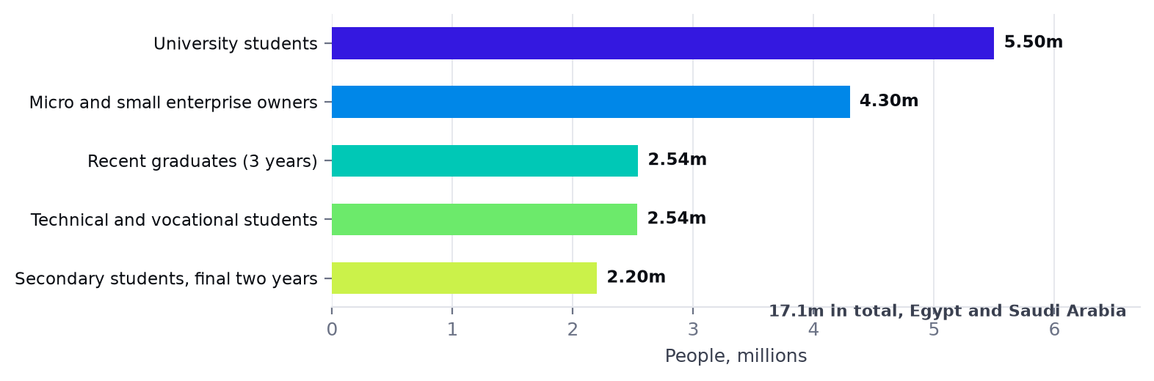
The population served, across both markets. Secondary and technical students roughly match the university population, and are almost entirely unserved.
Competitive advantage
Generic guides give advice; StartPad gives a path. The defensible layer is not the software — it is the certified facilitator pool, the bilingual MENA-composed curriculum, the institutional relationships and the cohort evidence record that a buyer would have to abandon to switch. Those take years to build and are the reason a well-funded imitator cannot simply copy the product.
The eight engines
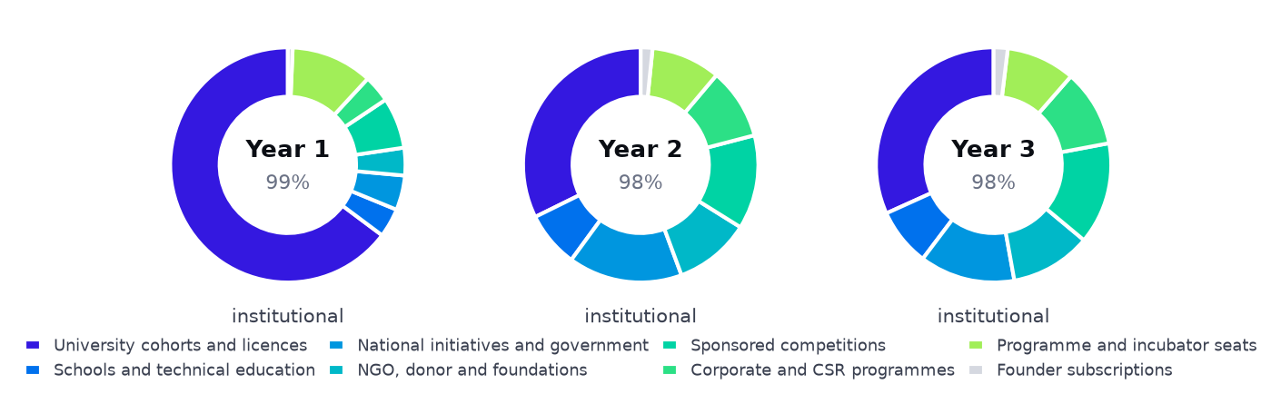
Revenue mix across five years. The business is institutional in every year; founder subscriptions never become the point.
Engine | Who signs the contract | Share, Y1 | Share, Y3
University cohorts and licences | A dean, an entrepreneurship centre or a capstone coordinator | 65% | 32%
Schools and technical education | A school group, a principal or a technical institute director | 4% | 8%
National initiatives and government | A ministry, a donor or a national programme office | 5% | 13%
NGO, donor and foundation programmes | A foundation, an INGO country office or a development agency | 4% | 11%
Sponsored competitions | A bank, a telco, a ministry or a foundation | 7% | 14%
Corporate and CSR programmes | A corporate CSR or innovation budget holder | 4% | 11%
Programme and incubator seats | An incubator or accelerator director | 11% | 9%
Founder subscriptions | The founder, out of their own pocket | 1% | 2%

What this plan concludes
Sell to the budget holder, not the beneficiary
The person who benefits has almost no money; the person with the budget has a reporting problem StartPad solves. Every engine is built on that asymmetry, and it is why founder subscriptions are the smallest line.
Nothing starts on day one
Eight engines open on eight different gates across twelve quarters. A faculty licence cannot be sold before two cohorts have run; a ministry will not contract a platform that cannot show a cohort report. Only university cohorts earn in the Land quarter.
The constraint is certified delivery, not demand
Delivery peaks at 76 facilitator-equivalents in a quarter, and a certified pair runs 18 university cohorts a year. Certification is therefore the first operational priority, and the seat, competition and partner engines matter partly because they scale past that constraint.
Twelve people in year three, twenty in year five
The establishment is capped: 6 in year one, 9 in year two, 12 in year three, 16 in year four and 20 in year five. StartPad does not deliver cohorts at scale — it certifies and audits the organisations and freelancers who do. By year three, 107.287880957002 cohorts are delivered by a pool of 43 certified facilitators and 2 certified partner organisations, which is how 12 employees stand behind 3,167 learners each.
Every engine enters through a named programme that already exists
StartPad does not create demand; it attaches to budgets already committed. The plan names the organisations — Rowad 2030 and MSMEDA in Egypt, Monsha'at, Misk and TVTC in Saudi Arabia, Enactus Egypt, INJAZ and the bank-sponsored competition seasons — and states the route into each as one of six repeatable engagement plays.
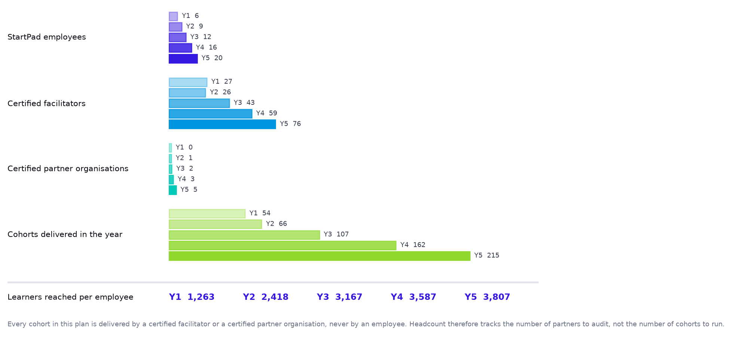
The whole argument for a twelve-person company in one figure: employees against the certified network that delivers for them.
SECTION 02
Company Description

Who StartPad is, what it is for, and what has to be true for it to work.
Mission
To give every first-time founder in MENA a method — and every institution that teaches them a way to prove it worked.
Vision
That within a decade, a young person in Cairo, Assiut, Riyadh or Jeddah who has an idea has an obvious first step, and the university, school, ministry or foundation around them has a standard way to support it. StartPad intends to be that standard: the layer the region's entrepreneurship education runs on, in Arabic, with the evidence attached.
Core values
Earn the yes
Free pilots before licences, results before scale. We do not ask an institution to believe us; we ask them to look at their own cohort report.
The founder does the work
The AI asks the question a mentor would ask. It never writes the answer. A platform that does the thinking destroys the only thing it was supposed to create.
Composed, not translated
Arabic is the first language of this product, in the dialect of the room it is used in. A translated product is a foreign product.
Status is earned
Ambassadors, facilitators and partners renew on results each term. A title that cannot be lost stops working.
Honest indicators
We report recorded progress and evidence. We do not certify that a venture will succeed, and we will not contract to a metric the product cannot measure.
Key success factors
01 A certified facilitator pool. Everything in-person depends on people who can deliver a StartPad cohort without StartPad in the room.
02 A cohort report worth renewing on. The automatic report is the sales document for every engine; if it is not good enough to circulate, nothing else works.
03 Two markets, two doors. Universities in Egypt, programme partners in Saudi Arabia. The same product, a local route in each.
04 Institutional trust. Student-controlled sharing, scoped data and a refusal to over-claim outcomes are commercial assets, not compliance overhead.
05 Engine diversity. Eight buyers means no single procurement freeze, budget cut or ministry reshuffle is existential.
Current situation
The platform is built: fifteen missions, five phases, 121 tools, the AI Co-Founder, the review loop, the institutional workspace and full bilingual support with right-to-left layout. The bootcamp curriculum is designed across six days with signature activities, daily deliverables and a judged public Bazaar. The company is pre-revenue and entering its first commercial year in both markets simultaneously from September 2026.
Motivation for expansion
Two things make this the moment. First, both governments have made youth entrepreneurship an explicit national priority with named programmes and published targets — and none of those programmes has a method or a reporting line. Second, Egypt's technical education reform and Saudi Arabia's vocational expansion have created a segment of several million students whose entire purpose is employability and who are served by almost nobody.
SECTION 03
Market Analysis

The industry, the segments, the size of each, and the gaps that make a method sellable.
Industry overview
MENA startups raised a record $7.5bn across 647 deals in 2025. Saudi Arabia led at $5bn across 211 deals; Egypt was third at $263m across 89 deals, with deal count rising even as value fell after the currency devaluation. Capital is concentrating in the Gulf while the founder population concentrates in Egypt — which is the structural case for operating in both markets rather than sequencing them.
Underneath the funding headlines sits an education and employability industry that is far larger and far less reported: higher education, technical and vocational training, secondary schooling, donor-funded youth programmes and corporate social investment. That is the industry StartPad actually sells into.
Target customer segments
There are two distinct customers and only one of them pays. The beneficiary is a young person or first-time founder. The buyer is an organisation responsible for preparing them.
Beneficiary segment | Size | Who pays for them
University students | 5,500,000 | Universities, faculties, national initiatives, competition sponsors
Recent graduates, within three years | 2,541,600 | Incubators, NGO programmes, national initiatives, themselves
Technical and vocational students | 2,536,000 | Technical institutes, ministries, donor employability programmes
Secondary students, final two years | 2,200,000 | Schools, school groups, CSR programmes, competition sponsors
Micro and small enterprise owners | 4,300,000 | Banks, MSME agencies, NGOs, themselves
Total | 17,077,600

Population by segment across Egypt and Saudi Arabia.
The buyer universe
Buyer universe | Count | Basis
University buying units | 1,515 | 951 in Egypt (551 CAPMAS public colleges plus private faculties), 564 in KSA. The buying unit is the college — three of the four doors sit below university level
Schools with a budget | 3,700 | Private, international, national and applied-technology schools. A government school on a fixed ministry budget is reached through a national programme instead
Technical and vocational institutions | 2,314 | Egyptian technical schools plus 314 TVTC institutions in the Kingdom
National initiative seats a year | 1,200,000 | Addressable seats at steady state across both markets — far below the stated targets, which total several million
NGOs, donors and foundations | 1,800 | With a youth employability or entrepreneurship mandate and a budget
Youth competitions a year | 1,100 | Run by universities, schools, banks, telcos, ministries and foundations
Large corporates | 1,400 | With a CSR, innovation or youth budget
Incubators and startup programmes | 250 | That select applicants and would benefit from a prepared pool

Market size and growth
Sizing is bottom-up and counts, for each engine, the organisation that signs the contract, not the student who benefits. That choice is the most important methodological decision in this plan: counting students produces a large and unconvertible number, while counting buyers produces a number a sales team can actually work.
The market reference prices used for sizing are what a buyer in this market typically pays for one unit of the thing. They are deliberately separate from StartPad's own price list: a total addressable market does not shrink because StartPad decides to charge less than the going rate, and these figures therefore do not move when the financial model is repriced.
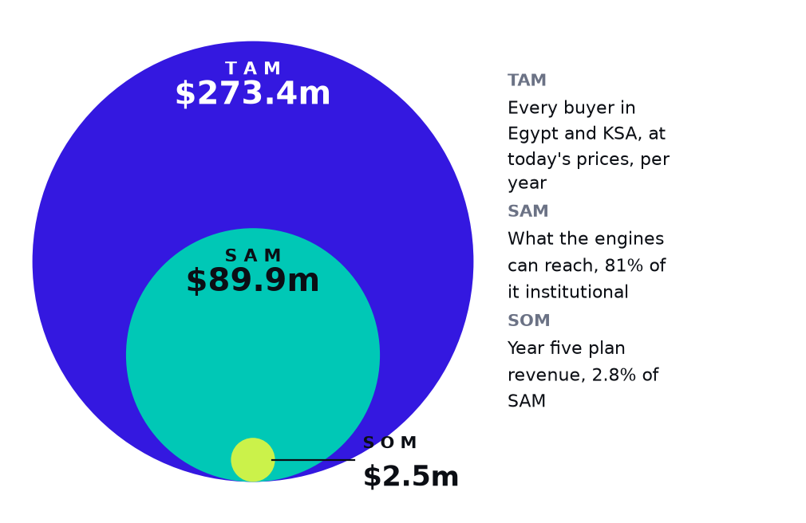
TAM, SAM and SOM. Areas are proportional to value, so the obtainable share is drawn at the size it actually is.
$273.4m  TAM, every buyer at today's prices | $89.9m  SAM, 81% institutional | $2.5m  SOM, 2.8% of SAM by year five

The obtainable figure is not a share chosen to look modest. It is the year five revenue the financial model produces, $2.5m, read straight from the workbook. Across both markets 17.1m young people sit behind 12,079 organisations that could pay for them.
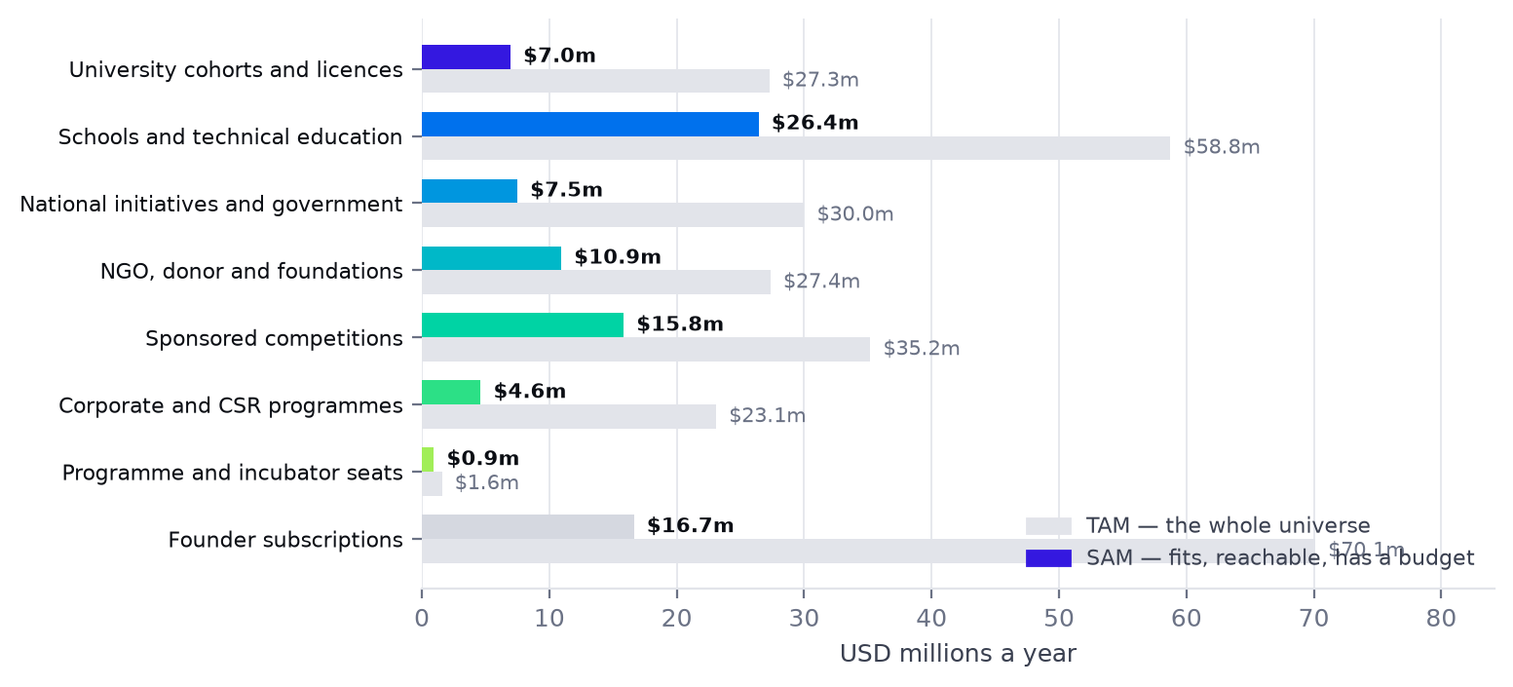
TAM and SAM, engine by engine.
Engine | TAM basis | TAM | SAM
University cohorts and licences | 1,515 university buying units x $18,000 a year | $27.3m | $7.0m
Schools and technical education | 3,700 schools x $9,000 and 2,314 technical institutes x $11,000 | $58.8m | $26.4m
National initiatives and government | 1,200,000 seats a year x $20, plus trainer certification | $30.0m | $7.5m
NGO, donor and foundation programmes | 1,800 NGOs and donors x 0.4 programmes x $38,000 | $27.4m | $10.9m
Sponsored competitions | 1,100 competitions a year x $32,000 | $35.2m | $15.8m
Corporate and CSR programmes | 1,400 corporates x 0.3 programmes x $55,000 | $23.1m | $4.6m
Programme and incubator seats | 250 programmes x 150 seats x $42 | $1.6m | $945k
Founder subscriptions | 6% of 12.3m adults and 1% of 4.7m under-18s x $89 | $70.1m | $16.7m
Total |  | $273.4m | $89.9m

The subscription line has the largest TAM on paper — $70.1m — because there are millions of young people and in principle any of them could pay. It is the least realisable number in the table. A plan built on it would be built on the one figure here that cannot be converted at these willingness-to-pay levels.
Who already runs these programmes
A market sized from populations is an argument; a market with named buyers running named programmes is a plan. Every organisation below already runs something StartPad would sit inside, and already has the budget line. None of them is a signed partner, and no revenue in this plan is attributed to any one of them — they are listed so a reader can verify that the demand described is observable rather than inferred. The route into each is set out in the Engagement Model.
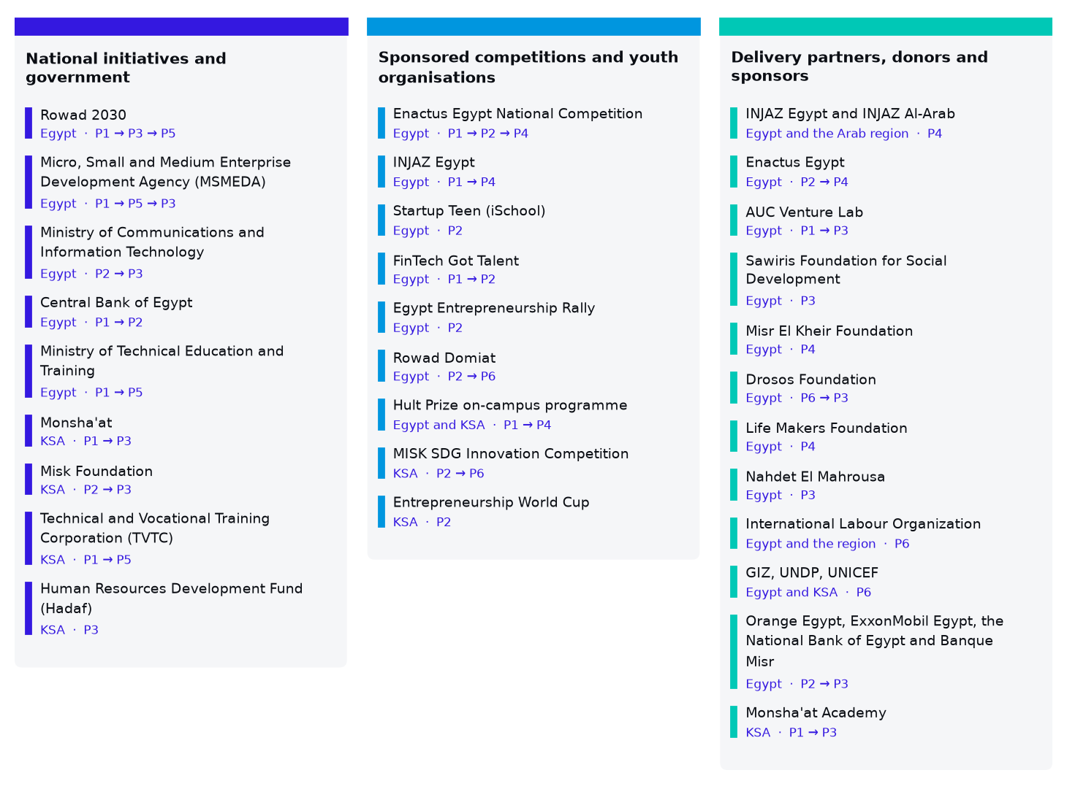
Named target organisations by engine, each tagged with the engagement plays that open it. Not signed partners: evidence that the buyers exist.
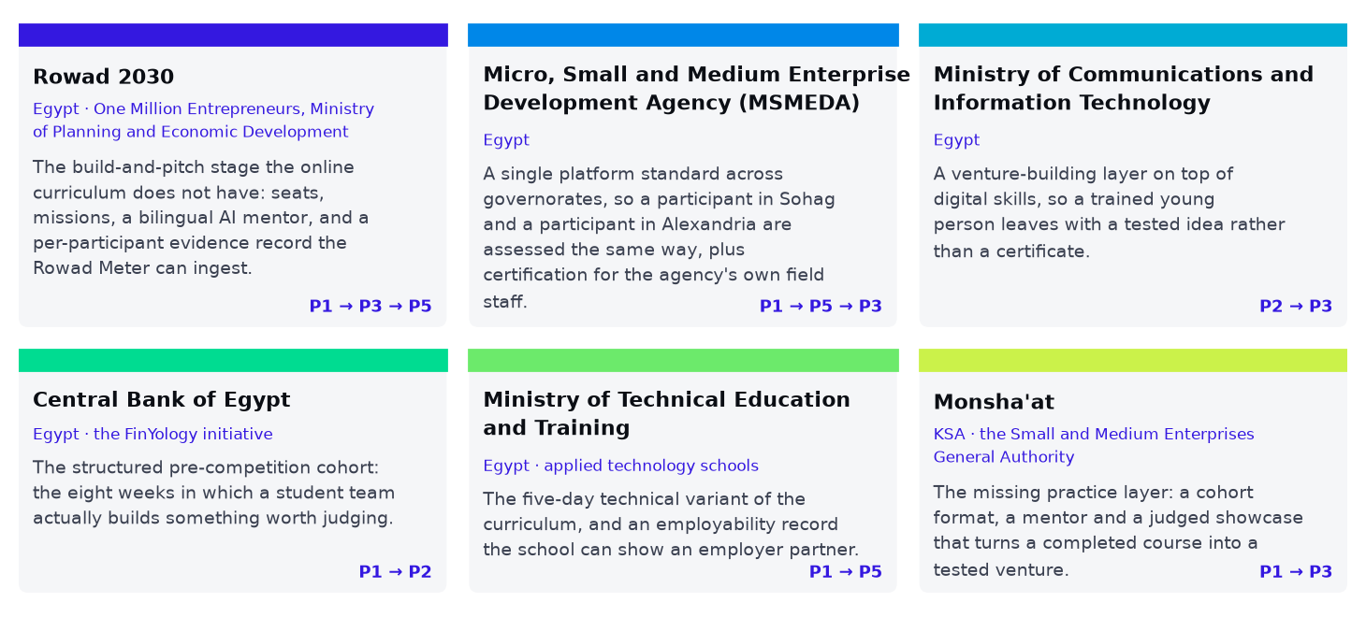
The public programmes in detail, and what StartPad supplies to each.
Programme or organisation | Market | What it already runs
Rowad 2030 — One Million Entrepreneurs, Ministry of Planning and Economic Development | Egypt | A state-backed programme to qualify one million entrepreneurs by 2030, delivered as a three-stage online curriculum with the Rowad Meter data platform tracking participants. Universities including Alexandria University have signed protocols funding seats for their own students, and AUC Venture Lab has run training under the programme with the Drosos Foundation.
Micro, Small and Medium Enterprise Development Agency (MSMEDA) | Egypt | Governorate-level enterprise development and a national network of service centres reaching first-time owners far outside Cairo.
Ministry of Communications and Information Technology, and ITIDA | Egypt | National digital-skills and youth-innovation programmes, including patronage of school-level competitions such as Startup Teen.
Central Bank of Egypt — the FinYology initiative | Egypt | A university financial-technology initiative spanning more than thirty Egyptian universities, with the FinTech Got Talent competition as its annual showcase.
Ministry of Technical Education and Training — applied technology schools | Egypt | A reform programme converting technical secondary schools into applied technology schools with employer partnerships.
Monsha'at — the Small and Medium Enterprises General Authority | KSA | Monsha'at Academy, an online academy that has run more than two hundred training events — bootcamps, workshops and self-paced programmes — across planning, finance, marketing, e-commerce and franchising.
Misk Foundation | KSA | A youth foundation working in education and entrepreneurship since 2011, running its own programmes and partnered competitions including the MISK SDG Innovation Competition with UNDP.
Technical and Vocational Training Corporation (TVTC) | KSA | 336,150 trainees across 314 institutions in 2024, under a Vision 2030 mandate to connect training to employment and self-employment.
Human Resources Development Fund (Hadaf) and the Social Development Bank | KSA | Subsidised training and finance for Saudi job-seekers and micro-enterprise owners, with per-beneficiary funding already in place.

The common shape is worth naming: every one of these has a target or a mandate it cannot meet with the delivery capacity it owns. Rowad 2030 is committed to a million entrepreneurs and delivers a three-stage online curriculum; Monsha'at Academy has run more than two hundred training events with no build stage after them; TVTC has 314 institutions and a self-employment mandate. That gap — between a published commitment and the means to deliver it — is the market this plan is addressed to.
Market drivers
▪ Published national targets. Egypt's One Million Entrepreneurs (Rowad 2030), 1 Million Qualified Innovators (with UNDP, MBRF and ICESCO) and One Million International Licences (with Cisco) all have million-scale goals and reported progress far behind them.
▪ Technical education reform. Egypt's applied-technology schools and technical secondary system — over two million students — exist explicitly to produce employability outcomes.
▪ Vision 2030 and vocational expansion in the Kingdom. TVTC reported 336,150 trainees across 314 institutions in 2024, with continued expansion planned.
▪ Formalisation incentives. Egypt's Law 6 of 2025 offers tax incentives for informal businesses to formalise, creating a cohort of first-time formal founders who need method and documentation.
▪ Accreditation pressure. Universities increasingly need demonstrable entrepreneurship and employability outcomes for accreditation, and have no systematic way to produce them.
▪ Donor and CSR appetite. Youth employability remains one of the most consistently funded themes in both markets.
Market needs and gaps
Who | What they need | What exists today | The gap
Universities | Entrepreneurship outcomes they can report | Ad-hoc workshops and in-house clubs | No method, no evidence trail, nothing comparable across cohorts
Schools and technical institutes | Employability content that fits a term | Imported curricula, usually in English | Nothing age-appropriate, bilingual and outcome-recorded
National programmes | Delivery capacity at scale with per-participant evidence | Events, awareness campaigns, fragmented training | No platform that can serve a governorate and report on it
Donors and NGOs | Logframe-compatible youth programmes | Bespoke training contracts, rebuilt each time | No repeatable product with per-participant records
Sponsors | A credible competition that produces real finalists | Pitch competitions judged on slides | No qualification process and no evidence behind the shortlist
Founders | A first step and a path | Scattered templates, English-language courses | No sequence, no feedback, no proof of work

Regulatory environment
Student data and institutional access
Institutional visibility is scoped to progress, activity, shared evidence and review states, switched on by the student. Private account data and AI chats are excluded and staff can never edit student work. This is designed as a commercial asset — a cohort metric built on compelled consent is one a dean cannot defend.
Safeguarding and child protection
The schools engine serves minors. Facilitator vetting, safeguarding training, parental consent and incident procedures are a condition of entry to that market, carried as a standing cost rather than improvised per contract.
Public procurement, in two jurisdictions
Ministry and donor contracts require pre-qualification documentation, audited accounts and formal reporting — a capability, not paperwork. A Saudi entity, local employment compliance and cross-border invoicing are first-year requirements, not year-two conveniences.
SECTION 04
Competitive Analysis

Who a buyer uses instead, how StartPad compares, and what would actually be hard to copy.
Direct competitors
University entrepreneurship centres running their own programmes
The real incumbent and the one to respect. They have the room, the students and the budget. We beat an in-house programme on method, bilingual content, the evidence trail and the reporting line — and we enter as the thing that makes their centre look good, never as its replacement.
Training consultancies and event agencies
The direct competitor for cohorts, competitions and corporate programmes. Comparable or higher day rates, nothing left behind when the trainer goes, no per-participant record. This comparison is what makes the cohort price look cheap in front of a dean.
Regional entrepreneurship education providers
Fragmented, mostly project-based, usually without a platform. They win on local relationships and lose on repeatability.
Indirect competitors
Online course platforms
Cheaper and broader. They sell completion, not evidence; no institution can report a cohort outcome from a course certificate.
Generic AI assistants
Will write a business plan on request — which is precisely the failure mode. They produce a document and no founder capability, and they leave no record an institution can inspect.
Incubators and accelerators
They select founders; we prepare them. In practice they are a channel rather than a competitor — a better-prepared applicant pool is what they most want.
Doing nothing
The most common competitor in every segment, and the reason the free pilot exists.
Competitive comparison
Dimension | Generic guides and courses | Training consultancies | StartPad
Structure | A list of things to consider | A trainer's own deck | Fifteen sequenced missions with a gate
AI | None, or a bolted-on chatbot | None | A co-founder inside every mission
Evidence | Nothing recorded | Attendance | Every answer reviewed, scored and retained
For the buyer | No visibility | A feedback form | Cohort workspace and a decision-ready report
Language | English, translated at best | Local, inconsistent | Arabic composed by dialect, full right-to-left
After the programme | Nothing | Nothing | Missions 11–15 stay open; progress stays visible
Cost per student | Low | High | Low to moderate

Barriers to entry and defensibility
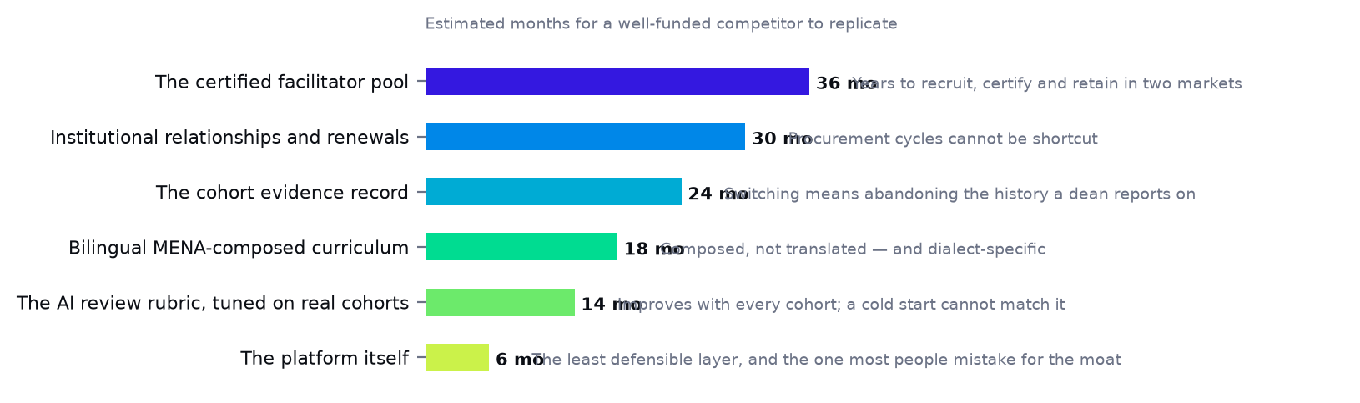
What is actually defensible, ordered by how long it would take a well-funded competitor to replicate.
The platform is the least defensible layer and the one most people mistake for the moat. What is hard is everything around it: a certified pool in two markets, a curriculum composed in two dialects, institutional relationships that move at procurement speed, and a cohort evidence record a buyer would have to abandon to switch away.
Porter's Five Forces
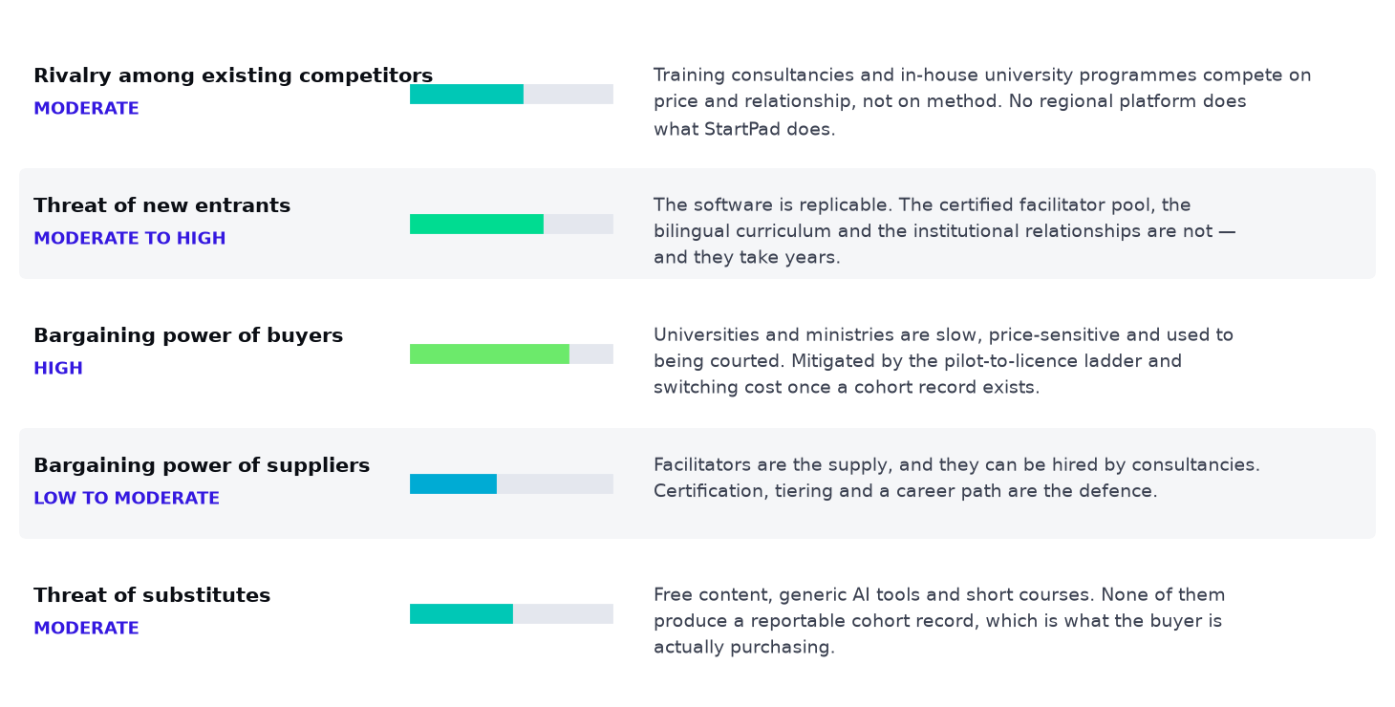
The five forces, with the intensity of each and what mitigates it.
Market positioning
We do not win by being the best content. We win by being the only option that leaves the buyer with something they can report.
StartPad positions as infrastructure for entrepreneurship education, not as a course and not as a startup programme. The competitive frame we want in a buyer's head is not "versus another course" but "versus building and staffing this yourself" — a comparison we win on cost, speed, language and evidence.
SECTION 05
Products and Services

What is actually sold, to whom, in what format, and at what price.
The platform
Fifteen missions across five phases, 4,050 points, 121 tools. Each mission has a brief, a short lesson, five tasks with an explicit standard for what a good answer needs, and an evidence slot. Submission triggers an AI review across specificity, depth, evidence, actionability and relevance; at 70% the next mission unlocks, below it the founder gets one highest-gain fix and a full report with answers retained.
Phase | Missions | Points | Est. time | What it produces
Discovery | 01–03 | 350 | 4–6 h | A prioritised problem worth solving
Validation | 04–06 | 550 | 5–7 h | A tested problem–solution canvas
Business model | 07–09 | 850 | 11–19 h | A full BMC and a working prototype
Build and MVP | 10–13 | 1,350 | 29–54 h | A shipped MVP with analytics
Launch | 14–15 | 950 | 15–30 h | A live launch and first customers

Features and what each is for
Feature | What it does | Who it is really for
Mission journey | Fifteen sequenced missions with a review gate | The founder — it removes the blank page
AI Co-Founder | Asks the follow-up a mentor would ask | The founder — and the institution, which cannot staff 1:1 mentoring
Tool library | 121 canvases and frameworks mapped to missions | The founder and the facilitator
Question Writer | Interview and survey questions, exported to Forms | The founder doing real validation
Programme admin workspace | Cohort progress, review states, follow-up | The buyer — this is the product they are purchasing
Automatic cohort report | A decision-ready export per cohort | The buyer's own reporting line, and our renewal
Student-controlled sharing | Consent switch per student | The student — and the institution's defensibility
Community, mentors, leaderboard | Peers, bookable experts, progress | Retention between the in-person days

The in-person layer
Three formats, because a university student, a sixteen-year-old and a technical trainee are not the same room. All three end in a public showcase judged on reviewed work rather than slides.
Format | Length | Group | What it ends with | Price
University bootcamp | 6 days over 2 weeks | 25 students | Final Projects Bazaar, certificates, report | $3,500
School cohort | 4 days | 30 students | Public showcase and certificates | $2,400
Technical institute cohort | 5 days | 25–30 trainees | Employability showcase | $2,500
Train-the-trainer | 3 days | Partner facilitators | Certified trainers who deliver independently | $4,000

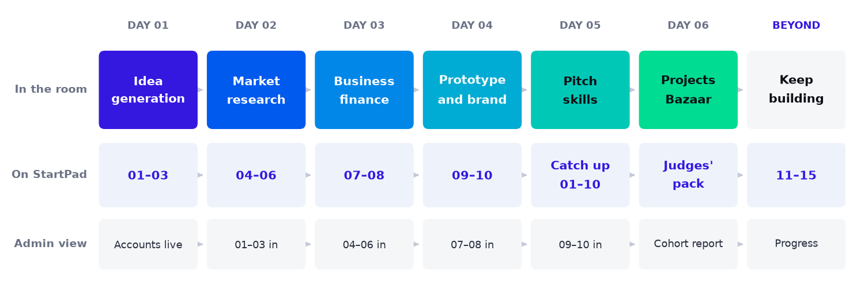
The university format: learn it in the room, build it on StartPad that evening, and the programme sees it the next morning.
Pricing strategy
Price is anchored against what the buyer already spends on the alternative, not against software. A cohort at $3,500 across 25 students is $140 a student — below what the same institution pays per student for a single external trainer day that leaves nothing behind. Seats in national programmes are priced for volume and fall as volume rises. Competitions are priced against event sponsorship, not against training.
Line | Buyer | Price | Anchored against
University cohort | Faculty or centre | $3,500 | An external trainer day with no platform
Faculty licence | Dean | $8,000 / year | The cost of running it in-house
School cohort | School or group | $2,400 | An enrichment or activities budget
Whole-school licence | School group | $5,000 / year | Per-student enrichment spend
Technical institute cohort | Institute director | $2,500 | Employability programme budgets
Sponsored seat | Ministry or donor | $5 / seat | Cost per beneficiary in comparable programmes
Train-the-trainer | Partner programme | $4,000 | External facilitator day rates
NGO programme | Foundation or INGO | $12,000 | A bespoke training contract
Sponsored competition | Bank, telco, ministry | $10,000 | Event sponsorship with no platform or evidence
Corporate programme | CSR or innovation lead | $12,000 | Agency-delivered CSR activation
Platform seat | Incubator | $18 / seat / term | Per-participant tooling spend
Pro / Team | The founder | $15 / $35 a year | A student's discretionary spend in Cairo

Development stage and intellectual property
The platform is built and operating in demo with full bilingual support. The university curriculum is complete; the school and technical variants are a Prove-quarter build. The proprietary assets are the mission sequence and its review rubric, the 121-tool mapping, the facilitator certification rubric, the bootcamp curriculum and the bilingual composed content — all held as trade secret and copyright, with trademark protection on the name and mark in both markets.
SECTION 06
Marketing Strategy

Not consumer acquisition. The job is to make a dean take a meeting, a sponsor return a call and a ministry shortlist us — and to know which institutions are ready before we spend a trip on them.
Value proposition, by audience
Audience | What we say | Why it works
Dean or university leader | Entrepreneurship outcomes you can put in an accreditation file | Their problem is evidence, not enthusiasm
Entrepreneurship centre | A structured programme your centre runs, that makes your centre look good | They are measured on activity and have no method
School principal or group | A term-length programme that ends in a showcase parents attend | Visible outcomes to families are the school's currency
Technical institute director | Turn a trade into a business — employability you can demonstrate | Their mandate is employment, and they are judged on it
Ministry or programme office | The delivery method and per-participant evidence your target needs | They have the target and no way to hit or report it
Donor or foundation | A repeatable youth programme with logframe-ready reporting | Reporting burden is their real constraint
Competition sponsor | A qualification process that produces finalists worth photographing | They are tired of funding pitch theatre
CSR lead | A programme with named beneficiaries and a report for the board | CSR spend is judged on demonstrable impact
The founder | A path, not advice — and the first three missions are free | They do not know what to do next

The two customer journeys
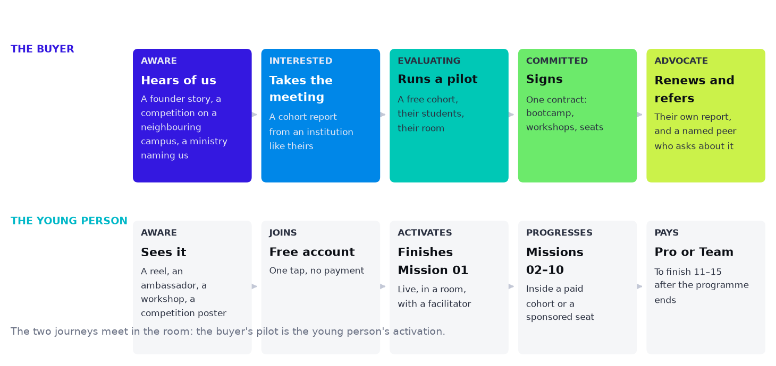
Two journeys, because there are two customers and only one of them pays. They meet in the room: the buyer's pilot is the young person's activation.
Activation is finishing Mission 01, not creating an account. This is the single most important definition in the marketing plan, because it separates channels that work from channels that look like they work. An account that never completes a mission is indistinguishable from no account at all — and for an institutional buyer, a cohort of unactivated accounts is worse than nothing, because it appears in their report.
Marketing channels
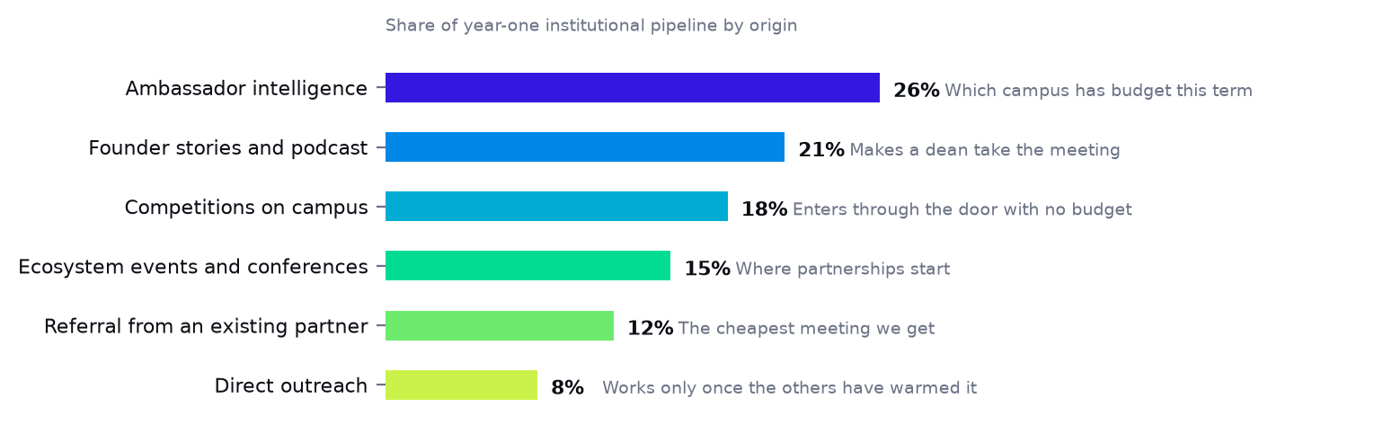
Where institutional pipeline comes from in year one, and what each channel is actually for.
The ambassador network — intelligence first, sign-ups second
60 ambassadors across twelve campuses in year one, rising to 340 by year three. Their most valuable output is not registrations: it is knowing which entrepreneurship centre has budget this term, which dean is under accreditation pressure and which student-activities office is looking for an event. That is what turns a cold institutional list into a warm pipeline.
Mission Zero — the credibility asset, set out in full below
One founder story, many pieces: an episode in Egyptian Arabic or Saudi dialect, recorded on a partner campus, cut into reels and posts, every piece ending at Mission 01. This is not a brand exercise. A dean responds to a graduate of a university like theirs, and an institution whose students appear on camera distributes the episode itself.
Competitions as a marketing channel that pays for itself
A sponsored competition puts StartPad on a campus with a bank already paying, reaches roughly 700 entrants who each open an account, and leaves behind both a university relationship and a sponsor relationship. It is the only marketing channel in the plan that is also a revenue line.
Ecosystem events and conferences — where partnerships start
The Global Entrepreneurship Festival in Cairo and the Saudi equivalents are pipeline events, not brand events. Attendance is judged on meetings booked, not on stand traffic.
The annual readiness report — becoming a reference
Published sector research on founder readiness in both markets, built from anonymised cohort data. It is how a vendor becomes a reference that ministries and journalists cite, and it is the single highest-leverage content investment in the plan.
Targeted digital — retargeting and event fill only
There is no cold paid-acquisition line. Digital spend retargets people the engines already reached and fills competition and event seats.
Mission Zero — the founder podcast
Mission Zero · المهمة صفر. A first-time founder walks through the one decision that nearly ended the venture — the mission they got wrong — and what they would do differently. No success stories; the failure is the content.
The podcast is in this plan as a demand-generation instrument with a measurable job, not as brand decoration. It does three things no advertisement does. It gives a dean a reason to say yes, because their students appear on camera. It gives a sponsor something deliverable to attach a name to. And it produces curriculum material as a by-product, because each episode is mapped to the mission it illustrates and handed to the learner stuck on exactly that problem.
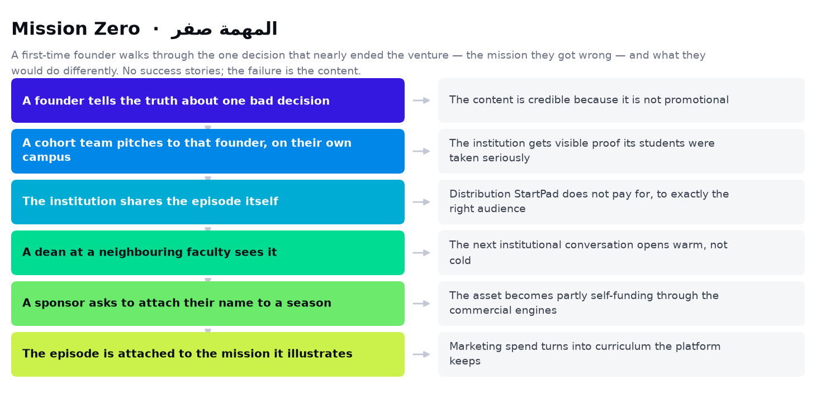
How an episode becomes institutional pipeline. The last link feeds the first: a founder who has been featured is how the next founder is persuaded to appear.
Format
Length
Thirty to thirty-five minutes, video-first, published as video, audio and a written mission note
Language
Arabic as the default, with English episodes for regional and international guests, both subtitled in the other language
Cadence
Weekly within a season; twelve episodes a season, three seasons a year with production breaks between them
Guests
Two in three are first-time founders two to five years in; one in three are the people who decide — a dean, a programme director, an investor, a judge
The student segment
Every episode closes with one cohort team pitching to the guest for eight minutes, filmed on their own campus
Where it is made
Recorded on campus during cohort weeks and at partner events, not in a studio, so each episode carries the institution's name
Where it is published
Channel | What goes there
YouTube | The primary home: full episodes, chapters, and the student pitch published separately
Spotify and Apple Podcasts | Audio, for the commute audience that becomes the subscription audience
Instagram, TikTok and LinkedIn | Six to eight vertical clips per episode; LinkedIn carries the decision-maker cut
The platform itself | Episodes attached to the mission they illustrate, so a learner stuck on pricing is handed the episode about pricing

What it is held to
Views are the last row on purpose. A podcast that reaches thirty thousand people and produces no institutional conversation has failed at the job it was funded for.
Measure | Year 1 | Year 2 | Year 3
Episodes published | 24 | 36 | 36
Founders featured | 16 | 24 | 24
Student teams featured on camera | 24 | 36 | 36
Partner institutions named in an episode | 14 | 30 | 44
Average views per episode | 4,000 | 12,000 | 30,000
Inbound institutional enquiries credited to it | 18 | 55 | 130
Episodes mapped into the curriculum as mission material | 24 | 60 | 96

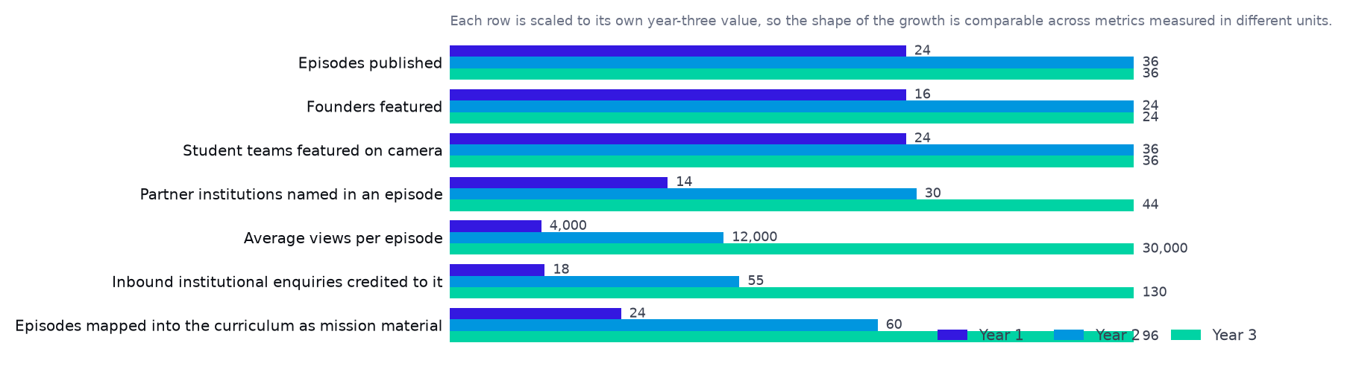
Each row scaled to its own year-three value, so measures in different units can be compared by shape rather than by size.
Guest supply is the risk, and it is managed structurally rather than hoped for: every cohort showcase, every competition final and every partner event in this plan is also a recording opportunity, and the student pitch segment means a guest is giving eight minutes of mentoring rather than sitting for an interview. Founders decline interviews; they rarely decline students.
Brand strategy
The brand has to carry two audiences without splitting in half. To a young person it is energetic, Arabic-first and achievable — points, levels, missions, a path. To an institution it is credible, evidenced and safe to sign. The resolution is that both audiences see the same proof: a cohort of real students with real recorded work.
Position
Infrastructure for entrepreneurship education in MENA — not a course, not an accelerator.
Voice
Direct and unsentimental. Egyptian colloquial in Egypt, Saudi dialect in the Kingdom, composed not translated. No motivational language, because the product's value is rigour.
Proof
Cohort reports, named institutions, founder stories and published research — in that order of weight with a buyer.
What we never say
Outcome claims the product cannot measure. We do not promise jobs created or ventures funded.
Content marketing
Asset | Audience | Purpose | Cadence
Mission Zero, the founder podcast | Young people and deans | Credibility, story supply and curriculum material | Weekly in season; three seasons a year
Reels and short video | Young people | Reach and Mission 01 sign-ups | 3–5 a week
Cohort case studies | Every institutional buyer | The core sales asset | One per flagship cohort
The annual readiness report | Ministries, donors, press | Become a cited reference | Annual, with a quarterly data note
Facilitator and educator guides | Partner institutions | Reduce delivery friction and support cost | Per curriculum release
Competition coverage | Sponsors and campuses | Sponsor obligation and next-sale collateral | Per competition

Marketing budget
Line | Year 1 | What it is for
Mission Zero — production, editing and distribution | $26,000 | Mission Zero: founder stories in both dialects, recorded on partner campuses — the asset that makes an institutional pitch credible
Ambassador network | $10,500 | 60 ambassadors: the cheapest source of founders and the early-warning system for which campuses are ready to buy
Conferences, events and ecosystem presence | $20,000 | Where partnership conversations start; judged on meetings booked
Targeted digital — retargeting and event fill | $10,000 | Retargeting, competition entry and event fill only — no cold acquisition
Collateral, case studies and cohort reports | $10,000 | Cohort reports, case studies and the proposal pack: the most used sales assets in the company
Sector research and the annual readiness report | $12,000 | Published research that turns a vendor into a reference
Total | $88,500

Against a subscriber lifetime value of $15, buying strangers through cold paid social in these markets costs more per paying founder than the founder is worth. The budget that would have funded it buys content, ambassadors and events instead — all of which feed the institutional pipeline as well as the subscription one.
SECTION 07
Sales Strategy

Eight engines, four selling motions, and one rule: never sell a cohort there is no certified pair to deliver.
The sales model
Motion | Engines | Cycle | Who sells it | Decision maker
Land-and-expand | Universities; schools and technical | 1–2 terms | Heads plus associates | Centre director, capstone coordinator, dean, principal
Public tender and grant | National initiatives; NGO and donor | 9–15 months | Head of Government; Head of NGO, with the bid administrator | Programme office, donor committee
Sponsorship | Competitions; corporate and CSR | 2–5 months | Competitions manager; CEO on anchor deals | Marketing, CSR or communications budget holder
Product-led partner | Programme and incubator seats; subscriptions | 2–8 weeks | Associates; self-serve for subscriptions | Programme director; the founder

Sales team structure
Eight engines, and at no point more than 8 people selling them. Heads own a buyer type rather than a territory, because the buying behaviour of a ministry and a bank have nothing in common and the skills do not transfer. The Saudi country manager is the deliberate exception and owns every engine in the Kingdom, because there the relationship precedes the product line. Where a head does not yet exist, the engine is carried by somebody else and the plan says who.
Role | Engines owned | Y1 | Y2 | Y3 | Y4 | Y5
Head of Partnerships — Egypt | Engines 1 and 7 in Egypt; carries 2, 5 and 6 until their own heads arrive | 1 | 1 | 1 | 1 | 1
Country Manager — KSA (Riyadh) | Every engine in Saudi Arabia | 0 | 1 | 1 | 1 | 1
Head of Government, Initiatives and Donors | Engines 3 and 4; takes engine 5 from year three | 0 | 0 | 1 | 1 | 1
Partnerships and bids associate | Proposals, tenders and the named-target list, across all engines | 0 | 0 | 1 | 1 | 1
Head of Schools and Technical Education | Engine 2 in both markets | 0 | 0 | 0 | 1 | 1
Account manager — renewals | The signed base, across all engines | 0 | 0 | 0 | 0 | 1

Three engines have no dedicated owner in year one and two have none until year four. That is a stated cost of the headcount cap, not an oversight: the Egyptian partnerships head carries competitions, schools and corporate sponsors through year one, which is exactly why the roadmap gates those engines late and why the school engine ramps more slowly than its population would justify.
The sales process
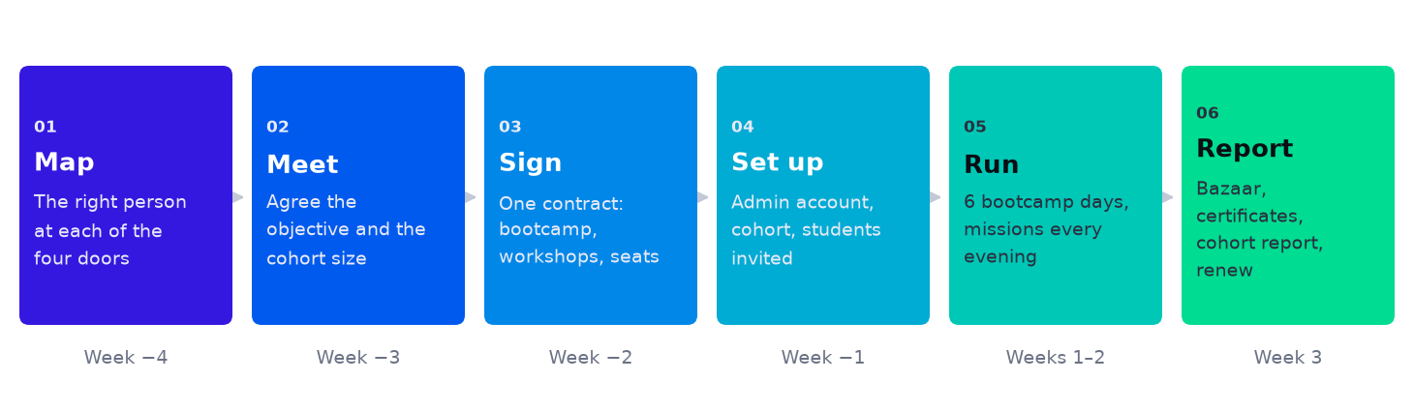
From identifying the right person to a cohort report, in six steps over seven weeks.
One contract covers all three layers — the in-person bootcamp, the on-campus workshops and a platform seat for every student under one programme admin account. Selling the layers separately would triple the procurement cycle inside institutions where procurement is already the longest part of the sale.
The four doors into a university
Door | Who | What they want | What we offer first
01 | Entrepreneurship centre | A structured programme to show | A free pilot cohort
02 | Capstone coordinator | A method for graduation projects | Missions mapped to the term
03 | Dean of faculty | Outcomes for accreditation | A faculty-wide licence
04 | Student activities | Events that fill rooms | A sponsored competition — their budget is zero and ours is a sponsor's

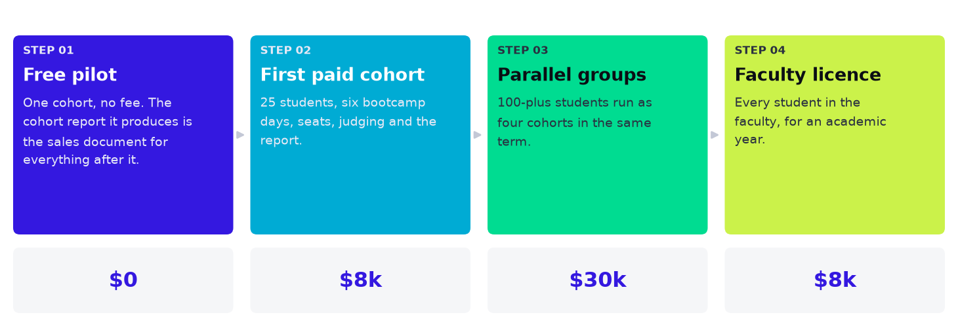
The land-and-expand ladder. The free pilot is not a discount — it is how the institution's own report becomes the sales document for everything after it.
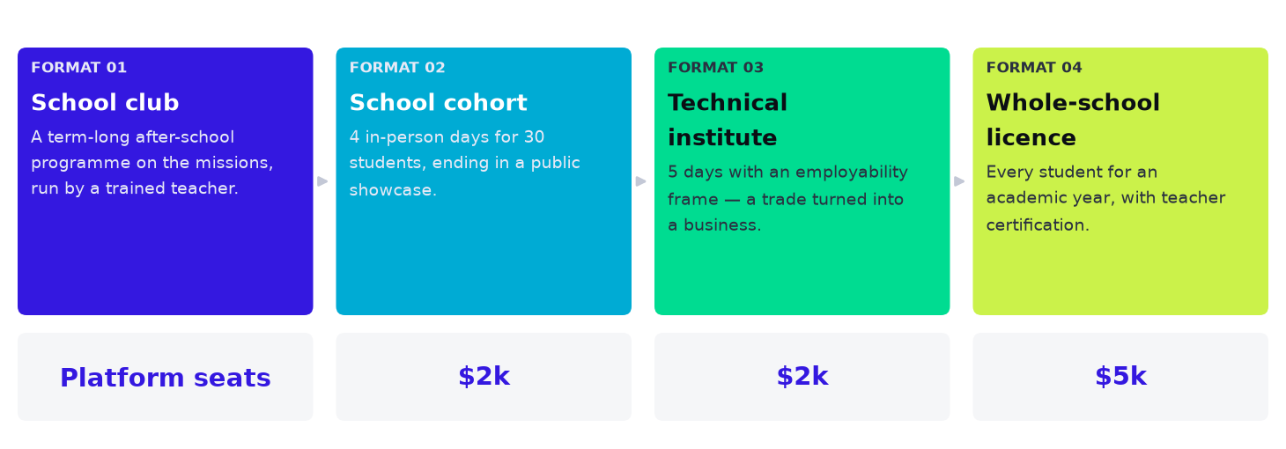
The same ladder in schools and technical education, with a shorter format and a different frame.
The institutional pipeline
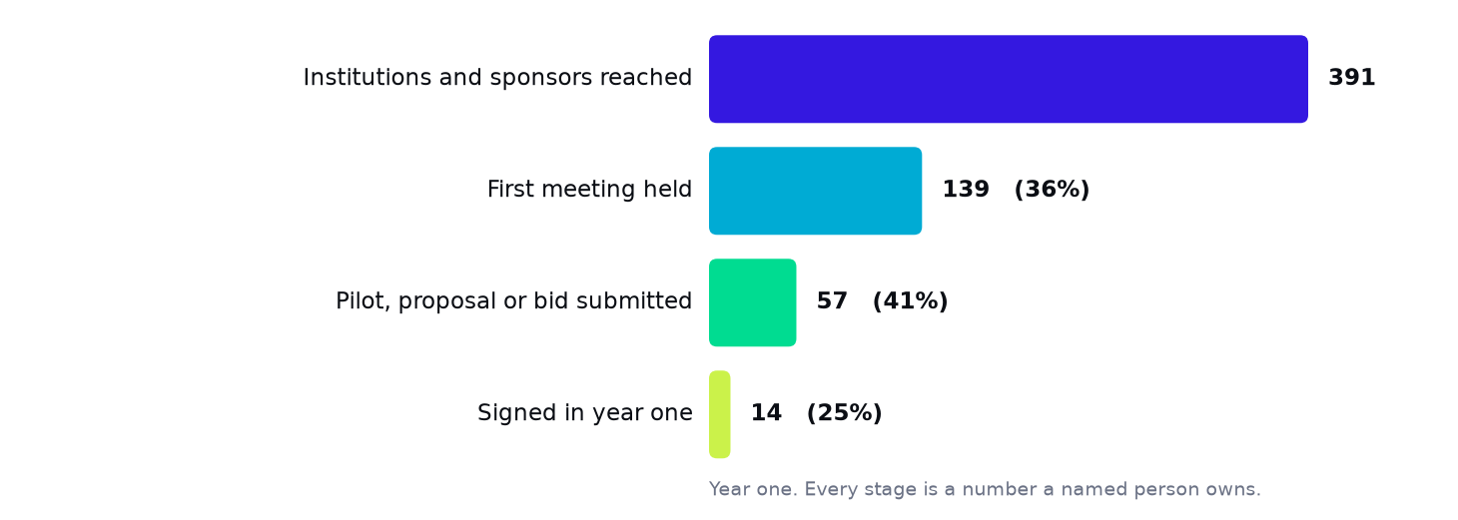
The funnel the company actually runs. Every stage is a number a named person owns.
Stage | Year one | Conversion | Who owns it
Institutions and sponsors reached | 391 | — | The bids associate and the ambassador network
First meeting held | 139 | 36% | The relevant head, or the country manager in Saudi Arabia
Pilot, proposal or bid submitted | 57 | 41% | Head of the relevant engine, with the bids associate
Signed in year one | 14 | 25% | The signing head, against the partner network manager's capacity forecast

Strategic partnerships
Banks
Sponsor competitions, fund MSME programmes and reach first-time founders they want as future customers. The most commercially aligned partner type in the plan.
Incubators and accelerators
Require StartPad missions as part of their application and get a prepared pool. Channel as much as revenue.
School groups and operators
One relationship, many schools — the fastest route to volume in Engine 2.
Implementing partners for donors
The organisations that actually deliver donor programmes; they need a method and we need their contracts.
Ministries
The largest contracts and the longest cycles. Pursued in pairs so no single relationship is existential.
Sales metrics
▪ Qualified meetings booked per head per month — the only leading indicator that moves early.
▪ Pilot-to-paid conversion, by engine. The number that proves the cohort report does its job.
▪ Second-term renewal rate — the single most important number in the company.
▪ Net revenue retention across the signed base, owned by the account manager from year two.
▪ Capacity-constrained losses: deals not pursued because no certified pair was available. If this is zero, we are under-selling; if it is large, certification is behind.
SECTION 08
Engagement Model

Naming the organisations is half the work. This part says how StartPad actually gets inside each of them: the six ways in, who is approached, what the first ask is, how the money moves, and what has to be true before the ask can be made at all.
StartPad is never the programme — it is inside somebody else's
This is the governing idea of the whole commercial plan and it is worth stating before the mechanics. StartPad does not ask an institution to start something new. It attaches to a programme that already exists, already has a budget, already has a target it is measured against, and is already failing to meet it in a specific way. A competition already runs; it cannot tell a good team from a well-coached one. An academy already has two hundred courses; nothing happens after a learner finishes one. A ministry has committed to a million entrepreneurs; it has an online curriculum and no build stage. In every case the sale is a component, not a programme — which is why it can be bought out of money already committed, and why the decision does not have to reach a minister.
Enter at the edge, never at the centre
A campus team, a governorate branch, a single chapter, one college. The edge can authorise a first; head office can only authorise a precedent. Every route in this plan starts one level below where an outsider would aim, and that is deliberate.
Pay for the proof yourself
The first cohort inside a new organisation is funded by StartPad. It costs roughly the price of a sales trip and it produces the one asset every later conversation needs: a completed cohort with their name on the report. Year one runs eight of these.
Sell the component, not the programme
The ask is always a line inside something they already fund — a build stage before their competition, a block of seats on their initiative, a capstone to their course. New programmes need new budget and new approval; components need neither.
End at certification, wherever volume is the point
No provider can staff a national initiative, and proposing to signals that the scale has not been understood. The destination for every public engine is that the institution's own trainers are certified, audited and licensed by StartPad.
The six engagement plays
These are the only six ways StartPad ever enters an organisation. They are ordered by how little the counterparty has to risk in order to say yes, which is also the order a single relationship moves through as it matures — most of the named targets in this plan are a sequence of two or three of them rather than one.
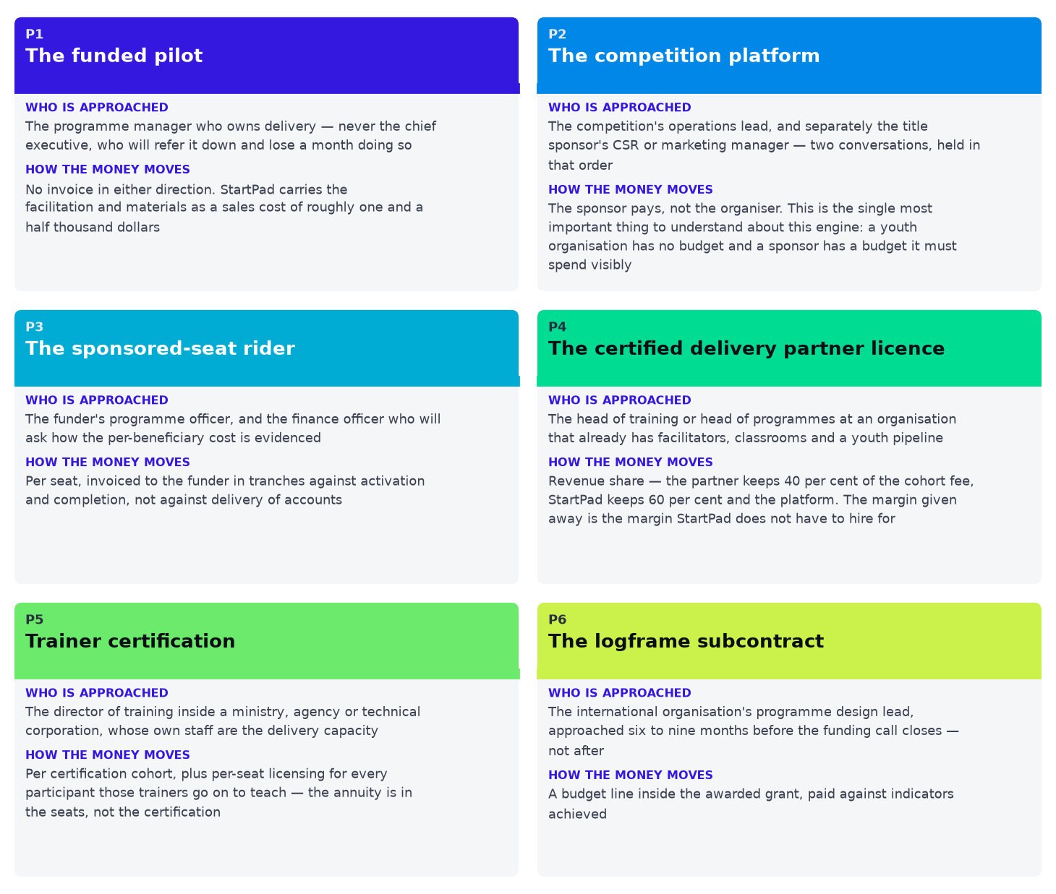
The six plays, with the person approached and the way money moves in each. An engagement model that names neither is a diagram of a hope.
 | The play | The first ask | How long it takes
P1 | The funded pilot | One cohort inside a programme you already run, at our cost, with your name on the report and your logo on the showcase | Six to ten weeks from first meeting to showcase
P2 | The competition platform | Run your next season's entry, team formation, mentor matching, judging and scoring on our platform, under your brand, with a build cohort for teams between rounds | One season — three to five months — because competitions buy on an annual calendar and a missed cycle costs a year
P3 | The sponsored-seat rider | Add a block of seats to a budget that already exists, as a line item in your programme rather than a programme of ours | Nine to fifteen months for a national programme; three to six for a foundation
P4 | The certified delivery partner licence | Deliver StartPad cohorts yourselves under licence. We certify your facilitators, audit the delivery and keep the standard; you keep the relationship and the larger share of the fee | A certification cohort plus one supervised delivery — about one quarter
P5 | Trainer certification | Certify your trainers to run this themselves. You stop buying delivery and start buying the standard | Two to four quarters, and it is the only play that scales a public programme past what any provider could staff
P6 | The logframe subcontract | Name StartPad as the delivery partner for the entrepreneurship component of the proposal you are writing now | Twelve to eighteen months from first conversation to first delivery, which is why this engine must be started long before it is needed

What must exist before each play can be run
The sequencing in the roadmap is not arbitrary. Each play is gated on an asset the company does not have on day one, and the order in which those assets are built is the order in which the engines open.
What has to exist | Unlocks | By | Why it lands then
A completed cohort with a named institution on the report | P1 | Q4 2026 | Eight funded pilots in the Land and Prove quarters exist for exactly this reason
A judging rubric and competition flow on the platform | P2 | Q1 2027 | Built during the Prove quarter against the first competition, which runs with manual support
A per-participant evidence record in a format an M&E officer accepts | P3 | Q2 2027 | Designed with the first NGO programme, which is bought partly to force this into existence
A written certification standard, assessment and audit regime | P4 | Q3 2027 | The first certified delivery partner cannot be signed before the standard that certifies it exists
A train-the-trainer curriculum and cohort reports at volume | P5 | Q3 2027 | The first train-the-trainer cohorts run alongside the first initiative seats
A published mapping to the ILO Start and Improve Your Business methodology | P6 | Q2 2027 | One quarter of curriculum work that unlocks donor procurement across the region

The route in, step by step
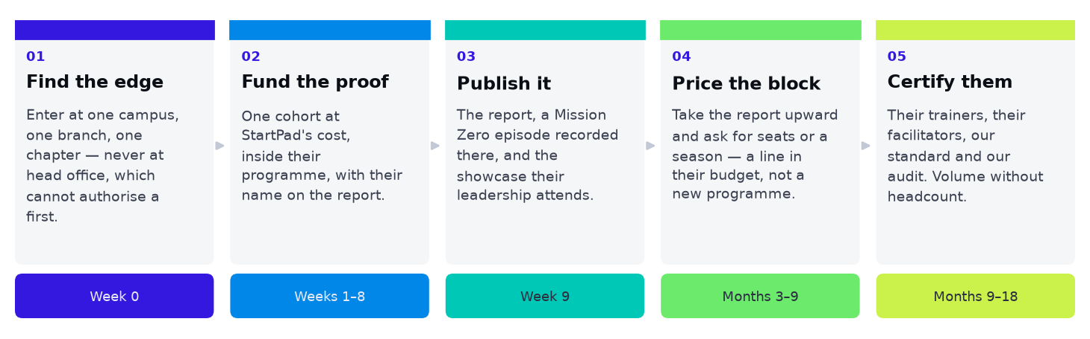
The same five steps every time. The route is a repeatable procedure, not a series of fortunate introductions.
01 Find the edge. Identify the smallest unit inside the target that can authorise a pilot without a committee — a campus chapter, a governorate branch, one college, one school with an employer partner. Name the individual, not the organisation.
02 Fund the proof. Run one cohort at StartPad's cost, inside their programme, under their name, with a showcase their leadership is invited to attend. Ask for nothing in return except permission to publish the report with their name on it.
03 Publish it. The cohort report, a Mission Zero episode recorded on their site, and the case study. The institution now has something to circulate internally, which is the mechanism by which the decision moves upward without StartPad pushing it.
04 Price the block. Take the report to the budget holder and ask for a line inside an existing programme: a season, a seat block, a term. Never a new programme; never a platform licence in isolation.
05 Certify them. Where the volume is larger than any provider could staff, move the relationship to trainer certification. StartPad keeps the standard, the assessment and the audit; the institution gains capacity it owns. This is where the engagement becomes an annuity.
The five steps compress or stretch, but they do not reorder. Attempting step four before step two — asking for budget before there is a report with their name on it — is the single most common way an institutional sale in this market dies, and it dies slowly, consuming a quarter before it does.
National initiatives and government: the route into each
The longest cycles in the company and the largest eventual volumes. Each row names the plays in sequence and the specific door.
Organisation | Plays | How StartPad gets engaged
Rowad 2030 — One Million Entrepreneurs, Ministry of Planning and Economic Development | P1 → P3 → P5 | Do not approach the ministry first. Approach a university that has already signed a Rowad protocol and run a funded pilot (P1) for its students on the programme, so the first ministry conversation opens with a completed cohort inside their own initiative rather than a proposal about it. Take the report to the programme's delivery unit with one ask: a priced seat block for one governorate (P3). The destination is trainer certification (P5) — a million seats cannot be facilitated by any provider, so the only version of this that reaches the stated target is one where the programme's own trainers are certified.
Micro, Small and Medium Enterprise Development Agency (MSMEDA) | P1 → P5 → P3 | Enter through one governorate branch, not head office. The branch manager can authorise a pilot; head office cannot authorise anything without a precedent. Run two funded cohorts in a governorate outside Cairo — the geography is the point, because the agency's internal problem is that quality collapses away from the capital. Certify that branch's own field officers (P5), then let the comparison between a certified branch and an uncertified one make the case at head office for a seat block (P3).
Ministry of Communications and Information Technology, and ITIDA | P2 → P3 | The route is through the competitions the ministry already patronises rather than through the ministry. Win the platform role on one patronised competition (P2); the ministry's name is already on it, so the pilot is effectively a public-sector reference without a public-sector sales cycle. Convert that into a seat rider on a digital-skills programme (P3) at the next budget cycle.
Central Bank of Egypt — the FinYology initiative | P1 → P2 | Enter at one participating university, through the faculty staff member who manages its FinYology involvement, with a funded build cohort (P1) ahead of the competition. Teams that went through a cohort and teams that did not are visibly different at the pitch, and that difference is the entire argument. Take it to the initiative's organisers as a platform proposal for the following season (P2), funded by one of the participating banks rather than by the central bank itself.
Ministry of Technical Education and Training — applied technology schools | P1 → P5 | Enter through a single applied technology school with an active employer partner, because that employer is the one who will say the graduates are not ready, and that complaint is the opening. Run a funded cohort (P1), then certify the school's own workshop instructors (P5) — they already teach practical work and are a better fit for this curriculum than an academic. Safeguarding clearance must be in place before the first school visit, not negotiated during it.
Monsha'at — the Small and Medium Enterprises General Authority | P1 → P3 | The academy's own catalogue is the opening, because a two-hundred-course catalogue with no build stage has a completion problem its managers already know about. The country manager approaches the academy's programmes lead with a funded cohort (P1) run as the capstone to an existing Monsha'at course, measured on one number: how many participants finish with something. Price a seat block against that (P3). A Saudi entity and a Saudi bank account are prerequisites, not afterthoughts.
Misk Foundation | P2 → P3 | Approach through the competition rather than the foundation: the SDG Innovation Competition has a UN partner, which means it already reports against indicators and therefore already has the problem StartPad solves (P2). Arabic-first delivery is not a feature here but an entry requirement; an English-led pitch will not survive the first meeting. A funded programme follows (P3).
Technical and Vocational Training Corporation (TVTC) | P1 → P5 | This is a certification sale from the beginning — at 314 institutions, no external provider could ever staff it, and proposing to would signal misunderstanding. Run one funded cohort at a single college in Riyadh (P1) with the explicit framing that it is a certification pilot, then price trainer certification by region (P5). The annuity is the per-seat licence behind each certified trainer, not the certification fee.
Human Resources Development Fund (Hadaf) and the Social Development Bank | P3 | Lead with the lender's problem, not the learner's: default rates on micro-enterprise lending are a function of how ready the borrower was, and a cohort score is a screening instrument. Approach the credit or programme function with a seat rider on an existing subsidised cohort (P3), priced per beneficiary against the funding already allocated.

Competitions and youth organisations: the route into each
The fastest engine to enter and the one that reaches the most young people per deal, because somebody else has already assembled them. The structural fact that governs every row below: the organiser has no budget and the sponsor does, so the organiser is the partner and the sponsor is the customer.
Competition | Plays | How StartPad gets engaged
Enactus Egypt National Competition | P1 → P2 → P4 | Start at one campus team, not at the national office. A university Enactus team is run by students who want to win and have no budget, which makes a funded build cohort (P1) an easy yes and a visible result at the national final. With one campus result, approach the national office for the platform role across the season (P2) and Orange Egypt's CSR function separately for the funding — the sponsor has renewed for seventeen years and needs new substance to renew against, which is the actual sale. Long-term, Enactus Egypt is a certified delivery partner (P4): it has campus presence StartPad will never build.
INJAZ Egypt — the Company Program and the Youth Entrepreneurship Celebration | P1 → P4 | INJAZ's constraint is mentor matching: a corporate volunteer base that has to be paired with hundreds of student companies by hand, every cycle. Lead with that, not with curriculum — INJAZ has curriculum. Run one funded track (P1) with platform mentor matching, then move directly to a certified delivery partner licence (P4) rather than selling cohorts: INJAZ has the schools, the universities, the volunteers and the regional network, and is worth far more as a partner than as a customer.
Startup Teen (iSchool), under the patronage of the Ministry of Communications and Information Technology | P2 | A first-edition competition needs a second edition that looks more substantial than the first, and its organiser is a commercial education company that will recognise a platform proposition immediately (P2). The unlock is not the curriculum but compliance: age-appropriate accounts, parental consent, moderated mentor contact and safeguarded data. Bring that to the first meeting. Forty schools reached through one competition is the cheapest route into the school engine that exists.
FinTech Got Talent — Central Bank of Egypt FinYology initiative | P1 → P2 | Enter campus by campus with funded build cohorts (P1), then sell the season (P2) with one of the participating banks as sponsor. The argument is standardisation: thirty universities currently prepare teams thirty different ways, so the competition cannot tell a good team from a well-coached one.
Egypt Entrepreneurship Rally | P2 | The sponsor is the customer. A bank that has funded the same event for six years has an internal reporting problem — it cannot evidence what the money produced beyond attendance. Approach the bank's CSR or marketing function with the impact report as the product and the platform as the means of producing it (P2), and bring the academy in as co-signer rather than as buyer.
Rowad Domiat | P2 → P6 | This one is a bridge, not a revenue target. Winning the platform role on a small governorate competition (P2) buys something disproportionate: a working relationship with an ILO country programme and a demonstrated mapping to the Start and Improve Your Business framework. That mapping is the entry ticket to the logframe subcontract play (P6) across every donor that uses the same methodology, which is most of them.
Hult Prize on-campus programme | P1 → P4 | Campus chapters are run by student organisers with no budget and a hard deadline, which makes a delivered programme (P1) genuinely welcome. The value is not the fee but the door: a Hult chapter sits inside a university that has not yet bought anything, and a successful campus round is the warmest possible introduction to that university's entrepreneurship centre. Chapters that run it twice become certified (P4).
MISK SDG Innovation Competition | P2 → P6 | A competition with a UN co-organiser is two engines at once: the competition itself (P2) and a relationship with a UNDP country office that commissions programmes (P6). Approach the foundation's programme lead and the UNDP focal point in the same week, with the same material, framed differently — the foundation buys a better competition, the UN office buys measurable indicators.
Entrepreneurship World Cup — Saudi national round | P2 | The national round's organiser has a quality problem at the top of the funnel: most entrants are not ready to be judged. Sell the build track as the fix (P2), funded by a national sponsor. It is also the fastest credibility purchase available in the Saudi market, because the brand is recognised and the national round is small enough to influence.

Delivery partners, donors and sponsors: the route into each
The organisations in this table are mostly not customers. They are the delivery capacity, the funding and the distribution that let a company of 12 people operate at national scale, and several are worth considerably more as partners than they would ever be worth as accounts.
Organisation | Plays | How StartPad gets engaged
INJAZ Egypt and INJAZ Al-Arab | P4 | Begin with the mentor-matching problem, prove it on one track, then negotiate a network licence rather than a per-cohort price. The regional network is the prize: a licence signed in Cairo is a route into nine other country offices without nine other sales processes.
Enactus Egypt | P2 → P4 | Campus team first, national office second, sponsor third. Never reverse that order: the national office will ask what campus has done it, and the sponsor will ask what the national office thinks.
AUC Venture Lab | P1 → P3 | Approach as a peer, not a vendor: V-Lab selects and accelerates, and does not need a curriculum. The offer is pre-acceleration — seats for the applicants it rejects, who are not bad founders but unready ones. That turns a rejection list into a pipeline and costs V-Lab nothing.
Sawiris Foundation for Social Development | P3 | Approach with a seat block attached to a programme the foundation already funds, not a new programme. Foundations fund gaps in things they are already committed to far more readily than they fund new commitments.
Misr El Kheir Foundation | P4 | This is a geography partnership. Lead with coverage: the foundation has staff in governorates StartPad cannot reach, and StartPad has a standard the foundation's programmes currently lack. Certify its field educators and audit on sample.
Drosos Foundation | P6 → P3 | Enter through a grantee rather than the foundation: become the delivery component of a proposal an existing grantee is writing (P6). A foundation meets its best delivery partners through the organisations it already funds.
Life Makers Foundation | P4 | Two asks in one conversation: certify a first group of facilitators from its volunteer base, and open its branches to ambassador recruitment. The second costs nothing and makes the first worth more to both sides.
Nahdet El Mahrousa | P3 | Same pre-acceleration argument as the V-Lab route, priced per seat. A selective incubator's rejection list is its most underused asset.
International Labour Organization — Start and Improve Your Business | P6 | Not a customer: a standard to be compatible with. Publish an explicit mapping between StartPad missions and the methodology's modules, have it reviewed by a certified trainer, and put it in every donor proposal. The mapping costs one quarter of curriculum work and removes the most common objection in donor procurement.
GIZ, UNDP, UNICEF and the British Council | P6 | Work the design phase, not the tender. Track each organisation's published portfolio, identify components being designed six to nine months out, and get named in the proposal. Responding to a published tender means competing on price against incumbents who helped write it.
Orange Egypt, ExxonMobil Egypt, the National Bank of Egypt and Banque Misr | P2 → P3 | Sell reporting, not goodwill. A sponsor renewing a decade-old commitment needs to show its board something new, and currently receives attendance figures and photographs. Offer a named season, a measurable outcome per participant and a report it can publish — then ask for the seat block as the second-year extension.
Monsha'at Academy | P1 → P3 | Attach to a specific existing course as its capstone, measured on completion and on ventures started. Do not propose a parallel programme; the academy's managers are judged on their own catalogue, not on somebody else's.

What StartPad gives away, and why
A certified delivery partner keeps 40% of the cohort fee. A competition organiser keeps its own brand on the competition. A ministry that certifies its trainers stops buying delivery altogether and buys only the standard and the seats. Each of these is margin, brand or revenue deliberately surrendered, and each buys the same thing: volume that does not have to be hired for. The margin given away is the margin StartPad does not have to carry a payroll against — which is the arithmetic behind an establishment of 12 people in year three and 20 in year five.
The limit is equally deliberate. StartPad never gives away the certification standard, the assessment rubric, the evidence record or the right to withdraw a licence. A partner may own the relationship and the room; it never owns the definition of what good looks like. The moment that is conceded, the company is a training supplier rather than a standard, and everything defensible about it is gone.
SECTION 09
Go-to-Market Roadmap

Eight engines, eight different starting lines. This is the part of the plan that says when each one opens and what has to be true first.
Nothing starts on day one
A plan that shows eight revenue lines running from the first quarter is a plan that has not been thought through. A faculty licence cannot be sold before two cohorts have run at that faculty. A ministry will not contract a platform that cannot show a cohort report. A school cohort needs a school variant of the curriculum that does not exist in the Land quarter. Each engine therefore opens on a gate — a condition, not a date.
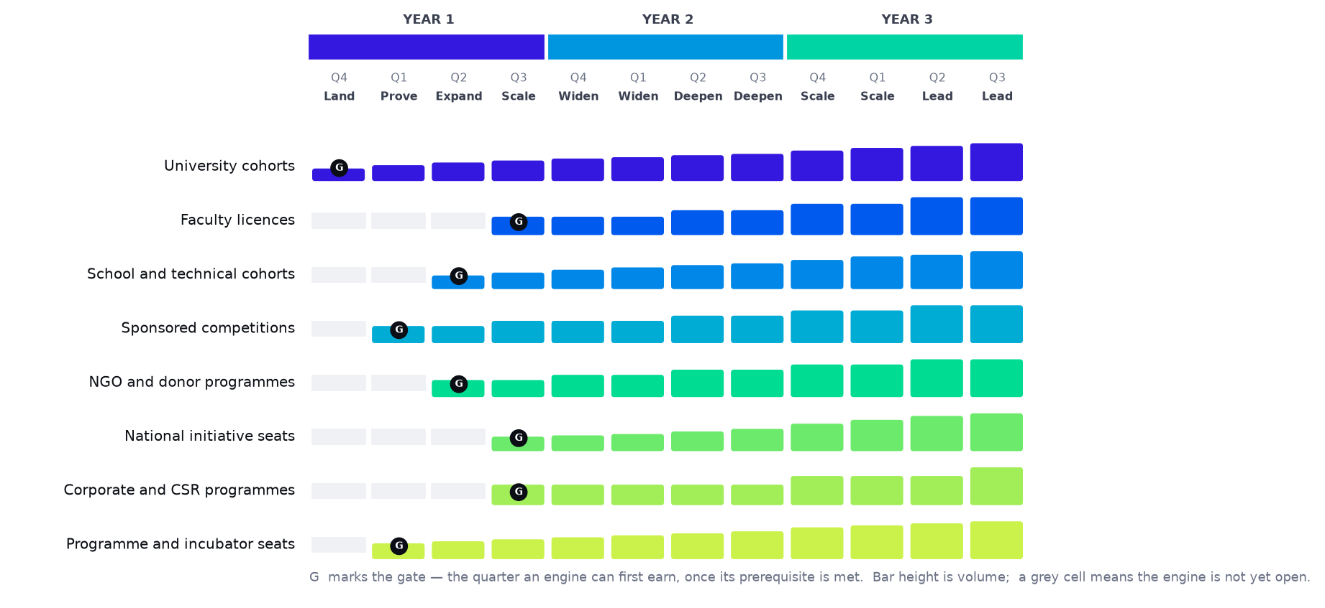
The twelve-quarter roadmap. Each engine's bar begins at its gate; a grey cell means the engine is not yet open.
The gates
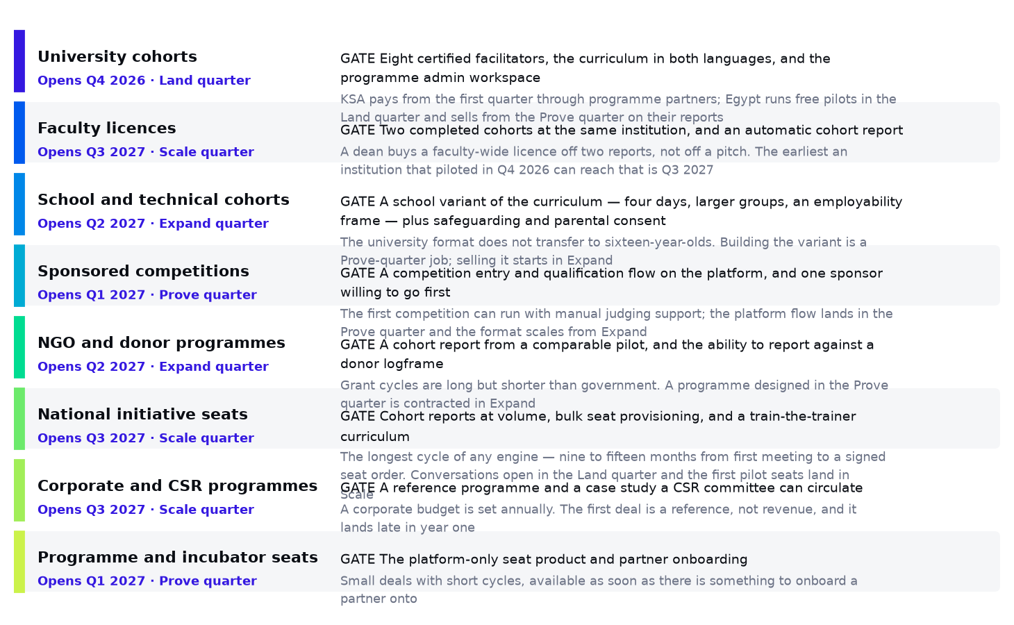
What has to be true before each engine can sell anything, and why.
The four phases of year one
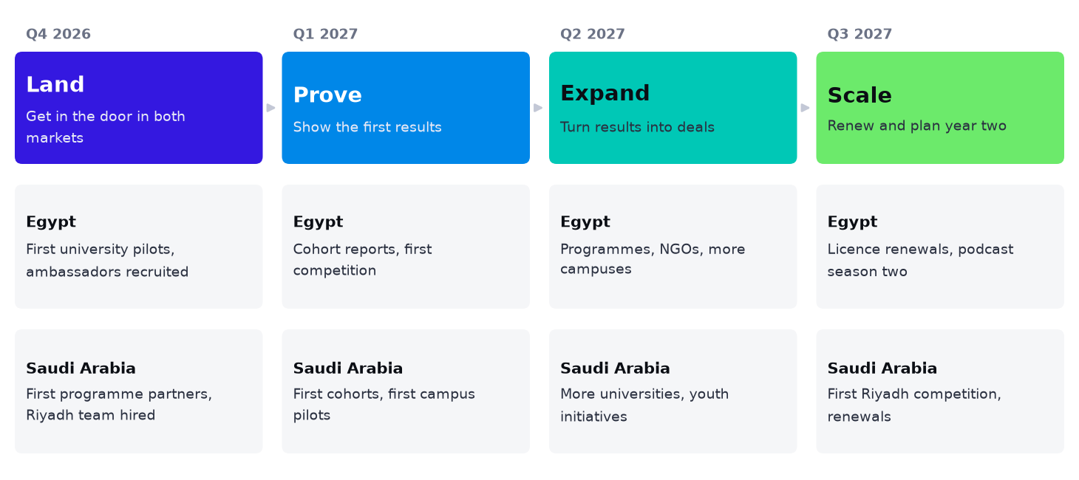
Egypt and Saudi Arabia, in parallel, through four phases.
Quarter | Phase | What opens | What is being proven
Q4 2026 | Land | University cohorts only — paid in KSA through programme partners, free pilots in Egypt | That a cohort can be delivered to standard, and that the report is worth circulating
Q1 2027 | Prove | Paid Egyptian cohorts, the first sponsored competition, programme and incubator seats | That a pilot report converts to a paid cohort, and that a sponsor will fund a competition
Q2 2027 | Expand | School and technical cohorts, NGO and donor programmes | That the method transfers to a younger room and to a donor logframe
Q3 2027 | Scale | Faculty licences, national initiative seats, corporate programmes, train-the-trainer | That an institution renews and widens, and that a ministry will contract a private platform

Delivery volume, quarter by quarter
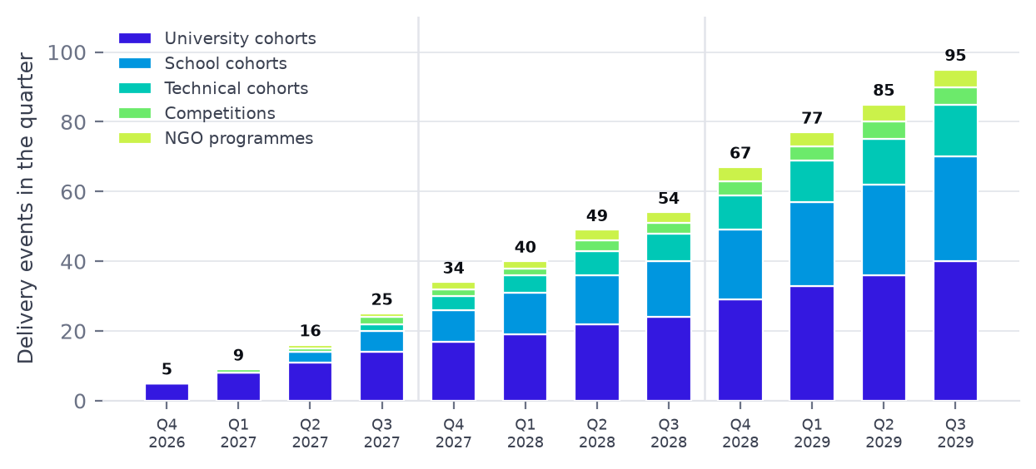
What the company is physically delivering each quarter, across all in-person formats.
The five moves
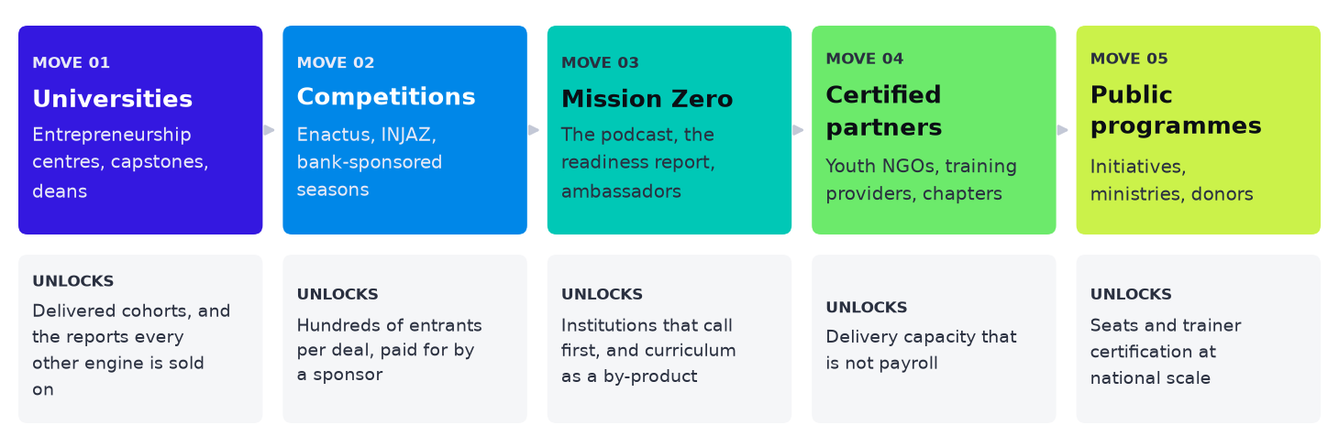
The five moves and what each unlocks. The order is load-bearing: each move is affordable only because the one before it happened.
The critical path
One chain determines whether year one works, and every item on it is an input to the next.
01 Certify four facilitators and finish the bilingual curriculum before the Land quarter opens. Nothing else can start.
02 Deliver four free Egyptian pilots flawlessly. They are the only sales collateral the Prove quarter will have.
03 Ship the automatic cohort report. Until it generates without manual editing, every engine is selling a promise.
04 Convert a pilot into a paid cohort. This single event validates the land-and-expand motion the whole education family depends on.
05 Open government conversations in the Land quarter even though they cannot close for a year. Starting late pushes seat volume out of year two entirely.
06 Build the school variant in Prove so Engine 2 can open in Expand. It is the largest unserved segment and the one most likely to slip.
If the roadmap slips anywhere, it should slip at the engines with the shortest cycles — competitions and programme seats can be recovered within a quarter. The two that must not slip are facilitator certification and the government conversations, because neither can be compressed later.
Two markets, two doors
 | Egypt | Saudi Arabia
First door | Universities and campuses | Programmes and youth initiatives
Lead engine | University cohorts | Sponsored seats, then a Riyadh competition
Why this door | Scale of the student population and campus access | Funded programmes move faster than university procurement
Voice | Egyptian colloquial | Saudi dialect, composed not translated
Team | Core team in Cairo | A country manager, supported from Cairo
Paid revenue from | Q1 2027, after the pilots | Q4 2026, from the first quarter

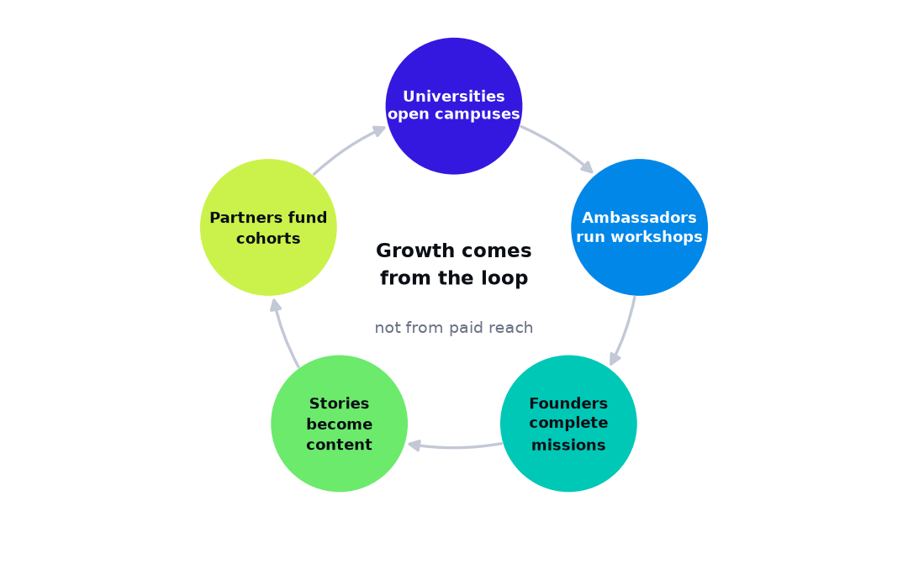
Why it compounds: founders who progress become the stories that win the next campus, sponsor and programme.
SECTION 10
Operations Plan

How a signed contract becomes a delivered cohort, repeatedly, by people the customer has never met — and what breaks first if it does not.
The operating model
StartPad runs a hybrid delivery model: a software platform with near-zero marginal cost, wrapped in an in-person layer with real marginal cost. The economics and the risks of the business both sit in that second layer, and so does this plan's binding constraint.
Layer | What it is | Marginal cost | Scales by
Platform | Missions, AI review, workspace, reporting | Near zero | Engineering and inference capacity
In-person delivery | Bootcamps, school cohorts, technical cohorts | High — two certified facilitators for four to six days | Certified facilitators
Events | Competitions, Bazaars, showcases | Moderate, per event | Event staff and calendar
Partner-delivered | Train-the-trainer, programme seats, school clubs | Low after certification | Certified partner trainers

The strategic consequence: engines that scale through the first and fourth rows — sponsored seats, programme seats, train-the-trainer — grow past the facilitator ceiling, while engines in the second row do not. That is why the revenue mix shifts the way it does.
Twelve people, three hundred cohorts
The establishment is capped at 12 people in year three. That cap is the central design constraint of this plan rather than an aspiration attached to it, and it is only survivable because StartPad does not deliver cohorts itself at scale. It certifies the organisations and the freelancers who do, audits them, and employs the people who define the standard. Headcount therefore grows with the number of partners to audit, not with the number of cohorts to run — which is the difference between a company that can reach national volume and a training provider that cannot.
Employees against the network that delivers for them, across five years, on one scale.
 | Year 1 | Year 2 | Year 3
StartPad employees | 6 | 9 | 12
Certified facilitators in the pool | 27 | 26 | 43
Certified partner organisations | 0 | 1 | 2
Cohorts delivered in the year | 54 | 66 | 107
Learners reached, cohorts and seats | 7,578 | 21,759 | 38,000
Learners per employee | 1,263 | 2,418 | 3,167

Two ratios hold the whole structure up
One partner network manager can hold roughly 7 certified partner organisations, and one delivery coordinator can schedule and report on roughly 120 cohorts a year. Those two numbers, not the revenue, are what determine when the next person is hired. They are stated here so that a reader who disbelieves the cap can argue with the ratio rather than with the conclusion.
A certified facilitator is part-time, and that is the design
Each gives StartPad about 45% of a delivery year — they are university staff, trainers and practitioners with other work. That is why the pool is large (43 by year three) while the payroll is not, and why a quarter in which a university postpones costs the company almost nothing.
A certified partner organisation runs its own cohorts
Roughly 9 a year each, under licence, keeping 40% of the fee. StartPad supplies the curriculum, the platform, the certification and the audit, and takes no delivery risk at all on those cohorts.
The binding constraint
A facilitator pair runs 18 university cohorts a year once travel, preparation and campus holidays are taken out — 26 of the shorter school format and 22 technical cohorts. The quarterly delivery plan therefore converts directly into a facilitator headcount, and that number, not the sales target, is the operating plan's primary schedule.
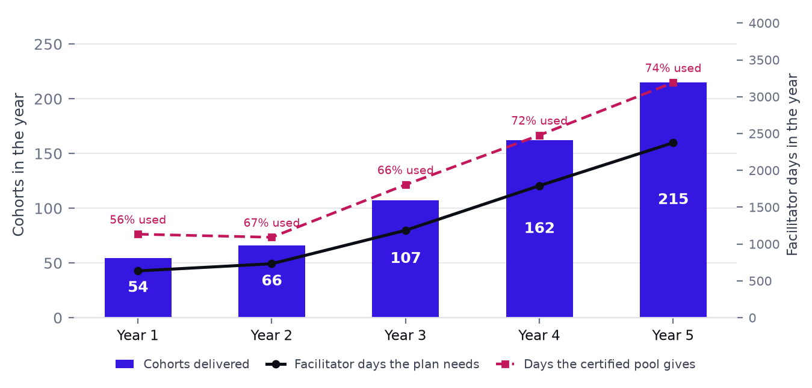
Delivery load against the facilitator capacity it requires, across all twelve quarters.
Year | Cohorts delivered | Facilitator days needed | Certified pool | Days the pool gives | Utilisation
Year 1 | 54.2 | 635 | 27 | 1,134 | 56%
Year 2 | 66.1 | 733 | 26 | 1,092 | 67%
Year 3 | 107.3 | 1,187 | 43 | 1,806 | 66%
Year 4 | 162.0 | 1,792 | 59 | 2,478 | 72%
Year 5 | 214.8 | 2,375 | 76 | 3,192 | 74%

Certification — the only thing StartPad does not delegate
The certified pool and the certified partner network are the operational asset and the main single point of failure. Four steps, run by the partner network manager and signed off by the Head of Curriculum, who is the only person who can pass or fail a candidate.
01 Observe a full cohort end to end, without delivering.
02 Co-deliver two days under a facilitator already certified at lead tier.
03 Deliver a full cohort observed and scored against the facilitator rubric.
04 Recertify each term against cohort outcomes and student feedback.
Nobody facilitates unobserved before step three is passed, including under schedule pressure — which is precisely the only time the rule matters. Recruitment runs a quarter ahead of the delivery plan, never against it. A company whose entire argument is that certification substitutes for employment cannot afford a certification that passes everybody, and the Head of Curriculum's success measure is written to make failing candidates the correct behaviour rather than an awkward one.
Partner organisations are certified on the same principle one level up: a certification cohort for their facilitators, one supervised delivery, then sample audits each term, with licence withdrawal as a real and occasionally used sanction. A licence that has never been withdrawn from anybody is not a licence.
The same machinery certifies partner and ministry trainers under the train-the-trainer engine. That is what makes 19,149 sponsored seats in year three deliverable by an organisation of this size: StartPad certifies, the partner delivers.
Service delivery — the cohort machine
Every cohort runs the same way, and the sameness is the point: it lets a freelance facilitator deliver a cohort the company has never seen, and makes the report comparable across institutions.
01 Scheduling. Dates are fixed against the institution's academic calendar, not ours. Egyptian and Saudi terms differ and Ramadan moves. The calendar is built a term ahead and is the constraint sales sells against.
02 Facilitator assignment. A certified pair per group, with a lead-tier facilitator on the first cohort at any new institution and on any cohort a newly certified partner delivers. There are no employed facilitators: the tier, not the contract, is what earns the assignment.
03 Materials. Printed kits, problem cards, canvases and certificates shipped to the venue a week ahead; digital copies in the workspace.
04 The daily loop. Opener on last night's progress; short input, then apply it; checkpoint marked Meets, Partly or Not yet; the team splits that night's missions and submits; AI feedback lands before the next opener.
05 The showcase. The final day is public — faculty, families, partners and judges, who see reviewed work rather than slides.
06 Report and handover. Certificates and the cohort report issue within five working days. Missions beyond the camp stay open to the student, and the institution keeps visibility.
Supply chain and facilities
Input | Source | Risk | Mitigation
Certified facilitators | Recruited and certified in-house | The highest-risk input in the business | Certify a quarter ahead; tiered day rates; a progression path
Certified partner organisations | Youth NGOs, training providers, university centres | A partner that under-delivers damages the standard, not just a cohort | Sample audit each term; published standard; licence withdrawal
Venues | Provided by the institution under contract | Cancellation or double-booking | Venue confirmed in the contract; a standing fallback per city
Printed materials | Local print partners in Cairo and Riyadh | Lead time and customs on cross-border shipment | Print locally in each market; never ship kits across a border
Cloud and AI inference | Major cloud and model providers | Cost per review at seat scale; provider outage | Cost monitored per active user; fallback provider for review
Mentors and judges | The mentor network | Availability at Bazaar season | Network managed continuously, not per event

Facilities are deliberately light: one office in Cairo, a desk in Riyadh, and from year three small regional hubs in Upper Egypt, the Delta and Jeddah — placed where facilitators live rather than where management does, because travel time is the hidden cost in cohort delivery.
Technology infrastructure
Capability | Which engine needs it | Needed by
Programme admin workspace: cohort creation, bulk invitation, educator assignment | Engines 1, 2, 4, 7 — without it there is no institutional product | Q4 2026
Student-controlled sharing with scoped programme data | All engines — the trust position that makes an institution sign | Q4 2026
AI review at cohort volume, overnight | Engines 1 and 2 — the daily loop breaks without it | Q4 2026
Full Arabic parity, right-to-left, including exported PDFs | All engines — a ministry cannot circulate a report it cannot read | Q4 2026
Competition entry, qualification and judging flow | Engine 5 — entry as an account, rounds as missions, a generated judges' pack | Q1 2027
The automatic cohort report | Every education and public engine — the renewal document | Q1 2027
Safeguarding controls and parental consent records | Engine 2 — a legal condition of selling to schools | Q2 2027
Bulk seat provisioning and partner reporting by region | Engine 3 — programmes place thousands of seats at once | Q3 2027

Quality control
Four gates are measured on every cohort. A cohort failing any one of them triggers a review before another is scheduled at that institution.
▪ Mission completion. At least 80% of students complete the programme's required missions by the showcase. Below that, the evening loop is not working and facilitator pairing is examined first.
▪ Review turnaround. AI feedback available before the next day's opener, every night. This is a platform SLA, not a target.
▪ Showcase delivery. Every team presents and every member speaks. A team that cannot is a facilitation failure that showed up two days earlier and was not caught.
▪ Report issued inside five working days to the person who signed.
Regulatory compliance
Safeguarding and child protection
Facilitator and partner vetting, safeguarding training, parental consent and a written incident procedure — owned by the CEO until the COO arrives in year four, and externally attested in both markets because an internal attestation is worth nothing here. Non-negotiable before any school cohort runs, including a partner's.
Data protection
Scoped institutional visibility, student-controlled sharing, server-side scoring, and documented retention periods.
Two jurisdictions
An Egyptian operating company and a Saudi entity, with local employment and invoicing compliance in each.
Procurement readiness
A maintained pre-qualification library — registrations, policies, certifications and references — because a missing document loses a bid more often than a weak proposal does.
Operational KPIs
KPI | Why it matters | Target
Certified pairs available vs. plan | The constraint on everything | Ahead of plan every quarter
Mission completion rate per cohort | What the buyer is paying for | 80% or above
Overnight review SLA met | The daily loop depends on it | 100% of nights
Report issued within five working days | Renewal depends on it | 100%
Seat activation rate (sponsored programmes) | Where seat programmes actually fail | 70% or above
Facilitator retention, term on term | Protects the core asset | 85% or above
Safeguarding incidents | Licence to operate in schools | Zero
Cohorts declined for lack of capacity | Honesty about the constraint | Tracked and reported, not hidden
Certified capacity vs. booked demand, next quarter | The number the whole headcount cap rests on | Capacity ahead in every quarter
Partner-delivered cohort scores vs. StartPad-run | Whether certification actually transfers the standard | Within five points, or the partner is audited
Partner audits completed per term | An audit nobody runs is not a control | Every active partner, every term
Institutional enquiries credited to Mission Zero | Whether the content budget is pipeline or decoration | 18 in year one, rising

SECTION 11
Management and Organization

6 employees in year one, 12 in year three and 20 in year five — a hard cap, not a forecast — in five reporting lines, plus three layers that are not on the payroll and carry almost all of the delivery.
The cap, and why it is a cap
Most plans state a headcount and then discover it. This one states a ceiling and designs backwards from it: 6, 9, 12, 16, 20. Four rules hold it there, and each has a visible cost that is admitted elsewhere in this part rather than hidden.
01 Employ the people who define and audit the standard; contract the people who deliver it. Every cohort in this plan is run by a certified freelance facilitator or a certified partner organisation, never by an employee. Cohort growth therefore cannot become payroll growth, which is the only reason the cap survives contact with the delivery plan.
02 No role is created until it is genuinely full-time. Until then it is part of a larger role, the role description says so, and it names the year it splits out. The cost is real: the Egyptian partnerships head carries competitions, schools and sponsors through year one, which is precisely why the school engine ramps slowly.
03 Standard, regulated functions are bought, not hired. Bookkeeping, payroll, audit, corporate legal, the Saudi entity, video production and translation quality assurance sit with firms and freelance panels. They appear in operating costs and not on the establishment.
04 The chief executive carries operations until the network outgrows one person. The plan puts that in year four, and the chief operating officer arrives then and not before. This is the single largest key-person risk in the plan, and it is named in the risk register rather than argued away.
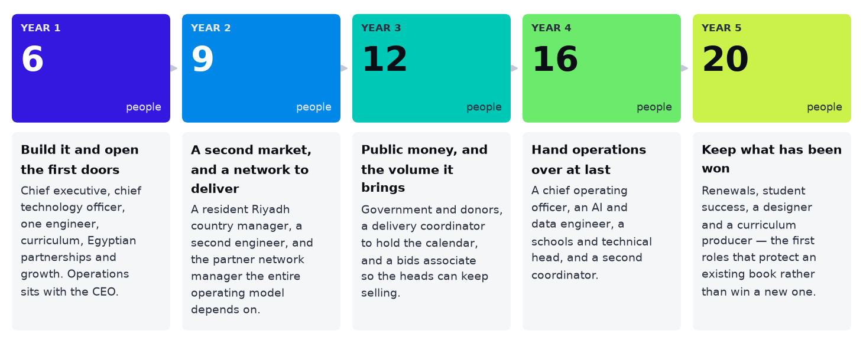
Six to twenty, and the reason for each step. Every hire in years four and five is a function the earlier years deliberately merged into somebody else's job.
Organisational structure
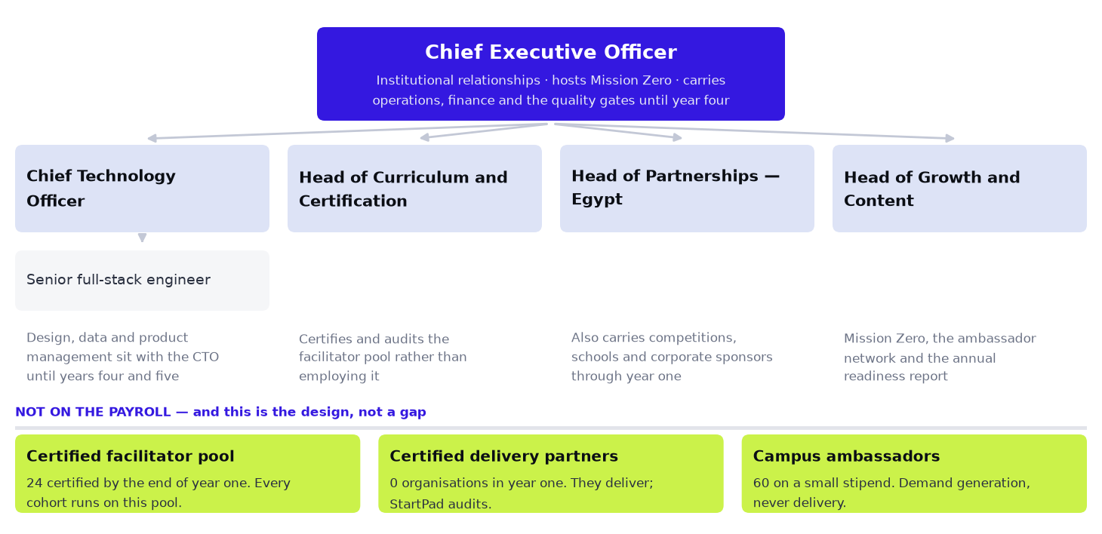
The year-one organisation. The grey notes matter more than the boxes: they say what is carried by somebody whose title says something else.
The structure follows the engines, not the functions. Institutional sales is organised by buyer type — university, school, government, donor, sponsor — because the buying behaviour of a ministry and a bank have nothing in common and the skills do not transfer. The Saudi country manager is the one exception: in that market the relationship comes before the product line, so one person owns every engine.
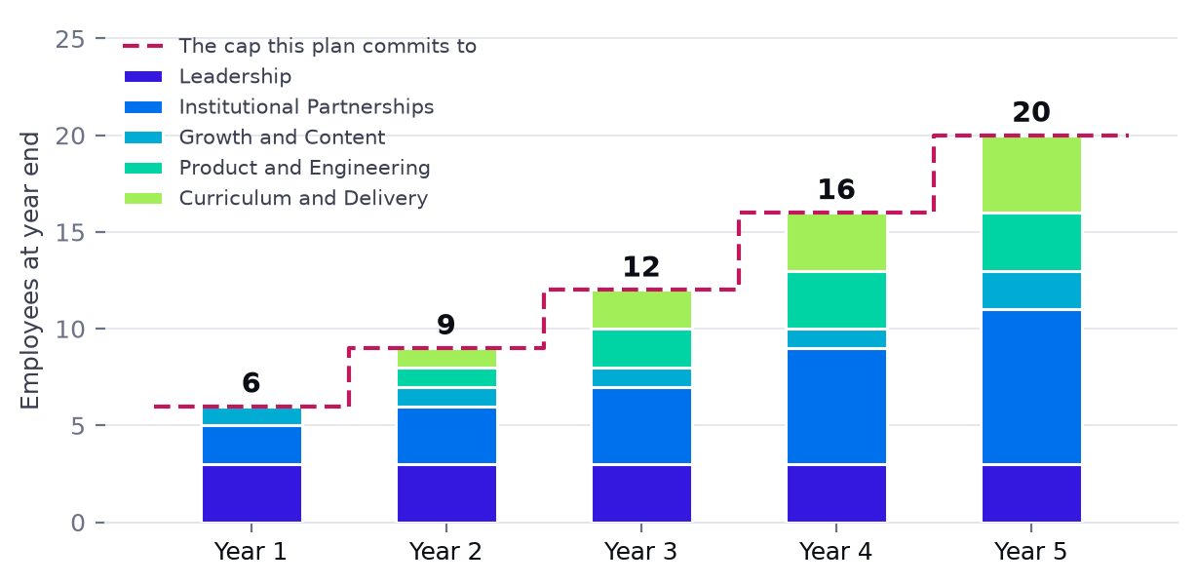
The establishment across five years against the cap it commits to. Bars that touch the dashed line and never cross it are the whole argument.
Function | Y1 | Y2 | Y3 | Y4 | Y5 | What it owns
Leadership | 3 | 3 | 3 | 3 | 3 | Direction, institutional relationships, and arbitration between sales ambition and certified capacity
Product and Engineering | 0 | 1 | 2 | 3 | 3 | The platform, the review pipeline, the mentor and institutional reporting
Curriculum and Delivery | 0 | 1 | 2 | 3 | 4 | What is taught, who is fit to teach it, and the network that teaches it
Institutional Partnerships | 2 | 3 | 4 | 6 | 8 | All eight engines, organised by buyer type
Growth and Content | 1 | 1 | 1 | 1 | 2 | Mission Zero, ambassadors, the readiness report and learner retention

The structure follows the buyer, not the function. Institutional partnerships is organised by buyer type — university, school, government, donor, sponsor — because the buying behaviour of a ministry and a bank have nothing in common and the skills do not transfer. The Saudi country manager is the deliberate exception: in that market the relationship precedes the product line, so one person owns every engine.
Three layers that are not on the payroll
These carry almost all of the delivery, and they are the reason the establishment can be capped at all. Treating them as an afterthought would misread the company entirely: the certified network is the operating model, and the employees exist to define and defend it.
The certified freelance facilitator pool
Every in-person engine runs on them — there are no employed facilitators in this plan at all. Paid $85 a day, each giving about 45% of a delivery year, rising from 27 certified at the end of year one to 43 by year three. This keeps the largest variable cost genuinely variable, which is what protects the business in a quarter when a university postpones.
Certified delivery partner organisations
Youth NGOs, training providers and university innovation centres that deliver StartPad cohorts under licence, keeping 40% of the fee: 0 in year one, 2 by year three, each running roughly 9 cohorts a year. They bring the geography and the youth pipeline StartPad would otherwise have to build.
60 campus ambassadors, rising to 340
A stipend, free Pro access and standing — not a salary. Their most valuable output is intelligence about which institution is ready to buy, not registrations.
Bought, not hired
The functions below are deliberately absent from the establishment. Each is listed with who supplies it and why buying beats hiring, because an organisation plan that simply omits finance and legal is not lean, it is incomplete.
Function | Who supplies it | Why it is bought
Bookkeeping, payroll and statutory filing | A Cairo accounting firm, with a Riyadh counterpart for the Saudi entity | Monthly retainer. Hiring a finance manager before year five would cost more than the firm and deliver less compliance cover.
Audit, corporate legal and the KSA entity | Regional firms on fixed scopes | Needed a few weeks a year at a standard no single hire could match.
Video production and editing for Mission Zero | A freelance two-person crew per shoot day, briefed by the Head of Growth and Content | Production is bursty — three recording blocks a year. A staff videographer would be idle most of it.
Arabic copy-editing and translation quality assurance | A certified freelance panel | Volume arrives in waves with each curriculum release.
Facilitation, in every market and every format | The certified facilitator pool and certified partner organisations | This is the central design choice of the company: the people who deliver are certified, not employed.
Safeguarding training and background checks for school work | An accredited provider in each market | A legal obligation that must be externally attested to be worth anything.

Hiring plan
6 people in year one. Each row below states what the hire unlocks and what was being carried by somebody else until it arrived.
When | Who | Why then
Before Q4 2026 | Chief executive, chief technology officer, Head of Curriculum and Certification | Nothing can be certified or sold until the standard and the platform have owners. The CEO carries operations, finance and the quality gates from here until year four
Q4 2026 · Land | One senior full-stack engineer, Head of Partnerships — Egypt, Head of Growth and Content | The admin workspace must exist before a cohort can run, the funded pilots need somebody to open the doors, and Mission Zero has to start recording in the quarter the first cohorts happen or there is nothing to record
Year 2 · 3 added | Country Manager — KSA (Riyadh), a second engineer, partner network manager | A resident principal is the only way Saudi Arabia moves, and the partner network manager is the hire the entire operating model rests on — the first certified partners cannot be signed without one
Year 3 · 3 added | Head of Government, Initiatives and Donors; programme delivery coordinator; partnerships and bids associate | Public money arrives on a cycle that had to be worked for two years before it paid, the delivery calendar outgrows the CEO, and bids start being lost for administrative reasons rather than commercial ones
Year 4 · 4 added | Chief operating officer, AI and data engineer, Head of Schools and Technical Education, second delivery coordinator | The partner network passes what one person can hold, seat volume makes inference cost and assessment quality binding, and the school engine finally gets a dedicated owner
Year 5 · 4 added | Account manager — renewals, student success, product designer, bilingual curriculum producer | The first roles that protect an existing book rather than win a new one. Renewal becomes the main revenue event and nobody owned it before

What is conspicuously absent: no facilitators, no finance manager, no marketing team, no customer support function and no regional offices. Delivery is certified rather than employed; finance and legal are bought from firms; marketing is one person and a podcast; support arrives in year five when sponsored-seat volume finally justifies it. Each absence is a decision with a stated cost, and the costs are gathered in the risk register rather than scattered where they are easy to miss.
Role descriptions
Every role on the establishment, with the purpose it exists for, the responsibilities that belong to it and nobody else, and the one measure it is held to.
Chief Executive Officer
Reports to the board
Owns the institutional relationships the company is built on, the story that opens them, and — until year four — operations as well.
– Carry the first conversation at ministry, agency, donor and university-leadership level, where the counterparty expects a principal rather than a salesperson
– Own the delivery calendar and the rule that sales sells against certified capacity rather than the reverse — this is the chief operating officer's job and the CEO holds it until the partner network passes roughly a dozen organisations, which the plan puts in year four
– Host Mission Zero and own the narrative that makes a dean take a meeting
– Hold the quality gates personally in years one and two: a cohort that fails one is reviewed by the CEO, not delegated, because the standard is the product
– Arbitrate between delivery capacity and sales ambition every quarter, and publish the decision so the company can see the trade being made
Signed relationships at the level only a founder can reach, and no quarter in which more cohorts were sold than the network could deliver.
Chief Technology Officer
Reports to CEO
Owns the platform the whole commercial plan assumes exists, and writes code as well as directing it.
– Sequence engineering against the roadmap gates rather than feature requests — the admin workspace before the competition flow, the competition flow before bulk seat provisioning
– Own the bilingual AI mentor: its prompts, its evaluation harness, its cost per learner, and the Arabic quality that most of the market gets wrong
– Build the certification and audit tooling that lets twelve people stand behind a network of certified facilitators and partner organisations
– Own data protection, the safeguarding architecture for accounts held by minors, and Saudi data-residency obligations
– Carry product management and design until year five, with the Head of Curriculum as the second opinion on anything a learner touches
Every roadmap gate met in the quarter it is due, and inference cost per learner falling year on year.
Chief Operating Officer
Reports to CEO
Takes operations off the CEO once the partner network is too large for one person to hold alongside the company's external relationships. Arrives in year four, deliberately late.
– Own the delivery calendar, the partner network and the certification regime as a single system rather than three functions
– Own the four quality gates and the review that follows any cohort failing one of them
– Own safeguarding and child-protection compliance across both markets, and the external attestation that makes it mean something
– Run the readiness review for each roadmap phase and report honestly when a gate will not be met
– Manage the outsourced finance, legal and audit relationships, which remain outsourced
Every scheduled cohort delivered, on standard, with its report issued inside five working days — at any network size.
Senior full-stack engineer
Reports to CTO
Builds and runs the platform. Two of these are the entire engineering team through year three, which means breadth over specialism.
– Ship the mission engine, the programme admin workspace, the competition flow and bulk provisioning, in the order the gates demand
– Own one vertical slice end to end — database to interface — rather than a layer, because a two-engineer team cannot afford hand-offs
– Carry on-call for a platform used in live cohort rooms, where an outage is twenty-five people and a facilitator standing still
– Build the reporting that produces a cohort report automatically, since that report is what every other engine is sold on
– Keep the Arabic interface first-class rather than translated, including right-to-left layout that is tested rather than assumed
Gate features shipped on time, and no cohort disrupted by a platform failure.
AI and data engineer
Reports to CTO
Makes the mentor good enough to be trusted with a learner, and the evidence record good enough to be trusted by a donor. Arrives in year four, when seat volume makes inference cost and assessment quality the binding problems.
– Own the mentor's evaluation harness: a fixed set of learner situations, scored every release, in both languages
– Drive inference cost per learner down as seat volume rises, which is the difference between a seat business that works and one that does not
– Build the assessment model behind the readiness score, and document it well enough that a ministry's evaluator can interrogate it
– Own the data pipeline that turns cohort activity into the per-participant evidence record donors and initiatives require
Mentor quality scores rising while cost per learner falls, and a readiness score no evaluator has successfully challenged.
Product designer
Reports to CTO
Owns what a learner and a facilitator actually see. Arrives in year five; until then the CTO and the Head of Curriculum share the work and the plan says so rather than pretending design is free.
– Own the learner experience in Arabic first, with English as the translation rather than the reverse
– Design for the room: a facilitator with twenty-five people and six days needs different screens from a learner at home
– Own the accessibility and reading-age standard for school and technical cohorts, where the audience is younger than the platform was built for
– Maintain the design system so two engineers can ship interface work without a designer in the loop
Measured task completion in the cohort room, and no facilitator workaround that exists because a screen was wrong.
Head of Curriculum and Certification
Reports to CEO
Owns the standard — what is taught, what is assessed, and who is allowed to teach it. In a company that certifies rather than delivers, this is the role that protects the asset.
– Own the mission curriculum and its three variants — university, school and technical — and the rule that a variant is a different programme, not a shortened one
– Own facilitator certification: the assessment, the pass mark, the re-certification cycle, and the willingness to fail candidates the company commercially needs to pass
– Own the certification standard that delivery partner organisations are audited against, and conduct the audits in year one and two
– Own the train-the-trainer curriculum that makes public-sector volume possible at all
– Own the mapping to external methodologies — the ILO's Start and Improve Your Business framework in particular — that donor procurement requires
– Carry product input on anything a learner touches, as the CTO's second opinion, until a designer arrives in year five
Cohort quality scores that do not fall as the network grows — the single number that says certification is real.
Partner network manager
Reports to COO (the CEO until year four)
Recruits, certifies, supports and audits the organisations and freelancers who deliver every cohort in this plan. The leverage of the whole business model sits in this one role.
– Recruit and qualify delivery partner organisations — training providers, university innovation centres, youth NGOs — against a written standard, and reject the ones that do not meet it
– Run the facilitator pipeline from sourcing to certification to first supervised delivery, holding a pool large enough for peak quarters and small enough to keep busy
– Own partner economics: the revenue share, the invoicing, and the conversation when a partner wants a larger share than the standard
– Audit on sample and escalate any partner whose cohort scores drift, including withdrawal of the licence
– Hold the capacity forecast that sales is required to sell against, quarter by quarter
Certified capacity ahead of booked demand in every quarter, with no cohort cancelled for want of a facilitator.
Programme delivery coordinator
Reports to COO (the CEO until year four)
Makes the calendar happen: scheduling, logistics, reports and the hundred small failures that would otherwise reach the Head of Curriculum.
– Schedule every cohort across both markets against certified capacity, and own the re-scheduling when a campus closes or a partner pulls out
– Provision accounts, materials and venues, and confirm readiness a week before each cohort rather than the day before
– Issue every cohort report inside five working days of the showcase
– Run the post-cohort data collection that feeds the evidence record, including chasing the facilitators who have not submitted
– Be the first line of support for partners and facilitators in delivery week
Every cohort starting on its scheduled date, and every report out inside five working days.
Bilingual curriculum producer
Reports to Head of Curriculum and Certification
Turns the standard into the material a facilitator can pick up and run without asking a question. Arrives in year five; until then the Head of Curriculum produces, with freelance editors on volume.
– Produce facilitator guides, learner workbooks and slide decks in Arabic and English for all three format variants
– Produce the Mission Zero episode notes that attach each episode to the mission it illustrates
– Maintain version control so a partner in Riyadh and a partner in Assiut are demonstrably running the same release
– Manage the freelance translation and copy-editing panel against a published quality standard
No facilitator question that the material should have answered.
Head of Partnerships — Egypt
Reports to CEO
Owns every Egyptian institutional relationship until the engines are large enough to split. In year one that is universities, schools, competitions and sponsors in one pair of hands, and the plan is explicit that this is a merged role.
– Open and close university cohort and faculty licence business across Egypt, working the four doors into an institution rather than the front one
– Carry competitions and corporate sponsors in year one, handing competitions to the government and initiatives head as that role lands in year three
– Carry schools and technical institutes until a dedicated head arrives in year four, with the honest consequence that the school engine is deliberately slower in years one and two
– Convert delivered cohorts into faculty licences, which is where the margin is and where most of this role's quota should come from
– Feed the named-target list and the engagement play applied to each, so pipeline is a plan rather than a list of contacts
Signed Egyptian revenue against quota, and the ratio of licences to one-off cohorts rising each year.
Country Manager — KSA (Riyadh)
Reports to CEO
Is the company in Saudi Arabia: a resident, Arabic-speaking principal who can sit with Monsha'at, the Misk Foundation and TVTC without an introduction.
– Own the Saudi entity's commercial relationships across every engine — there is no engine split in Saudi Arabia until year five
– Open the three Saudi doors that matter most: the SME authority's academy, the youth foundations and the technical training corporation, each through the engagement play the plan specifies for it
– Recruit and hold the Saudi facilitator pool, where day rates, visas and availability work differently from Egypt
– Own Saudi compliance in practice: the entity, data residency, procurement registration and the paperwork that decides whether a public body can pay an invoice at all
– Localise rather than translate: Saudi institutions buy a Saudi programme, and a visibly Egyptian one will lose on preference alone
Saudi revenue per Saudi head above the Egyptian equivalent, which is what justifies the cost of the role.
Head of Government, Initiatives and Donors
Reports to CEO
Works the longest sales cycles in the company — ministries, agencies, national initiatives, donors and international organisations — and starts them years before they pay.
– Own the seat-rider and trainer-certification plays into national initiatives, entering through a university or a governorate branch rather than through head office
– Own the donor logframe subcontract play: track published portfolios, identify components in design six to nine months out, and get StartPad named in the proposal before the call opens
– Own public procurement mechanics in both markets — registration, pre-qualification, bid formats and the paperwork that disqualifies otherwise winning bids
– Own the evidence record as a commercial asset, working with the Head of Curriculum so what a donor's monitoring function needs is what the platform already produces
– Carry competitions from year three, since the sponsors and the public bodies are substantially the same room
Pipeline measured in named opportunities with a dated decision point, not in meetings held.
Partnerships and bids associate
Reports to the relevant Head
Does the work that would otherwise stop a head from selling: research, proposals, bids, contracting and the follow-up nobody has time for.
– Maintain the named-target list — organisation, engine, engagement play, named contact, dated next step — as the company's actual pipeline
– Assemble proposals, tender responses and donor budget annexes against deadlines that do not move
– Run contracting and purchase-order chasing through to a payable invoice, which in public-sector work is a distinct skill
– Prepare the cohort reports and case studies that each head takes into the next meeting
No bid missed for an administrative reason, and no signed deal waiting on paperwork.
Head of Schools and Technical Education
Reports to COO
Owns the engine with the largest population and the smallest budget per head, where volume has to come from ministries, chains and partners rather than from individual schools. Arrives in year four.
– Own school and technical institute business across both markets, selling to chains, groups and ministry programmes rather than one school at a time
– Own the applied-technology and TVET relationships where the buyer is a public body and the play is certification
– Own safeguarding in the commercial conversation, since no school signs before it is satisfied and no school asks about it last
– Convert school cohorts into school licences, which is the only way this engine's unit economics work
School and technical revenue per sales day comparable to the university engine, despite a lower price point.
Account manager — renewals
Reports to COO
Exists because the second year of an institutional relationship is worth more than the first and is nobody's job while everyone is hunting. Arrives in year five, when the renewal book is large enough to justify it.
– Own renewal and expansion for every institution past its first delivered cohort
– Run the structured review that turns a delivered cohort into the case for a faculty or school licence
– Hold the relationship through the staff turnover that is the real cause of institutional churn in this market
– Report renewal rate and expansion rate by engine, honestly
Renewal rate by engine at or above the retention assumed in the plan.
Head of Growth and Content
Reports to CEO
Owns demand: Mission Zero, the ambassador network, the content that makes an institution call first, and the community the subscription engine is drawn from.
– Own Mission Zero end to end — guest booking, the campus recording schedule, the freelance crew, publication and the clip calendar — as a pipeline instrument measured in enquiries, not in views
– Run the campus ambassador network: recruitment, training, the stipend, and the monthly rhythm that keeps a volunteer network alive rather than nominal
– Own the annual readiness report, which is the company's single most effective door-opener into institutions and ministries
– Own organic acquisition into subscriptions, which the plan treats as a consequence of the institutional engines rather than a channel of its own
– Own brand consistency across two languages and every partner's co-branded material
Institutional enquiries attributable to content and Mission Zero, and cost per subscription from organic channels.
Student success (bilingual)
Reports to COO
Keeps the learners who arrived through somebody else's programme. Arrives in year five, when sponsored-seat volume makes activation the difference between a renewed seat order and a cancelled one.
– Own activation of sponsored and initiative seats, where an unactivated seat is a line item the funder will not pay for twice
– Run the bilingual support queue for learners and for partner administrators
– Own the progression path from a completed cohort to a paid subscription, which is the entire subscription engine
– Feed recurring learner problems back to curriculum and product as evidence rather than anecdote
Seat activation rate, and the share of cohort completers who continue on a paid subscription.
Company culture
Delivery is the product
The highest-status work in this company is running a cohort well. Everyone, including engineers and the CEO, spends time in a room with students each term.
Say the number
Completion rates, declined cohorts, failed gates and missed SLAs are reported as they are. A plan this dependent on capacity cannot survive optimistic reporting.
Bilingual by default
Internal documents that matter exist in both languages. A company that works in English and sells in Arabic eventually builds an English product.
Refuse gracefully
Declining a cohort there is no certified pair for, or a contract with an outcome we cannot measure, is correct behaviour and is treated as such.
Compensation structure
Cairo base, one Riyadh exception
Every role is priced at Cairo except one. The Saudi country manager is priced at Riyadh and is 40% of year-two payroll as a single person out of 9. Under-pricing that role is the most common way a plan like this fails quietly, and the alternative — covering Saudi Arabia from Cairo — fails loudly.
Founders below market
The three leadership roles sit below what any of them could earn elsewhere. A deliberate runway decision, to be corrected at the next raise rather than left as a permanent feature.
Facilitators are a career, not a gig
Certification, a rising day rate by tier, first refusal on lead-tier assignments and visible cohort outcomes are what stop the pool leaking to the consultancies competing for exactly these people. In a company with no employed facilitators at all, this is not a staff-welfare policy — it is supply-chain management for the only input that cannot be bought at short notice.
Sales paid on signing and on renewal
Commission at 6% of institutional revenue. The The account manager added in year five is compensated on retained and expanded revenue rather than on new logos, because renewal is where this business lives.
Advisors and governance
The board should carry four competencies the executive team does not have in depth: public-sector procurement in Egypt, Saudi institutional relationships, education policy and safeguarding, and scaled operations. An advisory bench of practising founders and entrepreneurship-centre directors doubles as the mentor network's senior tier and as reference customers.
Professional development
▪ Facilitator tiering with a published progression path from certified to lead to certification trainer.
▪ Every employee observes at least one full cohort a year, whatever their function.
▪ Arabic and English language support where a role requires the second language.
▪ Curriculum and delivery staff rotate into partner train-the-trainer cohorts, which is the fastest way to find out what does not travel.
SECTION 12
Financial Plan

Five years, October 2026 to September 2031, in US dollars. Revenue reaches $2.5m in year five against $1.8m of cost, and the company turns a profit in year 1. Year one spends $218k, which is not a budget anybody set: it is what the activity plan, the hiring plan and the cost drivers add up to.
How this model is built, and why that matters
An input is a decision or a rate: how many campus workshops the team runs, who is on the payroll and what they are paid, what a cohort is priced at, how long a buyer takes to sign, what share of proposals are won. Everything else is produced from those and is typed nowhere.
There is no volume plan. A cohort exists in a given month because somebody ran a workshop earlier and a contract was won; cut the activity and the cohort disappears with it. The chain runs:
01 Activity produces leads, online through cost per click and offline through workshops, events, partner sessions and direct outreach.
02 Leads split across six buyer types, each with its own conversion and its own clock.
03 Meetings, proposals and wins follow those conversion rates, with signature lagged by the buyer's sales cycle.
04 Mobilisation lags again, between signature and the first delivery day.
05 The contract book holds every live contract, and each one delivers a fixed number of units evenly across its life.
06 Revenue, cost, profit and tax fall out of that volume.
The same discipline applies to cost. The year one total is an output of the Expenses sheet, not a ceiling typed into it. Doubling direct outreach in the model raises it immediately, which is the test that it is genuinely produced.
What the model opens on
Not forecasts. The position the company is actually in on day one, carried into the model as fact.
What is already true | Value | Note
Registered users on the platform | 300 | already signed up, before any paid cohort
Paying subscribers | 2 | the honest starting point for the direct engine
Live competition participants | 100 | the competition running now
Prize money committed on the live competition | 100,000 | converted to dollars at the rate above
University memoranda signed | 5 | MSA, Coventry Egypt, CIC, ESLSCA and Zewail
Partnerships at heads of terms | 1 | Enactus Egypt, close but not signed
Opening cash | $50k | founder capital already contributed

The five signed memoranda are not a special case in the arithmetic. They enter as contracts already signed, mobilising across the first three months, and run through the same contract book as anything the funnel wins later. That is why year one is produced rather than asserted.
Acquisition assumptions
Online channels
Budget divided by cost per click gives paid clicks. Organic and referral traffic are taken as a stated share of paid, never assumed free. Then the first conversion stage, click to lead.
Channel | Monthly budget, Y1 | Y5 | Cost per click | Organic | Referral | Click to lead
Short video, TikTok, Instagram, Facebook | $100 | $1,200 | $0.10 | 18% | 5% | 1.5%
Paid social, targeted by age, city, university | $80 | $1,100 | $0.18 | 8% | 3% | 2.0%
Influencers and student creators | $50 | $900 | $0.14 | 12% | 6% | 1.8%
Mission Zero, the founder podcast | $40 | $750 | $0.26 | 20% | 8% | 2.8%
Webinars, live Mission 01 sessions | $30 | $400 | $0.55 | 6% | 10% | 14.0%
SEO, content and the readiness report | $40 | $600 | $0.05 | 25% | 4% | 2.2%

Online spend is sized as business to business inbound, not as a consumer channel. At $15 a year for Pro, a paid click cannot pay for itself, so most paying accounts arrive free, from learners who sat in a cohort.
Offline activity, what the team actually does
Activity | Per month, Y1 | Y5 | Cost each | Free sign ups | Institutional leads
Campus workshops | 1.0 | 14.0 | $180 | 30 | 0.8
Ambassador campus activity | 2.0 | 15.0 | $80 | 22 | 0.3
Events, fairs and conferences | 0.2 | 3.0 | $600 | 80 | 1.8
Partner sessions inside somebody else's cohort | 0.3 | 5.0 | $150 | 40 | 1.0
Direct outreach by the commercial team | 30.0 | 85.0 | $0 | 0 | 1.0

Who buys, and how long each kind takes
Complexity shows up twice: once as the sales cycle before signature, once as mobilisation between signature and the first delivery day.
Buyer type | Share of leads | Lead to meeting | Meeting to proposal | Proposal to win | Sales cycle | Mobilisation
Institutions, universities and schools | 40% | 40% | 45% | 28% | 1 mo | 2 mo
Sponsors, banks, telcos and corporates | 16% | 35% | 40% | 25% | 1 mo | 1 mo
NGOs, donors and development agencies | 14% | 30% | 35% | 20% | 1 mo | 3 mo
Government and national initiatives | 12% | 25% | 30% | 20% | 1 mo | 3 mo
CSR and corporate innovation budgets | 10% | 30% | 35% | 22% | 1 mo | 2 mo
Accelerators, incubators and programme operators | 8% | 45% | 50% | 35% | 1 mo | 1 mo

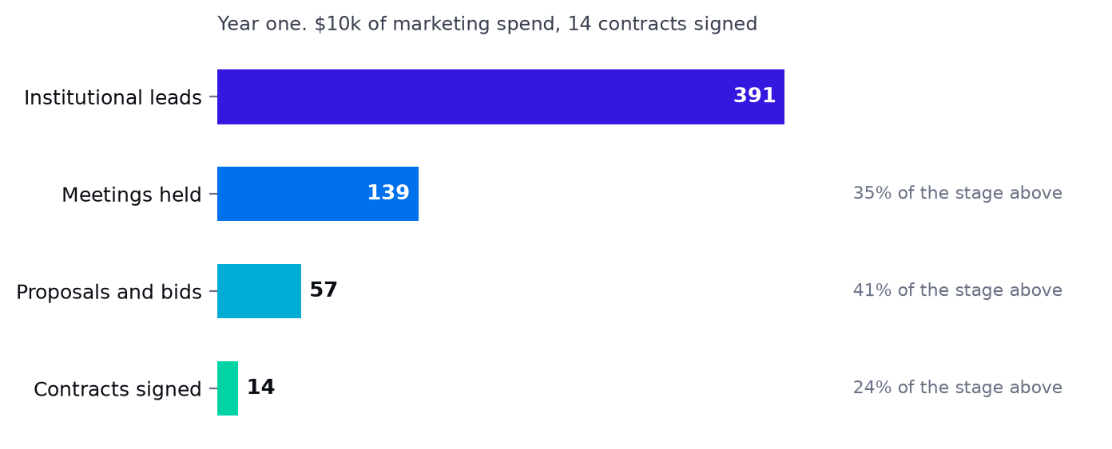
Year one, from marketing spend to signed contracts, with the conversion at each stage.
Revenue assumptions
What a won contract turns into
Each engine takes a share of one buyer type's contracts and delivers a fixed number of units evenly across a contract life. A contract is signed with a buyer, not with an engine, so a buyer's contracts are spread across whichever of that buyer's engines are open.
Engine | Buyer | Share | Units per contract | Contract life | Unit
University cohorts, Egypt | inst | 50% | 8 | 12 mo | cohorts
University cohorts, Saudi Arabia | inst | 12% | 8 | 12 mo | cohorts
Faculty licences | inst | 8% | 1 | 12 mo | licences
School cohorts | inst | 20% | 7 | 12 mo | cohorts
School licences | inst | 4% | 1 | 12 mo | licences
Technical and vocational cohorts | inst | 6% | 6 | 12 mo | cohorts
National initiative seats | govt | 70% | 20,000 | 12 mo | seats
Train the trainer cohorts | govt | 30% | 3 | 12 mo | cohorts
NGO and donor programmes | ngo | 100% | 3 | 12 mo | programmes
Competitions, sponsored | spon | 65% | 3 | 12 mo | competitions
Mission Zero seasons carrying a sponsor | spon | 35% | 2 | 12 mo | seasons
Corporate and CSR programmes | csr | 100% | 3 | 12 mo | programmes
Programme and incubator seats | prog | 100% | 900 | 12 mo | seats

Pricing
Price | Year 1 | Year 2 | Year 3 | Year 4 | Year 5
University cohort, all in programme fee | $4k | $4k | $4k | $4k | $5k
Faculty licence, annual | $8k | $8k | $10k | $11k | $12k
School cohort | $2k | $3k | $3k | $3k | $3k
School licence, annual | $4k | $5k | $6k | $6k | $7k
Technical and vocational cohort | $2k | $3k | $3k | $3k | $4k
National initiative seat | $5 | $8 | $7 | $6 | $6
Train the trainer cohort | $4k | $6k | $7k | $7k | $8k
NGO or donor programme | $12k | $16k | $18k | $20k | $22k
Sponsored competition season | $10k | $12k | $14k | $16k | $18k
Corporate or CSR programme | $12k | $18k | $21k | $24k | $26k
Programme or incubator seat | $18 | $20 | $22 | $24 | $26
Mission Zero season sponsorship | $5k | $7k | $9k | $11k | $13k

The direct engine is priced for the market it is in: $15 a year for Pro and $35 for Team. It is a reach product, not the business.
Delivery pace, and the year one ceiling
A contract signed is not a contract delivered at full tilt. In year one an institution is still localising the curriculum and training its own faculty, so cohorts run at 100% of the rate the contract settles at, rising to 100% from year two. This is also where the year one spending ceiling is held: it is a decision about how fast to go, and year one lands at $218k because of it.
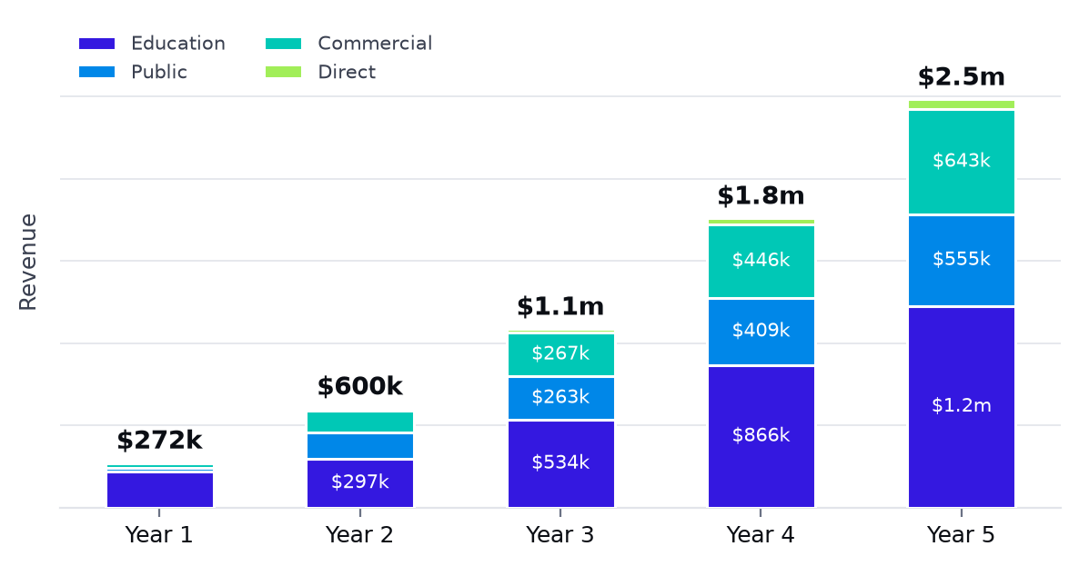
Revenue by family across five years, with the total on each column.
Expense assumptions
Nothing here is a flat monthly figure chosen by eye. Every line has a driver: a desk per employee, facilitator days per cohort, inference per active learner, travel per head on the road.
Direct cost of delivery
Direct cost line | Year 1 | Year 2 | Year 3 | Year 4 | Year 5
Facilitation, university cohorts | 50,896 | 56,277 | 99,778 | 157,856 | 218,775
Facilitation, school cohorts | 2,348 | 10,089 | 18,775 | 29,704 | 41,167
Facilitation, technical cohorts | 755 | 3,243 | 6,035 | 9,548 | 13,232
Materials, kits and showcases | 14,953 | 19,077 | 33,278 | 52,648 | 72,963
Competition delivery, sponsored | 5,714 | 22,694 | 45,048 | 75,099 | 109,612
Competition delivery and prizes, self funded | 2,779 | 0 | 0 | 0 | 0
Mission Zero production | 2,500 | 7,000 | 13,500 | 15,600 | 17,400
NGO and donor programme delivery | 3,884 | 17,664 | 34,851 | 57,471 | 82,135
Corporate programme delivery | 4,239 | 16,298 | 32,929 | 56,358 | 81,304
Train the trainer delivery | 254 | 1,154 | 2,216 | 3,676 | 5,280
National initiative seat support | 5,425 | 24,674 | 38,298 | 54,245 | 68,446
Programme and incubator seat support | 3,729 | 6,288 | 10,292 | 15,319 | 20,195
Subscription hosting and inference | 183 | 988 | 2,379 | 4,531 | 7,344
Certifying facilitators into the delivery pool | 3,240 | 1,080 | 2,040 | 1,920 | 2,040
Revenue share, certified delivery partners | 0 | 7,413 | 36,540 | 94,000 | 170,801
Revenue share, youth and channel organisations | 4,684 | 12,200 | 22,905 | 38,168 | 55,690
Revenue share, aggregators and payment processing | 926 | 6,620 | 10,119 | 12,757 | 16,113
Total direct cost | 106,509 | 212,759 | 408,982 | 678,900 | 982,498

Operating cost
Operating cost line | Year 1 | Year 2 | Year 3 | Year 4 | Year 5
Payroll, fully loaded | 60,984 | 127,512 | 216,216 | 297,990 | 374,220
Sales commission | 10,802 | 23,600 | 42,585 | 68,877 | 97,001
Marketing, offline channels | 6,060 | 23,340 | 45,720 | 60,480 | 75,240
Marketing, online channels | 4,080 | 14,160 | 28,800 | 44,400 | 59,400
Ambassador stipends | 1,680 | 5,250 | 11,550 | 18,900 | 26,250
Desk and office | 4,680 | 9,180 | 14,400 | 21,120 | 28,800
Utilities, internet and communications | 1,440 | 2,700 | 4,032 | 5,760 | 7,680
Cloud, AI inference and APIs | 2,058 | 5,377 | 11,737 | 19,277 | 26,308
Software and tooling | 3,960 | 7,560 | 11,520 | 16,320 | 21,600
Travel | 2,880 | 8,640 | 15,840 | 23,040 | 31,200
Outsourced finance, legal and audit | 3,960 | 9,600 | 16,800 | 22,800 | 27,600
Safeguarding and compliance | 480 | 2,160 | 5,400 | 8,400 | 10,800
Partner enablement, certification and audit | 0 | 2,400 | 9,600 | 18,000 | 25,200
Insurance, bank charges and sundries | 1,320 | 2,160 | 3,360 | 4,320 | 5,280
Contingency | 4,175 | 9,746 | 17,502 | 25,187 | 32,663
Depreciation and amortisation | 3,222 | 4,603 | 7,389 | 8,524 | 8,745
Total operating cost | 111,781 | 257,988 | 462,451 | 663,395 | 857,988
Total expenses, direct and operating | 218,290 | 470,747 | 871,433 | 1,342,295 | 1,840,486

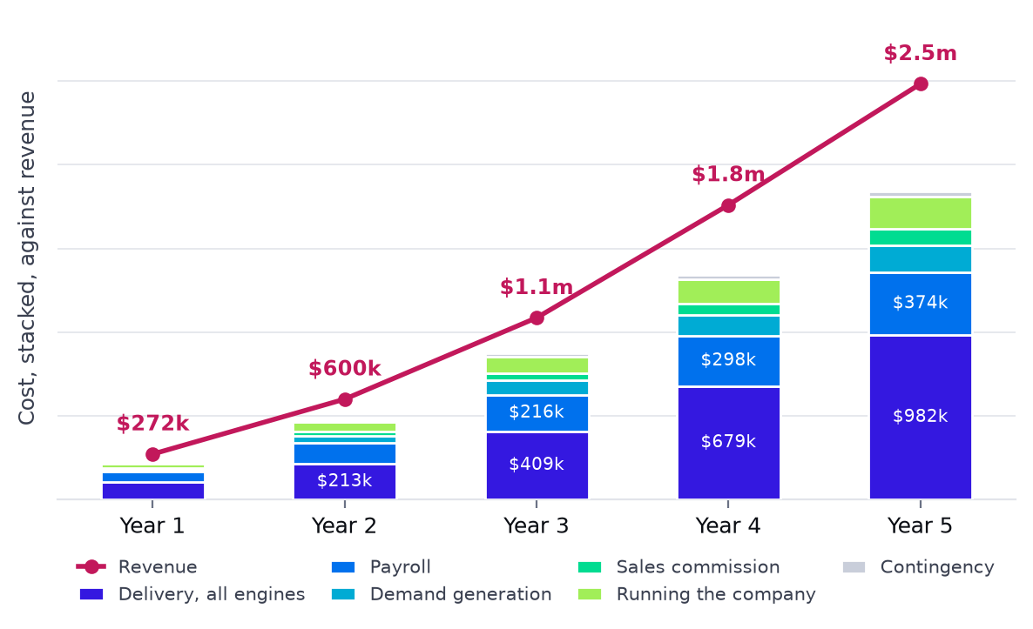
What the money is spent on each year, against the revenue it produces.
Working capital, funding and tax
Basis | Value | Why it is set there
Days sales outstanding, institutional | 75 days | Universities and ministries pay slowly. This is the largest single cash risk in the model
Days sales outstanding, subscriptions | 2 days | Card payment, collected on the day
Days payable outstanding | 35 days | What suppliers and freelance facilitators are paid on
Accrued payroll | 10 days | Salaries earned but not yet paid at a month end
Invoiced in advance | 25% | The share of institutional contracts billed up front, which creates deferred revenue
Seed round | $150k | Landing in month 4, sized on the cash trough rather than on a round number
Corporate income tax | 22% | Egyptian corporate income tax, paid in month 4 of the following year, after losses carried forward

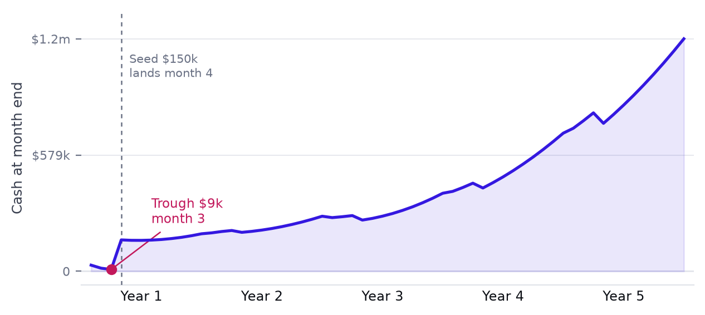
Cash month by month across sixty months, with the trough marked.
The trough is $9k in month 3, against a stated minimum buffer of $25k. The round is sized on that trough: the ask is $150k.
Income statement
Five years to 30 September. Every line is a formula over the assumptions above.
Income statement | Year 1 | Year 2 | Year 3 | Year 4 | Year 5
FOR THE YEARS ENDED 30 SEPTEMBER
Total revenue | 271,838 | 599,690 | 1,085,654 | 1,759,672 | 2,483,099
Annual growth |  | 120.6% | 81.0% | 62.1% | 41.1%
Cost of revenue | 106,509 | 212,759 | 408,982 | 678,900 | 982,498
Gross profit | 165,329 | 386,932 | 676,672 | 1,080,772 | 1,500,601
Gross profit margin | 60.8% | 64.5% | 62.3% | 61.4% | 60.4%
Operating expenses
Payroll, fully loaded | 60,984 | 127,512 | 216,216 | 297,990 | 374,220
Sales commission | 10,802 | 23,600 | 42,585 | 68,877 | 97,001
Marketing, offline channels | 6,060 | 23,340 | 45,720 | 60,480 | 75,240
Marketing, online channels | 4,080 | 14,160 | 28,800 | 44,400 | 59,400
Ambassador stipends | 1,680 | 5,250 | 11,550 | 18,900 | 26,250
Desk and office | 4,680 | 9,180 | 14,400 | 21,120 | 28,800
Utilities, internet and communications | 1,440 | 2,700 | 4,032 | 5,760 | 7,680
Cloud, AI inference and APIs | 2,058 | 5,377 | 11,737 | 19,277 | 26,308
Software and tooling | 3,960 | 7,560 | 11,520 | 16,320 | 21,600
Travel | 2,880 | 8,640 | 15,840 | 23,040 | 31,200
Outsourced finance, legal and audit | 3,960 | 9,600 | 16,800 | 22,800 | 27,600
Safeguarding and compliance | 480 | 2,160 | 5,400 | 8,400 | 10,800
Partner enablement, certification and audit | 0 | 2,400 | 9,600 | 18,000 | 25,200
Insurance, bank charges and sundries | 1,320 | 2,160 | 3,360 | 4,320 | 5,280
Contingency | 4,175 | 9,746 | 17,502 | 25,187 | 32,663
Total operating expenses | 108,559 | 253,385 | 455,062 | 654,871 | 849,243
EBITDA | 56,770 | 133,547 | 221,611 | 425,901 | 651,359
EBITDA margin | 20.9% | 22.3% | 20.4% | 24.2% | 26.2%
Depreciation and amortisation | 3,222 | 4,603 | 7,389 | 8,524 | 8,745
EBIT, operating profit | 53,548 | 128,944 | 214,222 | 417,376 | 642,614
Profit before tax | 53,548 | 128,944 | 214,222 | 417,376 | 642,614
Tax losses carried forward, opening | 0 | 0 | 0 | 0 | 0
Tax losses carried forward, closing | 0 | 0 | 0 | 0 | 0
Taxable profit | 53,548 | 128,944 | 214,222 | 417,376 | 642,614
Corporate income tax | (12,048) | (29,012) | (48,200) | (93,910) | (144,588)
Net profit for the year | 41,500 | 99,931 | 166,022 | 323,467 | 498,026
Net profit margin | 15.3% | 16.7% | 15.3% | 18.4% | 20.1%
Total expenses, direct and operating | 218,290 | 470,747 | 871,433 | 1,342,295 | 1,840,486

Balance sheet
At each year end. The check line is the test that the statement balances, and it reads nil in every column.
Balance sheet | At inception | Year 1 | Year 2 | Year 3 | Year 4 | Year 5
STATEMENT OF FINANCIAL POSITION
Cash and cash equivalents | 50,000 | 186,591 | 274,027 | 388,474 | 687,949 | 1,157,965
Trade receivables | 0 | 93,578 | 153,298 | 274,039 | 410,456 | 563,800
Property and equipment, net | 0 | 6,608 | 5,845 | 12,296 | 8,692 | 4,867
Intangible assets, net | 0 | 2,450 | 1,850 | 1,250 | 650 | 50
Total assets | 50,000 | 289,228 | 435,020 | 676,058 | 1,107,747 | 1,726,682
Trade and other payables | 0 | 21,991 | 38,519 | 73,313 | 111,147 | 153,844
Accrued payroll | 0 | 1,694 | 3,542 | 6,006 | 8,278 | 10,395
Deferred revenue | 0 | 11,994 | 22,515 | 41,087 | 63,493 | 88,910
Tax payable | 0 | 12,048 | 29,012 | 48,200 | 93,910 | 144,588
Total liabilities | 0 | 47,728 | 93,589 | 168,605 | 276,828 | 397,737
Share capital | 50,000 | 200,000 | 200,000 | 200,000 | 200,000 | 200,000
Retained earnings | 0 | 41,500 | 141,431 | 307,453 | 630,919 | 1,128,945
Total equity | 50,000 | 241,500 | 341,431 | 507,453 | 830,919 | 1,328,945
Total liabilities and equity | 50,000 | 289,228 | 435,020 | 676,058 | 1,107,747 | 1,726,682
CHECK, total assets less liabilities and equity | 0 | 0 | 0 | 0 | 0 | 0

Cash flow statement
Indirect method, built monthly and summed to the year. Cash moves only through working capital, capital expenditure and funding, so the closing balance reconciles to the balance sheet by construction.
Cash flow | Year 1 | Year 2 | Year 3 | Year 4 | Year 5
OPERATING ACTIVITIES
EBIT, operating profit | 53,548 | 128,944 | 214,222 | 417,376 | 642,614
Corporate income tax charge | (12,048) | (29,012) | (48,200) | (93,910) | (144,588)
Net profit | 41,500 | 99,931 | 166,022 | 323,467 | 498,026
Add back depreciation and amortisation | 3,222 | 4,603 | 7,389 | 8,524 | 8,745
WORKING CAPITAL BALANCES AT MONTH END
Trade receivables | 93,578 | 153,298 | 274,039 | 410,456 | 563,800
Trade and other payables | 21,991 | 38,519 | 73,313 | 111,147 | 153,844
Accrued payroll | 1,694 | 3,542 | 6,006 | 8,278 | 10,395
Deferred revenue | 11,994 | 22,515 | 41,087 | 63,493 | 88,910
Tax payable | 12,048 | 29,012 | 48,200 | 93,910 | 144,588
Tax paid in the month | 0 | 12,048 | 29,012 | 48,200 | 93,910
CASH FLOW
(Increase) decrease in receivables | (93,578) | (59,720) | (120,741) | (136,418) | (153,344)
Increase (decrease) in payables | 21,991 | 16,528 | 34,793 | 37,835 | 42,697
Increase (decrease) in accrued payroll | 1,694 | 1,848 | 2,464 | 2,272 | 2,118
Increase (decrease) in deferred revenue | 11,994 | 10,521 | 18,572 | 22,406 | 25,417
Increase (decrease) in tax payable | 12,048 | 16,964 | 19,188 | 45,710 | 50,678
Net cash from operating activities | (1,129) | 90,676 | 127,687 | 303,795 | 474,336
Capital expenditure | (12,280) | (3,240) | (13,240) | (4,320) | (4,320)
Net cash used in investing activities | (12,280) | (3,240) | (13,240) | (4,320) | (4,320)
Share capital raised | 150,000 | 0 | 0 | 0 | 0
Net cash from financing activities | 150,000 | 0 | 0 | 0 | 0
Net movement in cash | 136,591 | 87,436 | 114,447 | 299,475 | 470,016
Cash at the start of the month | 8,783 | 186,591 | 254,846 | 388,474 | 687,949
Cash at the end of the month | 186,591 | 274,027 | 388,474 | 687,949 | 1,157,965
Headroom against the minimum cash buffer | (16,217) | 166,128 | 229,846 | 372,932 | 687,304
Cumulative free cash flow | (13,409) | 74,027 | 188,474 | 487,949 | 957,965
CASH FLOW STATEMENT, ANNUAL
Net profit for the year | 41,500 | 99,931 | 166,022 | 323,467 | 498,026
Depreciation and amortisation | 3,222 | 4,603 | 7,389 | 8,524 | 8,745
(Increase) decrease in receivables | (93,578) | (59,720) | (120,741) | (136,418) | (153,344)
Increase (decrease) in payables | 21,991 | 16,528 | 34,793 | 37,835 | 42,697
Increase (decrease) in accrued payroll | 1,694 | 1,848 | 2,464 | 2,272 | 2,118
Increase (decrease) in deferred revenue | 11,994 | 10,521 | 18,572 | 22,406 | 25,417
Increase (decrease) in tax payable | 12,048 | 16,964 | 19,188 | 45,710 | 50,678
Net cash from operating activities | (1,129) | 90,676 | 127,687 | 303,795 | 474,336
Net cash used in investing activities | (12,280) | (3,240) | (13,240) | (4,320) | (4,320)
Net cash from financing activities | 150,000 | 0 | 0 | 0 | 0
Net movement in cash | 136,591 | 87,436 | 114,447 | 299,475 | 470,016
Cash at the end of the year | 186,591 | 274,027 | 388,474 | 687,949 | 1,157,965

What the numbers say
Indicator | Year 1 | Year 2 | Year 3 | Year 4 | Year 5
Total revenue | 271,838 | 599,690 | 1,085,654 | 1,759,672 | 2,483,099
Revenue growth | n/a | 120.6% | 81.0% | 62.1% | 41.1%
Institutional and sponsor share of revenue | 99.3% | 98.4% | 98.1% | 97.9% | 97.7%
Cohorts delivered | 54.2 | 66.1 | 107.3 | 162.0 | 214.8
New registered accounts | 7,577.9 | 21,758.7 | 37,999.9 | 57,390.1 | 76,141.3
Registered accounts at year end | 7,877.9 | 29,636.6 | 67,636.5 | 125,026.6 | 201,167.9
Active paid accounts at year end | 198.7 | 690.4 | 1,474.4 | 2,617.1 | 4,041.4
Employees at year end | 6 | 9 | 12 | 16 | 20
Revenue per employee | 45,306 | 66,632 | 90,471 | 109,979 | 124,155
Certified facilitators in the pool | 27 | 26 | 43 | 59 | 76
Gross profit | 165,329 | 386,932 | 676,672 | 1,080,772 | 1,500,601
Gross margin | 60.8% | 64.5% | 62.3% | 61.4% | 60.4%
EBITDA | 56,770 | 133,547 | 221,611 | 425,901 | 651,359
EBITDA margin | 20.9% | 22.3% | 20.4% | 24.2% | 26.2%
Net profit | 41,500 | 99,931 | 166,022 | 323,467 | 498,026
Net margin | 15.3% | 16.7% | 15.3% | 18.4% | 20.1%
Total expenses, direct and operating | 218,290 | 470,747 | 871,433 | 1,342,295 | 1,840,486
Blended cost per lead, online | 4.66 | 4.61 | 4.64 | 4.69 | 4.69
Cost per paid account | 7.47 | 8.05 | 8.47 | 7.73 | 7.06
Subscriber lifetime value | 15.20 | 16.13 | 15.58 | 15.35 | 15.11
Subscriber LTV to CAC | 2.04x | 2.00x | 1.84x | 1.99x | 2.14x
Cost per institutional contract won | 1,777 | 2,619 | 3,281 | 3,491 | 3,582
Average institutional contract value | 19,243 | 23,493 | 25,875 | 30,704 | 33,722
Institutional LTV to CAC | 16.47x | 14.47x | 12.29x | 13.50x | 14.22x
Contracts live at year end | 17.7 | 23.5 | 38.7 | 53.8 | 69.5
Cash at year end | 186,591 | 274,027 | 388,474 | 687,949 | 1,157,965
Lowest cash balance in the year | 8,783 | 191,128 | 254,846 | 397,932 | 712,304
Net cash from operations | (1,129) | 90,676 | 127,687 | 303,795 | 474,336
Free cash flow | (13,409) | 87,436 | 114,447 | 299,475 | 470,016
Average monthly burn or generation | (1,117) | 7,286 | 9,537 | 24,956 | 39,168
Months of runway at year end cash | 167.0 | 99.0 | 99.0 | 99.0 | 99.0
Debtor days achieved | 125.6 | 93.3 | 92.1 | 85.1 | 82.9

Capacity, checked rather than assumed
The plan is only credible if the people exist to run the activity and the network exists to deliver what is sold. Both are tested every month in the model, and neither is ever exceeded.
Capacity | Year 1 | Year 2 | Year 3 | Year 4 | Year 5
Activity utilisation | 58% | 51% | 47% | 40% | 37%
Meeting utilisation | 23% | 28% | 34% | 33% | 31%
Certified facilitators in the pool | 27 | 26 | 43 | 59 | 76
Certified delivery partners | 0 | 1 | 2 | 3 | 5
Contracts live at year end | 17.7 | 23.5 | 38.7 | 53.8 | 69.5
Activity asked for beyond capacity | 0.00 | 0.00 | 0.00 | 0.00 | 0.00
Meetings asked for beyond capacity | 0.00 | 0.00 | 0.00 | 0.00 | 0.00

The last two rows must read nil in every month of every year, and do. If either moved off nil the plan would be selling work nobody is free to do.
How the model is checked
A model can contain nothing but formulas and still be wrong, if those formulas point at the wrong cells. Three independent checks run against the workbook, and all three have to pass before any figure in this part is quoted.
No static values
Every cell is audited for a number sitting outside a designated input, and for any number buried inside a formula that is not structural. Both report zero.
Every figure recomputes
The whole acquisition engine is rebuilt a second time, in Python, from the input cells read back out of the workbook, and compared month by month: leads, meetings, proposals, contracts signed after each buyer's cycle, contracts mobilised after each lag, the live contract book, and the volume each engine delivers. Then every revenue line against volume times price, cost against its drivers, and the balance sheet and cash flow identities.
The whole model moves
Fourteen inputs are changed at once and the workbook recalculated, to confirm that outputs across every calculating sheet respond and that the balance sheet still checks to nil.
What still needs a decision
▪ The cash trough. $9k in month 3 is thin against a $25k buffer. A larger round, or pulling institutional collection in from 75 days, closes it. Both are inputs.
▪ The sales cycles. Every buyer type is currently modelled at one month from proposal to signature. That is fast for a ministry or a donor, and it is the assumption most likely to be challenged in a funding conversation. Lengthening it pushes revenue right without changing anything else.
▪ Exit and valuation inputs. Pre-money at each round, the dilution assumed from later rounds and the exit multiples are negotiating positions rather than facts, which is why they are inputs rather than results.
SECTION 13
Strategic Analysis

An honest view of where the company is strong, where it is exposed, and what it will do when something goes wrong.
SWOT analysis
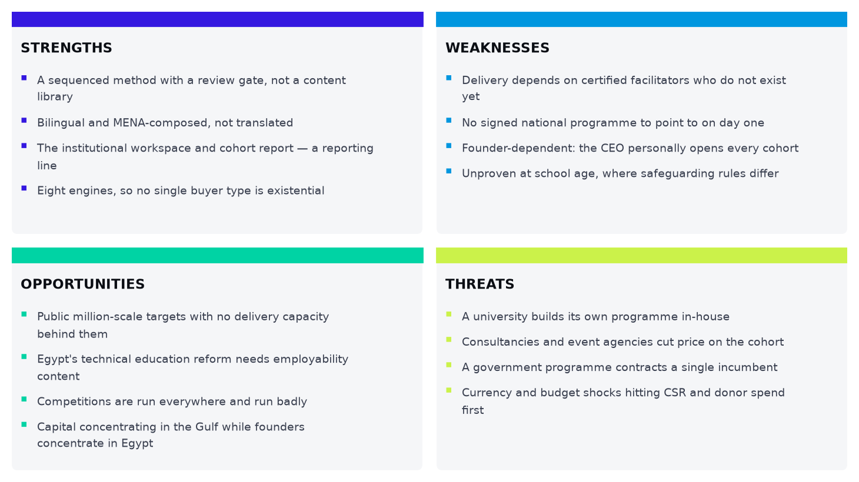
Strengths, weaknesses, opportunities and threats.
PESTLE analysis
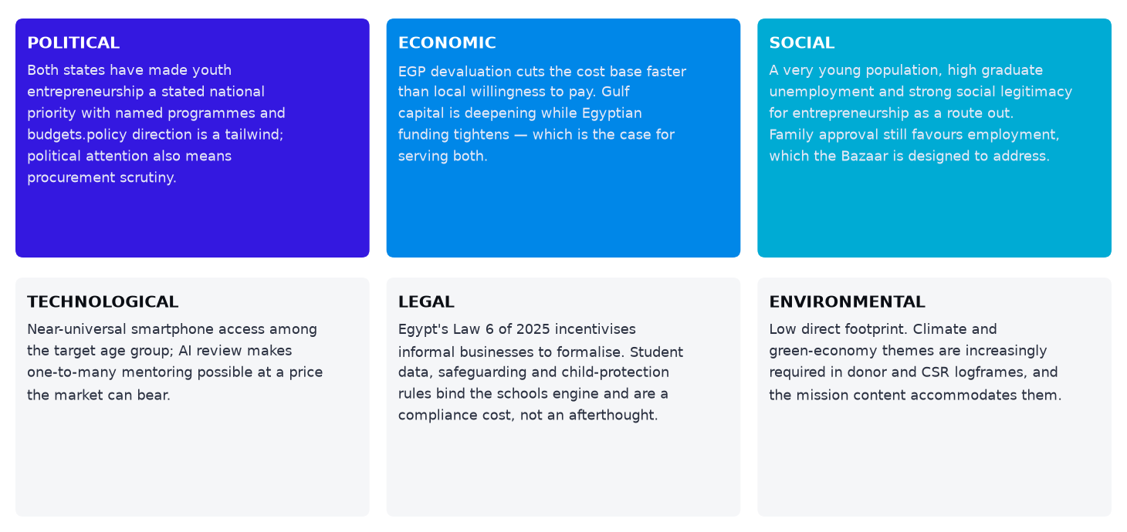
The external environment across six dimensions.
Risk analysis and mitigation
Risk | What it looks like early | Mitigation
Facilitator capacity does not materialise | Certification slips, or the pool leaks to consultancies paying more a day | Certification starts in the Land quarter, a term ahead of need; a tiered career with a rising day rate; the plan is cut to capacity rather than the reverse
University procurement is slower than planned | Pilots run but contracts sit unsigned through the Prove quarter | One contract covering all three layers; free pilots that make the report the sales document; competitions enter through Door 04 with a sponsor paying; Saudi revenue lands from Q4
The school variant does not transfer | School cohorts miss the completion gate, or safeguarding proves prohibitive | A separate curriculum variant rather than a shortened one, and a separately certified facilitator tier for school work; safeguarding carried as a standing cost from before the first school visit; the engine is gated to Expand so there is time to find out
Key-person dependency on the chief executive | Operations, finance, the quality gates and every senior institutional relationship sit with one person until the COO arrives in year four | The single largest structural risk created by the headcount cap, and accepted knowingly. Mitigated by making the quality gates documented and auditable rather than judgement-based, by the partner network manager owning the capacity forecast independently from year two, and by the COO being a dated commitment in the hiring plan rather than a contingency. If institutional volume arrives earlier than planned, that hire moves forward — it is the one line in the establishment the plan would willingly bring forward at the expense of another
The certified network dilutes the standard | Cohort scores drift at partner-delivered sites while StartPad-run cohorts hold, or a partner quietly sends uncertified facilitators | Sample audits every term; the pass mark owned by the Head of Curriculum and by nobody with a revenue target; licence withdrawal used at least once early, visibly, so that the network understands the audit is real
No national initiative partnership lands | Enthusiastic meetings, no budget line, repeated deferral | Engine 3 is 5% of year-one revenue, so year one survives without it; two partnerships pursued in parallel; the year-three plan sits inside 25% of addressable seats
Sponsor and CSR budgets move | Competition and corporate conversations stall simultaneously — usually a macro signal | Those two engines together are 11% of year one; the education and public families carry the plan without them
Currency and macro shock | EGP devaluation repricing costs against institutional budgets | Most costs are EGP and institutional pricing can be set in EGP with a USD reference; devaluation lowers the cost base faster than local willingness to pay
Key-person concentration | The CEO personally opens every cohort and carries every senior relationship | Day 01 onboarding is handed to certified facilitators before the Expand quarter; four buyer-type heads hold relationships independently
A safeguarding incident | Any incident involving a minor in a school cohort | Vetting, training, consent records and a written incident procedure before the first school cohort; this is a licence-to-operate risk, not a reputational one

Contingency planning
If this happens | Then
Certification is behind at the end of any quarter | Cut the next quarter's cohort plan to the certified pairs actually available and reallocate sales effort to seat, competition and partner engines, which do not consume facilitator capacity
The automatic cohort report slips past Q1 2027 | Produce reports manually for the pilot institutions only, cap new cohort sales at the manual capacity, and treat the report as the single highest engineering priority
No paid Egyptian cohort by the end of Q1 2027 | Treat the pilot proposition as unproven: run two further pilots at different institution types before scaling the sales team, and lean on Saudi partner revenue meanwhile
A national programme contracts a competitor exclusively | Redirect Engine 3 effort to governorate-level and ministry-of-education routes, and to the Saudi equivalents, rather than competing for the same central contract
School safeguarding approval proves prohibitive in one market | Run Engine 2 in the other market first and serve the blocked market through technical institutes, which are post-compulsory
Demand exceeds capacity materially | Raise price before raising volume, and shift the mix toward train-the-trainer so partners absorb the delivery

SECTION 14
Appendix

Every figure behind the plan, so a reader can argue with the inputs rather than the conclusions.
External figures
Figure | Value | Source
Egypt higher-education enrolment, 2024/25 | 3,900,000 | CAPMAS annual bulletin
Saudi tertiary enrolment, 2022 | 1,600,000 | UNESCO UIS. The 84% gross enrolment ratio reported for 2024 implies growth; the lower figure is held
Egypt graduates, 2023 | 547,200 | CAPMAS, reported via Ahram Online
Egypt technical secondary students | 2,200,000 | CAPMAS 2021/22, reported via Statista. The Ministry reported 595,848 passing first-term technical diploma exams in 2024/25 at a 70.47% pass rate, implying roughly 845,000 sitting
Saudi TVTC trainees, 2024 | 336,000 | TVTC — 336,150 trainees across 314 institutions, 98,716 graduates
Egypt public colleges | 551 | CAPMAS — 28 universities, 551 colleges
MENA startup funding, 2025 | $7.5bn across 647 deals | Wamda full-year
Egypt startup funding, 2025 | $263m across 89 deals | Wamda
Saudi startup funding, 2025 | $5.0bn across 211 deals | Wamda
One Million Entrepreneurs registrations | ~18,000 | Egyptian Ministry of Planning

Our estimates
These are not published figures. Each is derived, the derivation is stated, and each is a number a reader may reasonably dispute.
Estimate | Value | How it was derived
Saudi graduates a year | 300,000 | Enrolment over a four-year degree, discounted 25% for longer programmes and attrition
Secondary students, final two years | 2,200,000 | Egypt derived from total secondary less the technical stream; KSA from population and enrolment ratios
Micro and small enterprise owners | 4,300,000 | Widely cited formal and informal MSME counts in both markets
University buying units | 1,515 | 551 CAPMAS public colleges plus ~400 Egyptian private faculties; ~45 Saudi universities at ~12 colleges each plus 24 private colleges
Schools with a budget | 3,700 | Private, international, national and applied-technology schools in both markets
Egyptian technical institutions | 2,000 | Technical secondary schools; the Saudi figure of 314 is published by TVTC
Initiative seats a year | 1,200,000 | Addressable at steady state across both markets, far below the stated targets which total several million
NGOs and donors with a budget | 1,800 | Donors, foundations, bank foundations and INGO country offices with a youth employability mandate
Competitions a year | 1,100 | Universities, schools, banks, telcos, ministries and foundations
Large corporates | 1,400 | With a CSR, innovation or youth budget line

Operating assumptions
Assumption | Value | Reasoning
Faculty fit filter | 35% | Business, engineering, computing, design and applied science carry capstones that map to the missions
Delivery reachability | 73% | Greater Cairo, Alexandria, the Delta, Upper Egypt hubs; Riyadh, Jeddah, Dammam
Initiative share one provider could serve | 25% | Year three sits at 2% of addressable, inside this ceiling
University cohorts per pair per year | 18 | One per two weeks, with slack for travel, preparation and campus holidays
School cohorts per pair per year | 26 | A shorter format fits more into the same year
Technical cohorts per pair per year | 22 | Five days, between the other two
Facilitator day rate | $85 | Certified freelance rate, Egypt
Subscriber life | 1.6 years | A founder who finishes has no reason to renew a third year; one who stalls churns inside the first
Institutional commission | 6% | Institutional business is sold by people, and people on a number are paid on it

What this plan does not claim
▪ It does not claim an outcome number. StartPad records mission progress, evidence and review scores. It does not certify that a venture will succeed, and no partnership should be contracted against a metric the product cannot measure.
▪ The financial plan in this document is produced by the financial model, not written beside it. Every figure in it is read from the recalculated workbook, so the two cannot disagree. What the model cannot do is make its inputs true: the sales cycles, the conversion rates and the prices are decisions and estimates, not observations.
▪ Subscription conversion rates and pipeline conversion rates are modelled, not measured. Both will be replaced with observed figures after the first cohort quarter.
▪ Competition, corporate and NGO pricing is benchmarked against comparable sponsorship and contract spend rather than against signed StartPad deals, because there are none yet. These are the prices most likely to move.
▪ Several population figures are derived rather than published, and are marked as such above. Where a published figure exists we use it even when it is older than we would like.

