
StartPad template
Market Sizing — TAM, SAM, SOM
A number you can defend, built from the bottom up

What you will have when this is filled: Three sized figures, the arithmetic behind them, and the assumption that breaks them
startpad.me

About this template

What it is
TAM is everyone who could ever buy this. SAM is the part you could serve with your model, in your geography. SOM is what you could realistically win in three years. The purpose is not a big number — it is a defensible one. A bottom-up figure with visible arithmetic beats a top-down figure taken from a report, every time, in front of anyone who has done this before.
Why it earns its place
— Show whether the business can ever be large enough to be worth the years it will take.
— Replace a cited market report with arithmetic a reader can check line by line.
— Expose the one assumption the whole number rests on.
— Give a realistic three-year target instead of '1% of a huge market', which signals inexperience immediately.
Where it sits in your missions
Missions 4 and 12, and required for any pitch.
Where it comes from
PRIMARY SOURCE
Blank, S. & Dorf, B. (2012). The Startup Owner's Manual. K&S Ranch. — market size and type in customer discovery.
ORIGIN
The bottom-up method is Fermi estimation: decompose an unknown quantity into quantities you can estimate or count, and multiply. The discipline is old and comes from physics, not business — its value here is that every step is inspectable, so a reader can challenge one assumption instead of rejecting the whole figure.
FURTHER READING
— Mullins, J. (2003). The New Business Road Test. FT Prentice Hall.
— Weinstein, L. & Adam, J. (2008). Guesstimation. Princeton University Press.
How to fill it in
1. Do the bottom-up calculation first: number of potential customers x price x purchase frequency per year. Show every figure.
2. Source each figure. A government statistic, a census, a platform's published number, or your own count — with the date.
3. Do a top-down estimate separately as a sanity check. If the two differ by more than 10x, one of them is wrong; find out which.
4. Work in EGP and give the USD equivalent with the rate and date you used.
5. State the assumption the whole number depends on — usually price or adoption rate — and what the number becomes if you halve it.
6. Set SOM against a real constraint: your channel, your capacity, your funding. Not a percentage of SAM.
What done well looks like
☐ Every number has a source and a date next to it.
☐ The arithmetic is visible and a reader can redo it.
☐ SOM is justified by a constraint, not by a percentage.
☐ The breaking assumption is named, with the halved case shown.

The template
Print it, or type straight into the boxes. The small italic text is a prompt — delete it as you fill each box.
TAM — total addressable market
Everyone who could buy this, anywhere, if you had no limits. Definition, number, and how you got it.
SAM — serviceable available market
The part your model and geography can actually reach. What did you exclude, and why?
SOM — serviceable obtainable market
What you can realistically win in three years, limited by channel, capacity or capital. Name the constraint.
BOTTOM-UP CALCULATION
Customers x price x frequency. Every figure gets a source and a date.
Step | Figure | Where it came from | Date of source | Running total
Population or universe of the segment
% that fit the definition
= Potential customers
Price per purchase (EGP)
Purchases per customer per year
= Annual market value (EGP)
Top-down sanity check — same figure, different route
WHAT BREAKS THE NUMBER
The assumption everything rests on  Which single figure, if wrong, changes the answer most? Usually price or adoption. | Halve it — what happens?  Recalculate with that assumption cut in half. Is the business still worth doing?
Currency and date
EGP figures, the USD rate used, and the date. Market numbers age faster than founders expect.

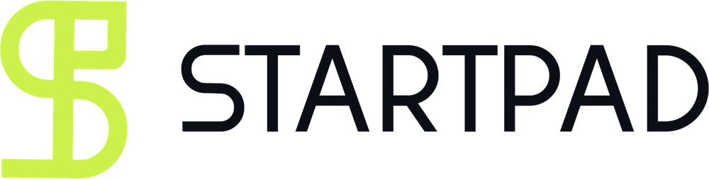
StartPad is where you become someone the ecosystem takes seriously.

Programmes ask for four things. Most first-time founders have two. StartPad is the fifteen missions that close the gap — and the file you apply with at the end.
It is a founder-readiness platform for Egypt and the wider MENA region. It takes someone with an idea and no company, moves them through fifteen structured missions, and issues verifiable proof of what they completed. Not a course. Not an incubator. The step before both.
It never costs you your idea. Nothing you put into StartPad assigns any right in what you build, and no template in this library changes that. You finish the work. We keep the file.
The fifteen missions, in five moves
— Discovery — analyse the problem, define it, and rank problems by importance and frequency.
— Ideation — select an idea, describe it, and test the solution hypothesis.
— Model — build the business model and decide what you actually sell.
— Build — prototype, validate the market, and ship a minimum version.
— Launch — test product-market fit and go to market.

startpad.me
Part of GrowthLabs. This template is free to use, copy and teach from. If you publish it, keep the credit line.

