STARTPAD
One Million First-Time Founders
مليون رائد أعمال لأول مرة
Technical and Financial Proposal
For CSR sponsors, NGOs and development partners
Wave 1 · March – August 2027 · Aligned with Egypt Vision 2030 and the national entrepreneurship agenda
StartPad · Cairo, Egypt · hello@startpad.me
November 2026 · Version 1.0 · Confidential: prepared for prospective partners

Contents
1 Executive summary
2 Why now: Egypt Vision 2030 and the entrepreneurship agenda
3 The initiative: what a first-time founder gets
4 Technical proposal
5 Delivery plan, team and governance
6 Impact: economy, society, knowledge and work
7 Financial proposal
8 Partnership packages and benefits
9 Risk register
10 How to join and next steps
Appendices: A The fifteen missions · B Key assumptions · C Ideas-bank rules · D Sources

1 Executive summary
Every year, hundreds of thousands of young Egyptians have an idea and nowhere structured to take it. They can read, watch and guess, or they can win one of a handful of accelerator seats. Between the two there is nothing. StartPad closes that gap with a method: fifteen reviewed missions that take a first-time founder from an observed problem to a tested model, a prototype and a launch plan, in Arabic, on a phone.
We invite corporate CSR programmes, NGOs and development partners to fund Wave 1: six months, March to August 2027, to put that method in the hands of 1,000,000 young Egyptians, and to give 120,000 of the most committed of them the full fifteen-mission programme.

The offer in six numbers
1,000,000 | 450,000 | 225,000 | 120,000 | 306,000 | 864
young Egyptians register (free, forever, missions 01–03) | finish Mission 01 and state a real problem | finish the free tier and qualify for a Pro seat | sponsor-funded Pro seats, missions 04–15 | consented ideas in a national ideas bank | ventures trading 12 months after the wave (modelled)

What we are asking for, and why the number is what it is
- Price: $5 per activated Pro seat. A sponsor pays only for a founder who has finished Missions 01–03 and unlocked the full programme: it buys outcomes, not sign-ups. Blocks under 5,000 seats and private branded cohorts are $10.
- Budget: $496,557 for the wave and its preparation (November 2026 – October 2027). This is 2.5 times the $200,000 in our earlier framework because the earlier figure left out sponsor acquisition, government engagement, accommodation, platform credits, production monitoring, support, legal, audit and a contingency. Section 7 reconciles every dollar.
- Revenue and margin: At 120,000 funded seats and $5 per seat the coalition contributes $600,000. After all costs and fees that leaves a surplus of about $103,443 (17% of revenue), which StartPad retains as its platform and programme-management fee. Anything above a 20% margin is reinvested in additional seats or seed grants.
- Tiers: Founding Partner $100,000 (20,000 seats), Partner $40,000 (8,000 seats), Supporting Partner $10,000 (2,000 seats); NGOs and donors can buy seat blocks from 1,000 seats ($5,000); in-kind support is credited at market value; student and youth organisations join without paying anything.
- Gate: We will not commit Wave 1 spend beyond pre-wave preparation until about 98,000 seats (about $490k) are pledged, so no sponsor funds a wave that cannot be delivered.
Every $5 puts one young Egyptian founder through the complete method: reviewed, mentored by webinar, counted in a national report and eligible for a regional showcase.

Alignment
The initiative is designed to serve Egypt Vision 2030: entrepreneurship and SMEs as an engine of economic development, knowledge and innovation, education and training, and social justice through opportunity outside Cairo. It maps to SDGs 4, 5, 8, 9 and 10, and every partner receives audit-ready reporting that can be dropped into an annual or GRI report.

2 Why now: Egypt Vision 2030 and the entrepreneurship agenda

2.1 The demographic and labour-market case
- Egypt's population is about 108 million, and CAPMAS counted more than 21 million people aged 18–29 in August 2025: close to one in five Egyptians (Ahram Online, citing CAPMAS).
- Unemployment fell to 6.3% in 2025, but for ages 15–29 it was 13.2%: 8.1% for young men and 33.8% for young women. For educated youth it was 16.8%, and 38.3% for educated young women (CAPMAS, 2025).
- The public sector cannot absorb these graduates. Jobs will come from enterprises that do not yet exist, started by people who have never started one.
The gap is not enthusiasm. It is the absence of a structured, affordable, Arabic-language path from an idea to a first customer that a student in Minya or Assiut can start on a Tuesday evening.

2.2 How the initiative serves Egypt Vision 2030
Egypt's Sustainable Development Strategy: Egypt Vision 2030 sets national goals across economic, social and environmental dimensions, and treats entrepreneurship and small and medium enterprises as a priority for growth and job creation (OECD, SME and Entrepreneurship Policy in Egypt). The table shows how Wave 1 contributes. This mapping is StartPad's own; it does not imply endorsement by any ministry, and patron-ministry memoranda are part of the pre-wave plan.
Vision 2030 priority | What Wave 1 does | Measured by
Economic development: entrepreneurship and SME growth | Takes first-time founders from idea to tested model, prototype and launch plan; feeds regional showcases and incubators | Founders finishing all 15 missions; ventures trading at month 12; formalised ventures
Knowledge, innovation and research | Builds the first structured national dataset of what young Egyptians want to build (the ideas bank and quarterly direction report) | Consented ideas; direction reports published; partners using the data
Education and training | A reviewed, Arabic-first entrepreneurship curriculum reaching campuses and governorates; trains chapter leaders as certified hosts | Missions completed; leaders trained; webinar reach
Social justice and inclusion | Free entry for everyone; governorate rivalry and NGO networks aimed outside Cairo; a 40% target for women participants | Participation by governorate and gender; completion gaps
Digital transformation and jobs | Digital, mobile-first learning and AI-assisted review at national scale; ventures that hire | Jobs held in trading ventures (modelled); formalisations
Partnership and efficiency of public resources | One accountable programme, a shared dashboard, audited reporting, and a coalition of CSR, NGO and ministry partners instead of parallel pilots | Cost per founder; audit opinion; partner council attendance

2.3 Sustainable Development Goals
SDG | Contribution
4 Quality education | Reviewed practical entrepreneurship learning at scale
5 Gender equality | Target of 40% women; disaggregated completion data; partners with women's economic empowerment mandates
8 Decent work and economic growth | Ventures, jobs and formalisation
9 Industry, innovation and infrastructure | Digital learning infrastructure; innovation pipeline
10 Reduced inequalities | Reach into Upper Egypt and the Delta; free tier forever

3 The initiative: what a first-time founder gets

3.1 Fifteen missions in five stages
Each mission asks a few hard questions, each is submitted, and each submission is reviewed against a rubric rather than ticked off. A founder who finishes has a tested problem, a defined user, a business model, a prototype and a launch plan, with the evidence trail that produced each. Appendix A lists the missions.
Stage | Missions | Outcome
1 Discover the opportunity | 01–03 | Problem analysis, definition and prioritisation
2 Shape the concept | 04–06 | Testable problem, selected solution, value proposition and assumptions
3 Test with people | 07 | First assumption test with real users
4 Model and prototype | 08–10 | Business model canvas, learning prototype, prototype user test
5 Prove readiness | 11–15 | Go-to-market experiment, demand validation, MVP scope, traction review, launch and incubator readiness

3.2 Free tier and Pro seat
- Free tier, forever: Missions 01–03 are free to every Egyptian, with or without a sponsor. Nothing that asks for a payment on the first screen has ever spread in this market.
- Pro seat, sponsor-funded: A founder who finishes Missions 01–03 (and, through the referral unlock, brings two peers through Mission 01) qualifies for a Pro seat: Missions 04–15, full review, live webinars, showcase eligibility. A sponsor funds that seat at $5. 15% of funded seats are reserved for members of youth foundations and student chapters who qualify (about 18,000 in the Base plan).
- Pay for outcomes: Sponsors are billed when a founder activates, not when they register. Activated founders without a funded seat wait on the free tier until a sponsor funds them, which is also the sponsor's opportunity: sponsor a governorate, a sector or a chapter and unlock its founders by name.

3.3 Three delivery layers
- The platform: fifteen missions, tools, review and progress record; Arabic-first; works on a phone.
- 24 live webinars in Arabic: one a week, recorded; a funding partner's name on the ones they fund; no paid in-person cohorts in this wave.
- Partner-hosted info sessions: 300 evenings in a partner's or chapter's own room, with our kit and trained hosts. We pay $20 for a kit, not for a room.
- Community: 150 chapters, 1,000 student ambassadors, and Mission Zero, the founder podcast.

3.4 How a million is reached
500,000 registrations are seeded by the coalition's own channels: telecom, bank and corporate messaging (180,000), 150 chapters (150,000), 1,000 ambassadors (60,000), 18 NGO networks (54,000), and podcast, press and organic (56,000). The other 500,000 come through a referral loop built into the product at a viral coefficient of 0.50: Mission 04 opens when a founder brings two others through Mission 01, and every finished mission produces a shareable Arabic card. We treat 0.50 as the riskiest number in the plan; the sensitivity in Section 7.7 shows the wave at 0.25.
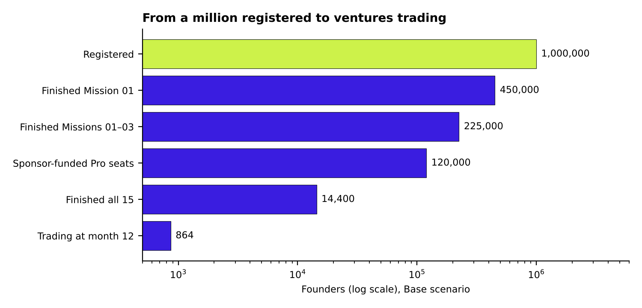
Figure 1. Base-case funnel, modelled from stated assumptions, not measured results

4 Technical proposal
This section states the system the sponsors are paying to run at national scale and the service levels we commit to. Targets are proposals for the partner agreement; where a number is a planning assumption it is labelled as such.

4.1 Architecture overview
Layer | What it does | Design principle
Learner app (Arabic first) | Mobile-web app; mission flow, tools library, submission, feedback, progress, shareable cards | Low bandwidth; works on entry-level phones; right-to-left throughout
Mission and review engine | Delivers the fifteen missions; rubric-based AI review of every submission; human sampling and escalation | Queue-based and asynchronous so a traffic spike delays feedback, never submission
Referral and community service | Invite codes, unlock logic, chapter and governorate leaderboards, ambassador codes | Fraud checks on invite codes; leaderboards by completion as well as registration
Ideas bank and consent service | Stores structured ideas with separate consent flags; aggregate views by default; themed calls | Aggregate-only for under-18s; consent withdrawable at any time
Partner dashboard and reporting | Weekly dashboard per partner, quarterly direction report, closing report with SDG mapping | One source of truth; the same data feeds every partner and the evaluator
Operations layer | Monitoring, alerting, logging, on-call, support helpdesk, backups | Production monitoring is a budgeted line, not a favour

4.2 Scalability and load
- Planned peak: 220,000 registrations in launch month (March 2027) and 1,000,000 accounts by August (Base).
- Load test for one million accounts in February 2027, with a rehearsal of the referral loop with a partner NGO, before any public launch.
- Stateless application tier behind a content-delivery network; autoscaling; separate queues for AI review so peak submissions do not slow the learner experience.
- Capacity planning is driven by the assumptions in the workbook: about 2.4 million AI review passes in the Base case, roughly 1.0 million free-tier and 0.6 million Pro submissions.
- Cloud and AI credits donated in-kind by a technology partner reduce the AI review line directly; the budget assumes none.

4.3 AI review: quality, fairness and human oversight
- Every submission is reviewed against a published rubric per mission; feedback is returned in Arabic and states what to fix, not only a score.
- Human sampling: trained reviewers audit a weekly sample, and low-confidence or sensitive submissions are escalated to a human.
- Quality targets: 95% of reviews returned within two hours; 99% within 24 hours; a reviewer-agreement rate reported monthly in the partner dashboard.
- Bias and language checks: Arabic dialect samples, gender and governorate parity checks on review outcomes, reported in the closing report.
- No founder is rejected by an automated decision alone: a founder can request a human re-review.

4.4 Data protection, consent and safeguarding
- Compliance with Egypt's Personal Data Protection Law (Law 151 of 2020); a named data protection lead; policy supplied to partners before signature.
- Consent is asked in Arabic at registration, separately for anonymous aggregate use and for any identified sharing; it can be withdrawn from the account, and withdrawal removes the record from future reports.
- The founder owns the idea. No partner acquires ownership, a licence or a right of first refusal by sponsoring (Appendix C).
- Under-18s are aggregate-only under every tier: no identified sharing, no themed calls, no contact; guardian consent recorded at registration.
- A named safeguarding lead, a written policy, vetting for everyone who works with minors, and a reporting route that reaches the steering committee in the same week.
- Security: encryption in transit and at rest, role-based access, audit logging, and an independent penetration test before launch (budgeted).

4.5 Production monitoring, support and incident response
Service level (proposed) | Target | How it is monitored
Platform availability during the wave | 99.5% monthly | Uptime probes; public status page
Page response on a mobile connection | Core screens usable on 3G-class networks | Synthetic tests; real-user monitoring
AI review turnaround | 95% within 2 hours | Queue metrics on the dashboard
Support response (Arabic helpdesk) | First response within one working day | Helpdesk reports
Critical incident | Acknowledge in 30 minutes, update every hour, post-incident report within 5 working days | On-call DevOps retainer (January – August 2027)
Data requests and withdrawals | Actioned within 30 days | Consent service log

4.6 Accessibility and inclusion
- Arabic first; Egyptian-Arabic examples and rubrics produced for the audience, not translated.
- In-kind data bundles from a telecom partner are the difference between a registered account and a completed mission in low-income governorates.
- Info sessions in partners' venues reach founders who have no reliable connection at home.
- Disaggregated reporting by governorate, gender, age band and student/graduate status.

5 Delivery plan, team and governance

5.1 Timeline
When | Phase | Key activities
Nov 2026 – Feb 2027 | Pre-wave | Assemble the coalition; patron-ministry memoranda; community charters and 1,000 ambassadors; train hosts; localise content; load test (February, during Ramadan: no public launch)
Mar 2027 | Wave: launch | National launch in Cairo after Eid al-Fitr; all chapters and ambassadors activate in the same week; every partner sends its first message on a committed date; first challenge week
Apr 2027 | Wave: the loop | Strongest campus month; referral unlock overtakes partner channels; chapter leaderboard live
May 2027 | Wave: exams | Campus activity pauses; NGO networks, youth centres and partner-hosted sessions carry the wave; mid-wave report
Jun 2027 | Wave: summer | Exams end; completion becomes the headline number
Jul 2027 | Wave: showcases | Six regional showcases; first national read of the ideas bank to partners
Aug 2027 | Wave: demo day | National demo day; closing report; independent evaluation commissioned
Sep – Oct 2027 | Close-out | Evaluation, audit, publication, Wave 2 decision with partners

5.2 Team
A lean team of four, strengthened by two Programme Specialists approved by our board:
- Programme Manager: overall delivery, steering committee secretary.
- Community Manager: chapters, ambassadors, leaderboards.
- Content Producer: localisation, webinars, host kit.
- Analyst (part-time): dashboard, direction report, evaluation data.
- Programme Specialist, partnerships and government relations (new): sponsor and donor relationships, ministry memoranda, reporting to partners.
- Programme Specialist, events, logistics and accommodation (new): launch, six showcases, demo day, travel and accommodation of finalists and ambassadors.
StartPad's engineering, product and leadership time is contributed and is not charged to the coalition.

5.3 Governance
Body | Members | Role
Steering committee | Founding Partners, StartPad, patron-ministry observers | Meets at months 0, 3 and 6. Approves the plan and the national report; decides on an extension
Partner council | Every partner, plus community-supporter leads | Monthly, one hour, one dashboard
Community council | Chapter and youth-foundation leads | Run by them; owns the charter, league table and showcase selection rules
Independent evaluator | Chosen by the steering committee, not StartPad | Commissioned at month six; published whatever it says
Safeguarding and data protection leads | Named individuals | Policies, vetting, consent, incident route

6 Impact: economy, society, knowledge and work
All figures below are modelled from stated assumptions, in the same convention as our framework. The initiative has not run yet. The month-12 follow-up and the independent evaluation replace the model with measurements.
Dimension | Base-case result | How it is worked out
Knowledge | 1,000,000 young Egyptians trained in the method; 306,000 consented ideas; four quarterly direction reports; 1,500 chapter leaders certified as hosts | Registrations × funnel rates; 150 chapters × 10 leaders
Work | 14,400 founders finish all 15 missions; 864 ventures trading at month 12; about 2,592 jobs held in them | Funded Pro seats × 12% × 6%; 3.0 jobs per venture (assumption)
Economy | About $6.9M of year-one venture turnover (modelled); roughly half of trading ventures formalise | $8,000 average turnover per venture (assumption); 50% formalise (assumption)
Society | Reach in all 27 governorates; a 40% target for women; NGO networks and chapters aimed outside Cairo; a public governorate map | Targets, not forecasts; reported by governorate and gender
Public value | About $575 of programme budget per trading venture, and about $192 per job held | Total budget ÷ outcome

6.1 What each partner can say it paid for
- Direction of youth thinking: the first national read of what young Egyptians want to build, by sector, governorate, gender and age, before it is published.
- Demand-led programme design: open the accelerator track the applicants already exist for.
- A filtered pipeline: showcase ventures have been through fifteen missions and an AI review on each.
- Reporting that survives an audit: completion rates, disaggregation, SDG mapping, cost per outcome.
- Measured staff engagement: mentor and judge hours are logged and reported.
- For NGOs: staff trained to host, an evidence base for the next donor proposal, and beneficiaries moved from relief to income.
- For youth organisations: a free programme for every member, a credential for leaders, a national stage and the chapter's own data.

6.2 Measurement framework
Level | Indicator | Target (Base) | Source | When
Output | Registered founders | 1,000,000 | Platform | Weekly
Output | Webinars delivered | 24 | Platform | Monthly
Output | Chapter leaders trained | 1,500 | Training log | Pre-wave, quarterly
Outcome | Finished Mission 01 / missions 01–03 | 450,000 / 225,000 | Platform | Weekly
Outcome | Finished all 15 missions | 14,400 | Platform | Monthly
Outcome | Women among participants | 40% target | Registration data | Monthly
Outcome | Participants outside Greater Cairo | Report; target set at steering committee | Registration data | Monthly
Impact | Ventures trading at month 12 | 864 | Follow-up survey | Aug 2028
Impact | Jobs and turnover per venture | 3.0 jobs; $8,000 (assumptions) | Follow-up survey | Aug 2028
Evaluation | Independent evaluation | Published | Evaluator | Month 6

7 Financial proposal

7.1 The budget in one table
Budget line (USD) | Downside | Base | Upside | Earlier $200k framework
A Programme team (incl. 2 new specialists) | $70,620 | $82,920 | $82,920 | $35,000
B Marketing and sponsor acquisition | $54,333 | $61,000 | $66,000 | $0
C Government, partnerships and accommodation | $43,600 | $43,600 | $43,600 | $0
D Platform, AI credits and infrastructure | $78,168 | $110,878 | $136,489 | $60,000 (D + E)
E Production monitoring, support and security | $39,800 | $43,800 | $46,800
F Content, webinars and info-session kit | $25,000 | $25,000 | $25,000 | $25,000
G Community: ambassadors and chapters | $30,000 | $30,000 | $30,000 | $30,000
H Events | $33,000 | $33,000 | $33,000 | $35,000
I Measurement, reporting, evaluation and audit | $20,000 | $20,000 | $20,000 | $15,000
J Legal and insurance | $17,000 | $17,000 | $17,000 | $0
K Contingency | $20,576 | $23,360 | $25,040 | $0
Total cost before bank fees | $432,097 | $490,557 | $525,850 | $200,000
Bank, FX and payment fees (1%) | $3,000 | $6,000 | $8,600
TOTAL BUDGET | $435,097 | $496,557 | $534,450 | $200,000
Revenue at $5 per funded Pro seat | $300,000 | $600,000 | $860,000 | $200,000
Surplus | ($135,097) | $103,443 | $325,550
Margin on revenue | (45%) | 17% | 38%

Downside = viral coefficient 0.25, 60,000 funded seats, one specialist. Base = 0.50, 120,000 seats, two specialists. Upside = 0.60, 172,000 seats. The Base column is the plan; the others show what the budget does if the loop or the coalition under- or over-delivers.
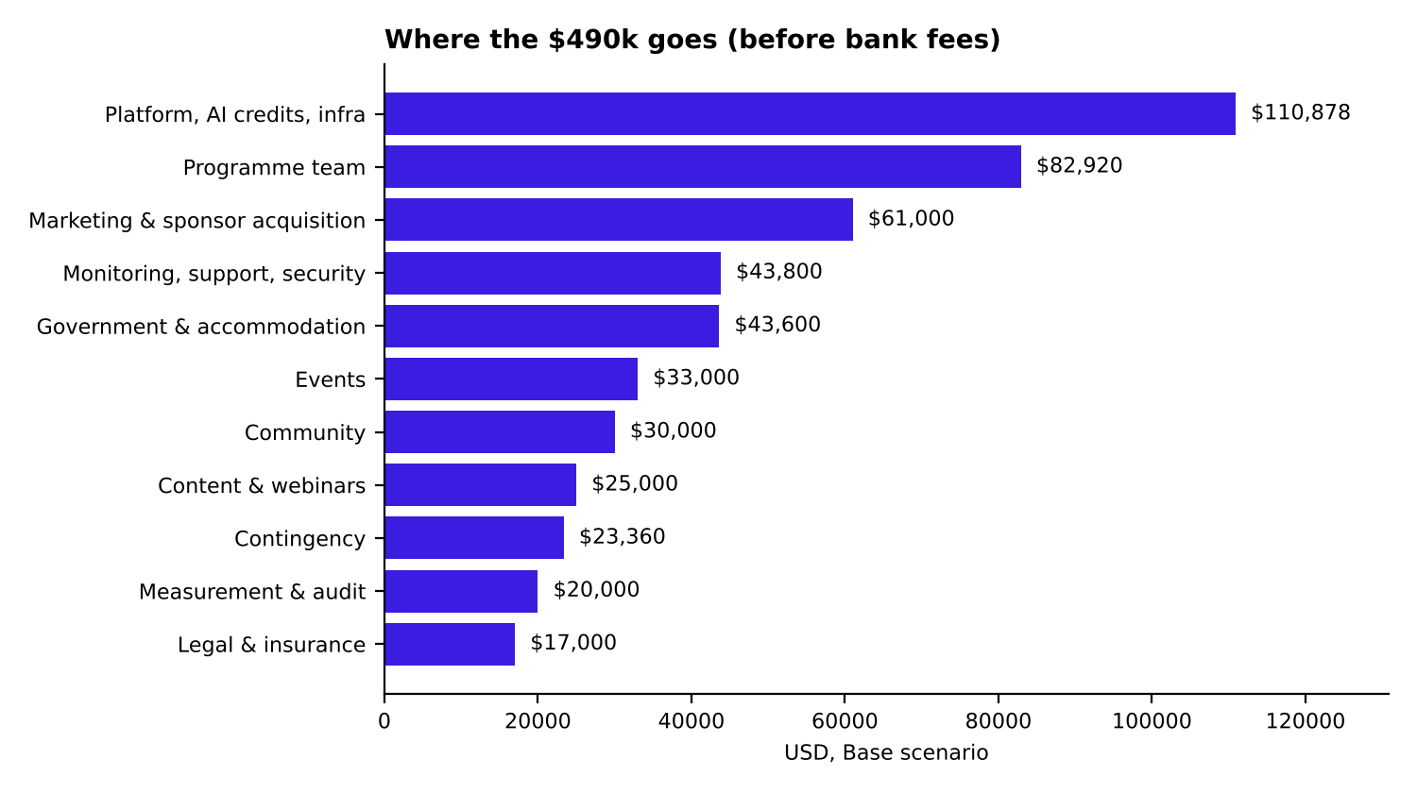
Figure 2. Base cost by category

7.2 What changed from the earlier $200,000 framework, and why
- Marketing and sponsor acquisition ($61,000): approaching sponsors, the launch film, creator amplification and PR were carried by the company before; they are real costs of a national wave.
- Two programme specialists ($31,080 incl. recruitment): partnerships and government relations; events, logistics and accommodation.
- Government, partnerships and accommodation ($43,600): ministry memoranda and protocol, governorate travel, and accommodation, travel and meals for 60 finalist teams and the top 50 ambassadors at the national demo day.
- Platform and AI credits ($110,878 vs $60,000 with monitoring): the earlier figure did not include verification messaging, load testing or the AI review of the free tier at one million accounts.
- Production monitoring, support and security ($43,800): observability, on-call DevOps, an Arabic helpdesk, a penetration test and data-protection compliance.
- Legal, insurance, audit ($22,000) and contingency ($23,360): needed for a programme that promises audit-ready reporting, and for a USD revenue / EGP cost mismatch.
- Unchanged: content and webinars ($25,000), community ($30,000), events ($33,000 after moving demo-day accommodation to line C) and measurement ($15,000).

7.3 Pricing model: $5 per activated Pro seat
A Pro seat is one founder who has finished Missions 01–03 and unlocked Missions 04–15. Seats are bought in blocks, drawn down as founders activate, and reported by name of governorate, sector or chapter where the sponsor chooses a focus. Unused seats at the end of the wave are carried into Wave 2 or reallocated to another governorate or sector at the sponsor's option; they are not forfeited.
Measure | Downside | Base | Upside
Pro seats served | 60,000 | 120,000 | 172,000
Cost per Pro seat | $7.20 | $4.09 | $3.06
Break-even price per seat | $7.27 | $4.13 | $3.09
Price for a 15% margin | $8.57 | $4.87 | $3.64
Break-even Pro seats at $5 | 88,215 | 98,396 | 104,008

Reading: $5 is the right standard price for the Base plan: it covers cost per seat ($4.09) and meets the margin target ($4.87 needed). It is a floor rather than a cushion: below roughly 98,000 funded seats the wave loses money at $5, and in the Downside the price needed for a 15% margin is $8.57.
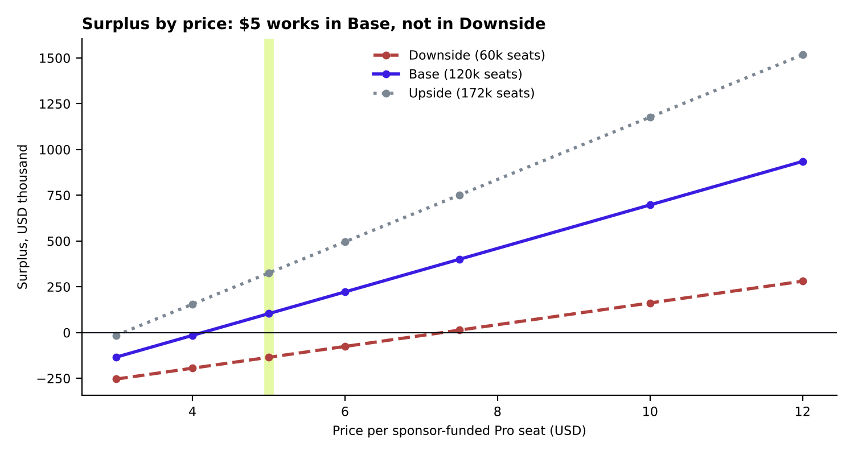
Figure 3. Surplus by price per Pro seat, by scenario
Why not charge $10 to everyone? At $10 the Base margin rises above 55%, which CSR teams and donors will read as profit rather than cost recovery, and a fixed sponsor budget funds half as many founders. We therefore keep $5 for blocks of 5,000 seats or more, and charge $10 for smaller blocks, employee programmes and private branded cohorts, where legal, reporting and dashboard overheads are the same as for a large block. If pledges lag the plan at the January 2027 review, new blocks move to $7.50.

7.4 Tiers expressed in seats
Tier | Slots | Seats | Cash at $5 | Principal benefits
Founding Partner | 2 | 20,000 | $100,000 | Steering committee seat; a sector or governorate group carried under their name; four webinars; quarterly direction report before publication; a themed call into the ideas bank; first look at showcase ventures; closing report
Partner | 5 | 8,000 | $40,000 | Named across all surfaces; partner council seat; two webinars; direction report; closing report
Supporting Partner | 10 | 2,000 | $10,000 | One of the fifteen missions carried under their name; one webinar; sector slice of the direction report; named in the closing report
NGO / donor seat block | Open | from 1,000 | from $5,000 | Seats for a partner's own beneficiaries, trained hosts, shared evidence base and a seat in the coalition
In-kind partner | Open | Credited at value |  | Reach, airtime, venues, hotel rooms, cloud and AI credits, company formation, prizes; credited at the matching tier
Community supporter | Open |  | No cash, ever | Free missions 01–03 for every member; reserved Pro seats for qualifying members; leaders trained as hosts; leaderboard place; chapter data; national stage

Coalition capacity at full sale is $500,000 from corporate tiers plus donor seat blocks; the Base plan assumes $600k in total.

7.5 Payment terms and cash flow
- 30% at signature (January – February 2027), 40% at launch and during March – April, 30% across May – July. This removes most of the pre-wave bridge StartPad would otherwise carry.
- Before the first sponsor payment arrives, StartPad carries pre-wave spend. In the Base plan the peak bridge is about $42,540 (December 2026).
- Funds are held in a dedicated programme account and reported against the budget lines above at each partner council meeting.
- Payment in USD or EGP at the rate on the invoice date; EGP invoices for Egyptian entities.
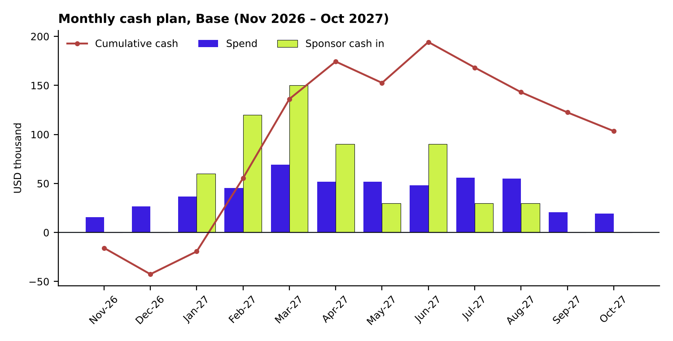
Figure 4. Base monthly cash plan

7.6 Financial controls and transparency
- A dedicated programme budget and bank account; monthly dashboard of spend against budget.
- An independent financial audit of sponsor funds (budgeted: $5,000) and an independent evaluation chosen by the steering committee.
- Margin policy: StartPad retains a surplus of up to 20% of revenue as its platform and programme-management fee. Anything above 20% is reinvested in additional Pro seats or seed grants, not retained.
- StartPad contributes the platform, the curriculum and its engineering and leadership time without charge to the coalition.

7.7 Sensitivities and what we do if funding falls short
If… | Then…
The referral loop is weaker (0.25) | Registrations fall to about 667,000 and AI/hosting costs fall; the funded-seat count, not registrations, sets revenue, so the budget is protected.
Pledges stop below ~98,000 seats | Do not commit Wave 1 spend; new blocks at $7.50; defer the second specialist; reduce regional showcases from six to two; halve the ambassador programme; cut paid amplification. Together these save about $70,000.
A donor funds a large seat block | Seats rise and surplus rises; above 20% margin the surplus is reinvested in more seats.
EGP weakens against USD | Most costs are in EGP and revenue in USD, which favours the programme; the contingency covers the reverse.

8 Partnership packages and benefits

8.1 Three roles
Role | Gives | Gets
CSR sponsor | Cash seat blocks, in-kind reach, staff as mentors and judges | Named association with a national initiative; webinars under their name; audit-ready reporting; the direction report; filtered pipeline
NGO and development partner | Reach into beneficiary networks, staff time, venues, co-funding where available | The method for their beneficiaries; staff trained to host; an evidence base; seat beside corporate CSR decision makers
Community supporter (youth foundations such as Enactus, INJAZ, AIESEC, Hult Prize chapters) | Members, chapters as hosts, leaders trained to run sessions. Never money | Free missions 01–03 for every member and a reserved pool of sponsor-funded Pro seats for those who qualify; leaders' credential; leaderboard; chapter data; national stage

8.2 What a sponsor should expect to receive
- A weekly partner dashboard with their own line in it.
- The quarterly direction report on what young Egyptians are building.
- A closing report with completion rates, governorate and gender disaggregation, cost per outcome and SDG mapping, in the structure of an annual or GRI report.
- Logged staff mentor and judge hours.
- Named recognition in Arabic and English in front of every participant.

9 Risk register
Risk | Likelihood / impact | Mitigation | Owner
Referral loop does not fire | Medium / High | Measure from week 1; partner messaging calendar fixed at signature; budget protected because revenue is seat-based | Programme Manager
Coalition does not fill | Medium / High | Launch gate at ~98,000 seats; $7.50 trigger; cost levers worth ~$70,000; pre-wave only spend until the gate is met | CEO / Specialist 1
Registration without completion | High / Medium | Four challenge weeks; showcase as the reason to finish; completion, not registration, is the headline | Community Manager
Platform load or outage | Low / High | Load test for 1M in February; autoscaling; on-call retainer; status page | Engineering lead
Safeguarding incident involving a minor | Low / Critical | Named lead; written policy; vetting; aggregate-only data for under-18s; same-week reporting to steering committee | Safeguarding lead
Data breach or consent failure | Low / High | Law 151/2020 compliance; penetration test; consent service; DPO | Data protection lead
AI review quality or bias | Medium / Medium | Human sampling; rubric; parity checks; human re-review on request | Product lead
Foreign-exchange movement | Medium / Medium | 5% contingency; EGP/USD invoicing options | Finance
Perceived profit-taking | Medium / High | Published margin policy; audit; reinvestment above 20% | CEO
Ramadan and exam calendar | Certain / Medium | February: no public launch; May: offline and NGO-led; June: completion focus | Programme Manager

10 How to join and next steps
Step | What happens | Time
1 Conversation | Twenty minutes: the platform, the direction-report mock-up, the referral loop. No deck. | Week 1
2 Tier and shape | A one-page summary: cash seat block, in-kind equivalent or community charter; the governorate or sector under your name. | Week 1–2
3 Paperwork | Sponsorship agreement or charter, safeguarding and data policies, your due-diligence pack. | Weeks 2–4 (longer for foundation boards)
4 Council | A seat on the partner council from the month you sign. | From signature

What we ask of you
- A named counterpart who can make a decision.
- Your reporting requirements in writing before the wave starts.
- Your governorate or sector preference.
- For in-kind partners: the market value you want the contribution credited at.
- A messaging calendar for your channels, agreed at signature.

Contact
StartPad · Cairo, Egypt · hello@startpad.me
Three Founding Partners and the rest of the coalition follows. Help put a Pro seat in the hands of a million first-time founders in Egypt.

Appendix A The fifteen missions
# | Mission | Stage | Points
01 | Problem analysis | Discover the opportunity | 100
02 | Problem definition | Discover the opportunity | 100
03 | Opportunity prioritisation | Discover the opportunity | 150
04 | Testable problem statement | Shape the concept | 150
05 | Solution selection | Shape the concept | 200
06 | Value proposition and assumptions | Shape the concept | 200
07 | First assumption test | Test with people | 250
08 | Business model canvas | Model and prototype | 300
09 | Build a learning prototype | Model and prototype | 300
10 | Prototype user test | Model and prototype | 300
11 | Go-to-market experiment | Prove readiness | 300
12 | Demand and market validation | Prove readiness | 350
13 | MVP scope and build | Prove readiness | 400
14 | Early traction review | Prove readiness | 450
15 | Launch and incubator readiness | Prove readiness | 500

Appendix B Key assumptions
Every figure in this proposal is generated by the accompanying workbook (StartPad_Wave1_Budget_v2.xlsx). The main assumptions are listed below; each is an editable input in the workbook.
Assumption | Value | Basis
Seed registrations | 500,000 | Partner channels, chapters, ambassadors, NGO networks, media (framework)
Viral coefficient | 0.25 / 0.50 / 0.60 | Framework sensitivity points
Registered → Mission 01 | 45% | Framework
Mission 01 → Missions 01–03 | 50% | Framework
Activated → all 15 | 12% | Framework
Full finishers trading at month 12 | 6% | Framework
Funded Pro seats (Downside / Base / Upside) | 60,000 / 120,000 / 172,000 | Coalition pipeline assumptions: not yet pledged
AI review cost per pass; passes per submission | $0.02; 1.5 | Management estimate; verify against the invoice
Salaries | Programme Manager $1,500/month; specialists $1,000–1,200/month; 20% on-costs | Management estimates; confirm with HR
Contingency; bank fees | 5%; 1% | Management estimate
Jobs per venture; turnover per venture | 3.0; $8,000 | Management assumptions replaced by month-12 survey
Exchange rate | EGP 53.22 per USD | Framework

Appendix C Ideas-bank rules
- By default, partners see counts, shares and trends only: no individual idea, founder or contact.
- Consent is requested in Arabic at registration, separately for aggregate and identified sharing, and can be withdrawn at any time.
- The founder owns the idea. Sponsorship buys direction and distribution, never ownership and never first refusal.
- Under-18s appear in the aggregate only under every tier.
- Never sold. Access ends with the partnership and carries an undertaking not to re-identify or re-sell.

Appendix D Sources
- Ahram Online, Egypt's unemployment rate drops to 6.3% in 2025: CAPMAS (youth rate 13.2%; young women 33.8%; young men 8.1%; more than 21 million aged 18–29): https://english.ahram.org.eg/News/566952.aspx
- OECD, SME and Entrepreneurship Policy in Egypt, executive summary: https://www.oecd.org/en/publications/sme-and-entrepreneurship-policy-in-egypt_195d9c43-en/full-report/executive-summary_8f7a387d.html
- Egyptian Personal Data Protection Law, Law No. 151 of 2020.
- StartPad Sponsorship Framework, Wave 1 (internal): funnel, seed channels, governance and the earlier $200,000 budget.
- Pricing, budget, impact and cash-plan figures: StartPad_Wave1_Budget_v2.xlsx (modelled from stated assumptions; not measured results).

