
StartPad template
Lean Canvas
A whole business model on one page, built around the risk that kills it

What you will have when this is filled: One page you can hand to anyone, with the riskiest part named
startpad.me

About this template

What it is
The Lean Canvas is a one-page business model for a company that does not exist yet. It replaces the business plan at the stage where a plan would be fiction. Where a traditional plan describes a future, this describes a set of guesses — and puts the most dangerous ones where you cannot avoid looking at them.
Why it earns its place
— Force a whole model into one page, so gaps become visible instead of hiding in paragraphs.
— Put Problem and Customer Segments first, because everything else is downstream of getting those two right.
— Surface the assumption that would sink the business, so you test that one first rather than the one that is easiest to test.
— Give you a single artefact an investor, a mentor or a programme reviewer can read in two minutes.
Where it sits in your missions
Missions 5, 6 and 8 — idea selection, idea description, and the business model. Revisit it after Mission 12.
Where it comes from
PRIMARY SOURCE
Maurya, A. (2012). Running Lean: Iterate from Plan A to a Plan That Works. 2nd ed. O'Reilly.
ORIGIN
Adapted by Ash Maurya from the Business Model Canvas (Osterwalder & Pigneur, 2010), replacing four blocks — Key Partners, Key Activities, Key Resources and Customer Relationships — with Problem, Solution, Key Metrics and Unfair Advantage, on the argument that a startup's risk sits in problem and solution, not in operations it does not have yet.
FURTHER READING
— Blank, S. (2013). Why the Lean Start-Up Changes Everything. Harvard Business Review, 91(5).
— Ries, E. (2011). The Lean Startup. Crown Business.
How to fill it in
1. Fill Customer Segments and Problem first, together. A problem with no named person attached is not a problem yet.
2. Write Existing Alternatives inside the Problem box — what they do today, including doing nothing. This is your real competitor.
3. Leave Solution until last among the top boxes. It is the block founders are most attached to and least sure about.
4. Write the Unique Value Proposition as one sentence a customer would repeat to a friend, not a slogan.
5. Circle the single box you are least sure about. That is your next experiment, and it belongs in Mission 7.
6. Date the canvas. Fill a fresh one after each round of interviews rather than editing this one — the difference between versions is your learning.
What done well looks like
☐ Every box is filled, and at least one says 'we do not know yet' out loud.
☐ The Problem box names what people do today instead of your product.
☐ Customer Segments names a specific group, not 'young people in Egypt'.
☐ You can point at the riskiest box without hesitating.

The template
Print it, or type straight into the boxes. The small italic text is a prompt — delete it as you fill each box.
Problem  The top three problems your customer has. Under each, write the existing alternative — what they do about it today, including nothing. |  | Solution  The top three features. One line each. No more. |  | Unique Value Proposition  One clear, compelling sentence that says why you are different and worth attention. Underneath: the high-level concept — 'the X for Y'. |  | Unfair Advantage  Something that cannot be easily copied or bought. If you have none yet, write 'none yet' — that is an honest answer at this stage. |  | Customer Segments  Who exactly. Name the segment and, separately, your early adopters — the sharpest version of that person.
 |  | Key Metrics  The single number that tells you whether this is working. Not signups. |  |  |  | Channels  Your path to customers. Free and paid. Which one will you test first?
Cost Structure  What it costs to run the next three months. Fixed and variable. Be specific in EGP. |  |  |  |  | Revenue Streams  Who pays, for what, how much, and how often. If nobody pays yet, write what you will charge and why.

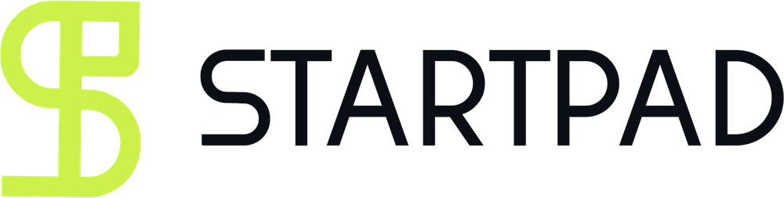
StartPad is where you become someone the ecosystem takes seriously.

Programmes ask for four things. Most first-time founders have two. StartPad is the fifteen missions that close the gap — and the file you apply with at the end.
It is a founder-readiness platform for Egypt and the wider MENA region. It takes someone with an idea and no company, moves them through fifteen structured missions, and issues verifiable proof of what they completed. Not a course. Not an incubator. The step before both.
It never costs you your idea. Nothing you put into StartPad assigns any right in what you build, and no template in this library changes that. You finish the work. We keep the file.
The fifteen missions, in five moves
— Discovery — analyse the problem, define it, and rank problems by importance and frequency.
— Ideation — select an idea, describe it, and test the solution hypothesis.
— Model — build the business model and decide what you actually sell.
— Build — prototype, validate the market, and ship a minimum version.
— Launch — test product-market fit and go to market.

startpad.me
Part of GrowthLabs. This template is free to use, copy and teach from. If you publish it, keep the credit line.

