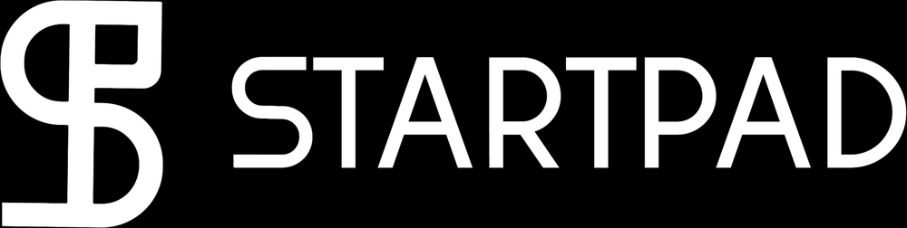
StartPad template
SWOT & TOWS Analysis
Four lists are a warm-up; the pairings are the actual work

What you will have when this is filled: A SWOT that ends in four strategies, not four lists
startpad.me

About this template

What it is
SWOT sets your internal strengths and weaknesses against external opportunities and threats. On its own it produces four columns and no decision, which is why it has a poor reputation. This template includes the step that rescues it: the TOWS matrix, which pairs the quadrants into strategies — use this strength on that opportunity, defend this weakness against that threat.
Why it earns its place
— Separate what is inside your control from what is not, which founders routinely mix.
— Force each entry to be specific enough to act on.
— Convert the four lists into four strategy types through deliberate pairing.
— Give a mentor or a committee a structure they already know how to read.
Where it sits in your missions
Mission 5, and revisited before Mission 15.
Where it comes from
PRIMARY SOURCE
Weihrich, H. (1982). The TOWS Matrix: A Tool for Situational Analysis. Long Range Planning, 15(2), 54-66.
ORIGIN
SWOT is widely credited to Albert Humphrey at Stanford Research Institute in the 1960s, developing from an earlier SOFT framework. The frequent claim that it originated at Harvard with Learned, Christensen, Andrews and Guth (1965) is not supported: that book uses the four words but never presents SWOT as a tool, and Guth himself denied the attribution. Recent historical work in Long Range Planning and the Journal of Management History traces the line from SOFT to SWOT. Treat any confident single-origin story with suspicion.
FURTHER READING
— Puyt, R. W., Lie, F. B. & Wilderom, C. P. M. (2023). The Origins of SWOT Analysis. Long Range Planning, 56(3).
— Learned, E., Christensen, C. R., Andrews, K. & Guth, W. (1965). Business Policy: Text and Cases. Irwin. — the LCAG framework, often miscited as SWOT.
How to fill it in
1. Fix the subject first. SWOT of what — the company, one product, one market? An unfixed subject produces unusable lists.
2. Strengths and weaknesses are internal and present tense. If you cannot change it, it belongs on the right-hand side.
3. Opportunities and threats are external and future-facing. Name the source: a regulation, a competitor, a cost, a behaviour change.
4. Be specific. 'Good team' is not a strength; 'two engineers who have shipped a payments integration before' is.
5. Cap each quadrant at five entries, ranked. A list of twelve is a way of avoiding the ranking.
6. Do the TOWS pairings. This is the part that produces decisions, and the part most people skip.
What done well looks like
☐ Nothing appears in two quadrants at once.
☐ Every entry is specific enough that someone could disagree with it.
☐ All four TOWS boxes contain a real action with an owner.
☐ At least one pairing surprised you.

The template
Print it, or type straight into the boxes. The small italic text is a prompt — delete it as you fill each box.
Subject of this analysis
The company, product or market this SWOT is about, and the date. One subject only.
Strengths — internal, present  What you have that others do not. Team, access, cost position, relationships, data, speed. Rank the top five. | Weaknesses — internal, present  What you lack or do badly. Be honest; this page is not a pitch. Rank the top five.
Opportunities — external, future  Shifts you could ride: regulation, behaviour, cost, a gap a competitor left. Name the source of each. | Threats — external, future  What could damage the plan: an incumbent, a rule, a price, a platform you depend on. Name the source of each.
TOWS — THE PAIRINGS THAT PRODUCE STRATEGY
SO — strength on opportunity  Which strength lets you take which opportunity faster than anyone else? Write the action and who owns it. | WO — fix a weakness to reach an opportunity  Which weakness is blocking an opportunity worth the cost of fixing? What is the fix?
ST — strength against threat  Which strength reduces which threat? What would you do the week the threat arrives? | WT — weakness exposed to threat  Where a weakness meets a threat, you avoid, insure or exit. Which is it, and by when?
The one thing this analysis changes
If this SWOT changes nothing in your plan, it was a writing exercise. What is different now?


StartPad is where you become someone the ecosystem takes seriously.

Programmes ask for four things. Most first-time founders have two. StartPad is the fifteen missions that close the gap — and the file you apply with at the end.
It is a founder-readiness platform for Egypt and the wider MENA region. It takes someone with an idea and no company, moves them through fifteen structured missions, and issues verifiable proof of what they completed. Not a course. Not an incubator. The step before both.
It never costs you your idea. Nothing you put into StartPad assigns any right in what you build, and no template in this library changes that. You finish the work. We keep the file.
The fifteen missions, in five moves
— Discovery — analyse the problem, define it, and rank problems by importance and frequency.
— Ideation — select an idea, describe it, and test the solution hypothesis.
— Model — build the business model and decide what you actually sell.
— Build — prototype, validate the market, and ship a minimum version.
— Launch — test product-market fit and go to market.

startpad.me
Part of GrowthLabs. This template is free to use, copy and teach from. If you publish it, keep the credit line.

