CONFIDENTIAL · PRE-SEED 2026
Angelsta
Competitor and Comparables Analysis
Startup and investor operating systems across Egypt, Qatar, the GCC, MENA, Africa, the emerging markets and globally, and what buyers pay for them
Item | Detail
Scope | 80 companies and alternatives; 34 mapped module by module; 12 scored on eight dimensions; transaction and valuation comparables
Evidence base | Angelsta SaaS Marketing Competitive Analysis (supplied, research cut-off 19 August 2026) as the controlling source, extended with public sources to November 2026
Markets | Egypt (home), Qatar (second), Saudi Arabia, UAE, Kuwait, Bahrain, Oman; rest of MENA and Africa; global self serve
Prepared | November 2026, as an investment analyst's view for the pre-seed round
Companion files | Angelsta Pricing Strategy v2.0; Angelsta Financial Model 2027 to 2031 v2.0

Contents
1. Executive summary
2. Scope, method and evidence
3. The market: Egypt, Qatar, the GCC, MENA and Africa
4. Market map and the fragmented workflow
5. Competitive positioning and module coverage
6. Competitive scoring
7. Regional deep dives
8. High-relevance competitor profiles
9. Pricing benchmarks
10. Threat assessment and battlecards
11. Comparables: funding, transactions and multiples
12. Market gaps and where Angelsta must prove itself
13. Strategic implications for the round
14. Full competitor and alternative directory
15. References

1. Executive summary
80 | 11 of 11 | 9.5 | $300k | Month 20
companies and  alternatives mapped | modules Angelsta  covers | most by any rival,  RasMal, Saudi Arabia | Angelsta pre-seed,  from year one cost | Angelsta break even,  inside year two

- The workflow is fragmented. No product in the region runs the whole chain from the founder's financial model and valuation, through the cap table, data room and fundraising, to the investor's diligence and portfolio monitoring. Most competitors cover two to five of the eleven modules. Angelsta's claim is the shared record across all of them.
- The closest regional rival is RasMal and its investor arm Pentugram, in Saudi Arabia. It covers about 9.5 of 11 modules, raised $4.8m pre-Series A at LEAP 2025 and has a Saudi Unicorns Programme seal. It is the competitor to plan against in the GCC, and it is not present in Egypt or Qatar.
- The strongest global two-sided reference is Visible. It scored 34 of 40 in the primary research, with 7,050+ founders and VC funds. It does not offer native financial modelling, valuation, MENA market analysis or stress testing, and it has no Arabic or regional presence.
- Investor-side tooling is crowded and quote-based. Standard Metrics, Vestberry, Rundit and Dynamo are mature, but they are sold to funds outside the region and priced on request. That leaves room for a transparent Institutional plan at $499 to $599 a month.
- Founder-side cap table tools are price-anchored low in the region. Govy sells at $24.99 a month flat. Angelsta should not try to win on cap table price. It should lead with the valuation, the model and the investor network.
- Egypt and Qatar have no local operating system. Egypt has angel networks (Cairo Angels, AUC Angels) and deal marketplaces, but no founder or investor OS. Qatar has capital (QIA's $3bn Fund of Funds, a record QR214m VC year) but no tooling. Both are open ground for a first mover.
- Comparables support a disciplined valuation. 2026 multiples are low: public SaaS at 3.2 to 3.4 times revenue and private SaaS M&A at 3.1 to 4.0 times. The model uses 4 times ARR at exit. The pre-seed is priced at $2.6m pre-money for an ask of $300k, which is 10.3% and a 20 per cent discount to the model's fair value.
- Capital efficient by design. Year one expenses of $301k, a Cairo team paid in Egyptian pounds and marketing as the largest use of funds take Angelsta to monthly break even in month 20, inside year two, with no further round required in the base case.
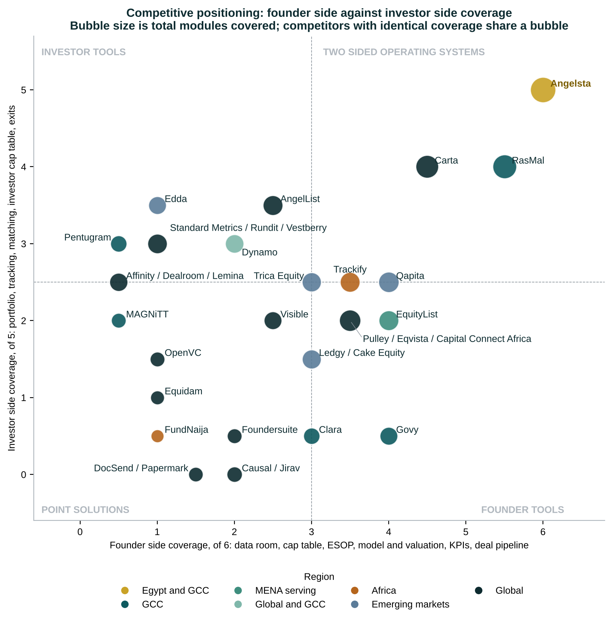
Figure 1. Competitive positioning: Angelsta is the only product in the top right on both sides

2. Scope, method and evidence
Angelsta is the benchmark, and every competitor is compared with its current SaaS scope. The supplied competitive analysis is the controlling evidence. Where it and later public sources differ, the supplied figures are kept, and the newer source is noted.
Type | Meaning for Angelsta
Direct or closest | Covers substantial functionality across both startup and investor sides, or closely reproduces Angelsta's workflow
Partial | Competes strongly with one side or one major module: valuation, portfolio monitoring, market data, fundraising or data rooms
Alternative | Does not reproduce Angelsta as a platform but gets the same job done: spreadsheets, advisers, networks, marketplaces
Partner or customer | Angel networks, funds and ecosystem programmes that Angelsta sells to or through

Module coverage uses the supplied 11-module matrix for 27 platforms. For seven more (Trackify, Capital Connect Africa, Dynamo, Clara, Equidam, Lemina and FundNaija), the coverage is an analyst mapping from the supplied startup-side and investor-side feature matrices. Scores are the supplied primary research scores (1 to 5 on eight dimensions). Prices are entry paid plans, on annual billing where offered.

3. The market: Egypt, Qatar, the GCC, MENA and Africa
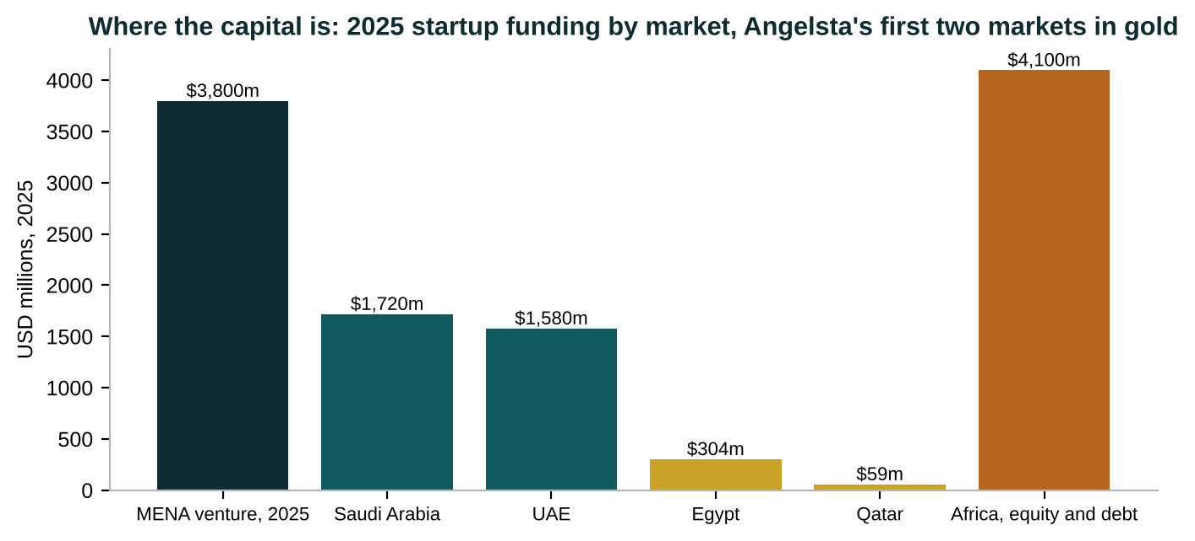
Figure 2. 2025 startup funding by market
Source: MAGNiTT FY2025; QDB and MAGNiTT; Arab News; Partech Africa Tech VC Report 2025
Table 1. Market context by roll-out order
Market | 2025 capital | Ecosystem facts | What it means for Angelsta
Egypt, month 1 | USD 304m over 69 VC deals (MAGNiTT); USD 614m including debt (planning ministry) | Cairo Angels, about 50 active angels; AUC Angels; 12 M&A exits in 2025 | Home market for founders; price at 60 per cent in EGP
Qatar, month 4 | QR 214m, about USD 59m, a record, up 81 per cent | QIA Fund of Funds raised to USD 3bn, more than USD 1bn committed, 12 managers in Doha; Rasmal Ventures; QDB, QSTP | Institutional buyers arriving with no local tooling; Web Summit Qatar
Saudi Arabia, month 10 | USD 1.72bn over 257 deals, 45 per cent of MENA funding | OQAL 600+ angels; 65+ VC firms, angel groups and accelerators; RasMal and Govy local | Biggest market and strongest local competition
UAE, month 13 | USD 1.58bn over 231 deals | DIFC and ADGM managers; MAGNiTT, Clara, Dynamo present | Institutional and family office demand
Kuwait, Bahrain, Oman, month 19 | Small, family office led; Bahrain USD 22m startup private debt | Self serve and partners | Self serve plus country lead
Africa, self serve | USD 4.1bn, equity USD 2.4bn over 462 deals, debt USD 1.6bn | Kenya USD 1.04bn, South Africa USD 715m, Egypt USD 604m, Nigeria USD 572m | Trackify, Capital Connect Africa, Lemina are early local rivals

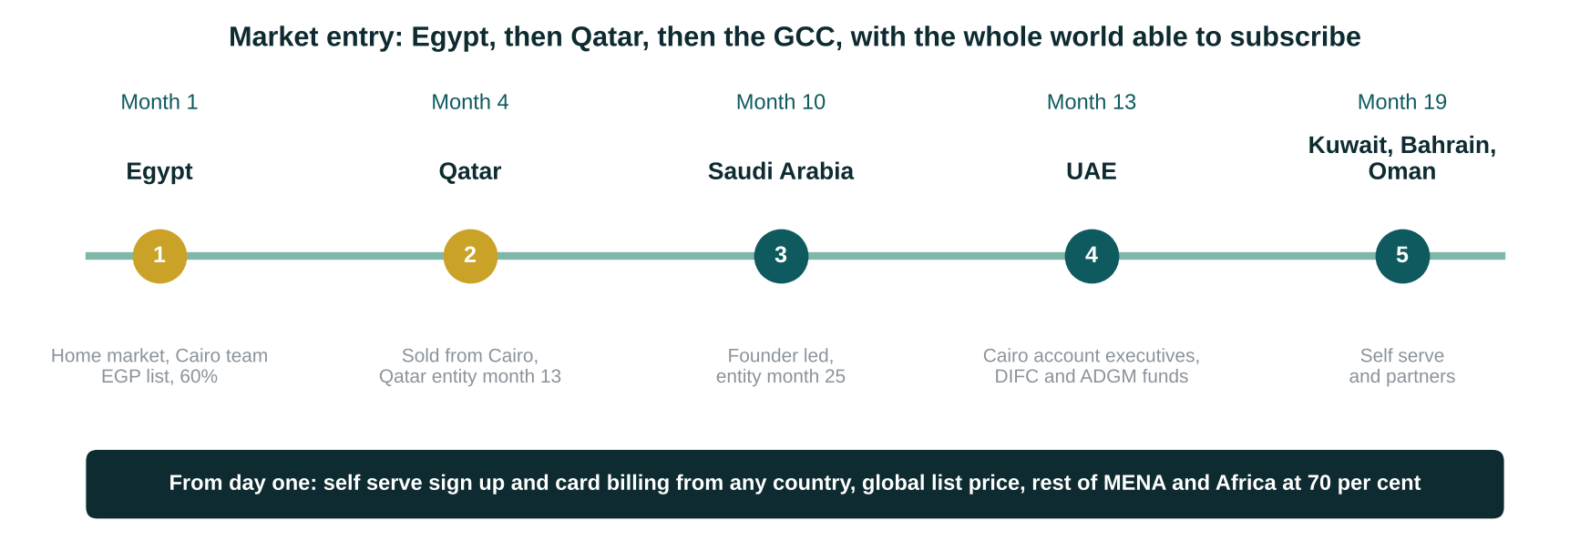
Figure 3. Angelsta's market entry sequence

4. Market map and the fragmented workflow
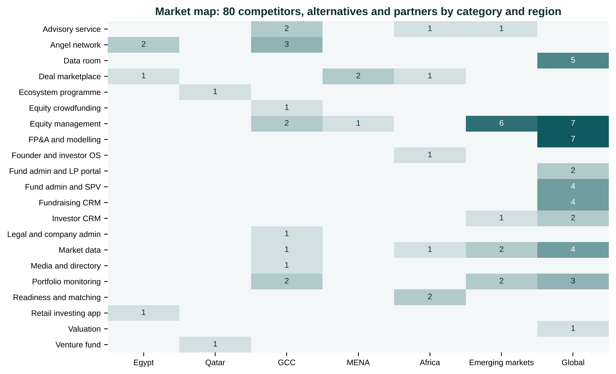
Figure 4. Who is in the market, by category and region
The map shows the structure. Equity management and FP&A tools cluster in the global and emerging-market columns. Angel networks and marketplaces cluster in Egypt and the GCC. Portfolio monitoring is split between enterprise global vendors and one regional player, Pentugram. No category in Egypt or Qatar has a software operating system.
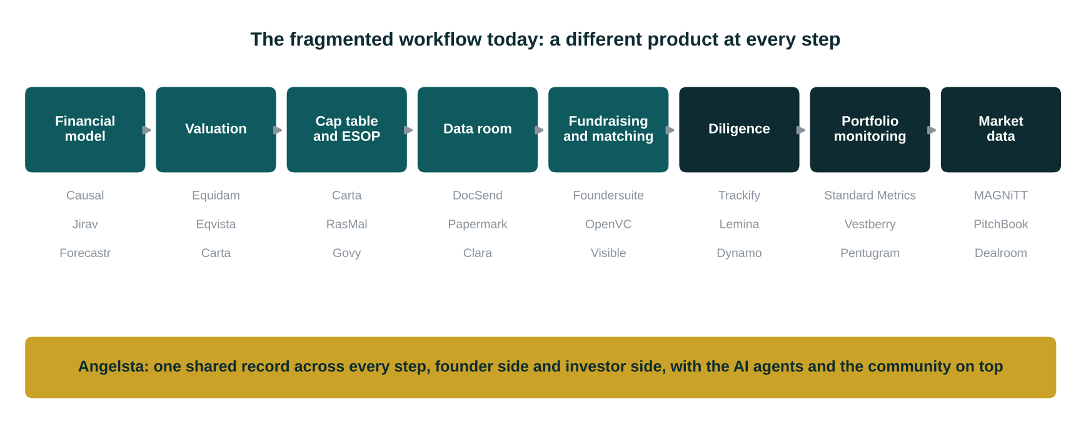
Figure 5. The fragmented founder-to-investor workflow, and Angelsta's single record

5. Competitive positioning and module coverage
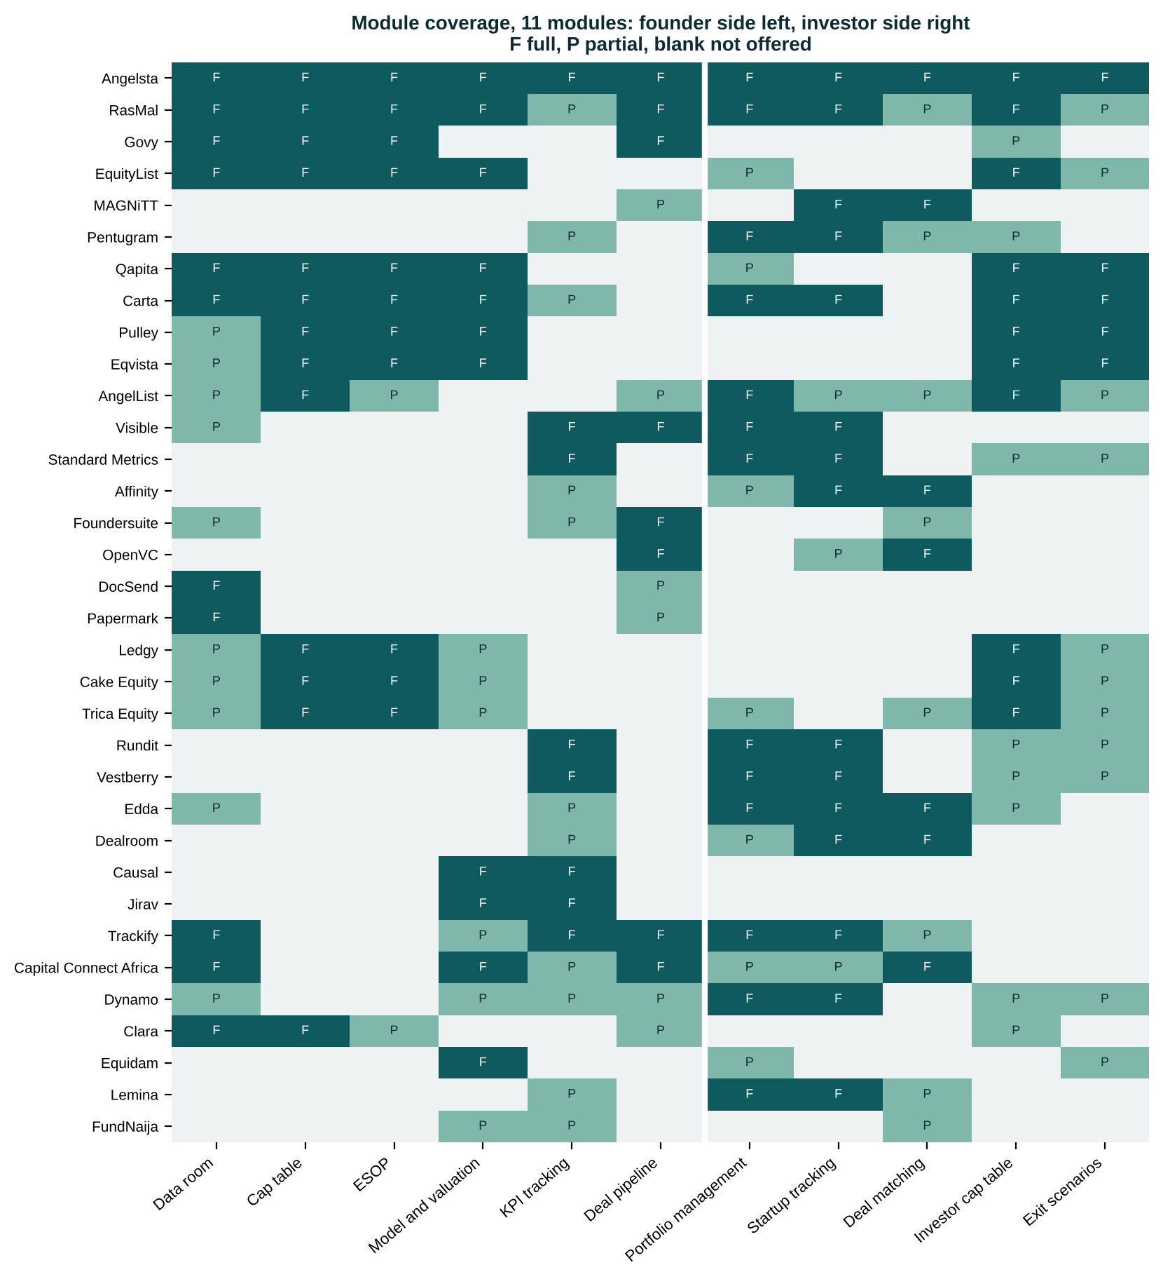
Figure 6. Module coverage for 34 platforms
Table 2. Coverage scores, full module = 1, partial = 0.5
Platform | Region | Founder side, of 6 | Investor side, of 5 | Total, of 11 | Coverage basis
Angelsta | Egypt and GCC | 6.0 | 5.0 | 11.0 | Product scope
RasMal | GCC | 5.5 | 4.0 | 9.5 | Supplied matrix
Carta | Global | 4.5 | 4.0 | 8.5 | Supplied matrix
Qapita | Emerging markets | 4.0 | 2.5 | 6.5 | Supplied matrix
EquityList | MENA serving | 4.0 | 2.0 | 6.0 | Supplied matrix
AngelList | Global | 2.5 | 3.5 | 6.0 | Supplied matrix
Trackify | Africa | 3.5 | 2.5 | 6.0 | Analyst mapping
Pulley | Global | 3.5 | 2.0 | 5.5 | Supplied matrix
Eqvista | Global | 3.5 | 2.0 | 5.5 | Supplied matrix
Trica Equity | Emerging markets | 3.0 | 2.5 | 5.5 | Supplied matrix
Capital Connect Africa | Africa | 3.5 | 2.0 | 5.5 | Analyst mapping
Dynamo | Global and GCC | 2.0 | 3.0 | 5.0 | Analyst mapping
Govy | GCC | 4.0 | 0.5 | 4.5 | Supplied matrix
Visible | Global | 2.5 | 2.0 | 4.5 | Supplied matrix
Ledgy | Emerging markets | 3.0 | 1.5 | 4.5 | Supplied matrix
Cake Equity | Emerging markets | 3.0 | 1.5 | 4.5 | Supplied matrix
Edda | Emerging markets | 1.0 | 3.5 | 4.5 | Supplied matrix
Standard Metrics | Global | 1.0 | 3.0 | 4.0 | Supplied matrix
Rundit | Emerging markets | 1.0 | 3.0 | 4.0 | Supplied matrix
Vestberry | Emerging markets | 1.0 | 3.0 | 4.0 | Supplied matrix
Pentugram | GCC | 0.5 | 3.0 | 3.5 | Supplied matrix
Clara | GCC | 3.0 | 0.5 | 3.5 | Analyst mapping
Affinity | Global | 0.5 | 2.5 | 3.0 | Supplied matrix
Dealroom | Emerging markets | 0.5 | 2.5 | 3.0 | Supplied matrix
Lemina | Africa | 0.5 | 2.5 | 3.0 | Analyst mapping
MAGNiTT | GCC | 0.5 | 2.0 | 2.5 | Supplied matrix
Foundersuite | Global | 2.0 | 0.5 | 2.5 | Supplied matrix
OpenVC | Global | 1.0 | 1.5 | 2.5 | Supplied matrix
Causal | Global | 2.0 | 0.0 | 2.0 | Supplied matrix
Jirav | Global | 2.0 | 0.0 | 2.0 | Supplied matrix
Equidam | Global | 1.0 | 1.0 | 2.0 | Analyst mapping
DocSend | Global | 1.5 | 0.0 | 1.5 | Supplied matrix
Papermark | Global | 1.5 | 0.0 | 1.5 | Supplied matrix
FundNaija | Africa | 1.0 | 0.5 | 1.5 | Analyst mapping

6. Competitive scoring
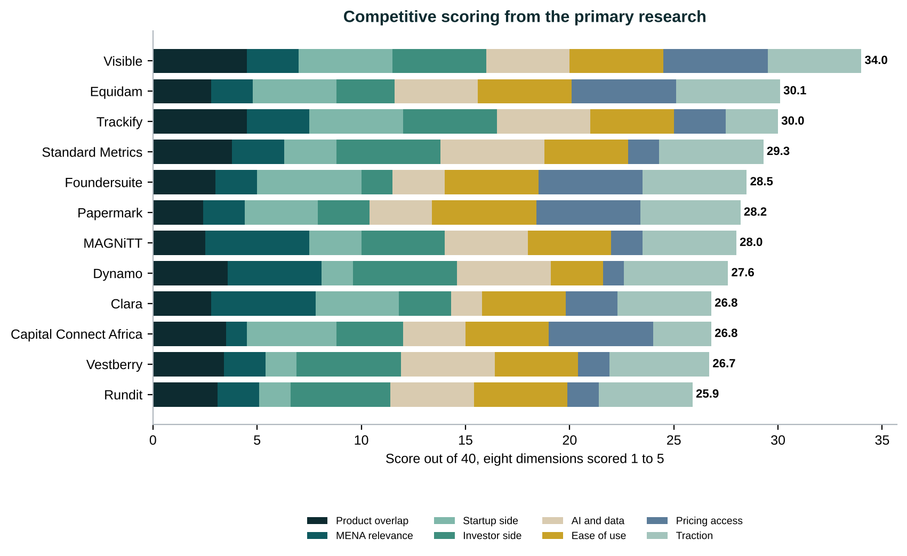
Figure 7. Scores out of 40 from the primary research
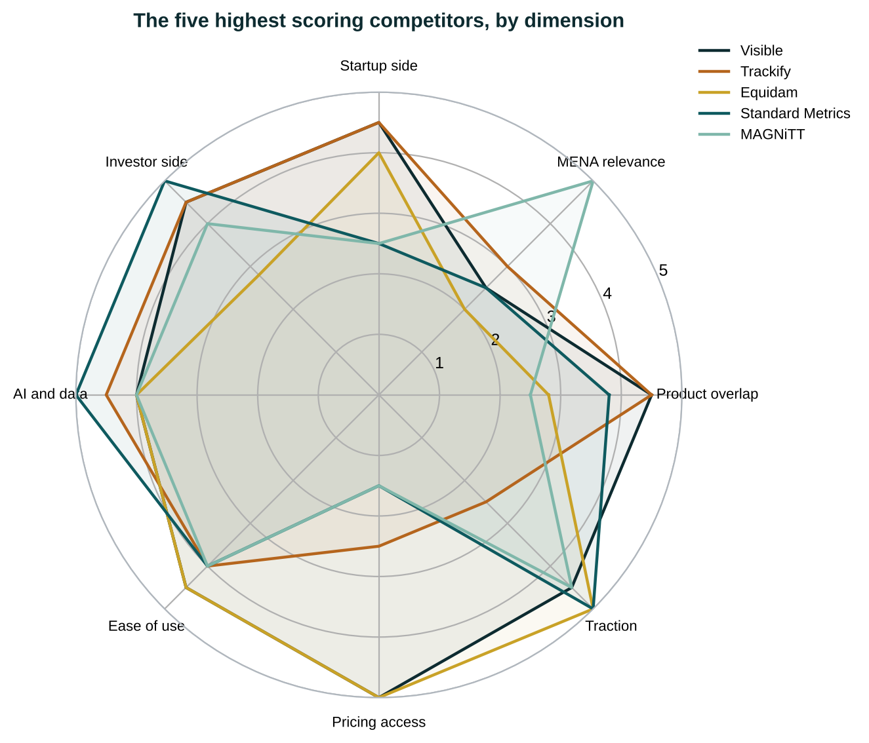
Figure 8. The five highest-scoring competitors by dimension
Visible leads on breadth, ease and price transparency. Trackify scores high on overlap but low on traction and pricing access. Standard Metrics, Dynamo and Vestberry score 5 on the investor side but 1.5 on the startup side. MAGNiTT and Clara score 5 on MENA relevance but are a data product and a legal and admin product. None scores above 3 on MENA relevance and above 4 on both sides at the same time, which is the position Angelsta is built for.

7. Regional deep dives

7.1 Egypt and North Africa
Company | HQ | Side | Category | Threat | Pricing | Note
Cairo Angels | Cairo | Investor | Angel network | Partner | Membership | Egypt's first formal angel network, about 50 active angels; syndicate fund writes $100k to $250k. Target customer and channel.
AUC Angels | Cairo | Investor | Angel network | Partner | Membership | First university based angel network in MENA. Target customer and channel.
Fabeh | MENA | Both | Deal marketplace | Moderate | Transaction based | Lists deals; no cap table, portfolio or AI layer per Angelsta deck.
Thndr | Cairo | Investor | Retail investing app | Low | Free and commissions | 4m+ users, $15.7m round led by Prosus 2025; public markets, adjacent only.

7.2 Qatar
Company | HQ | Side | Category | Threat | Pricing | Note
Rasmal Ventures | Doha | Investor | Venture fund | Partner | Fund | Qatar's first independent VC; first fund in QIA's Fund of Funds. Target Institutional customer.
Qatar FinTech Hub, QDB, QSTP | Doha | Both | Ecosystem programme | Partner | Programme | Accelerator and ecosystem channels for Qatar founders.

7.3 Saudi Arabia, UAE and the wider GCC
Company | HQ | Side | Category | Threat | Pricing | Note
Thanawi | MENA | Both | Deal marketplace | Moderate | Transaction based | Secondary and deal listing positioning; no operating system.
Finstreet | MENA | Investor | Deal marketplace | Moderate | Transaction based | Investment marketplace positioning.
RasMal | Riyadh | Both | Equity management | Critical | Not disclosed | $4.8m pre-Series A at LEAP 2025; cap table, ESOP, valuation, data rooms; Pentugram for investors.
Pentugram | Riyadh | Investor | Portfolio monitoring | High | Not disclosed | RasMal's investor arm: deal flow and investor reporting for Gulf VCs and angels.
Govy | Saudi Arabia | Founder | Equity management | Critical | $24.99 a month flat | Cap table, ESOP, governance, data room; Arabic RTL in progress.
EquityList | Singapore and India | Founder | Equity management | Critical | Quote by stakeholders | $2.2m seed; counts Tabby as a customer.
MAGNiTT | Dubai | Investor | Market data | High | $2,400 to $30,000+ a year | Reference MENA venture dataset; 25 staff.
Clara | Dubai and Abu Dhabi | Founder | Legal and company admin | High | Not disclosed | 5,000+ businesses; acquired by Ascentium, Feb 2026.
Dynamo | Dubai office | Investor | Portfolio monitoring | High | Quote | Enterprise alternative assets software; Dubai since 2022.
Numu Angels | Riyadh | Investor | Angel network | Moderate | Membership | Built its own investor tooling.
OQAL Angel Investors Network | Riyadh | Investor | Angel network | Moderate | Membership | 600+ registered Saudi angels.
Jeddah Angels | Jeddah | Investor | Angel network | Low | Membership | Launched January 2025.
Eureeca | Dubai, DIFC | Both | Equity crowdfunding | Low | Success fee | Regulated DFSA, FCA, AFM; raises $300k to $800k.
Sharikat Mubasher | Riyadh | Investor | Media and directory | Low | Free and advertising | KSA SME and PE news and directory.
CFO.Ventures | Dubai | Founder | Advisory service | Low | Retainer | Outsourced CFO with cap table as a service.
Aranca | Dubai and Mumbai | Founder | Advisory service | Low | Project fees | Valuation and 409A advisory incumbent.

7.4 Africa
Company | HQ | Side | Category | Threat | Pricing | Note
GetEquity | Lagos, Nigeria | Investor | Deal marketplace | Moderate | Transaction based | Retail private market investing marketplace.
Trackify | Africa | Both | Founder and investor OS | High | Not public | Founder OS and Investor OS; 1,000+ monthly active users reported.
Capital Connect Africa | Nairobi | Both | Readiness and matching | Moderate | Free; $49.99 to $99.99 services | 5,200+ investors in database.
Lemina | Nigeria | Investor | Market data | Moderate | Not stated | 998+ African tech companies database; AI diligence.
FundNaija | Nigeria | Founder | Readiness and matching | Low | Not stated | 1,173 founders reported.
Confluence Africa | Africa | Founder | Advisory service | Low | Not stated | Fundraising advisory alternative.

7.5 Emerging markets: India, South East Asia, Europe
Company | HQ | Side | Category | Threat | Pricing | Note
Qapita | Singapore | Founder | Equity management | High | Quote | $26.5m Series B led by Charles Schwab, Oct 2025.
Trica Equity | Bengaluru | Founder | Equity management | Moderate | Quote | 800+ companies; LetsVenture group.
Hissa | Bengaluru | Founder | Equity management | Low | Quote | Indian equity platform.
Cake Equity | Brisbane | Founder | Equity management | Moderate | From about $50 a month | 4.8 of 5 on G2.
Ledgy | Zurich | Founder | Equity management | Moderate | EUR 150 to 400 a month | 70+ HRIS integrations.
Vestd | United Kingdom | Founder | Equity management | Low | From low hundreds GBP | UK EMI focus.
Rundit | Helsinki | Investor | Portfolio monitoring | Moderate | Quote by fund size | 4,500+ fund managers in 35+ countries; Launch Africa a customer.
Vestberry | Bratislava | Investor | Portfolio monitoring | Moderate | Enterprise quote | 500+ funds, $45bn+ AUM.
Edda | New York and Paris | Investor | Investor CRM | Moderate | Quote | Deal flow plus portfolio.
Dealroom | Amsterdam | Investor | Market data | Moderate | $20,000+ a year | European ecosystem data; thin in MENA.
Tracxn | Bengaluru | Investor | Market data | Moderate | $5,000 to $20,000 a year | Listed in India; covers MENA.
Waveup | Remote, Europe | Founder | Advisory service | Low | $100 to $5,000+ | Pitch deck and valuation agency.

Reading the regional tables
Egypt and Qatar have capital and networks but no operating system, so Angelsta sells to and through Cairo Angels, AUC Angels, Rasmal Ventures, QDB and QSTP rather than against them. The GCC has the real software competition, from RasMal, Pentugram, Govy and EquityList, which are founder-side heavy apart from RasMal.

8. High-relevance competitor profiles
Company | Type and geography | Strongest overlap | Facts, pricing, traction | Gap against Angelsta
Visible | Direct, global | Fundraising CRM, updates, data rooms, KPIs; investor portfolio monitoring | Founded 2015; 7,050+ founders and funds; $0, $59, $129, $199 a month | No native model, valuation, MENA market analysis or stress testing
RasMal and Pentugram | Direct, Saudi Arabia | Cap table, ESOP, valuation, data rooms, deal flow and investor reporting | Founded 2019; $4.8m pre-Series A at LEAP 2025; Saudi Unicorns Programme | Not in Egypt or Qatar; no public pricing; limited AI agent layer
Trackify | Direct, Africa | Founder OS and Investor OS | 1,000+ monthly active users reported | Depth, security and pricing not verifiable
Standard Metrics | Direct investor side, global | Portfolio data collection, KPIs, AI parsing, LP reporting | $23.7m Series A 2022; 150+ firms, 10,000+ companies; SOC 2 | Post-investment only; sales-led pricing
Dynamo | Partial, global and UAE | Institutional portfolio monitoring, valuation, reporting | Since 1998; Dubai office 2022; quote based | Enterprise, not founder-centric
Govy | Partial, Saudi Arabia | Cap table, ESOP, governance, data room | $24.99 a month flat | No valuation, model or investor OS
EquityList | Partial, MENA serving | Cap table, ESOP, valuations, data rooms | $2.2m seed; Tabby a customer | Quote pricing; no investor portfolio OS
MAGNiTT | Partial, UAE | Startup, investor and deal data, benchmarks | Since 2013; $2,400 to $30,000+ a year | Data, not a workspace; a potential data partner
Clara | Partial, UAE | Formation, legal docs, cap table, data room | 5,000+ businesses; acquired by Ascentium Feb 2026 | No model, valuation, KPIs or portfolio
Capital Connect Africa | Adjacent, Kenya | Readiness, forecasts, valuation, investor matching | Founded 2022; 5,200+ investors; $49.99 to $99.99 services | Readiness, not ongoing portfolio
Equidam | Partial, global | Valuation and projections | 160,000 companies valued; $412 to $1,990 a year | Valuation point solution
Carta | Partial, global | Cap table, 409A, fund admin | $500m ARR 2025; $3.5bn secondary valuation | US-centric pricing; no MENA presence or Arabic

9. Pricing benchmarks
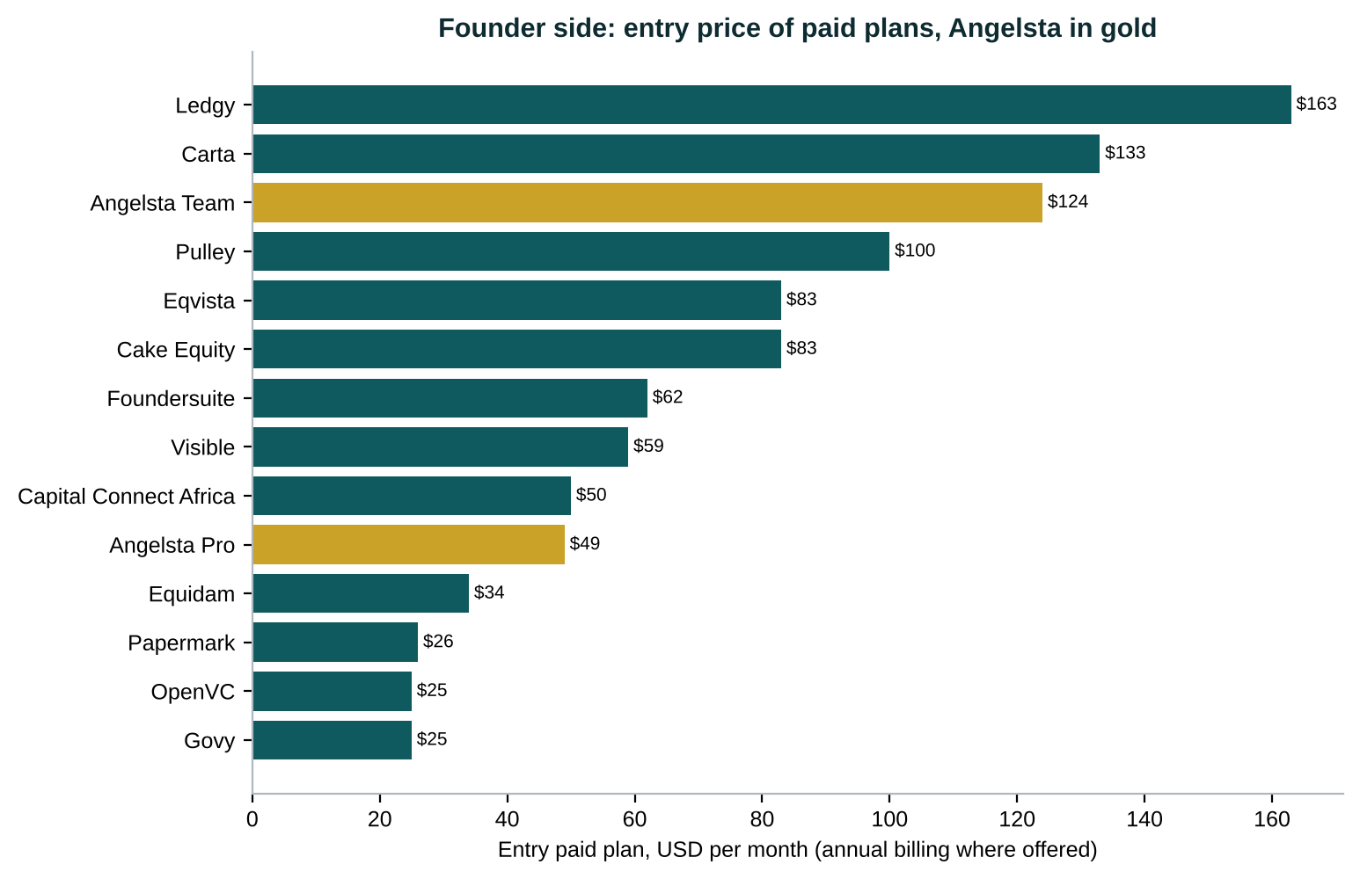
Figure 9. Founder side entry prices
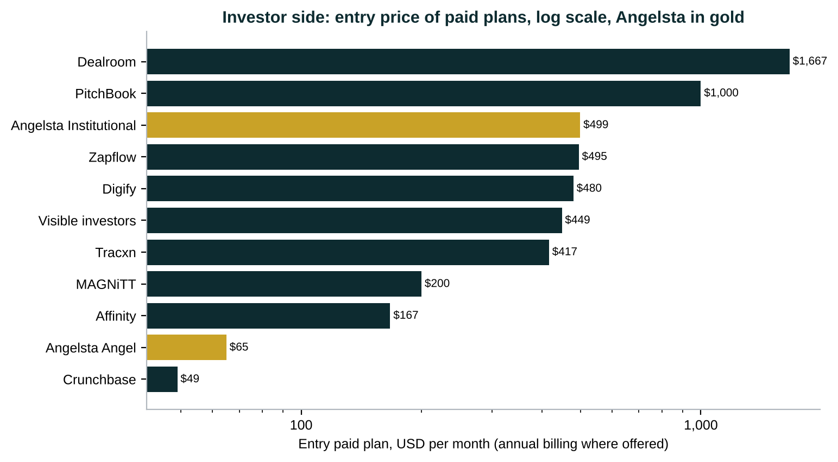
Figure 10. Investor side entry prices
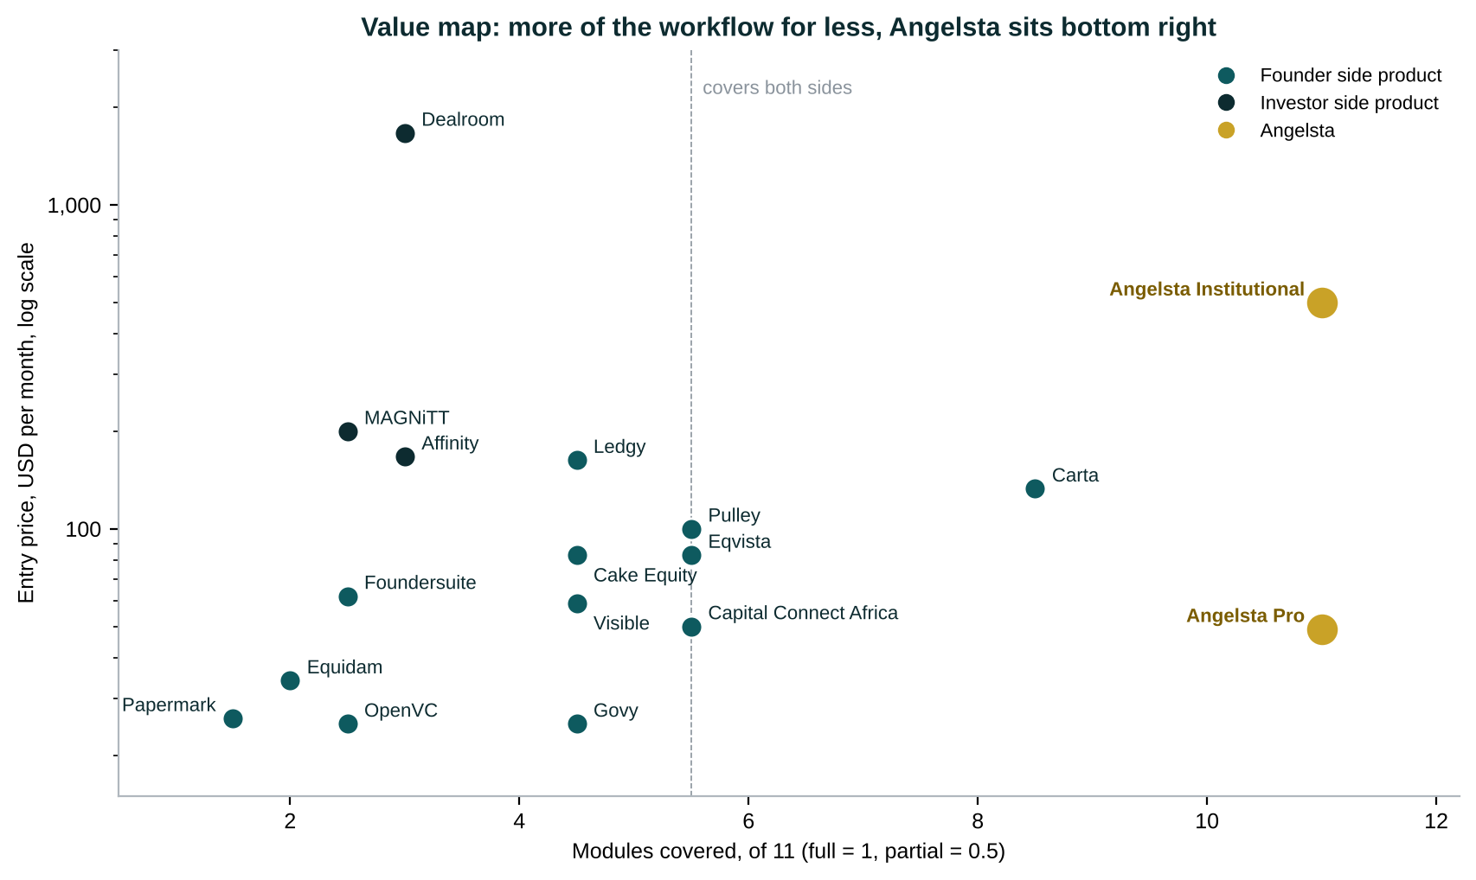
Figure 11. Value map: modules covered against entry price
Founder tools publish self serve prices, between $25 and $163 a month. Institutional tools are quoted, and reported prices start at about $170 per user a month. Angelsta's Institutional plan publishes a price at the level of Zapflow's five-seat plan while covering eleven modules. The pricing strategy keeps that transparency as a deliberate edge.

10. Threat assessment and battlecards
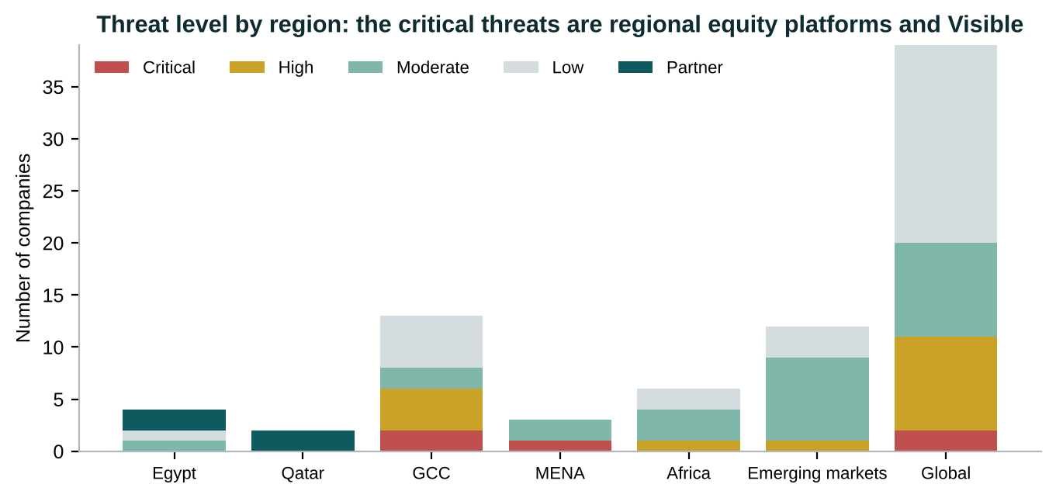
Figure 12. Threat level by region
Competitor | Why it matters | How Angelsta wins | What to prove
Spreadsheets, Drive, email | The real incumbent everywhere, free | One record replaces 3+ tools; the model, valuation and data room are built from data already entered | Time saved per round; investor update cycle time
RasMal and Pentugram | Closest two-sided regional rival, Saudi backed | Egypt and Qatar first; Arabic and English; AI agents; transparent pricing; the community | SOC 2 and data residency before the KSA push
Visible | Strongest global two-sided brand | Model, valuation, stress tests, MENA data, Arabic, local billing | Investor adoption: founders invite investors for free
Govy | Low regional price anchor | Do not compete on cap table price; lead with valuation and investor side | Pro conversion triggered by the raise, not the cap table
Carta and Pulley | Global category owners | A third of the price; regional legal templates; the investor network | Migration tooling from Carta exports
Standard Metrics, Vestberry, Rundit, Dynamo | Mature investor-side tooling | Published price; founders on the same record, so KPI collection costs nothing | Pilot conversion; LP pack quality
MAGNiTT | Owns MENA venture data | Partner for benchmarks rather than build data | Data partnership terms

11. Comparables: funding, transactions and multiples
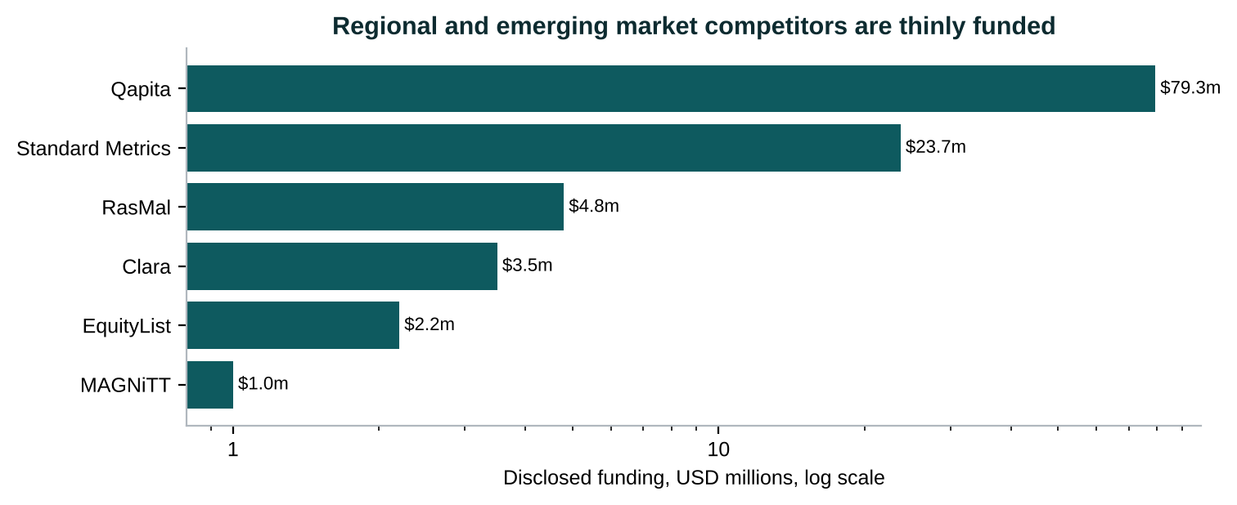
Figure 13. Disclosed funding of regional and emerging-market competitors
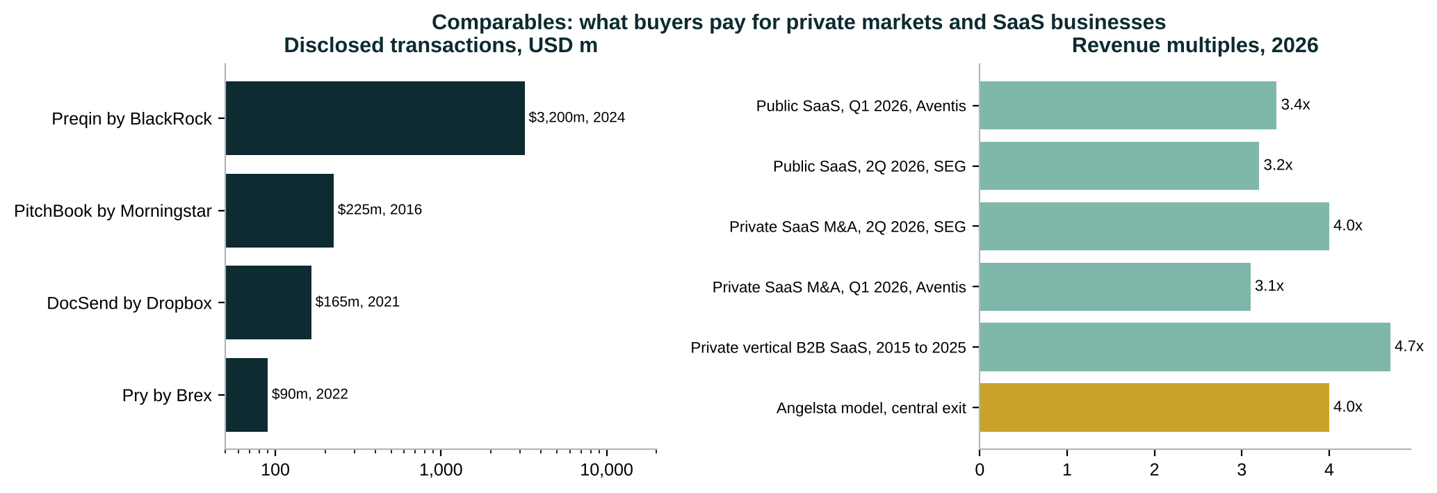
Figure 14. Transaction comparables and 2026 revenue multiples
Table 3. Transaction comparables
Comparable | Year | Value | Relevance
Preqin by BlackRock | 2024 | $3,200m | Private markets data
PitchBook by Morningstar | 2016 | $225m | Private markets data, implied value
DocSend by Dropbox | 2021 | $165m | Data rooms
Pry by Brex | 2022 | $90m | Startup financial planning
Global Shares by J.P. Morgan | 2022 | Undisclosed | Equity plan administration
Causal by Lucanet | 2024 | Undisclosed | Startup financial modelling
Finmark by BILL | 2022 | Undisclosed | Startup financial planning, sunset April 2026
Clara by Ascentium | 2026 | Undisclosed | MENA company formation and equity admin
LTSE Equity customers to Astrella | 2024 | Undisclosed | Cap table, market exit
Capshare by Solium | 2017 | Undisclosed | Cap table

Table 4. Revenue multiples, 2026
Benchmark | Multiple
Public SaaS, Q1 2026, Aventis | 3.4x
Public SaaS, 2Q 2026, SEG | 3.2x
Private SaaS M&A, 2Q 2026, SEG | 4.0x
Private SaaS M&A, Q1 2026, Aventis | 3.1x
Private vertical B2B SaaS, 2015 to 2025 | 4.7x
Angelsta model, central exit | 4.0x

Table 5. Private funding comparables
Private round comparable | Stage | Raised | Read across
RasMal, Saudi Arabia | Pre-Series A, 2025 | $4.8m | Regional two-sided equity platform; sets the GCC benchmark Angelsta must grow into
Qapita, Singapore | Series B, Oct 2025 | $26.5m, $79.3m total | Emerging market equity management at scale
Standard Metrics, USA | Series A, 2022 | $23.7m | Investor-side AI data collection
Clara, UAE | Seed | about $3.5m, then acquired 2026 | MENA founder admin; exit to a strategic buyer
EquityList, India and MENA | Seed | $2.2m | Founder equity platform selling into MENA
Angelsta, Egypt and Qatar | Pre-seed, 2026 | $300k | $2.6m pre-money, 10.3% offered; built from year one cost

What the comparables mean for the valuation
Buyers of private-markets software paid from about $90m (Pry) to $3.2bn (Preqin). In 2026, SaaS trades at 3.1 to 4.0 times revenue in private M&A. The model values Angelsta at exit on 4.0 times ARR ($11.3m in 2031), and prices the pre-seed at $2.6m pre-money. That price is a weighted blend of discounted cash flow, the venture capital method, a scorecard against the MENA pre-seed median, and Berkus.

12. Market gaps, and where Angelsta must prove itself
Gap in the market | Evidence | Angelsta's answer
Founder-to-investor data continuity | Few products run model, valuation, KPIs, data room, diligence and monitoring together | One shared record
Modelling, valuation and readiness together | Equidam (valuation), Foundersuite (fundraising) and Capital Connect Africa (readiness) each cover one part | Model to valuation to investor pack, automated
Investor-side risk and stress testing | Strong only at Vestberry and Dynamo | Issuer-published shocks and five-level stress tests
Fragmented MENA specialisation | Clara (legal), MAGNiTT (data), RasMal, Govy and EquityList (equity) each cover a piece | Regional OS in Arabic and English
Egypt and Qatar have no operating system | Only networks, marketplaces and programmes | First mover in both

Where Angelsta must prove itself:
- AI extraction is now common (Standard Metrics, Vestberry, Rundit, Dynamo, Visible, Trackify), so 'AI-powered' is not a differentiator on its own. The agents must show time saved.
- Security expectations are high. Standard Metrics and Papermark carry SOC 2 and ISO 27001, and the model funds certification in month 20.
- Spreadsheet compatibility matters. Excel and Sheets import and export must be first-class.
- Pricing is split: transparent for founders, quote-based for institutions. Angelsta publishes both, and must hold that line in enterprise deals.

13. Strategic implications for the round
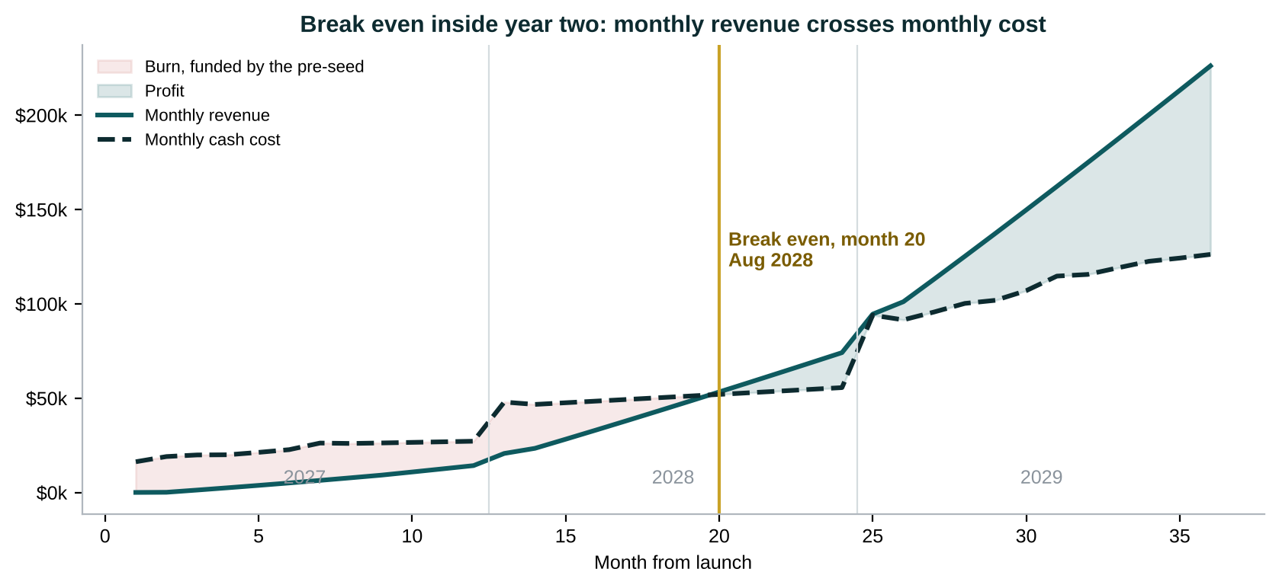
Figure 15. Break even in year two on the pre-seed alone
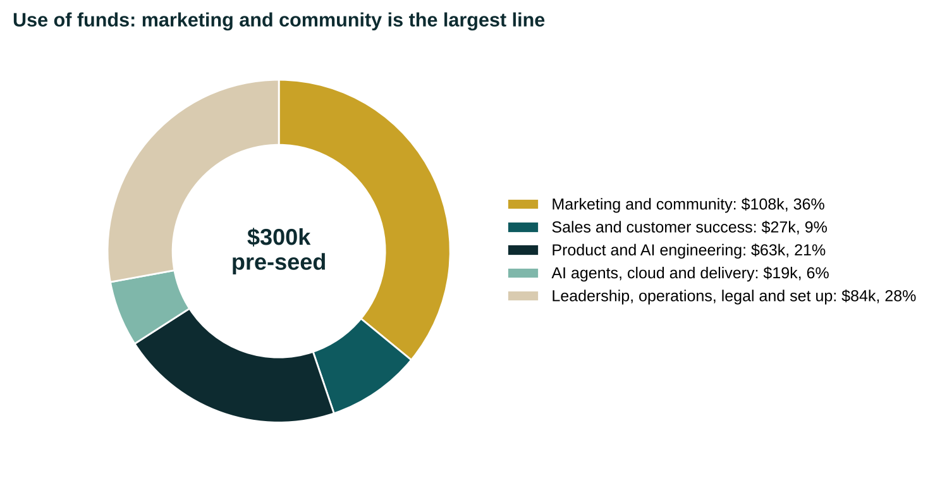
Figure 16. The pre-seed, sized from year one expenses, and where it goes
- Win Egypt and Qatar before RasMal arrives. A lean Cairo team sells Egypt from month 1 and Qatar from month 4, with Cairo-based account executives and founders travelling to Doha, before Saudi Arabia in month 10.
- Be profitable before the competition scales. The model breaks even in month 20 on a $300k pre-seed and needs no further capital. RasMal raised $4.8m to reach its stage; Angelsta's capital efficiency is its edge.
- Spend the round on demand. Marketing and community is 36 per cent of the use of funds, the largest line, because network effects reward the first platform to hold both founders and their investors.
- Sell to the networks, not against them. Cairo Angels, AUC Angels, OQAL, Rasmal Ventures and the QIA Fund of Funds managers are customers and channels.
- Lead with valuation and the investor side. That is where regional cap table tools are weakest and where Visible stops.
- Partner with MAGNiTT for data. Licensing benchmarks is cheaper than building them, and it removes a competitor from the investor-side pitch.
- Certify early. SOC 2 and ISO 27001 by month 20 and KSA data residency before the Saudi institutional push in 2029.

14. Full competitor and alternative directory
Table 6. All 80 companies and alternatives
Company | Region | HQ | Side | Category | Threat | Pricing | Note
AUC Angels | Egypt | Cairo | Investor | Angel network | Partner | Membership | First university based angel network in MENA. Target customer and channel.
Cairo Angels | Egypt | Cairo | Investor | Angel network | Partner | Membership | Egypt's first formal angel network, about 50 active angels; syndicate fund writes $100k to $250k. Target customer and channel.
Thndr | Egypt | Cairo | Investor | Retail investing app | Low | Free and commissions | 4m+ users, $15.7m round led by Prosus 2025; public markets, adjacent only.
Fabeh | Egypt and MENA | MENA | Both | Deal marketplace | Moderate | Transaction based | Lists deals; no cap table, portfolio or AI layer per Angelsta deck.
Qatar FinTech Hub, QDB, QSTP | Qatar | Doha | Both | Ecosystem programme | Partner | Programme | Accelerator and ecosystem channels for Qatar founders.
Rasmal Ventures | Qatar | Doha | Investor | Venture fund | Partner | Fund | Qatar's first independent VC; first fund in QIA's Fund of Funds. Target Institutional customer.
Aranca | GCC | Dubai and Mumbai | Founder | Advisory service | Low | Project fees | Valuation and 409A advisory incumbent.
CFO.Ventures | GCC | Dubai | Founder | Advisory service | Low | Retainer | Outsourced CFO with cap table as a service.
Clara | GCC | Dubai and Abu Dhabi | Founder | Legal and company admin | High | Not disclosed | 5,000+ businesses; acquired by Ascentium, Feb 2026.
Eureeca | GCC | Dubai, DIFC | Both | Equity crowdfunding | Low | Success fee | Regulated DFSA, FCA, AFM; raises $300k to $800k.
Govy | GCC | Saudi Arabia | Founder | Equity management | Critical | $24.99 a month flat | Cap table, ESOP, governance, data room; Arabic RTL in progress.
Jeddah Angels | GCC | Jeddah | Investor | Angel network | Low | Membership | Launched January 2025.
MAGNiTT | GCC | Dubai | Investor | Market data | High | $2,400 to $30,000+ a year | Reference MENA venture dataset; 25 staff.
Numu Angels | GCC | Riyadh | Investor | Angel network | Moderate | Membership | Built its own investor tooling.
OQAL Angel Investors Network | GCC | Riyadh | Investor | Angel network | Moderate | Membership | 600+ registered Saudi angels.
Pentugram | GCC | Riyadh | Investor | Portfolio monitoring | High | Not disclosed | RasMal's investor arm: deal flow and investor reporting for Gulf VCs and angels.
RasMal | GCC | Riyadh | Both | Equity management | Critical | Not disclosed | $4.8m pre-Series A at LEAP 2025; cap table, ESOP, valuation, data rooms; Pentugram for investors.
Sharikat Mubasher | GCC | Riyadh | Investor | Media and directory | Low | Free and advertising | KSA SME and PE news and directory.
Finstreet | MENA | MENA | Investor | Deal marketplace | Moderate | Transaction based | Investment marketplace positioning.
Thanawi | MENA | MENA | Both | Deal marketplace | Moderate | Transaction based | Secondary and deal listing positioning; no operating system.
EquityList | MENA serving | Singapore and India | Founder | Equity management | Critical | Quote by stakeholders | $2.2m seed; counts Tabby as a customer.
Dynamo | Global and GCC | Dubai office | Investor | Portfolio monitoring | High | Quote | Enterprise alternative assets software; Dubai since 2022.
Capital Connect Africa | Africa | Nairobi | Both | Readiness and matching | Moderate | Free; $49.99 to $99.99 services | 5,200+ investors in database.
Confluence Africa | Africa | Africa | Founder | Advisory service | Low | Not stated | Fundraising advisory alternative.
FundNaija | Africa | Nigeria | Founder | Readiness and matching | Low | Not stated | 1,173 founders reported.
GetEquity | Africa | Lagos, Nigeria | Investor | Deal marketplace | Moderate | Transaction based | Retail private market investing marketplace.
Lemina | Africa | Nigeria | Investor | Market data | Moderate | Not stated | 998+ African tech companies database; AI diligence.
Trackify | Africa | Africa | Both | Founder and investor OS | High | Not public | Founder OS and Investor OS; 1,000+ monthly active users reported.
Cake Equity | Emerging markets | Brisbane | Founder | Equity management | Moderate | From about $50 a month | 4.8 of 5 on G2.
Dealroom | Emerging markets | Amsterdam | Investor | Market data | Moderate | $20,000+ a year | European ecosystem data; thin in MENA.
Edda | Emerging markets | New York and Paris | Investor | Investor CRM | Moderate | Quote | Deal flow plus portfolio.
Hissa | Emerging markets | Bengaluru | Founder | Equity management | Low | Quote | Indian equity platform.
Ledgy | Emerging markets | Zurich | Founder | Equity management | Moderate | EUR 150 to 400 a month | 70+ HRIS integrations.
Qapita | Emerging markets | Singapore | Founder | Equity management | High | Quote | $26.5m Series B led by Charles Schwab, Oct 2025.
Rundit | Emerging markets | Helsinki | Investor | Portfolio monitoring | Moderate | Quote by fund size | 4,500+ fund managers in 35+ countries; Launch Africa a customer.
Tracxn | Emerging markets | Bengaluru | Investor | Market data | Moderate | $5,000 to $20,000 a year | Listed in India; covers MENA.
Trica Equity | Emerging markets | Bengaluru | Founder | Equity management | Moderate | Quote | 800+ companies; LetsVenture group.
Vestberry | Emerging markets | Bratislava | Investor | Portfolio monitoring | Moderate | Enterprise quote | 500+ funds, $45bn+ AUM.
Vestd | Emerging markets | United Kingdom | Founder | Equity management | Low | From low hundreds GBP | UK EMI focus.
Waveup | Emerging markets | Remote, Europe | Founder | Advisory service | Low | $100 to $5,000+ | Pitch deck and valuation agency.
Abacum, Cube, Mosaic, Pigment | Global | USA and Europe | Founder | FP&A and modelling | Low | From $1,500 a month | Series B+ finance teams.
Affinity | Global | San Francisco | Investor | Investor CRM | High | $2,000 to $2,700 a user a year | 3,000+ customers in 70+ countries.
Allocations | Global | Miami | Investor | Fund admin and SPV | Low | Per vehicle | Fast SPV launch.
Allvue Systems | Global | Miami | Investor | Fund admin and LP portal | Low | Enterprise | Vista owned.
AngelList | Global | San Francisco | Both | Fund admin and SPV | High | Free under $1m; fund fees | $170bn+ assets on platform; US entities only.
Ansarada | Global | Sydney | Investor | Data room | Low | $244 to $5,134 a month | M&A VDR.
Astrella | Global | USA | Founder | Equity management | Moderate | Tiered | Took over LTSE Equity customers.
Bunch | Global | Berlin | Investor | Fund admin and SPV | Low | Quote per fund | European emerging managers.
CB Insights | Global | New York | Investor | Market data | Low | Enterprise | Corporate research.
Carta | Global | San Francisco | Both | Equity management | Critical | Build about $1,600 a year | $500m ARR 2025; ~35,000 startups; $3.5bn secondary valuation.
Causal, Lucanet | Global | London | Founder | FP&A and modelling | Moderate | Was $250 a month | Acquired by Lucanet, Oct 2024.
Chronograph | Global | New York | Investor | Portfolio monitoring | Low | Enterprise | LP look-through.
Crunchbase | Global | San Francisco | Investor | Market data | Low | Free; Pro about $49 a month | MENA data often incomplete.
Datasite, Intralinks, Firmex, iDeals | Global | USA, Canada, UK | Investor | Data room | Low | Per deal or enterprise | M&A virtual data rooms, upmarket.
DealCloud, Intapp | Global | Palo Alto | Investor | Investor CRM | Moderate | $2,000+ a user a year | Mid-market and large PE.
Digify | Global | Singapore | Founder | Data room | Moderate | From $480 a month | SMB and mid-market VDR.
DocSend | Global | San Francisco | Founder | Data room | High | From $15 a user a month | Acquired by Dropbox for $165m.
Equidam | Global | Netherlands | Founder | Valuation | High | $412 to $1,990 a year | 160,000 companies valued in 90 countries.
Eqvista | Global | Nevada | Founder | Equity management | High | Free to 20 holders; $990+ a year | Aggressive pricing.
Fidelity Private Shares | Global | USA | Founder | Equity management | Low | Bundled | Distribution led.
Finmark, BILL | Global | Raleigh | Founder | FP&A and modelling | Low | Was from $50 a month | Sunset April 2026: a gap below $300 a month.
Flowlie | Global | New York | Founder | Fundraising CRM | Moderate | Freemium | AI investor matching.
Forecastr | Global | Louisville | Founder | FP&A and modelling | Moderate | Tiered plus analysts | Fundraising models with analysts.
Foundersuite | Global | San Francisco | Founder | Fundraising CRM | High | $745 to $1,609 a year | 100,000+ users, $21bn raised.
Global Shares, J.P. Morgan | Global | Cork | Founder | Equity management | Low | Enterprise | Acquired by J.P. Morgan 2022.
Jirav | Global | San Francisco | Founder | FP&A and modelling | Moderate | Quote | Fractional CFO channel.
Juniper Square | Global | San Francisco | Investor | Fund admin and LP portal | Low | Enterprise | Valued above $1bn.
Metal | Global | New York | Founder | Fundraising CRM | Low | Freemium | Intro pathway intelligence.
Morgan Stanley at Work | Global | USA | Founder | Equity management | Low | Enterprise | Late stage and public.
OpenVC | Global | Remote | Founder | Fundraising CRM | High | Free; $25 to $99 a month | 15,000+ verified investors.
Papermark | Global | Berlin | Founder | Data room | Moderate | EUR 24 to 99 a month | Open source; SOC 2 Type II, ISO 27001.
PitchBook | Global | Seattle | Investor | Market data | Moderate | $12,000 to $70,000+ a year | Thin MENA coverage.
Preqin | Global | London | Investor | Market data | Low | Enterprise | Acquired by BlackRock, about $3.2bn.
Pry, Brex | Global | San Francisco | Founder | FP&A and modelling | Low | Bundled | Acquired by Brex for $90m.
Pulley | Global | San Francisco | Founder | Equity management | High | $1,200 to $3,500 a year | 4.7 on G2.
Standard Metrics | Global | San Francisco | Investor | Portfolio monitoring | High | Quote | $23.7m Series A; 150+ VC and PE firms, 10,000+ companies; SOC 2.
Sturppy | Global | Denver | Founder | FP&A and modelling | Low | Low cost | Model in ten minutes.
Sydecar | Global | San Francisco | Investor | Fund admin and SPV | Low | Flat fee per SPV | Syndicate SPVs.
Visible | Global | Detroit | Both | Portfolio monitoring | Critical | Founders $59 to $249 a month | 7,050+ founders and VC funds.
Excel, Google Drive, Notion | Everywhere | - | Both | Manual alternative | Critical | Free | The real incumbent: spreadsheets, folders and email.

15. References
Topic | Source
Supplied primary research | Angelsta SaaS Marketing Competitive Analysis, MENA, Africa, Global, research cut-off 19 August 2026, including its 36 source URLs (visible.vc, standardmetrics.io, clara.co, mytrackify.com, magnitt.com, dynamosoftware.com, capitalconnect.africa, lemina.co, fundnaija.com, rundit.com, vestberry.com, foundersuite.com, equidam.com, papermark.com)
MENA venture 2025 | MAGNiTT FY2025 MENA VC Report, magnitt.com ; Wamda 2025 year review ; Arab News
Egypt 2025 | MAGNiTT via TechCabal and Enterprise AM ; Egypt planning ministry via Ahram Online ; Cairo Angels interview, CairoScene ; VC4A, AUC Angels
Qatar | QIA Fund of Funds, qia.qa ; QNA ; Gulf Times ; Semafor ; QDB and MAGNiTT report via Gulf Times
Saudi Arabia and GCC | MAGNiTT Saudi FY2025 with SVC ; Stride Ventures GCC private debt via Arab News
Africa | Partech 2025 Africa Tech VC Report ; Briter Africa Investment Report 2025
Competitor funding | RasMal via Fintech News UAE, Finextra, Wamda ; Qapita via DealStreetAsia, YourStory, CB Insights ; Clara via MENAbytes, IBS Intelligence, Wamda ; Thndr via Arab Founders
Transactions | Morningstar 10-Q and 10-K, PitchBook ; supplied directory for Preqin, DocSend, Pry, Global Shares, Causal, Finmark
Multiples | Aventis Advisors SaaS Valuation Multiples 2015 to 2026 ; SEG via SaaSRise ; Multiples.vc
Pricing | Vendor pricing pages; CostBench; PricingSaaS; Capterra; G2; see the Pricing Strategy references

Company-reported traction is shown as reported, not audited. Analyst mappings are marked as such. Missing fields are left missing, not estimated.

