Software Engineering

Sheet #UML

**Q1:**

**The Big Book Store (BBS) is a small chain of bookshops which sell books directly to university library staff. BBS sales staff use a basic computer system to manage their stock but they wish to improve this system. In order to develop an improved system, they need a UML (the Unified Modelling Language) model of the current system. The systems analyst has recorded the following telephone conversation which needs modelling in UML.**

*[Customer] “Hello – my account number is 14502, I would like to purchase the book titled “Software Engineering” by the author “Yasser Fouad””*

*[Sales Agent] “Hello Mr. Ahmed – I have found your file –can I just confirm your details? Is your address still the Alexandria University, Computer Science Department, Egypt?”*

*[Customer] “Yes – that’s the correct address”*

*[Sales Agent] “Let me have a search for that book. Yes, we have 33 copies of the book in stock.”*

*[Customer] “Great – I’ll take two copies – do you have any other books by author in*

*stock?”*

*[Sales Agent] “Let me search again... Yes, we also have his book “Computer Graphics” – do you want that too?”*

*[Customer] “Yes but just one copy... I think you have my credit card number stored on file – please charge that”.*

*[Sales Agent] – “I have found your credit-card record. I will now create an order for the three books – the cost is E.L. 550 – let me just process the payment by checking with the credit card company.*

*[Sales Agent]” Thank you – the order is being dispatched to your usual address.”*

**Draw the following diagrams to describe this interaction including as much detail as you can derive from the telephone call. If you need to make assumptions, then these should be noted within the diagram.**

(a) A Use Case Diagram for the interaction.

(b) A Class Diagram for the system described in the interaction. Include any methods and attributes you know.

**Q2:**

Design UML diagram for the license issuing process of vehicles. The requirements are as follows:

* The country is divided into departments (Cairo, Giza, Alex…. etc.). Each department is described by a code (unique), and several service locations (e.g., for Cairo department, there are: Heliopolis, Nasr City etc.).
* Each Vehicle is described by a number (unique: for all vehicles in the same department), model, type (private, Limousine, taxi…. etc.), color, motor capacity, number of seats, manufacturing year, license issue date, license expiry date, owner, tax rate, and a set of fins. The owner, type, and tax rate information are mandatory for each vehicle. Each vehicle type is identified by a code (unique), name (unique), and has a set of tax categories. Each tax category has a specific tax rate.
* Each vehicle fin is described by number (unique), type, date, and vehicle
* Each fin type is associated with specific value. When a vehicle is transferred from one department to another or sometimes when its license is renewed, a new number is assigned to the vehicle. it is required to keep track of those old numbers (if any) for each vehicle with period of each (start date and end date. it is also requires to keep track of the total amount of fins for each vehicle.
* Each owner is described by a national number (unique), name, type (individual, organization, government, etc. address, and set of phone numbers.

**Q3:**

Design UML for the following set of requirements for a university database that is used keep track of student’s transcripts.

1. The university keeps track of each student’s name, student number, social security number, current address and phone, permanent address and phone birthdate, sex, major department, minor department (if any), and degree program (B.A., B.S., Ph.D.). Both student number and social security number have unique values for each student.
2. Each department is described by a name, department code, office number office phone, Both name end code have unique values for each department
3. Courses are described by a course name, course number, credit hours and department. each course has one or more prerequisite course.
4. Each section has an instructor, semester (spring) , year , course , and section number. The section number is unique.
5. A grade report needs to be printed out to display the student number, the section and the numeric grade

**Q4:**

Coﬀee management system requirements are:

1. A coﬀee machine dispenses coﬀee at the press of a button.

2. There are diﬀerent coﬀee ﬂavors (espresso, cappuccino, or latte macchiato) with diﬀerent prices.

3. Every user has an account on the coﬀee management system.

4. Every user logs on to the system using some identiﬁcation (a password or picture).

5. Users choose the coﬀees they had (or will have) and mark them as “dispensed”.

6. The price for the coﬀee is automatically deducted from their account.

7. A special user (the “administrator”) can recharge user’s accounts.

1. **Create a use case for “A student gets a coﬀee”**
2. **Develop a class model for the coﬀee management system listing: classes – attributes – essential methods, and – relationships..**

Q5:

NorthEgypt University wants to install a new student self-service system for student enrollment, registration and payment.   A local bank called YMOM (Your Money is Our Money) Bank Corp. will join NorthEgypt to create a flexible bank account that can be used to conveniently pay for courses as well as other on-campus expenses.  NorthEgypt will issue a new campus-wide Id card that combines all the features of a bank ATM card as well as a University ID card.

The course registration system is available as a web-based application.  It is part of the joint application maintained by NE and YMOM.

The following are some of the business rules governing the application:

1.     Every course has a cost.

2.     Every course has an optional list of prerequisites, in the form a list of courses.

3.     Every course has a list of quarters when it is offered.

4.     A student must have an established NE student enrollment record in the system, with an ID card and YMOM account before registering for a course.

5.     A student will have a list of courses, described with the quarter they took the course, payment status and their grade, if appropriate.

6.     A student can register for a course without having the money to pay for it in their YMOM account, as long as all prior courses have been paid for.

7.     Registration for a specific course is only possible during a defined window of time, 3 week before the end of the current quarter and 2 weeks into the beginning of the next quarter.

8.     A student will not see a grade for a course unless they have registered for the course and have paid for it in full.

9.     A professor can submit a grade for a course for a student, but the student will not see the grade until the course is paid for in full.

10.  A student may declare a Major and a Minor, each one implying a list of required and optional courses.

11.  A student can drop a course they have registered for and the money will be automatically made available in their YMOM account.

The students can access the system via their own PC accessing the web or via a network of YMOM ATMs. The number on their student id/ATM card is the user id for the application and the ATM PIN number is the password for the site.

They can:

1.     See their current transcripts,

2.     Register for a course in the next quarter.

When they register for a course, they will be presented with the set of courses that match their Major or Minor selections, the current courses offered and the courses with which they have fulfilled the prerequisites.

3.     Transfer funds from the YMOM account to pay for a course.

The University is a progressive IT customer.  They want to roll out system functionality as fast as it can be made available. They want to engage student-lead focus groups to assess the quality and acceptance of the application. They are concerned with the security and integration of the application with the YMOM systems. The system development is not with out risks however, as developers has very limited experience with the kind of networking complexity and distributed computing involved in this project.

a.     What software process life cycle model would you choose for this project?  What life cycle would be the least appropriate? Explain your choice.

b.     Produce a UML class diagram specifying all the classes involved.

c.     Produce a UML use case diagram involved in implementing the rules that control the registration, grade submission, grade visibility, payment and dropping of a course for a student.

d.     From the requirements phase right through to the delivery of the code to the bank, describe as many of the non-programming tasks to be performed in this project as you can.  Using a timeline, identify when these tasks would be performed.

Q6:

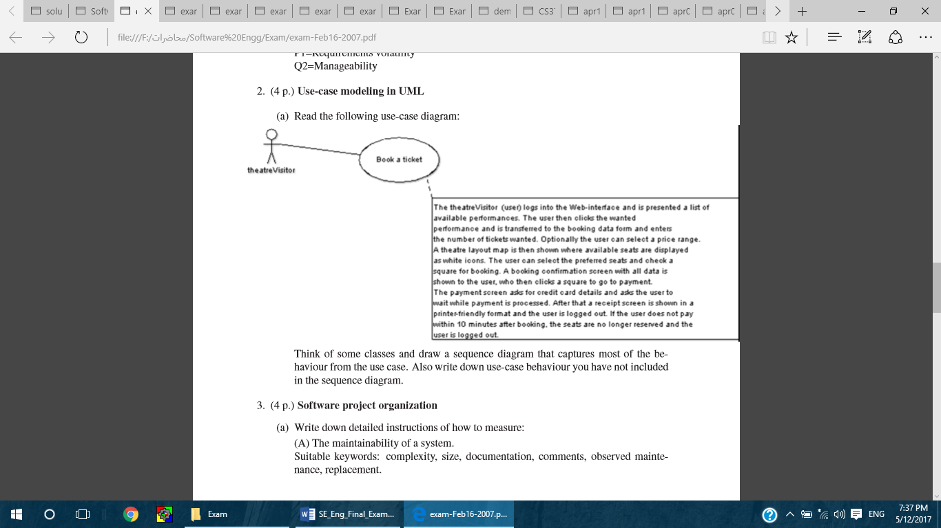Read the following use-case diagram: draw the class diagram that captures most of the behavior from the use case. Also, write down use-case behavior you have not included in the diagram.

Q7:

A conference chair system (CCS) is to be designed and implemented to automate the review process for scientific events such as conferences and workshops as described below. An author can submit three different types of papers using CCS: long research paper, short research paper or industrial experience paper. All papers should include a title, an abstract, list of keywords, size, and a list of authors. For industrial experience papers, it is also mandatory to submit the source code of the application.

Not every paper submitted is to be selected for presentation and included in the proceedings. The review and selection process is performed by an organization committee. The organization committee consists of members. One of the members is assigned as the chair of the organization. The chair is responsible for checking the completeness of the submitted papers and assigning the papers to other members for reviewing. When the chair assigns a paper to a reviewer, it is first checked that the area of expertise of the reviewer matches the keywords provided in the paper. Each paper is assigned to at least two reviewers. Each reviewer is responsible for reviewing the assigned paper(s) and writing a review. Based on the reviews, papers to be included in the final proceedings are selected by the chair. Once the selection is completed, the chair can send notification emails about the decisions to all authors using CCS

Draw a use case diagram for CCS described above

Q8:

A local bank has given you the requirements specification for a system to manage customer accounts. In particular, the specification identifies the data, the processes, and the user interface expected. The data include name, address, current balance, and the transaction type, and amount. Likewise, the processes include the creation, update, and deletion of customer accounts, and deposit and withdrawal transactions keyed in at a terminal. Based on the information given, use UML class Diagram to define and develop design outlines for the system.