A composition-aware physics-embedded neural network for moisture transport in concrete: identification, prediction for unseen mixes and comparison with physics-informed neural networks
Abderrahmane Sghuri^{a,b}, Xuande Chen^{a,b,*}, Xiaodong Wangª
ª Department of Mathematics, Computer Science and Engineering, Université du Québec à Rimouski (UQAR), Rimouski, QC, Canada
^{b} Research Center on Concrete Infrastructures (CRIB), Québec, QC, Canada
* Corresponding author: [e-mail address]

Highlights
- A neural network maps mix composition to moisture transport parameters of concrete.
- Trained through a differentiable solver, the transport equation holds exactly.
- Unseen mixes predicted with R² = 0.994, 34% lower error than a data-driven net.
- A standard PINN fits the data but its parameters fail an independent solver check.
- Data cleaning, identifiability analysis and code are reported for reproducibility.

Abstract
Laboratory drying tests on concrete usually record only the specimen mass, that is, the average degree of saturation. Turning these data into transport properties and internal moisture fields is an ill-posed inverse problem, which is generally solved one mix at a time. This study develops a physics-embedded neural network in which a small network maps mix composition (water-to-binder ratio, fly ash and slag fractions) to the parameters of a nonlinear vapour–capillary diffusivity model, and a differentiable finite-volume solver of the moisture transport equation turns these parameters into drying curves. Because the network is trained through the solver, the governing equation is satisfied exactly and the parameters of a mix that was never seen in training are genuine predictions. The approach is evaluated on 932 cleaned drying measurements of 20 plain, binary and ternary concretes. An identifiability analysis shows that two parameters per mix, the reference vapour diffusivity and the intrinsic permeability, can be recovered from average-saturation curves. On six mixes withheld from training, the model reaches R² = 0.9935 and RMSE = 0.013, a 34% lower error than a purely data-driven network and the same accuracy as a classical finite-difference identification combined with composition regression. A physics-informed neural network (PINN) trained on the same data reproduces the curves (R² = 0.983) but its parameters do not reproduce them when inserted into an independent solver (R² = 0.86), because the PDE residual cannot enforce the early-time capillary regime. Embedding the solver, rather than penalising a residual, therefore yields physically consistent parameters.
Keywords: Concrete; Moisture transport; Physics-embedded neural network; Physics-informed neural networks; Inverse problem; Supplementary cementitious materials

1 Introduction
Moisture is the carrier, reactant or controlling factor of most deterioration processes in concrete, including chloride ingress, carbonation, freeze–thaw damage, alkali–silica reaction and drying shrinkage [1, 2]. Predicting how water moves through the pore network is therefore a prerequisite for service-life design and for the maintenance of existing structures. In unsaturated concrete, moisture moves as liquid driven by capillary pressure and as vapour diffusing through the gas-filled pores. The relative weight of these mechanisms depends on the local degree of saturation and on the pore structure, which is controlled by the water-to-binder ratio (w/b) and by supplementary cementitious materials (SCMs) such as fly ash and slag [3–5].
Most laboratory characterisations rely on gravimetric measurements: the specimen is weighed during drying or absorption, which yields its average degree of saturation $S_{\text{avg}}\left(t\right)$ [6, 7]. These data are cheap and robust but contain no direct information on the internal saturation profile $S\left(x,t\right)$, which controls local damage and the penetration of aggressive species [3]. Numerical models based on finite elements or finite differences can compute $S\left(x,t\right)$ once the transport properties are known [8–11], but these properties are rarely measured for every mix and are usually calibrated by fitting simulated mass-loss curves. The calibration is an inverse problem that is generally ill-posed: different parameter sets can reproduce the same global response [12, 13]. It is also performed mix by mix, so the effect of composition on the transport properties is not captured by a single model.
Physics-informed neural networks (PINNs) have been proposed to address such problems [14, 15]. A PINN represents the unknown field by a neural network and penalises the residual of the governing equation, computed by automatic differentiation [16], together with the misfit to the data; unknown coefficients of the equation can be learned in the same optimisation [14, 17]. PINNs have identified constitutive relationships of unsaturated soils [18, 19] and chloride diffusion coefficients of concrete and mortars [20, 21], and neural networks have recovered moisture diffusivities of concrete from synthetic data [22]. However, PINN training is known to fail for stiff, transport-dominated problems: the optimiser can converge to solutions that satisfy the residual almost everywhere while violating the initial condition or the early-time dynamics [23–25]. For an inverse problem, such a failure is difficult to detect from the data fit alone, because the network can reproduce the measurements with parameters that are not consistent with the governing equation.
An alternative is to embed a numerical solver in the learning loop. In this differentiable physics approach, a network predicts the unknown parameters or closures, a conventional discretisation solves the equations, and gradients are propagated through the solver by automatic differentiation [26, 27]. The governing equation is then satisfied to the accuracy of the discretisation, and the network only has to learn the mapping to the parameters. To the authors’ knowledge, this approach has not been applied to moisture transport in cementitious materials, and the consistency of PINN-identified moisture parameters has not been checked against an independent solver.
This study addresses these gaps. Its contributions are:
- A documented cleaning of a public database of 27 drying curves and an identifiability analysis showing which transport parameters can be recovered from average-saturation data.
- A composition-aware physics-embedded neural network (PENN) that predicts the transport parameters of any mix from its composition, trained through a differentiable finite-volume solver.
- A systematic comparison, on mixes withheld from training, with a classical finite-difference identification, a purely data-driven network and a composition-aware PINN, including an independent solver check of the identified parameters.
- The resulting transport parameters, diffusivity curves and internal saturation fields of plain, binary and ternary concretes, and their dependence on w/b and SCM content.
Section 2 describes the experimental database and its cleaning, Section 3 the physical model and its identifiability, and Section 4 the methods. Results are presented in Section 5 and discussed in Section 6; Section 7 concludes.

2 Experimental database

2.1 Source and test protocol
The data are taken from the experimental campaign of Zhuang et al. [7] on the drying and capillary absorption of concretes with fly ash and slag. Discs 100 mm in diameter and 50 mm thick were cut from 100 mm × 150 mm cylinders, vacuum-saturated for 24 h and dried in an oven at 50 °C, following the conditioning procedure of ASTM C1585 [28]. The specimens were weighed daily until constant mass, defined as a mass change below 0.1% in 24 h, and the degree of saturation was expressed relative to the saturated and oven-dry states. The drying curves used here were digitised from the figures of the original publication.

2.2 Concrete mixes
The test programme covers four w/b ratios (0.3–0.6) and seven binder systems: plain Portland cement (C), 20% and 40% fly ash (F20, F40), 20% and 40% slag (S20, S40), and ternary blends with 10% + 10% and 20% + 20% fly ash and slag (F10S10, F20S20). The mix proportions are listed in Table 1.
Table 1. Mix proportions of the concretes (kg/m³), after Zhuang et al. [7].
Mix | w/b | Water | Cement | Fly ash | Slag
C-0.3 | 0.3 | 179 | 596 | – | –
C-0.4 | 0.4 | 204 | 509 | – | –
C-0.5 | 0.5 | 226 | 451 | – | –
C-0.6 | 0.6 | 236 | 393 | – | –
F20-0.3 | 0.3 | 173 | 461 | 115 | –
F20-0.4 | 0.4 | 200 | 399 | 100 | –
F20-0.5 | 0.5 | 222 | 355 | 89 | –
F20-0.6 | 0.6 | 233 | 311 | 78 | –
F40-0.3 | 0.3 | 167 | 334 | 223 | –
F40-0.4 | 0.4 | 197 | 296 | 197 | –
F40-0.5 | 0.5 | 217 | 260 | 174 | –
F40-0.6 | 0.6 | 231 | 231 | 154 | –
S20-0.3 | 0.3 | 176 | 470 | – | 118
S20-0.4 | 0.4 | 205 | 409 | – | 102
S20-0.5 | 0.5 | 227 | 363 | – | 91
S20-0.6 | 0.6 | 237 | 316 | – | 79
S40-0.3 | 0.3 | 174 | 348 | – | 232
S40-0.4 | 0.4 | 205 | 307 | – | 205
S40-0.5 | 0.5 | 223 | 268 | – | 178
S40-0.6 | 0.6 | 237 | 237 | – | 158
F10S10-0.3 | 0.3 | 175 | 466 | 58 | 58
F10S10-0.4 | 0.4 | 202 | 403 | 50 | 50
F10S10-0.5 | 0.5 | 223 | 357 | 45 | 45
F10S10-0.6 | 0.6 | 236 | 315 | 39 | 39
F20S20-0.3 | 0.3 | 170 | 341 | 114 | 114
F20S20-0.4 | 0.4 | 196 | 295 | 98 | 98
F20S20-0.5 | 0.5 | 224 | 269 | 90 | 90
F20S20-0.6 | 0.6 | 241 | 241 | 80 | 80

2.3 Data cleaning
The raw digitised file contains 1,562 points for 27 mixes (S20-0.5 is missing). For most mixes it holds two digitisations of the same drying curve: a short series with daily points up to 14 days and a long series up to 40–100 days. Matching equal saturation values shows that the long series is shifted in time by +1.05 days (interquartile range 0.97–1.13 days over 18 consistent mixes). The short series is the one consistent with drying from $t=0$, since $1−S_{\text{avg}}$ grows as $\sqrt{t}$ at early times. Each curve was therefore rebuilt from the short series up to 14 days and the time-corrected long series beyond, which removes the duplicated points (Fig. 1a,b).
For w/b = 0.6 the two series are not consistent: the long series of S20-0.6 and S40-0.6 are identical copies, the short series of F20S20-0.6 mixes two curves, and the time shifts are erratic (Fig. 1c). In addition, the remaining w/b = 0.6 curves dry more slowly at early ages than the w/b = 0.5 curves, and their classical fit drives the permeability to the lower bound of its admissible range, which is physically inconsistent. These mixes were therefore excluded until they can be re-digitised. The final database contains 932 points for 20 mixes with w/b = 0.3–0.5. All decisions are scripted and reported in the code repository.
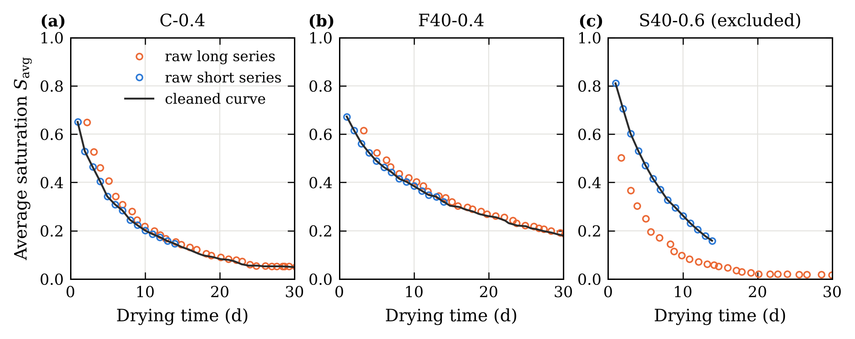
Fig. 1. Examples of the raw digitised series and of the cleaned curves: (a) C-0.4 and (b) F40-0.4, where the long series is the short series shifted by about one day; (c) S40-0.6, where the two series are inconsistent and the mix is excluded.

3 Physical model

3.1 Governing equation
Neglecting sources and sinks, which is reasonable once hydration has largely ceased [3], moisture conservation in one dimension reads
$$\frac{∂S}{∂t}=\frac{∂}{∂x}\left[D\left(S;θ\right) \frac{∂S}{∂x}\right] \left(1\right)$$
where $S\left(x,t\right)∈\left[0,1\right]$ is the degree of saturation, $D$ [m²/s] the effective moisture diffusivity and $θ$ the vector of material parameters.

3.2 Saturation-dependent diffusivity
The diffusivity follows the dual-regime formulation of Chen et al. [10], which blends a capillary (liquid) contribution and a vapour contribution:
$$D\left(S;θ\right)=f\left(S\right) D_{\text{cap}}\left(S\right)+\left[1−f\left(S\right)\right]D_{\text{vap}}\left(S\right) \left(2\right)$$
$$D_{\text{vap}}\left(S\right)=D_{v}\left[α_{0}+\frac{1−α_{0}}{1+{\left(\frac{1−S}{1−S_{c}}\right)}^{n}}\right] \left(3\right)$$
$$D_{\text{cap}}\left(S\right)=\frac{K_{\text{int}}}{η_{l}}\left|\frac{∂P_{c}}{∂S}\right|, \frac{∂P_{c}}{∂S}=−β P_{c0} S^{−β−1} \left(4\right)$$
$$f\left(S\right)=\frac{1}{1+exp\left[−k \left(S−S_{\text{cap}}\right)\right]} \left(5\right)$$
Equation (3) has the sigmoidal form of Bažant and Najjar [8], with $D_{v}$ the reference diffusivity, $α_{0}$ the ratio of minimum to maximum diffusivity, $n$ a shape exponent and $S_{c}$ the transition saturation. In Eq. (4), $K_{\text{int}}$ is the intrinsic permeability, $η_{l}$ the dynamic viscosity of water, $P_{c0}$ a reference capillary pressure and $β$ the capillary pressure exponent. The switching function (5) gives vapour-dominated transport at low saturation ($f→0$) and capillary-dominated transport at high saturation ($f→1$). The fixed constants are listed in Table 2; Section 3.4 explains which parameters are identified.
Table 2. Fixed constants of the physical model.
Symbol | Meaning | Value | Source
$L$ | Equivalent half-thickness ($V/A$ of the disc) | 12.5 mm | [7]
$T$ | Drying temperature | 50 °C | [7]
$η_{l}$ | Viscosity of water at 50 °C | 5.47 × 10⁻⁴ Pa·s | –
$P_{c0}$ | Reference capillary pressure | 5 MPa | [10]
$β$ | Capillary pressure exponent | 2.5 | [10]
$S_{c}$ | Transition saturation in Eq. (3) | 0.80 | [10]
$S_{\text{cap}}$, $k$ | Switching saturation and steepness | 0.75, 50 | [10]
$α_{0}$ | Minimum-to-maximum diffusivity ratio | 0.05 | Section 3.4
$n$ | Shape exponent (shared by all mixes) | 2 | Section 3.4
$S_{0}$, $S_{\text{init}}$ | Surface and initial saturation | 0, 1 | Section 3.3

3.3 Geometry, initial and boundary conditions
The discs dry through all their faces. Their volume-to-exposed-surface ratio is $V/A=12.5$ mm, which is used as the half-thickness $L$ of an equivalent slab dried from both faces; the same ratio governs the early-time drying rate. The domain is $x∈\left[0,L\right]$, with $x=0$ the drying face and $x=L$ the plane of symmetry. The specimens are vacuum-saturated at the start of drying, and the drying face is assumed to equilibrate instantly with the oven atmosphere, whose saturation defines the oven-dry reference ($S=0$):
$$S\left(x,0\right)=1, S\left(0,t\right)=0, \frac{∂S}{∂x}\left(L,t\right)=0 \left(6\right)$$
The average saturation compared with the measurements is
$$S_{\text{avg}}\left(t\right)=\frac{1}{L}\int_{0}^{L}{S}\left(x,t\right) dx \left(7\right)$$

3.4 Identifiability
A single average-saturation curve cannot determine many parameters independently. Identifiability was assessed by fitting Eqs. (1)–(7) to four representative mixes with three parameter sets, using the classical solver of Section 4.1 (Table 3). When $D_{v}$, $α_{0}$ and $K_{\text{int}}$ are identified together, $D_{v}$ and $α_{0}$ are perfectly correlated ($\left|ρ\right|=1.00$) and the Jacobian is ill-conditioned (condition number ≈ 10³–10⁴). Adding $n$ improves the fit but every pair of parameters is correlated above 0.98. With $α_{0}$ fixed, $D_{v}$ and $K_{\text{int}}$ are well determined: their correlation is about 0.65, the condition number 10–17 and the relative standard errors below 1%. The exponent $n$ was then profiled over six mixes; the total misfit is minimal for $n=2$ (mean $R^{2}$ = 0.9979), which is used for all mixes. The identified parameters are therefore $θ=\left[\log_{10}D_{v},\log_{10}K_{\text{int}}\right]$.
Table 3. Identifiability study (classical solver, $n=6$ when not identified): fit quality, largest parameter correlation and condition number of the Jacobian.
Mix | Identified | $R^{2}$ | RMSE | max $|ρ|$ | cond($J$)
C-0.4 | $D_{v},α_{0},K_{\text{int}}$ | 0.9908 | 0.0139 | 1.00 | 1.7 × 10³
C-0.4 | $D_{v},α_{0},n,K_{\text{int}}$ | 0.9985 | 0.0055 | 0.99 | 1.7 × 10³
C-0.4 | $D_{v},K_{\text{int}}$ | 0.9910 | 0.0137 | 0.64 | 14
F20-0.3 | $D_{v},α_{0},K_{\text{int}}$ | 0.9989 | 0.0052 | 1.00 | 1.6 × 10³
F20-0.3 | $D_{v},α_{0},n,K_{\text{int}}$ | 0.9990 | 0.0049 | 1.00 | 4.8 × 10³
F20-0.3 | $D_{v},K_{\text{int}}$ | 0.9980 | 0.0069 | 0.64 | 10
S40-0.5 | $D_{v},α_{0},K_{\text{int}}$ | 0.9948 | 0.0109 | 1.00 | 1.7 × 10³
S40-0.5 | $D_{v},α_{0},n,K_{\text{int}}$ | 0.9993 | 0.0041 | 0.99 | 1.5 × 10³
S40-0.5 | $D_{v},K_{\text{int}}$ | 0.9950 | 0.0107 | 0.66 | 13
F20S20-0.5 | $D_{v},α_{0},K_{\text{int}}$ | 0.9988 | 0.0050 | 1.00 | 1.0 × 10⁴
F20S20-0.5 | $D_{v},α_{0},n,K_{\text{int}}$ | 0.9994 | 0.0035 | 0.99 | 2.0 × 10³
F20S20-0.5 | $D_{v},K_{\text{int}}$ | 0.9948 | 0.0105 | 0.65 | 17

4 Methods

4.1 Finite-volume solver and classical identification
Equations (1)–(6) are discretised with a cell-centred finite-volume scheme on 60–80 cells refined geometrically towards the drying face (growth ratio 1.06), with arithmetic averaging of $D$ at the faces. The resulting system of ordinary differential equations is integrated with an implicit BDF scheme [29] (relative tolerance 10⁻⁶). For a constant diffusivity, the solver reproduces the analytical series solution of slab drying to within 2 × 10⁻³ in $S_{\text{avg}}$.
For the classical identification, $θ$ is fitted to each mix separately by nonlinear least squares (trust-region reflective algorithm, three starting points). Standard errors and correlations are obtained from the Jacobian at the optimum. To predict a mix that is not in the training set, the classical route regresses the identified parameters linearly on the composition of the training mixes and runs the solver with the regressed parameters (FD + regression).

4.2 Physics-embedded neural network
The proposed model is shown in Fig. 2. A multilayer perceptron $g_{w}$ with two hidden layers of 16 tanh neurons maps the composition vector $c=\left[\left(\text{w/b}−0.3\right)/0.3, \text{FA}/0.4, \text{SL}/0.4\right]$ — FA and SL being the fly ash and slag mass fractions of the binder — to the parameters
$$θ\left(c\right)=θ_{min}+\left(θ_{max}−θ_{min}\right)⊙σ​\left(g_{w}\left(c\right)\right) \left(8\right)$$
where $σ$ is the logistic function and the bounds are $\log_{10}D_{v}∈\left[−12,−6\right]$ and $\log_{10}K_{\text{int}}∈\left[−23,−18\right]$. The parameters feed a differentiable version of the finite-volume solver of Section 4.1, written with tensor operations and integrated by a linearly implicit Euler scheme on 240 logarithmically spaced time steps from 10⁻⁴ to 100 days. At each step the diffusivity is evaluated at the previous state and a linear system is solved, so that every operation is differentiable. The predicted average saturation is interpolated at the measurement times, and the network weights are obtained by minimising
$$L\left(w\right)=\frac{1}{N}\sum_{j=1}^{N}{{\left[S_{\text{avg}}​\left(t_{j};θ\left(c_{j}\right)\right)−S_{\text{avg},exp}\left(t_{j}\right)\right]}^{2}} \left(9\right)$$
over all training points, with gradients computed by automatic differentiation through the solver [26, 27]. The differentiable solver agrees with the BDF solver to about 3 × 10⁻³ in $S_{\text{avg}}$. Training uses Adam [30] (learning rate 0.02, decay 0.995 per iteration, weight decay 10⁻⁴) for 400 full-batch iterations. Since the governing equation is solved rather than penalised, it holds to discretisation accuracy for any network weights, and the internal field $S\left(x,t\right)$ is a direct output of the solver.
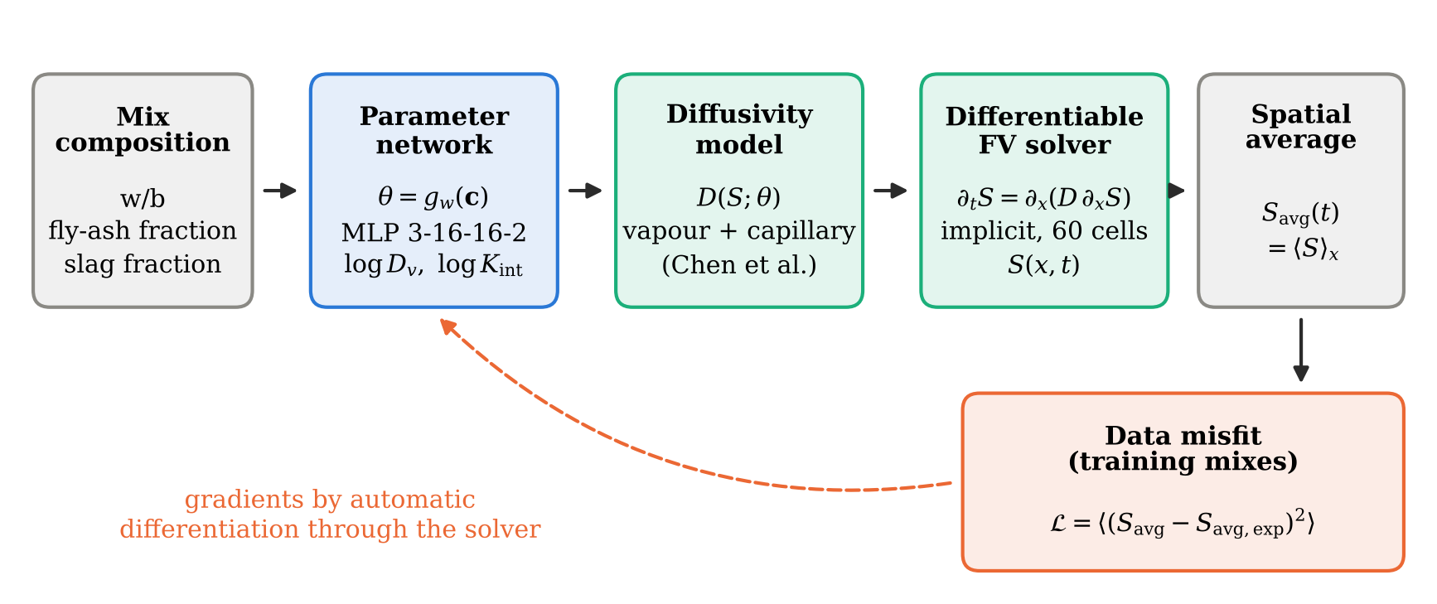
Fig. 2. Physics-embedded neural network. The parameter network predicts the transport parameters from the mix composition; the differentiable finite-volume solver returns the saturation field and its average; the data misfit is back-propagated through the solver to the network weights.

4.3 Physics-informed neural network
For comparison, a composition-aware PINN was trained on the same data with the same parameter network (8). A field network $N$ with four hidden layers of 48 tanh neurons takes $\left(x/L,\sqrt{t/t_{\text{ref}}},c\right)$ as inputs, with $t_{\text{ref}}=100$ days. The initial and boundary conditions are imposed exactly through the ansatz
$$S=1−exp\left(−\frac{ξ}{s}A\right), A=a\left(s\right)+\text{softplus}\left(N\right), ξ=x/L, s=\sqrt{t/t_{\text{ref}}} \left(10\right)$$
where $a\left(s\right)$ is a lower bound described below. The loss combines the integral data misfit, the PDE residual written in the dimensionless variables (and weighted by $t/t_{\text{ref}}$ so that it remains bounded at early times), and the symmetry condition at $ξ=1$:
$$L=\frac{1}{σ_{d}^{2}} L_{\text{data}}+λ_{\text{PDE}} L_{\text{PDE}}+λ_{\text{sym}} L_{\text{sym}} \left(11\right)$$
with $σ_{d}=0.01$, $λ_{\text{PDE}}=10$ and $λ_{\text{sym}}=1$. Half of the 3,000 collocation points per iteration are sampled in the similarity variable $ξ/s$ so that the drying front is resolved at all times. Training uses 3,000 Adam iterations followed by 1,000 L-BFGS iterations.
Without the lower bound $a\left(s\right)$, the PINN systematically converged to a trivial solution in which the specimen dries almost instantly after $t=0$. This solution satisfies the residual almost everywhere and is a known failure mode of PINNs for stiff transport problems [23, 25]; causal weighting of the residual [25] did not remove it. The bound $a\left(s\right)=0.1exp\left[−{\left(s/0.2\right)}^{2}\right]$, which limits the speed of the drying front at early times, prevents the collapse and is used for all reported PINN results.

4.4 Data-driven baseline and validation protocol
The purely data-driven baseline is a network with four hidden layers of 48 tanh neurons mapping $\left(\sqrt{t/t_{\text{ref}}},c\right)$ directly to $S_{\text{avg}}$, trained with Adam for 4,000 iterations. As an ablation, the PINN was also trained without the PDE residual.
Six mixes covering the four binder families and three w/b ratios — C-0.4, C-0.5, F10S10-0.3, F20-0.3, F20S20-0.4 and S40-0.4 (278 points) — were withheld from all training and parameter regression. The remaining 14 mixes (654 points) were used for training. The neural models were trained with five (PENN, data-driven network) or three (PINN) random seeds, and results are reported as mean ± standard deviation. Accuracy is measured by
R2=1−j​yj−yj2j​yj−y2, RMSE=1Nj​yj−yj2 12
Finally, the physical consistency of each model is tested by inserting its predicted parameters into the independent BDF solver of Section 4.1, without any fitting, and comparing the resulting curves with the model output (forward verification). All computations ran on a single CPU core.

5 Results

5.1 Classical identification
With the two identifiable parameters, the classical solver reproduces every drying curve with $R^{2}$ between 0.9945 and 0.9995 (median 0.9988, median RMSE 0.0054), at about 24 s per mix. The identified reference diffusivities range from 10^{−9.82} to 10^{−9.02} m²/s and the intrinsic permeabilities from 10^{−19.90} to 10^{−19.00} m², both within the ranges reported for cementitious materials [4, 5]. These per-mix fits use the data of each mix and serve as the reference parameters in the following sections.

5.2 Prediction of unseen mixes
Table 4 compares the methods on the six withheld mixes, and Fig. 3 shows the predicted curves. The PENN reaches $R^{2}$ = 0.9935 ± 0.0001 and RMSE = 0.0133 ± 0.0001, with $R^{2}$ between 0.981 (S40-0.4) and 0.998 (F20S20-0.4) for the individual mixes (Table 5). Its error is 34% lower than that of the data-driven network (RMSE 0.0202) and 38% lower than that of the PINN (0.0216). The classical FD + regression route gives the same accuracy (RMSE 0.0131), which is expected since both approaches solve the same equation and differ only in how the parameters are linked to composition. For reference, fitting the classical solver directly to the withheld curves, which uses their data, gives RMSE = 0.0059; the remaining gap reflects the information lost when parameters are predicted from three composition descriptors only.
Table 4. Accuracy on the six withheld mixes (278 points). ª Sum of the 14 per-mix fits.
Method | $R^{2}$ | RMSE | Training time
Physics-embedded neural network (PENN) | 0.9935 ± 0.0001 | 0.0133 ± 0.0001 | 291 s
Classical FD + regression on composition | 0.9938 | 0.0131 | 364 sª
Data-driven network | 0.9852 ± 0.0012 | 0.0202 ± 0.0008 | 9 s
PINN | 0.9826 ± 0.0071 | 0.0216 ± 0.0043 | 438 s
PINN without PDE residual | 0.9411 ± 0.0640 | 0.0365 ± 0.0210 | 197 s
Reference: FD fitted to each withheld mix | 0.9987 | 0.0059 | 24 s per mix

Table 5. Coefficient of determination for each withheld mix (mean over seeds).
Mix | PENN | FD + regression | Data-driven | PINN
C-0.4 | 0.994 | 0.993 | 0.995 | 0.985
C-0.5 | 0.990 | 0.988 | 0.897 | 0.894
F10S10-0.3 | 0.997 | 0.998 | 0.994 | 0.997
F20-0.3 | 0.994 | 0.994 | 0.994 | 0.989
F20S20-0.4 | 0.998 | 0.999 | 0.996 | 0.998
S40-0.4 | 0.981 | 0.982 | 0.987 | 0.980
The data-driven network and the PINN lose accuracy mainly on C-0.5, the most permeable withheld mix ($R^{2}$ ≈ 0.89), which lies at the edge of the composition range covered by the training mixes. The physics-based models extrapolate to this mix without loss of accuracy ($R^{2}$ = 0.990), because its faster drying follows from larger transport parameters rather than from a different curve shape. The PINN also illustrates over-fitting: it reproduces the training curves almost exactly (training RMSE 0.0033, against 0.0125 for the PENN) but generalises worse. Removing its PDE residual degrades the prediction further (RMSE 0.0365) and makes it strongly seed-dependent, which confirms that the physics constraint does carry information. The residuals of the PENN are largest during the first days of drying (Fig. 4), when the rate of mass loss is highest and digitisation errors are relatively larger.
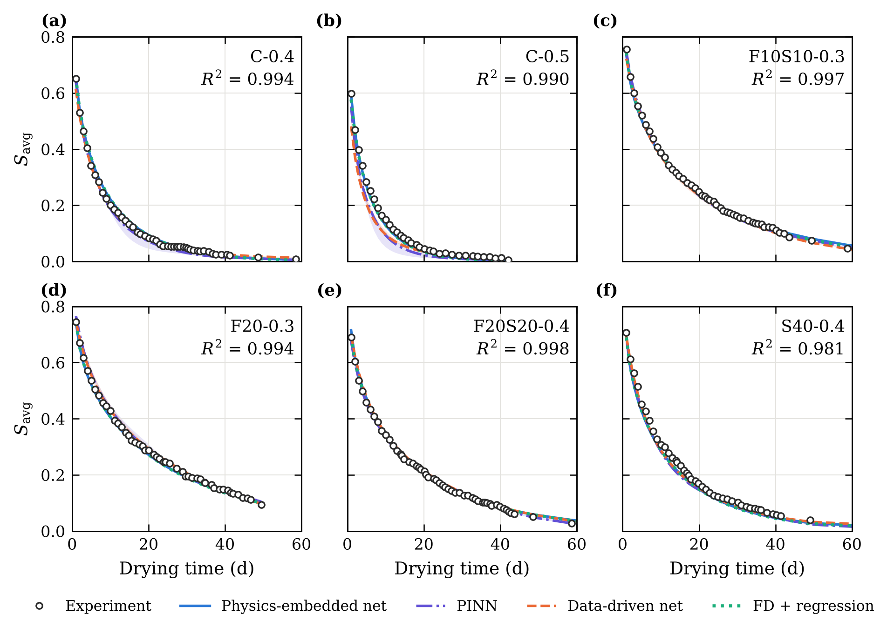
Fig. 3. Drying curves of the six mixes withheld from training: experiment and predictions of the four methods. Bands show the range over random seeds; $R^{2}$ refers to the PENN.
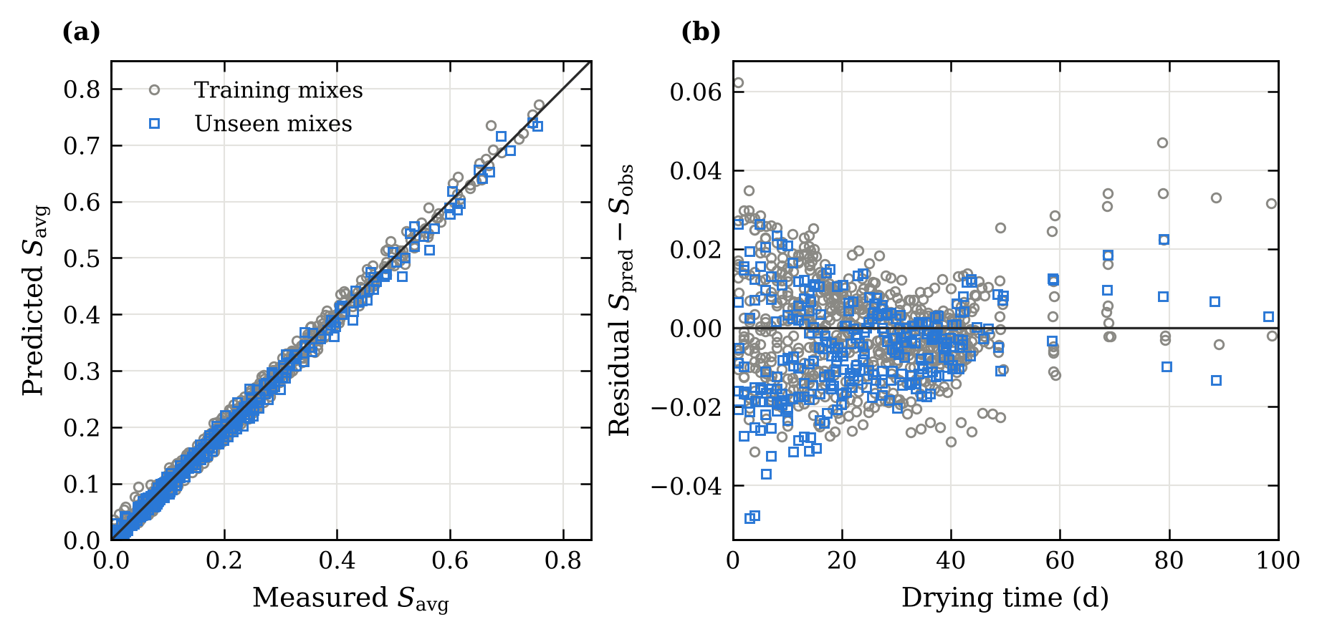
Fig. 4. PENN predictions: (a) predicted versus measured average saturation for training and unseen mixes; (b) residuals as a function of drying time.

5.3 Physical consistency of the identified parameters
Accuracy on the data does not guarantee that the identified parameters are consistent with the governing equation. Figure 5 shows the forward verification. Run with the parameters of the PENN, the independent BDF solver reproduces the PENN curves with $R^{2}$ = 0.9998 (RMSE = 0.0021), the residual difference being the discretisation error of the differentiable solver. With the parameters of the PINN, the same solver gives curves that drift systematically from those of the PINN ($R^{2}$ = 0.860, RMSE = 0.061) and from the data ($R^{2}$ = 0.897 on the withheld mixes).
The cause is the permeability. The PINN reference diffusivities agree reasonably with the classical values (mean absolute difference 0.06 decade), but its permeabilities are lower by 1.09 decades on average. $K_{\text{int}}$ controls the capillary regime ($S>0.75$), which prevails in the specimen during the first day of drying, before the first measurement. The PINN residual is weakest exactly there: the steep early-time gradients make the residual hard to minimise, and the data cannot correct it. The network can therefore reproduce the measured curves with a field that does not satisfy the transport equation at early times. Because the PENN integrates the equation from $t=0$, this inconsistency cannot arise.
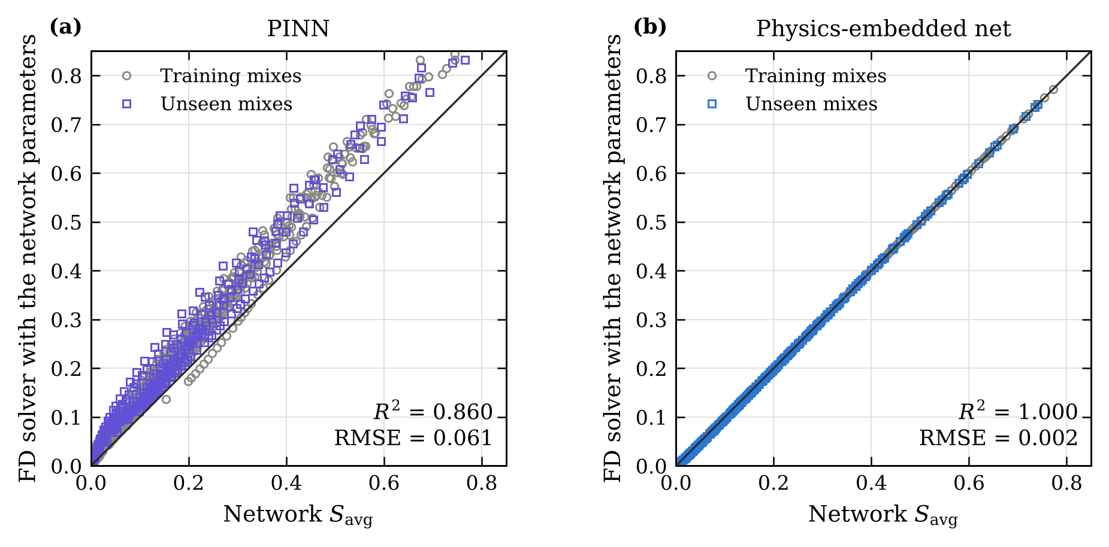
Fig. 5. Forward verification: average saturation computed by the independent BDF solver with the parameters predicted by (a) the PINN and (b) the PENN, against the output of each model.

5.4 Transport parameters and effect of composition
Figure 6 compares the parameters predicted by the PENN from composition alone with the classical per-mix fits. The reference diffusivities agree closely (mean absolute difference 0.024 decade, $r$ = 0.991), including for the withheld mixes. The permeabilities follow the same trend but over a narrower range (10^{−19.78} to 10^{−19.54} m², against 10^{−19.90} to 10^{−19.00} m²; $r$ = 0.69). The parameter network smooths the mix-to-mix scatter of $K_{\text{int}}$, which is less well constrained by the data than $D_{v}$. The variability across random seeds is negligible (0.001 decade for $D_{v}$, 0.005 for $K_{\text{int}}$).
Both parameters increase with w/b. For plain concrete, $D_{v}$ rises from 10^{−9.39} to 10^{−8.96} m²/s between w/b = 0.3 and 0.5, consistent with the coarser and better connected capillary porosity of high-w/b pastes [1, 3]. At a given w/b, SCMs reduce $D_{v}$; the reduction is largest for 40% fly ash (10^{−9.78} m²/s at w/b = 0.3, a factor of 2.5 below plain concrete), followed by the ternary blends and slag. This ranking agrees with the pore refinement produced by the pozzolanic and latent hydraulic reactions [1].
The diffusivity curves (Fig. 7) vary by more than one order of magnitude with saturation, from 2–6 × 10⁻¹¹ m²/s in the dry state to about 10⁻⁹ m²/s at $S≈0.8$. Vapour transport dominates below $S≈0.7$ and capillary transport above. The transition at $S_{\text{cap}}=0.75$ is imposed by the model of Chen et al. [10] and is not identified from the data.
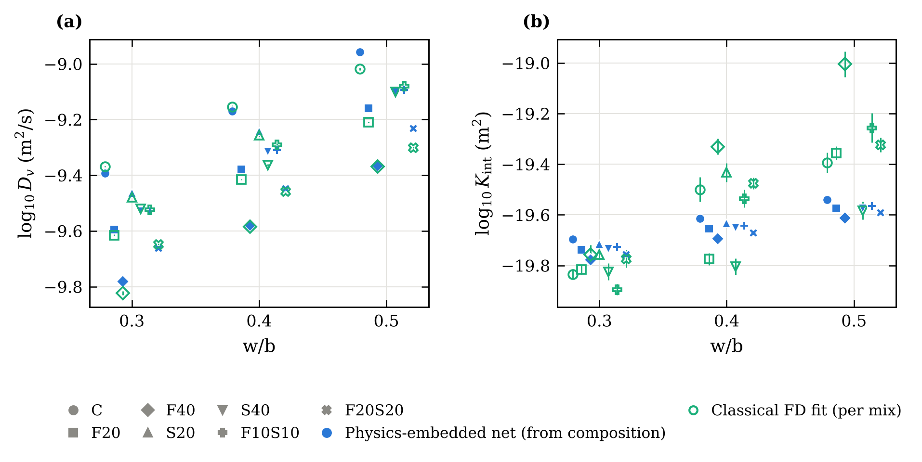
Fig. 6. Transport parameters versus w/b: (a) reference diffusivity $D_{v}$ and (b) intrinsic permeability $K_{\text{int}}$. Filled symbols: PENN predictions from composition (error bars: standard deviation over seeds); open symbols: classical per-mix fits (error bars: standard errors).
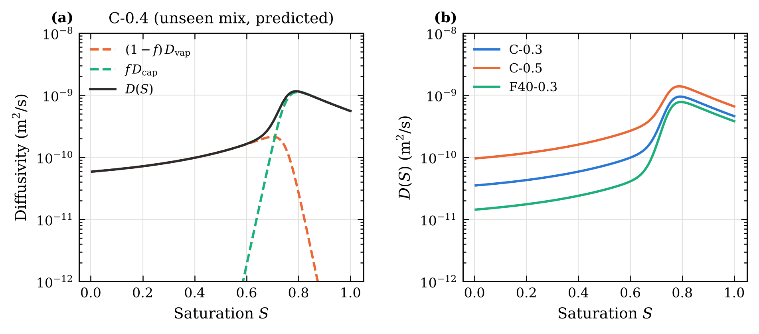
Fig. 7. Diffusivity predicted by the PENN: (a) vapour and capillary contributions for the withheld mix C-0.4; (b) effect of w/b and fly ash.

5.5 Internal saturation fields
Figure 8 shows the saturation profiles of three withheld mixes. After 0.5 days, a steep drying zone about 1–2 mm deep has formed at the exposed face while the core remains above S = 0.88. The zone then progresses inwards and the profile flattens: for C-0.4, the depth at which the saturation falls to 70% of the core value grows from 1.7 mm at 0.5 days to 6.1 mm at 28 days. The core saturation falls below 0.5 after 5.4 days for C-0.4, 7.4 days for S40-0.4 and 13.5 days for F20-0.3, illustrating how strongly fly ash slows internal drying. The PINN profiles are close to those of the PENN after a few days but differ markedly during the first two days, which is the period of the parameter inconsistency discussed in Section 5.3.
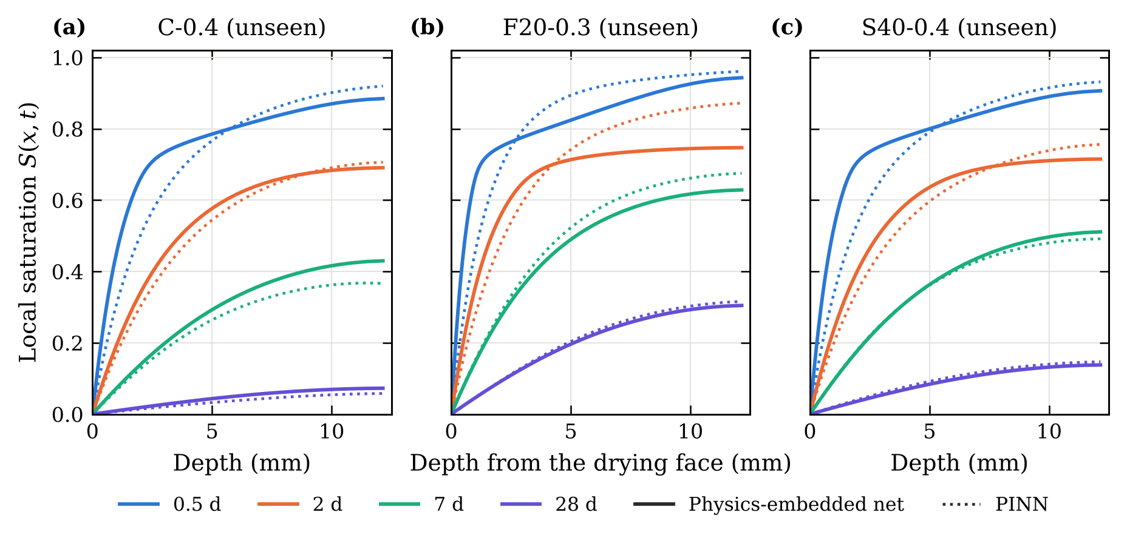
Fig. 8. Saturation profiles of three withheld mixes at 0.5, 2, 7 and 28 days predicted by the PENN (solid) and the PINN (dotted).

6 Discussion

6.1 Embedding versus penalising the physics
The results separate two properties that are often conflated: fitting the data and identifying physically meaningful parameters. Every method fits the training data, and the physics-based ones also predict unseen mixes well. However, only the methods that solve the transport equation — the classical solver and the PENN — return parameters that reproduce the data when used in an independent model. The PINN residual is a soft constraint whose weight must be balanced against the data, and it is weakest where the solution is steepest, at early times. For moisture transport this is exactly where the capillary parameters act. A PINN may still be useful as a fast surrogate of the curves, but in this problem its parameters should not be reported without the forward check of Fig. 5. We recommend this check whenever PINNs are used to identify material parameters.
The PENN reaches the accuracy of the classical route while offering three practical advantages. A single model covers all compositions and is trained end-to-end in about 5 minutes. The parameters of a new mix are obtained by one evaluation of the network, without a new inverse analysis. And the mapping from composition to parameters can be extended to additional descriptors, such as curing age or porosity, without changing the solver. Compared with the data-driven network, which is faster to train but less accurate and returns neither parameters nor internal fields, the PENN keeps the physical interpretability of the classical approach.

6.2 Limitations
Several limitations must be acknowledged. The identified parameters are effective values of a simplified isothermal one-dimensional model with an equivalent thickness, and they should not be interpreted as intrinsic properties without independent measurements; in particular, their absolute values scale with $L^{2}$. Only two parameters per mix are identifiable from average-saturation data, so the remaining constants of the diffusivity model, including the regime transition, are fixed from the literature. The database comes from a single laboratory and a single drying condition, the curves were digitised from published figures, and the w/b = 0.6 mixes had to be excluded. Finally, the internal saturation fields are model predictions that have not been compared with direct measurements, for example by gamma-ray attenuation or NMR.

7 Conclusions
A physics-embedded neural network was developed to identify moisture transport parameters and internal saturation fields of concrete from gravimetric drying data, and compared with classical identification, a data-driven network and a physics-informed neural network. The main conclusions are:
- Only two transport parameters, the reference diffusivity $D_{v}$ and the intrinsic permeability $K_{\text{int}}$, are identifiable from average-saturation curves; $D_{v}$ and $α_{0}$ are perfectly correlated and must not be identified together.
- The PENN predicts the drying of mixes withheld from training with $R^{2}$ = 0.9935 and RMSE = 0.013, a 34% lower error than a purely data-driven network, and matches the accuracy of classical identification combined with composition regression.
- Because the network is trained through the solver, its parameters satisfy the transport equation: an independent solver reproduces its predictions with $R^{2}$ = 0.9998. A PINN trained on the same data fits the curves but its parameters fail this check ($R^{2}$ = 0.86), with permeabilities about one order of magnitude too low.
- The predicted parameters increase with w/b and decrease with SCM content, most strongly with 40% fly ash, in agreement with the known effects of these materials on the pore structure.
Future work will use the absorption tests available for the same mixes to validate the identified parameters independently, extend the model to wetting and to drying–wetting cycles, add uncertainty quantification [31], and couple moisture with chloride transport for comparison with TransChlor [11].

Declarations
CRediT authorship contribution statement. Abderrahmane Sghuri: Conceptualization, Methodology, Software, Formal analysis, Visualization, Writing – original draft. Xuande Chen: Conceptualization, Supervision, Validation, Writing – review & editing, Funding acquisition. Xiaodong Wang: […].
Data and code availability. The experimental data are those of Zhuang et al. [7]. The digitised and cleaned data, the code and all scripts that produce the results and figures of this paper are available at https://github.com/Abderahmane2002/hybrid-pinn-lstm-concrete [archive a release on Zenodo and cite its DOI].
Declaration of competing interest. The authors declare that they have no known competing financial interests or personal relationships that could have appeared to influence the work reported in this paper.
Funding. [Funding agency and grant number]
Declaration of generative AI use. [Elsevier requires a statement if AI tools were used in preparing the manuscript or code; state the tool and purpose.]

Appendix A. Training histories
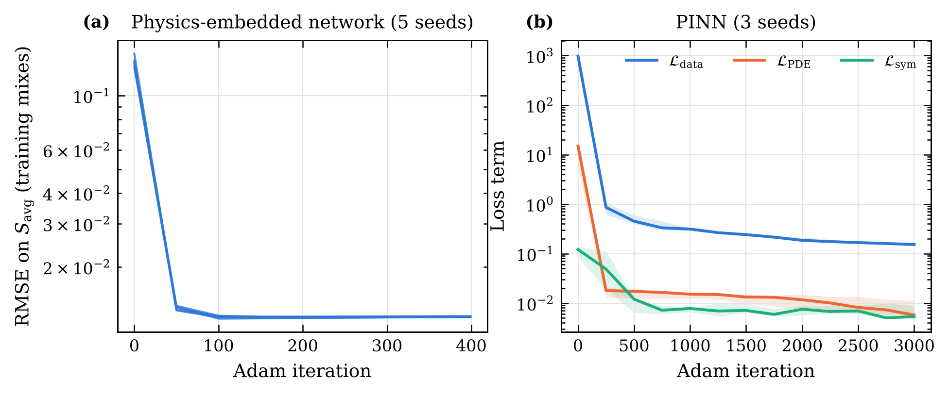
Fig. A.1. Training histories: (a) RMSE of the PENN on the training mixes (five seeds); (b) loss terms of the PINN (median and range over three seeds).

References
[1] P.K. Mehta, P.J.M. Monteiro, Concrete: Microstructure, Properties, and Materials, 4th ed., McGraw-Hill Education, New York, 2014.
[2] A.M. Neville, Properties of Concrete, 5th ed., Pearson Education, Harlow, 2011.
[3] V. Baroghel-Bouny, Water vapour sorption experiments on hardened cementitious materials. Part I: Essential tool for analysis of hygral behaviour and its relation to pore structure, Cem. Concr. Res. 37 (2007) 414–437. https://doi.org/10.1016/j.cemconres.2006.11.019
[4] V. Baroghel-Bouny, M. Mainguy, T. Lassabatère, O. Coussy, Characterization and identification of equilibrium and transfer moisture properties for ordinary and high-performance cementitious materials, Cem. Concr. Res. 29 (1999) 1225–1238.
[5] M. Mainguy, O. Coussy, V. Baroghel-Bouny, Role of air pressure in drying of weakly permeable materials, J. Eng. Mech. 127 (2001) 582–592.
[6] C. Hall, W.D. Hoff, Water Transport in Brick, Stone and Concrete, 2nd ed., Spon Press, London, 2012.
[7] S. Zhuang, Q. Wang, M. Zhang, Water absorption behaviour of concrete: Novel experimental findings and model characterization, J. Build. Eng. 53 (2022) 104602. https://doi.org/10.1016/j.jobe.2022.104602
[8] Z.P. Bažant, L.J. Najjar, Nonlinear water diffusion in nonsaturated concrete, Matér. Constr. 5 (1972) 3–20.
[9] H.M. Künzel, Simultaneous Heat and Moisture Transport in Building Components: One- and Two-Dimensional Calculation Using Simple Parameters, Fraunhofer IRB Verlag, Stuttgart, 1995.
[10] X. Chen, T. Sanchez, D. Conciatori, H. Chaouki, L. Sorelli, B. Selma, M. Chekired, Numerical modeling of 2D hygrothermal transport in unsaturated concrete with capillary suction, J. Build. Eng. 45 (2022) 103640. https://doi.org/10.1016/j.jobe.2021.103640
[11] D. Conciatori, H. Sadouki, E. Brühwiler, Capillary suction and diffusion model for chloride ingress into concrete, Cem. Concr. Res. 38 (2008) 1401–1408.
[12] J. Kaipio, E. Somersalo, Statistical and Computational Inverse Problems, Springer, New York, 2005.
[13] A. Tarantola, Inverse Problem Theory and Methods for Model Parameter Estimation, SIAM, Philadelphia, 2005.
[14] M. Raissi, P. Perdikaris, G.E. Karniadakis, Physics-informed neural networks: A deep learning framework for solving forward and inverse problems involving nonlinear partial differential equations, J. Comput. Phys. 378 (2019) 686–707. https://doi.org/10.1016/j.jcp.2018.10.045
[15] G.E. Karniadakis, I.G. Kevrekidis, L. Lu, P. Perdikaris, S. Wang, L. Yang, Physics-informed machine learning, Nat. Rev. Phys. 3 (2021) 422–440. https://doi.org/10.1038/s42254-021-00314-5
[16] A.G. Baydin, B.A. Pearlmutter, A.A. Radul, J.M. Siskind, Automatic differentiation in machine learning: a survey, J. Mach. Learn. Res. 18 (2018) 1–43.
[17] S. Cuomo, V.S. Di Cola, F. Giampaolo, G. Rozza, M. Raissi, F. Piccialli, Scientific machine learning through physics-informed neural networks: where we are and what’s next, J. Sci. Comput. 92 (2022) 88.
[18] A.M. Tartakovsky, C.O. Marrero, P. Perdikaris, G.D. Tartakovsky, D. Barajas-Solano, Physics-informed deep neural networks for learning parameters and constitutive relationships in subsurface flow problems, Water Resour. Res. 56 (2020) e2019WR026731.
[19] T. Bandai, T.A. Ghezzehei, Physics-informed neural networks with monotonicity constraints for Richardson-Richards equation: Estimation of constitutive relationships and soil water flux density from volumetric water content measurements, Water Resour. Res. 57 (2021) e2020WR027642.
[20] Y. Wan, W. Zheng, Y. Wang, Identification of chloride diffusion coefficient in concrete using physics-informed neural networks, Constr. Build. Mater. 393 (2023) 132049. https://doi.org/10.1016/j.conbuildmat.2023.132049
[21] Y. Wan, W. Zheng, Physics-informed neural network approach for identifying free chloride diffusion coefficient in alkali-activated mortars, J. Build. Eng. 112 (2025) 113820. https://doi.org/10.1016/j.jobe.2025.113820
[22] J.M. Lee, C.J. Lee, Inverse estimation of moisture diffusion model for concrete using artificial neural network, Materials 15 (2022) 5945. https://doi.org/10.3390/ma15175945
[23] A.S. Krishnapriyan, A. Gholami, S. Zhe, R.M. Kirby, M.W. Mahoney, Characterizing possible failure modes in physics-informed neural networks, Adv. Neural Inf. Process. Syst. 34 (2021) 26548–26560.
[24] S. Wang, Y. Teng, P. Perdikaris, Understanding and mitigating gradient flow pathologies in physics-informed neural networks, SIAM J. Sci. Comput. 43 (2021) A3055–A3081.
[25] S. Wang, S. Sankaran, P. Perdikaris, Respecting causality for training physics-informed neural networks, Comput. Methods Appl. Mech. Eng. 421 (2024) 116813.
[26] C. Rackauckas, Y. Ma, J. Martensen, C. Warner, K. Zubov, R. Supekar, D. Skinner, A. Ramadhan, A. Edelman, Universal differential equations for scientific machine learning, arXiv:2001.04385 (2020).
[27] N. Thuerey, P. Holl, M. Mueller, P. Schnell, F. Trost, K. Um, Physics-based Deep Learning, arXiv:2109.05237 (2021).
[28] ASTM C1585, Standard Test Method for Measurement of Rate of Absorption of Water by Hydraulic-Cement Concretes, ASTM International, West Conshohocken, PA.
[29] E. Hairer, G. Wanner, Solving Ordinary Differential Equations II: Stiff and Differential-Algebraic Problems, 2nd ed., Springer, Berlin, 1996.
[30] D.P. Kingma, J. Ba, Adam: A method for stochastic optimization, in: Proc. 3rd Int. Conf. Learn. Represent. (ICLR), San Diego, 2015. arXiv:1412.6980.
[31] L. Yang, X. Meng, G.E. Karniadakis, B-PINNs: Bayesian physics-informed neural networks for forward and inverse PDE problems with noisy data, J. Comput. Phys. 425 (2021) 109913.

