Learning moisture transport parameters of blended concretes from drying curves: identifiability, generalisation across binders, and a comparison of physics-embedded and physics-informed neural networks
Abderrahmane Sghuri^{a,b}, Xuande Chen^{a,b,*}, Xiaodong Wangª
ª Department of Mathematics, Computer Science and Engineering, Université du Québec à Rimouski (UQAR), Rimouski, QC, Canada
^{b} Research Center on Concrete Infrastructures (CRIB), Québec, QC, Canada
* Corresponding author: [e-mail address]

Highlights
- Drying curves identify only two moisture transport parameters of concrete per mix.
- A solver-embedded network learns them from mix composition with R² = 0.9931.
- No detectable gain over two-stage inversion; flexible maps fail on new binders.
- Pooling mixes in one model keeps predictions stable when drying curves are short.
- A PINN fits the same data, but its parameters fail an independent solver check.

Abstract
Gravimetric drying tests give the average saturation of concrete specimens, from which moisture transport parameters are usually identified mix by mix. We examine what can be learned across mixes and which modelling choices make the result trustworthy. A vapour–capillary diffusion model of the actual disc specimens was fitted to 932 drying measurements of 20 plain, binary and ternary concretes from a published database, after correcting a time offset between duplicated digitised series. Profile likelihoods showed that only two parameters per mix are identifiable: the reference diffusivity to within 0.05 decade and the intrinsic permeability to within 0.42 decade (median 95% intervals). A physics-embedded neural network (PENN), which maps composition to these parameters and is trained through tabulated solutions of the transport equation, predicted six withheld mixes with R² = 0.9931. Classical inversion followed by linear regression gave similar accuracy (R² = 0.9934), with no statistically detectable difference in leave-one-mix-out or leave-one-binder-family-out validation. With a binder family withheld, flexible composition models failed for several mixes (lowest R² 0.20), whereas the linear physics-based models kept R² ≥ 0.962. End-to-end training was more robust when the training curves were short. Synthetic tests revealed that weight decay compressed the learned permeabilities; a linear map trained to convergence removed this bias. A physics-informed neural network fitted the curves but returned permeabilities about 1.1 decade too low, which diagnostic runs link to its soft-constrained loss. Fixed constitutive constants shift the parameters by up to 0.4 decade without changing the ranking of the mixes.
Keywords: Concrete; Moisture transport; Drying; Supplementary cementitious materials; Inverse analysis; Identifiability; Physics-embedded neural network; Physics-informed neural network

1 Introduction
The moisture state of concrete controls most of its deterioration processes. Water carries chlorides to the reinforcement, governs the rate of carbonation, drives freeze–thaw damage and alkali–silica reaction, and its loss causes drying shrinkage [1, 2]. Service-life models therefore need moisture transport properties, and these depend strongly on the water-to-binder ratio (w/b) and on supplementary cementitious materials (SCMs) such as fly ash and slag, which refine the pore structure [3, 4]. Moisture moves partly as liquid under capillary pressure gradients and partly as vapour through the gas-filled pores, and the balance between the two changes with the local degree of saturation [5, 6].
The most common laboratory measurement is gravimetric: a specimen is weighed while it dries or absorbs water, which gives its average degree of saturation $S_{\text{avg}}\left(t\right)$ [7, 8]. The test is inexpensive, but the curve does not show the moisture profile inside the specimen or the material functions that produce it. These are obtained by inverse analysis: a transport model [6, 9–11] is run repeatedly and its parameters are adjusted until the simulated mass loss matches the measurement. Two difficulties are well known. The problem is ill-posed, because different parameter sets can reproduce the same curve [12, 13], and the calibration is carried out mix by mix, so a new composition needs a new test and a new inversion. Practical identifiability, i.e. whether the available data constrain each parameter, is rarely examined in this context, although tools such as profile likelihoods are well established in other fields [14].
Machine learning has been used to relate composition to transport indicators across many mixes, most often for chloride diffusion coefficients [15]. These models are purely statistical and do not provide the material functions that a transport simulation needs. Physics-informed neural networks (PINNs) offer a way to combine data and governing equations [16–18]. A PINN represents the unknown field by a neural network and adds the residual of the governing equation, computed by automatic differentiation [19], to the data misfit; unknown coefficients are learned in the same optimisation. PINNs have identified constitutive relations of unsaturated soils [20], chloride diffusion coefficients of concrete and alkali-activated mortars [21, 22] and moisture diffusivities of stone [23], and neural networks have recovered moisture diffusivities of concrete from synthetic profiles [24]. Their training is, however, fragile for stiff transport problems: the optimiser can settle on fields that satisfy the residual almost everywhere while missing the initial condition or the early dynamics [25–28]. In an inverse setting this is easily overlooked, because the network may still fit the measurements closely.
An alternative is to keep a conventional solver and place it inside the learning loop, so that gradients of the data misfit flow through the solver to the quantities being learned [29, 30]. Bandai et al. [31] used this differentiable-solver approach to learn soil water retention and conductivity functions from moisture data. The governing equation then holds to the accuracy of the discretisation. For concrete, where the unknowns are a few parameters per mix, the same idea can be combined with a model of how these parameters depend on composition. Whether such end-to-end learning offers anything over the simpler two-stage route — inverting each mix and regressing the results on composition — has not been tested, and neither has the consistency of PINN-identified moisture parameters with an independent solver.
This paper addresses these questions on a published drying database of plain, binary and ternary concretes [8]. Its contributions are:
- a documented reconstruction of the database, including statistical evidence that its duplicated series are one curve digitised with a time offset;
- a practical identifiability analysis of a vapour–capillary diffusion model of the real disc specimens, with profile likelihoods that account for correlated residuals, synthetic recovery tests, and the sensitivity of the parameters to fixed constants and boundary conditions;
- a physics-embedded neural network (PENN) that learns the composition–parameter relationship through tabulated solutions of the transport equation, compared under identical folds with two-stage inversion (four regression models) and a data-driven network, including binder-family extrapolation, mix-level statistics, robustness tests and data-efficiency studies;
- a controlled comparison with a PINN, with diagnostic runs that locate the origin of its parameter inconsistency.
Section 2 describes the database, Section 3 the transport model and Section 4 the methods. The results are presented in Section 5, discussed in Section 6 and summarised in Section 7.

2 Experimental database

2.1 Source and test protocol
The data come from the experimental programme of Zhuang et al. [8]. Concrete cylinders 100 mm in diameter and 150 mm high were cured sealed at 20 ± 2 °C and 95 ± 5% relative humidity. At the test age, discs 100 mm in diameter and 50 mm thick were cut from the centre of the cylinders, vacuum-saturated for 24 h and dried in an oven at 50 °C, following the conditioning procedure of ASTM C1585 [32]. The discs were weighed daily until the mass loss over 24 h fell below 0.1%, and the degree of saturation was plotted against drying time. The source reports drying curves at curing ages of 28 and 56 days [8] and notes that curing age changes the drying behaviour markedly. The curves used here were digitised from the published figures; the data file does not record their curing age, which is examined in Section 2.4, and the source does not state whether the lateral surface was sealed during drying.

2.2 Concrete mixes
The programme covers four w/b ratios (0.3–0.6) and seven binder systems: plain Portland cement (C), 20% and 40% fly ash (F20, F40), 20% and 40% slag (S20, S40), and ternary blends with 10% + 10% and 20% + 20% fly ash and slag (F10S10, F20S20). The proportions are given in Table 1.
Table 1. Mix proportions of the concretes (kg/m³), after Zhuang et al. [8]. S20-0.5 has no drying curve in the digitised data.
Mix | w/b | Water | Cement | Fly ash | Slag | Used
C-0.3 | 0.3 | 179 | 596 | – | – | training
C-0.4 | 0.4 | 204 | 509 | – | – | withheld
C-0.5 | 0.5 | 226 | 451 | – | – | withheld
C-0.6 | 0.6 | 236 | 393 | – | – | –
F20-0.3 | 0.3 | 173 | 461 | 115 | – | withheld
F20-0.4 | 0.4 | 200 | 399 | 100 | – | training
F20-0.5 | 0.5 | 222 | 355 | 89 | – | training
F20-0.6 | 0.6 | 233 | 311 | 78 | – | –
F40-0.3 | 0.3 | 167 | 334 | 223 | – | training
F40-0.4 | 0.4 | 197 | 296 | 197 | – | training
F40-0.5 | 0.5 | 217 | 260 | 174 | – | training
F40-0.6 | 0.6 | 231 | 231 | 154 | – | –
S20-0.3 | 0.3 | 176 | 470 | – | 118 | training
S20-0.4 | 0.4 | 205 | 409 | – | 102 | training
S20-0.5 | 0.5 | 227 | 363 | – | 91 | –
S20-0.6 | 0.6 | 237 | 316 | – | 79 | –
S40-0.3 | 0.3 | 174 | 348 | – | 232 | training
S40-0.4 | 0.4 | 205 | 307 | – | 205 | withheld
S40-0.5 | 0.5 | 223 | 268 | – | 178 | training
S40-0.6 | 0.6 | 237 | 237 | – | 158 | –
F10S10-0.3 | 0.3 | 175 | 466 | 58 | 58 | withheld
F10S10-0.4 | 0.4 | 202 | 403 | 50 | 50 | training
F10S10-0.5 | 0.5 | 223 | 357 | 45 | 45 | training
F10S10-0.6 | 0.6 | 236 | 315 | 39 | 39 | –
F20S20-0.3 | 0.3 | 170 | 341 | 114 | 114 | training
F20S20-0.4 | 0.4 | 196 | 295 | 98 | 98 | withheld
F20S20-0.5 | 0.5 | 224 | 269 | 90 | 90 | training
F20S20-0.6 | 0.6 | 241 | 241 | 80 | 80 | –

2.3 Reconstruction of the drying curves
The digitised file contains 1,562 points for 27 mixes. For most mixes it holds two series: a short series with daily points up to 14 days and a long series extending to 40–100 days. Over their common saturation range, the long series is the short series delayed by a nearly constant time (median 1.05 d, interquartile range 0.97–1.13 d over the 18 mixes in which the two agree). Two curves measured on different specimens or at different curing ages would differ by a change of time scale rather than by a shift, since diffusion-controlled drying scales with $t/D$. Fitting both relations to every mix with w/b ≤ 0.5 settles the question: a pure shift reproduces the short series to within 0.005 in saturation (median RMS), a pure time scaling only to within 0.026, and a free combination of both returns a scale factor of 0.98 (interquartile range 0.97–1.00), i.e. no scaling. The two series are therefore one curve plotted with two time origins; a one-day offset is consistent with time counted from the start of the 24 h vacuum saturation. Each curve was rebuilt from the short series up to 14 days and the time-corrected long series beyond (Fig. 1a,b). The offset estimated from the training mixes alone (1.06 d) differs from the global value by less than 0.02 d.
The w/b = 0.6 series could not be repaired. The long series of S20-0.6 and S40-0.6 are identical copies, the short series of F20S20-0.6 mixes two curves, and the offsets between the two series are erratic and of the wrong sign (Fig. 1c). The remaining w/b = 0.6 short series dry more slowly at early ages than the corresponding w/b = 0.5 curves, which is implausible, and a classical fit drives the permeability to the lower bound of its range. These mixes were excluded. The reconstructed data file keeps their short series for reference but flags them, so it holds 1,001 points, of which the 69 flagged w/b = 0.6 points are never used. Every analysis in this paper uses the remaining 932 points of 20 mixes with w/b between 0.3 and 0.5. All steps are scripted, and the effect of the reconstruction choices on the results is quantified in Section 5.5.

2.4 Curing age of the digitised curves
Because curing age affects drying markedly, it matters which of the two published sets of curves was digitised. The source gives two quantitative statements that allow a check. After 28 days of curing, the time needed to dry the vacuum-saturated discs to 70% saturation is 1.5, 1.0, 0.8 and 0.6 days for w/b = 0.3, 0.4, 0.5 and 0.6, and the type and content of mineral admixture have little effect. After 56 days, both admixture and w/b have a large effect, with differences of 2–4 days between binders at the same w/b [8]. For the digitised curves, the time to 70% saturation obtained from the fitted disc model averages 1.60, 0.95 and 0.62 days for w/b = 0.3, 0.4 and 0.5. These values differ from the 28-day values by 0.11 day on average, and the spread between binders at a given w/b is at most 0.9 day. Both observations match the 28-day description and not the 56-day one. Had the time origin of the long series been used instead, the times would exceed the 28-day values by about one day (1.0 day on average), which independently supports the time origin chosen in Section 2.3. We therefore interpret the database as drying curves after 28 days of curing; the composition effects identified below refer to that age and may be larger at later ages.
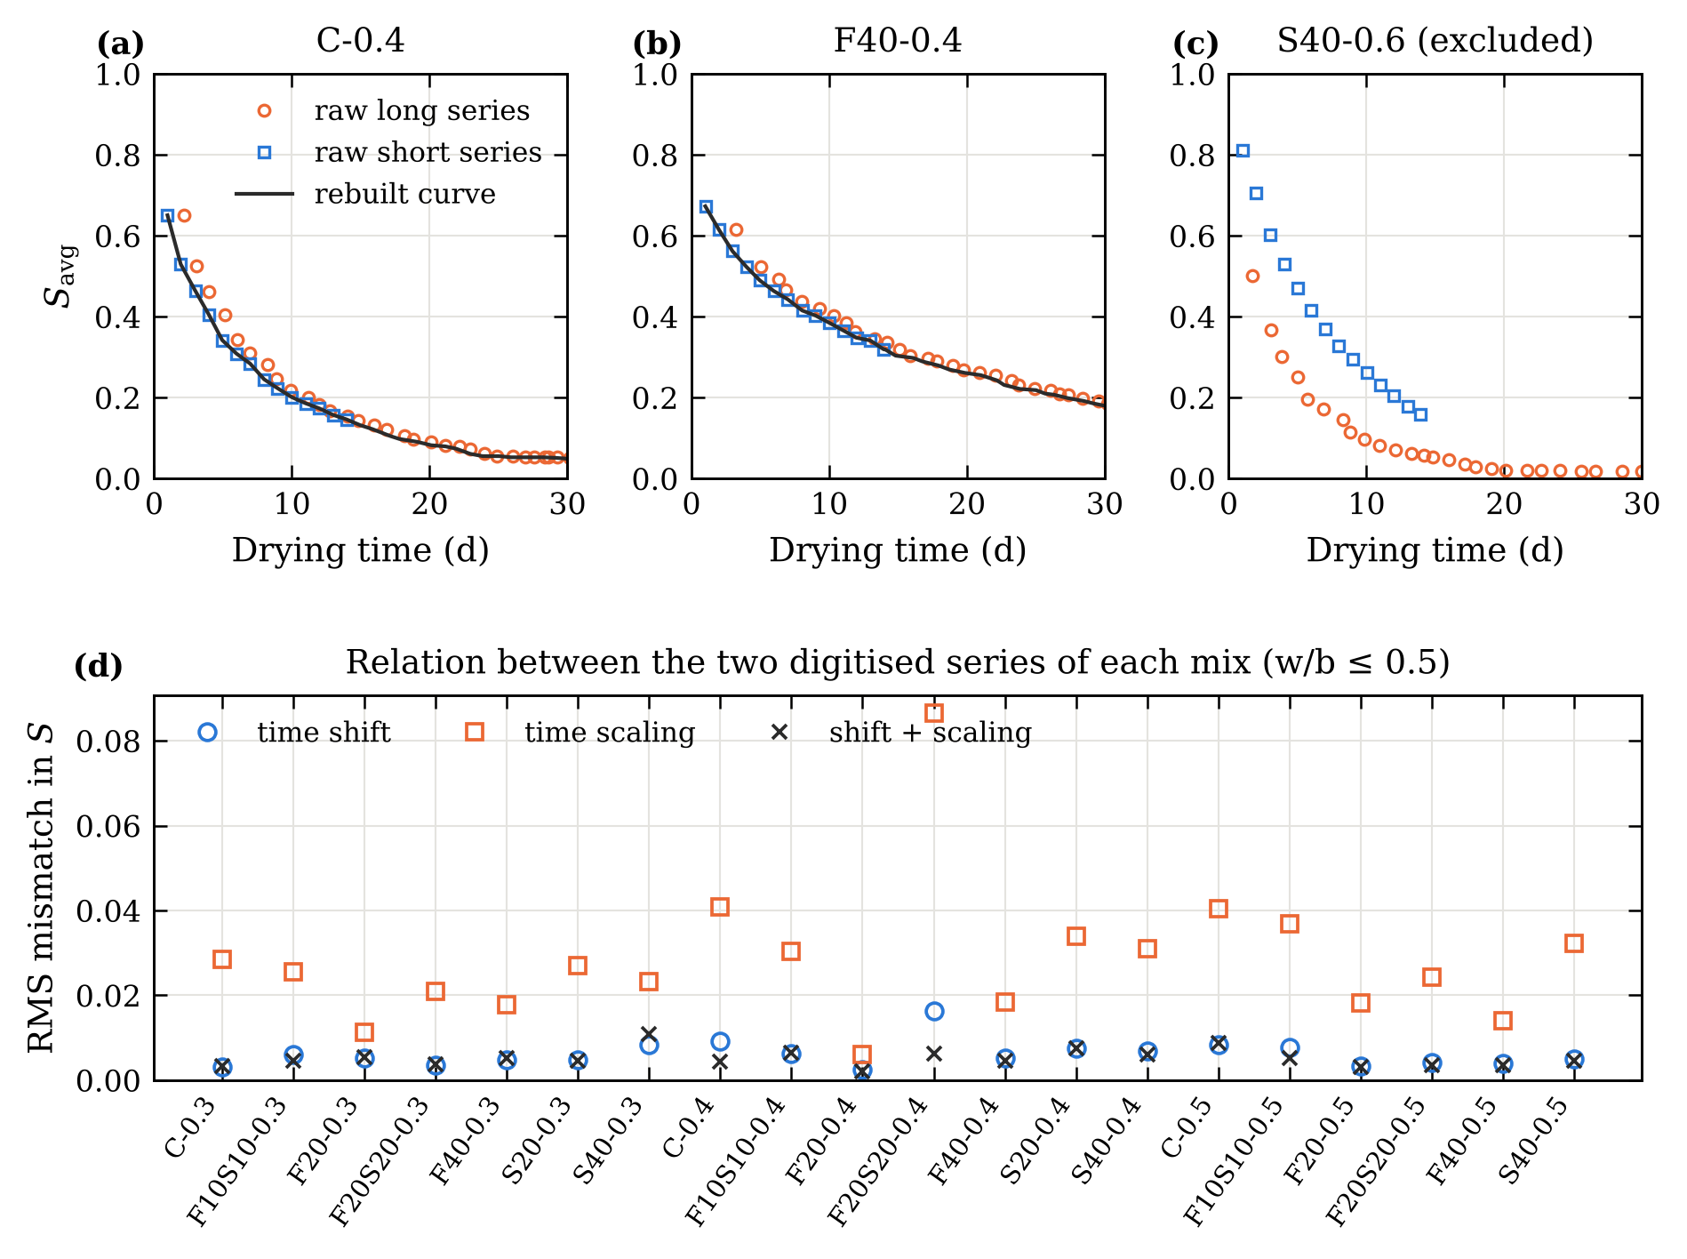
Fig. 1. Reconstruction of the drying curves. (a) C-0.4 and (b) F40-0.4: raw short and long series and the rebuilt curve. (c) S40-0.6: inconsistent series, mix excluded. (d) Median RMS mismatch between the two series of each mix (w/b ≤ 0.5) when they are related by a time shift, a time scaling, or both.

3 Moisture transport model

3.1 Governing equation and diffusivity
Once hydration has largely stopped, sources and sinks of water can be neglected [3], and moisture conservation reads
$$\frac{∂S}{∂t}=∇⋅\left[D\left(S;θ\right) ∇S\right] \left(1\right)$$
where $S∈\left[0,1\right]$ is the degree of saturation and $D$ [m²/s] the effective moisture diffusivity. We use the dual-regime diffusivity of Chen et al. [6], which blends a capillary and a vapour contribution:
$$D\left(S;θ\right)=f\left(S\right) D_{\text{cap}}\left(S\right)+\left[1−f\left(S\right)\right]D_{\text{vap}}\left(S\right) \left(2\right)$$
$$D_{\text{vap}}\left(S\right)=D_{v}\left[α_{0}+\frac{1−α_{0}}{1+{\left(\frac{1−S}{1−S_{c}}\right)}^{n}}\right] \left(3\right)$$
$$D_{\text{cap}}\left(S\right)=\frac{K_{\text{int}}}{η_{l}}\left|\frac{∂P_{c}}{∂S}\right|, \frac{∂P_{c}}{∂S}=−β P_{c0} S^{−β−1} \left(4\right)$$
$$f\left(S\right)=\frac{1}{1+exp\left[−k \left(S−S_{\text{cap}}\right)\right]} \left(5\right)$$
Equation (3) has the sigmoidal form of Bažant and Najjar [9], with $D_{v}$ the reference diffusivity, $α_{0}$ the ratio of minimum to maximum vapour diffusivity, $n$ a shape exponent and $S_{c}$ the transition saturation. In Eq. (4), $K_{\text{int}}$ is the intrinsic permeability, $η_{l}$ the viscosity of water, $P_{c0}$ a reference capillary pressure and $β$ an exponent. The switch (5) makes vapour transport dominant at low saturation and capillary transport dominant at high saturation. The fixed constants are listed in Table 2. Since $D_{\text{cap}}$ depends on $K_{\text{int}}$ only through $K_{\text{int}}P_{c0}/η_{l}$, only this product is identifiable: a different choice of $P_{c0}$ or $η_{l}$ shifts $\log_{10}K_{\text{int}}$ by a known constant and leaves every prediction unchanged.
Table 2. Fixed constants of the transport model. Their influence on the identified parameters is quantified in Section 5.9.
Symbol | Meaning | Value | Source
$R$, $H$ | Disc radius and half-thickness | 50 mm, 25 mm | [8]
$T$ | Drying temperature | 50 °C | [8]
$η_{l}$ | Viscosity of water at 50 °C | 5.47 × 10⁻⁴ Pa·s | –
$P_{c0}$ | Reference capillary pressure | 5 MPa | [6]
$β$ | Capillary pressure exponent | 2.5 | [6]
$S_{c}$ | Transition saturation in Eq. (3) | 0.80 | [6]
$S_{\text{cap}}$, $k$ | Switching saturation and steepness | 0.75, 50 | [6]
$α_{0}$ | Minimum-to-maximum diffusivity ratio | 0.05 | Section 5.2
$n$ | Shape exponent, shared by all mixes | 8 | Section 5.2

3.2 Specimen geometry and boundary conditions
With the axis and the mid-plane as planes of symmetry, Eq. (1) is solved on $0≤r≤R$, $0≤z≤H$ with
$$S\left(r,z,0\right)=1, S\left(R,z,t\right)=S\left(r,H,t\right)=0, \frac{∂S}{∂r}\left(0,z,t\right)=\frac{∂S}{∂z}\left(r,0,t\right)=0 \left(6\right)$$
The specimen starts saturated, and the exposed surfaces are assumed to reach the oven-dry state immediately, which defines $S=0$. The quantity compared with the measurements is the volume average
$$S_{\text{avg}}\left(t\right)=\frac{2}{R^{2}H}\int_{0}^{H}{​}​\int_{0}^{R}{S}\left(r,z,t\right) r dr dz \left(7\right)$$
A one-dimensional slab whose half-thickness equals the volume-to-surface ratio, $L=V/A=12.5$ mm, is a common simplification. It reproduces the early drying of the disc but not its later stages, because the edges dry from two sides: with the same parameters, the slab curve departs from the disc curve by up to 0.13 in $S_{\text{avg}}$. A slab model fitted to the same data returns parameters biased by −0.33 to −0.25 decade in $D_{v}$ and up to +0.55 decade in $K_{\text{int}}$ (Fig. 2). The disc geometry is therefore used for every result on transport parameters; the slab is kept only for the controlled comparison with the PINN (Section 5.7), where both methods use the same simplified model.
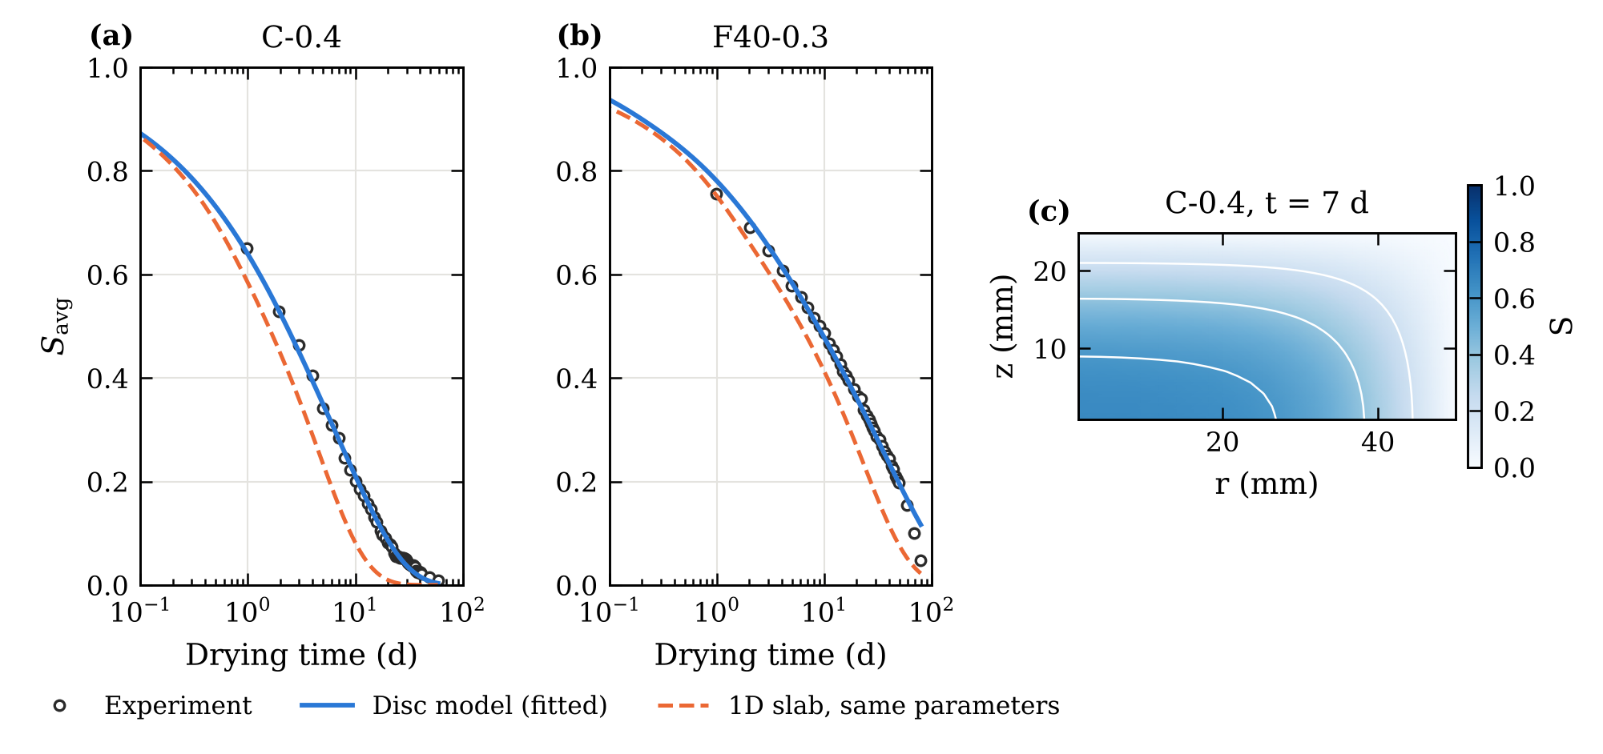
Fig. 2. Disc model and one-dimensional slab. (a, b) Measured average saturation, disc model fitted to the data, and slab model ($L=V/A$) run with the same parameters. (c) Saturation in one quarter of the disc after 7 days for C-0.4; the edge dries from two sides.

4 Methods

4.1 Numerical solution and verification
Equation (1) is discretised with a cell-centred finite-volume scheme on a mesh refined towards the drying faces (24 × 16 cells in $\left(r,z\right)$ for the disc, 60–80 cells for the slab) and integrated in time with an implicit BDF scheme [33] at a relative tolerance of 10⁻⁶. This direct solver is the reference model of the study. It was verified against the analytical solution for constant diffusivity, by mesh and time-step refinement, by a global water balance, and by checking that a disc of very large radius reproduces the slab solution (Section 5.1, Appendix A).
Learning requires many evaluations of the model and gradients with respect to its parameters. Because only two parameters are identified (Section 5.2), the disc problem was solved once with the direct solver on a 49 × 49 grid of $\left(\log_{10}D_{v},\log_{10}K_{\text{int}}\right)$ covering $\left[−10,−7.5\right]×\left[−21,−18.5\right]$, at 120 logarithmically spaced times between 0.05 and 110 days. Between grid points, $S_{\text{avg}}$ is interpolated with bicubic convolution [34] in the parameters and linearly in log-time. The interpolant is differentiable and every value it returns is a combination of solutions of Eq. (1). We refer to it as the tabulated solver; it is used for training and, for speed, in the extensive validation experiments, after checking that it reproduces the direct solver to within 9 × 10⁻⁵ in $S_{\text{avg}}$ and the classical parameter estimates to within 0.002 decade. For the slab, a differentiable version of the finite-volume scheme (linearly implicit Euler, 240 logarithmic time steps) is used instead.

4.2 Classical inversion and identifiability
For each mix, $θ=\left[\log_{10}D_{v},\log_{10}K_{\text{int}}\right]$ is estimated by nonlinear least squares (trust-region reflective algorithm, several starting points). Practical identifiability was assessed in three ways. First, the Jacobian at the optimum gives parameter correlations and a condition number, computed for two, three and four free parameters. Second, profile likelihoods [14] were computed for every mix: one parameter is fixed on a grid and the other re-optimised, and the 95% interval is the range where the deviance $N_{\text{eff}}ln\left(\text{SSE}/{\text{SSE}}_{min}\right)$ stays below $3.84 c$. Digitised curves have strongly autocorrelated residuals, so the number of points $N$ was replaced by $N_{\text{eff}}=N\left(1−ρ_{1}\right)/\left(1+ρ_{1}\right)$, with $ρ_{1}$ the lag-1 autocorrelation of the residuals. Because this correction is itself approximate, its coverage was checked by simulation: for every mix, 100 replicate curves were generated from the fitted model with AR(1) errors having the residual standard deviation and lag-1 autocorrelation of that curve, and each replicate was analysed exactly as the data. The factor $c$ is the value that gives 95% coverage over all replicates, determined separately for each parameter. The resulting intervals are approximate: they assume AR(1) errors. Third, synthetic curves with known parameters, generated on a finer mesh (36 × 24) than the one used for inversion, were inverted with and without perturbations (Section 5.2). The shared exponent $n$ was selected by profiling the total misfit of five training mixes; including or excluding the withheld mix C-0.5 does not change the choice.

4.3 Models linking composition and transport parameters
The composition of a mix is described by $c=\left[\left(\text{w/b}−0.3\right)/0.3, \text{FA}/0.4, \text{SL}/0.4\right]$, where FA and SL are the fly ash and slag mass fractions of the binder. Two families of models predict $θ\left(c\right)$ for a mix that was not tested.
Two-stage inversion. The classical estimates of the training mixes are regressed on $c$, and the transport model is run with the regressed parameters. Four regressions were compared: ordinary least squares (OLS, linear), ridge regression with the penalty selected by leave-one-out cross-validation on the training mixes, quadratic features with the same ridge penalty, and Gaussian-process (GP) regression with an anisotropic squared-exponential kernel and a noise term, fitted by maximum marginal likelihood [35].
Physics-embedded neural network. In the PENN (Fig. 3), a small network $g_{w}$ maps $c$ to the parameters, mapped smoothly into the admissible range,
$$θ\left(c\right)=θ_{min}+\left(θ_{max}−θ_{min}\right)⊙σ​\left(g_{w}\left(c\right)\right) \left(8\right)$$
with $σ$ the logistic function. The parameters are passed to the tabulated solver and the weights minimise the misfit over all training points,
$$L\left(w\right)=\frac{1}{N}\sum_{j=1}^{N}{{\left[S_{\text{avg}}​\left(t_{j};θ\left(c_{j}\right)\right)−S_{\text{avg},exp}\left(t_{j}\right)\right]}^{2}} \left(9\right)$$
with gradients obtained by automatic differentiation through the solver [29, 30]. No per-mix inversion is needed: the network is trained directly on the drying curves of all training mixes at once. The reference PENN has two hidden layers of 16 tanh units; a reduced network (one layer of 8 units) and a linear map ($g_{w}$ affine in $c$) were also tested. Training uses Adam [36] (learning rate 0.02, decay 0.995 per iteration, weight decay 10⁻⁴) for 400 full-batch iterations, after which the training error no longer changes (Fig. D.1a). A revised PENN, introduced in Section 5.6, uses a linear map without weight decay trained to convergence with full-batch L-BFGS.
Data-driven network. A network with four hidden layers of 48 tanh units maps $\left(\sqrt{t/t_{\text{ref}}},c\right)$, $t_{\text{ref}}=100$ d, directly to $S_{\text{avg}}$ (Adam, 4000 iterations, weight decay 10⁻⁵).
Choice of settings. The settings of the PENN and of the data-driven network given above were fixed in the original study, before this analysis, and are retained for both model classes so that neither is tuned more than the other. To check them without using the withheld mixes, every setting was also compared in an inner leave-one-family-out cross-validation restricted to the training mixes (Appendix C). For the PENN the original setting lies within 0.001 RMSE of the best configuration in the inner validation. For the data-driven network it prefers a ten times stronger weight decay (10⁻³); this inner-CV setting is therefore reported as a second data-driven baseline in every validation scheme, and conclusions about the data-driven approach are drawn only where both settings agree. Neither the choice of the primary setting nor the interpretation uses the accuracy on the withheld mixes.
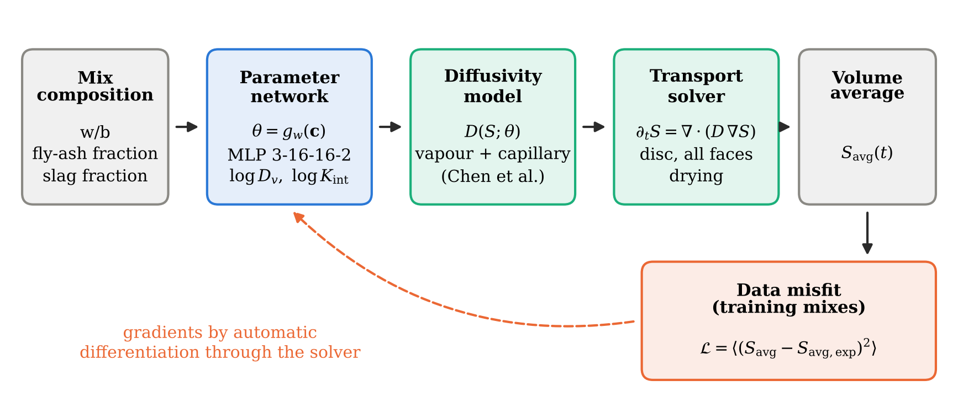
Fig. 3. Physics-embedded neural network. The parameter network predicts the transport parameters from the composition; the tabulated solver returns the average saturation; the data misfit is back-propagated through the solver to the network weights. In the two-stage route, the parameters are instead identified mix by mix and then regressed on composition.

4.4 Physics-informed neural network
The PINN was set up on the slab version of the problem ($L=12.5$ mm, $n=2$ from the corresponding profile) with the same parameter network (8). A field network $N$ with four hidden layers of 48 tanh units takes $\left(ξ,s,c\right)$ as input, with $ξ=x/L$ and $s=\sqrt{t/t_{\text{ref}}}$. The boundary condition at the drying face and the initial condition are built into the field,
$$S=1−exp\left(−\frac{ξ}{s}A\right), A=a\left(s\right)+\text{softplus}\left(N\right) \left(10\right)$$
so that $S→1$ when $t→0$ and $S=0$ at $ξ=0$. The loss combines the integral data misfit, the dimensionless PDE residual and the symmetry condition at $ξ=1$,
$$L=σ_{d}^{−2} L_{\text{data}}+λ_{\text{PDE}} L_{\text{PDE}}+λ_{\text{sym}} L_{\text{sym}} \left(11\right)$$
with $σ_{d}=0.01$, $λ_{\text{PDE}}=10$ and $λ_{\text{sym}}=1$. The residual is multiplied by $t/t_{\text{ref}}$, which keeps it bounded at early times, and half of the 3000 collocation points per iteration are sampled in the similarity variable $ξ/s$ so that the drying front is resolved at every time. Training uses 3000 Adam iterations followed by 1000 L-BFGS iterations (Fig. D.1b). Without the term $a\left(s\right)={10}^{−3}+0.1exp\left[−{\left(s/0.2\right)}^{2}\right]$, which bounds the speed of the drying front at early times, the PINN converged in every trial to a trivial field that dries almost instantly, a known failure mode for stiff transport problems [25, 27] that causal weighting of the residual [27] did not remove.

4.5 Validation protocol
- Hold-out test. Six mixes covering four binder families and three w/b ratios (C-0.4, C-0.5, F10S10-0.3, F20-0.3, F20S20-0.4 and S40-0.4; 278 points) were withheld; the other 14 mixes (654 points) were used for training. Networks were trained with five random seeds (three for the PINN).
- Cross-validation. Leave-one-mix-out (LOMO, 20 folds) and leave-one-binder-family-out (LOFO, 7 folds), one seed per fold. Because the points of one curve are not independent, the mix is the statistical unit: methods are compared through per-mix RMSE differences, with 95% bootstrap intervals (10 000 resamples of the mixes [37]) and Wilcoxon signed-rank tests. Because mixes of the same binder family share most of their composition, the comparison was repeated with the binder family as the unit: per-mix differences are averaged within each of the seven families, and the family means are resampled (cluster bootstrap) and tested with the Wilcoxon test; with seven families the smallest attainable two-sided $p$ is 0.016. A non-significant difference does not show that two methods are equally accurate; to judge practical equivalence we use a margin of ±0.002 in per-mix RMSE, about one third of the residual RMSE of direct per-mix fits (0.0063) and below the digitisation uncertainty. Two methods are called practically equivalent when the 90% family-level interval of their difference lies within this margin (two one-sided tests at the 5% level). The margin was set during this revision, after the main comparisons had been run, so this criterion is descriptive rather than a pre-registered test.
- Robustness. The training data were perturbed by independent noise (standard deviation 0.01 and 0.02), by correlated digitisation-like errors (per-curve offset plus AR(1) noise), by random time-origin errors (0.25 d), and by alternative reconstructions of the curves (offset at the bounds of its interquartile range, short or long series only). Predictions were always scored against the unperturbed withheld curves.
- Data efficiency. Models were trained on 5, 8, 11 or 14 randomly drawn mixes (10 draws each, identical for all methods) and tested on the remaining ones, and on training curves truncated after 3, 4, 7 or 14 days.
- Solver check. The parameters returned by each model were inserted, without fitting, into the direct solver, and the resulting curves were compared with the model output.
Accuracy is reported as the coefficient of determination and the root-mean-square error,
R2=1−j​yj−yj2j​yj−y2, RMSE=1Nj​yj−yj2 12
pooled over all points of a test set, and per mix. All computations ran on a single CPU core.

5 Results

5.1 Numerical verification
The direct solver behaves as expected (Appendix A, Table A.1). For a constant diffusivity it reproduces the analytical series solution of slab drying to within 2 × 10⁻³. Under mesh refinement the slab solution converges at second order, with an error of 9 × 10⁻⁵ in $S_{\text{avg}}$ at 80 cells, and the water lost through the drying face balances the change in stored water to machine precision (relative error 10⁻¹⁵). The disc solution on the 24 × 16 mesh differs from a 96 × 64 reference by at most 4 × 10⁻³, mostly in the first hours of drying, before the first measurement. Refitting eight mixes on a 36 × 24 mesh changed the identified parameters by at most 0.001 decade for $D_{v}$ and 0.007 decade for $K_{\text{int}}$, well inside their uncertainty (Section 5.2). The tabulated solver differs from the direct solver by at most 9 × 10⁻⁵ in $S_{\text{avg}}$, and classical fits obtained with it agree with direct fits to within 0.0003 decade for $D_{v}$ and 0.002 decade for $K_{\text{int}}$. Differences between the learning methods compared below are therefore not caused by numerical approximation.

5.2 Identifiability of the transport parameters
With $α_{0}$ and $n$ fixed, the disc model reproduces every drying curve with $R^{2}$ between 0.9917 and 0.9995 (median 0.9986, median RMSE 0.0060). Freeing more parameters does not help (Table 3). When $D_{v}$, $α_{0}$ and $K_{\text{int}}$ are fitted together, $D_{v}$ and $α_{0}$ are perfectly correlated ($|ρ|$ = 1.00) and the condition number of the Jacobian rises to 4 × 10²–2 × 10³; adding $n$ leaves parameter pairs correlated above 0.99. With two free parameters the correlation is 0.72–0.82 and the condition number 12–16. The total misfit decreases with $n$ and levels off beyond $n≈8$: on the five training mixes of the profile it is 49% higher at $n=2$ and only 2% lower at $n=16$, the same pattern as with the withheld mix included. The value $n=8$ lies in the range reported by Bažant and Najjar [9]. Because $D_{v}$ and $α_{0}$ cannot be separated, the identified $D_{v}$ is conditional on $α_{0}=0.05$.
Table 3. Jacobian-based identifiability with the disc model ($n=8$ when not identified): fit quality, largest parameter correlation and condition number.
Mix | Identified | $R^{2}$ | RMSE | max $|ρ|$ | cond($J$)
C-0.4 | $D_{v}$, $α_{0}$, $K_{\text{int}}$ | 0.9974 | 0.0074 | 1.00 | 1.3 × 10³
C-0.4 | $D_{v}$, $α_{0}$, $n$, $K_{\text{int}}$ | 0.9989 | 0.0048 | 1.00 | 1.1 × 10⁴
C-0.4 | $D_{v}$, $K_{\text{int}}$ | 0.9975 | 0.0073 | 0.77 | 14
F20-0.3 | $D_{v}$, $α_{0}$, $K_{\text{int}}$ | 0.9985 | 0.0061 | 1.00 | 1.5 × 10³
F20-0.3 | $D_{v}$, $α_{0}$, $n$, $K_{\text{int}}$ | 0.9985 | 0.0061 | 1.00 | 1.5 × 10⁶
F20-0.3 | $D_{v}$, $K_{\text{int}}$ | 0.9984 | 0.0063 | 0.82 | 12
S40-0.5 | $D_{v}$, $α_{0}$, $K_{\text{int}}$ | 0.9988 | 0.0053 | 1.00 | 1.2 × 10³
S40-0.5 | $D_{v}$, $α_{0}$, $n$, $K_{\text{int}}$ | 0.9994 | 0.0036 | 0.99 | 2.0 × 10⁴
S40-0.5 | $D_{v}$, $K_{\text{int}}$ | 0.9988 | 0.0052 | 0.82 | 16
F20S20-0.5 | $D_{v}$, $α_{0}$, $K_{\text{int}}$ | 0.9993 | 0.0038 | 1.00 | 4.4 × 10²
F20S20-0.5 | $D_{v}$, $α_{0}$, $n$, $K_{\text{int}}$ | 0.9993 | 0.0038 | 1.00 | 4.3 × 10³
F20S20-0.5 | $D_{v}$, $K_{\text{int}}$ | 0.9993 | 0.0038 | 0.72 | 12
The Jacobian gives only a local picture, and it assumes independent errors. The profile likelihoods (Fig. 4a–c) show a well-defined minimum for both parameters in every mix. The residuals of the digitised curves, however, are strongly autocorrelated (median lag-1 correlation 0.63, so that a median of 46 points carries the information of about 11 independent ones). A simulation with correlated errors matched to each curve shows how much this matters for the 95% intervals (Section 4.2): intervals that treat the points as independent, from the profile or from the Jacobian, contain the true value in only 67% ($K_{\text{int}}$) and 64% ($D_{v}$) of the replicates. Replacing $N$ by $N_{exteff}$ raises the coverage to 90% and 88%, still below the nominal level, and scaling the deviance threshold by 1.46 ($K_{extint}$) and 1.78 ($D_{v}$) restores 95%. With these calibrated intervals, $D_{v}$ is determined to within 0.05 decade (median width; at most 0.44) and $K_{extint}$ to within 0.42 decade. For 3 mixes with very strongly autocorrelated residuals (F10S10-0.5, F20S20-0.3, F40-0.3), the $K_{extint}$ interval reaches the bound of the admissible range: their permeability is constrained only on one side. The reference diffusivity is thus a precise quantity, whereas the permeability is known only to a few tenths of a decade from a drying curve, and not at all for some curves. These intervals rest on an AR(1) model of the digitisation errors and should be read as approximate.
The synthetic tests confirm this asymmetry (Fig. 4d). Inverting exact curves generated on a finer mesh recovers the true parameters to within 0.001 decade for $D_{v}$ and 0.008 decade for $K_{\text{int}}$, also when only the first 14 days are available (0.007 decade), so the model is structurally identifiable over the experimental time range. Measurement-like perturbations affect mainly $K_{\text{int}}$: independent noise of 0.01 produces errors of up to 0.25 decade (against 0.018 for $D_{v}$), correlated noise up to 0.26, and an error of 0.25 d in the time origin up to 0.39 decade. $K_{\text{int}}$ controls the capillary stage of the first day, which is described by only a few early points of each curve.
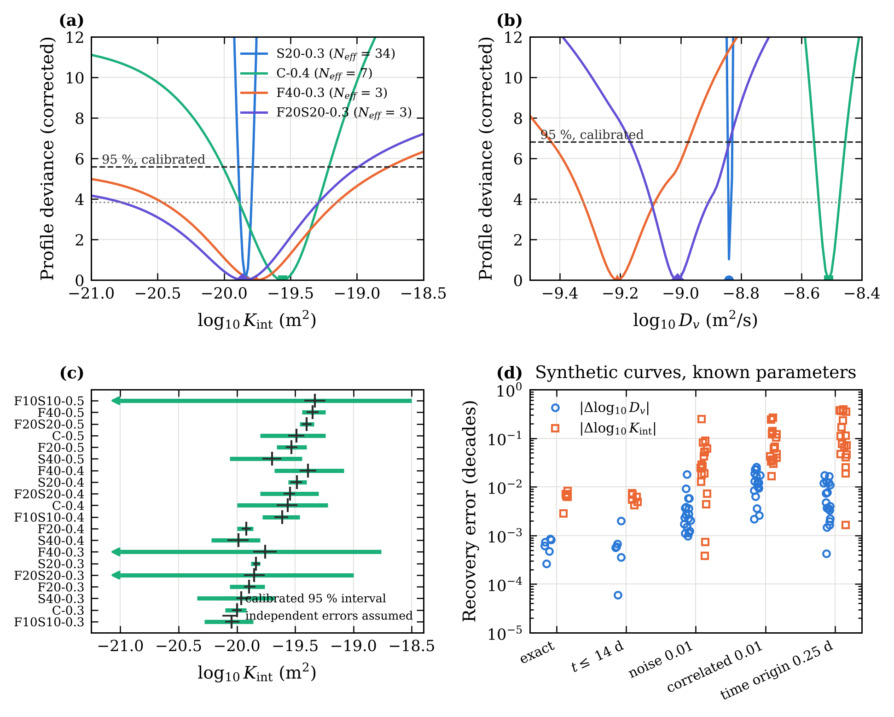
Fig. 4. Identifiability. (a, b) Profile deviance, corrected for residual autocorrelation, of $\log_{10}K_{\text{int}}$ and $\log_{10}D_{v}$ for four mixes; the dashed line is the 95% threshold. (c) 95% profile intervals of $\log_{10}K_{\text{int}}$ for all mixes, with and without the correction. (d) Recovery errors on synthetic curves with known parameters under five conditions (six parameter sets, three replicates for the noisy conditions).

5.3 Prediction of withheld mixes
Table 4 lists the accuracy on the six withheld mixes and Fig. 5 shows the curves. All methods that use the transport model are close: the PENN reaches $R^{2}$ = 0.9931 (RMSE = 0.0137 ± 0.0002 over five seeds), two-stage inversion with linear regression 0.9934 (RMSE 0.0135), and the other two-stage and PENN variants lie between RMSE 0.0130 and 0.0141. The data-driven network is less accurate (RMSE 0.0202; 0.0309 with the setting chosen by inner cross-validation), and so is the Gaussian-process regression (RMSE 0.0204), which extrapolates poorly from 14 mixes. Fitting the model directly to the withheld curves, which uses their data, gives RMSE 0.0063; the difference with the predictive methods measures what is lost when the parameters must be inferred from three composition descriptors.
Table 4. Accuracy on the six withheld mixes (278 points). Networks: mean ± standard deviation over five seeds. ª After a one-off tabulation of the disc solutions (14 min). ^{b} Sum of the per-mix fits of the training mixes.
Method | $R^{2}$ | RMSE | Training time
Two-stage, linear (OLS) | 0.9934 | 0.0135 | 555 s^{b}
Two-stage, ridge | 0.9933 | 0.0136 | 555 s^{b}
Two-stage, quadratic | 0.9939 | 0.0130 | 555 s^{b}
Two-stage, Gaussian process | 0.9849 | 0.0204 | 555 s^{b}
PENN | 0.9931 ± 0.0002 | 0.0137 ± 0.0002 | 1 sª
PENN, revised (linear map, L-BFGS) | 0.9937 ± 0.0000 | 0.0132 ± 0.0000 | < 1 sª
PENN, linear composition map | 0.9928 ± 0.0001 | 0.0141 ± 0.0001 | 1 sª
PENN, 1 × 8 units | 0.9932 ± 0.0000 | 0.0137 ± 0.0000 | 1 sª
Data-driven network | 0.9852 ± 0.0012 | 0.0202 ± 0.0008 | 12 s
Data-driven network, inner-CV setting | 0.9654 ± 0.0012 | 0.0309 ± 0.0005 | 12 s
Reference: classical fit to each withheld mix | 0.9986 | 0.0063 | 41 s per mix

Table 5. Coefficient of determination for each withheld mix (networks: mean over five seeds).
Mix | Two-stage, linear | PENN | PENN, revised (linear map, L-BFGS) | Two-stage, Gaussian process | Data-driven network
C-0.4 | 0.994 | 0.992 | 0.994 | 0.997 | 0.995
C-0.5 | 0.986 | 0.999 | 0.992 | 0.970 | 0.897
F10S10-0.3 | 0.998 | 0.996 | 0.998 | 0.974 | 0.994
F20-0.3 | 0.994 | 0.994 | 0.995 | 0.985 | 0.994
F20S20-0.4 | 0.998 | 0.998 | 0.998 | 0.993 | 0.996
S40-0.4 | 0.981 | 0.977 | 0.979 | 0.976 | 0.987
The largest differences between methods occur for C-0.5, the most permeable withheld mix and the only plain concrete at w/b = 0.5 (Table 5). The data-driven network underestimates its saturation during the first week ($R^{2}$ = 0.897), whereas linear two-stage inversion and the PENN variants predict it with $R^{2}$ ≥ 0.98. In these models, faster drying of a more permeable mix follows from larger parameters, not from a curve shape that must have been seen in training.
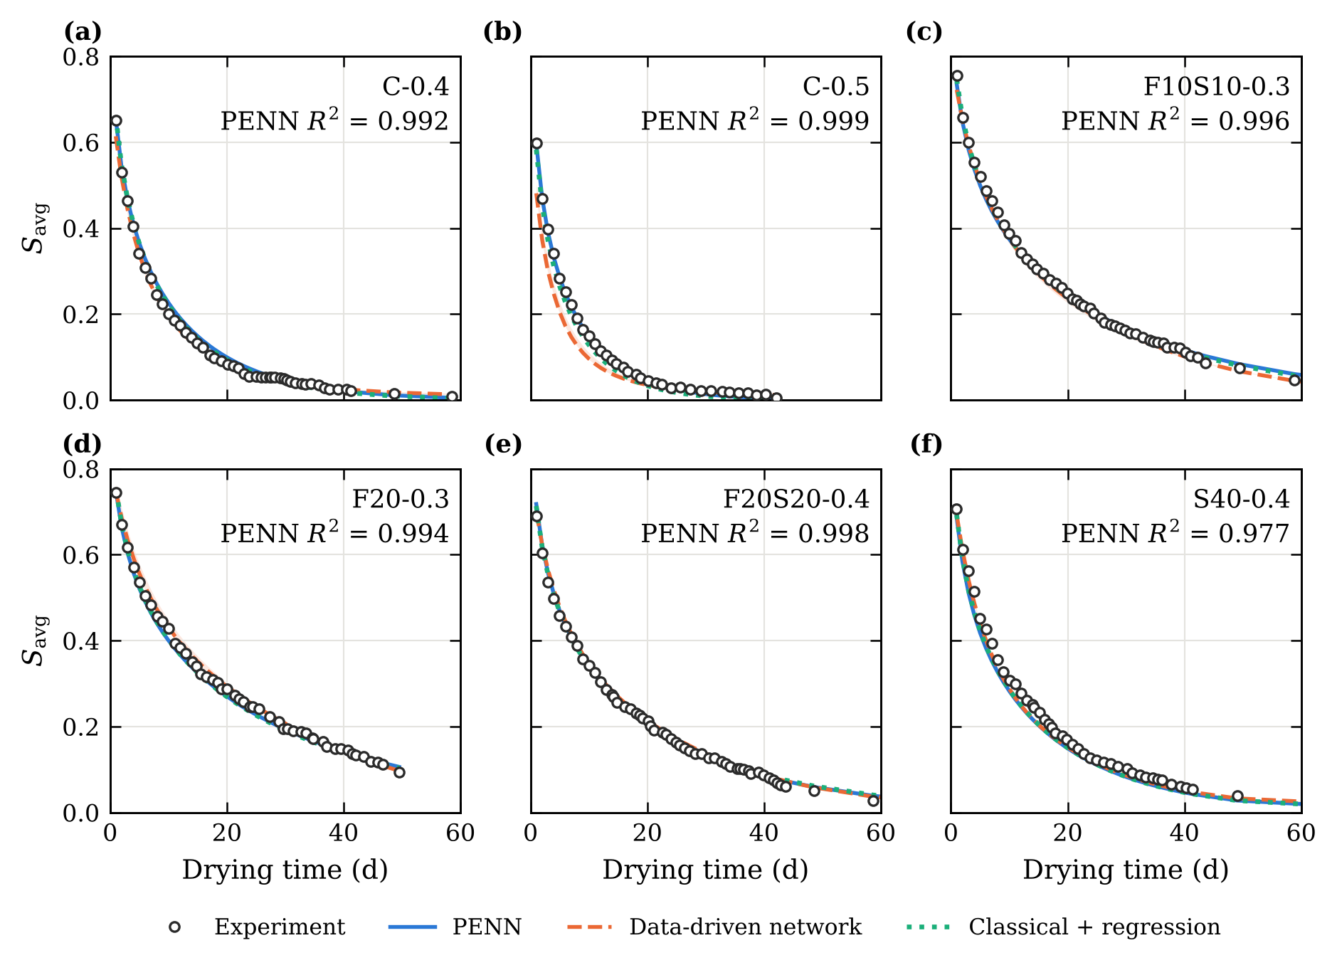
Fig. 5. Drying curves of the six withheld mixes: experiment and predictions. Bands show the range over random seeds; $R^{2}$ refers to the PENN.

5.4 Generalisation across mixes and binder families
Cross-validation over all 20 mixes gives the same ranking (Table 6, Fig. 6). In leave-one-mix-out validation, linear and ridge two-stage inversion and all PENN variants reach a pooled $R^{2}$ of 0.991–0.992, and the paired per-mix comparison detects no statistically significant difference between the PENN and linear two-stage inversion (mean RMSE difference +0.0006, 95% interval −0.0012 to +0.0020; Wilcoxon $p$ = 0.09). With the binder family as the unit the result is the same (family-level $p$ = 0.375), and the 90% family-level interval, −0.0009 to +0.0018, lies within the ±0.002 equivalence margin; the same holds for the revised PENN (−0.0008 to +0.0009). The Gaussian-process and quadratic regressions are significantly worse than the PENN ($p$ = 0.002 and 0.01). The original data-driven network is not significantly worse than the PENN in this scheme (−0.0025, $p$ = 0.52), whereas the inner-CV setting is (pooled RMSE 0.0326, $p$ < 0.001); the comparison with the data-driven approach in leave-one-mix-out validation therefore depends on its setting.
Withholding a whole binder family separates the models more clearly. Linear two-stage inversion, ridge regression and the PENN variants keep $R^{2}$ ≥ 0.962 for every mix, and again no statistically detectable difference is found between them (PENN against linear inversion: +0.0005, interval −0.0011 to +0.0018, $p$ = 0.22; family level $p$ = 0.469, 90% interval −0.0003 to +0.0012, within the equivalence margin). With seven families this is the outcome of a small number of independent units, and it applies to the binder families and composition range studied here. The flexible models fail for several mixes: the lowest per-mix $R^{2}$ is 0.381 for the Gaussian process, 0.198 for quadratic regression and 0.218 for the data-driven network, which has 7 mixes below $R^{2}$ = 0.95. The PENN is significantly more accurate than the data-driven network (mean per-mix RMSE difference −0.0172, interval −0.0283 to −0.0077, $p$ = 0.001; family level $p$ = 0.031). The inner-CV setting of the data-driven network avoids the worst failures (lowest per-mix $R^{2}$ 0.832) but is less accurate on average (pooled RMSE 0.0335, 7 mixes below 0.95; difference to the PENN −0.0167, family level $p$ = 0.016), so the conclusion holds for both settings. At the family level, the advantage of the PENN over the quadratic regression remains significant ($p$ = 0.016), while that over the Gaussian process, although its cluster-bootstrap interval (−0.0281 to −0.0040) excludes zero, is not significant by the Wilcoxon test with seven families ($p$ = 0.078). The quadratic and Gaussian-process regressions also use the transport model, so the failures are not caused by the absence of physics: they come from composition maps that are too flexible to extrapolate to a binder they have not seen. What generalises is the combination of the transport model with a low-capacity, nearly linear composition map, whether it is fitted in two stages or end to end.
Table 6. Cross-validation over the 20 mixes (one seed per fold). Lowest $R^{2}$ and number of mixes below 0.95 refer to per-mix values.
Method | LOMO $R^{2}$ | LOMO RMSE | LOMO lowest $R^{2}$ | LOFO $R^{2}$ | LOFO RMSE | LOFO lowest $R^{2}$ | LOFO mixes < 0.95
Two-stage, linear (OLS) | 0.9919 | 0.0147 | 0.974 | 0.9913 | 0.0152 | 0.965 | 0
Two-stage, ridge | 0.9918 | 0.0148 | 0.972 | 0.9916 | 0.0150 | 0.966 | 0
Two-stage, quadratic | 0.9870 | 0.0186 | 0.965 | 0.9012 | 0.0513 | 0.198 | 6
Two-stage, Gaussian process | 0.9814 | 0.0223 | 0.918 | 0.9484 | 0.0371 | 0.381 | 5
PENN | 0.9909 | 0.0156 | 0.975 | 0.9903 | 0.0160 | 0.968 | 0
PENN, revised (linear map, L-BFGS) | 0.9916 | 0.0150 | 0.974 | 0.9908 | 0.0156 | 0.962 | 0
PENN, linear composition map | 0.9912 | 0.0153 | 0.970 | 0.9899 | 0.0164 | 0.969 | 0
PENN, 1 × 8 units | 0.9911 | 0.0154 | 0.974 | 0.9905 | 0.0159 | 0.966 | 0
Data-driven network | 0.9868 | 0.0188 | 0.953 | 0.9355 | 0.0415 | 0.218 | 7
Data-driven network, inner-CV setting | 0.9602 | 0.0326 | 0.845 | 0.9580 | 0.0335 | 0.832 | 7
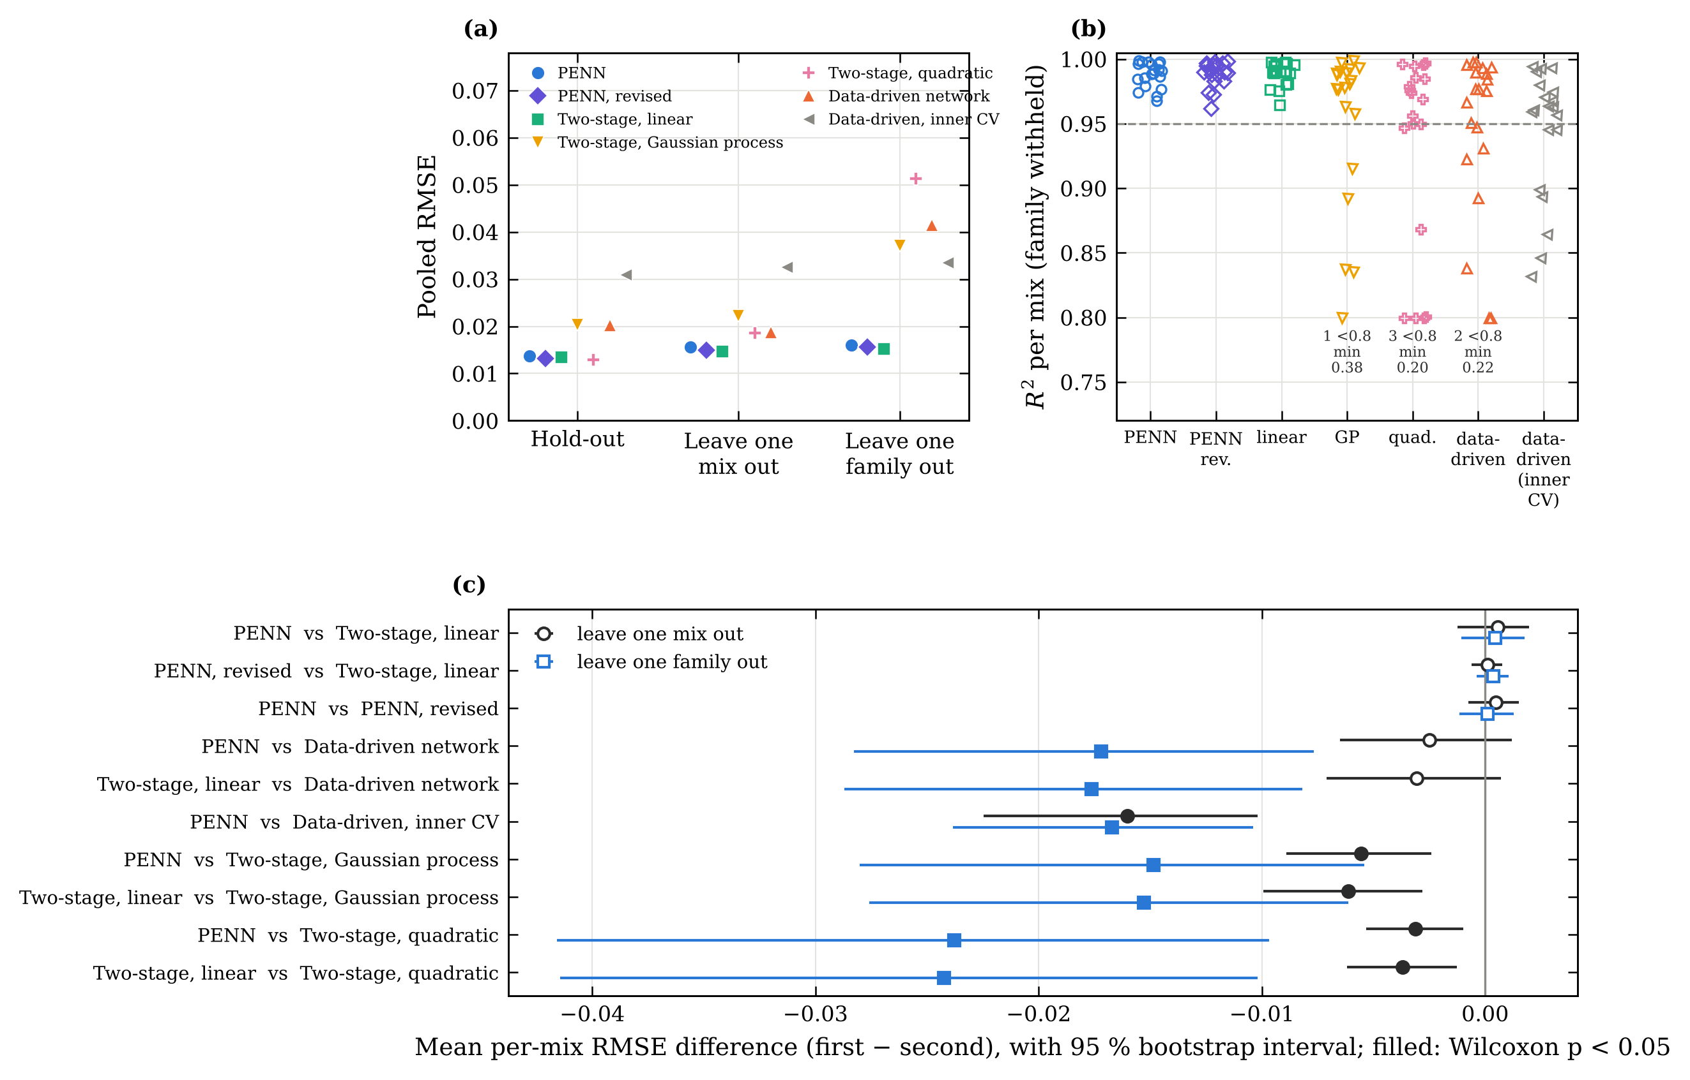
Fig. 6. Model comparison. (a) Pooled RMSE in the three validation schemes. (b) Per-mix $R^{2}$ when the whole binder family is withheld; values below 0.80 are drawn at the lower edge and counted. (c) Mean per-mix RMSE differences between pairs of methods with 95% bootstrap intervals over mixes; filled symbols: Wilcoxon $p$ < 0.05. “Inner CV” denotes the data-driven network with the setting selected by inner cross-validation (Section 4.3).

5.5 Robustness and data efficiency
Measurement and processing uncertainty. Perturbing the training data changes the accuracy on the withheld mixes very little for the physics-based models (Fig. 7a, Table 7). With correlated, digitisation-like errors the RMSE becomes 0.0142 for the PENN and 0.0147 for linear two-stage inversion, against 0.0271 for the data-driven network; independent noise and time-origin errors have smaller effects. The reconstruction of the curves is not a sensitive choice: moving the time offset to either end of its interquartile range, or estimating it from the training mixes only, changes the classical parameters by at most 0.002 decade for $D_{v}$ and 0.009 decade for $K_{\text{int}}$. Using only the short (≤ 14 d) or only the long series gives the same accuracy. The parameters, however, react differently. The per-mix classical estimates of $K_{\text{int}}$ move by up to 0.219 decade under correlated noise and 0.207 decade under time-origin errors (Fig. 7b), consistent with the profile intervals, whereas parameters predicted from composition move less, because they pool all training curves: by up to 0.133 decade for the revised PENN. The original PENN moves by only 0.009 decade, but this stability partly reflects the compression of $K_{\text{int}}$ discussed in Section 5.6.
Table 7. Robustness: RMSE on the unperturbed withheld curves after perturbing the training data, and largest shift of $\log_{10}K_{\text{int}}$ over the 20 mixes (classical: per-mix fits; PENN: predicted parameters). Noise variants: mean of five replicates.
Perturbation of the training data | RMSE linear | RMSE PENN | RMSE PENN rev. | RMSE data-driven | max Δlog K classical | max Δlog K PENN | max Δlog K PENN rev.
None (reference) | 0.0135 | 0.0137 | 0.0132 | 0.0202 | – | – | –
Independent noise, s.d. 0.01 | 0.0137 | 0.0139 | 0.0134 | 0.0205 | 0.070 | 0.014 | 0.032
Independent noise, s.d. 0.02 | 0.0139 | 0.0140 | 0.0136 | 0.0214 | 0.145 | 0.032 | 0.069
Correlated noise, s.d. 0.01 | 0.0147 | 0.0142 | 0.0142 | 0.0271 | 0.219 | 0.009 | 0.133
Time-origin error, s.d. 0.25 d | 0.0140 | 0.0140 | 0.0137 | 0.0203 | 0.207 | 0.033 | 0.060
Offset 0.97 d | 0.0133 | 0.0136 | 0.0131 | 0.0201 | 0.009 | 0.005 | 0.010
Offset 1.13 d | 0.0136 | 0.0138 | 0.0133 | 0.0203 | 0.009 | 0.005 | 0.010
Offset from training mixes | 0.0135 | 0.0138 | 0.0132 | 0.0202 | 0.001 | 0.001 | 0.002
Short series only | 0.0148 | 0.0135 | 0.0135 | 0.0245 | 0.197 | 0.090 | 0.223
Long series only | 0.0136 | 0.0138 | 0.0133 | 0.0194 | 0.170 | 0.007 | 0.062
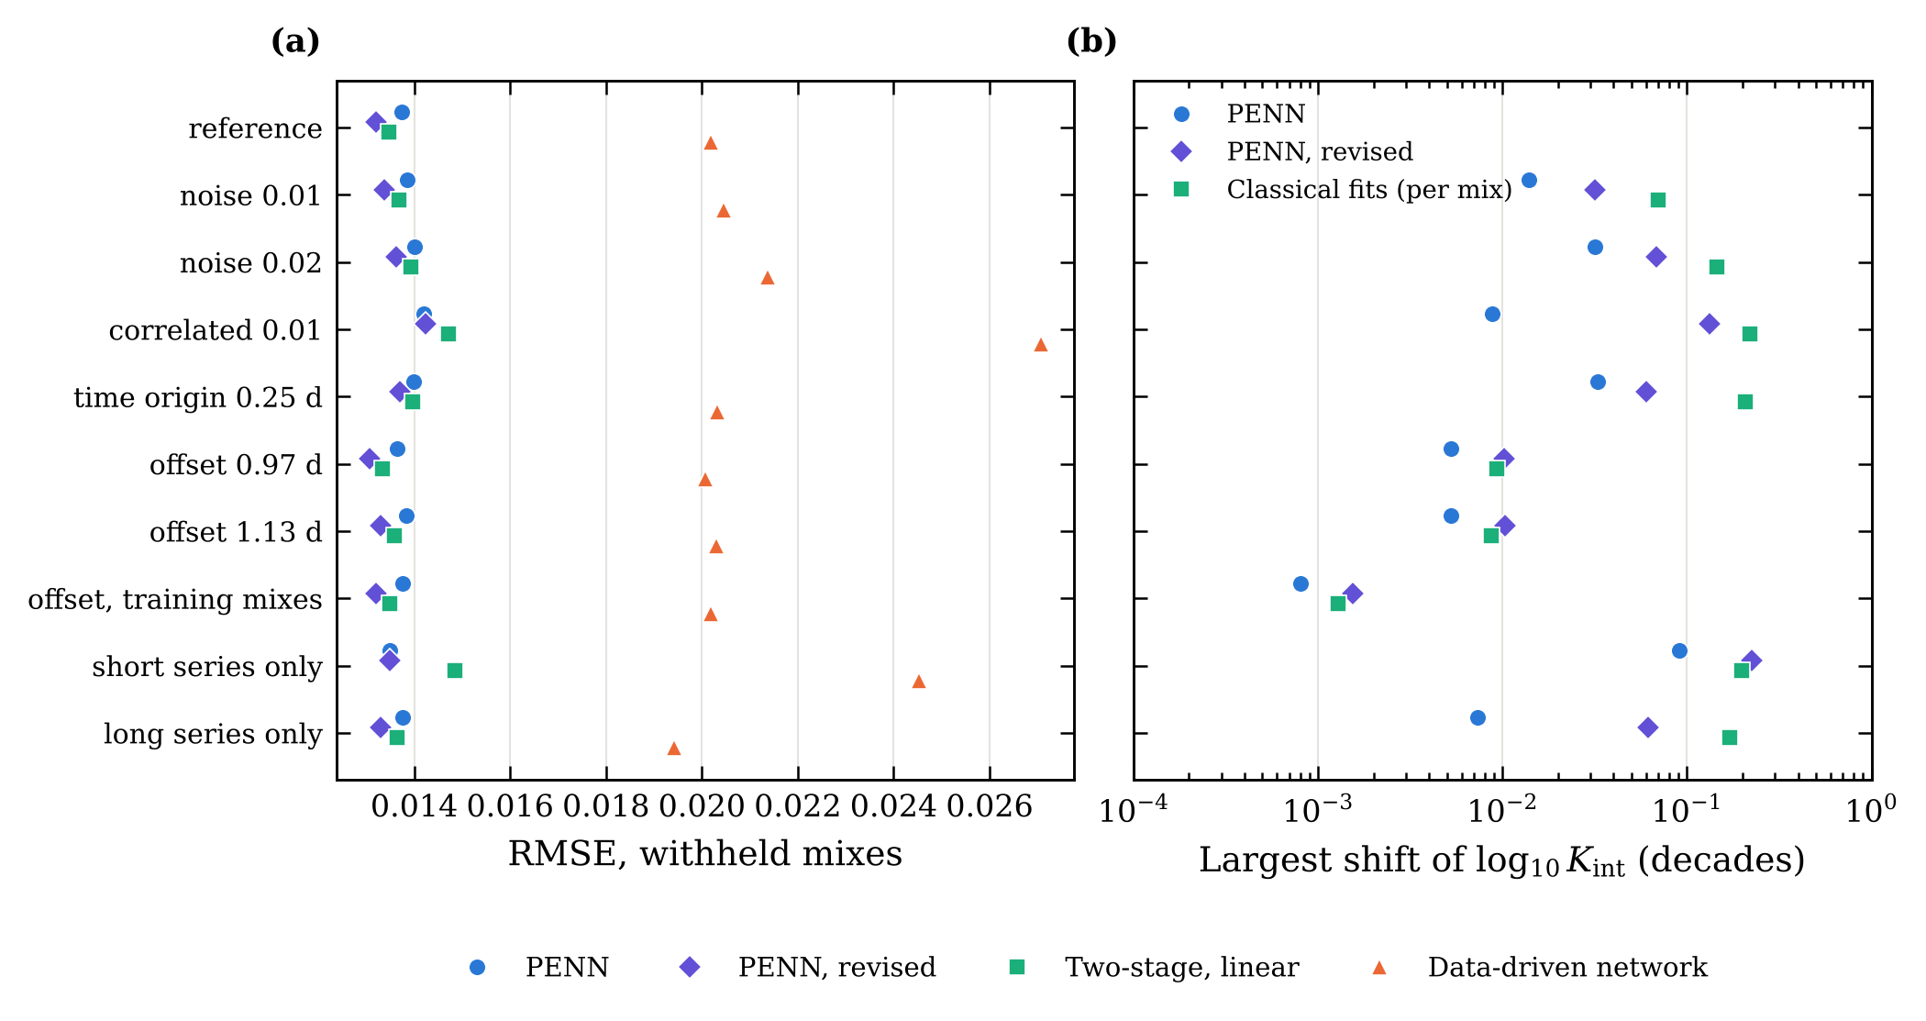
Fig. 7. Robustness. (a) RMSE on the withheld mixes after perturbing the training data. (b) Largest shift of the identified or predicted $\log_{10}K_{\text{int}}$ relative to the unperturbed reference.
Number of training mixes. With 8, 11 or 14 training mixes, linear two-stage inversion and the PENN variants perform similarly; with 14 mixes the median RMSE over ten random draws is 0.0142 for linear inversion, 0.0162 for the PENN and 0.0159 for the revised PENN (Fig. 8a,b). With only five mixes, the original PENN is more accurate and more stable (median RMSE 0.0220, worst-mix $R^{2}$ 0.92) than linear inversion (0.0256, 0.89) and ridge regression (0.0268), whose four regression coefficients are poorly constrained by five points; the revised PENN, an unregularised linear map, behaves like linear inversion (0.0275). The advantage therefore comes from the regularisation of the original network rather than from end-to-end training as such. The data-driven network and the Gaussian process are the least accurate at every training size.
Short drying curves. The clearest advantage of end-to-end training appears when the training curves are short (Fig. 8c). With curves cut after 7 days (84 points instead of 654), the PENN predicts the complete curves of the withheld mixes with RMSE 0.0138, against 0.0165 for two-stage inversion and 0.0314 for the data-driven network. With curves cut after 3 or 4 days, two-stage inversion can only use the 11 mixes that still have at least three points, and its error rises to 0.0258; the PENN, which uses every point of every training mix, stays at 0.0180. The revised PENN, whose linear map is not regularised, lies in between (RMSE 0.0222 at 4 days and 0.0143 at 7 days). Per-mix inversion of a short curve is poorly conditioned, whereas the PENN constrains the parameters of all mixes jointly through the composition map; with very little data, the regularisation of the original PENN is an advantage rather than a bias.
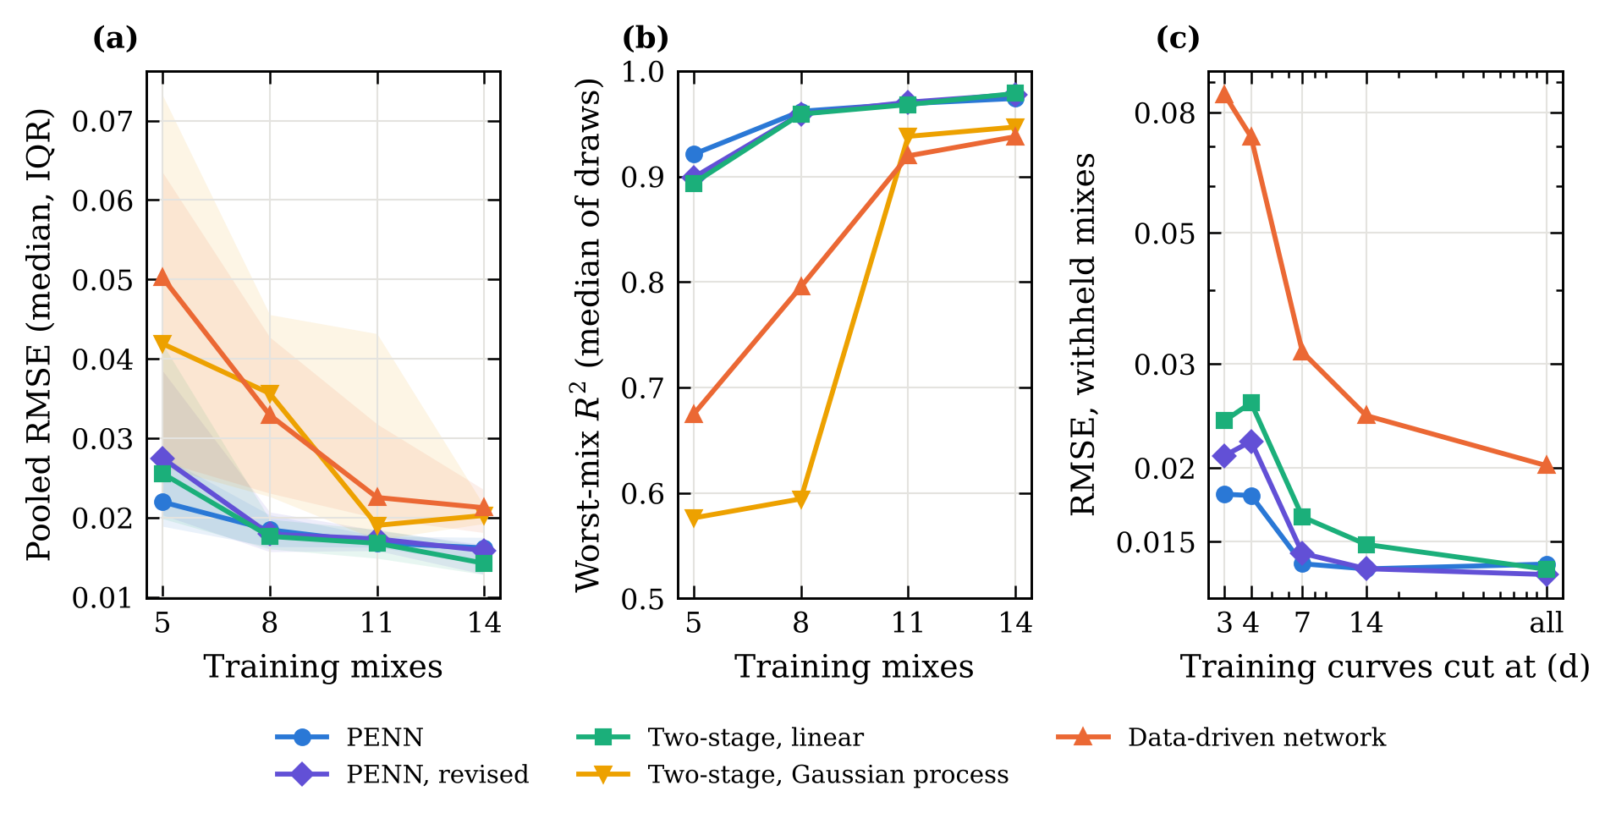
Fig. 8. Data efficiency. (a) Median pooled RMSE (band: interquartile range over ten random draws of the training mixes) and (b) median worst-mix $R^{2}$ against the number of training mixes. (c) RMSE on the complete withheld curves when the training curves are cut after a given drying time.

5.6 End-to-end learning and parameter recovery
Accuracy on withheld curves does not show whether the learned parameters are right. The composition maps were therefore also tested on synthetic curves generated, for the 20 mixes and at their measurement times, from known parameters that depend linearly on composition, with noise of 0.01 added. Linear two-stage inversion recovers the permeability of the withheld mixes with a mean error of 0.024 decade. The PENN in its original setting recovers $D_{v}$ well but compresses the variation of $K_{\text{int}}$ between mixes: the slope of estimated against true $\log_{10}K_{\text{int}}$ over the training mixes is only 0.17, and the error on the withheld mixes is 0.088 decade. Training longer with the same weight decay does not help (slope 0.16). Removing the weight decay restores the slope (0.86) on synthetic data, but on the experimental data the unregularised 2 × 16 network then over-fits the composition map: its hold-out RMSE rises to 0.0187 and its lowest per-mix $R^{2}$ in leave-one-family-out validation falls to 0.78. Weight decay is thus what lets the original PENN generalise, and also what biases its permeabilities.
A linear composition map cannot over-fit in this way. Trained with Adam and a decaying step, it remains under-converged in the weakly sensitive $K_{\text{int}}$ direction (slope 0.85); trained to convergence with L-BFGS and without weight decay, it recovers $K_{\text{int}}$ as well as two-stage inversion (slope 0.96, mean error 0.022 decade on the withheld mixes). When the synthetic truth also contains mix-to-mix scatter not explained by composition, the two have similar errors on the withheld mixes (0.130 and 0.139 decade). This revised PENN was selected on synthetic data only and then evaluated once on the experimental data. Its predictive accuracy is close to that of the original PENN and of linear two-stage inversion (hold-out RMSE 0.0132; lowest leave-one-family-out $R^{2}$ 0.962; Tables 4 and 6), and its permeabilities follow the classical estimates more closely (correlation 0.78, against 0.48 for the original PENN), falling inside the 95% profile interval of the classical estimate for 15 of the 20 mixes (original PENN: 10). A hidden regulariser or an under-converged optimiser can therefore bias a weakly identifiable parameter without any visible effect on the predicted curves; only the synthetic recovery test revealed it.

5.7 PENN versus PINN consistency
The PINN was compared with the PENN on the slab model with identical constants, data split and parameter network (Table 8). On the withheld mixes the PINN is less accurate (RMSE 0.0216 against 0.0133) and varies more between seeds, although it fits the training data far more closely (training RMSE 0.0033 against 0.0125). Without its PDE residual it degrades further (RMSE 0.0365), so the residual does carry information.
The solver check reveals the inconsistency (Fig. 9a,b). Run with the PENN parameters, the direct solver reproduces the PENN output with $R^{2}$ = 0.9998. Run with the PINN parameters it does not ($R^{2}$ = 0.860): the PINN reference diffusivities are close to the classical values (mean difference 0.06 decade), but its permeabilities are about 1.1 decade too low.
Four diagnostic runs narrow down the likely cause (Fig. 9c,d and Appendix D). Starting the PINN from the classical parameters does not prevent the drift (bias −1.08 decade), and a ten times larger PDE weight barely changes it (−1.03). Training on synthetic curves generated by the slab solver from the classical parameters, i.e. without model error or noise, gives the same bias (−1.13) although the PINN then fits the data to RMSE 0.0003. Finally, with the parameters fixed at their classical values, the PINN reaches the same total loss as with free parameters (0.135 against 0.135), with a lower data misfit but a larger PDE residual (RMS 0.107 against 0.048), and its parameters then pass the solver check ($R^{2}$ = 0.9988). The PINN loss therefore appears nearly flat along $K_{\text{int}}$. A plausible mechanism is that the field network satisfies the residual more easily with a too-low permeability, which slows the early capillary stage that the similarity ansatz represents least well, while the data term cannot tell the difference because that stage ends before the first measurement. Taken together, the runs indicate that the inconsistency arises from the soft-constrained formulation as implemented here rather than from the data, the initialisation or the loss weighting; other architectures and optimisers were not tested and may behave differently. The saturation profiles of the two models differ most during the first two days (Fig. D.2).
Table 8. Controlled comparison on the one-dimensional slab model (six withheld mixes). Solver check: $R^{2}$ between each model and the direct solver run with the parameters returned by that model.
Method | $R^{2}$ (withheld) | RMSE (withheld) | RMSE (training) | Solver check $R^{2}$
PENN (differentiable solver) | 0.9935 ± 0.0001 | 0.0133 ± 0.0001 | 0.0125 | 0.9998
Classical + regression | 0.9938 | 0.0131 | – | exact
PINN | 0.9826 ± 0.0071 | 0.0216 ± 0.0043 | 0.0033 | 0.860
PINN without PDE residual | 0.9411 ± 0.0640 | 0.0365 ± 0.0210 | 0.0031 | –
Data-driven network | 0.9852 ± 0.0012 | 0.0202 ± 0.0008 | 0.0059 | –
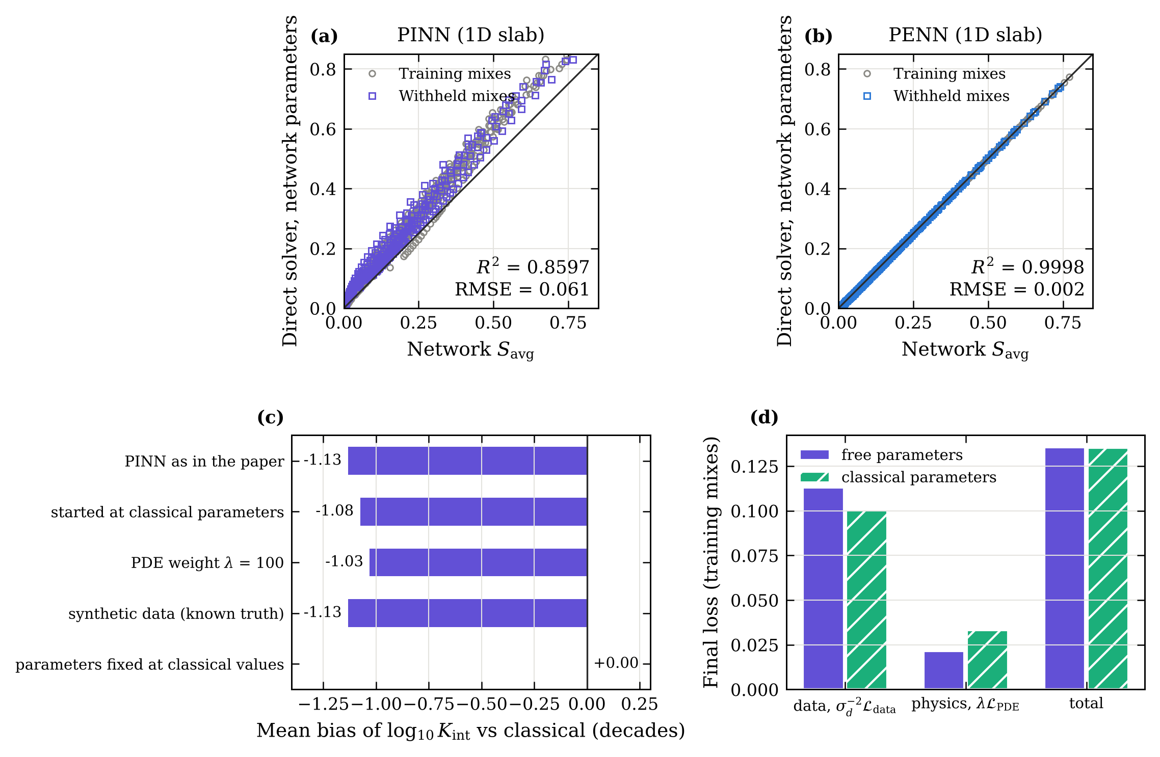
Fig. 9. PINN consistency on the slab model. (a, b) Average saturation computed by the direct solver with the parameters returned by the PINN and the PENN, against the output of each network. (c) Mean bias of the PINN permeability relative to the classical estimates in the diagnostic runs; a PINN with parameters fixed at the classical values has none. (d) Final loss terms with free and with classical parameters.

5.8 Transport parameters and their physical interpretation
Figure 10 compares the classical estimates, with their 95% profile intervals, with the parameters predicted from composition alone. The reference diffusivities agree closely (mean absolute difference 0.025 decade for the PENN, 0.023 for the revised PENN). Both parameters increase with w/b. For plain concrete, $D_{v}$ rises from 10^{−8.76} to 10^{−8.36} m²/s between w/b = 0.3 and 0.5, consistent with the coarser and better-connected capillary porosity of high-w/b pastes [1, 3]. At a given w/b all SCMs lower $D_{v}$. The effect is largest for 40% fly ash, whose reference diffusivity at w/b = 0.3 (10^{−9.15} m²/s) is 2.5 times lower than that of plain concrete, followed by the 20% + 20% ternary blend and 20% fly ash; slag reduces $D_{v}$ less, and 20% slag least. This ranking agrees with the pore refinement produced by the pozzolanic and latent hydraulic reactions [1]. It refers to 28 days of curing (Section 2.4); since these reactions continue after 28 days, and the source reports larger admixture effects at 56 days [8], the effect of the SCMs is likely to be underestimated for older concrete. The permeabilities increase with w/b as well, but their profile intervals often overlap between neighbouring mixes, so differences of less than about 0.3 decade between individual mixes should not be interpreted.
The diffusivity varies by about an order of magnitude with saturation (Fig. 11), between 4 × 10⁻¹¹ and 2 × 10⁻¹⁰ m²/s in the dry, vapour-dominated range and up to 7 × 10⁻¹⁰–2 × 10⁻⁹ m²/s near $S$ = 0.79, where capillary transport takes over. The position of this transition is set by $S_{\text{cap}}$ and is not identified from the data.
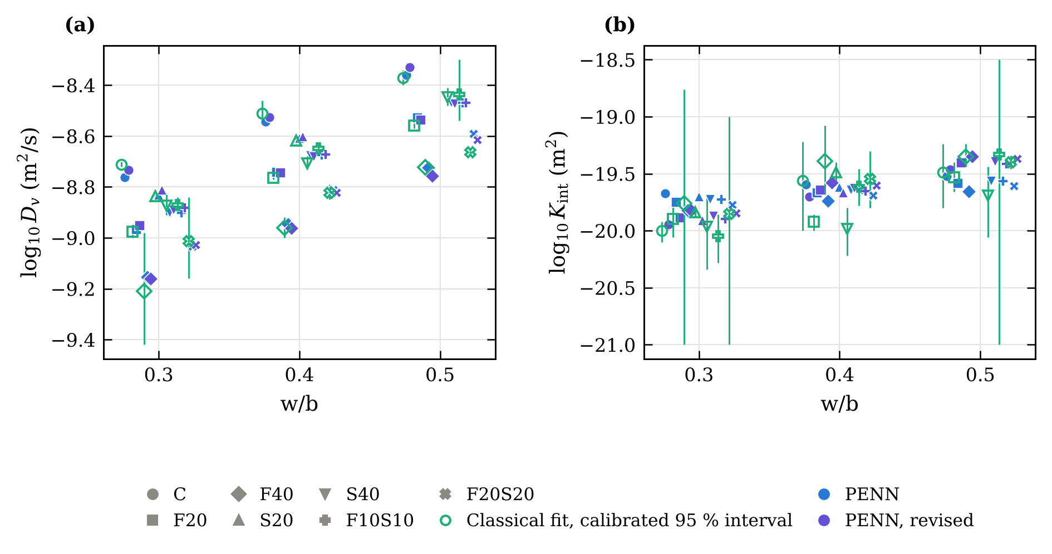
Fig. 10. Transport parameters against w/b: (a) reference diffusivity and (b) intrinsic permeability. Open symbols: classical estimates with 95% profile intervals (corrected for autocorrelation). Filled symbols: predictions from composition by the PENN and the revised PENN (hold-out models).
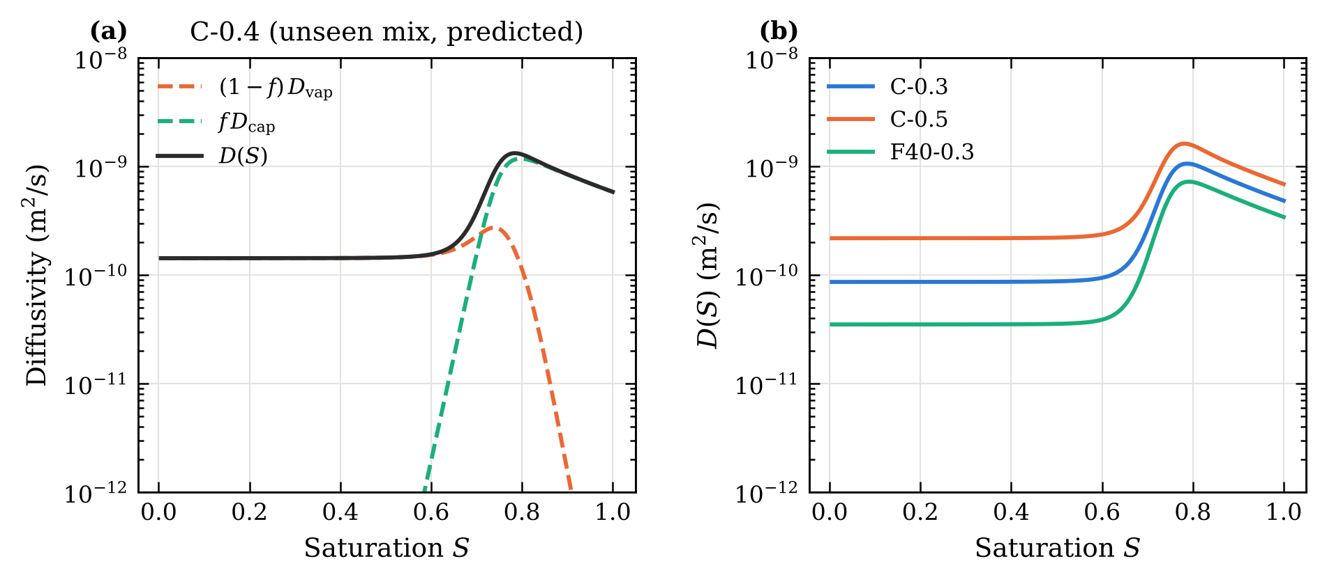
Fig. 11. Diffusivity predicted by the PENN: (a) vapour and capillary contributions for the withheld mix C-0.4; (b) effect of w/b and fly ash.

5.9 Sensitivity to the modelling assumptions
The identified parameters are conditional on the fixed constants of Table 2. Changing one constant at a time within plausible bounds and refitting eight representative mixes with the direct solver shows how strong this dependence is (Fig. 12, Table 9). The minimum-to-maximum ratio $α_{0}$ acts almost only on $D_{v}$, which shifts by +0.39 decade for $α_{0}$ = 0.02 and −0.30 decade for $α_{0}$ = 0.10, as expected from the perfect correlation of the two parameters (Section 5.2). The constants that shape the transition between the vapour and capillary regimes ($S_{c}$, $S_{\text{cap}}$, $k$, $β$ and $n$) act mainly on $K_{\text{int}}$, by up to 0.4 decade for an individual mix. None of these changes alters the fit quality by more than 6%, so the data cannot arbitrate between them. The shifts are, however, nearly uniform across mixes: the rank correlation of the parameters with the reference estimates is at least 0.88. Comparisons between mixes, and the composition trends of Section 5.8, are therefore robust, whereas absolute values carry an uncertainty of a few tenths of a decade from the constitutive assumptions alone, in addition to the statistical uncertainty of Section 5.2.
Two boundary assumptions were also tested. A finite surface exchange (surface time constant 0.1 d) changes $K_{\text{int}}$ by at most 0.08 decade, and an initial saturation of 0.97 instead of 1 by at most 0.22 decade. A sealed lateral surface, which reduces the problem to one-dimensional drying through the two flat faces, fits the data clearly worse (RMSE 2.18 times larger), shifts $K_{\text{int}}$ by up to 1.16 decade and drives two fits to the bound of the admissible range. This supports the assumption that the discs dried on all faces.
Table 9. Sensitivity of the classical estimates to the modelling assumptions (eight mixes): mean shift of the parameters, ratio of the fit RMSE to the reference, and Spearman rank correlation with the reference estimates.
Change (reference value) | mean Δlog $D_{v}$ | mean Δlog $K_{\text{int}}$ | max |Δlog $K_{\text{int}}$| | RMSE ratio | rank corr. $D_{v}$ | rank corr. $K_{\text{int}}$
Finer mesh (36 × 24) | −0.001 | +0.007 | 0.007 | 1.00 | 1.00 | 1.00
Lateral surface sealed (1D, L = 25 mm) | +0.296 | +0.938 | 1.161 | 2.18 | 1.00 | 0.83
$α_{0}$ = 0.02 (0.05) | +0.393 | −0.121 | 0.193 | 1.01 | 1.00 | 0.98
$α_{0}$ = 0.10 (0.05) | −0.299 | +0.034 | 0.051 | 1.00 | 1.00 | 1.00
$n$ = 4 (8) | −0.050 | −0.248 | 0.377 | 1.06 | 1.00 | 0.88
$n$ = 16 (8) | +0.003 | +0.047 | 0.067 | 1.00 | 1.00 | 1.00
$S_{c}$ = 0.75 (0.80) | −0.011 | −0.246 | 0.411 | 1.02 | 1.00 | 0.93
$S_{\text{cap}}$ = 0.70 (0.75) | −0.008 | −0.172 | 0.246 | 1.03 | 1.00 | 1.00
$S_{\text{cap}}$ = 0.80 (0.75) | +0.005 | +0.114 | 0.284 | 0.99 | 1.00 | 0.93
$k$ = 25 (50) | −0.012 | −0.125 | 0.149 | 1.03 | 1.00 | 1.00
$β$ = 2.0 (2.5) | +0.000 | +0.142 | 0.145 | 1.00 | 1.00 | 1.00
$β$ = 3.0 (2.5) | −0.000 | −0.125 | 0.128 | 1.00 | 1.00 | 1.00
$S_{\text{init}}$ = 0.97 (1) | +0.005 | −0.141 | 0.220 | 1.00 | 1.00 | 1.00
Surface exchange, $τ_{b}$ = 0.1 d (10⁻⁴ d) | −0.002 | +0.048 | 0.084 | 1.02 | 1.00 | 1.00
$P_{c0}$ or $η_{l}$ × c | 0 | −log₁₀ c (exact) | – | 1.00 | 1.00 | 1.00
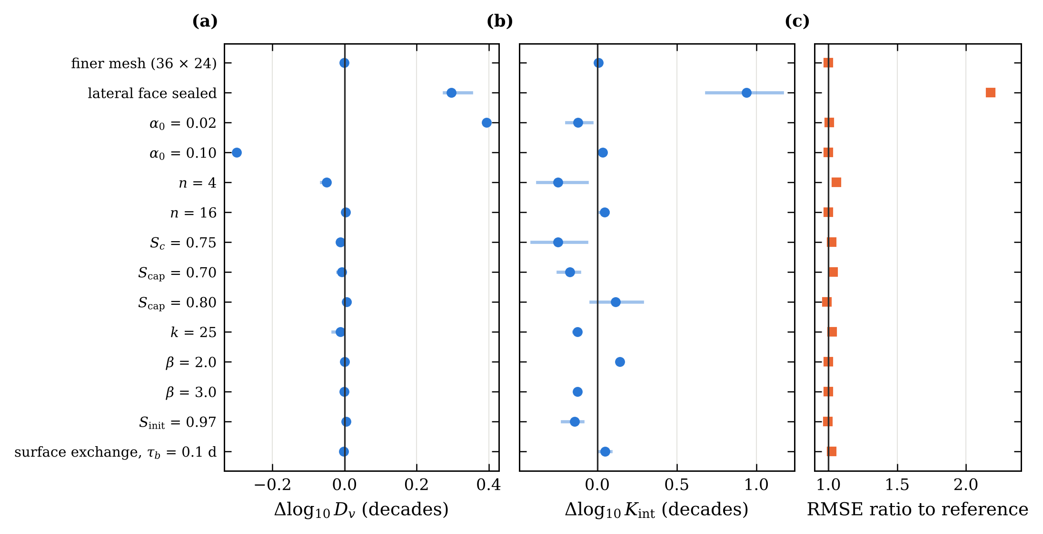
Fig. 12. Sensitivity of the identified parameters to the modelling assumptions: mean (dot) and range (bar) over eight mixes of the shift of (a) $\log_{10}D_{v}$ and (b) $\log_{10}K_{\text{int}}$, and (c) ratio of the fit RMSE to the reference model.

5.10 Internal saturation fields
Because the PENN runs the transport model, every prediction comes with the saturation field inside the specimen (Fig. 13). After one day a dry layer a few millimetres thick has formed along the exposed faces, while the centre is still almost saturated ($S$ = 0.97 for C-0.4). The centre falls below $S$ = 0.5 after about 14 days for C-0.4, 18 days for S40-0.4 and 35 days for F20-0.3. Such fields are what durability models need as initial conditions for chloride ingress or carbonation analyses. They are model predictions, conditional on the assumptions of Section 3, and have not been compared with measured profiles.
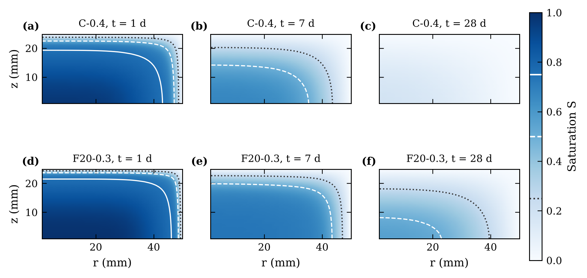
Fig. 13. Saturation in one quarter of the disc (drying faces at the top and right) predicted by the PENN for the withheld mixes C-0.4 and F20-0.3 after 1, 7 and 28 days. Contours: $S$ = 0.75 (solid), 0.50 (dashed) and 0.25 (dotted).

6 Discussion

6.1 What the physics-embedded network adds, and what it does not
The results do not support the claim that a physics-embedded network predicts drying more accurately than classical identification. On complete curves, with 8 or more training mixes, no statistically detectable difference was found between the PENN and two-stage inversion with a linear composition map, either with mixes or with binder families as the unit, and the simpler method is slightly ahead on average. The family-level intervals of their difference lie within ±0.002 RMSE, a margin set in this revision, so within the conditions evaluated (one laboratory, seven binder families, w/b 0.3–0.5) any difference is small in practical terms; it remains possible that differences would appear for other binders, test conditions or larger databases. What makes both of them generalise is the same: a verified transport model, which turns composition into a full drying curve through two physically meaningful parameters, and a composition map simple enough to extrapolate. Flexible maps fail when a binder family is withheld whether or not the transport model is used, as the Gaussian-process and quadratic regressions show.
End-to-end training is useful in a narrower but practically relevant situation: when the individual curves do not constrain their parameters well. With curves of a few days, the PENN pools the information of all curves through the composition map and remains accurate where per-mix inversion becomes unstable; with very few training mixes, the regularised original PENN is the most stable model, an effect of its regularisation rather than of end-to-end training itself. It is also convenient: a new mix requires one network evaluation, curves of different length are used as they are, and further descriptors can be added without changing the solver. The price is a tabulated or differentiable solver and, as Section 5.6 showed, the need to check that the training settings do not bias the parameters. We would recommend synthetic recovery tests as a routine part of any such model.

6.2 Accuracy is not identification
Three observations in this study separate fitting curves from identifying parameters. First, the classical fits reach $R^{2}$ > 0.99 for every mix, yet the calibrated profile intervals show that $K_{\text{int}}$ is uncertain by a few tenths of a decade, and only bounded on one side for three mixes, once the autocorrelation of digitised residuals is acknowledged. Second, the original PENN and the revised PENN predict the withheld curves with similar accuracy but differ in how faithfully they reproduce the variation of $K_{\text{int}}$ between mixes. Third, the PINN fits the training curves best of all methods and returns the least consistent permeabilities. In each case the predicted average saturation hides an error in a parameter that matters for other uses of the model: $K_{\text{int}}$ governs the capillary regime, which dominates wetting and therefore chloride ingress under cyclic exposure. Parameters intended for durability modelling should be reported with profile intervals and checked by running the identified model in an independent solver.
The PINN result should not be generalised to all PINNs. It holds for this formulation, with hard-constrained boundary and initial conditions and a similarity ansatz, on a stiff nonlinear diffusion problem observed through spatial averages. Our diagnostics indicate that initialisation and loss weighting are not the cause, and the result is consistent with the loss-landscape difficulties reported for PINNs [25, 28], but they do not exclude that a different architecture or optimiser would behave better. Other architectures or training strategies may do better, but any PINN used for parameter identification should be checked against an independent solver.

6.3 Limitations
The study rests on one published dataset. The curves were digitised from figures; their curing age is inferred (28 days, Section 2.4) rather than recorded, the sealing condition of the lateral surface during drying is not reported, and eight mixes (w/b = 0.6 and S20-0.5) could not be used. The digitisation errors are autocorrelated and affect $K_{\text{int}}$ in particular. The transport model is isothermal, at the 50 °C of the oven, and uses fixed constitutive constants; transferring the parameters to service temperatures requires a temperature-dependent model. The identified parameters are effective values conditional on these constants and should not be read as intrinsic properties without independent measurements, such as sorption isotherms, permeability tests or measured moisture profiles. No such measurements were available, so the identified parameters have been checked for consistency with the model, not validated experimentally. The absorption tests of the same programme [8] could provide such a validation if the raw data become available. Finally, the internal saturation fields are model predictions.

6.4 Engineering implications
For mix design and durability assessment, the study suggests a simple workflow. A drying test of moderate length gives a precise reference diffusivity and an order-of-magnitude permeability for each tested mix. Across a family of mixes, a transport model with a linear composition map, fitted in two stages or end to end, predicts the drying of untested compositions within the binder systems represented, and extrapolates to a new binder system with an accuracy close to that of a direct fit. Flexible machine-learning models trained on the same small database should not be used for such extrapolation. Where only short tests are available, joint end-to-end training is preferable to per-mix inversion. In all cases, the identified parameters inherit the uncertainty of the fixed constitutive constants, which should be stated when they are transferred to service-life models.

7 Conclusions
A vapour–capillary moisture transport model of the actual disc specimens was combined with several ways of learning its parameters from mix composition, using a reconstructed public database of 20 plain, binary and ternary concretes. The main conclusions are:
- Average-saturation curves identify two parameters per mix. The reference diffusivity is determined to within 0.05 decade; the intrinsic permeability to within 0.42 decade (median widths of approximate 95% intervals calibrated for autocorrelated residuals), and only on one side for three mixes. Both depend on fixed constitutive constants, which shift them by up to 0.4 decade but preserve the ranking of the mixes.
- A physics-embedded neural network predicts six withheld mixes with $R^{2}$ = 0.9931 (RMSE 0.0137). Classical inversion followed by linear regression on composition gives similar accuracy (RMSE 0.0135); no statistically detectable difference between the two was found in leave-one-mix-out or leave-one-binder-family-out validation, and their family-level 90% intervals lie within a practical margin of ±0.002 RMSE under the conditions evaluated.
- Generalisation to a new binder family requires the transport model and a low-capacity composition map. Gaussian-process, quadratic and data-driven models (the latter with either setting) are less accurate and fail for several mixes (lowest $R^{2}$ 0.20), whereas linear two-stage inversion and the PENN keep $R^{2}$ ≥ 0.962 for every mix.
- End-to-end training is more robust than per-mix inversion when the training curves are short (RMSE 0.0138 against 0.0165 with 7-day curves), and a regularised PENN is the most stable model when only a few mixes are available. Weight decay in the network compresses the permeability towards its mean; synthetic recovery tests revealed this, and a linear composition map trained to convergence without weight decay removes the bias without loss of predictive accuracy.
- A PINN trained on the same data fits the curves but returns permeabilities about 1.1 decade too low, which fail an independent solver check. The bias persists with exact synthetic data, a warm start and a larger PDE weight, and disappears only when the parameters are fixed. These diagnostics strongly suggest that it arises from the soft-constrained formulation used here rather than from the data or the settings tested; other PINN designs were not examined.
Future work should validate the identified parameters against independent measurements, in particular absorption tests and measured moisture profiles, extend the database beyond one laboratory, and propagate the parameter uncertainty to chloride-ingress predictions [11, 38].

Declarations
CRediT authorship contribution statement. Abderrahmane Sghuri: Conceptualization, Methodology, Software, Formal analysis, Visualization, Writing – original draft. Xuande Chen: Conceptualization, Supervision, Validation, Writing – review & editing, Funding acquisition. Xiaodong Wang: […].
Data and code availability. The experimental data are those of Zhuang et al. [8]. The digitised and reconstructed data and the code that produces every result, table and figure of this paper are available at https://github.com/Abderahmane2002/hybrid-pinn-lstm-concrete [archive the release on Zenodo and cite its DOI].
Declaration of competing interest. The authors declare that they have no known competing financial interests or personal relationships that could have appeared to influence the work reported in this paper.
Funding. [Funding agency and grant number]
Declaration of generative AI use. [Elsevier requires authors to disclose the use of generative AI tools in preparing the manuscript or code; state the tool and its purpose here.]

Appendix A. Numerical verification
Table A.1. Verification of the solvers: maximum error in $S_{\text{avg}}$ between 0.25 and 90 days for three representative parameter sets, against a fine reference solution (640 cells for the slab solver, a 160-cell BDF solution for the differentiable solver, 96 × 64 cells for the disc).
Check | Setting | Max. error in $S_{\text{avg}}$
1D finite-volume solver (BDF) | 20 cells | 1.4 × 10⁻³
1D finite-volume solver (BDF) | 40 cells | 3.4 × 10⁻⁴
1D finite-volume solver (BDF) | 60 cells | 1.5 × 10⁻⁴
1D finite-volume solver (BDF) | 80 cells | 8.5 × 10⁻⁵
1D finite-volume solver (BDF) | 160 cells | 2.1 × 10⁻⁵
1D differentiable solver | 60 time steps | 1.2 × 10⁻²
1D differentiable solver | 120 time steps | 5.9 × 10⁻³
1D differentiable solver | 240 time steps | 3.0 × 10⁻³
1D differentiable solver | 480 time steps | 1.6 × 10⁻³
1D differentiable solver | 960 time steps | 8.1 × 10⁻⁴
Disc model (BDF) | 12 × 8 cells | 3.8 × 10⁻²
Disc model (BDF) | 24 × 16 cells | 3.7 × 10⁻³
Disc model (BDF) | 48 × 32 cells | 7.8 × 10⁻⁴
Global mass balance, 1D | 28 days | 1.2 × 10⁻¹⁵ (relative)

Appendix B. Reproducibility of the original results
Before any change was made, the complete original pipeline was re-run from a clean copy of the code, starting from the raw digitised file: curve reconstruction, classical fits, tabulation of the disc solutions, all network trainings, cross-validation and verification. Table B.1 compares the regenerated results with those of the original analysis. 46 of 46 compared quantities agree within the stated tolerances.
Table B.1. Independent re-run of the original pipeline. Tolerances allow for the random starting points of the multi-start optimisation; all network results, including the PINN, were reproduced exactly. The reconstructed data file holds 1,001 points, including the 69 flagged points of the w/b = 0.6 mixes; every result in this paper, in the original analysis and in the revision, was computed from the same file restricted to the 932 points with w/b ≤ 0.5.
Quantity | Original | Re-run | Status
Reconstructed data file: all points (incl. flagged w/b = 0.6) | 1001 | 1001 | reproduced
Reconstructed data file: flagged w/b = 0.6 points (excluded) | 69 | 69 | reproduced
Points used in the analyses (w/b <= 0.5) | 932 | 932 | reproduced
Reconstructed data: largest difference in S | 0 | 0 | reproduced
Reconstructed data: largest difference in t (d) | 0 | 0 | reproduced
Disc: classical $\log_{10}D_{v}$, largest difference | 0 | 0.0001568 | reproduced
Disc: classical $\log_{10}K_{\text{int}}$, largest difference | 0 | 0.001002 | reproduced
Disc: classical fits, median R² | 0.9986 | 0.9986 | reproduced
Slab: classical $\log_{10}D_{v}$, largest difference | 0 | 0 | reproduced
Slab: classical $\log_{10}K_{\text{int}}$, largest difference | 0 | 0 | reproduced
Slab: classical fits, median R² | 0.9988 | 0.9988 | reproduced
Disc: PENN hold-out R² | 0.9931 | 0.9931 | reproduced
Disc: PENN hold-out RMSE | 0.01374 | 0.01374 | reproduced
Disc: data-driven hold-out R² | 0.9852 | 0.9852 | reproduced
Disc: data-driven hold-out RMSE | 0.02018 | 0.02018 | reproduced
Disc: two-stage hold-out R² | 0.9934 | 0.9934 | reproduced
Disc: two-stage hold-out RMSE | 0.01347 | 0.01347 | reproduced
Disc: direct fit hold-out R² | 0.9986 | 0.9986 | reproduced
Disc: direct fit hold-out RMSE | 0.0063 | 0.0063 | reproduced
Disc: solver check PENN R² | 1 | 1 | reproduced
Slab: PENN hold-out R² | 0.9935 | 0.9935 | reproduced
Slab: PENN hold-out RMSE | 0.01333 | 0.01333 | reproduced
Slab: data-driven hold-out R² | 0.9852 | 0.9852 | reproduced
Slab: data-driven hold-out RMSE | 0.02018 | 0.02018 | reproduced
Slab: two-stage hold-out R² | 0.9938 | 0.9938 | reproduced
Slab: two-stage hold-out RMSE | 0.01311 | 0.01311 | reproduced
Slab: PINN hold-out R² | 0.9826 | 0.9826 | reproduced
Slab: PINN hold-out RMSE | 0.02159 | 0.02159 | reproduced
Slab: PINN without PDE hold-out R² | 0.9411 | 0.9411 | reproduced
Slab: PINN without PDE hold-out RMSE | 0.03646 | 0.03646 | reproduced
Slab: solver check PENN R² | 0.9998 | 0.9998 | reproduced
Slab: solver check PINN R² | 0.8597 | 0.8597 | reproduced
CV LOFO two-stage pooled R² | 0.9913 | 0.9913 | reproduced
CV LOFO two-stage worst-mix R² | 0.9647 | 0.9647 | reproduced
CV LOFO data-driven pooled R² | 0.9355 | 0.9355 | reproduced
CV LOFO data-driven worst-mix R² | 0.2177 | 0.2177 | reproduced
CV LOFO PENN pooled R² | 0.9903 | 0.9903 | reproduced
CV LOFO PENN worst-mix R² | 0.9677 | 0.9677 | reproduced
CV LOMO two-stage pooled R² | 0.9919 | 0.9919 | reproduced
CV LOMO two-stage worst-mix R² | 0.9736 | 0.9736 | reproduced
CV LOMO data-driven pooled R² | 0.9868 | 0.9868 | reproduced
CV LOMO data-driven worst-mix R² | 0.9533 | 0.9533 | reproduced
CV LOMO PENN pooled R² | 0.9909 | 0.9909 | reproduced
CV LOMO PENN worst-mix R² | 0.9746 | 0.9746 | reproduced
Numerical verification (Table A.1): largest relative difference | 0 | 0.01562 | reproduced
Slab-disc geometry check: largest relative difference | 0 | 0.0005191 | reproduced

Appendix C. Hyper-parameter check
The settings of the PENN and of the data-driven network were compared with alternatives in an inner leave-one-family-out cross-validation on the 14 training mixes only (Table C.1). For the PENN, the original setting ranks 5 of 9 configurations, with an inner RMSE (0.0178) within 0.001 of the best (0.0173); the configuration selected by the inner validation gives RMSE 0.0138 on the withheld mixes, the same as the original setting. For the data-driven network the inner validation prefers a ten times stronger weight decay (inner RMSE 0.0346 against 0.0826 for the original setting, which ranks last of four). The original setting is nevertheless kept as the primary baseline because it was fixed before this analysis, as was the PENN setting; this choice was made on that ground and not on test accuracy. The inner-CV setting is evaluated in every scheme and reported alongside (Tables 4 and 6, Fig. 6): hold-out RMSE 0.0309 (original 0.0202), leave-one-mix-out 0.0326 (0.0188), leave-one-family-out 0.0335 (0.0415), with lowest per-mix $R^{2}$ 0.832 against 0.218 in the last scheme. The PENN is significantly more accurate than either setting when a binder family is withheld, and in leave-one-mix-out validation it is significantly more accurate than the inner-CV setting but not than the original one. The inner-CV setting is thus more robust to extrapolation and less accurate on average; neither setting changes the conclusions drawn in Section 5.4.
Table C.1. Inner cross-validation (leave one family out within the training mixes): RMSE of every configuration tested.
Model | Configuration | Inner RMSE
PENN | 2 × 8 tanh, 200 iterations | 0.0180
PENN | 2 × 8 tanh, 400 iterations | 0.0179
PENN | 2 × 8 tanh, 800 iterations | 0.0179
PENN | 2 × 16 tanh, 200 iterations | 0.0179
PENN | 2 × 16 tanh, 400 iterations (original setting) | 0.0178
PENN | 2 × 16 tanh, 800 iterations | 0.0178
PENN | 2 × 32 tanh, 200 iterations | 0.0173
PENN | 2 × 32 tanh, 400 iterations | 0.0174
PENN | 2 × 32 tanh, 800 iterations | 0.0174
Data-driven network | 2 × 16 tanh, weight decay 10⁻⁵ | 0.0623
Data-driven network | 2 × 16 tanh, weight decay 10⁻³ | 0.0351
Data-driven network | 4 × 48 tanh, weight decay 10⁻⁵ (original setting) | 0.0826
Data-driven network | 4 × 48 tanh, weight decay 10⁻³ | 0.0346

Appendix D. PINN diagnostics and training histories
Table D.1. PINN diagnostic runs (slab model, training mixes, seed 0): final loss terms, training RMSE, PDE residual, solver check and permeability bias relative to the classical slab estimates.
Run | Total loss | Data term | PDE term | Training RMSE | PDE residual RMS | Solver check $R^{2}$ | Bias of log $K_{\text{int}}$
As in the comparison | 0.135 | 0.113 | 0.0021 | 0.0034 | 0.048 | 0.864 | −1.13
Parameters started at classical values | 0.137 | 0.113 | 0.0024 | 0.0034 | 0.049 | 0.893 | −1.08
PDE weight λ = 100 | 0.186 | 0.107 | 0.0007 | 0.0033 | 0.034 | 0.898 | −1.03
Synthetic training data (known parameters) | 0.020 | 0.001 | 0.0019 | 0.0003 | 0.046 | 0.828 | −1.13
Parameters fixed at classical values | 0.135 | 0.101 | 0.0033 | 0.0032 | 0.107 | 0.999 | +0.00
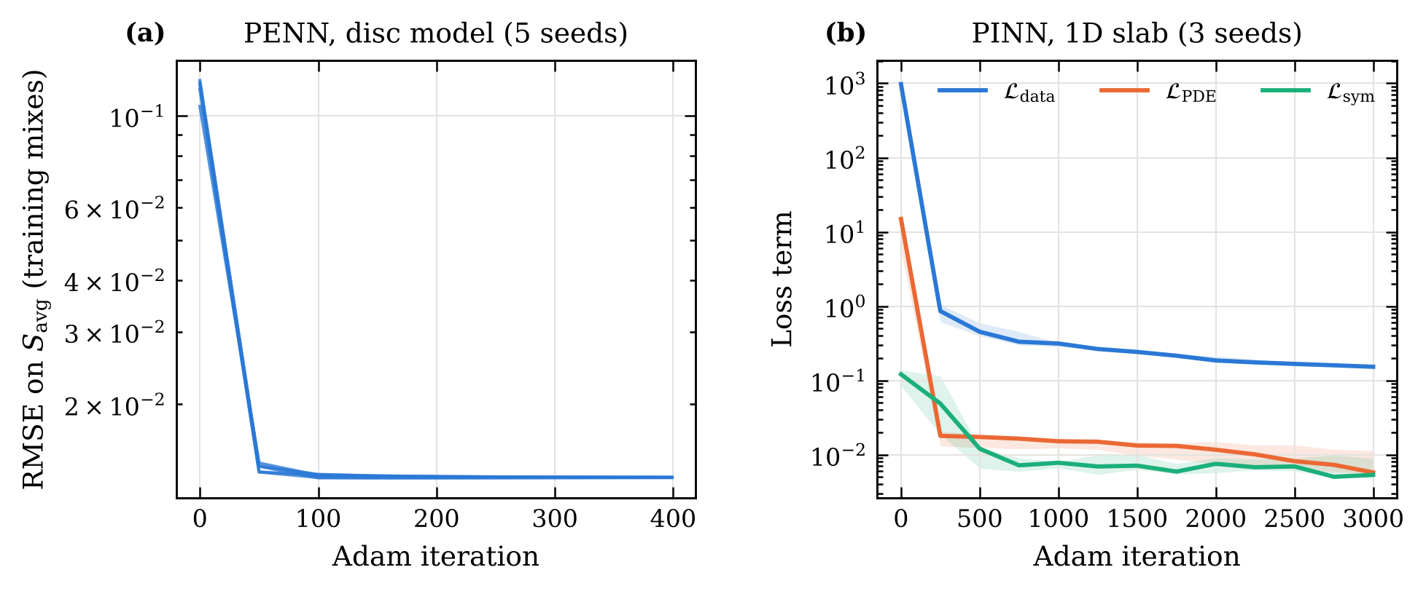
Fig. D.1. Training histories: (a) RMSE of the PENN on the training mixes (five seeds); (b) loss terms of the PINN (median and range over three seeds).
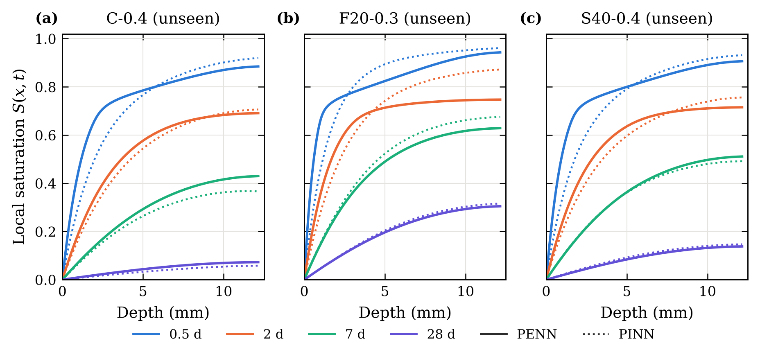
Fig. D.2. Saturation profiles of three withheld mixes on the slab model, computed by the direct solver with the PENN parameters (solid) and by the PINN (dotted). The two differ most during the first two days.

References
[1] P.K. Mehta, P.J.M. Monteiro, Concrete: Microstructure, Properties, and Materials, 4th ed., McGraw-Hill Education, New York, 2014.
[2] A.M. Neville, Properties of Concrete, 5th ed., Pearson Education, Harlow, 2011.
[3] V. Baroghel-Bouny, Water vapour sorption experiments on hardened cementitious materials. Part I: Essential tool for analysis of hygral behaviour and its relation to pore structure, Cem. Concr. Res. 37 (2007) 414–437. https://doi.org/10.1016/j.cemconres.2006.11.019
[4] V. Baroghel-Bouny, M. Mainguy, T. Lassabatère, O. Coussy, Characterization and identification of equilibrium and transfer moisture properties for ordinary and high-performance cementitious materials, Cem. Concr. Res. 29 (1999) 1225–1238.
[5] M. Mainguy, O. Coussy, V. Baroghel-Bouny, Role of air pressure in drying of weakly permeable materials, J. Eng. Mech. 127 (2001) 582–592.
[6] X. Chen, T. Sanchez, D. Conciatori, H. Chaouki, L. Sorelli, B. Selma, M. Chekired, Numerical modeling of 2D hygrothermal transport in unsaturated concrete with capillary suction, J. Build. Eng. 45 (2022) 103640. https://doi.org/10.1016/j.jobe.2021.103640
[7] C. Hall, W.D. Hoff, Water Transport in Brick, Stone and Concrete, 2nd ed., Spon Press, London, 2012.
[8] S. Zhuang, Q. Wang, M. Zhang, Water absorption behaviour of concrete: Novel experimental findings and model characterization, J. Build. Eng. 53 (2022) 104602. https://doi.org/10.1016/j.jobe.2022.104602
[9] Z.P. Bažant, L.J. Najjar, Nonlinear water diffusion in nonsaturated concrete, Matér. Constr. 5 (1972) 3–20. https://doi.org/10.1007/BF02479073
[10] H.M. Künzel, Simultaneous Heat and Moisture Transport in Building Components: One- and Two-Dimensional Calculation Using Simple Parameters, Fraunhofer IRB Verlag, Stuttgart, 1995.
[11] D. Conciatori, H. Sadouki, E. Brühwiler, Capillary suction and diffusion model for chloride ingress into concrete, Cem. Concr. Res. 38 (2008) 1401–1408.
[12] J. Kaipio, E. Somersalo, Statistical and Computational Inverse Problems, Springer, New York, 2005.
[13] A. Tarantola, Inverse Problem Theory and Methods for Model Parameter Estimation, SIAM, Philadelphia, 2005.
[14] A. Raue, C. Kreutz, T. Maiwald, J. Bachmann, M. Schilling, U. Klingmüller, J. Timmer, Structural and practical identifiability analysis of partially observed dynamical models by exploiting the profile likelihood, Bioinformatics 25 (2009) 1923–1929. https://doi.org/10.1093/bioinformatics/btp358
[15] W. Liu, G. Liu, X. Zhu, Applicability of machine learning algorithms in predicting chloride diffusion in concrete: Modeling, evaluation, and feature analysis, Case Stud. Constr. Mater. 21 (2024) e03573.
[16] M. Raissi, P. Perdikaris, G.E. Karniadakis, Physics-informed neural networks: A deep learning framework for solving forward and inverse problems involving nonlinear partial differential equations, J. Comput. Phys. 378 (2019) 686–707. https://doi.org/10.1016/j.jcp.2018.10.045
[17] G.E. Karniadakis, I.G. Kevrekidis, L. Lu, P. Perdikaris, S. Wang, L. Yang, Physics-informed machine learning, Nat. Rev. Phys. 3 (2021) 422–440. https://doi.org/10.1038/s42254-021-00314-5
[18] S. Cuomo, V.S. Di Cola, F. Giampaolo, G. Rozza, M. Raissi, F. Piccialli, Scientific machine learning through physics-informed neural networks: where we are and what’s next, J. Sci. Comput. 92 (2022) 88.
[19] A.G. Baydin, B.A. Pearlmutter, A.A. Radul, J.M. Siskind, Automatic differentiation in machine learning: a survey, J. Mach. Learn. Res. 18 (2018) 1–43.
[20] A.M. Tartakovsky, C.O. Marrero, P. Perdikaris, G.D. Tartakovsky, D. Barajas-Solano, Physics-informed deep neural networks for learning parameters and constitutive relationships in subsurface flow problems, Water Resour. Res. 56 (2020) e2019WR026731.
[21] Y. Wan, W. Zheng, Y. Wang, Identification of chloride diffusion coefficient in concrete using physics-informed neural networks, Constr. Build. Mater. 393 (2023) 132049. https://doi.org/10.1016/j.conbuildmat.2023.132049
[22] Y. Wan, W. Zheng, Physics-informed neural network approach for identifying free chloride diffusion coefficient in alkali-activated mortars, J. Build. Eng. 112 (2025) 113820. https://doi.org/10.1016/j.jobe.2025.113820
[23] J. Huang, J. Hu, Z. Li, Y. Zhang, Y. Cheng, Physics-informed neural network for predicting the moisture diffusion and parameter inversion in stone heritage, Int. Arch. Photogramm. Remote Sens. Spatial Inf. Sci. XLVIII-M-9-2025 (2025) 595–600. https://doi.org/10.5194/isprs-archives-XLVIII-M-9-2025-595-2025
[24] J.M. Lee, C.J. Lee, Inverse estimation of moisture diffusion model for concrete using artificial neural network, Materials 15 (2022) 5945. https://doi.org/10.3390/ma15175945
[25] A.S. Krishnapriyan, A. Gholami, S. Zhe, R.M. Kirby, M.W. Mahoney, Characterizing possible failure modes in physics-informed neural networks, Adv. Neural Inf. Process. Syst. 34 (2021) 26548–26560.
[26] S. Wang, Y. Teng, P. Perdikaris, Understanding and mitigating gradient flow pathologies in physics-informed neural networks, SIAM J. Sci. Comput. 43 (2021) A3055–A3081.
[27] S. Wang, S. Sankaran, P. Perdikaris, Respecting causality for training physics-informed neural networks, Comput. Methods Appl. Mech. Eng. 421 (2024) 116813.
[28] P. Rathore, W. Lei, Z. Frangella, L. Lu, M. Udell, Challenges in training PINNs: A loss landscape perspective, in: Proc. 41st Int. Conf. Mach. Learn. (ICML), Proc. Mach. Learn. Res. 235 (2024) 42159–42191.
[29] C. Rackauckas, Y. Ma, J. Martensen, C. Warner, K. Zubov, R. Supekar, D. Skinner, A. Ramadhan, A. Edelman, Universal differential equations for scientific machine learning, arXiv:2001.04385 (2020).
[30] N. Thuerey, P. Holl, M. Mueller, P. Schnell, F. Trost, K. Um, Physics-based Deep Learning, arXiv:2109.05237 (2021).
[31] T. Bandai, T.A. Ghezzehei, P. Jiang, P. Kidger, X. Chen, C.I. Steefel, Learning constitutive relations from soil moisture data via physically constrained neural networks, Water Resour. Res. 60 (2024) e2024WR037318. https://doi.org/10.1029/2024WR037318
[32] ASTM C1585, Standard Test Method for Measurement of Rate of Absorption of Water by Hydraulic-Cement Concretes, ASTM International, West Conshohocken, PA.
[33] E. Hairer, G. Wanner, Solving Ordinary Differential Equations II: Stiff and Differential-Algebraic Problems, 2nd ed., Springer, Berlin, 1996.
[34] R.G. Keys, Cubic convolution interpolation for digital image processing, IEEE Trans. Acoust. Speech Signal Process. 29 (1981) 1153–1160. https://doi.org/10.1109/TASSP.1981.1163711
[35] C.E. Rasmussen, C.K.I. Williams, Gaussian Processes for Machine Learning, MIT Press, Cambridge, MA, 2006.
[36] D.P. Kingma, J. Ba, Adam: A method for stochastic optimization, in: Proc. 3rd Int. Conf. Learn. Represent. (ICLR), San Diego, 2015. arXiv:1412.6980.
[37] B. Efron, R.J. Tibshirani, An Introduction to the Bootstrap, Chapman & Hall, New York, 1993.
[38] L. Yang, X. Meng, G.E. Karniadakis, B-PINNs: Bayesian physics-informed neural networks for forward and inverse PDE problems with noisy data, J. Comput. Phys. 425 (2021) 109913.

