**Simple Web Scraping with Pandas**

**1. Initial Test to Import the First Table**

To verify the functionality of the web scraping process, an initial test was conducted by importing the first table from the Wikipedia page.

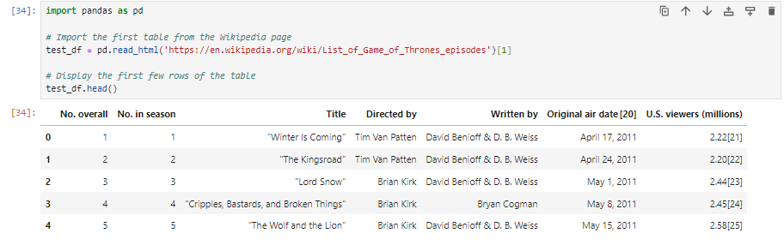

**2. Importing All Seasons**

Subsequently, all eight seasons of Game of Thrones were imported, with each season presented in a separate table starting from the second table on the page.

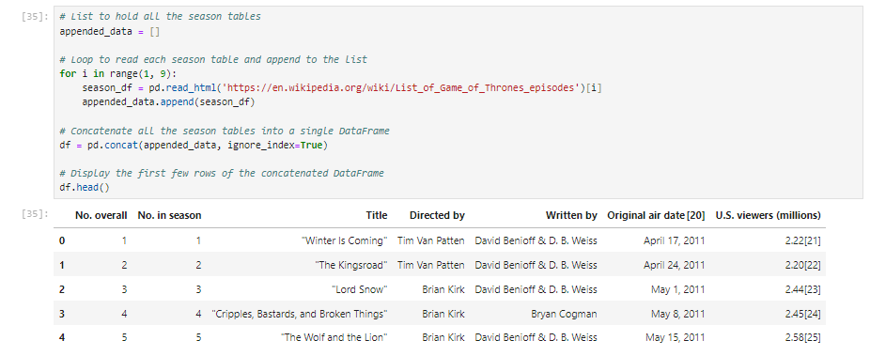

**3. Data Inspection**

The DataFrame was inspected to understand the data types, revealing that the column 'U.S. viewers (millions)' was of type "object" instead of "float".

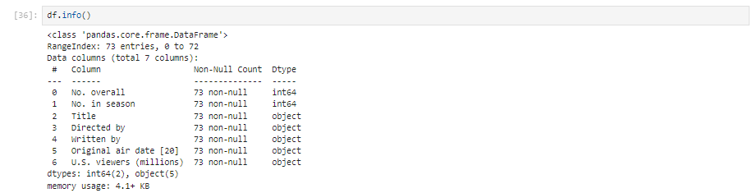

**4. Data Cleaning**

The 'U.S. viewers (millions)' column was cleaned by extracting the numeric part and converting it to float.

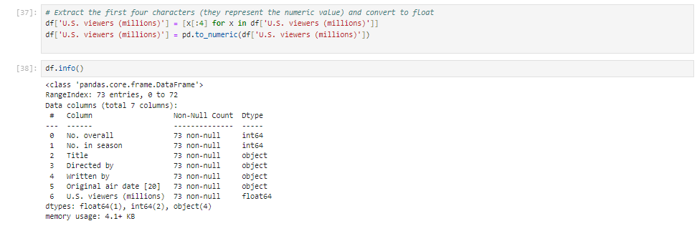

**5. Bar Chart of U.S. Views by Overall Episode Number**

A bar chart was created to visualize U.S. viewers by the overall episode number.

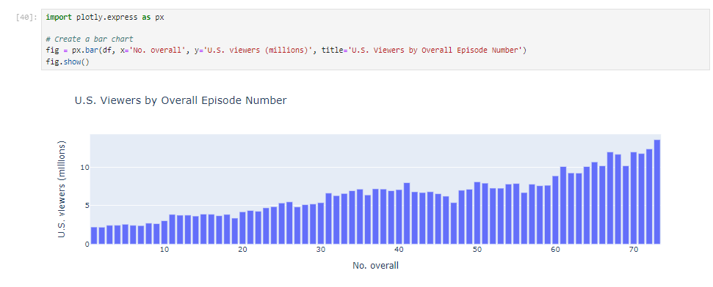

**6. Creating a 'Season' Column**

A new column 'season' was added to indicate the season number for each episode.

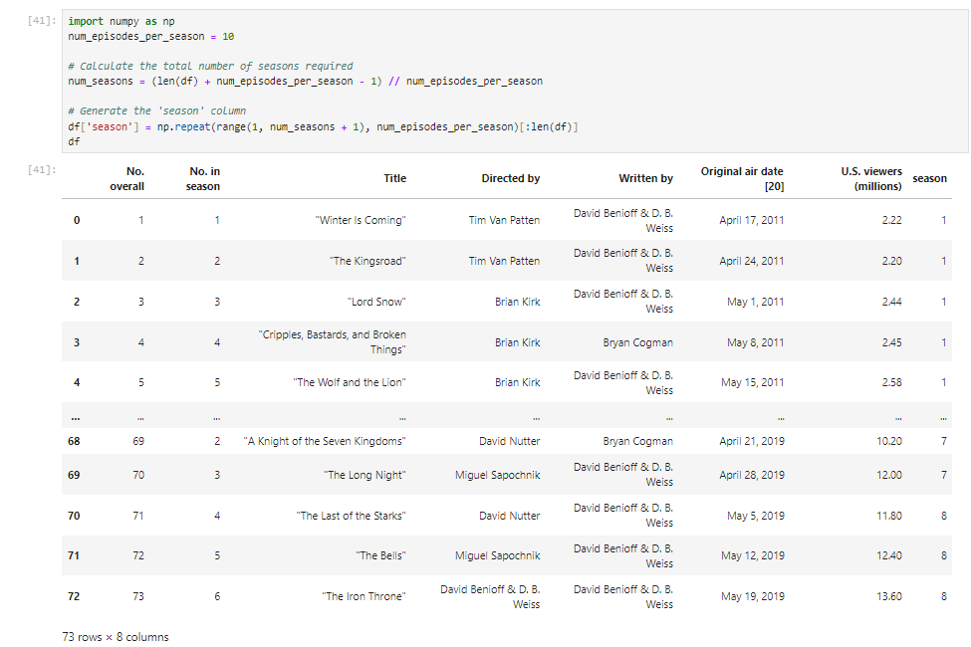

**7. Grouping Data by Season**

The data was grouped by 'season' to analyze the average number of U.S. viewers per season.

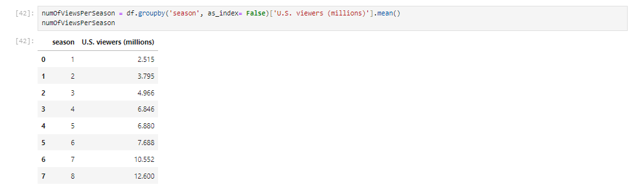

**8. Bar Chart of U.S. Views by Season**

A bar chart was created to visualize the average number of U.S. viewers per season.

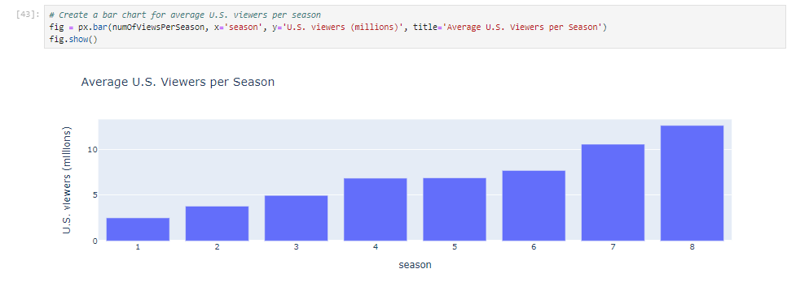

**Summary**

The project successfully demonstrated the process of web scraping, data cleaning, and data visualization using pandas and Plotly. Tables from a Wikipedia page were extracted and combined into a single DataFrame. The 'U.S. viewers (millions)' column was cleaned and converted to a numeric type. Visualization techniques were employed to create bar charts that display U.S. viewership trends across episodes and seasons.

Analysis of the data revealed that the number of views per season increased from **season 1** to **season 8**, with the final season having the highest number of views. This indicates a growing interest and audience engagement in the series over time. This project provides valuable insights into the viewership patterns of Game of Thrones episodes.