**Class Work #10**

* Decide if 3 colors are sufficient to color G1 and G2

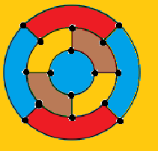

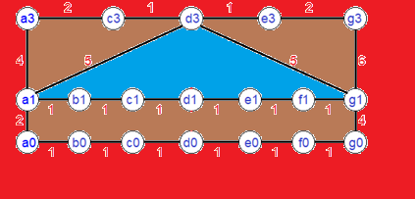

4 color Purple can be painted as green(Min 2 color)

* Find a minimum spanning tree in G1 and G2

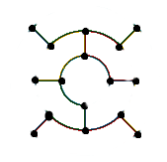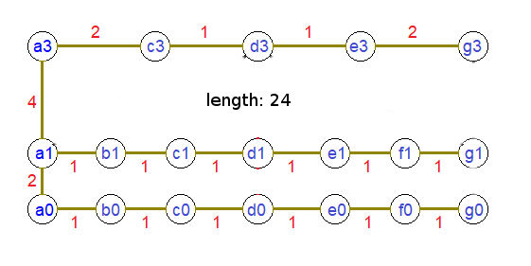

* Find a Hamiltonian circuit (cycle) in G1 and G2

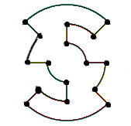 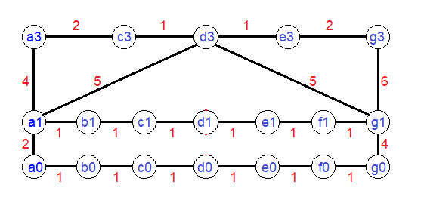

Does not include Hamiltonian cycle

* Decide if G1 and G2 contain an Eulerian circuit

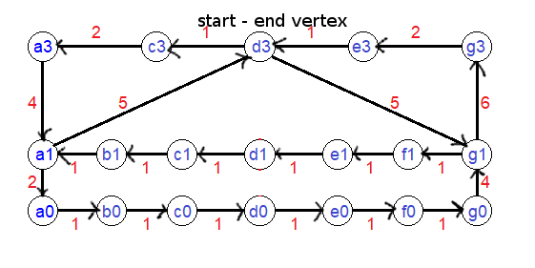

G1 does not contain