Abdessalam Aithaqi (1975004) & Pavel Sushko (2032295)

Mr. Aref Mourtada

420-3P5-AB sec.02 Programming III

17/Dec/2021

# **Pharmacy Abdel & Pavel ®**

## Description

The application is a simple inventory tracking app for the back store of a pharmacy. It allows managers and owners to keep track of available medicine in the pharmacy. The name of the medication as well as the current quantity currently in the cabinets, the minimum quantity required in the cabinets, the location of the medication (which cabinet is it stored in), the name of the supplier and the category of medicine are displayed for the user to see. Medicine can be added and taken out of the tracking system. The owner can update available quantities. A list of medication to order, based on the medicine below the minimum quantity required in store, can be generated to make the manager’s life easier.

## Functionalities

Add medication adds medicine to the list of available medicine

Remove medication: remove medication from the list of available medicine

Update information: allows the editing of the information of medicine

*In-Stock* report: generates a list of all available items, current quantity, and minimum quantity

*Out-of-Stock* report: generates a list of medication that have quantities below the minimum their minimum quantity

Import items: load a list of items from a csv file

Save: saves any changes made to the items

## Development approach

### Setting up

* Creating a repository on GitHub
* Creating a branch each
* Creating a word document for the report

### Understanding the problem

* Reading the demands from the client and resuming them in bullet point
* Understanding the application’s use, target audience, etc

### Formulating the problem

* Understanding what is to be displayed and what is to be hidden
* The format of what is displayed or produced

### Developing the application

* Creating a UML diagram for each one of the classes we plan to use
* Sketching out the design of the windows (button placement, proportions, colors, and patterns)
* Writing pseudo code when the functions are complex or bulky

### Implementing the application

* Starting with the .xaml
  + Implementing window layouts previously sketched
  + Setting up the events and the event handlers for interactive components of the window
* Class implementation
  + Implementing the data fields, method and properties previously designed with UML
  + Implementing the pseudo code or set the non-implemented exception to come back to later
* Window backend
  + Writing the code behind the event handlers, one event handler at a time
  + Testing and fixing one button at a time
  + Adapting the class code and UML as needed
  + Pushing the changes every time a button is finished

### Testing

* Testing edge case numbers implemented
* Testing button mashing
* Testing buttons misuse

## Design of OOP classes

### UML Diagrams

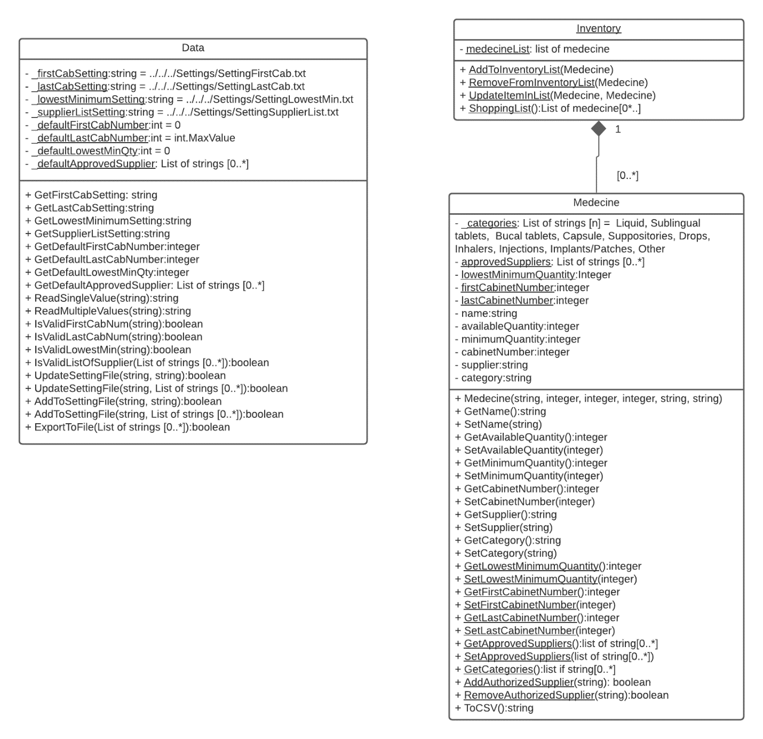

# Contributions

## Abdel

* Project report
* UML Designs
* Classes
  + Data Class
    - Global constants
    - Methods
      * ReadSingleValue
      * ReadMultipleValues
      * IsValidFirstCabNum
      * IsValidLastCabNum
      * IsValidListOfSupplier
      * AddToSettingFile
  + Inventory Class
  + Medicine Class
* Xamel code
  + MainWindow
  + MedicineWindow
  + ModifyWindow
  + SettingWindow
  + SupplierWindow
* Xamel.cs
  + MainWindow
    - LoadDefaultSetting
    - BtnAdd_Click
    - BtnRemove_Click
    - BtnModify_Click
  + MedicineWindow
    - LoadOptions
    - BtnSave_Click
    - ClearForm
    - CheckUserInput
  + ModifyWindow
  + SettingWindow
    - LoadSettings
    - BtnFirstCabNum_Click
    - BtnLastCabNum_Click
    - BtnLowestMinQty_Click
    - BtnAddSupp_Click
    - BtnRemoveSupp_Click
  + SupplierWindow

## Pavel

* Reducing the lines of code required
* Comments and documentation of all code
* Classes
  + Data Class
    - Properties
    - Methods
      * UpdateSettingFile
      * ExportToFile
* Xamel code
  + MedecineWindow
* Xamel.cs
  + MainWindow
    - LoadDefaultSetting
    - BtnImport_click
    - BtnInStockReport_Click
    - BtnOutOfStockReport_Click
    - BtnSave_Click
  + MedicineWindow
    - GetUserInput
    - BtnSaveClose_Click
  + SettingWindow
    - BtnImportSupp_Click
    - BtnModify*_Click

## Future Work

* A logo
* Search (searches for item by name, shows multiple matches)